Replace And Modernize Legacy VPN

Architectures With a Cloud-native Zscalar

Zero Trust

COLLEGE NAME : Shri Nehru Maha Vidhyalaya College of Arts & Science.
TEAM ID: SWTID-2026-2207

Team Leader: HARSHINI N
Email: 23bcaharshini@gmail.com

Team Member: AZMAL THAHASEEN A
Email: 23bcasnmvazmal@gmail.com

Team Member: NITHISH D S
Email: nr8332084@gmail.com

Team Member: DEVENDRAN S
Email: 23snmvbcadevendran@gmail.com

Project Title
Replace And Modernize Legacy VPN Architectures With a Cloud-native Zscalar Zero Trust
Overview of the project
- Legacy VPN Limitations
Traditional VPNs provide full network access, increasing security risks and exposing internal systems.
- Need for Modern Security
With remote work and cloud usage, organizations require a more flexible and secure access model
- Introduction to Zero Trust
Zero Trust follows the principle “Never trust, always verify” for every user and device.
Role of Zscaler
- Zscaler provides a cloud-native platform that replaces VPN with secure, direct access to applications.
- Zscaler Internet Access (ZIA)
- Secures user access to the internet and protects against cyber threats.
- Zscaler Private Access (ZPA)
- Provides secure access to internal applications without exposing the network.
- Cloud-Cloud-Native Architecture
Eliminates on-premise hardware like VPN gateways and firewalls.
Improved Security
Prevents lateral movement and reduces the attack surface by granting limited access.
Abstract

- Traditional Virtual Private Network (VPN) architectures have long been used to provide secure remote access to organizational resources. However, with the rapid growth of cloud computing, mobile workforces, and distributed environments, legacy VPN solutions have become inefficient, complex, and vulnerable to modern cyber threats.
- This project focuses on replacing and modernizing legacy VPN architectures with a cloud-native Zero Trust security model using Zscaler solutions.
- The Zero Trust approach operates on the principle of “never trust, always verify,” ensuring that all users and devices are continuously authenticated and authorized before accessing any application or resource.
- The proposed solution leverages Zscaler’s cloud platform, including Zscaler Internet Access (ZIA) and Zscaler Private Access (ZPA), to provide secure, direct, and policy-based access to applications without exposing the internal network.
- By eliminating the need for on-premise VPN hardware and adopting a scalable cloud-based model, the system enhances performance, simplifies management, and supports modern digital transformation initiatives
- Overall, this project demonstrates how transitioning from legacy VPN systems to a Zero Trust architecture using Zscaler can provide a secure, efficient, and future-ready approach to enterprise network access.

Use case Scenarios
- Use Case: Remote Workforce Access
Employees access company applications from home without VPN using Zscaler
Output: •Secure, direct application access
•No full network exposure
•Improved login speed and user experience
- Use Case: Secure Private Application Access
Internal applications are accessed without exposing them to the internet
Output:
•Applications remain hidden from public networks
•Access is granted only after identity verification
•No inbound firewall rules required
- Use Case: Performance Optimization
Users experience slow VPN connections
Output:
•Faster application access
•Reduced latency and congestion
- Use Case: Data Loss Prevention (DLP)
Sensitive company data is accessed or shared by users
Output:
•Unauthorized data transfers are blocked
•Policy-based control over uploads/downloads
•Compliance with data security standards
- Use Case: Cloud Application Security (SaaS)
Users access cloud apps like email or storage services
Output:
•Secure internet traffic inspection
• Data leakage prevention
STAGE 1
TITLE:
OWASP TOP 10
OVERVIEW:
The OWASP Top 10 is a standard awareness document published by the Open Web Application Security Project (OWASP) that identifies the most critical security risks to web applications. It is designed to help developers, security professionals, and organizations understand common vulnerabilities that attackers often exploit. The OWASP Top 10 highlights major risks such as Broken Access Control, Cryptographic Failures, Injection, Insecure Design, Security Misconfiguration, Vulnerable and Outdated Components, Identification and Authentication Failures, Software and Data Integrity Failures, Security Logging and Monitoring Failures, and Server-Side Request Forgery (SSRF). These vulnerabilities can allow attackers to gain unauthorized access, steal sensitive data, modify information, or even take full control of a system. For example, Injection attacks occur when malicious code is inserted into a program, while Broken Access Control allows users to access resources they are not authorized to use. Similarly, Cryptographic Failures happen when sensitive data such as passwords or credit card information is not properly encrypted. The OWASP Top 10 serves as a guideline for improving application security by encouraging organizations to adopt secure coding practices, proper configuration, regular updates, and continuous monitoring. By understanding and addressing these risks, developers can build more secure and reliable web applications and reduce the chances of cyberattacks.
Rank | Vulnerability
1 | Broken Access Control
2 | Security Misconfiguration
3 | Software Supply Chain Failures
4 | Cryptographic Failures
5 | Injection
6 | Insecure Design
7 | Authentication Failures
8 | Software or Data Integrity Failures
9 | Security Logging and Alerting Failures
10 | Mishandling of Exceptional conditions

S.NO |  | Vulnerability | CWE/CVE NO
1. |  | Relative Path Traversal | CWE-23
2. | Active Debug Code |  | CWE-489
3. | Use of Unmaintained Third Party Components |  | CWE-1104
4. | Small Space of Random Values |  | CWE-334
5. | Process Control |  | CWE-114
6. | External Control of File Name or Path |  | CWE-73
7. | Use of Default Password |  | CWE-1393
8. | Untrusted Search Path |  | CWE-426
9. | Insertion of Sensitive Information into Log File |  | CWE-532
10. | Unchecked return value |  | CWE-252

REPORT:
1.Vulnerability Name : Relative Path Traversal
CWE NO : CWE-23
OWASP Category : Broken Access Control
Description: Relative Path Traversal (Directory Traversal) is a vulnerability where attackers manipulate file paths (using sequences like ../) to access unauthorized files on a server. In traditional IT environments that rely on VPN-based access, this vulnerability becomes more dangerous because users are often given broad network-level access after authentication. Relative Path Traversal is a serious vulnerability, but its impact is much higher in legacy VPN environments due to excessive access. By adopting a Zero Trust model using Zscaler, organizations can contain and minimize the damage, ensuring secure and controlled access to applications
Business Impact: Relative Path Traversal is a critical vulnerability, and its business impact differs significantly between legacy VPN architectures and a Zero Trust model using Zscaler. Limited Access, Attack Containment, Reduced Data Exposure, Better Monitoring, Lower Business Risk

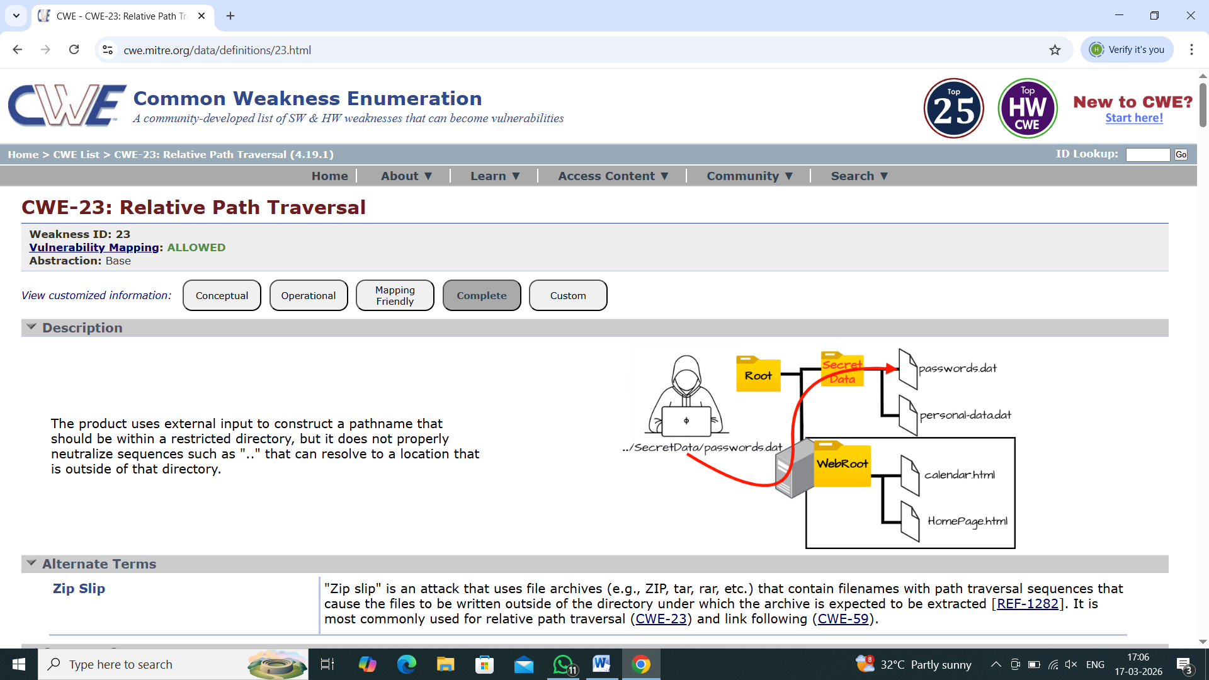

2) Vulnerability Name : Active Debug Code
CWE NO :CWE-489
OWASP Category: Security Misconfiguration
Description: Active Debug Code refers to debugging statements or code segments that are still enabled and running in a live (production) application. These are originally added by developers to test, monitor, and troubleshoot software during development but should normally be removed or disabled before deployment. Active Debug Code is useful during development but becomes a security risk in production systems. Properly managing and disabling debug code is essential for maintaining application security.
Business Impact : Active debug code in a live system can expose sensitive information and system details, making it easier for attackers to exploit vulnerabilities. This can lead to data breaches, financial loss, legal and compliance issues, and damage to the organization’s reputation.
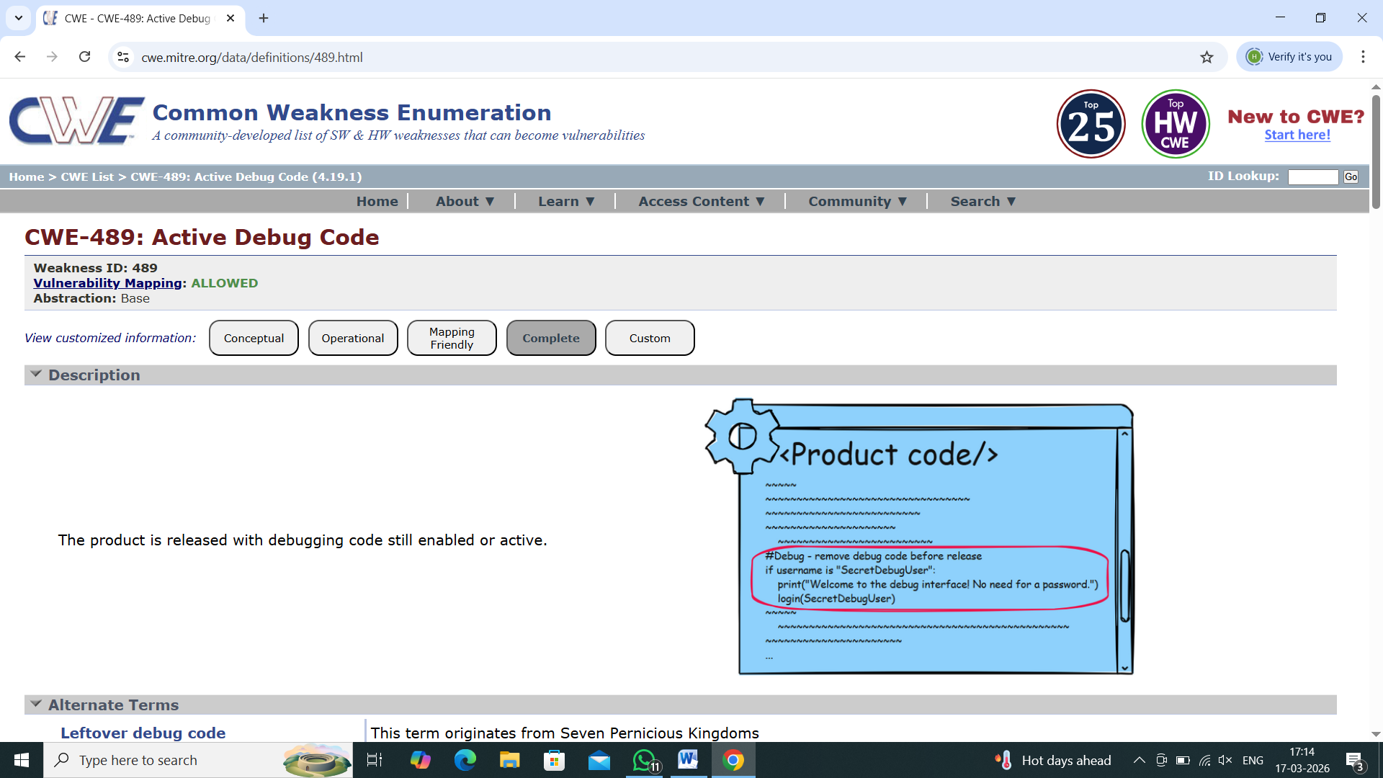

3) Vulnerability Name : Use of Unmaintained Third Party Components
CWE NO: CWE-1104
OWASP Category: Software supply chain Failures
Description: The use of unmaintained third-party components refers to including external libraries, frameworks, or software modules in an application that are no longer updated, supported, or patched by their developers.
Business Impact : Using unmaintained third-party components can expose applications to known security vulnerabilities, increasing the risk of data breaches and cyber attacks. This can result in financial loss, compliance violations, system instability, and damage to the organization’s reputation.
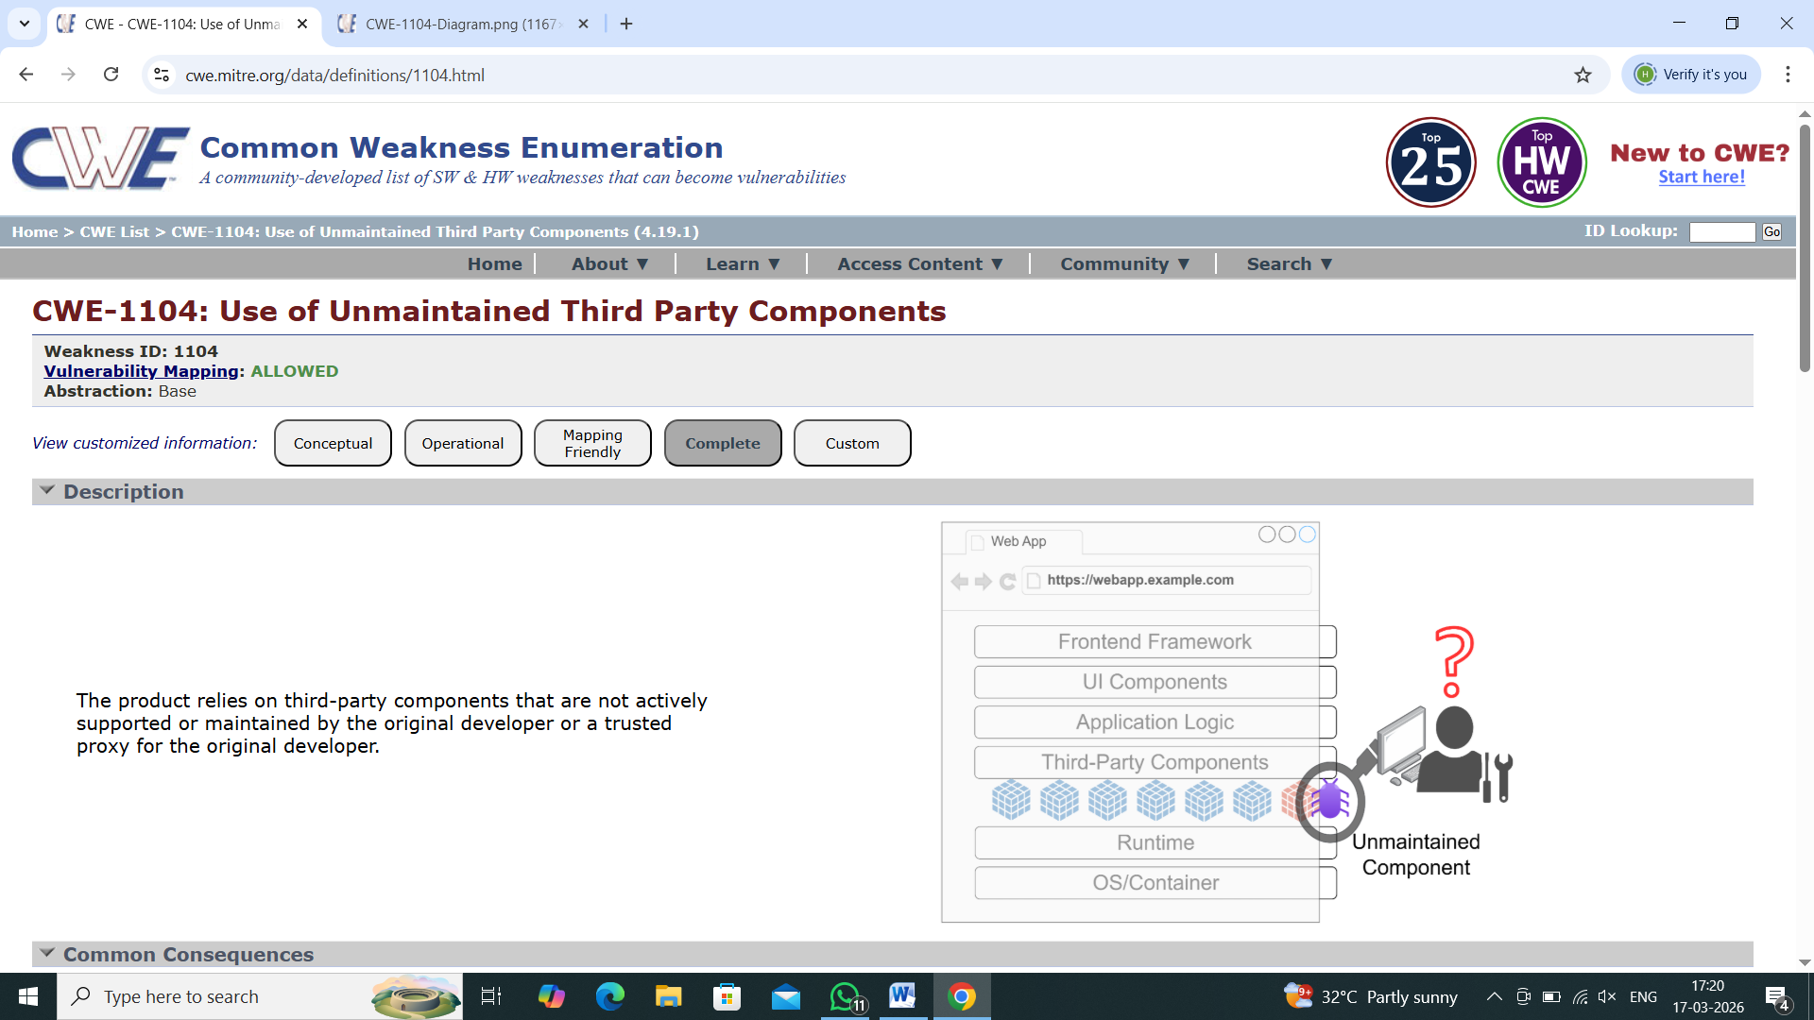

4) Vulnerability Name : Small Space of Random Values
CWE NO : CWE-334
OWASP Category: Cryptography failures
Description: Small Space of Random Values is a security weakness where a system uses random values (like tokens, passwords, or keys) from a limited or small range, making them easier to guess or predict. This low entropy makes it possible for attackers to guess or brute-force the values, leading to account hijacking, unauthorized access, and broken authentication.
Business Impact : Using a small range of random values makes it easier for attackers to guess tokens, passwords, or keys, leading to unauthorized access. This can result in data breaches, financial loss, security incidents, and damage to the organization’s reputation.
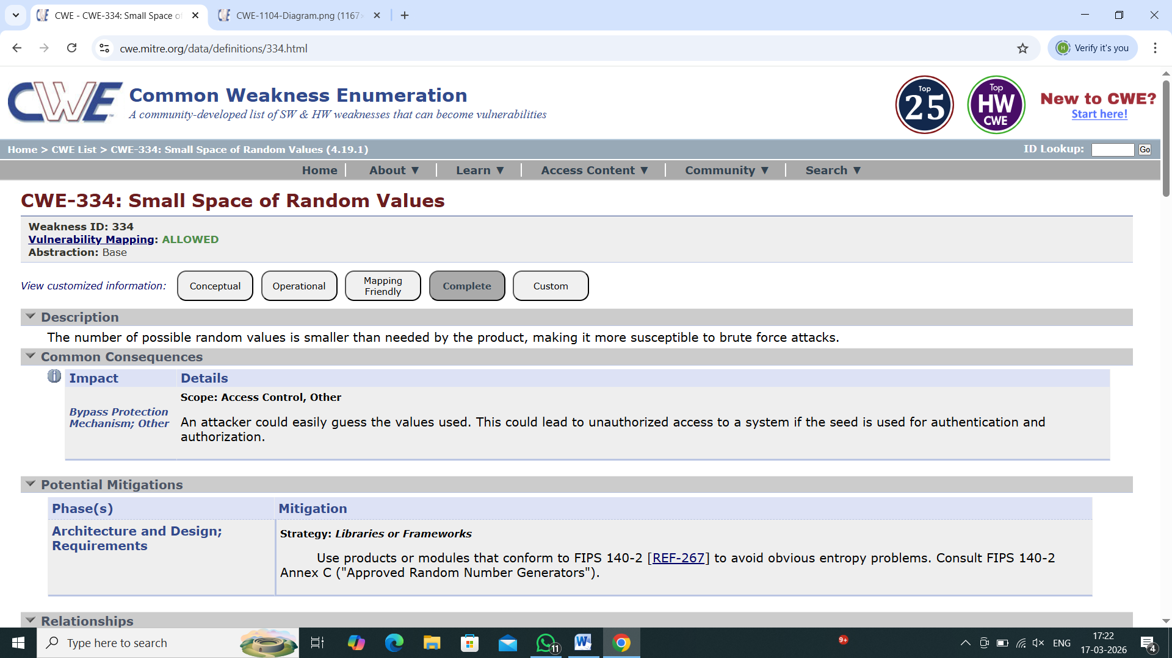

5) Vulnerability Name : Process Control
CWE NO : CWE-114
OWASP Category: Injection
Description: Process Control refers to the management and regulation of system processes to ensure they operate correctly, securely, and efficiently within a computer system or application. A process is a program in execution. Process control involves Starting and stopping processes, managing process execution
Business Impact : Effective process control helps organizations maintain secure, stable, and efficient systems, reducing risks and supporting continuous business operations. Operational Efficiency is Proper process control ensures smooth system performance and optimal resource usage

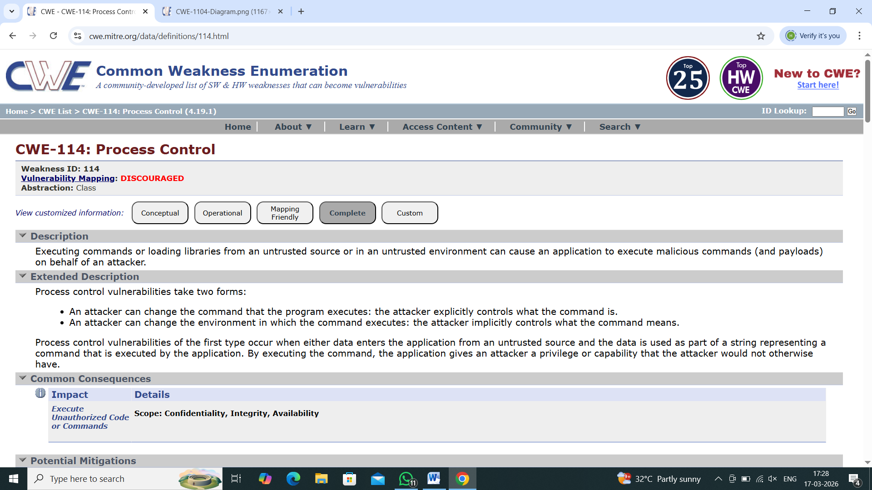

6) Vulnerability Name : External Control of File Name or Path
CWE NO : CWE-73
OWASP Category: Insecure Design
Description: External Control of File Name or Path is a security vulnerability where an application allows user input (external data) to directly control the file name or file path used in file operations (like reading, writing, or deleting files) without proper validation.
Business Impact : Allowing external input to control file names or file paths without proper validation can lead to serious security risks, as attackers may exploit this vulnerability to access sensitive files such as configuration data, user information, or system files, resulting in unauthorized data exposure and potential data breaches.
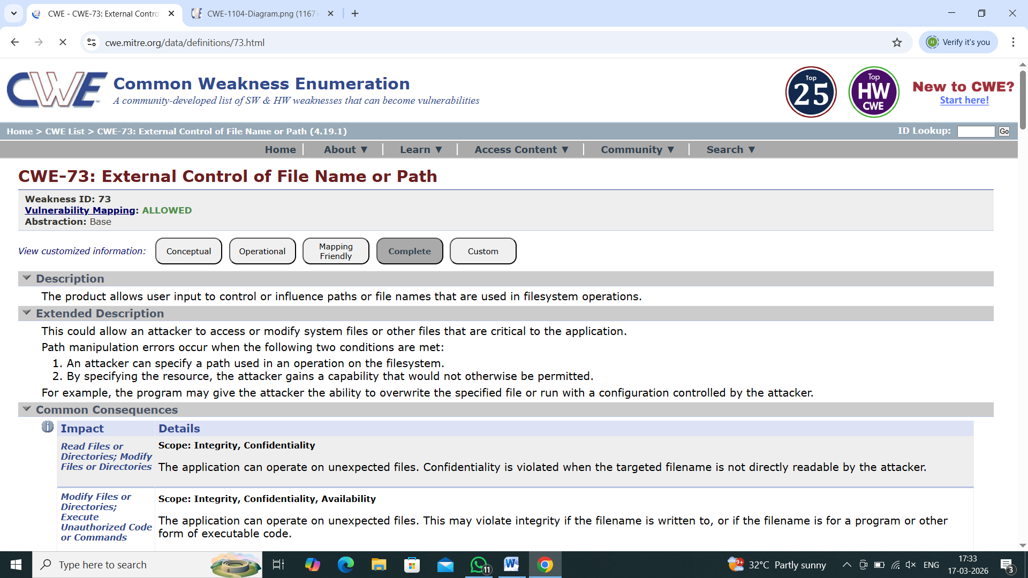

7) Vulnerability Name : Use of default password
CWE NO : CWE-1393
OWASP Category: Authentication Failures
Description: The use of default passwords refers to a security weakness where systems, applications, or devices continue to use predefined credentials (such as “admin/admin” or “admin/password”) that are set by the manufacturer or developer and are not changed by users after installation.
Business Impact : The use of default passwords in systems and applications can create significant security risks, as attackers can easily guess or obtain these commonly known credentials to gain unauthorized access to critical systems, sensitive data, and administrative controls without requiring advanced hacking techniques.
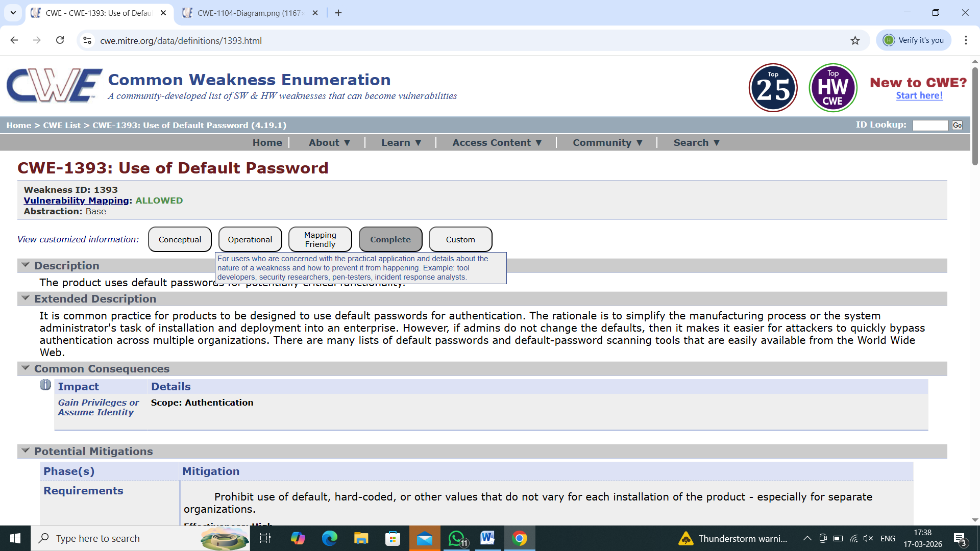
8) Vulnerability Name : Untrusted Search Path
CWE NO : CWE-426
OWASP Category: Software or data integrity failures
Description: Untrusted Search Path is a security vulnerability that occurs when a system or application uses external or untrusted locations to search for executable files (like programs, scripts, or libraries) without proper validation or restriction.
Business Impact: The untrusted search path vulnerability can have serious consequences for organizations, as it allows attackers to execute malicious programs by placing them in locations that the system searches automatically, leading to unauthorized code execution without the user’s knowledge.
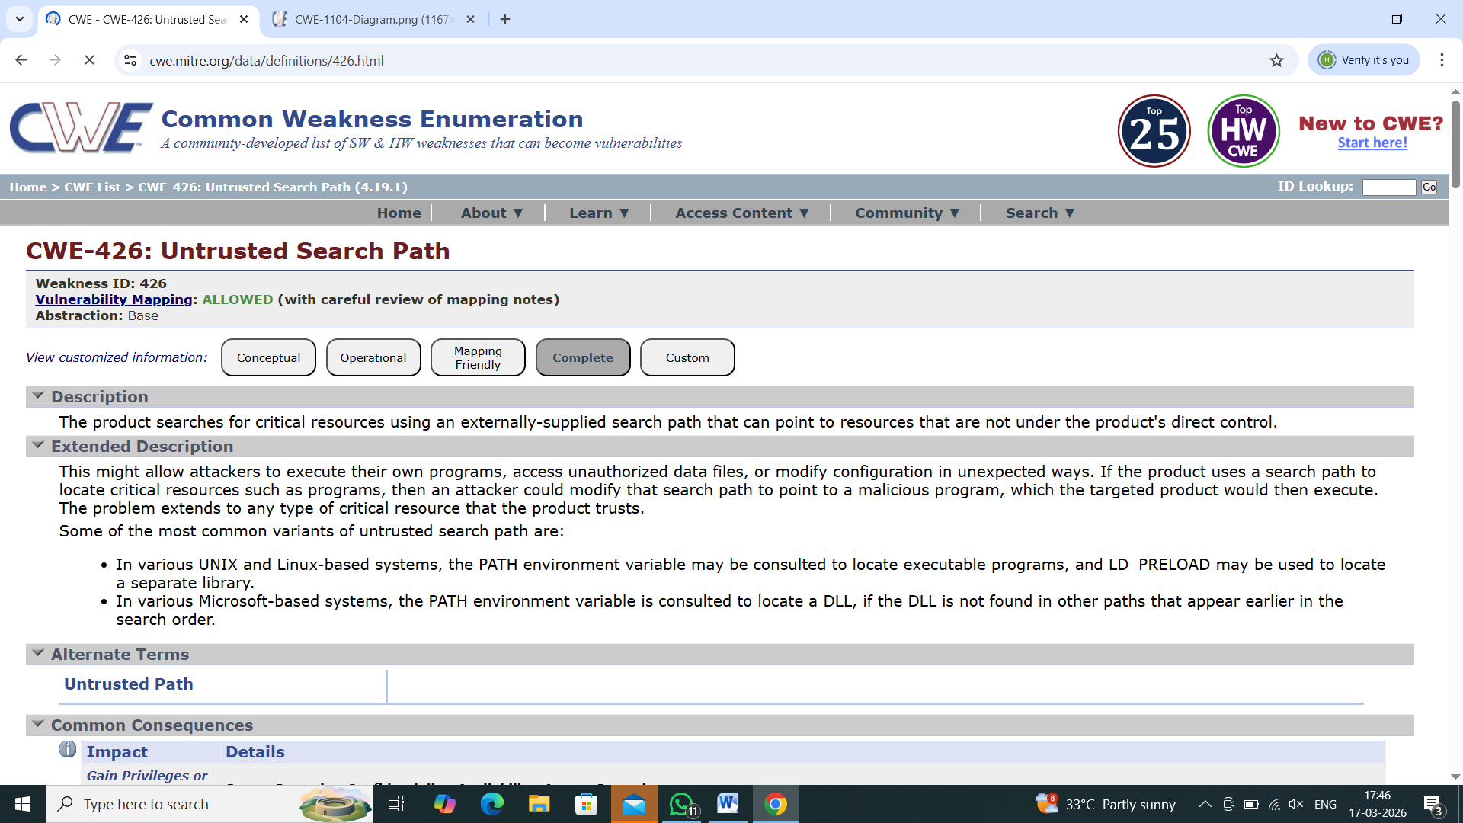
9) Vulnerability Name : Insertion of Sensitive information into log file
CWE NO: CWE-532
OWASP Category: Security logging and alerting failures
Description: Insertion of sensitive information into log files is a security issue where an application stores confidential data in its logs, such as passwords, credit card numbers, personal details, session IDs, or API keys.
Business Impact: Storing sensitive information such as passwords, personal data, credit card details, or session tokens in log files can create serious security risks, as these logs may be accessed by unauthorized users, attackers, or even internal personnel without proper clearance, leading to unintended exposure of confidential information.
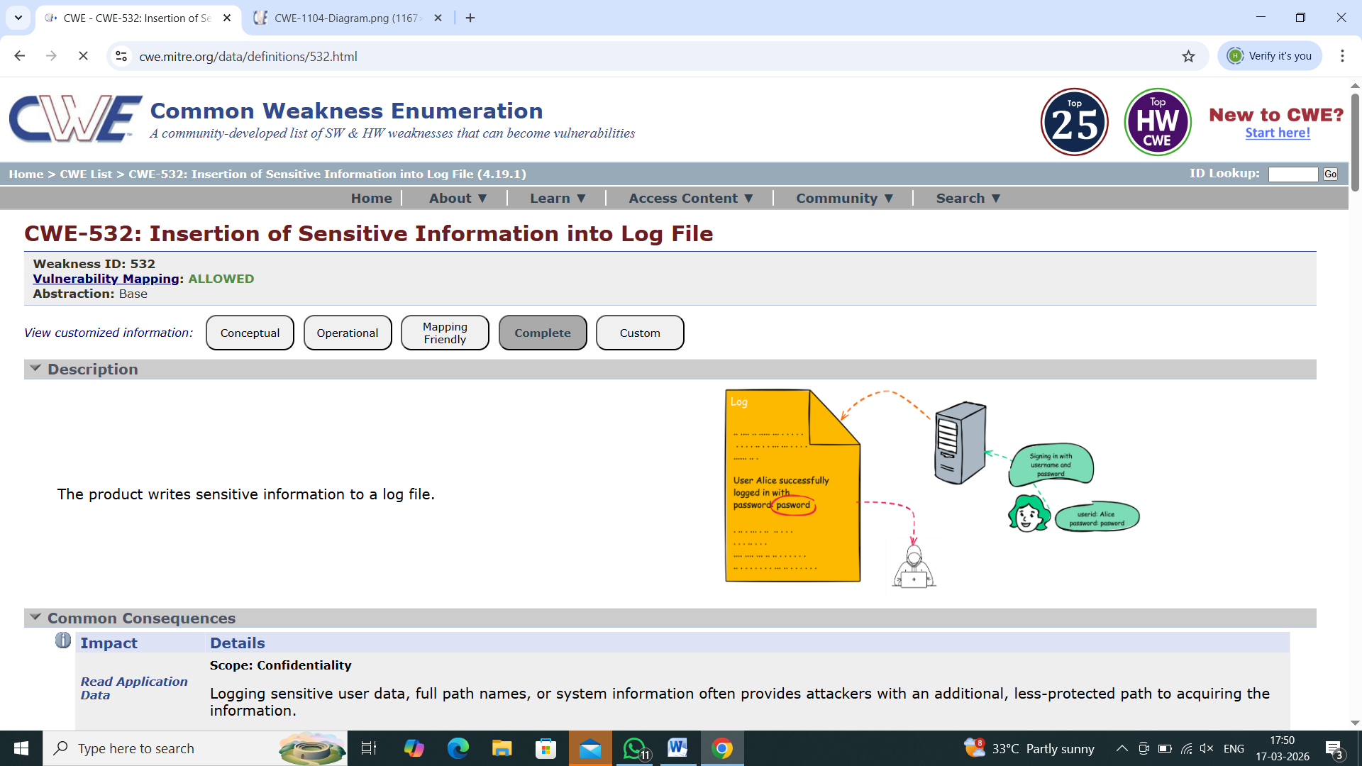
10) Vulnerability Name : Unchecked return value
CWE NO : CWE-252
OWASP Category: Mishandling and Exceptional handling
Description: Unchecked Return Value (CWE-252) occurs when a program does not check the return value of a function or method to verify whether the operation was successful or failed. Many functions return a value that indicates the result of the operation. If the program ignores this return value, it may continue execution even when an error has occurred, which can lead to unexpected behavior or security vulnerabilities.
Business Impact : This vulnerability can cause system errors, application crashes, or security weaknesses because failures are not detected or handled properly. Attackers may exploit these situations to disrupt services, manipulate system operations, or gain unauthorized access. For businesses, this can result in service interruptions, operational issues, financial loss, and damage to reputation.
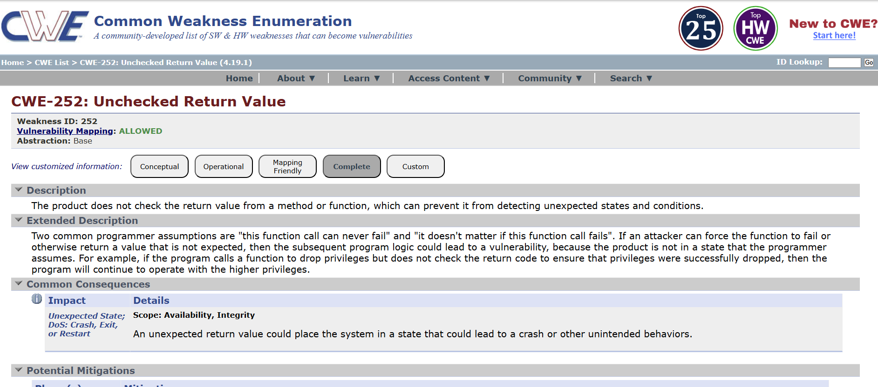

STAGE2

TITLE: NESSUS SCAN
OVERVIEW:
Nessus is a widely used vulnerability scanning tool developed by Tenable. It is used by security professionals to identify security weaknesses, misconfigurations, and vulnerabilities in computers, networks, servers, and applications. Nessus works by scanning systems and comparing them with a large database of known vulnerabilities to detect potential security risks.
During a Nessus scan, the tool checks for issues such as outdated software, missing security patches, weak configurations, open ports, and known security vulnerabilities. It uses thousands of plugins to test systems and identify problems that attackers could exploit. After the scan is completed, Nessus generates a detailed report that lists the vulnerabilities found, their severity levels (Critical, High, Medium, Low), and recommendations for fixing them.
Nessus scanning helps organizations improve their security posture by identifying risks before attackers can exploit them. It allows security teams to prioritize vulnerabilities, apply patches, and strengthen system security. Regular Nessus scans are an important part of vulnerability management and cybersecurity practices.
S.NO | Vulnerability Name | Severity | Plugins
1. | Nessus SYN Scanner | INFO | 11219
2. | Canonical Ubuntu Linux SEoL(14.04.x) | CRITICAL | 201408
3. | ICMP Timestamp Request Remote Date Disclosure | LOW | 10114
4. | Apache Banner Linux Distribution Disclosure | INFO | 18261
5. | Service Detection | INFO | 22964
6. | Back ported Security Patch Detection(WWW) | INFO | 39521
7. | Remote Services Not Using Post-Quantum Ciphers | INFO | 277650
8. | Host Fully Qualified Domain Name(FQDN)Resolution | INFO | 12053
9. | SSH Terrapin Prefix Truncation Weakness (CVE-2023-48795) | MEDIUM | 187315
10. | OpenSSH Detection | INFO | 181418

REPORT:
1)Nessus SYN scanner
Description: This plugin is a SYN 'half-open' port scanner. It shall be reasonably quick even against a firewalled target.Note that SYN scans are less intrusive than TCP (full connect) scans against broken services, but they might cause problems for less robust firewalls and also leave unclosed connections on the remote target, if the network is loaded.
Solution: Protect your target with an IP filter.
Severity: Info
ID:11219

2)Canonical Ubuntu Linux SEoL (14.04.x)
Description: According to its version, Canonical Ubuntu Linux is 14.04.x. It is, therefore, no longer maintained by its vendor or provider.Lack of support implies that no new security patches for the product will be released by the vendor. As a result, it may contain security vulnerabilities.
Solution: Upgrade to a version of Canonical Ubuntu Linux that is currently supported.
Severity: Critical
ID:201408

3)ICMP Timestamp Request Remote Date Disclosure
Description: The remote host answers to an ICMP timestamp request. This allows an attacker to know the date that is set on the targeted machine, which may assist an unauthenticated, remote attacker in defeating time-based authentication protocols.Timestamps returned from machines running Windows Vista / 7 / 2008 / 2008 R2 are deliberately incorrect, but usually within 1000 seconds of the actual system time.
Solution: Filter out the ICMP timestamp requests (13), and the outgoing ICMP timestamp replies (14).
Severity: Low
ID:10114

4)Apache Banner Linux Distribution Disclosure
Description: Nessus was able to extract the banner of the Apache web server and determine which Linux distribution the remote host is running.
Solution: If you do not wish to display this information, edit 'httpd.conf' and set the directive 'ServerTokens Prod' and restart Apache.
Severity: Info
ID:18261

5)Service Detection
Description: Nessus was able to identify the remote service by its banner or by looking at the error message it sends when it receives an HTTP request.
Solution: Configure the affected services to suppress banner information and avoid disclosing service names or version details. Disable or remove any unnecessary services running on the system to reduce the attack surface. Implement firewall rules to restrict access to required ports and allow only trusted hosts. Additionally, ensure all services are regularly updated and patched to prevent exploitation of known vulnerabilities.
Severity: Info
ID:22964

6)Backported Security Patch Detection (WWW)
Description: Security patches may have been 'backported' to the remote HTTP server without changing its version number.Banner-based checks have been disabled to avoid false positives.Note that this test is informational only and does not denote any security problem.
Solution: No action is required as this is an informational finding and does not indicate a security vulnerability. However, administrators should ensure that all security patches are regularly applied and maintained through trusted sources. Proper patch management practices should be followed to keep the system secure and up to date.
Severity: Info
ID:39521

7) Remote Services Not Using Post-Quantum Ciphers
Description: This plugin reports network services that do not offer post-quantum ciphers. Tenable makes no attempt to determine whether the remote service would be vulnerable to a post-quantum attack.
However, cryptography that depends on the classic difficulty of solving the discrete logarithm problem or on the classic difficulty of large prime factorization is broken by Shor's algorithm. Examples of this are RSA asymmetric encryption and Diffie-Hellman key exchange.
Solution: Update and configure the affected services to support post-quantum cryptographic algorithms where available. Replace or supplement traditional cryptographic methods such as RSA and Diffie-Hellman with quantum-resistant algorithms (e.g., lattice-based cryptography). Ensure all cryptographic libraries and software are up to date and follow current best practices and standards. Additionally, adopt a hybrid cryptographic approach (combining classical and post-quantum algorithms) to maintain compatibility while improving future security readiness.
Severity: Info
ID:277650

8)Host Fully Qualified Domain Name (FQDN) Resolution
Description: Nessus was able to resolve the fully qualified domain name (FQDN) of the remote host.
Solution: No action is required as this is an informational finding and does not indicate a security issue. However, if disclosure of the fully qualified domain name (FQDN) is not desired, administrators can restrict DNS information exposure by properly configuring DNS servers and limiting external name resolution. Firewall rules may also be implemented to control access to DNS services.
Severity: Info
ID:12053

9)SSH Terrapin Prefix Truncation Weakness (CVE-2023-48795)
Description: The remote SSH server is vulnerable to a man-in-the-middle prefix truncation weakness known as Terrapin. This can allow a remote, man-in-the-middle attacker to bypass integrity checks and downgrade the connection's security.

Note that this plugin only checks for remote SSH servers that support either ChaCha20-Poly1305 or CBC with Encrypt-then-MAC and do not support the strict key exchange countermeasures. It does not check for vulnerable software versions.
Solution: Contact the vendor for an update with the strict key exchange countermeasures or disable the affected algorithms.
Severity: Medium
ID:187315

10)OpenSSH Detection
Description: An OpenSSH-based SSH server was detected on the remote host.
Solution: Ensure the OpenSSH service is securely configured and regularly updated to the latest version. Disable root login and use strong authentication methods such as key-based authentication instead of passwords. Limit access to the SSH service using firewall rules or allow only trusted IP addresses. Additionally, change the default SSH port if necessary and disable any unused SSH features to reduce the attack surface.
Severity: Info
ID:181418

STAGRE 3
TITLE:
Replace And Modernize Legacy VPN Architectures With a Cloud-native Zscalar Zero Trust
Overview:

Replacing legacy VPNs with Zscaler Private Access™ (ZPA) adopts a cloud-native, identity-centric architecture to eliminate inbound firewall rules and network-level access, effectively reducing the attack surface. By directly connecting users to specific applications rather than the network, Zscaler stops lateral movement, mitigates ransom ware risks, and enhances user experience through localized, secure access.
the project focus is on transforming the newly implemented Zero Trust environment into a resilient, adaptive, and continuously secure framework that can evolve with the organization’s business needs and emerging cybersecurity threats. This stage emphasizes not only maintaining the security posture established in earlier stages but also proactively enhancing it through continuous monitoring, policy refinement, and user awareness.
All user activity, application access, and network traffic are continuously monitored through the Zscaler cloud platform, providing real-time visibility into potential anomalies, unauthorized access attempts, or policy violations, which allows security teams to respond instantly and prevent potential breaches. Access policies and Role-Based Access Control (RBAC) rules are regularly reviewed and optimized to ensure that each user has strictly least-privilege access, significantly reducing the risk of internal misuse or lateral movement within the network.
Regular vulnerability assessments, audits, and automated security checks are conducted to identify and remediate any gaps, misconfigurations, or emerging threats, ensuring that the environment remains hardened against evolving cyberattacks. At the same time, employees and users are continuously educated on secure access practices, Multi-Factor Authentication (MFA), and the principles of Zero Trust, fostering a culture of security awareness and responsibility across the organization.
ensures scalability and future readiness, enabling seamless onboarding of new applications, devices, or remote users without compromising security. By combining continuous monitoring, adaptive policies, proactive vulnerability management, and user education, Stage 3 guarantees that the cloud-native Zscaler Zero Trust solution remains a dynamic, secure, and future-proof infrastructure, capable of minimizing the attack surface, preventing lateral movement, and maintaining organizational resilience in the face of modern cybersecurity challenges.

Conclusion :
Stage 1: Assessment and Planning
To understand the existing VPN infrastructure, identify security risks, and create a structured plan for migrating to a cloud-native Zero Trust architecture using Zscaler.
1 Evaluate Existing VPN Infrastructure:
Analyze VPN gateways, network architecture, and connectivity patterns.
Identify applications, servers, and resources currently accessible via VPN.
2 Identify Risks and Vulnerabilities:
Assess exposed systems, open ports, and network segments prone to lateral movement.
Highlight potential threats from legacy configurations and outdated security policies.
3 Map Users and Roles:
Define user groups, roles, and access requirements.
Prepare Role-Based Access Control (RBAC) structure for Zero Trust implementation.
4 Select Identity Providers (IdPs):
Choose platforms like Azure AD or Okta for Single Sign-On (SSO) and Multi-Factor Authentication (MFA).
5 Develop Migration Plan:
Create a phased roadmap for migrating applications and users from VPN to Zscaler Zero Trust.

Stage 2: Implementation and Integration
Deploy Zscaler Internet Access (ZIA) for secure web and SaaS traffic.
Deploy Zscaler Private Access (ZPA) for secure, application-level access without exposing internal networks.
Integrate with IdPs for SSO and MFA, ensuring identity-driven access.
Apply RBAC and policy enforcement for least-privilege access.
Conduct vulnerability assessments (e.g., Nessus scans) to detect and remediate security gaps.
Test user access and monitor for anomalies, ensuring a secure operational environment.

Stage 3: Optimization and Continuous Security
Continuously monitor traffic, user activity, and security events via Zscaler dashboards.
Refine access policies and RBAC rules based on emerging threats and organizational needs.
Conduct regular vulnerability assessments and compliance audits.
Educate users on Zero Trust principles and secure access practices.
Scale the environment for new applications, remote users, and devices.

Future Scope:

Stage 1: Expansion and Integration
Extend Zero Trust coverage across more users, devices, and applications.
Integrate additional Identity Providers (IdPs) to support wider Single Sign-On (SSO) coverage.
Include mobile devices, remote endpoints, and IoT devices under Zero Trust policies.
Onboard new cloud and on-premise applications using Zscaler Private Access (ZPA).
Implement user behavior analytics to detect anomalous activity early.
Benefits: Broader security coverage, seamless access, and enhanced visibility across the organization.

Stage2: Advanced Security and Automation
Improve threat detection, response, and operational efficiency.
Integrate with SIEM (Security Information and Event Management) and SOAR platforms for centralized monitoring and automated response.
Deploy AI and machine learning-based threat detection to proactively prevent attacks.
Automate dynamic policy adjustments based on risk scoring, device posture, and user context.
Enhance real-time monitoring and alerting for faster incident mitigation.
Benefits: Proactive threat mitigation, reduced manual effort, and improved overall security posture.

Stage3:
Compliance, Analytics, and Continuous Improvement
Maintain regulatory compliance, optimize policies, and scale for the future.
Conduct regular compliance audits (GDPR, HIPAA, PCI DSS, etc.) to ensure adherence to standards.
Generate advanced analytics and reports on user activity, application usage, and security events.
Continuously refine RBAC and access policies to enforce least-privilege access.
Plan for global scalability to support multi-region, hybrid cloud and new business requirements.
Benefits: Stronger compliance, data-driven policy optimization, and a continuously evolving, secure network architecture.

Topics Explored:
OWASP 10 , Scanning ,Vulnerability, Awareness, Identity
Tools Explored:
Zscaler, Nessus, OWASP 10,testfire

