Experiment No. 3

1. Aim

Implement control structures and form validation; create a grading system based on user-entered marks.

2. Software / Tools Required
- Any text editor (VS Code / Notepad++ / Sublime Text)
- Web Browser (Google Chrome / Mozilla Firefox / Microsoft Edge)
- HTML, CSS, and JavaScript

3. Code

index.html

<!DOCTYPE html>

<html lang="en">

<head>

<meta charset="UTF-8">

<title>Student Grade Calculator</title>

<link rel="stylesheet" href="style.css">

</head>

<body>

<div class="card">

<div class="header">

<h2>Grade Calculator</h2>

<p class="subtitle">Enter details to calculate the grade</p>

</div>

<label for="name">Student Name</label>

<input type="text" id="name" placeholder="e.g. Harry Sharma">

<label for="prn">PRN</label>

<input type="text" id="prn" placeholder="e.g. 12345678">

<label for="branch">Branch / Class</label>

<input type="text" id="branch" placeholder="e.g. Computer Engineering">

<label for="semester">Semester</label>

<input type="text" id="semester" placeholder="e.g. 5th Semester">

<div class="subjects-header">Subject Marks (0–100 each)</div>

<div class="subjects-grid">

<div class="subject-row">

<span class="subject-label">Maths</span>

<input type="number" class="marks-input" id="sub1" min="0" max="100" placeholder="Marks">

</div>

<div class="subject-row">

<span class="subject-label">Physics</span>

<input type="number" class="marks-input" id="sub2" min="0" max="100" placeholder="Marks">

</div>

<div class="subject-row">

<span class="subject-label">Chemistry</span>

<input type="number" class="marks-input" id="sub3" min="0" max="100" placeholder="Marks">

</div>

<div class="subject-row">

<span class="subject-label">Computer Sci</span>

<input type="number" class="marks-input" id="sub4" min="0" max="100" placeholder="Marks">

</div>

<div class="subject-row">

<span class="subject-label">English</span>

<input type="number" class="marks-input" id="sub5" min="0" max="100" placeholder="Marks">

</div>

</div>

<button onclick="calculateGrade()">Get Grade</button>

<div id="result"></div>

</div>

<script src="script.js"></script>

</body>

</html>

script.js

const shopName = "SneakPeak"; // const

var gst = 18; // var

let cart = []; // let

const products = [

{

id: 1,

name: "Nike Air Max",

price: 5999

},

{

id: 2,

name: "Adidas Ultraboost",

price: 7499

},

{

id: 3,

name: "Puma RS-X",

price: 4999

},

{

id: 4,

name: "Vans Old Skool",

price: 4299

}

];

function addToCart(id) {

let product = products.find(item => item.id === id);

let qty = Number(document.getElementById("qty" + id).value);

let size = document.getElementById("size" + id).value;

if (qty <= 0) {

alert("Please enter a valid quantity.");

return;

}

// Object Destructuring

const { name, price } = product;

cart.push({

name,

price,

qty,

size

});

displayCart();

document.getElementById("qty" + id).value = 0;

alert(name + " added to cart!");

}

function displayCart() {

let output = "";

if (cart.length === 0) {

document.getElementById("cartItems").innerHTML =

"<p>Your cart is empty.</p>";

return;

}

cart.forEach((item, index) => {

output += `

<p>

<b>${index + 1}. ${item.name}</b><br>

Size : ${item.size}<br>

Quantity : ${item.qty}<br>

Price : ₹${item.price}

</p>

<hr>

`;

});

document.getElementById("cartItems").innerHTML = output;

}

function generateBill() {

if (cart.length === 0) {

alert("Your cart is empty!");

return;

}

let subtotal = 0;

let bill = `<h2>${shopName} Bill</h2>`;

cart.forEach(item => {

let total = item.price * item.qty;

subtotal += total;

bill += `

<p>

${item.name}<br>

Size : ${item.size}<br>

₹${item.price} × ${item.qty} = ₹${total}

</p>

<hr>

`;

});

let gstAmount = subtotal * gst / 100;

let discount = 0;

if (subtotal >= 10000) {

discount = 1000;

}

let finalAmount = subtotal + gstAmount - discount;

bill += `

<h3>Subtotal : ₹${subtotal.toFixed(2)}</h3>

<h3>GST (${gst}%) : ₹${gstAmount.toFixed(2)}</h3>

<h3>Discount : ₹${discount}</h3>

<hr>

<h2>Total : ₹${finalAmount.toFixed(2)}</h2>

<br>

<h3>Thank You for Shopping!</h3>

`;

document.getElementById("billOutput").innerHTML = bill;

}

function clearCart() {

cart = [];

document.getElementById("cartItems").innerHTML =

"<p>Your cart is empty.</p>";

document.getElementById("billOutput").innerHTML = "";

}

style.css

* {

box-sizing: border-box;

}

.card {

background: rgba(255, 255, 255, 0.94);

padding: 35px 45px;

border-radius: 16px;

box-shadow: 0 10px 30px rgba(0,0,0,0.35);

width: 480px;

animation: fadeIn 0.4s ease;

backdrop-filter: blur(2px);

}

body {

font-family: 'Segoe UI', Arial, sans-serif;

background: url('background.jpg');

background-size: cover;

background-position: center;

background-repeat: no-repeat;

background-attachment: fixed;

display: flex;

justify-content: center;

align-items: center;

min-height: 100vh;

margin: 0;

padding: 30px 10px;

}

@keyframes fadeIn {

from { opacity: 0; transform: translateY(10px); }

to { opacity: 1; transform: translateY(0); }

}

.header {

text-align: center;

margin-bottom: 20px;

}

h2 {

margin: 0;

color: #333;

font-size: 24px;

}

.subtitle {

margin: 6px 0 0;

color: #888;

font-size: 13px;

}

label {

display: block;

margin-top: 14px;

font-size: 13px;

font-weight: 600;

color: #444;

}

input {

width: 100%;

padding: 10px 12px;

margin-top: 6px;

border: 1.5px solid #e0e0e0;

border-radius: 8px;

font-size: 14px;

transition: border-color 0.2s, box-shadow 0.2s;

}

input:focus {

outline: none;

border-color: #764ba2;

box-shadow: 0 0 0 3px rgba(118, 75, 162, 0.15);

}

.subjects-header {

margin-top: 22px;

margin-bottom: 6px;

font-size: 13px;

font-weight: 700;

color: #764ba2;

text-transform: uppercase;

letter-spacing: 0.5px;

border-bottom: 1.5px solid #eee;

padding-bottom: 6px;

}

.subjects-grid {

display: grid;

grid-template-columns: 1fr 1fr;

gap: 12px 20px;

margin-top: 10px;

}

.subject-row {

display: flex;

flex-direction: column;

gap: 4px;

}

.subject-label {

font-size: 13px;

color: #444;

}

.marks-input {

width: 100%;

margin-top: 0;

text-align: center;

}

button {

width: 100%;

margin-top: 22px;

padding: 12px;

background: linear-gradient(135deg, #667eea, #764ba2);

color: #fff;

border: none;

border-radius: 8px;

cursor: pointer;

font-size: 15px;

font-weight: 600;

letter-spacing: 0.3px;

transition: transform 0.15s, box-shadow 0.15s;

}

button:hover {

transform: translateY(-1px);

box-shadow: 0 6px 14px rgba(118, 75, 162, 0.35);

}

button:active {

transform: translateY(0);

}

#result {

margin-top: 20px;

text-align: center;

font-size: 14px;

min-height: 20px;

}

.info-box {

text-align: left;

background: #f9fafb;

border-radius: 8px;

padding: 12px 14px;

margin-bottom: 12px;

}

.info-row {

display: flex;

justify-content: space-between;

padding: 3px 0;

font-size: 13px;

color: #444;

}

.info-row span:first-child {

color: #888;

}

.subject-table {

width: 100%;

border-collapse: collapse;

margin-bottom: 12px;

font-size: 13px;

}

.subject-table th, .subject-table td {

text-align: left;

padding: 6px 8px;

border-bottom: 1px solid #eee;

}

.subject-table th {

color: #888;

font-weight: 600;

font-size: 12px;

text-transform: uppercase;

}

.subject-table td:last-child, .subject-table th:last-child {

text-align: right;

}

.error {

color: #dc2626;

font-weight: 500;

background: #fef2f2;

padding: 8px;

border-radius: 6px;

display: block;

}

.stats-row {

display: flex;

justify-content: space-between;

gap: 10px;

margin-bottom: 12px;

}

.stat-box {

flex: 1;

background: #f0f4ff;

border-radius: 8px;

padding: 8px;

}

.stat-label {

font-size: 11px;

color: #888;

text-transform: uppercase;

}

.stat-value {

font-size: 16px;

font-weight: 700;

color: #444;

margin-top: 2px;

}

.success-box {

padding: 14px;

border-radius: 8px;

background: #f0fdf4;

border: 1px solid #bbf7d0;

}

.grade-badge {

display: inline-block;

margin-top: 4px;

padding: 6px 18px;

border-radius: 20px;

background: linear-gradient(135deg, #16a34a, #22c55e);

color: #fff;

font-size: 18px;

font-weight: 700;

letter-spacing: 1px;

}

.grade-badge.fail {

background: linear-gradient(135deg, #dc2626, #ef4444);

}

4. Output

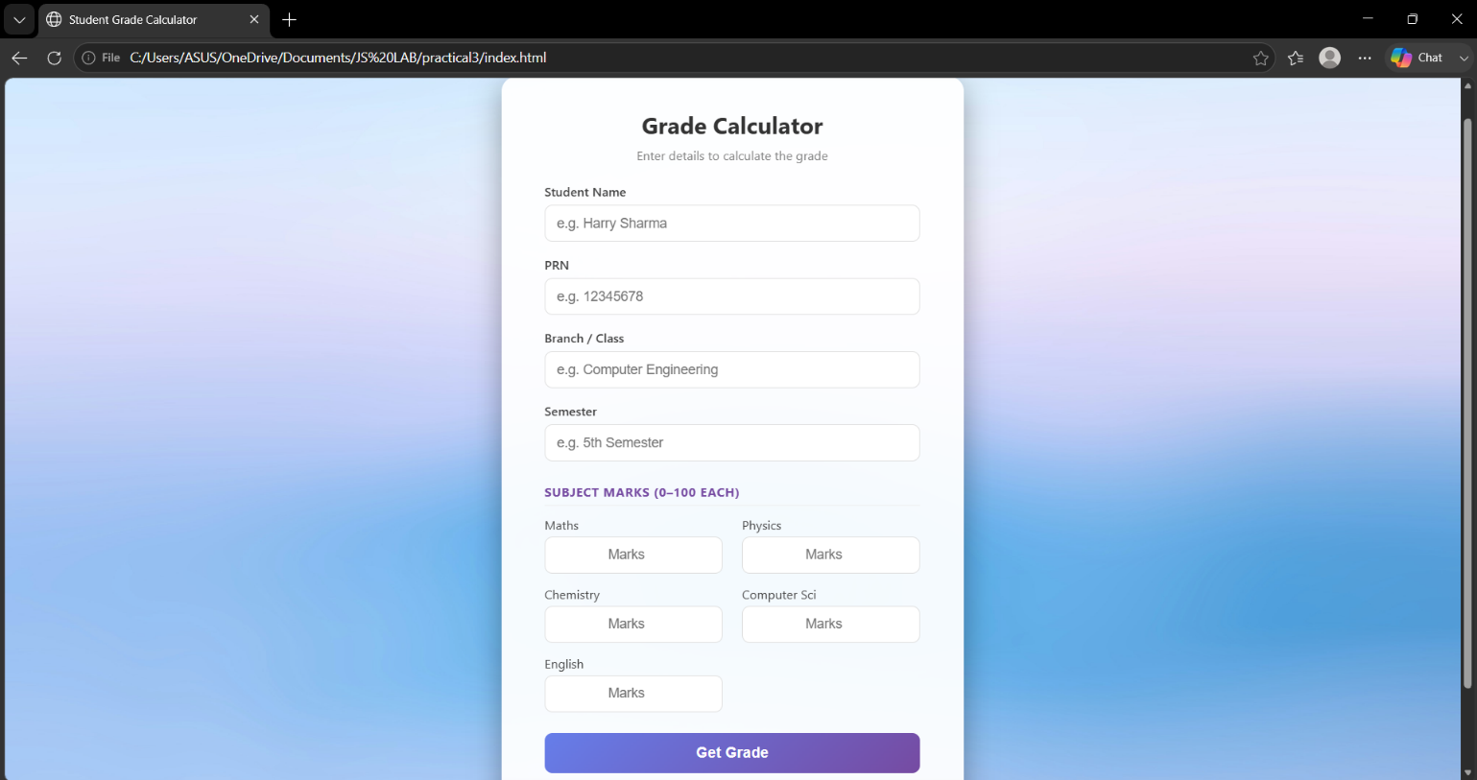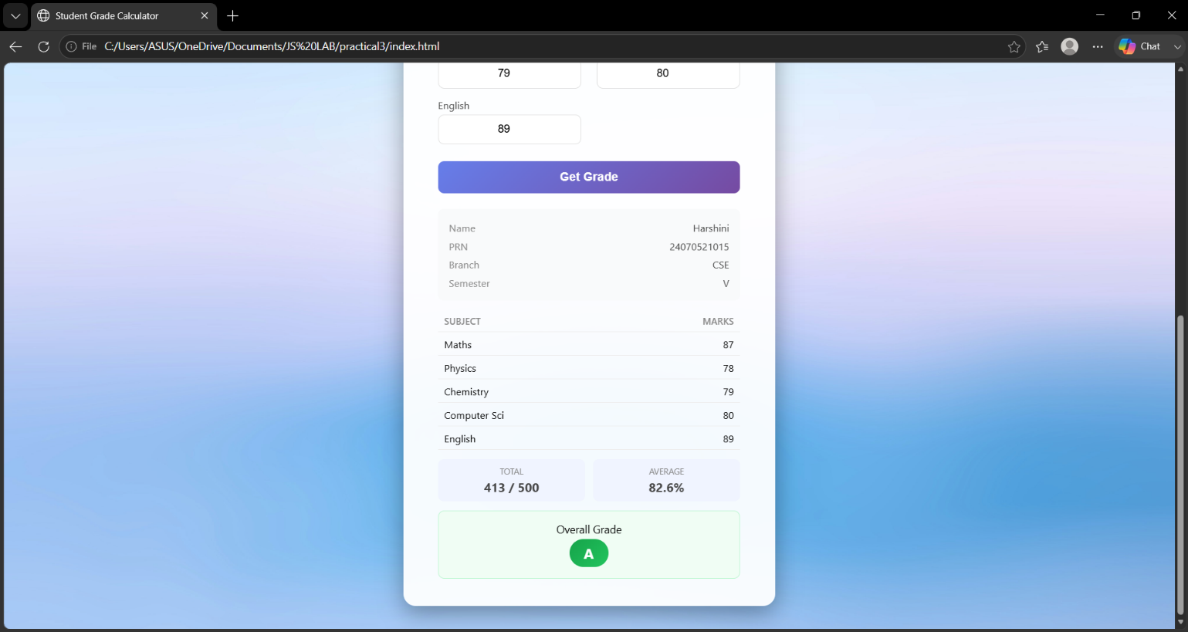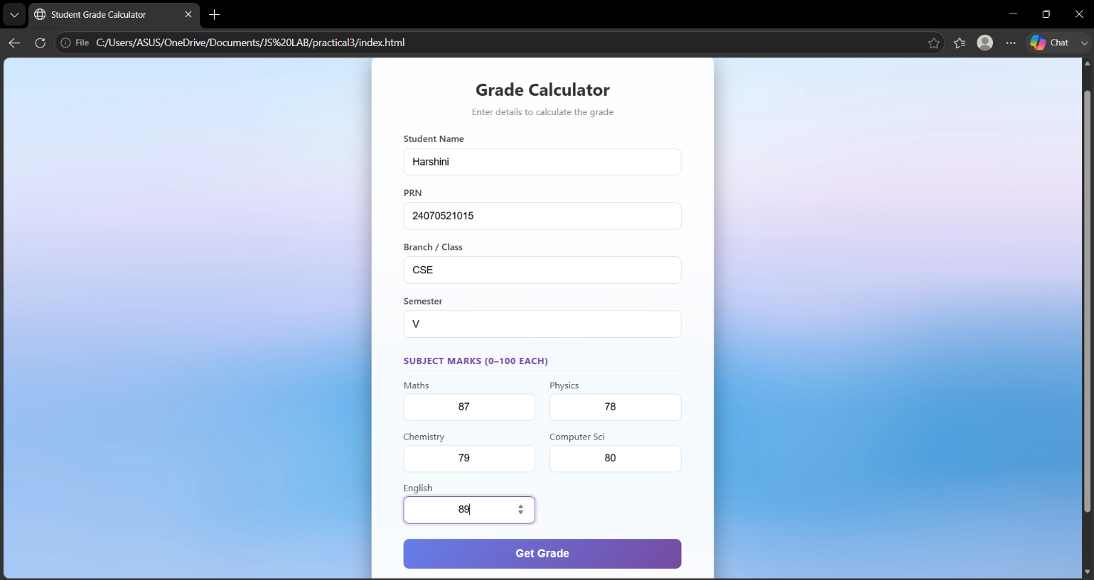
Harshini Bonde
24070521015
Harshini Bonde
24070521015
Harshini Bonde
24070521015

5. Case Study

index.html

<!DOCTYPE html>

<html>

<head>

<title>

Student Grading System

</title>

<body>

<h2>Student Grading System</h2>

<form>

<label>Student Name: </label><br>

<input type="text" id="name"><br><br>

<label>Marks:</label><br>

<input type="number" id="marks"><br><br>

<input type="button" value="Calculate Grade" onclick="gradeSystem()">

</form>

</body>

</head>

</html>

5. Case Study Output
Harshini Bonde
24070521015

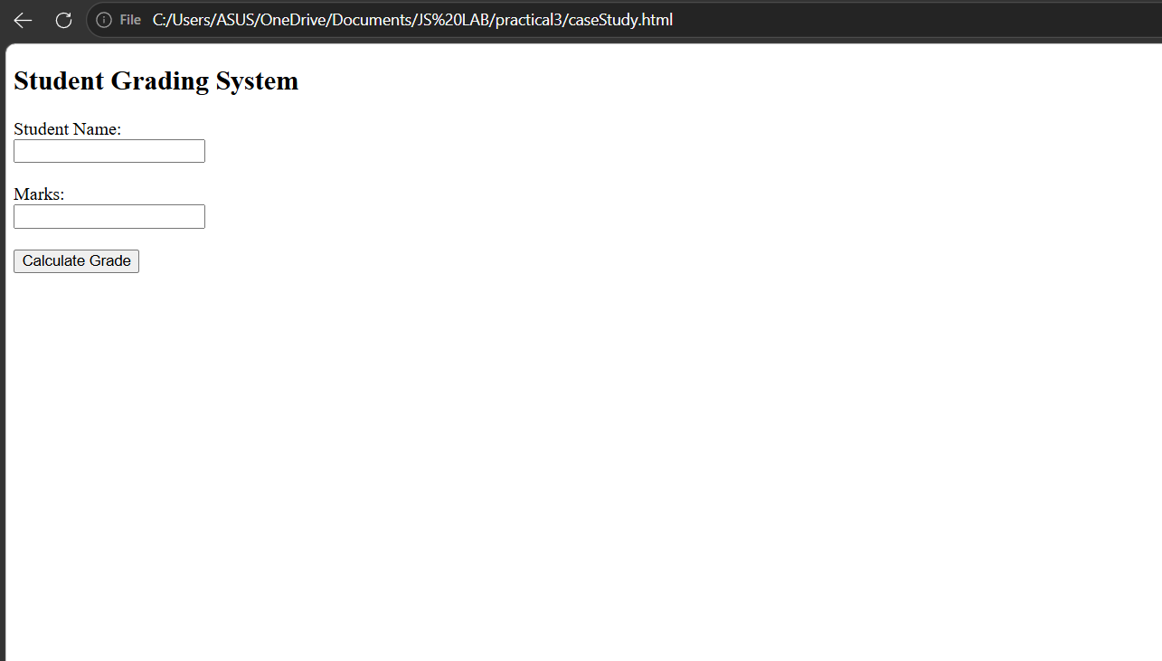
Harshini Bonde
24070521015

