**Curneu technical assessment**

**Alpha beta pruning Coding:-**

#include<iostream>

#include<cstdlib>

using namespace std;

const int MAX = 1000;

const int MIN = -1000;

int minimax(int depth, int nodeIndex,bool maximizingPlayer, int values[], int alpha,

int beta)

{

if (depth == 1)

return values[nodeIndex];

if (maximizingPlayer)

{

int best = MIN;

for (int i = 0; i < 2; i++)

{

int val = minimax(depth + 1, nodeIndex * 2 + i, false, values, alpha, beta);

best = max(best, val);

alpha = max(alpha, best);

if (beta <= alpha)

break;

}

return best;

}

else

{

int best = MAX;

for (int i = 0; i < 2; i++)

{

int val = minimax(depth + 1, nodeIndex * 2 + i, true, values, alpha, beta);

best = min(best, val);

beta = min(beta, best);

if (beta <= alpha)

break;

}

return best;

}

}

int main()

{

int values[100] ;

for(int i=1;i<=100;i++)

{

values[i]=(rand()%1000)+1;

}

cout <<"The optimal value is : "<< minimax(0, 0, true, values, MIN, MAX);;

return 0;

}

**EXPLANATION:**

* IN this program first we have given the initial values for alpha and beta that is -infinity value and +infinityvalue.
* The root node is checked after that we are moving to the left sub tree since alpha beta pruning uses the brute force search that is the combination of depth first search and breadth first search.
* First the node is checked from the terminal node since the max is the first player to play it will compare the two terminal nodes and returns a max value and the max value is assigned to alpha.
* Now the backtracking takes place. In backtracking only value is moved upward now it is the turn for min player to play the game since it is min it chooses the best minimum value and assign to beta after getting both the values for alpha and beta the condition is checked.
* Condition alpha>=beta or beta<=alpha If this condition is satisfied the value is passed to root node rest of the tree is pruned this is the advantage of alpha beta pruning.
* If the condition is not satisfied the same process is carried to right subtree and again the above mentioned activities take place
* IN this program i rand()function to generate 100 random numbers and it is imported from the standard library #include<cstdlib>.

**Output :-**

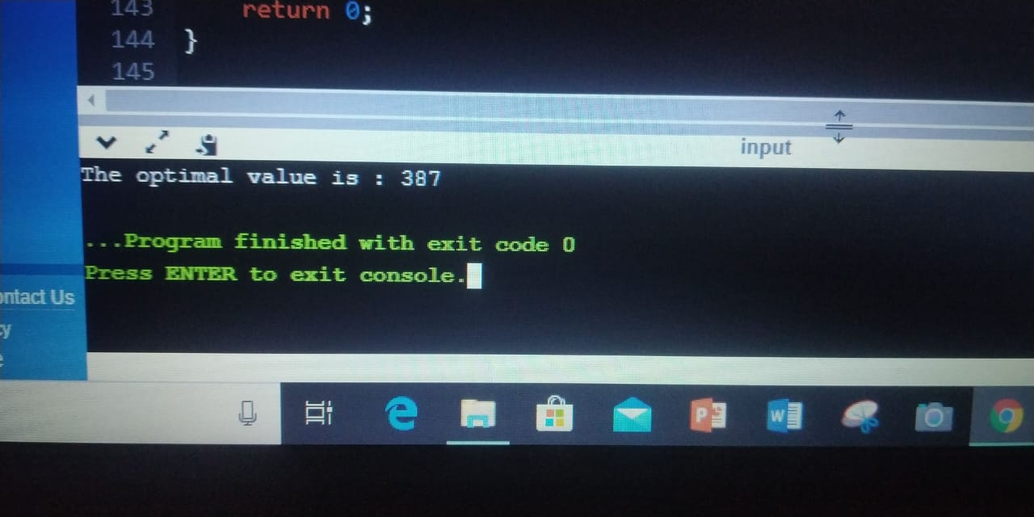

**By:**

**J. Harshini**

**18bct122**