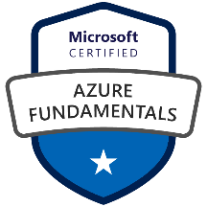
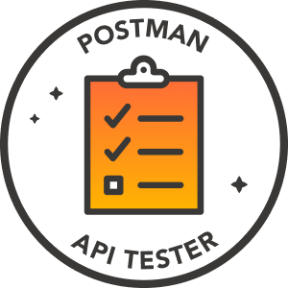
HARSHINI M
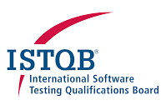
harshinimk369@gmail.com | 737-758-4480‬‬‬‬
https://www.linkedin.com/in/harshinimkarre
SDET | QA Automation Engineer (Azure & Test Automation)
Azure DevOps | Selenium | Playwright | Java | API Automation | Python
CERTIFICATIONS

- ISTQB Certified Tester – Advanced Level - International Software Testing Qualifications Board
- Selenium WebDriver Certification - Test Automation University (Applitools)
- Microsoft Azure Fundamentals
- Postman API Testing Certification - Postman
PROFESSIONAL SUMMARY
{% for k in SUMMARY %}
- {{r k }} {% endfor %}

SKILL MATRIX

{%tr for category in SKILL_MATRIX %}
{{ category.NAME }} | {{ category.SKILLS }}
{%tr endfor %}

EDUCATION

- MS in Computer Science - University of New Haven, CT, USA May 2018
- BTech in Computer Science - Jawaharlal Nehru Technological University, India June 2013

PROFESSIONAL EXPERIENCE

Senior SDET 08/2023 to Current
Fiserv Irving, TX (Remote)
PROJECT DESCRIPTION:
{{PD_FS}}
KEY RESPONSIBILITIES:
{% for k in KEY_RESPONSIBILITES_FS %}
- {{r k }} {% endfor %}
ENVIRONMENT:
{{ENVIRONMENT_FS}}

SDET / Automation Engineer 02/2022 to 07/2023
Dish Network Plano, TX
PROJECT DESCRIPTION:
{{PD_DN}}
KEY RESPONSIBILITIES:
{% for k in KEY_RESPONSIBILITES_DN %}
- {{r k }} {% endfor %}
ENVIRONMENT:
{{ENVIRONMENT_DN}}

Software QA Engineer 02/2020 to 01/2022
RxSense Boston, MA (Remote)
PROJECT DESCRIPTION:
{{PD_RX}}
KEY RESPONSIBILITIES:
{% for k in KEY_RESPONSIBILITES_RX %}
- {{r k }} {% endfor %}
ENVIRONMENT:
{{ENVIRONMENT_RX}}

QA Automation Specialist 06/2018 to 01/2020
Lowe’s Charlotte, NC
PROJECT DESCRIPTION:
{{PD_LW}}
KEY RESPONSIBILITIES:
{% for k in KEY_RESPONSIBILITES_LW %}
- {{r k }} {% endfor %}
ENVIRONMENT:
{{ENVIRONMENT_LW}}

QA Engineer 07/2013 to 07/2016
HSBC India
PROJECT DESCRIPTION:
Validated critical online banking modules for authentication, account overview, fund transfers, bill payments, and transaction history within HSBC’s digital banking platform. Conducted comprehensive functional and regression testing, performed backend validation using SQL, and executed early automation tasks using Selenium WebDriver (Java) to support core retail banking workflows. Ensured accuracy, usability, and data integrity through detailed test case creation, requirement reviews, and multi-environment validation for customer-facing banking services.
KEY RESPONSIBILITIES:
- Designed and implemented Selenium automation frameworks, covering banking workflows such as fund transfers, account management, and internal financial dashboards.
- Developed UI automation scripts for web portals, validating navigation, forms, transaction flows, and reporting dashboards.
- Automated API workflows using Postman, verifying secure data exchange between frontend and backend systems for payments, transfers, and customer data.
- Developed SQL automation scripts to validate backend financial transactions, ledger entries, and reporting data, ensuring accuracy and compliance.
- Integrated automation scripts into Jenkins CI/CD pipelines, enabling continuous validation, early defect detection, and faster release cycles.
- Conducted cross-browser automation testing across Chrome, Firefox, Edge, and Safari, ensuring consistent user experience across internal and customer-facing banking portals.
- Implemented risk-based automation strategies, prioritizing high-impact workflows such as fund transfers, payment processing, and compliance reports.
- Mentored junior QA engineers, guiding them on Selenium best practices, reusable script development, and automation design patterns.
- Built Power BI dashboards to track automation coverage, execution trends, and defect metrics, providing visibility to management and stakeholders.
- Developed modular and reusable automation components, reducing redundant scripting and simplifying framework maintenance.
- Conducted regression automation testing, ensuring that updates did not disrupt critical banking workflows or internal reporting modules.
- Participated in shift-left practices, reviewing requirements and creating automation scenarios early in the SDLC to detect defects sooner.
- Automated validation of financial reporting dashboards, ensuring accurate calculations, reconciliation, and presentation of account data.
- Implemented error-handling and logging mechanisms in scripts for efficient debugging and faster resolution of issues in automation runs.
- Coordinated with product, development, and compliance teams to define automation priorities aligned with business objectives and regulatory requirements.
- Conducted data-driven automation, using parameterized scripts to validate multiple banking scenarios, including bulk transactions and edge cases.

ENVIRONMENT: Selenium, JavaScript, TypeScript, HTML5, CSS3, SQL, Postman, Jenkins, Git, Power BI, BrowserStack.

