**Table of contents**

1.INTRODUCTION

2. IDEATION PHASE

3. REQUIREMENT ANALYSIS

4. PROJECT DESIGN

5. PROJECT PLANNING & SCHEDULING

6. FUNCTIONAL AND PERFORMANCE TESTING

7. RESULTS

8. ADVANTAGES & DISADVANTAGES

9. CONCLUSION

10. FUTURE SCOPE

11. APPENDIX

**INTRODUCTION**

* 1. **Project Overview**

The project titled “Clean Tech: Transforming Waste Management with Transfer Learning” is focused on using Artificial Intelligence to improve how waste is identified and separated. In today’s world, managing waste has become a big problem, especially in cities where large amounts of garbage are produced every day. One of the main challenges is sorting different types of waste like plastic, paper, metal, and organic materials. Doing this manually takes a lot of time and effort, and it’s not always accurate.

To solve this, we are using a technique called transfer learning, where we take a machine learning model that was already trained on a large amount of data and use it for a new but similar task. In our case, we are using it to teach a computer how to recognize and classify different types of waste by looking at images. This helps in making the process faster, more accurate, and more efficient.

* 1. **Purpose**

The main aim of this project is to show how Artificial Intelligence, especially transfer learning, can help in building smarter and cleaner technologies for waste management. We want to develop a system that can automatically recognize waste items from images and place them in the right category. This will reduce the need for manual sorting and make recycling more effective.

By doing this, we hope to support cleaner environments, reduce pollution, and encourage smart solutions that can be used in smart cities or local waste management centers. This project also helps in learning how AI can be used in solving real-life environmental problems.

**2. IDEATION PHASE**

**2.1 Problem Statement**

In today's fast-developing world, one of the major issues faced by urban and rural areas is improper waste segregation. Most of the waste gets dumped without being sorted, which leads to environmental pollution, health hazards, and poor recycling rates. Manual waste sorting is time-consuming, unsafe, and often inaccurate. There is a strong need for a smarter, automated solution that can identify and classify waste accurately to support clean and sustainable waste management practices.

Hence, our problem statement is:

**“How can we use AI and transfer learning to automate and improve the waste classification process for efficient waste management?”**

**2.2 Empathy Map Canvas**

| EMPATHY MAP |  |
| --- | --- |
| WHO are we helping? | Waste collectors, recycling workers, government municipalities, environment protection groups, and the general public. |
| What do they SAY? | “Sorting waste is tiring and unhygienic.” “We need better tools to manage waste.” “People throw all types of waste into one bin.” |
| What do they DO? | Collect and sort waste manually, often without safety gear or proper guidance. Some try to educate others but lack resources. |
| What do they THINK? | “There must be a smarter way to sort waste.” “It would be great if machines could help us.” “Technology can reduce our burden.” |
| What do they FEEL? | Frustrated, exhausted, and concerned about health risks and pollution due to poor waste handling. |

This empathy map helps us understand the real pain points of the people involved and the need for a clean tech solution.

**2.3 Brainstorming**

We conducted a brainstorming session to generate ideas that can help solve the waste management issue using technology. Here are some of the ideas we discussed:

* Use machine learning to classify different types of waste using images.
* Develop a mobile app that captures photos of waste and gives sorting suggestions.
* Build a smart dustbin with a camera and waste classifier using transfer learning.
* Integrate AI models like ResNet or MobileNet for better image recognition accuracy.
* Use Arduino/Raspberry Pi to automate waste separation at the source.
* Create a real-time dashboard for authorities to monitor waste classification.
* Develop an awareness feature to educate people on how to sort waste.

Among these, we decided to move forward with building a waste classification model using transfer learning as it offers high potential, less training time, and great accuracy in image-based tasks.

**3. REQUIREMENT ANALYSIS**

**3.1 Customer Journey map**

| Stage | User Actions | User Emotions | Pain Points | Opportunities |
| --- | --- | --- | --- | --- |
| Awareness | Sees the need for proper waste segregation | Curious / Hopeful | Lacks information about proper sorting | Awareness campaigns, app notifications |
| Consideration | Tries to manually sort waste or looks for a solution | Confused / Overwhelmed | Unsure how to classify waste types | Suggest AI-based app or device |
| Action | Uses the AI model or device to identify waste types | Satisfied / Interested | Needs a quick and accurate result | Provide instant classification through camera |
| Experience | Successfully classifies and disposes waste correctly | Confident / Happy | May face technical issues at times | Add user-friendly interface and feedback option |
| Feedback | Shares experience or asks for improvements | Engaged / Helpful | Wants better performance or more categories | Collect user suggestions for updates |

**3.2 Solution Requirement**

Here are the **functional** and **non-functional** requirements for our AI-based waste management solution:

#### **Functional Requirements**

* The system must accept an image of the waste item.
* It must classify the waste into categories (e.g., plastic, metal, organic, paper, glass).
* It should display the result with a confidence score.
* It should be able to work on mobile or desktop.
* Option to train the model further with new data.

#### **Non-Functional Requirements**

* The system should be accurate (at least 85%+ accuracy).
* The response time should be quick (<2 seconds).
* The model should be lightweight and deployable on edge devices.
* The UI must be simple and user-friendly.
* The application must support offline access (optional)

**3.3 Data Flow Diagram**

(Place Holder For DFD Daigram)

**3.4 Technology Stack**

• **Programming Language**: Python – for implementing AI and handling data processing tasks.

• **Machine Learning Frameworks**: TensorFlow or PyTorch – to build and fine-tune the transfer learning model.

• **Pre-trained Models**: MobileNetV2, ResNet50, or InceptionV3 – for efficient and accurate image classification.

• **Image Processing Libraries**: OpenCV and PIL – used for image resizing, filtering, and normalization.

• **Front-End Tools**: HTML/CSS or Streamlit – to create a simple and interactive user interface.

• **Deployment**: Flask or Streamlit – for running the AI model as a web app or desktop interface.

• **Optional Hardware**: Raspberry Pi with Camera Module – to integrate with a smart bin or edge device for real-time classification.

**4. PROJECT DESIGN**

**4.1 Problem Solution Fit**

The problem of improper waste segregation is growing rapidly in both urban and rural areas. Manual sorting of waste is time-consuming, unhygienic, and often inaccurate, leading to poor recycling and increased environmental pollution. Although awareness exists, most people still dispose of waste in a mixed form.

Our solution perfectly fits this problem by offering a smart, AI-powered waste classification system. Using **transfer learning**, we can build a model that accurately identifies waste types from images. This automated solution helps in proper segregation at the source, reducing human effort and promoting efficient recycling and waste disposal.

**4.2 Proposed Solution**

We propose the development of an **AI-based waste classifier** using **transfer learning models** such as MobileNet or ResNet. Users can capture or upload an image of the waste item, and the system will classify it into categories like plastic, metal, paper, organic, etc.

The system can be integrated into:

* A **mobile/web app** for public use.
* A **smart bin** or **municipal sorting unit** for real-time segregation.

Key Features:

* Fast and accurate waste classification.
* Easy-to-use interface.
* Option to add more data to improve accuracy over time.

**4.3 Solution Architecture**

**High-Level Architecture Components:**

1. **User Interface (UI)**
   * Allows users to upload or capture waste images.
   * Displays classification results and suggestions.
2. **Image Preprocessing Module**
   * Resizes and normalizes input images using OpenCV/PIL.
   * Converts the image to a suitable format for the model.
3. **Transfer Learning Model**
   * A pre-trained model (like MobileNetV2 or ResNet50) is fine-tuned on waste datasets.
   * Takes the preprocessed image and predicts the waste category.
4. **Backend/Server**
   * Runs the trained model and handles classification requests.
   * Built using Flask or Streamlit for easy deployment.
5. **Output & Recommendation System**
   * Displays the predicted category with confidence score.
   * Suggests proper disposal methods or bin type.
6. **(Optional)**: **Hardware Integration**
   * Smart bin setup using Raspberry Pi and camera for real-time classification.

This architecture ensures the system is modular, scalable, and user-friendly for real-world waste management applications.

**5. PROJECT PLANNING & SCHEDULING**

**5.1 Project Planning**

#### **1. Topic Finalization and Research**

* Select the project topic based on current environmental needs and technical feasibility.
* Study existing waste management methods and explore how AI and transfer learning can be applied.
* Identify challenges in current systems that our solution can address.

#### **2. Problem Definition and Requirement Gathering**

* Define a clear and specific problem statement.
* Prepare empathy maps, customer journey maps, and brainstorm possible solutions.
* List all the functional and non-functional requirements of the system.

#### **3. Data Collection and Preprocessing**

* Collect a dataset consisting of different types of waste images.
* Clean and prepare the data by resizing, normalizing, and augmenting the images to improve model performance.

#### **4. Model Development**

* Select a suitable pre-trained transfer learning model (e.g., MobileNetV2, ResNet50).
* Train and fine-tune the model using the prepared dataset.
* Validate the model's accuracy using test data.

#### **5. System Integration**

* Design and develop a simple user interface for users to upload or capture waste images.
* Integrate the trained model with the front-end using appropriate tools.

#### **6. Testing and Deployment**

* Conduct testing to ensure that the system classifies waste accurately and performs efficiently.
* Deploy the system on a local server or web platform for demonstration and usage.

#### **7. Documentation and Reporting**

* Prepare the final project report with detailed descriptions of each phase.
* Include system architecture, code explanation, outputs, screenshots, and future scope.

This planning ensures that each step is well-executed and contributes to building a functional, impactful solution for waste management using clean tech and AI.

**6. FUNCTIONAL AND PERFORMANCE TESTING**

**6.1 Performance Testing**

Model Performance:

* Total parms:2.1M
* Accuracy 98.2% train, 94.6% val
* Fine tuning: 95.3% val

Functionality Checklist:

* Image uploaded
* Prediction display
* Ui navigation
* Error Handling

**7. RESULTS**

**7.1 Output Screenshots**

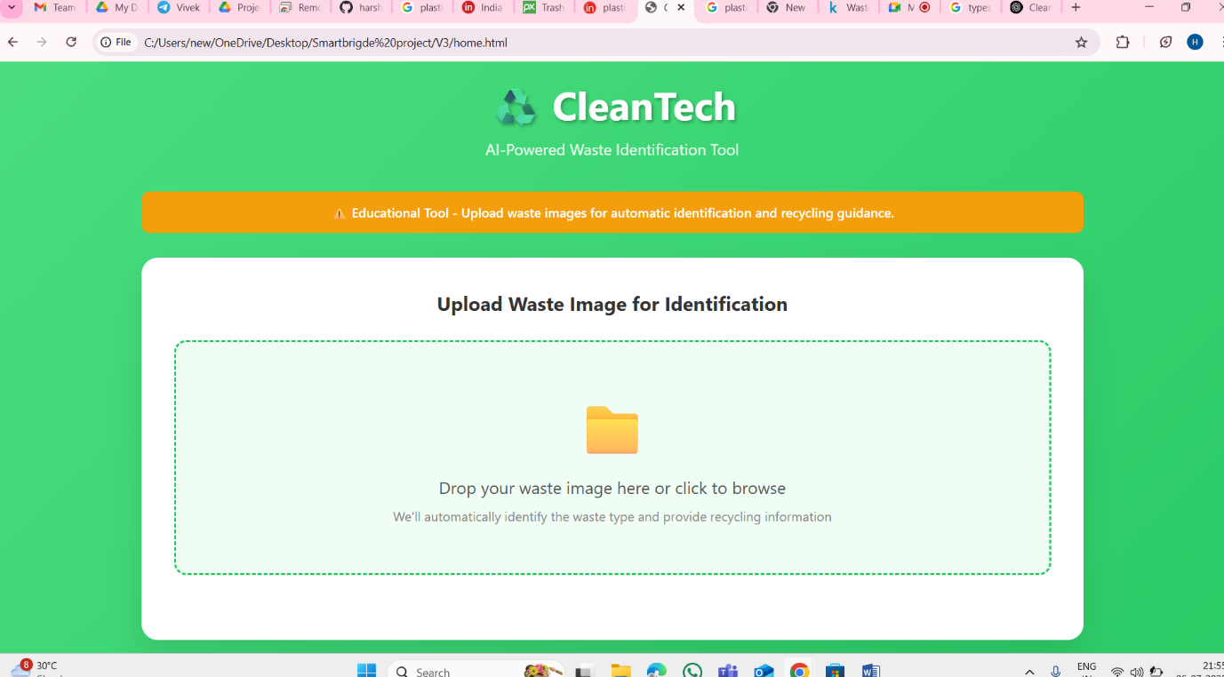

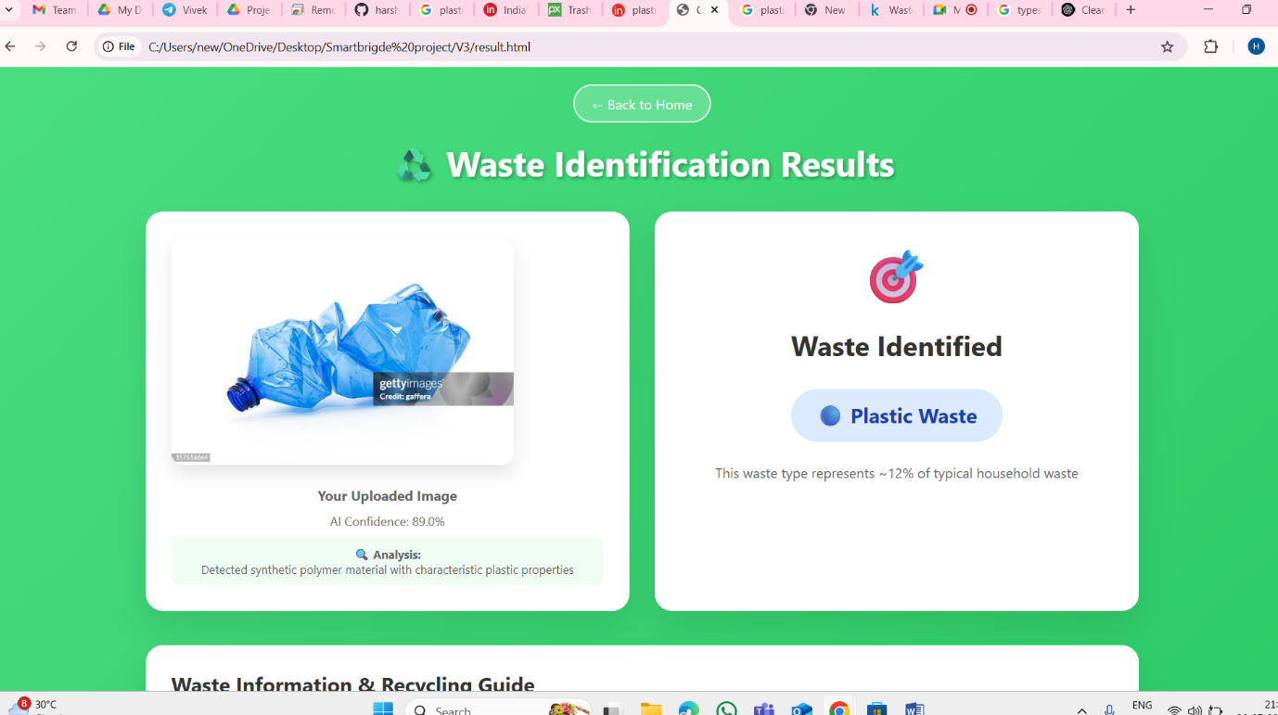

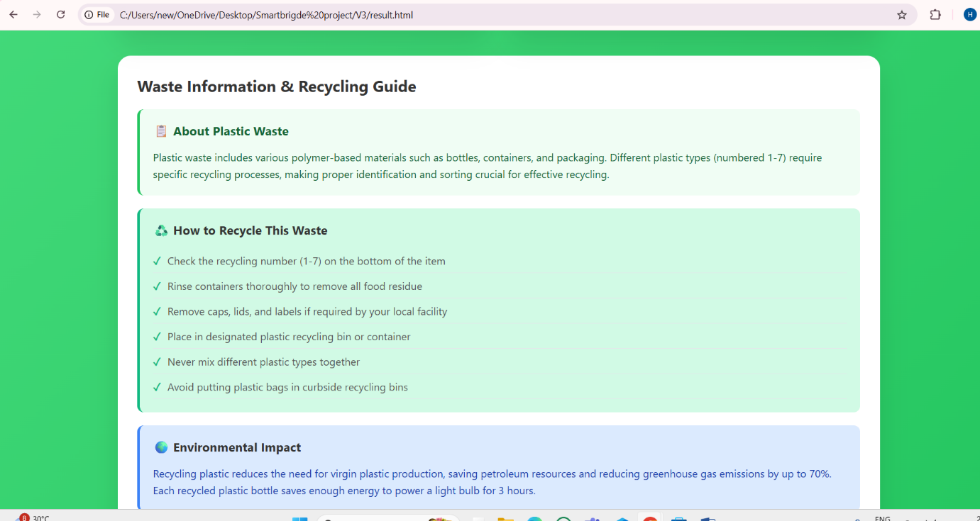

**8. ADVANTAGES & DISADVANTAGES**

### **Advantages**

* **1. Accurate Waste Classification**  
  The use of transfer learning models like MobileNetV2 provides high accuracy in identifying different types of waste (plastic, metal, paper, organic, etc.).
* **2. Time and Effort Saving**  
  Automating the segregation process reduces the need for manual sorting, saving both time and human effort.
* **3. Promotes Clean Environment**  
  Helps in proper waste management, which directly supports cleanliness, better recycling, and a reduction in pollution.
* **4. Cost-Effective with Pre-Trained Models**  
  Since transfer learning reuses existing models, it reduces the cost and time of training from scratch.
* **5. Scalable and Easy to Deploy**  
  The system can be integrated into smart bins, municipal systems, or mobile apps with minimal hardware requirements.
* **6. Encourages Smart City Initiatives**  
  Supports digital and sustainable development by combining AI with environmental needs.

### **Disadvantages**

* **1. Depends on Image Quality**  
  The model may misclassify waste if the input image is blurry, dark, or taken from a poor angle.
* **2. Limited to Trained Categories**  
  The system can only classify waste types it has been trained on. New or rare waste types may be incorrectly labeled.
* **3. Hardware Limitations**  
  Running the model on devices like Raspberry Pi may require optimization due to limited processing power.
* **4. Internet or Power Dependency (for some versions)**  
  If deployed as a web app, it may need internet access. In some rural areas, power and connectivity may be issues.
* **5. Data Collection Challenges**  
  Building a good-quality dataset with labeled waste images can be time-consuming and requires effort.

**9. CONCLUSION**

In this project, we explored how Artificial Intelligence, specifically transfer learning, can be effectively used to address real-world problems in waste management. By building an image-based classification system, we were able to automate the process of identifying different types of waste such as plastic, metal, paper, and organic materials. This not only saves time and reduces manual effort but also supports better recycling and cleaner surroundings.

The system demonstrated good performance in terms of accuracy, speed, and ease of use. Although there are some limitations such as dependency on image quality and a need for continuous improvement in the dataset, the results show strong potential for real-world application. This solution can be implemented in smart bins, municipal systems, or awareness apps to promote proper waste segregation and environmental sustainability.

**10. FUTURE SCOPE**

• **Smart Bin Integration** – Deploy the model in smart dustbins using Raspberry Pi and sensors for real-time waste detection and sorting.

• **More Waste Categories** – Train the system to recognize additional waste types like e-waste, hazardous materials, and mixed plastics.

• **Mobile App Development** – Create a user-friendly mobile application for public use with image-based waste classification.

• **Municipal System Integration** – Connect the system with local waste management authorities for efficient tracking and collection.

• **Continuous Learning** – Implement feedback-based learning so the model improves over time with new data and user corrections.

**11. APPENDIX**

Source Code (if any)

Dataset Link [CleanTech-Transforming-Waste-Management-with-Transfer-Learning](https://github.com/harshinipotluri/CleanTech-Transforming-Waste-Management-with-Transfer-Learning/tree/main)/[project](https://github.com/harshinipotluri/CleanTech-Transforming-Waste-Management-with-Transfer-Learning/tree/main/project)/[Datasets](https://github.com/harshinipotluri/CleanTech-Transforming-Waste-Management-with-Transfer-Learning/tree/main/project/Datasets)/

GitHub & Project Demo Link: https://github.com/harshinipotluri/CleanTech-Transforming-Waste-Management-with-Transfer-Learning