PROJECT REVIEW REPORT
On

ENHANCED LIGHTWEIGHT TELUGU HANDWRITTEN OCR USING MOBILENETV3 WITH IMPROVED IMAGE PROCESSING AND CONTEXT AWARE POST PROCESSING

Submitted for Partial Fulfillment of Award of
BACHELOR OF TECHNOLOGY

In

Information Technology

Submitted by
Name of the Student Register No.
<Name> <Reg No>

Under the Guidance of
<Project Supervisor>
<Designation of the project supervisor>


Department of Information Technology
Sagi Rama Krishnam Raju Engineering College (A)
SRKR Marg, Bhimavaram, Pin: 534204, West Godavari, Andhra Pradesh, India
Affiliated to
JAWAHARLAL NEHRU TECHNOLOGICAL UNIVERSITY, KAKINADA

<Academic Year>
RECOMMENDATION

I hereby recommend that the project titled “<Title of the project>” submitted by <Name of project group members> be accepted in partial fulfillment of the requirement for the Degree of B. Tech. in Information Technology from the Department of Information Technology, Sagi Rama Krishnam Raju Engineering College, SRKR Marg, Bhimavaram, Pin: 534204, West Godavari, Andhra Pradesh, India.
Place:

Date: Project Supervisor

ABSTRACT
Handwritten Telugu character recognition remains challenging because of complex glyph structures, visually similar characters, variations in writing styles, and subtle stroke differences. Traditional image-based classifiers often overlook subtle structural details distinguishing similar Telugu symbols, especially when individual strokes vary considerably in thickness, orientation, alignment, and continuity. This study presents a Telugu handwritten character recognition framework based on Stroke-Gated Feature Fusion MobileNetV3 (SGF-MobileNetV3). The framework recognizes characters from Achulu, Hallulu, Guninthamulu, and Othulu categories. A reduced-capacity MobileNetV3-Small is used as the baseline, while the proposed SGF-MobileNetV3 combines appearance features extracted by MobileNetV3-Small with structural information from a dedicated stroke branch. Skeleton patterns, stroke width, and edge magnitude are integrated through adaptive gated feature fusion to improve classification. Preprocessing includes grayscale conversion, ink-region cropping, resizing, denoising, and contrast enhancement using CLAHE. The selected dataset contains 73,463 images representing 76 character classes, with separate training, validation, and testing partitions. Performance is assessed using accuracy, precision, recall, F1-score, top-3 accuracy, and confusion matrices. SGF-MobileNetV3 achieves 95.90% test accuracy, 95.34% macro F1-score, and 99.48% top-3 accuracy, surpassing the 90.74% accuracy of the baseline. Under simulated upload variations, it achieves 90.63% accuracy. Unicode mapping and dictionary-based correction additionally support character-to-text conversion and ordered character-based word recognition.
Keywords: Telugu Handwritten Character Recognition, Optical Character Recognition, SGF-MobileNetV3, MobileNetV3-Small, Deep Learning, Stroke Feature Extraction, Gated Feature Fusion, Telugu Unicode.

TABLE OF CONTENTS
DESCRIPTION PAGE NUMBER
RECOMMENDATION BY SUPERVISOR i
ABSTRACT ii
1. INTRODUCTION 1
2. LITERATURE SURVEY 5
3. RESEARCH GAPS 10
4. OBJECTIVES 12
5. HARDWARE / SOFTWARE REQUIREMENT WITH SPECIFICATIONS 13
6. METHODOLOGY 15
7. ARCHITECTURE (IMPLEMENTATION AND TESTING) 32
8. RESULT AND ANALYSIS 66
9. CONCLUSION AND FUTURE SCOPE 68
10. REFERENCES 70

1. INTRODUCTION

1.1 PROBLEM STATEMENT
Handwritten Telugu character recognition is a challenging task in Optical Character Recognition (OCR) due to the complex structure of Telugu characters, variations in handwriting styles, and visual similarities between different character forms. Telugu script contains multiple character categories, including Achulu, Hallulu, Guninthamulu, and Othulu, which involve different combinations of curves, loops, strokes, and additional symbols. These characteristics make accurate automated recognition difficult, particularly when handwritten characters contain irregular shapes, inconsistent stroke thickness, or image distortions. Conventional image classification techniques primarily depend on visual appearance features to identify handwritten characters. However, appearance-based models may struggle to distinguish characters with similar shapes but different stroke structures. Variations in image size, alignment, background noise, contrast, and writing patterns can further reduce classification accuracy. Additionally, imbalanced character datasets may cause models to perform better on frequently occurring classes while producing less reliable predictions for underrepresented characters. Therefore, an intelligent deep learning framework is required to integrate visual appearance information with meaningful structural stroke characteristics. The proposed framework introduces Stroke-Gated Feature Fusion MobileNetV3 (SGF-MobileNetV3), combining MobileNetV3-Small appearance features with skeleton, stroke-width, and edge-based representations through an adaptive gating mechanism. The framework incorporates preprocessing, data augmentation, class balancing, and feature fusion to improve handwritten Telugu character classification. Furthermore, Telugu Unicode conversion and dictionary-based correction support the generation of readable Telugu text from recognized character sequences.

1.2 MOTIVATION
Handwritten Telugu character recognition is an important application of artificial intelligence and computer vision for digitizing handwritten Telugu content. Telugu is a complex Indian script containing characters with curved structures, connected strokes, and visually similar patterns. Variations in individual handwriting styles, character shapes, stroke thickness, and image quality make automated recognition a challenging task. Deep learning models such as MobileNetV3-Small can extract meaningful visual features from handwritten character images. However, relying exclusively on appearance-based representations may not sufficiently capture the structural differences between similar Telugu characters. Incorporating stroke-related information provides an additional opportunity to improve classification by analyzing skeleton patterns, stroke width, and edge characteristics. The project is further motivated by the need to address class imbalance, handwriting variability, image noise, and differences in character positioning. Image preprocessing, data augmentation, and class-balanced training can improve recognition consistency across different Telugu character categories. The proposed SGF-MobileNetV3 integrates visual feature extraction, structural stroke analysis, and adaptive gated feature fusion to improve character recognition accuracy. Additionally, Unicode mapping and dictionary-based correction provide a foundation for converting recognized handwritten character sequences into meaningful Telugu text.

1.3 SCOPE OF THE PROJECT
This project focuses on developing a Telugu Handwritten Character Recognition Framework using Stroke-Gated Feature Fusion MobileNetV3 (SGF-MobileNetV3) for recognizing handwritten characters from four major Telugu categories: Achulu, Hallulu, Guninthamulu, and Othulu. The dataset contains 292,752 original image entries across 121 character folders, which are processed through Unicode-based class merging and dataset balancing to obtain 73,463 selected images representing 76 character classes. The selected dataset is divided into 51,423 training, 11,020 validation, and 11,020 testing images. Image preprocessing includes grayscale conversion, ink-region cropping, resizing to 96 × 96 pixels, noise removal, and contrast enhancement using CLAHE. Data augmentation and class-balanced sampling are incorporated to improve generalization and reduce the influence of dataset imbalance.
Two deep learning models are implemented: a reduced-capacity MobileNetV3-Small baseline and the proposed SGF-MobileNetV3. The proposed architecture combines appearance-based feature extraction with a dedicated stroke branch that extracts skeleton structures, stroke-width information, and edge magnitude. An adaptive gated feature fusion mechanism integrates both representations to generate discriminative features for character classification. The framework also incorporates Telugu Unicode mapping to convert predicted character classes into their corresponding Telugu symbols. Dictionary-based correction using akshara-level edit distance supports recognition from ordered character images, although comprehensive word-level recognition remains outside the validated scope of the current experiments. Model performance is evaluated using accuracy, precision, recall, F1-score, top-3 accuracy, confusion matrices, class-wise evaluation, and inference latency. Experimental results demonstrate that SGF-MobileNetV3 achieves 95.90% classification accuracy, 95.34% macro F1-score, and 99.48% top-3 accuracy, outperforming the MobileNetV3-Small baseline with 90.74% accuracy. Under simulated image-upload variations, the proposed model achieves 90.63% recognition accuracy.
The project emphasizes stroke-aware feature learning, adaptive feature fusion, balanced training, and Telugu Unicode conversion to support accurate handwritten character recognition. Further evaluation using independent handwriting samples and complete word-level datasets is required to establish broader recognition reliability.

1.4 PROJECT INTRODUCTION
Handwritten Telugu character recognition is an important research area in artificial intelligence, computer vision, and Optical Character Recognition (OCR). Telugu is a widely used Indian language with a complex writing system containing vowels, consonants, vowel-modified consonants, and conjunct forms. These character categories exhibit significant variations in curvature, stroke patterns, structural arrangements, and visual appearance. Differences in handwriting styles, character alignment, image quality, and stroke thickness make automated recognition challenging.
This project proposes a Telugu Handwritten Character Recognition Framework using Stroke-Gated Feature Fusion MobileNetV3 (SGF-MobileNetV3) to improve the classification of handwritten Telugu characters. The framework processes four character categories: Achulu, Hallulu, Guninthamulu, and Othulu. A reduced-capacity MobileNetV3-Small is implemented as the baseline model to extract visual appearance features and establish reference classification performance. The proposed SGF-MobileNetV3 extends conventional visual feature extraction by incorporating a dedicated stroke-processing branch. The MobileNetV3-Small backbone extracts appearance-based representations from preprocessed character images, while the stroke branch processes skeleton information, stroke-width maps, and edge magnitude features. These complementary feature representations are integrated through an adaptive gated feature fusion mechanism, which dynamically determines the contribution of appearance and structural information during character classification.
The dataset consists of 73,463 selected Telugu handwritten character images across 76 classes, obtained through Unicode-based class merging and data balancing. Preprocessing techniques include grayscale conversion, character cropping, image resizing, denoising, and CLAHE-based contrast enhancement. Data augmentation and class-balanced sampling are applied during training to improve classification consistency across different handwriting variations and character categories. The framework also incorporates Telugu Unicode conversion and dictionary-based word correction. Predicted character classes are mapped to their corresponding Unicode representations, allowing individual character predictions to be combined into Telugu text. Akshara-level edit-distance correction is applied to ordered character sequences to identify possible dictionary matches. This component supports preliminary word recognition, while the main experimental evaluation focuses on individual handwritten characters.
The models are evaluated using accuracy, precision, recall, F1-score, top-3 accuracy, confusion matrices, and computational performance measurements. Experimental results demonstrate that SGF-MobileNetV3 achieves 95.90% classification accuracy, 95.33% macro precision, 95.71% macro recall, and 95.34% macro F1-score, outperforming the MobileNetV3-Small baseline, which achieves 90.74% accuracy and 90.69% macro F1-score. The proposed model also achieves 99.48% top-3 accuracy and 90.63% recognition accuracy under simulated image-upload variations, demonstrating improved recognition performance under the evaluated conditions. The proposed framework combines MobileNetV3-based visual feature extraction, structural stroke analysis, adaptive gated feature fusion, image preprocessing, data augmentation, class balancing, and Telugu Unicode mapping to enhance handwritten Telugu character recognition. Its results demonstrate the effectiveness of integrating appearance and stroke information for complex script classification. Further research can extend this approach to complete handwritten words, connected character sequences, and document-level Telugu text recognition.

2. LITERATURE SURVEY

2.1 Related Work
Handwritten character recognition has become an important research area in computer vision, pattern recognition, and Optical Character Recognition (OCR). Traditional recognition methods primarily depend on handcrafted features, statistical pattern analysis, and machine learning classifiers. However, complex writing structures, inconsistent stroke patterns, and variations in individual handwriting styles create significant challenges for accurate character classification. Sharma and Kaushik conducted a comprehensive survey of offline handwritten Indic script recognition, examining feature extraction methods, classification techniques, and challenges associated with Indian languages, including Telugu [1]. Their findings highlighted the importance of combining complementary feature extraction techniques to improve recognition performance. These investigations establish the significance of developing advanced deep learning frameworks capable of extracting both visual appearance and structural characteristics from handwritten Telugu characters.
Early research on Telugu handwritten character recognition investigated combinations of Convolutional Neural Networks (CNNs), Principal Component Analysis (PCA), Support Vector Machines (SVMs), and multiclassifier architectures. Soman et al. introduced an efficient multiclassifier framework for offline handwritten Telugu character recognition by combining CNN-based feature extraction with PCA and SVM classification [2]. Their method was evaluated using Telugu consonant-vowel character images and achieved 92.26% accuracy for consonant classification and 92% accuracy for vowel modifier classification. The study demonstrated the effectiveness of combining neural network representations with conventional classification techniques. However, variations in character shapes and similarities between stroke structures continue to present challenges for handwritten character recognition. Motivated by these findings, the present study investigates a deep learning architecture that integrates visual appearance features with explicit structural stroke information. Deep learning architectures have significantly advanced Telugu handwritten character recognition by automatically learning hierarchical representations from input images. Sonthi et al. proposed an intelligent Telugu handwritten character recognition framework using Multi-Objective Mayfly Optimization with a deep learning-based DenseNet architecture [3]. Their approach employed DenseNet-169 for feature extraction, a Functional Link Neural Network for classification, and optimization techniques for improving model parameters. The investigation demonstrated the usefulness of deep feature representations and optimization-based learning for handwritten character classification. Similarly, a 2024 IEEE conference study investigated CNN-based recognition of handwritten Telugu characters and reported 96.96% classification accuracy on its evaluated dataset [4]. These studies demonstrate the effectiveness of convolutional architectures for recognizing complex Telugu symbols. However, conventional CNN-based approaches primarily learn image appearance representations and may not explicitly distinguish the structural stroke characteristics of visually similar characters.
Hybrid deep learning architectures have also been investigated to improve recognition of handwritten Telugu text. A comparative study published in 2026 evaluated CNN, ResNet-101, and a hybrid CNN-LSTM architecture using a writer-independent Telugu handwriting dataset [5]. The hybrid CNN-LSTM model achieved 96.87% classification accuracy, outperforming the other evaluated architectures. The study demonstrated that combining spatial feature extraction with sequential representation learning can improve handwritten text recognition. Nevertheless, sequence-based models and character-level classifiers address different recognition settings, and their reported results cannot be directly compared without common datasets and evaluation protocols. The proposed SGF-MobileNetV3 investigates an alternative approach focused on individual character classification by integrating appearance and stroke-based structural representations through adaptive feature fusion. Lightweight convolutional neural networks have received considerable attention because they provide effective visual feature extraction with reduced computational complexity. Sandler et al. introduced MobileNetV2, which employs inverted residual structures and linear bottlenecks to improve computational efficiency while preserving discriminative feature representations [6]. Subsequently, Howard et al. introduced MobileNetV3, combining hardware-aware neural architecture search, NetAdapt, and architectural improvements to develop computationally efficient MobileNetV3-Large and MobileNetV3-Small models [7]. MobileNetV3-Small was specifically designed for resource-constrained image classification applications. These investigations establish the suitability of MobileNet architectures for efficient handwritten character recognition. Accordingly, the present framework implements a reduced-capacity MobileNetV3-Small as the baseline model and employs a full MobileNetV3-Small backbone in the proposed SGF-MobileNetV3 architecture for extracting appearance-based features from Telugu handwritten character images.
Structural stroke information plays an important role in handwritten character recognition because visually similar symbols may differ in stroke arrangement, connectivity, thickness, and boundary characteristics. Zhang and Suen introduced a parallel thinning algorithm for extracting skeleton representations from digital patterns while preserving important structural properties [8]. Skeletonization provides a simplified representation of character geometry and can help identify differences in stroke connectivity and shape. Similarly, distance-transform-based stroke-width measurements and gradient-based edge analysis provide additional information about character structure. These techniques motivate the dedicated stroke feature extraction branch incorporated into the proposed SGF-MobileNetV3. The stroke branch processes three complementary representations: character skeleton, normalized stroke width, and edge magnitude. A convolutional feature extractor transforms these descriptors into structural representations that complement the appearance features learned by MobileNetV3-Small. Image preprocessing is another essential component of handwritten character recognition because variations in image quality, illumination, character positioning, and background noise can influence classification accuracy. Otsu introduced an automatic threshold selection technique based on gray-level histograms, providing an effective foundation for separating foreground patterns from image backgrounds [9]. Zuiderveld subsequently introduced Contrast Limited Adaptive Histogram Equalization (CLAHE), which improves local image contrast while limiting excessive amplification [10]. Such preprocessing methods support the extraction of more consistent character representations from images containing uneven contrast and varying stroke visibility. The present framework incorporates grayscale conversion, polarity correction, ink-region cropping, square padding, resizing to 96 × 96 pixels, noise removal, and CLAHE-based contrast enhancement. Thresholding also supports stroke descriptor generation, while data augmentation is applied during training to improve robustness against handwriting variations.
Feature fusion mechanisms have become increasingly important in deep learning because complementary representations can provide information that may not be available from a single feature extraction branch. Arevalo et al. introduced Gated Multimodal Units (GMUs), which employ learned gating mechanisms to determine how different feature representations contribute to a combined representation [11]. Their investigation demonstrated that multiplicative gating can support adaptive information fusion rather than relying exclusively on fixed feature combinations. Although the original GMU framework was developed for multimodal information, its general principle of adaptive gating is relevant to combining different representations extracted from the same image. Inspired by this concept, the proposed SGF-MobileNetV3 incorporates an adaptive gated feature fusion mechanism that combines MobileNetV3 appearance features with stroke-based structural features. A learnable sigmoid gating function dynamically controls the relative contributions of both branches, allowing the classifier to utilize complementary information for recognizing handwritten Telugu characters. Class imbalance and handwriting variability remain important challenges in deep learning-based OCR systems. Different character categories may contain unequal numbers of training samples, causing classification models to favor frequently represented classes. Ahmed and Wahid conducted a comprehensive review of handwritten OCR techniques for Indic scripts, examining conventional machine learning, deep neural networks, feature extraction, preprocessing, and segmentation methods [12]. Their review emphasized the importance of dataset preparation and suitable recognition strategies for handling complex Indian scripts. Motivated by these observations, the present framework applies Unicode-based class merging and dataset balancing before training. The selected dataset contains 73,463 handwritten character images representing 76 classes, organized into training, validation, and testing partitions. Stratified data splitting, augmentation, and class-balanced sampling are employed to improve representation across different Telugu character categories.
Post-recognition processing is another important aspect of OCR because visually similar handwritten characters may produce incorrect predictions even when the classification model performs well. Research on handwritten text recognition and post-OCR correction has investigated techniques for identifying and correcting recognition errors through linguistic information and contextual constraints [13]. Such approaches demonstrate that recognition accuracy at the character level does not necessarily guarantee accurate reconstruction of complete words. The proposed framework incorporates a Telugu Unicode mapping mechanism that converts predicted character classes into corresponding Unicode symbols. It also uses akshara-level dictionary matching based on edit distance to identify possible corrections for ordered character sequences. This mechanism supports preliminary word recognition from individually supplied character images. However, complete handwritten word segmentation and large-scale word recognition accuracy require additional experimental validation. Recognition robustness is also an important consideration because handwritten character images may contain differences in resolution, scale, margins, compression, and blur. Even well-performing classification models can produce incorrect predictions when image characteristics differ from those encountered during training. Existing research on efficient handwriting recognition has investigated the relationship between recognition accuracy, computational complexity, and model size. Xiao et al. developed compact convolutional networks for offline handwritten Chinese character recognition, demonstrating that recognition architectures can be optimized to reduce computational and storage requirements while maintaining competitive classification performance [14]. These findings highlight the importance of evaluating not only predictive accuracy but also efficiency and robustness. Accordingly, the proposed framework evaluates MobileNetV3-Small and SGF-MobileNetV3 using classification metrics, model parameters, inference latency, and simulated image-upload variations involving additional margins, resizing, compression, and blur.
Existing studies collectively demonstrate the effectiveness of convolutional neural networks, hybrid classification techniques, lightweight architectures, image preprocessing, structural feature extraction, adaptive gating, and linguistic postprocessing for handwritten character recognition. However, several challenges remain, including visually similar Telugu characters, variations in handwriting styles, inconsistent stroke thickness, class imbalance, and reduced recognition performance under image distortions. To investigate these limitations, the proposed Stroke-Gated Feature Fusion MobileNetV3 (SGF-MobileNetV3) combines a MobileNetV3-Small appearance feature extractor with a dedicated structural stroke branch. Skeleton patterns, stroke-width representations, and edge magnitude features are integrated using an adaptive gated fusion mechanism before character classification. The framework also incorporates preprocessing, data augmentation, class-balanced training, Telugu Unicode conversion, and dictionary-based correction. The proposed architecture is evaluated against the reduced-capacity MobileNetV3-Small baseline using accuracy, precision, recall, F1-score, top-3 accuracy, confusion matrices, and robustness testing. Experimental results demonstrate that SGF-MobileNetV3 achieves 95.90% test accuracy, 95.34% macro F1-score, and 99.48% top-3 accuracy, compared with 90.74% test accuracy for the baseline model. Additionally, the proposed architecture achieves 90.63% accuracy under simulated image-upload variations, demonstrating improved robustness over the baseline under the evaluated conditions. Although the results indicate the effectiveness of combining appearance and structural stroke representations, further validation using independent handwriting datasets and complete word-level samples remains necessary to establish broader recognition reliability.

3. RESEARCH GAPS

3.1 Existing System
The existing system for Telugu handwritten character recognition primarily relies on traditional image processing techniques, machine learning classifiers, and Convolutional Neural Networks (CNNs) to identify handwritten Telugu characters. Conventional approaches utilize handcrafted features, Principal Component Analysis (PCA), Support Vector Machines (SVMs), and CNN-based architectures to recognize vowels, consonants, and other Telugu character forms.
Deep learning approaches, including CNN, DenseNet, and MobileNet architectures, extract visual features such as edges, curves, textures, and character shapes through convolutional layers and classification networks. A reduced-capacity MobileNetV3-Small model serves as the baseline in this project, processing grayscale character images through convolutional feature extraction, global average pooling, and classification layers. However, appearance-based classification models may struggle to distinguish visually similar Telugu characters containing subtle differences in stroke structure, connectivity, and thickness. Variations in handwriting styles, image resolution, alignment, and background noise can further affect recognition performance. Conventional character classifiers also do not necessarily incorporate dedicated structural stroke analysis or adaptive feature fusion. These limitations highlight the need for an improved recognition framework combining visual appearance extraction, structural stroke analysis, adaptive feature fusion, and Telugu Unicode conversion.

3.2 Disadvantages of existing system
- Limited Structural Feature Extraction: Conventional CNN models primarily extract appearance features without explicitly analyzing character skeletons and stroke thickness.
- Visually Similar Characters: Telugu characters containing similar curves and patterns may be incorrectly classified.
- Lack of Adaptive Feature Fusion: Conventional baseline models do not dynamically integrate visual appearance and structural stroke representations.
- Handwriting Variations: Differences in individual writing styles, character shapes, and stroke patterns may reduce recognition accuracy.
- Image Quality Sensitivity: Background noise, low contrast, image distortion, and improper character alignment can affect classification performance.
- Class Imbalance: Unequal character sample distributions may result in inconsistent recognition across different Telugu character categories.
- Limited Word Recognition: Character-level classification alone does not provide reliable recognition of complete handwritten words without additional processing.

4. OBJECTIVES

4.1 OBJECTIVE OF THE PROJECT
The primary objectives of this project are:
- Develop a Telugu Handwritten Character Recognition Framework: Design an intelligent deep learning framework capable of recognizing handwritten Telugu characters belonging to four categories: Achulu, Hallulu, Guninthamulu, and Othulu.
- Implement the Baseline Classification Model: Develop a reduced-capacity MobileNetV3-Small model to extract visual features from handwritten Telugu character images and establish baseline classification performance.
- Develop SGF-MobileNetV3: Design a proposed Stroke-Gated Feature Fusion MobileNetV3 architecture integrating MobileNetV3-Small, stroke feature extraction, adaptive gated feature fusion, and character classification.
- Implement Stroke-Based Feature Extraction: Extract structural features, including character skeletons, stroke width, and edge magnitude, to improve the recognition of visually similar Telugu handwritten characters.
- Apply Image Preprocessing and Data Augmentation: Perform grayscale conversion, ink-region cropping, resizing, noise removal, CLAHE-based contrast enhancement, and augmentation to improve image quality and model generalization.
- Implement Adaptive Feature Fusion: Combine appearance-based and stroke-based representations using a learnable gating mechanism that dynamically balances the contributions of both feature extraction branches.
- Implement Telugu Unicode Conversion and Word Correction: Convert predicted character classes into Telugu Unicode and apply dictionary-based correction using akshara-level edit distance to support text recognition from ordered character images.
- Evaluate Model Performance: Compare MobileNetV3-Small and the proposed SGF-MobileNetV3 using accuracy, precision, recall, F1-score, top-3 accuracy, confusion matrices, inference latency, and robustness testing.

5. HARDWARE / SOFTWARE REQUIREMENT WITH SPECIFICATIONS

5.1 Function and non-functional requirements

Functional Requirements
The proposed Telugu Handwritten Character Recognition System provides essential functionalities for automated character classification, image preprocessing, structural stroke extraction, adaptive feature fusion, Unicode conversion, and confidence-based prediction. The framework recognizes Telugu handwritten characters belonging to four categories: Achulu, Hallulu, Guninthamulu, and Othulu. The system processes input character images through grayscale conversion, polarity correction, ink-region cropping, resizing to 96 × 96 pixels, noise removal, and CLAHE-based contrast enhancement. The preprocessed images are analyzed using the proposed Stroke-Gated Feature Fusion MobileNetV3 (SGF-MobileNetV3), which integrates MobileNetV3-Small appearance feature extraction with a dedicated structural stroke branch. The stroke branch extracts character skeletons, stroke-width maps, and edge magnitude information. An adaptive gated feature fusion mechanism combines appearance and stroke representations to improve classification across 76 Telugu character classes. The system generates the predicted character, classification confidence score, and top-three alternative predictions. Predictions with confidence below 50% are identified as uncertain. The framework also supports Telugu Unicode conversion to transform predicted character classes into readable Telugu symbols. Dictionary-based correction using akshara-level edit distance supports word recognition from ordered character images. Additionally, the framework evaluates model performance using accuracy, precision, recall, F1-score, top-3 accuracy, classification reports, confusion matrices, and robustness testing. Trained model weights, Unicode mappings, and classification metadata are preserved to support future predictions without retraining.

Non-Functional Requirements
The proposed system must satisfy performance, reliability, accuracy, usability, scalability, maintainability, and reproducibility requirements to support effective Telugu handwritten character recognition. The framework is implemented using Python, PyTorch, Torchvision, OpenCV, Scikit-learn, NumPy, and Scikit-image for image processing, deep learning, structural feature extraction, and model evaluation. The recognition models process standardized character images of 96 × 96 pixels, while the proposed SGF-MobileNetV3 incorporates efficient MobileNetV3-based feature extraction and adaptive gated fusion. Performance is supported through pretrained model weights, optimized training, data augmentation, class-balanced sampling, learning-rate scheduling, early stopping, and GPU acceleration when available. CPU-based execution is also supported, although processing time may vary depending on hardware specifications. Reliability requirements include handling invalid images, unsupported image formats, missing model files, poor image quality, and prediction failures. The system should provide understandable recognition outputs, including predicted Telugu characters, Unicode representations, confidence percentages, alternative predictions, and uncertainty indicators. Input validation and safe image processing are necessary to prevent corrupted or unsupported files from affecting the recognition pipeline. Scalability and maintainability are supported through reusable preprocessing functions, modular appearance and stroke extraction branches, and saved model checkpoints. Reproducibility is improved through fixed random seeds, consistent dataset splitting, and standardized evaluation procedures. The framework achieves 95.90% character classification accuracy, demonstrating improved performance compared with the baseline model. However, recognition accuracy may decrease for unclear handwriting, distorted characters, and complete handwritten word sequences that have not undergone comprehensive validation.

5.2 HARDWARE REQUIREMENTS
Processor - I3/Intel Processor
Hard Disk - 160GB
Key Board - Standard Windows Keyboard
Mouse - Two or Three Button Mouse
Monitor - SVGA
RAM - 8GB

5.3 SOFTWARE REQUIREMENTS:
Operating System : Windows 7/8/10
Server side Script : HTML, CSS
Programming Language : Python
Libraries : Flask, Pandas, sqllite, NumPy, Computer Vision
IDE/Workbench : VsCode
Technology : Python 3.10+
Database : sqllite

6. METHODOLOGY

6.1 Proposed System
The proposed system introduces a Telugu Handwritten Character Recognition Framework using Stroke-Gated Feature Fusion MobileNetV3 (SGF-MobileNetV3). The framework integrates deep learning-based appearance feature extraction, structural stroke analysis, and adaptive gated feature fusion to improve Telugu handwritten character classification. It recognizes characters belonging to four categories: Achulu, Hallulu, Guninthamulu, and Othulu. The dataset initially contains 292,752 handwritten character images across 121 folders. Unicode-based class merging and dataset balancing are performed to obtain 73,463 selected images representing 76 character classes. The dataset is divided into 51,423 training, 11,020 validation, and 11,020 testing images.
Image preprocessing includes grayscale conversion, polarity correction, ink-region cropping, square padding, resizing to 96 × 96 pixels, noise removal, and contrast enhancement using Contrast Limited Adaptive Histogram Equalization (CLAHE). Data augmentation incorporates rotation, scaling, translation, shear, blur, and stroke variations to improve model generalization. Class-balanced sampling is applied during training to address unequal character distributions.
The framework implements two deep learning models: a reduced-capacity MobileNetV3-Small baseline and the proposed SGF-MobileNetV3. The baseline extracts visual appearance features through convolutional layers and performs character classification. The proposed SGF-MobileNetV3 consists of two complementary feature extraction branches. The appearance branch utilizes MobileNetV3-Small to extract visual representations from handwritten character images. The stroke branch extracts structural information using character skeletons, normalized stroke-width maps, and edge magnitude. These features are processed using convolutional layers to generate discriminative stroke representations. An Adaptive Gated Feature Fusion Mechanism combines the appearance and stroke representations through learnable gating weights. This mechanism dynamically determines the contribution of each feature branch before passing the fused representation to the final classification layer. The architecture enables the model to utilize both visual and structural characteristics for recognizing complex Telugu characters.
Additionally, the framework incorporates Telugu Unicode mapping and dictionary-based correction. Predicted character classes are converted into Telugu Unicode symbols, while akshara-level edit distance supports correction of ordered character sequences. This component provides preliminary word-recognition functionality, although comprehensive word-level validation remains incomplete. The models are evaluated using accuracy, precision, recall, F1-score, top-3 accuracy, classification reports, confusion matrices, and inference latency. Experimental results demonstrate that SGF-MobileNetV3 achieves 95.90% classification accuracy, 95.34% macro F1-score, and 99.48% top-3 accuracy, outperforming the MobileNetV3-Small baseline, which achieves 90.74% accuracy. Under simulated image-upload variations, the proposed model achieves 90.63% accuracy. The proposed framework provides an effective approach for Telugu handwritten character recognition by combining MobileNetV3-based appearance learning, stroke-aware structural feature extraction, adaptive gated fusion, and Unicode-based text conversion.

6.2 Advantages of Proposed System
- Enhanced Character Recognition: Utilizes the proposed SGF-MobileNetV3 architecture to improve handwritten Telugu character classification.
- Dual-Branch Feature Extraction: Combines MobileNetV3-Small appearance features with dedicated structural stroke representations.
- Stroke-Aware Recognition: Extracts character skeletons, stroke-width information, and edge magnitude to distinguish visually similar Telugu characters.
- Adaptive Gated Feature Fusion: Dynamically combines appearance and stroke features using learnable gating weights for improved classification.
- Improved Image Preprocessing: Incorporates grayscale conversion, ink-region cropping, denoising, resizing, and CLAHE-based contrast enhancement.
- Balanced Character Learning: Employs Unicode-based class merging, dataset balancing, and class-balanced sampling to reduce the influence of unequal class distributions.
- Handwriting Variation Handling: Applies data augmentation to improve recognition under different character orientations, shapes, stroke thicknesses, and image conditions.
- Improved Classification Performance: Achieves 95.90% accuracy and 95.34% macro F1-score, outperforming the MobileNetV3-Small baseline with 90.74% accuracy.
- Robustness Against Image Variations: Achieves 90.63% recognition accuracy under simulated image-upload variations involving resizing, blur, compression, and additional margins.
- Telugu Unicode Conversion: Converts predicted character classes into their corresponding Telugu Unicode symbols for readable text generation.
- Dictionary-Based Correction: Uses akshara-level edit-distance matching to support preliminary correction of recognized Telugu character sequences.
- Comprehensive Model Evaluation: Evaluates classification performance using accuracy, precision, recall, F1-score, top-3 accuracy, confusion matrices, and inference latency.

6.3 PROJECT FLOW
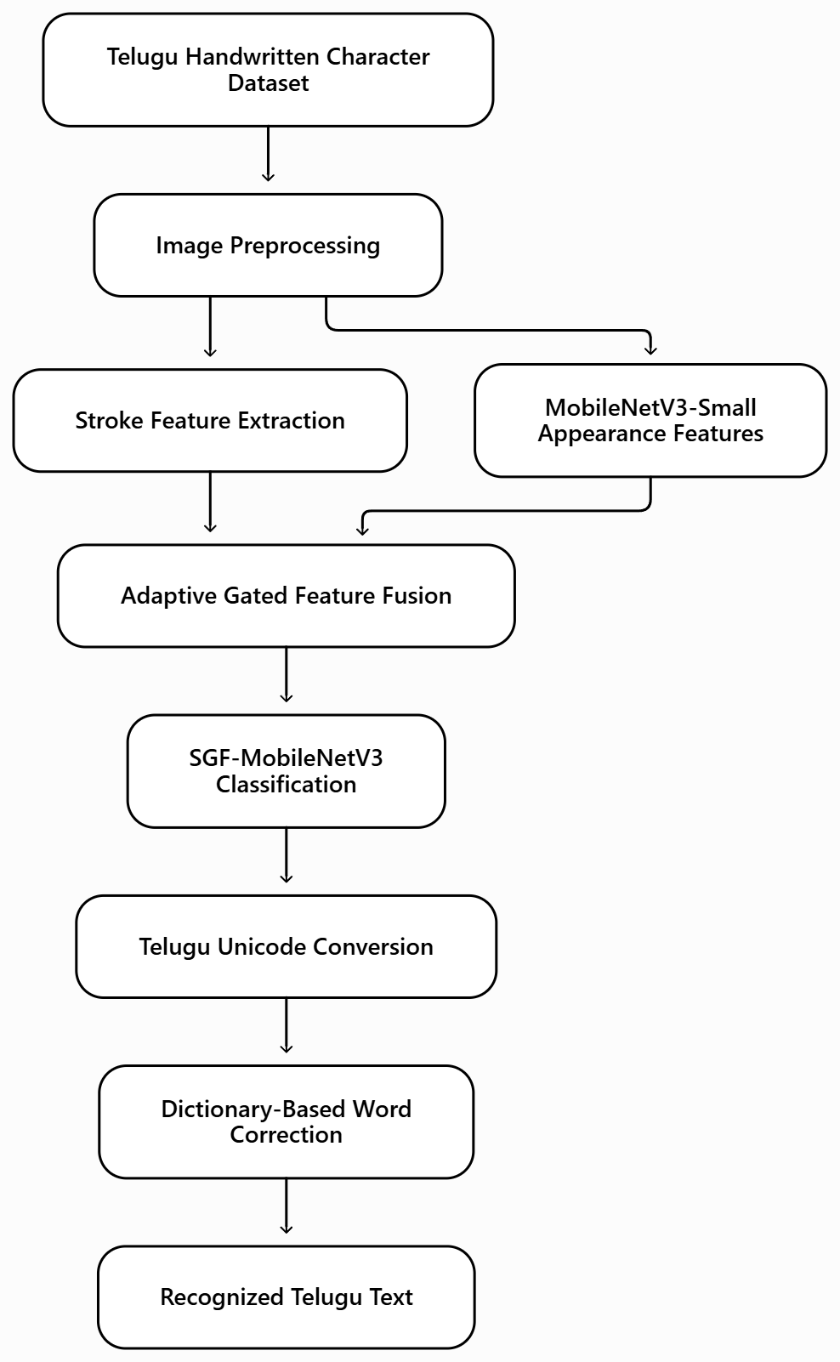
Figure 1 project flow

6.4 ARCHITECTURE:
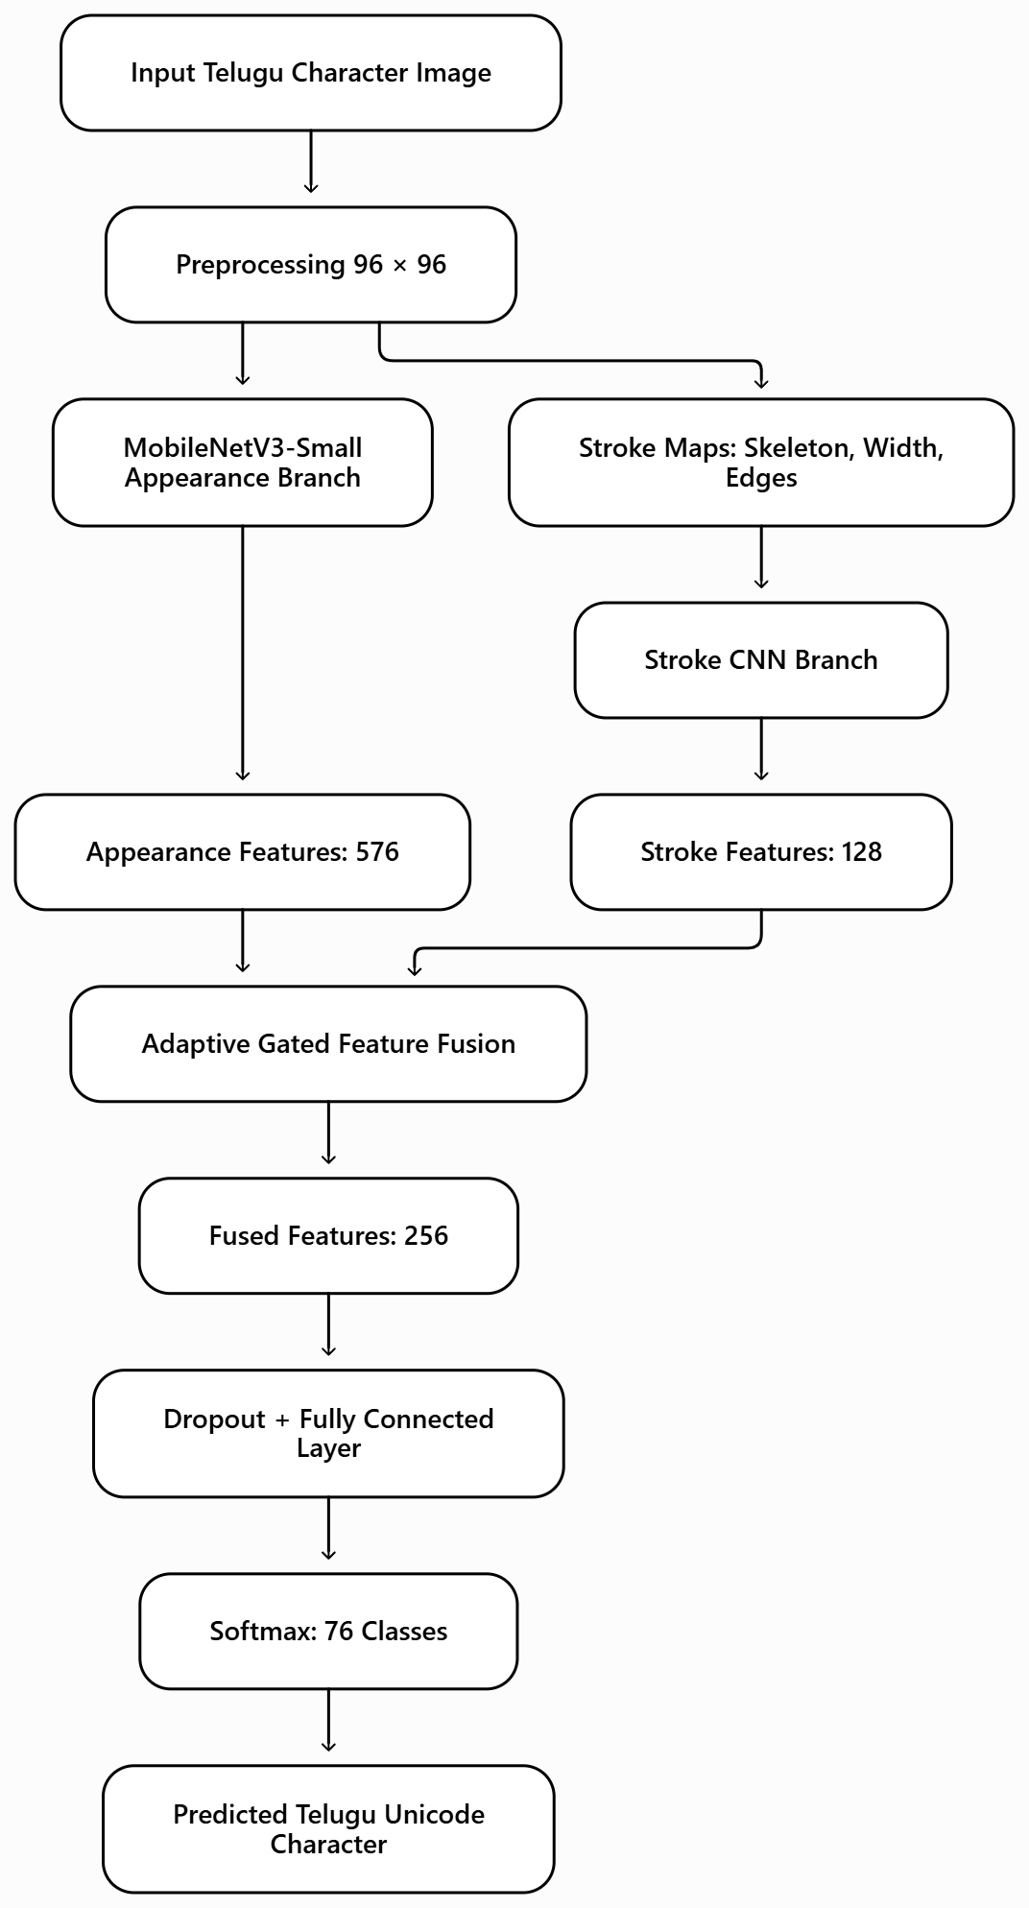
Figure 2 Architecture
The proposed methodology presents a deep learning-based framework for automated Telugu handwritten character recognition using visual appearance features and structural stroke information. The framework implements two classification models: a reduced-capacity MobileNetV3-Small baseline and the proposed Stroke-Gated Feature Fusion MobileNetV3 (SGF-MobileNetV3). It recognizes Telugu handwritten characters belonging to four categories: Achulu, Hallulu, Guninthamulu, and Othulu. The proposed SGF-MobileNetV3 integrates a MobileNetV3-Small appearance feature extraction branch with a dedicated stroke feature extraction branch. The appearance branch learns visual characteristics from handwritten character images, while the stroke branch extracts skeleton structures, stroke-width information, and edge magnitude. An adaptive gated feature fusion mechanism combines these complementary representations to improve character classification. The methodology includes dataset preparation, exploratory data analysis, image preprocessing, Unicode-based class merging, data augmentation, class-balanced sampling, model development, training, performance evaluation, robustness testing, and prediction. Telugu Unicode mapping and dictionary-based correction additionally support text generation from recognized character sequences.

6.5 Overview of Model Architectures
The proposed framework implements two deep learning architectures for Telugu handwritten character classification. The baseline model extracts appearance-based features, while the proposed SGF-MobileNetV3 incorporates both appearance and structural stroke representations.

MobileNetV3-Small Architecture
MobileNetV3-Small is implemented as the baseline model using ImageNet-pretrained weights. The architecture employs efficient convolutional operations, inverted residual blocks, and lightweight feature extraction to recognize handwritten Telugu characters.
The baseline utilizes the first nine feature-extraction stages of MobileNetV3-Small to generate a 96-dimensional visual representation from the input image. Adaptive Average Pooling converts the resulting feature map into a fixed-length feature vector.
The classification head consists of a Dropout layer with a probability of 0.35 and a fully connected layer containing 76 output neurons, corresponding to the Telugu character classes.
The baseline processes preprocessed grayscale character images of size 96 × 96 pixels, converted into normalized three-channel representations for compatibility with the pretrained backbone. It serves as the reference model for evaluating the proposed architecture.

SGF-MobileNetV3 Architecture
The proposed Stroke-Gated Feature Fusion MobileNetV3 (SGF-MobileNetV3) integrates two complementary feature extraction branches followed by adaptive gated fusion and character classification.
The appearance branch utilizes the full MobileNetV3-Small feature extraction backbone. It processes normalized character images and generates a 576-dimensional appearance feature vector through Adaptive Average Pooling.
The stroke branch receives three structural feature maps:
- Character skeleton representation.
- Normalized stroke-width representation.
- Edge magnitude representation.
These feature maps are processed through four convolutional blocks with output channels of 16, 32, 64, and 128. Each block contains a 3 × 3 convolution, Batch Normalization, and ReLU activation. Adaptive Average Pooling generates a 128-dimensional stroke feature vector.
The appearance and stroke representations are independently projected into a common 256-dimensional feature space using fully connected layers, Batch Normalization, and ReLU activation.
The feature extraction operations can be represented as:
$Fₐ=MobileNetV3\left(X\right)$ — (1)
$Fₛ=StrokeBranch\left(S\right)$ — (2)
where Fₐ denotes the 576-dimensional appearance representation, Fₛ represents the 128-dimensional stroke representation, X is the input character image, and S contains the three stroke descriptor maps.

Adaptive Gated Feature Fusion
The proposed architecture employs an adaptive gating mechanism to combine appearance and stroke representations. The original feature vectors are concatenated and passed through a fully connected layer followed by sigmoid activation to generate 256 gating weights.
The gating operation is expressed as:
$G=σ\left(Wg\left[Fₐ,Fₛ\right]+bg\right)$ — (3)
where G represents the learned gating vector, Wg and bg denote trainable parameters, and σ is the sigmoid activation function.
The fused representation is calculated as:
$Ffusion=G⊙Pₐ\left(Fₐ\right)+\left(1-G\right)⊙Pₛ\left(Fₛ\right)$ — (4)
where Pₐ and Pₛ represent the appearance and stroke projection functions, respectively, and ⊙ denotes element-wise multiplication.
This mechanism dynamically combines the two representations before classification.

Classification Module
The fused 256-dimensional feature vector is passed through a Dropout layer with a probability of 0.2 and a fully connected classification layer containing 76 output neurons.
The classification probabilities are obtained using Softmax:
$P\left(i\right)=exp\left(zi\right)/Σⱼexp\left(zj\right)$ — (5)
where zi represents the classification logit of the ith Telugu character class.
The character with the highest predicted probability is selected as the final classification result.

6.6 Dataset Preparation
The framework utilizes a Telugu handwritten character image dataset containing four major character groups: Guninthamulu, Achulu, Hallulu, and Othulu.
The initial dataset contains 292,752 image files distributed across 121 character folders. The folder names are resolved into Telugu Unicode characters, and duplicate folders representing identical Unicode symbols are merged into common character classes.
A total of 33 Telugu characters are identified as appearing in multiple folders. After Unicode-based class merging, the dataset contains 76 distinct character classes.
To reduce class imbalance, the number of images is limited to 1,000 per character and source-group combination. This balancing process produces 73,463 selected handwritten character images.

Table 6.1. Telugu Handwritten Character Dataset Distribution
Dataset | Images | Percentage
Training | 51,423 | 70%
Validation | 11,020 | 15%
Testing | 11,020 | 15%
Total | 73,463 | 100%
The dataset is divided using stratified sampling to preserve the class distribution across the training, validation, and testing partitions.
The four source character groups include:
- Achulu: Telugu vowel characters.
- Hallulu: Telugu consonant characters.
- Guninthamulu: Consonant-related characters, including vowel-modified forms.
- Othulu: Telugu conjunct and subscript consonant forms.
Each character class is assigned a numerical label ranging from 0 to 75. The corresponding Unicode representation is preserved for converting classification results into Telugu characters.

6.7 Exploratory Data Analysis (EDA)
Exploratory Data Analysis is performed to examine the Telugu handwritten character dataset before model training. The analysis begins by identifying the number of images and character folders in each source group. Class-distribution plots are generated to examine differences in sample availability and identify highly represented and underrepresented character categories. The initial dataset contains a considerable imbalance, particularly because Guninthamulu contributes a larger proportion of images. Unicode-based merging and image-count limiting are performed to reduce this imbalance.
Representative character images are visualized to examine variations in handwriting styles, stroke thickness, image quality, character alignment, and structural patterns. Additional visualizations compare character samples before and after preprocessing. Skeleton images, stroke-width maps, and edge magnitude representations are also examined to understand the structural features supplied to the proposed stroke branch. These analyses support the selection of appropriate preprocessing, class balancing, augmentation, and structural feature extraction techniques.

6.8 Preprocessing

Image Preprocessing
The image preprocessing pipeline standardizes Telugu handwritten character images before model training and prediction.
Each image is converted into grayscale format, and polarity correction ensures that characters appear as dark strokes against a lighter background. The character region is identified using thresholding and connected-component analysis. Unnecessary margins are removed, and the detected character is centered on a square canvas before resizing to 96 × 96 pixels.
Noise reduction is performed using Non-Local Means Denoising, followed by Contrast Limited Adaptive Histogram Equalization (CLAHE) to improve local contrast. Pixel values are converted into the range [0, 1]. For the MobileNetV3 appearance branch, normalized grayscale images are expanded into three channels.
The normalization operation is:
$Xnorm=\left(X-μ\right)/σ$ — (6)
where X represents the normalized input image, μ = 0.449, and σ = 0.226.

Structural Stroke Feature Extraction
The proposed SGF-MobileNetV3 extracts three structural representations from each preprocessed character image.
Skeleton Extraction: Binary thresholding and skeletonization reduce the handwritten character strokes into thin structural representations while preserving their principal shapes.
Stroke-Width Extraction: A distance transform is applied to the foreground character regions to generate normalized stroke-width information.
Edge Magnitude Extraction: Sobel operators calculate horizontal and vertical gradients to identify stroke boundaries.
The edge magnitude is calculated as:
$M=\sqrt{\left(Gx^{2}+Gy^{2}\right)}$ — (7)
where Gx and Gy represent horizontal and vertical image gradients.
The three structural representations are stacked to form a three-channel stroke feature input.

Image Data Augmentation
Data augmentation is applied to training images to improve model generalization across different handwriting styles and image variations.
The implemented transformations include random rotation within ±10°, scaling between 0.80 and 1.10, translation, shear, morphological erosion and dilation, Gaussian blur, resolution variation, and brightness and contrast adjustment.
These transformations are applied only during training. Validation and testing images undergo deterministic preprocessing without stochastic augmentation.

Class-Balanced Sampling
A Weighted Random Sampler is incorporated to reduce the influence of unequal class distributions during training.
Each training sample receives a sampling weight based on the frequency of its corresponding character class:
$wi = 1 / ni$ — (8)
where ni represents the number of training samples belonging to class i.
The sampler increases the probability of selecting examples from less frequent classes, producing approximately balanced training batches.

6.9 Model Training
Both models are trained using PyTorch with the AdamW optimizer. A fixed random seed of 42 is used to improve experimental reproducibility.
The following configurations are applied during training:
Training Parameter | Configuration
Input Image Size | 96 × 96
Batch Size | 64
Maximum Epochs | 30
Initial Learning Rate | 0.001
Weight Decay | 0.0001
Optimizer | AdamW
Learning Rate Scheduler | OneCycleLR
Loss Function | Cross-Entropy
Label Smoothing | 0.1
Early Stopping Patience | 7

MobileNetV3-Small Baseline Training
The baseline model is initialized using ImageNet-pretrained MobileNetV3-Small weights. Its reduced-capacity feature extractor processes the preprocessed character images.
The extracted appearance features are passed through global average pooling and the classification head to predict one of the 76 Telugu character classes.
The model is optimized using AdamW with label-smoothed Cross-Entropy Loss. Training and validation accuracy are monitored after each epoch, and the parameters producing the best validation accuracy are retained.

SGF-MobileNetV3 Training
The proposed SGF-MobileNetV3 is trained using both appearance images and their corresponding structural stroke representations.
The appearance branch extracts visual features using the full MobileNetV3-Small backbone. Simultaneously, the stroke branch processes skeleton, stroke-width, and edge magnitude maps.
The extracted representations are projected into a common feature space and combined using the adaptive gated fusion mechanism.
The fused features are passed through the classification head to generate predictions across the 76 Telugu character classes.
The label-smoothed Cross-Entropy Loss is expressed as:
$L=-Σᵢyi\left(LS\right)log\left(Pi\right)$ — (9)
where yi(LS) represents the label-smoothed target distribution and Pi denotes the predicted probability of character class i.
The One Cycle learning-rate scheduler adjusts the learning rate throughout training. Early stopping monitors validation accuracy, using validation loss to resolve equal-accuracy results.
Automatic mixed-precision training is enabled when compatible GPU hardware is available.
The best model parameters are retained for subsequent evaluation and inference.

6.10 Model Evaluation and Inference
Both models are trained using PyTorch with the AdamW optimizer. A fixed random seed of 42 is used to improve experimental reproducibility.
The following configurations are applied during training:
Training Parameter | Configuration
Input Image Size | 96 × 96
Batch Size | 64
Maximum Epochs | 30
Initial Learning Rate | 0.001
Weight Decay | 0.0001
Optimizer | AdamW
Learning Rate Scheduler | OneCycleLR
Loss Function | Cross-Entropy
Label Smoothing | 0.1
Early Stopping Patience | 7

MobileNetV3-Small Baseline Training
The baseline model is initialized using ImageNet-pretrained MobileNetV3-Small weights. Its reduced-capacity feature extractor processes the preprocessed character images.
The extracted appearance features are passed through global average pooling and the classification head to predict one of the 76 Telugu character classes.
The model is optimized using AdamW with label-smoothed Cross-Entropy Loss. Training and validation accuracy are monitored after each epoch, and the parameters producing the best validation accuracy are retained.

SGF-MobileNetV3 Training
The proposed SGF-MobileNetV3 is trained using both appearance images and their corresponding structural stroke representations.
The appearance branch extracts visual features using the full MobileNetV3-Small backbone. Simultaneously, the stroke branch processes skeleton, stroke-width, and edge magnitude maps.
The extracted representations are projected into a common feature space and combined using the adaptive gated fusion mechanism.
The fused features are passed through the classification head to generate predictions across the 76 Telugu character classes.
The label-smoothed Cross-Entropy Loss is expressed as:
$L=-Σᵢyi\left(LS\right)log\left(Pi\right)$ — (9)
where yi(LS) represents the label-smoothed target distribution and Pi denotes the predicted probability of character class i.
The OneCycle learning-rate scheduler adjusts the learning rate throughout training. Early stopping monitors validation accuracy, using validation loss to resolve equal-accuracy results.
Automatic mixed-precision training is enabled when compatible GPU hardware is available.
The best model parameters are retained for subsequent evaluation and inference.

6.11 Model Evaluation and Inference
The developed models are evaluated using the independent testing partition containing 11,020 Telugu handwritten character images.
The implemented evaluation metrics include accuracy, precision, recall, F1-score, weighted F1-score, top-3 accuracy, classification reports, and confusion matrices.
The evaluation measures are defined as follows:
Accuracy = Number of Correct Predictions / Total Predictions — (10)
Precision = TP / (TP + FP) — (11)
Recall = TP / (TP + FN) — (12)
F1 = 2 × Precision × Recall / (Precision + Recall) — (13)
where TP, FP, and FN represent true positives, false positives, and false negatives, respectively.
For multiclass evaluation, macro-averaged metrics are calculated by averaging the corresponding values across the 76 character classes.

Character Classification Results
The MobileNetV3-Small baseline and proposed SGF-MobileNetV3 are evaluated using the same testing dataset.

Table 6.2. Model Performance Comparison
Evaluation Metric | MobileNetV3-Small | SGF-MobileNetV3
Accuracy | 90.74% | 95.90%
Macro Precision | 89.97% | 95.33%
Macro Recall | 92.31% | 95.71%
Macro F1-score | 90.69% | 95.34%
Weighted F1-score | 90.89% | 95.89%
Top-3 Accuracy | 98.61% | 99.48%
The proposed SGF-MobileNetV3 achieves the highest classification accuracy of 95.90%, representing an improvement of 5.16 percentage points compared with the reduced-capacity MobileNetV3-Small baseline.
Class-wise classification reports and normalized confusion matrices are generated to examine recognition performance across different Telugu character categories. Additional analysis identifies frequently confused characters and compares recognition performance for Achulu, Hallulu, Guninthamulu, and Othulu.

Robustness Evaluation
Robustness testing is performed using 3,000 selected test images. The images are modified to simulate variations such as additional margins, random resizing, JPEG compression, and Gaussian blur.

Table 6.3. Robustness Evaluation Results
Model | Clean Images | Simulated Upload Images
MobileNetV3-Small | 90.67% | 85.10%
SGF-MobileNetV3 | 96.07% | 90.63%
The results indicate that the proposed model maintains higher classification accuracy than the baseline under the simulated image variations.

Model Efficiency Evaluation
Computational performance is assessed using model parameter count, stored model size, and average CPU inference latency.

Table 6.4. Model Efficiency Comparison
Parameter | MobileNetV3-Small | SGF-MobileNetV3
Parameters | 0.1942 million | 1.4065 million
Model Size | 0.859 MB | 5.7855 MB
CPU End-to-End Latency | 14.78 ms | 18.22 ms
The proposed model provides improved classification accuracy at the cost of a larger parameter count and slightly higher inference latency.

Character Prediction
During inference, the input handwritten character image undergoes grayscale conversion, preprocessing, resizing, normalization, and structural stroke extraction.
The selected SGF-MobileNetV3 generates a probability distribution across the 76 character classes.
The predicted character is determined by:
ŷ = argmaxᵢ P(i) — (14)
The prediction confidence is calculated as:
Confidence = maxᵢ P(i) — (15)
The predicted class index is converted into its corresponding Telugu Unicode character.
The recognition process also supports top-3 alternative predictions and confidence-based uncertainty identification. Predictions with confidence below 0.50 are marked as uncertain for further inspection.

7. ARCHITECTURE (IMPLEMENTATION AND TESTING)

7.1 SYSTEM DESIGN

7.1.1 Introduction of Input design
Input design is an essential component of the proposed Telugu Handwritten Character Recognition System, defining how user credentials, handwritten Telugu character images, and character sequences are collected, validated, and processed for automated recognition. The system provides an application interface that allows users to register, log in, and access two recognition modes: Single Character Recognition and Word Recognition. The character recognition module accepts one handwritten Telugu character image, while the word recognition module accepts multiple individual character images arranged in their intended reading order. The application supports JPG, JPEG, PNG, BMP, WEBP, TIF, and TIFF image formats, with a maximum combined upload request size of 32 MB and a limit of 40 character images per prediction. Uploaded images undergo grayscale conversion, polarity correction, ink-region cropping, square padding, resizing to 96 × 96 pixels, noise removal, and contrast enhancement using Contrast Limited Adaptive Histogram Equalization (CLAHE). The preprocessed images are processed using the proposed Stroke-Gated Feature Fusion MobileNetV3 (SGF-MobileNetV3). The appearance branch extracts visual features through MobileNetV3-Small, while the structural stroke branch generates skeleton, stroke-width, and edge magnitude representations. These features are combined through an adaptive gated fusion mechanism to support classification across 76 Telugu character classes. The input design also incorporates automatic recognition mode selection, optional filename-based ordering for multiple images, image readability verification, supported file extension validation, and trained model availability checks. User authentication is managed through MySQL-based credential verification and session handling. Uploaded files are temporarily stored using unique filenames and removed after prediction processing. The input design ensures consistent image preparation, reliable input validation, and compatibility with the trained recognition model.

Objectives for Input Design:
- User-Friendly Recognition Interface: Provide an application interface that allows registered users to upload handwritten Telugu character images for automated recognition.
- User Registration and Authentication: Collect email addresses, passwords, and password confirmation during registration and verify registered credentials using the MySQL database.
- Multiple Recognition Modes: Allow users to select Single Character Recognition, Word Recognition, or automatic mode selection based on the number of uploaded images.
- Single Character Image Upload: Enable users to upload one handwritten Telugu character image for classification using the proposed SGF-MobileNetV3.
- Word Recognition Input: Accept multiple separately cropped Telugu character images arranged in their intended reading order to generate a recognized character sequence.
- Supported Image Formats: Accept JPG, JPEG, PNG, BMP, WEBP, TIF, and TIFF image files for recognition.
- Grayscale Conversion: Convert uploaded character images into grayscale format to standardize the input representation.
- Ink-Region Cropping: Identify the handwritten character region and remove unnecessary background margins while preserving important character strokes.
- Image Resizing and Normalization: Resize character images to 96 × 96 pixels and normalize pixel values for compatibility with the trained MobileNetV3 architecture.
- Noise Removal and Contrast Enhancement: Apply Non-Local Means Denoising and CLAHE to improve character visibility and reduce image-quality variations.
- Structural Stroke Extraction: Generate skeleton, stroke-width, and edge magnitude maps to capture the structural characteristics of handwritten Telugu characters.
- Adaptive Feature Fusion: Process appearance and structural stroke inputs through the corresponding branches of SGF-MobileNetV3 for gated feature fusion.
- Character Image Ordering: Maintain the selected image sequence or optionally arrange uploaded files using natural filename sorting before word recognition.
- Input Validation: Verify mandatory image inputs, supported file extensions, valid recognition modes, readable images, and the availability of trained model artifacts.
- Input Size Restrictions: Restrict the combined upload request size to 32 MB and limit each recognition request to a maximum of 40 character images.
- Temporary Image Storage: Store uploaded images using securely processed, uniquely generated filenames and automatically remove temporary input files after recognition.

7.1.2 Output Design:
Output design defines how the proposed Telugu Handwritten Character Recognition System presents recognized Telugu characters, Unicode representations, prediction confidence scores, alternative predictions, structural stroke visualizations, corrected word outputs, model performance comparisons, and downloadable recognition reports. The system generates recognition results according to the selected prediction mode. In Single Character Recognition, the proposed SGF-MobileNetV3 processes the uploaded handwritten character image and classifies it into one of 76 Telugu character classes. The output displays the recognized Telugu Unicode character, corresponding character group, class identifier, Unicode code points, prediction confidence percentage, and top-three alternative predictions. A confidence-based uncertainty mechanism identifies predictions below the predefined 50% threshold and displays a warning when character recognition is uncertain. The system also generates a structural feature visualization containing the preprocessed character image, skeleton representation, stroke-width map, and edge magnitude map. Additionally, the adaptive gated fusion mechanism provides information about the relative contribution of appearance and structural stroke features during classification. These outputs support interpretation of the model's recognition behavior.
In Word Recognition, the system processes multiple uploaded character images in sequence and combines their predicted Unicode characters to generate Telugu text. A dictionary-based correction mechanism compares the recognized sequence with stored Telugu dictionary words using akshara-level edit distance. The system displays both the original recognized sequence and the final corrected text when a suitable dictionary match is identified. Character-wise confidence scores, mean confidence, minimum confidence, uncertain character positions, and correction information are also provided. The model performance module presents evaluation metrics for the MobileNetV3-Small baseline and proposed SGF-MobileNetV3, including accuracy, precision, recall, F1-score, top-3 accuracy, model size, inference latency, class-wise performance, and robustness evaluation results. The proposed model achieves 95.90% classification accuracy and 95.34% macro F1-score, compared with 90.74% accuracy for the baseline model. Additionally, the system supports downloadable PDF recognition reports containing recognized Telugu text, Unicode information, prediction confidence, character-wise classification results, alternative predictions, and correction details. The output design emphasizes readability, interpretation of recognition results, confidence-based uncertainty identification, and accessible presentation of Telugu handwritten character predictions.

Objectives of Output Design:
- Clear Telugu Character Recognition: Display the recognized handwritten Telugu character in its corresponding Unicode representation.
- Single Character Prediction Results: Present character classification results generated by the proposed SGF-MobileNetV3 using appearance feature extraction, structural stroke extraction, and adaptive gated feature fusion.
- Word Recognition Results: Combine the predictions generated from multiple ordered character images into a readable Telugu character sequence.
- Telugu Unicode Display: Convert predicted character classes into Telugu Unicode symbols and display their corresponding Unicode code points.
- Character Category Identification: Display the recognized character's classification group, such as Vowel, Consonant, or Conjunct, based on the stored class mapping.
- Prediction Confidence Score: Display the highest predicted Softmax probability as a confidence percentage for each recognized character.
- Top-Three Alternative Predictions: Present the three most probable Telugu character predictions with their corresponding confidence percentages.
- Prediction Uncertainty Indication: Mark character predictions with confidence below 50% as uncertain and provide a message recommending verification or clearer image input.
- Structural Stroke Visualization: Generate visual representations of the character skeleton, stroke-width distribution, and edge magnitude to illustrate the structural information extracted from handwritten images.
- Preprocessed Image Display: Present the standardized character image used during classification for comparison with its structural feature maps.
- Adaptive Gated Feature Analysis: Display the estimated relative contribution of appearance features and structural stroke features to the final character representation.
- Raw Telugu Text Recognition: Display the original Telugu text sequence obtained by combining the predicted Unicode characters in the supplied order.
- Dictionary-Based Word Correction: Apply akshara-level edit-distance matching to identify possible corrections and display the final corrected Telugu word when a suitable match is available.
- Correction Information Display: Indicate whether dictionary correction was applied, whether a matching word was found, and the corresponding edit distance.
- Character-Wise Prediction Details: Display the sequence position, uploaded filename, predicted character, Unicode information, confidence percentage, and alternative predictions for every character image.
- Overall Recognition Confidence: Calculate and display the mean and minimum confidence percentages across all recognized characters.
- Uncertain Character Identification: Identify the positions of low-confidence characters within a word sequence to assist users in reviewing potentially incorrect predictions.
- Prediction Processing Time: Display the inference time required to process the submitted character image or character sequence.
- Model Performance Comparison: Present accuracy, precision, recall, macro F1-score, weighted F1-score, top-3 accuracy, model size, and inference latency for MobileNetV3-Small and SGF-MobileNetV3.
- Character Group Performance Analysis: Display available recognition accuracy results for Achulu, Hallulu, Guninthamulu, and Othulu to illustrate differences in classification performance.
- Robustness Evaluation Results: Present model accuracy under clean and simulated image-upload conditions involving resizing, additional margins, compression, and blur.
- Class-Wise Evaluation Results: Display available classification reports and identify character classes with comparatively lower precision, recall, or F1-scores.
- Downloadable PDF Recognition Report: Generate a Telugu handwritten OCR report containing recognized text, Unicode code points, character-wise predictions, confidence scores, alternative predictions, and dictionary correction information.
- User-Friendly Error Messages: Provide informative messages for unsupported image formats, unreadable character images, invalid recognition modes, missing inputs, unavailable trained models, and prediction failures.
- Generated Result Management: Store recognition visualization images and PDF reports using unique filenames and periodically remove older generated files to manage storage resources.
- Prediction Reliability Information: Display appropriate warnings indicating that handwritten character predictions may contain recognition errors, particularly for unclear handwriting, visually similar characters, and character sequences requiring dictionary correction.

7.1.3 UML diagrams
UML stands for Unified Modelling Language. UML is a standardized general-purpose modelling language in the field of object-oriented software engineering. The standard is managed, and was created by, the Object Management Group.
The goal is for UML to become a common language for creating models of object-oriented computer software. In its current form UML is comprised of two major components: a Meta-model and a notation. In the future, some form of method or process may also be added to; or associated with, UML.
The Unified Modelling Language is a standard language for specifying, Visualization, Constructing and documenting the artefacts of software system, as well as for business modelling and other non-software systems.
The UML represents a collection of best engineering practices that have proven successful in the modelling of large and complex systems.
The UML is a very important part of developing objects-oriented software and the software development process. The UML uses mostly graphical notations to express the design of software projects.
GOALS:
The Primary goals in the design of the UML are as follows:
- Provide users a ready-to-use, expressive visual modelling Language so that they can develop and exchange meaningful models.
- Provide extendibility and specialization mechanisms to extend the core concepts.
- Be independent of particular programming languages and development process.
- Provide a formal basis for understanding the modelling language.
- Encourage the growth of OO tools market.
- Support higher level development concepts such as collaborations, frameworks, patterns and components.
- Integrate best practices.

7.1.3.1 USE CASE DIAGRAM
The use case diagram illustrates how a user interacts with the Telugu handwritten character recognition system. It includes registration, login, character recognition, word recognition, model performance viewing, report downloading, and logout.
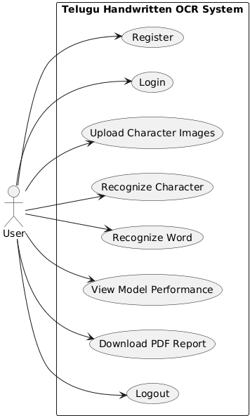
Figure 3 USECASE DIAGRAM

7.1.3.2 CLASS DIAGRAM
The class diagram represents the main deep learning model classes implemented in the project.It shows the baseline MobileNetV3 model and the proposed SGF-MobileNetV3, which incorporates a dedicated StrokeBranch.
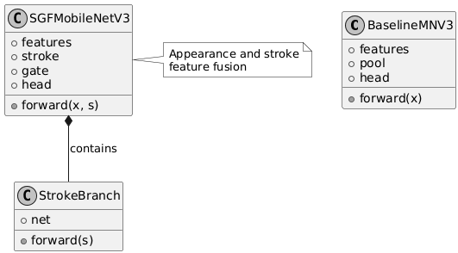
Figure 4 class diagram

7.1.3.3 SEQUENCE DIAGRAM
The sequence diagram illustrates the order of interactions between the user, Flask application, preprocessing utilities, and recognition model. It shows how uploaded character images are processed and converted into Telugu text with confidence scores.
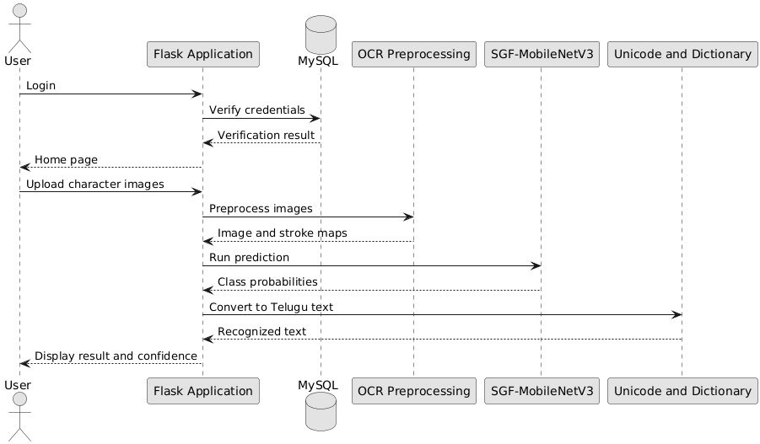
Figure 5 sequence diagram
Collaboration Diagram
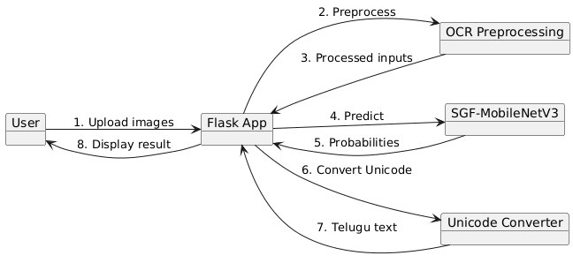

The collaboration diagram represents communication among the main components involved in Telugu character recognition. It illustrates how the user request travels through preprocessing, classification, and Unicode conversion before returning the result.

7.1.3.4 DEPLOYMENT DIAGRAM
The deployment diagram shows how the user's browser communicates with the Flask application and its supporting resources. It includes the PyTorch recognition model, saved model files, PDF reports, and MySQL database.
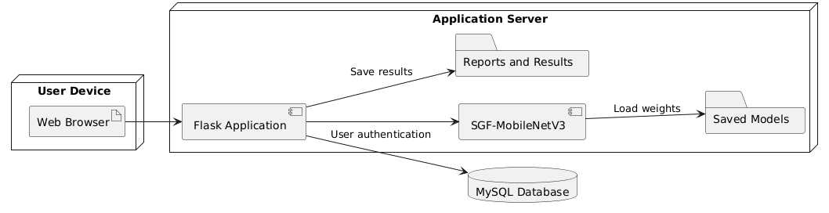
Figure 6 deployment diagram

7.1.3.5 ACTIVITY DIAGRAM:
The activity diagram represents the step-by-step process of recognizing handwritten Telugu characters and word sequences. It includes image validation, preprocessing, stroke extraction, classification, Unicode conversion, and result generation.
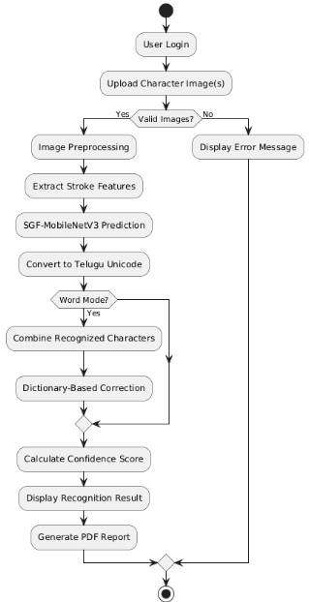
Figure 7 activity diagram

7.1.3.7 ER DIAGRAM:
The ER diagram represents the database structure used for user registration and authentication. The current Flask application uses a MySQL users table containing email and password fields; predictions and reports are not stored as relational database records.
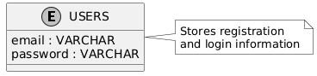
Figure 9 er diagram

7.1.4 DATA FLOW DIAGRAMS
Level 1 Diagram: The Level 1 Data Flow Diagram shows the major processes of the Telugu handwritten recognition system. It illustrates user authentication, image recognition, result generation, and interactions with model files and the database.
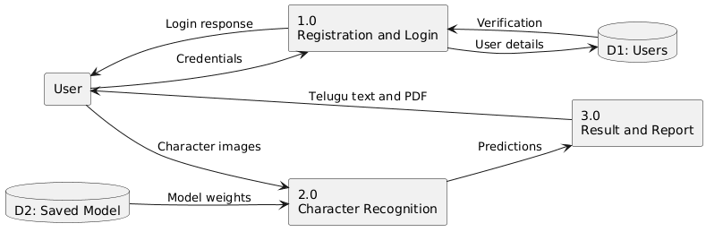
Figure 10 DFD LEVEL1
Level 2 Diagram: The Level 2 Data Flow Diagram explains the internal processing steps of the character recognition module. It shows image validation, preprocessing, parallel appearance and stroke extraction, gated classification, Unicode conversion, and output generation.
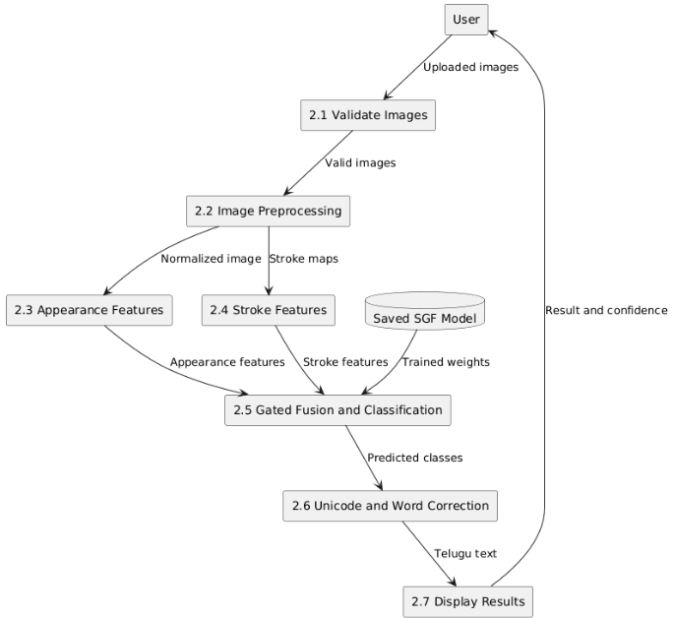
Figure 11 DFD LEVEL 2

7.2 IMPLEMENTATION

7.2.1 SYSTEM WORKFLOW

1. SYSTEM WORKFLOW
The system workflow encompasses the complete process of Telugu Handwritten Character Recognition using Stroke-Gated Feature Fusion MobileNetV3 (SGF-MobileNetV3). The proposed framework integrates deep learning, image preprocessing, structural stroke feature extraction, adaptive gated feature fusion, Telugu Unicode conversion, and dictionary-based word correction. The implementation incorporates two deep learning architectures: the reduced-capacity MobileNetV3-Small baseline and the proposed SGF-MobileNetV3. The trained model is integrated into a Flask-based web application supporting Single Character Recognition and Word Recognition. The system also incorporates confidence analysis, top-three alternative predictions, structural stroke visualization, model performance comparison, and downloadable PDF recognition reports. The implementation is organized into five sequential phases: Data Collection, Data Preprocessing, Model Training, Model Evaluation, and Deployment.

1. Data Collection
Telugu Handwritten Character Dataset:
- The Telugu Handwritten Character Dataset obtained from Kaggle serves as the primary data source for developing the recognition models. The original dataset contains 292,752 images distributed across 121 character folders.
- The dataset includes four major Telugu character groups: Achulu, Hallulu, Guninthamulu, and Othulu. These groups represent vowels, consonants, vowel-modified consonant forms, and conjunct-related character structures.
- Unicode-based class merging is performed to combine folders representing identical Telugu characters. Dataset balancing is subsequently applied to reduce excessive representation of frequently occurring character classes.
- After class merging and balancing, the selected dataset contains 73,463 images representing 76 distinct Telugu character classes.
- The dataset is divided using stratified sampling into 51,423 training images (70%), 11,020 validation images (15%), and 11,020 testing images (15%).
- The handwritten samples contain variations in character shape, stroke thickness, writing style, alignment, and image quality. These characteristics are utilized to train and evaluate the recognition models.

2. Data Preprocessing
Image Data Preprocessing:
- The preprocessing pipeline converts raw Telugu handwritten character images into standardized representations suitable for MobileNetV3-Small and SGF-MobileNetV3.
- Grayscale Conversion: Input images are converted into grayscale format to simplify processing and emphasize handwritten character structures.
- Polarity Correction: Character images are standardized to maintain dark handwritten strokes against a lighter background.
- Ink-Region Cropping: Thresholding and connected-component analysis identify the handwritten character region and remove unnecessary background margins.
- Image Resizing: Cropped character images are centered on a square canvas and resized to 96 × 96 pixels.
- Noise Removal: Non-Local Means Denoising is applied to reduce unwanted background noise while preserving important character strokes.
- Contrast Enhancement: Contrast Limited Adaptive Histogram Equalization (CLAHE) improves local contrast and character visibility.
- Image Normalization: Pixel intensities are converted into normalized representations compatible with the trained MobileNetV3 backbone.
Structural Stroke Feature Extraction:
- The proposed SGF-MobileNetV3 incorporates a dedicated stroke feature extraction process to capture structural characteristics of handwritten Telugu characters.
- Skeleton Extraction: Skeletonization generates thin representations of character strokes while preserving their principal structural patterns.
- Stroke-Width Extraction: Distance-transform operations produce normalized stroke-width maps to represent variations in handwritten stroke thickness.
- Edge Magnitude Extraction: Sobel gradient operators identify character boundaries and generate normalized edge magnitude maps.
- The three structural representations are combined into a three-channel stroke descriptor and supplied to the proposed model's stroke extraction branch.
Training Data Augmentation:
- Training images undergo random rotation, scaling, translation, shear, morphological transformations, blur, resolution variation, and brightness and contrast adjustments.
- Augmentation introduces controlled handwriting variations to improve model generalization.
- Validation and testing images undergo deterministic preprocessing without random augmentation.
- A Weighted Random Sampler is utilized during training to reduce the effect of unequal character class distributions.

3. Model Training
MobileNetV3-Small Baseline Training Process:
- The baseline architecture utilizes a reduced-capacity MobileNetV3-Small backbone containing the initial feature extraction stages of the pretrained network.
- Input character images are processed through convolutional feature extraction layers to generate a 96-dimensional appearance representation.
- Adaptive Average Pooling converts the extracted feature maps into fixed-length feature vectors.
- The classification head contains a Dropout layer with a probability of 0.35 and a fully connected layer generating predictions across 76 Telugu character classes.
- The baseline model is trained using the AdamW optimizer with an initial learning rate of 0.001, weight decay of 0.0001, and batch size of 64.
- Label-smoothed Cross-Entropy Loss, OneCycle learning-rate scheduling, and validation-based early stopping are used during training.
SGF-MobileNetV3 Training Process:
- The proposed Stroke-Gated Feature Fusion MobileNetV3 (SGF-MobileNetV3) integrates visual appearance feature extraction with a dedicated structural stroke branch.
- The appearance branch employs the full MobileNetV3-Small feature extraction backbone to generate a 576-dimensional appearance feature vector.
- The stroke branch processes skeleton maps, stroke-width representations, and edge magnitude information using convolutional layers.
- The stroke extraction network contains four convolutional blocks producing 16, 32, 64, and 128 feature channels, followed by Adaptive Average Pooling.
- The appearance and stroke representations are independently projected into a common 256-dimensional feature space using fully connected layers, Batch Normalization, and ReLU activation.
- An Adaptive Gated Feature Fusion Mechanism generates learnable gating weights through a sigmoid-activated neural layer.
- The gating mechanism dynamically combines the projected appearance and stroke features before classification.
- The fused representation is passed through a Dropout layer with a probability of 0.2 and a final classification layer containing 76 output neurons.
- SGF-MobileNetV3 is trained using AdamW with a learning rate of 0.001, weight decay of 0.0001, a batch size of 64, and label-smoothed Cross-Entropy Loss.
- Training is configured for a maximum of 30 epochs, with early stopping patience of seven epochs.
- Automatic mixed-precision training is enabled when compatible CUDA acceleration is available.
- The best-performing model parameters are retained based on validation accuracy, with validation loss used to resolve ties.

4. Model Evaluation
MobileNetV3-Small Baseline Evaluation:
- The baseline model is evaluated using the independent testing dataset containing 11,020 handwritten Telugu character images.
- Performance is measured using accuracy, macro precision, macro recall, macro F1-score, weighted F1-score, top-three accuracy, classification reports, and confusion matrices.
- MobileNetV3-Small achieves 90.74% classification accuracy, 89.97% macro precision, 92.31% macro recall, and 90.69% macro F1-score.
- The model also achieves 98.61% top-three accuracy, providing a reference for comparison with the proposed architecture.
SGF-MobileNetV3 Evaluation:
- The proposed SGF-MobileNetV3 is evaluated using the same independent testing partition.
- The evaluation examines the effectiveness of combining appearance features and structural stroke representations through adaptive gated fusion.
- SGF-MobileNetV3 achieves 95.90% classification accuracy, 95.33% macro precision, 95.71% macro recall, and 95.34% macro F1-score.
- The proposed model also achieves 95.89% weighted F1-score and 99.48% top-three accuracy.
- Compared with the baseline model, SGF-MobileNetV3 improves classification accuracy by 5.16 percentage points.
- Class-wise evaluation and confusion matrices are generated to examine recognition performance across the Telugu character categories.
Robustness Evaluation:
- Robustness testing is conducted using 3,000 selected test images, which are modified to simulate common image-upload variations.
- The simulated variations include additional image margins, random resizing, JPEG compression, and Gaussian blur.
- Under these conditions, the proposed SGF-MobileNetV3 achieves 90.63% recognition accuracy, compared with 85.10% accuracy for the baseline model.
- The evaluation demonstrates improved recognition performance for the proposed architecture under the tested image variations.
Model Efficiency Evaluation:
- Computational efficiency is evaluated using model parameter count, stored model size, and CPU inference latency.
- The MobileNetV3-Small baseline contains approximately 0.1942 million parameters, with a model size of 0.859 MB and average CPU end-to-end latency of 14.78 milliseconds.
- The proposed SGF-MobileNetV3 contains approximately 1.4065 million parameters, with a model size of 5.7855 MB and CPU end-to-end latency of 18.22 milliseconds.
- The results demonstrate improved recognition accuracy with a moderate increase in computational requirements.

5. Deployment
The selected SGF-MobileNetV3 model is integrated into a Flask-based web application named the Telugu Handwritten OCR System to support automated Telugu character recognition, character sequence processing, Unicode conversion, confidence analysis, structural stroke visualization, and downloadable recognition reports.
- Model Serialization: The trained model parameters are saved in PyTorch checkpoint format. The application loads best_model.pth and best_model_meta.json, or the supported checkpoint alternative, from the saved_models directory.
- Model Metadata: The saved metadata contains the model architecture name, image dimensions, class labels, stroke-feature configuration, and Telugu Unicode mappings required for prediction.
- Flask Application Integration: The application provides Registration, Login, Home, Prediction, Model Performance, About, and Logout pages.
- Multiple Recognition Modes: The prediction module supports Single Character Recognition, Word Recognition, and automatic recognition mode selection based on the submitted images.
- Character Recognition Module: Uploaded images undergo grayscale conversion, cropping, resizing, denoising, contrast enhancement, and stroke descriptor extraction before being passed to SGF-MobileNetV3.
- Word Recognition Module: Multiple individually cropped character images are processed in sequence, and their predicted Unicode symbols are combined into Telugu text. Dictionary-based correction is optionally applied.
- Unicode Conversion Module: Numerical classification outputs are mapped to Telugu Unicode symbols using the saved character mapping information.
- Confidence Analysis: The application generates character-wise confidence percentages, top-three alternative predictions, and uncertainty indicators.
- Stroke Visualization: Preprocessed character images, skeleton representations, stroke-width maps, and edge magnitude maps are generated for visualization.
- MySQL Database Integration: The Flask application connects to the MySQL BBR database for user registration and login. User credentials are stored in the users table, and Flask sessions control access to protected pages. The current implementation compares passwords directly; secure password hashing is required before production deployment.
- Model Performance Module: The application displays accuracy, precision, recall, F1-score, top-three accuracy, class-wise evaluation, robustness comparisons, model parameters, and inference latency using exported evaluation reports when available.
- Downloadable PDF Report: The ReportLab library is used to generate Telugu handwritten OCR reports containing recognition results, confidence scores, Unicode information, and character-wise prediction details.
- Temporary File Management: Uploaded character images are temporarily stored using unique filenames and deleted after processing. Generated visualization files and cached reports are periodically cleaned up.
- Hardware Compatibility: The application automatically selects CUDA execution when a compatible GPU is available and otherwise performs inference using the CPU.
- Error Handling: The application handles unsupported image formats, missing images, unreadable files, invalid recognition modes, missing model checkpoints, and prediction failures through informative messages.

2. USER WORKFLOW
The user workflow describes the complete interaction process, beginning with user registration and login and continuing through recognition mode selection, handwritten Telugu image upload, automated character classification, Unicode conversion, confidence analysis, word correction, model performance viewing, PDF report generation, and logout. The workflow provides a straightforward interface for accessing the proposed Telugu Handwritten Character Recognition System.

1. User Registration
New users access the registration page and provide their email address, password, and password confirmation. The Flask application verifies whether the required fields are completed and checks whether the password and confirmation password match. The application also queries the MySQL database to determine whether the submitted email address is already registered. If the registration information is valid, the user details are inserted into the database, and the user is redirected to the login page. Appropriate messages are displayed for missing information, password mismatches, and duplicate email registration. The current implementation uses direct password storage and comparison; password hashing and additional authentication security measures are necessary before production deployment.

2. User Login
Registered users access the login page and enter their email address and password.
The Flask application validates the submitted credentials against the records stored in the MySQL database. If the credentials match, a Flask session is created, and the user is redirected to the home page.
If incorrect credentials are submitted, the system displays an invalid credentials message. Session verification restricts access to the home and prediction pages. Users without an active session are redirected to the login page.

3. Home Page and Recognition Mode Selection
After successful authentication, users are redirected to the home page, which provides navigation to the application functionalities.
The application supports three recognition mode options:
- Single Character Recognition: Allows users to upload one handwritten Telugu character image for classification using SGF-MobileNetV3.
- Word Recognition: Allows users to upload multiple individual character images in their intended reading order to construct a Telugu character sequence.
- Automatic Mode Selection: Automatically selects character recognition when one image is provided and word recognition when multiple images are submitted.
The application also provides access to model performance information and project details.

4. Telugu Handwritten Character Image Upload
In Single Character Recognition mode, authenticated users upload an image containing an individual handwritten Telugu character. The application supports JPG, JPEG, PNG, BMP, WEBP, TIF, and TIFF file formats, with a maximum combined request size of 32 MB. The Flask backend validates the selected image extension and verifies that the uploaded file can be read.
Valid images are temporarily stored using securely processed filenames combined with unique identifiers to avoid naming conflicts. The uploaded image undergoes grayscale conversion, polarity correction, ink-region cropping, square padding, resizing to 96 × 96 pixels, denoising, and CLAHE-based contrast enhancement. The preprocessed image is then supplied to the SGF-MobileNetV3 architecture for character classification.

5. Multiple Character Upload for Word Recognition
In Word Recognition mode, users upload multiple images representing individual Telugu handwritten characters.
The application accepts a maximum of 40 character images for one recognition request. The selected images are processed in their submitted order. Users can also enable filename-based sorting to arrange the images in natural numerical order.
Each image undergoes the same preprocessing and feature extraction operations used for single-character recognition. The trained SGF-MobileNetV3 model independently classifies each character image. The predicted Unicode characters are combined sequentially to generate the recognized Telugu text. This mode expects separate character images and does not automatically segment an entire handwritten word image into individual characters.

6. SGF-MobileNetV3 Character Recognition
After image preprocessing, the proposed SGF-MobileNetV3 processes the submitted character image using two complementary feature extraction branches.
The MobileNetV3-Small appearance branch generates a 576-dimensional visual feature representation, while the structural stroke branch processes skeleton, stroke-width, and edge magnitude maps. The extracted features are projected into a shared representation space and combined through adaptive gated feature fusion. The final classification layer generates 76 character classification logits, which are converted into probabilities using Softmax activation.
The prediction results include:
- Predicted Character: Displays the Telugu handwritten character identified by the model.
- Character Class: Displays the corresponding predicted class identifier.
- Character Group: Identifies the character as a vowel, consonant, or conjunct-related symbol.
- Telugu Unicode: Displays the recognized Telugu character in Unicode format.
- Unicode Code Points: Provides the corresponding Unicode representation.
- Prediction Confidence: Displays the highest classification probability as a percentage.
- Top-Three Predictions: Displays three possible character predictions with their associated probabilities.
- Prediction Status: Indicates whether the character is detected or uncertain based on the predefined 50% confidence threshold.

7. Structural Stroke Visualization
The proposed recognition system generates visual representations of the structural information used by SGF-MobileNetV3.
The visualization module presents:
- Preprocessed Image: Displays the standardized handwritten character image supplied to the model.
- Skeleton Map: Illustrates the simplified structural arrangement of the handwritten strokes.
- Stroke-Width Map: Displays variations in character stroke thickness.
- Edge Magnitude Map: Highlights the boundaries and edges of the handwritten character.
- Gated Feature Information: Presents the relative contribution of appearance and structural stroke representations during character classification.
These visualizations help users understand the structural characteristics considered during the recognition process. The gating values represent internal feature-fusion weights rather than independently validated explanations of model decisions.

8. Telugu Unicode Conversion and Word Correction
After character classification, the system converts predicted numerical class identifiers into their corresponding Telugu Unicode characters. For Single Character Recognition, the predicted Unicode symbol is directly displayed.
The system then applies dictionary-based correction using akshara-level edit distance.
The correction process includes:
- Raw Text Generation: Combines the recognized Unicode characters into a Telugu sequence.
- Akshara Splitting: Divides the recognized text into Telugu akshara units.
- Dictionary Comparison: Compares the recognized sequence with stored dictionary words.
- Edit-Distance Calculation: Measures the differences between recognized and dictionary sequences.
- Word Correction: Selects a matching dictionary word when the calculated distance falls within the permitted threshold.
- Final Text Generation: Displays the corrected Telugu word or retains the original prediction when no suitable match is identified.
The system also displays whether dictionary correction was applied and the corresponding edit distance.

9. Recognition Result Display
After completing prediction, the application displays the character recognition results along with confidence and processing information. For Single Character Recognition, the output includes the predicted Telugu character, confidence percentage, character class, Unicode representation, alternative predictions, and structural stroke visualization.
Additional recognition details include:
- Number of Characters: Displays the total number of processed character images.
- Mean Confidence: Presents the average confidence percentage across all recognized characters.
- Minimum Confidence: Displays the lowest character prediction confidence.
- Uncertain Positions: Identifies characters having confidence below the predefined threshold.
- Dictionary Correction Details: Indicates whether a dictionary match was identified and correction was performed.
- Inference Time: Displays the processing duration of the recognition request.
- Recognition Warning: Advises users to verify important Telugu text because machine-generated predictions may contain errors.
The application presents these outputs to support interpretation and verification of recognition results.

10. Home Page and Model Performance
The home page provides navigation to the available Telugu handwritten character recognition functionalities.
The Model Performance page presents the experimental evaluation results of the MobileNetV3-Small baseline and proposed SGF-MobileNetV3.
The displayed performance information includes:
- Classification accuracy.
- Macro precision and macro recall.
- Macro F1-score and weighted F1-score.
- Top-three classification accuracy.
- Character-group recognition accuracy.
- Available class-wise classification reports.
- Model parameter count and stored model size.
- CPU inference latency.
- Clean-image and simulated-upload robustness comparison.
- Training and testing dataset information.
The proposed SGF-MobileNetV3 achieves 95.90% classification accuracy and 95.34% macro F1-score, outperforming the MobileNetV3-Small baseline, which achieves 90.74% accuracy and 90.69% macro F1-score.
The application retrieves evaluation results from exported CSV and JSON reports when available. Built-in performance values are used as fallbacks if the corresponding reports cannot be loaded.
The application also provides an About page containing project information.

11. Downloadable Telugu OCR Recognition Report
After successful character or word recognition, the application can generate a downloadable PDF report using the ReportLab library. The generated report contains the recognized Telugu character or text sequence, confidence scores, character classification information, and recognition details.
The PDF report includes:
- Recognition Summary: Displays the recognition mode, model name, recognized text, and prediction status.
- Telugu Unicode Information: Presents the predicted Unicode symbols or corresponding Unicode code points.
- Confidence Information: Displays mean and minimum confidence percentages.
- Character Images: Includes the preprocessed character images used for recognition.
- Character-Wise Results: Displays individual character predictions, classification groups, Unicode information, and confidence scores.
- Alternative Predictions: Lists the next most probable character classes and their confidence percentages.
- Dictionary Correction: Provides raw and corrected text information when word recognition is performed.
- Inference Time: Displays the recognition processing duration.
- Recognition Warning: Indicates that generated Telugu text should be verified before important use.
Generated reports are stored using unique identifiers in a dedicated report directory. Authenticated users can download available reports through the application's report download functionality. The system periodically removes older generated reports to manage storage utilization. PDF generation depends on the availability of the ReportLab library and successful report processing.

12. User Logout
Users can terminate their authenticated session by selecting the Logout option from the application interface. The Flask application clears the stored session information and redirects the user to the login page. After logout, users must authenticate again before accessing protected pages such as the home and prediction modules. The overall user workflow provides an integrated interface for Telugu handwritten image upload, SGF-MobileNetV3 character classification, structural stroke visualization, Unicode-based text generation, dictionary correction, model performance analysis, and downloadable recognition reports.

OUTPUT SCREENS
Home Page: Home Page introduces the Telugu Handwritten Character Recognition System using SGF-MobileNetV3, highlighting its stroke-aware deep learning approach. It displays project statistics, model accuracy, and the process of converting handwritten Telugu characters into digital Unicode text.
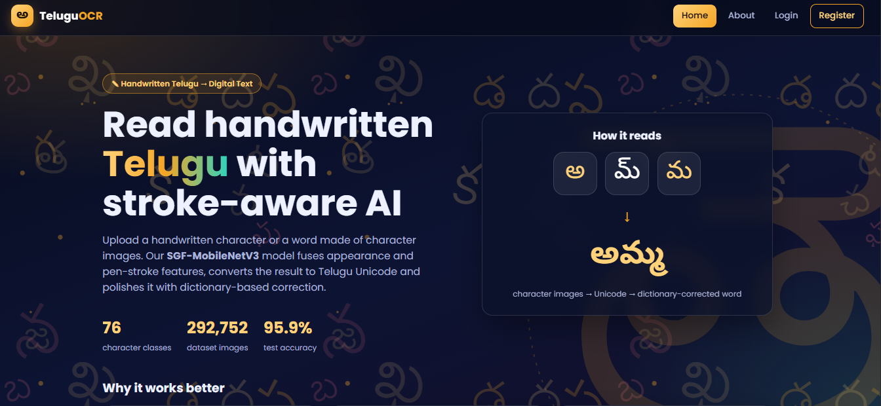
Figure 12 home page
About page: The About Page provides an overview of the Telugu Handwritten OCR System, including dataset preparation, preprocessing, model architectures, Unicode conversion, and dictionary-based correction. It explains the working process and highlights the MobileNetV3-Small baseline and proposed SGF-MobileNetV3 models.
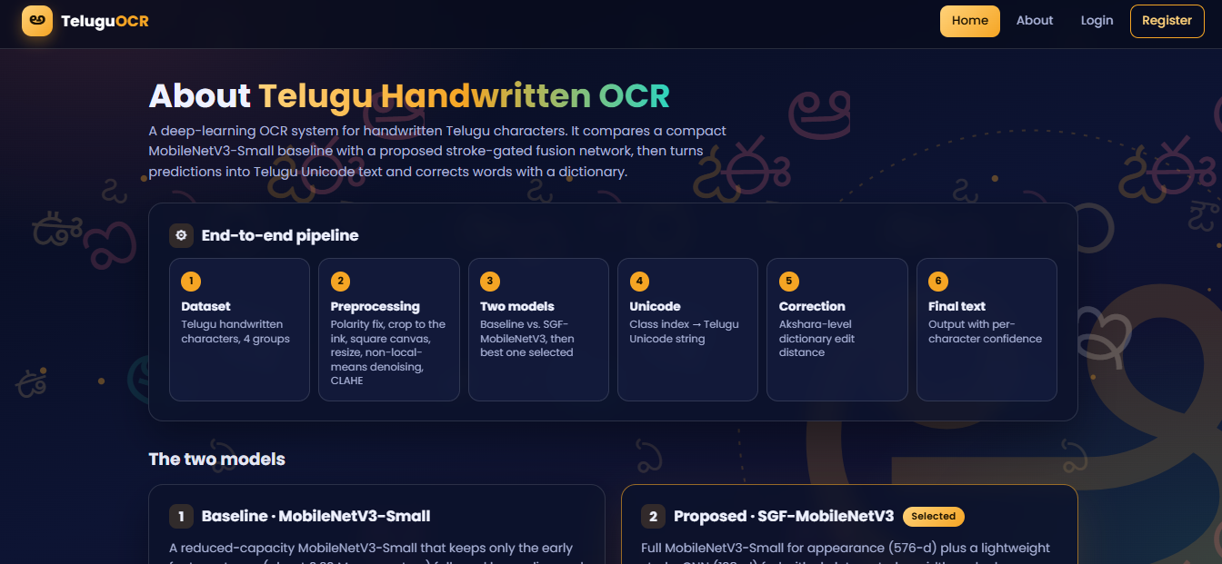
Register Page: The Registration Page allows new users to create an account by entering their email address, password, and password confirmation. It validates the entered details and stores user information in the MySQL database for future authentication.
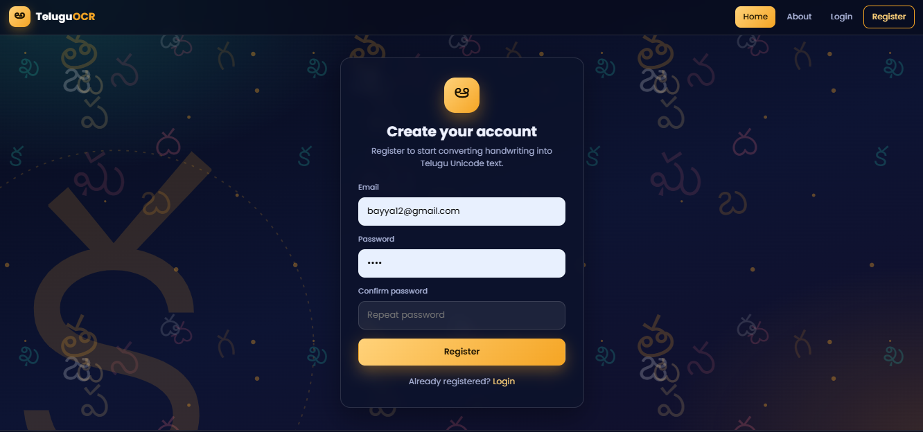
Figure 13 registration page
Login Page: Login Page allows registered users to securely access the Telugu Handwritten Character Recognition System by entering their email address and password.
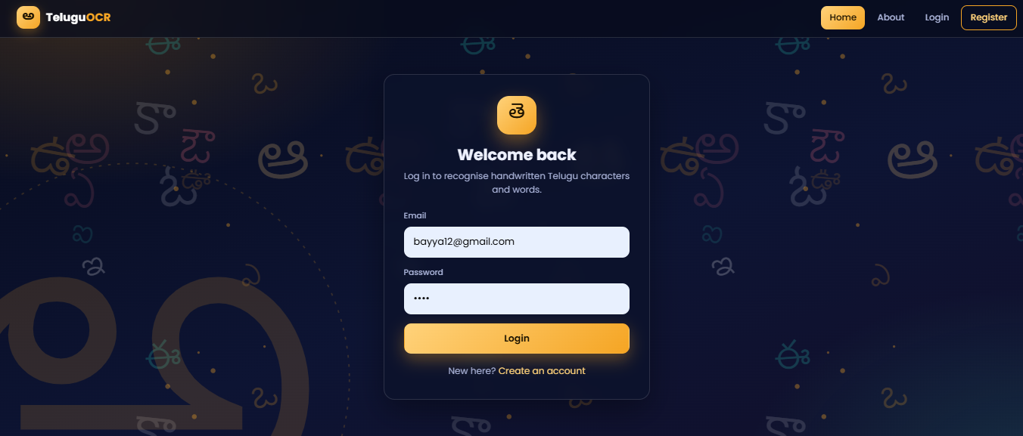
Figure 14 login page
Dashboard Page:
Dashboard Page displays the user's welcome message, dataset statistics, character classes, model accuracy, and navigation options for handwriting recognition, model performance, and project information.
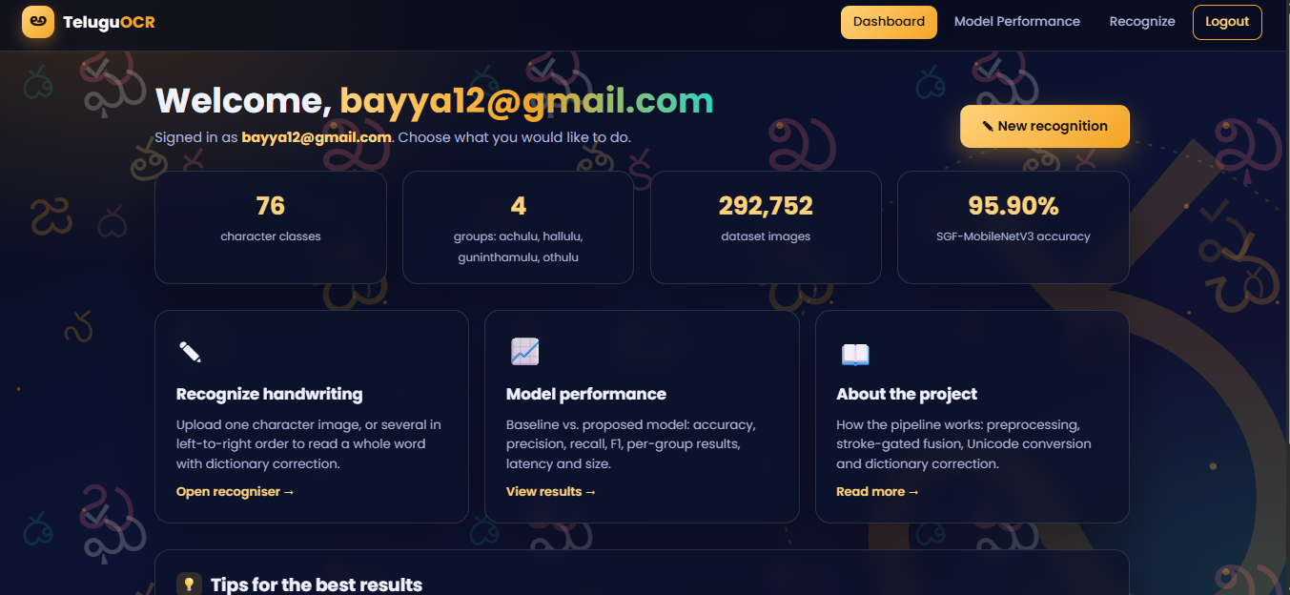
Figure 15 Dashboard SECTION
Model Page:
Model Performance Page displays the evaluation results of the proposed SGF-MobileNetV3, achieving 95.90% accuracy, 99.48% top-3 accuracy, and 95.34% macro F1-score. It also provides a comparative analysis of SGF-MobileNetV3 and the MobileNetV3-Small baseline, including accuracy, precision, recall, F1-score, model size, and inference time.
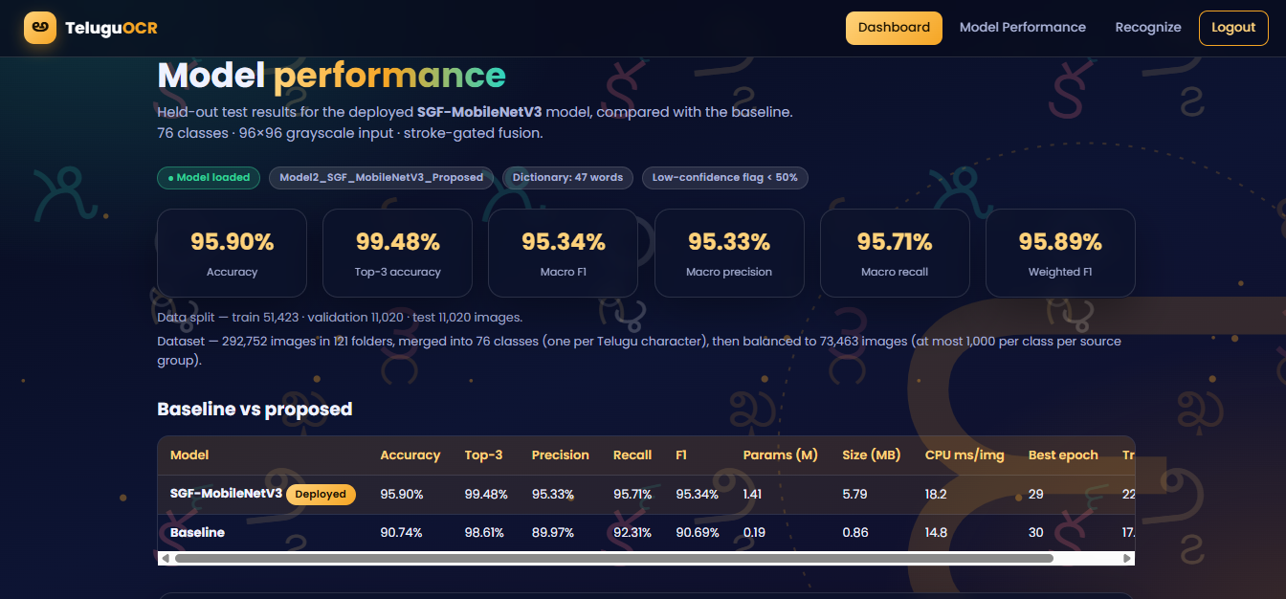
Prediction Page:
Prediction Page allows users to upload handwritten Telugu character images for recognition using the proposed SGF-MobileNetV3 model. The system displays the recognized Telugu character, confidence percentage, character category, and inference time after processing the uploaded image. It also provides prediction details, structural stroke visualizations, and a downloadable PDF report containing the recognition results.
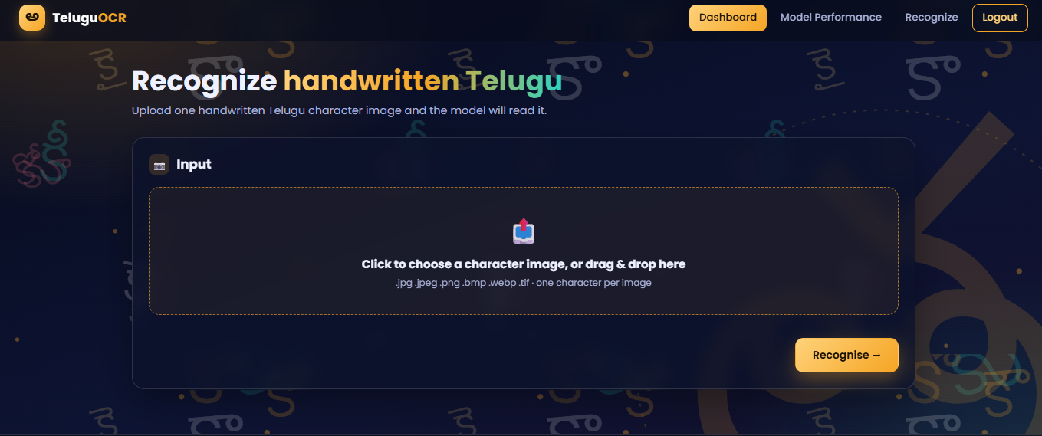
Figure 16 Image Detection page
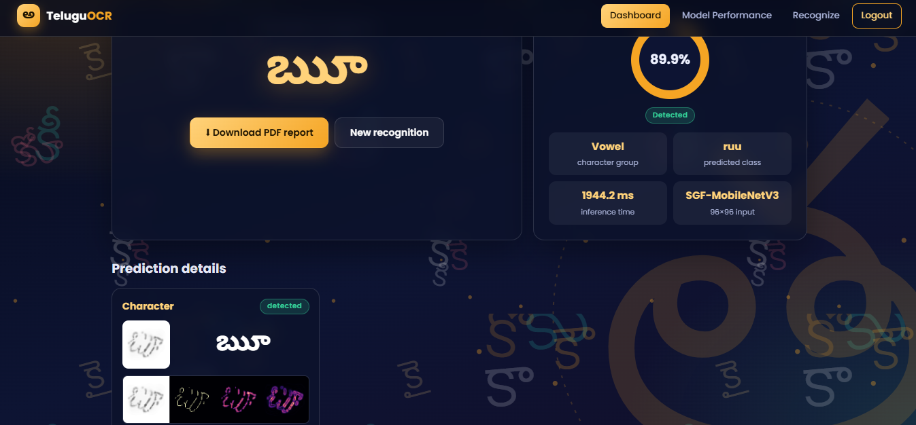
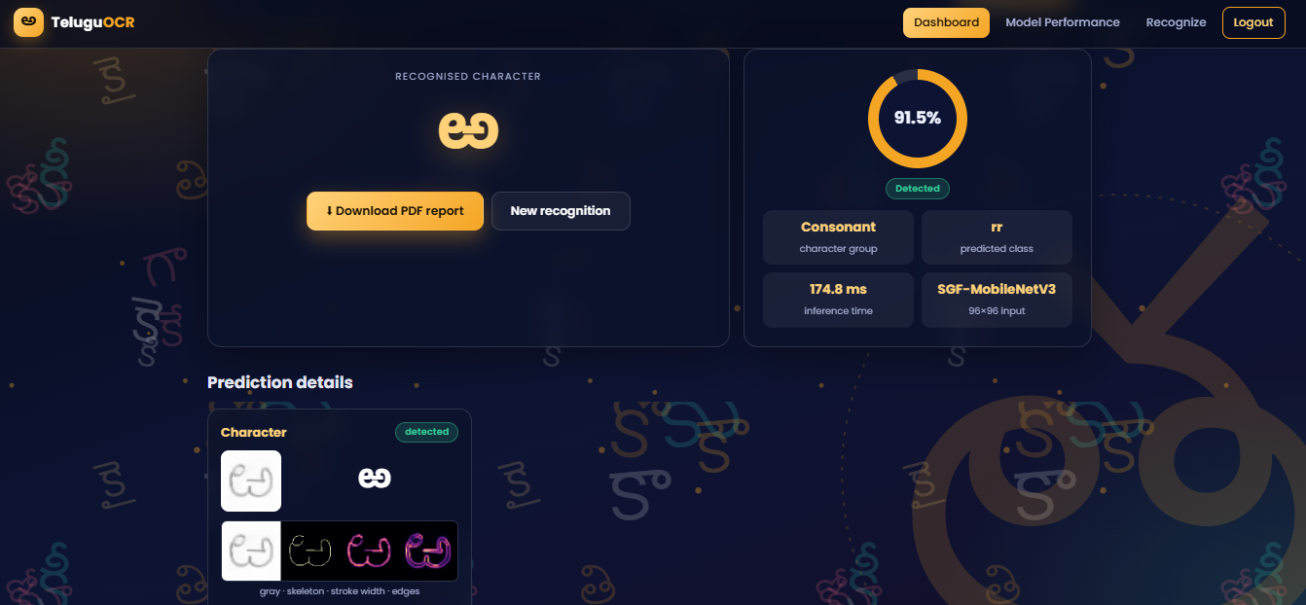

7.3 SYSTEM STUDY AND TESTING
The system study and testing phase evaluates the functionality, reliability, and performance of the proposed Telugu Handwritten Character Recognition System using Stroke-Gated Feature Fusion MobileNetV3 (SGF-MobileNetV3). The testing process focuses on image preprocessing, Telugu character classification, structural stroke feature extraction, adaptive gated feature fusion, Unicode conversion, dictionary-based word correction, prediction confidence analysis, and Flask-based application functionalities. Different testing approaches, including unit testing, integration testing, functional testing, white box testing, and black box testing, are considered to examine individual components and their interactions. The recognition framework utilizes a Telugu handwritten character dataset containing 73,463 selected images across 76 character classes, divided into 51,423 training, 11,020 validation, and 11,020 testing images. The system implements a reduced-capacity MobileNetV3-Small baseline and the proposed SGF-MobileNetV3 architecture. Classification performance is evaluated using accuracy, precision, recall, F1-score, top-three accuracy, classification reports, confusion matrices, and robustness testing. The recorded experiments demonstrate that SGF-MobileNetV3 achieves 95.90% test accuracy and 95.34% macro F1-score, outperforming the MobileNetV3-Small baseline, which achieves 90.74% accuracy. The application testing scope includes user registration, login, character image uploading, word recognition, image validation, confidence calculation, structural stroke visualization, Unicode conversion, dictionary correction, model performance reporting, PDF generation, and logout. These evaluations help identify system limitations and assess its suitability for Telugu handwritten character recognition.

7.3.1 FEASIBILITY STUDY
The feasibility study examines the technical, operational, and economic viability of the proposed Telugu Handwritten Character Recognition System. Technical feasibility is supported by the availability of Python, PyTorch, Torchvision, OpenCV, Scikit-learn, Scikit-image, NumPy, Flask, ReportLab, and MySQL for implementing deep learning models, image preprocessing, structural feature extraction, and application functionalities. The recognition component employs a reduced-capacity MobileNetV3-Small as the baseline architecture and the proposed SGF-MobileNetV3 for automated Telugu character classification. SGF-MobileNetV3 integrates visual appearance feature extraction, character skeleton analysis, stroke-width estimation, edge magnitude extraction, and adaptive gated feature fusion to improve recognition performance. The system processes handwritten character images standardized to 96 × 96 pixels and classifies them into 76 Telugu character classes. CUDA-based GPU acceleration supports computationally intensive model training and inference, while CPU compatibility enables execution without dedicated GPU hardware, although processing time may increase. Operational feasibility is supported by a Flask-based application that allows registered users to upload handwritten Telugu character images, select Single Character Recognition or Word Recognition, and obtain Unicode predictions, confidence scores, alternative character predictions, structural stroke visualizations, and downloadable PDF reports. MySQL supports user registration and login, while dictionary-based correction assists in processing ordered character sequences. Economic feasibility is supported by open-source development frameworks, the available handwritten character dataset, and existing computing infrastructure. Additional GPU resources may improve training efficiency but are not mandatory for CPU-based inference. The modular architecture supports model updates, reusable preprocessing components, and future improvements. The framework is technically feasible as a research prototype, while production deployment requires stronger authentication security, comprehensive application testing, and further validation using independently collected handwritten character and word datasets.

7.3.2 TYPES OF TESTING

7.3.2.1 UNIT TESTING
Unit testing focuses on validating individual components of the proposed Telugu Handwritten Character Recognition System. The image preprocessing module is examined for grayscale conversion, polarity correction, ink-region cropping, resizing to 96 × 96 pixels, noise removal, and CLAHE-based contrast enhancement. The structural stroke extraction module is assessed for generating valid skeleton representations, normalized stroke-width maps, and edge magnitude maps. The MobileNetV3-Small baseline is examined to verify its appearance feature extraction process and generation of 76-class character classification outputs. The proposed SGF-MobileNetV3 architecture is reviewed to validate the appearance feature extraction branch, dedicated stroke branch, feature projection layers, and adaptive gated fusion mechanism. The appearance branch generates a 576-dimensional representation, while the stroke branch produces a 128-dimensional structural feature vector. Both representations are projected into a common 256-dimensional feature space before gated fusion. The fusion module is examined to ensure that the sigmoid gating mechanism generates weights between 0 and 1 and combines appearance and stroke representations correctly. The Softmax classification module is checked for generating valid character probabilities. Additional unit-testing scenarios cover Telugu Unicode mapping, top-three alternative predictions, confidence calculation, uncertainty identification using the 50% threshold, akshara-level dictionary correction, image file validation, database functions, and PDF report generation. These checks define the unit-testing scope; separate automated unit-test execution results are not provided in the uploaded project files.

7.3.2.2 INTEGRATION TESTING
Integration testing evaluates the interaction between different modules of the proposed Telugu handwritten character recognition system. The image preprocessing and model inference components are examined to verify that uploaded character images are converted into standardized representations before being supplied to SGF-MobileNetV3. The integration between the MobileNetV3-Small appearance branch and the structural stroke branch is assessed through the adaptive gated feature fusion pipeline. The appearance branch extracts visual features, while the stroke branch processes character skeletons, stroke-width maps, and edge magnitude information. The resulting representations are projected into a common feature space and combined through learnable gating weights before final classification. The Telugu Unicode conversion module is integrated with the classification output to transform predicted class identifiers into readable Telugu symbols. In Word Recognition mode, multiple independently recognized characters are combined into a text sequence and passed through the dictionary-based correction module. The Flask application integrates these prediction operations with image upload processing, confidence calculation, result presentation, and structural stroke visualization. MySQL supports user authentication, while ReportLab supports downloadable PDF report generation. Integration testing also considers model checkpoint loading, metadata compatibility, session verification, temporary file deletion, and appropriate error handling when required model files are unavailable. The uploaded code implements these module connections, while formal end-to-end integration test execution remains necessary to establish their reliability under different deployment conditions.

7.3.2.3 FUNCTIONAL TESTING
Functional testing examines whether the proposed Telugu Handwritten Character Recognition System provides its intended features according to the specified functional requirements. The registration module validates mandatory fields, password confirmation, and duplicate email addresses. The login module verifies registered credentials and creates user sessions, while invalid credentials generate appropriate error messages. The prediction interface supports Single Character Recognition, Word Recognition, and Automatic Mode Selection. In Single Character Recognition mode, the application accepts one handwritten Telugu character image in JPG, JPEG, PNG, BMP, WEBP, TIF, or TIFF format. The uploaded image undergoes preprocessing and structural feature extraction before being classified using SGF-MobileNetV3. The output includes the recognized Telugu character, Unicode representation, classification group, confidence percentage, top-three alternative predictions, and structural stroke visualization. In Word Recognition mode, the application accepts multiple individual character images, with a maximum limit of 40 images per recognition request. The uploaded images are processed in sequence, and their predicted Unicode symbols are combined to generate Telugu text. Dictionary-based correction compares the recognized sequence with stored Telugu words using akshara-level edit distance. Input validation rejects unsupported file formats, missing images, unreadable files, invalid recognition modes, and requests exceeding the configured limit. The application restricts upload requests to 32 MB. The Model Performance page displays available classification metrics, robustness results, and model comparisons. The PDF reporting module generates recognition summaries containing character predictions, confidence scores, Unicode information, and correction details. Logout functionality clears the active user session. Formal functional testing is required to verify the consistent operation of these features across valid and invalid input scenarios.

7.3.2.4 WHITE BOX TESTING
White box testing examines the internal logic, algorithms, conditional operations, and source-code structure of the proposed Telugu Handwritten Character Recognition System. The image preprocessing implementation is reviewed to verify grayscale conversion, polarity correction, ink-region cropping, resizing, denoising, and CLAHE-based contrast enhancement. The structural feature extraction functions are examined to validate skeletonization, distance-transform-based stroke-width calculation, and Sobel-based edge magnitude generation. The MobileNetV3-Small baseline architecture is analyzed to verify convolutional feature extraction, Adaptive Average Pooling, Dropout, and character classification layers. The proposed SGF-MobileNetV3 is examined to validate the full MobileNetV3-Small appearance backbone, dedicated stroke extraction network, feature projection layers, and sigmoid-based adaptive gated feature fusion. The model training implementation is reviewed for AdamW optimization, Cross-Entropy Loss with label smoothing, OneCycle learning-rate scheduling, class-balanced sampling, data augmentation, and validation-based early stopping. The inference implementation is examined to verify Softmax probability generation, class selection, top-three prediction ranking, Unicode mapping, and uncertainty identification. Dictionary-based correction is reviewed for Telugu akshara segmentation, edit-distance calculation, and correction threshold handling. The Flask backend is inspected for authentication, image validation, recognition mode selection, model loading, file storage, result generation, PDF creation, and temporary file cleanup. Database operations, conditional branches, exception handling, and session management are also examined. Source-code inspection identifies security limitations, including plaintext password storage, a hardcoded Flask secret key, and enabled development debug mode. These concerns require correction before public deployment. Code inspection supports identification of implementation risks but does not replace automated white box testing.

7.3.2.5 BLACK BOX TESTING
Black box testing evaluates the proposed Telugu Handwritten Character Recognition System from the user's perspective without examining its internal source code. Users interact with the application through Registration, Login, Home, Prediction, Model Performance, Report Download, About, and Logout interfaces. Registration and login are examined using valid and invalid credentials to verify authentication behavior, session handling, and error messages. The Single Character Recognition interface is tested using supported handwritten Telugu character images to examine whether the application displays the predicted character, Unicode representation, confidence percentage, alternative predictions, and structural stroke visualizations. Unsupported image formats, corrupted images, empty uploads, and oversized requests are included in negative testing scenarios. Word Recognition functionality is examined using multiple individual character images to verify sequential character processing, Unicode text generation, and dictionary-based correction. The recognition interface is checked for rejecting requests containing more than 40 character images and for identifying invalid prediction modes. Confidence-based prediction status is examined using high-confidence and low-confidence outputs to verify detected and uncertain classifications. The Model Performance page is examined for presenting the available experimental results of MobileNetV3-Small and SGF-MobileNetV3, including classification accuracy, F1-score, robustness comparisons, and inference latency. The PDF reporting functionality is examined to verify that generated reports contain appropriate character predictions, Unicode information, confidence scores, and correction details. Black box testing should additionally assess processing time, browser compatibility, navigation, missing-model behavior, and the clarity of Telugu character rendering. These scenarios help determine whether the application meets its usability and functional requirements; comprehensive execution records are not included in the current project files.

7.3.2.6 TEST OBJECTIVES
The primary objective of testing is to evaluate the accuracy, reliability, functionality, usability, and integration performance of the proposed Telugu Handwritten Character Recognition System using SGF-MobileNetV3. The testing process aims to verify the recognition of handwritten Telugu characters belonging to Achulu, Hallulu, Guninthamulu, and Othulu categories using the MobileNetV3-Small baseline and proposed SGF-MobileNetV3 architecture. Classification performance is assessed using accuracy, precision, recall, macro F1-score, weighted F1-score, top-three accuracy, classification reports, and confusion matrices. Additional objectives include validating image preprocessing, structural stroke extraction, appearance-based feature learning, adaptive gated feature fusion, and Unicode-based character classification. The model evaluation process examines the effectiveness of combining character appearance with skeleton, stroke-width, and edge magnitude representations. The proposed SGF-MobileNetV3 achieves 95.90% test accuracy and 95.34% macro F1-score, compared with 90.74% accuracy and 90.69% macro F1-score for the baseline. Robustness testing evaluates recognition performance under simulated image-upload variations, including resizing, added margins, compression, and blur. Under these conditions, SGF-MobileNetV3 achieves 90.63% recognition accuracy, compared with 85.10% for the baseline. Computational evaluation examines parameter count, stored model size, and CPU inference latency to understand the trade-off between recognition performance and efficiency. The application testing process also aims to assess registration, login authentication, character image uploading, recognition mode selection, Unicode conversion, confidence calculation, alternative predictions, word correction, model loading, MySQL connectivity, session handling, structural visualization, PDF report generation, and temporary file management. Security testing should identify vulnerabilities related to credential storage, session configuration, file handling, and deployment settings. Performance and usability testing help identify processing limitations and application-related issues. The overall objective is to verify the intended functionalities, identify implementation errors, and determine the framework's readiness for research and demonstration use. The recorded model evaluation results establish character-level classification performance on the available testing dataset; however, comprehensive application testing and further validation using complete handwritten words, document images, and independently collected handwriting samples remain necessary.

8. RESULT AND ANALYSIS

MobileNetv3 small and SGF-MobileNetv3 models :
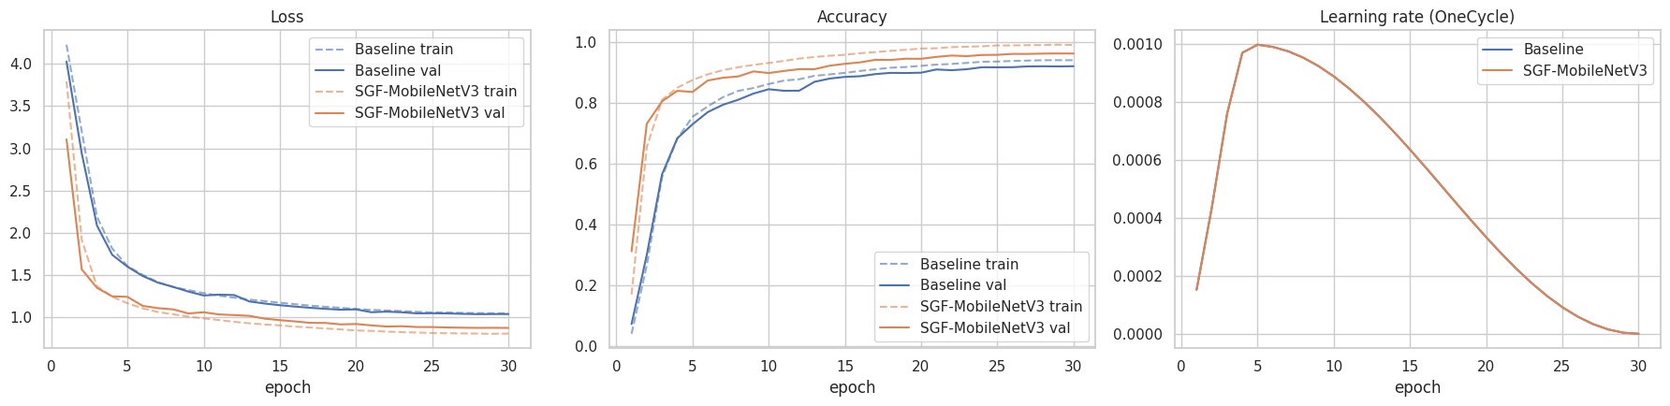
Training curves
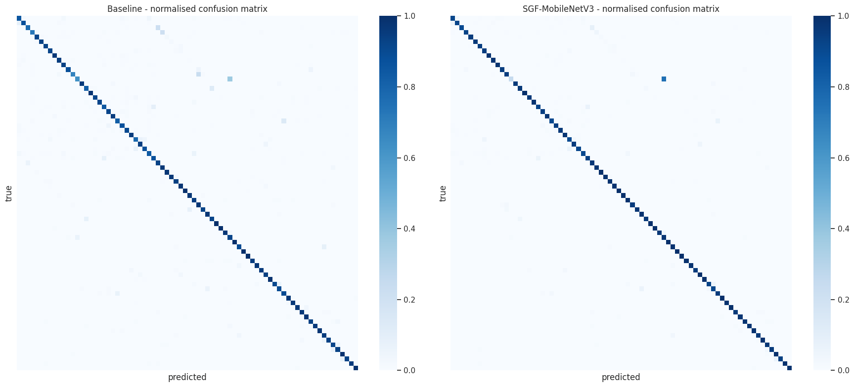
Confusion mtarix
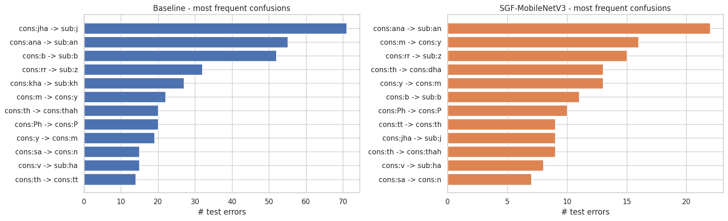
most confused pairs
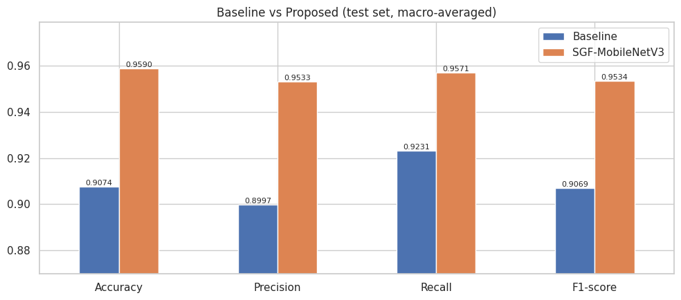
Performance comparison
The above figures present the training performance, normalized confusion matrices, classification errors, and comparative evaluation of the MobileNetV3-Small baseline and proposed SGF-MobileNetV3 models for Telugu handwritten character recognition. The training and validation loss curves demonstrate a consistent reduction in loss across 30 epochs, with SGF-MobileNetV3 achieving lower loss and higher validation accuracy than the baseline model. The accuracy curves indicate that the proposed model learns character patterns more effectively, while the OneCycle learning-rate scheduler gradually adjusts the learning rate to support model convergence. The normalized confusion matrices show a strong diagonal distribution for both models, indicating correct classification across most Telugu character classes. However, SGF-MobileNetV3 exhibits fewer off-diagonal errors, demonstrating improved recognition of visually similar characters. The most frequent confusion analysis further highlights a reduction in character misclassification errors compared with the baseline. The comparative performance graph demonstrates that SGF-MobileNetV3 achieves 95.90% accuracy, 95.33% macro precision, 95.71% macro recall, and 95.34% macro F1-score, whereas the baseline achieves 90.74% accuracy, 89.97% macro precision, 92.31% macro recall, and 90.69% macro F1-score. Overall, the experimental results demonstrate that integrating appearance features with structural stroke information through adaptive gated feature fusion improves Telugu handwritten character recognition performance.

9. CONCLUSION AND FUTURE SCOPE

9.1 CONCLUSION
The project successfully developed a Telugu Handwritten Character Recognition System using Stroke-Gated Feature Fusion MobileNetV3 (SGF-MobileNetV3) by integrating deep learning, image preprocessing, structural stroke feature extraction, adaptive gated feature fusion, and Telugu Unicode conversion. The framework utilized a Telugu handwritten character dataset containing 292,752 original images across 121 folders, which was processed through Unicode-based class merging and dataset balancing to obtain 73,463 selected images representing 76 character classes. Two deep learning architectures, a reduced-capacity MobileNetV3-Small baseline and the proposed SGF-MobileNetV3, were implemented for recognizing Telugu characters belonging to Achulu, Hallulu, Guninthamulu, and Othulu categories. The proposed architecture integrates MobileNetV3-Small appearance features with structural information extracted from character skeletons, stroke-width maps, and edge magnitude representations through an adaptive gated feature fusion mechanism. Experimental results demonstrate that the baseline MobileNetV3-Small achieved 90.74% classification accuracy, while the proposed SGF-MobileNetV3 achieved 95.90% accuracy, 95.34% macro F1-score, and 99.48% top-three accuracy. Additionally, SGF-MobileNetV3 achieved 90.63% accuracy under simulated image-upload variations, demonstrating improved robustness compared with the baseline model. The Flask-based web application integrated user registration, login, single-character recognition, character-sequence-based word recognition, Unicode conversion, dictionary-based correction, prediction confidence analysis, structural stroke visualization, model performance comparison, and downloadable PDF recognition reports using MySQL and PyTorch. The system demonstrates the effectiveness of combining visual appearance and structural stroke information for accurate Telugu handwritten character recognition. However, further validation is required for complete handwritten words, connected character sequences, and diverse real-world handwriting conditions. The developed framework provides a foundation for automated Telugu handwritten text digitization and future OCR applications.

9.2 FUTURE ENHANCEMENT
The developed Telugu Handwritten Character Recognition System using Stroke-Gated Feature Fusion MobileNetV3 (SGF-MobileNetV3) can be extended through several enhancements to improve its recognition accuracy, robustness, scalability, and real-world applicability. Future research can incorporate larger and more diverse Telugu handwriting datasets containing samples collected from different writers, age groups, writing instruments, document types, and handwriting styles to improve model generalization. The proposed SGF-MobileNetV3 architecture can be enhanced using advanced attention mechanisms, Vision Transformers (ViTs), improved structural feature extraction techniques, and optimized feature fusion strategies to strengthen recognition of visually similar Telugu characters. The existing character-level recognition approach can be extended into a complete handwritten word and sentence recognition system by incorporating automatic character segmentation, sequence modeling, and contextual language processing. Architectures such as CNN-LSTM, Bidirectional LSTM, and Transformer-based OCR models can be investigated for recognizing connected handwritten characters and complete Telugu text lines. The dictionary-based correction mechanism can be improved using larger Telugu lexical resources, contextual language models, and advanced spelling correction techniques to reduce recognition errors. Additional preprocessing methods can be introduced to handle skewed images, uneven illumination, overlapping characters, degraded documents, and complex backgrounds. The system can also be extended to support scanned handwritten documents, historical Telugu manuscripts, handwritten forms, and complete page-level text extraction. The Flask-based application can be strengthened through secure password hashing, improved authentication, prediction history, database optimization, and cloud deployment. Mobile application integration, camera-based image capture, batch document processing, and multilingual OCR support can further improve accessibility and usability. Model optimization techniques such as quantization, pruning, and knowledge distillation can be explored to reduce computational requirements and support deployment on resource-constrained devices. Finally, evaluation using independent real-world handwritten datasets, comprehensive word-level accuracy testing, confidence calibration, and user-based testing can contribute to developing a more reliable and scalable AI-based Telugu Handwritten Text Recognition and Digitization System.

10. REFERENCES
[1] R. Sharma and B. Kaushik, "Offline Recognition of Handwritten Indic Scripts: A State-of-the-Art Survey and Future Perspectives," Computer Science Review, vol. 38, 2020. https://doi.org/10.1016/j.cosrev.2020.100302
[2] S. T. Soman, A. Nandigam, and V. S. Chakravarthy, "An Efficient Multiclassifier System Based on Convolutional Neural Network for Offline Handwritten Telugu Character Recognition," National Conference on Communications (NCC), 2013. https://doi.org/10.1109/NCC.2013.6488008
[3] V. K. Sonthi, S. Nagarajan, and N. Krishnaraj, "An Intelligent Telugu Handwritten Character Recognition Using Multi-Objective Mayfly Optimization with Deep Learning-Based DenseNet Model," ACM Transactions on Asian and Low-Resource Language Information Processing, vol. 22, no. 3, 2023. https://doi.org/10.1145/3520439
[4] "Handwritten Telugu Character Recognition Using Machine Learning," International Conference on Distributed Computing and Optimization Techniques (ICDCOT), IEEE, 2024. https://doi.org/10.1109/ICDCOT61034.2024.10515646
[5] "Comparative Analysis of Deep Learning Models for Telugu Handwritten Text Recognition," IEEE International Conference on Intelligent Systems, Smart and Green Technologies (ICISSGT), 2026. https://doi.org/10.1109/ICISSGT67741.2026.11483721
[6] M. Sandler et al., "MobileNetV2: Inverted Residuals and Linear Bottlenecks," Proceedings of the IEEE Conference on Computer Vision and Pattern Recognition (CVPR), 2018. https://doi.org/10.1109/CVPR.2018.00474
[7] A. Howard et al., "Searching for MobileNetV3," Proceedings of the IEEE/CVF International Conference on Computer Vision (ICCV), pp. 1314–1324, 2019. https://doi.org/10.1109/ICCV.2019.00140
[8] T. Y. Zhang and C. Y. Suen, "A Fast Parallel Algorithm for Thinning Digital Patterns," Communications of the ACM, vol. 27, no. 3, pp. 236–239, 1984. https://doi.org/10.1145/357994.358023
[9] N. Otsu, "A Threshold Selection Method from Gray-Level Histograms," IEEE Transactions on Systems, Man, and Cybernetics, vol. 9, no. 1, pp. 62–66, 1979. https://doi.org/10.1109/TSMC.1979.4310076
[10] K. Zuiderveld, "Contrast Limited Adaptive Histogram Equalization," Graphics Gems IV, pp. 474–485, 1994. https://doi.org/10.1016/B978-0-12-336156-1.50061-6
[11] J. Arevalo, T. Solorio, M. Montes-y-Gómez, and F. A. González, "Gated Multimodal Units for Information Fusion," International Conference on Learning Representations (ICLR), 2017. https://arxiv.org/abs/1702.01992
[12] S. M. Ahmed and A. Wahid, "Handwritten OCR for Indic Scripts: A Comprehensive Overview of Machine Learning and Deep Learning Techniques," International Journal on Recent and Innovation Trends in Computing and Communication, vol. 11, no. 9, pp. 2245–2258, 2023. https://doi.org/10.17762/ijritcc.v11i9.9230
[13] "A Study on Handwritten Text Recognition and Post-OCR Error Correction Techniques," 9th International Conference on Trends in Electronics and Informatics (ICOEI), IEEE, 2026. https://doi.org/10.1109/ICOEI68323.2026.11541382
[14] X. Xiao, L. Jin, Y. Yang, W. Yang, J. Sun, and T. Chang, "Building Fast and Compact Convolutional Neural Networks for Offline Handwritten Chinese Character Recognition," 2017. https://arxiv.org/abs/1702.07975

