**DN 4.0 JAVA FSE SOLUTIONS – WEEK 6**

**SKILL: React**

**1. ReactJS-HOL**

**Code:**

**App.js**

import React from 'react';

function App(){

  return (

    <h1>welcome to the first session of React</h1>

  );

}

export default App;

**output:**

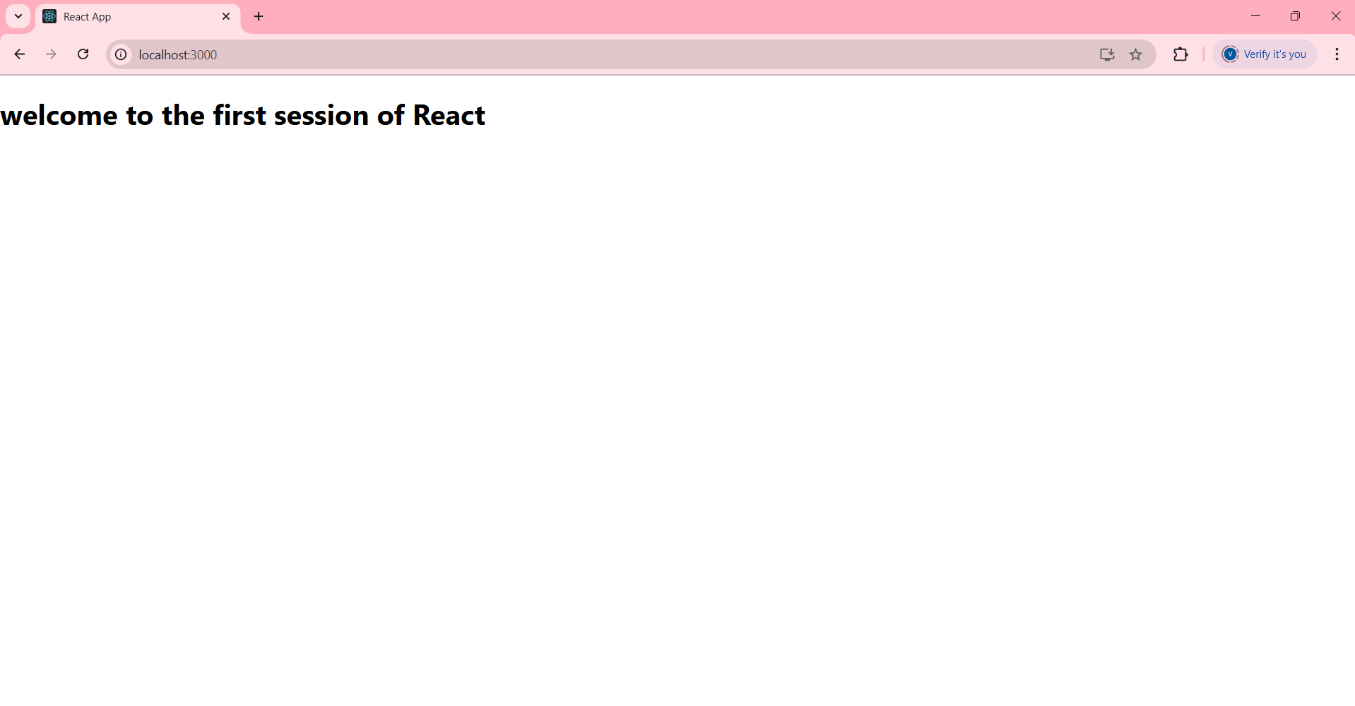

**2. ReactJS-HOL**

**Code:**

**src/Components/Home.js**

import React, { Component } from 'react';

class Home extends Component {

  render() {

    return (

      <div>

        <h3>Welcome to the Home Page of the Student Management Portal</h3>

      </div>

    );

  }}

export default Home;

**src/Components/Contact.js**

import React, { Component } from 'react';

class Contact extends Component {

  render() {

    return (

      <div>

        <h3>Welcome to the Contact Page of the Student Management Portal</h3>

      </div>

    );

  }

}

export default Contact;

**src/Components/About.js**

import React, { Component } from 'react';

class About extends Component {

  render() {

    return (

      <div>

        <h3>Welcome to the About Page of the Student Management Portal</h3>

      </div>

    );

  }}

export default About;

**src/App.js**

import './App.css';

import Home from './Components/Home';

import About from './Components/About';

import Contact from './Components/Contact';

function App() {

  return (

    <div >

      <Home/>

      <About/>

      <Contact/>

    </div>

  );

}

export default App;

**Output:**

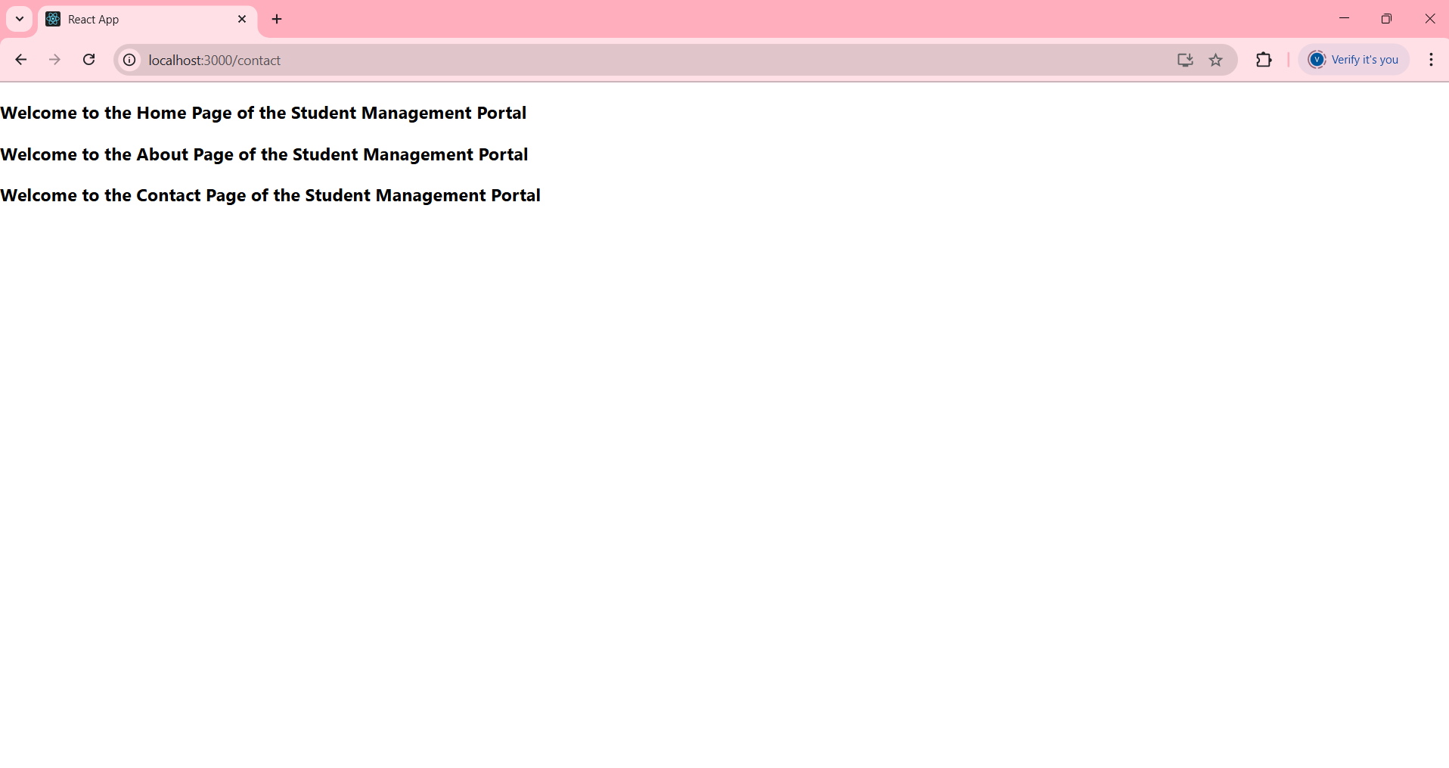

**3. ReactJS-HOL**

**Code:**

**Src/ Stylesheets /Mystyles.css:**

.Name {

  font-weight: 300;

  color: blue;

}

.School {

  color: crimson;

}

.Total {

  color: darkmagenta;

}

.formatstyle {

  text-align: center;

  font-size: large;

}

.Score {

  color: forestgreen;

}

**src/App.js**

import CalculateScore from './Components/CalculateScore';

function App()

{

return(

<div>

<CalculateScore Name={"Steeve"}

School={"DNV Public School"}

total={284}

goal={300}

/>

</div>

)

}

export default App;

**src/Components/** **CalculateScore.js**

import '../Stylesheets/mystyle.css';

const percentToDecimal = (decimal) => {

  return (decimal * 100).toFixed(2) + '%';

};

const calcScore = (total, goal) => {

  return percentToDecimal(total / goal);

};

const CalculateScore = ({ Name, School, total, goal }) => {

  return (

    <div className="formatstyle">

      <h1><font color="Brown">Student Details:</font></h1>

      <div className="Name">

        <b><span>Name:</span></b>

        <span>{Name}</span>

      </div>

      <div className="School">

        <b><span>School:</span></b>

        <span>{School}</span>

      </div>

      <div className="Total">

        <b><span>Total:</span></b>

        <span>{total} Marks</span>

      </div>

      <div className="Score">

        <b>Score:</b>

        <span>{calcScore(total, goal)}</span>

      </div>

    </div>

  );

};

export default CalculateScore;

**output:**

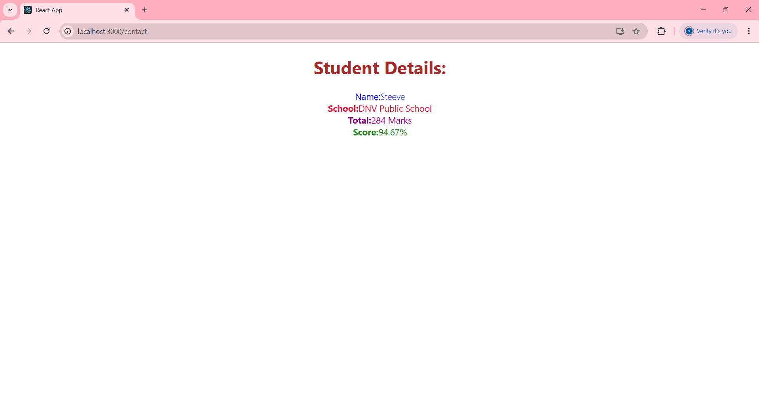

**4. ReactJS-HOL**

**Code:**

**Src/posts.js:**

import React from 'react';

import Post from './Post';

class Posts extends React.Component {

  constructor(props) {

    super(props);

    this.state = {

      posts: [],

    };

  }

  loadPosts = () => {

    fetch('https://jsonplaceholder.typicode.com/posts')

      .then(response => response.json())

      .then(data => this.setState({ posts: data }))

      .catch(error => console.error('Error fetching posts:', error));

  };

  componentDidMount() {

    this.loadPosts(); }

  componentDidCatch(error, info) {

    alert("An error occurred: " + error);

  }

  render() {

    return (

      <div>

        <h1>All Blog Posts</h1>

        {this.state.posts.map(post => (

          <Post key={post.id} title={post.title} body={post.body} />

        ))}

      </div>

    );

  }

}

export default Posts;

**Src/post.js:**

import React from 'react';

class Post extends React.Component {

  render() {

    return (

      <div className="post">

        <h2>{this.props.title}</h2>

        <p>{this.props.body}</p>

      </div>

    );

  }}

export default Post;

**src/app.js:**  
import React from 'react';

import './App.css';

import Posts from './Posts';

function App() {

  return (

    <div className="App">

      <Posts />

    </div>

  );

}

export default App;

**Output:**

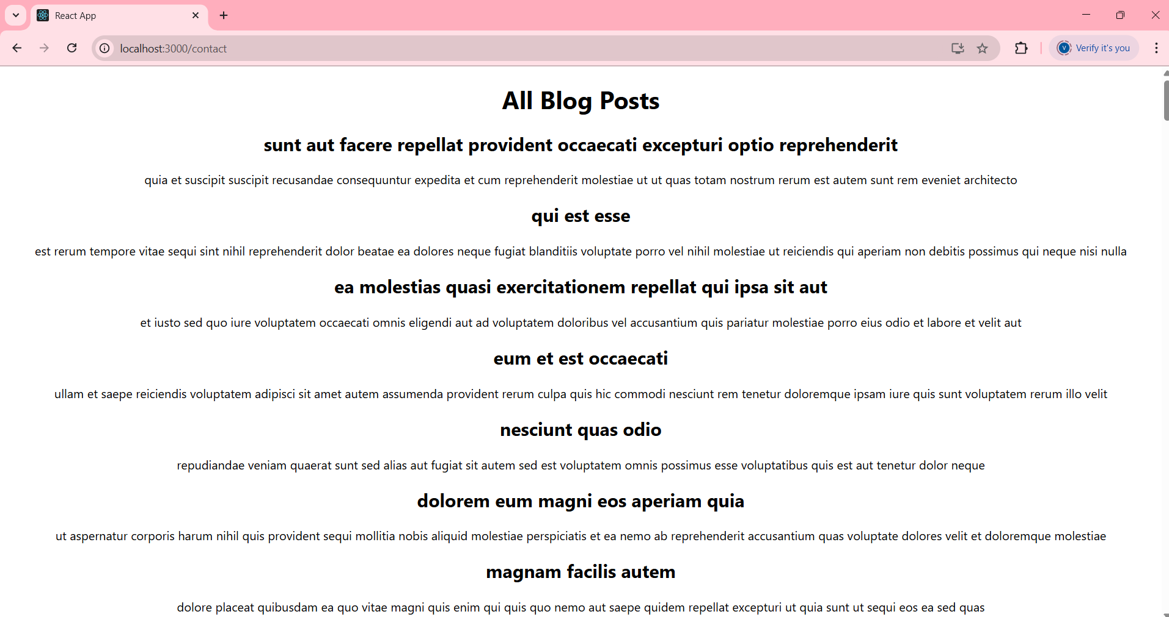

**5. ReactJS-HOL**

**Code:**

**Src/Cohort.js**

class Cohort {

constructor(cohortCode, startDate, technology, trainerName, coachName, currentStatus) {

this.cohortCode = cohortCode;

this.startDate = startDate;

this.technology = technology;

this.trainerName = trainerName;

this.coachName = coachName;

this.currentStatus = currentStatus;

}

}

const CohortsData = [

new Cohort('INTADMDF10','22-Feb-2022', '.NET FSD', 'Jojo Jose','Aathma', 'Scheduled'),

new Cohort('ADM21JF014','10-Sep-2021', 'Java FSD', 'Elisa Smith','Apoorv', 'Ongoing'),

new Cohort('CDBJF21025','24-Dec-2021', 'Java FSD', 'John Doe','Aathma', 'Ongoing'),

new Cohort('INTADMJF12','22-Feb-2022', 'Java FSD', 'To Be Assigned','Ibrahim', 'Scheduled'),

new Cohort('CDE22JF011','24-Dec-2021', 'Java FSD', 'Emma Swan','Apoorv', 'Ongoing'),

new Cohort('INTADMDF09','22-Feb-2022', 'Dataware Housing', 'Babjee Rao','Aathma', 'Scheduled'),

new Cohort('ADM22DF001','10-Sep-2021', '.NET FSD', 'Marie Curie','Ibrahim', 'Ongoing'),

];

**Src/Components/** **CohortDetails.js**

export { Cohort, CohortsData };  
import React from 'react';

import styles from './CohortDetails.module.css';

import { CohortsData } from '../Cohort';

function CohortDetails() {

return (

<div>

<h2><strong>Cohorts Details</strong></h2>

{CohortsData.map((cohort, index) => (

<div key={index} className={styles.box}>

<h3 style={{ color: cohort.currentStatus === 'Ongoing' ? 'green' : 'blue' }}>

{cohort.cohortCode} - {cohort.technology}

</h3>

<dl>

<dt>Started On</dt>

<dd>{cohort.startDate}</dd>

<dt>Current Status</dt>

<dd>{cohort.currentStatus}</dd>

<dt>Coach</dt>

<dd>{cohort.coachName}</dd>

<dt>Trainer</dt>

<dd>{cohort.trainerName}</dd>

</dl>

</div>

))}

</div>

);

}

src/Components/CohortDetails.module.css

export default CohortDetails;  
.box {

width: 300px;

display: inline-block;

margin: 10px;

padding: 10px 20px;

border: 1px solid black;

border-radius: 10px;

vertical-align: top;

}

dt {

font-weight: 500;

}

**Src/App.js**  
import React from 'react';

import CohortDetails from './Components/CohortDetails';

function App() {

return (

<div>

<CohortDetails />

</div>

);

}

export default App;

**Output:**

