**DN 4.0 JAVA FSE SOLUTIONS – WEEK 7**

**SKILL: React**

**HandsOn 1:**

**Code:**

**src/App.js -**

import React from 'react';

const players = [

  { name: 'Jack', score: 50 },

  { name: 'Michael', score: 70 },

  { name: 'John', score: 40 },

  { name: 'Ann', score: 61 },

  { name: 'Elisabeth', score: 61 },

  { name: 'Sachin', score: 95 },

  { name: 'Dhoni', score: 100 },

  { name: 'Virat', score: 84 },

  { name: 'Jadeja', score: 64 },

  { name: 'Raina', score: 75 },

  { name: 'Rohit', score: 80 }

];

const IndianTeam = ['Sachin1', 'Dhoni2', 'Virat3', 'Rohit4', 'Yuvaraj5', 'Raina6'];

const T20Players = ['First Player', 'Second Player', 'Third Player'];

const RanjiTrophyPlayers = ['Fourth Player', 'Fifth Player', 'Sixth Player'];

export const IndianPlayers = [...T20Players, ...RanjiTrophyPlayers];

const flag = false; **//**We can toggle flag to see different outputs

const ListofPlayers = ({ players }) => {

  return (

    <ul>

      {players.map((item, index) => (

        <li key={index}>

          Mr. {item.name} <span>{item.score}</span>

        </li>

      ))}

    </ul>

  );

};

const Scorebelow70 = ({ players }) => {

  const players70 = players.filter(player => player.score <= 70);

  return (

    <ul>

      {players70.map((item, index) => (

        <li key={index}>

          Mr. {item.name} <span>{item.score}</span>

        </li>

      ))}

    </ul>

  );

};

export function OddPlayers([first, , third, , fifth]) {

  return (

    <ul>

      <li>First : {first}</li>

      <li>Third : {third}</li>

      <li>Fifth : {fifth}</li>

    </ul>

  );

}

export function EvenPlayers([, second, , fourth, , sixth]) {

  return (

    <ul>

      <li>Second : {second}</li>

      <li>Fourth : {fourth}</li>

      <li>Sixth : {sixth}</li>

    </ul>

  );

}

const ListofIndianPlayers = ({ IndianPlayers }) => {

  return (

    <ul>

      {IndianPlayers.map((item, index) => (

        <li key={index}>Mr. {item}</li>

      ))}

    </ul>

  );

};

function App() {

  if (flag === true) {

    return (

      <div className="App">

        <h1>List of Players</h1>

        <ListofPlayers players={players} />

        <hr />

        <h1>List of Players having Scores Less than 70</h1>

        <Scorebelow70 players={players} />

      </div>

    );

  } else {

    return (

      <div className="App">

        <h1>Indian Team</h1>

        <h2>Odd Players</h2>

        {OddPlayers(IndianTeam)}

        <hr />

        <h2>Even Players</h2>

        {EvenPlayers(IndianTeam)}

        <hr />

        <h2>List of Indian Players Merged:</h2>

        <ListofIndianPlayers IndianPlayers={IndianPlayers} />

      </div>

    );

  }

}

export default App;

**Output:**

**If flag = false**

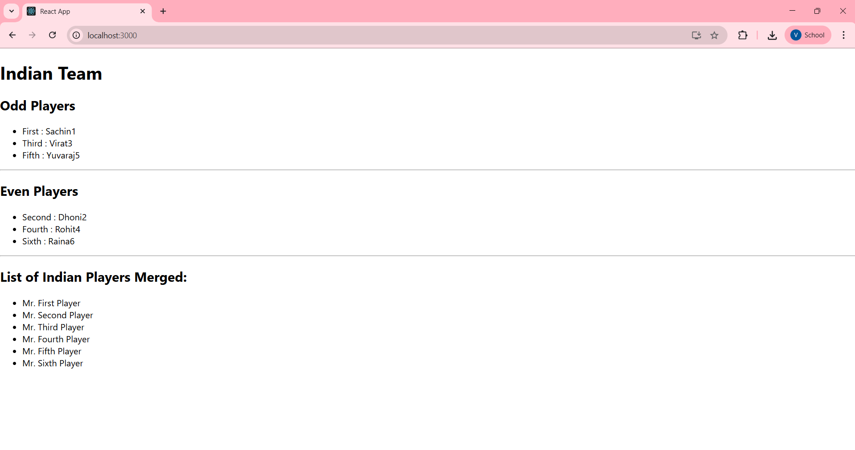

**If flag = true**

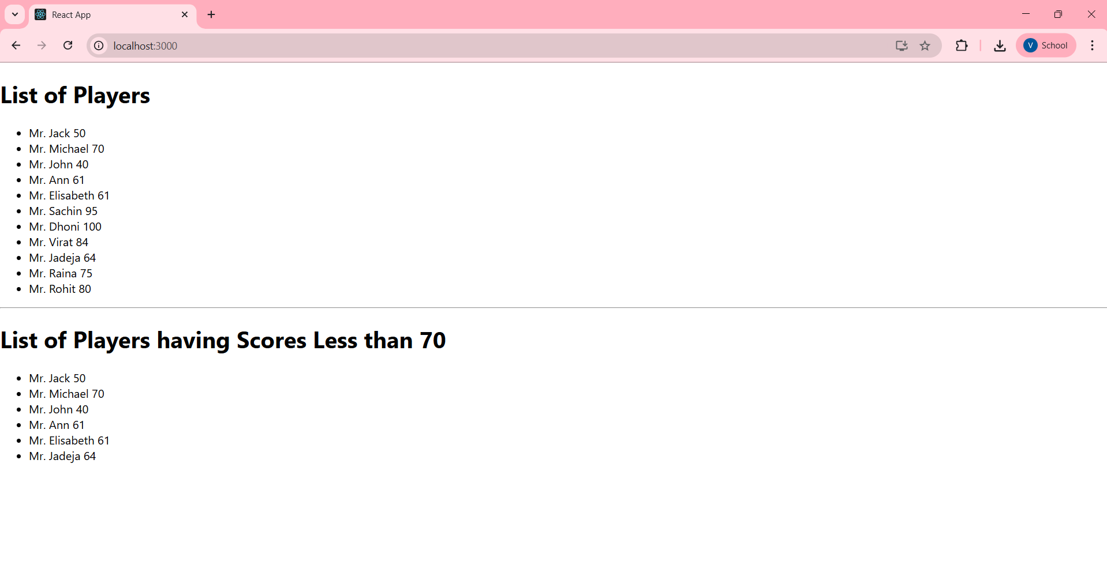

**HandsOn 2:**

**Code:**

**src/App.js -**

import React from 'react';

import './App.css';

import sr from './office.jpg';

function App() {

  let colors = [];

  const element = "Office Space";

  const jsxatt = <img src={sr} width="25%" height="25%" alt="Office Space" />;

  const ItemName = {

    Name: "DBS",

    Rent: 50000,

    Address: "Chennai"

  };

  if (ItemName.Rent <= 60000) {

    colors.push('textRed');

  } else {

    colors.push('textGreen');

  }

  return (

    <div className="App">

      <h1>{element} , at Affordable Range </h1>

      {jsxatt}

      <h1>Name: {ItemName.Name}</h1>

      <h3 className={colors.join(' ')}>Rent: Rs. {ItemName.Rent}</h3>

      <h3>Address: {ItemName.Address}</h3>

    </div>

  );

}

export default App;

**src/App.css -**

.App {

  font-family: Arial, sans-serif;

  padding: 20px;

  text-align: center;

}

.textRed {

  color: red;

}

.textGreen {

  color: green;

}

**Output:**

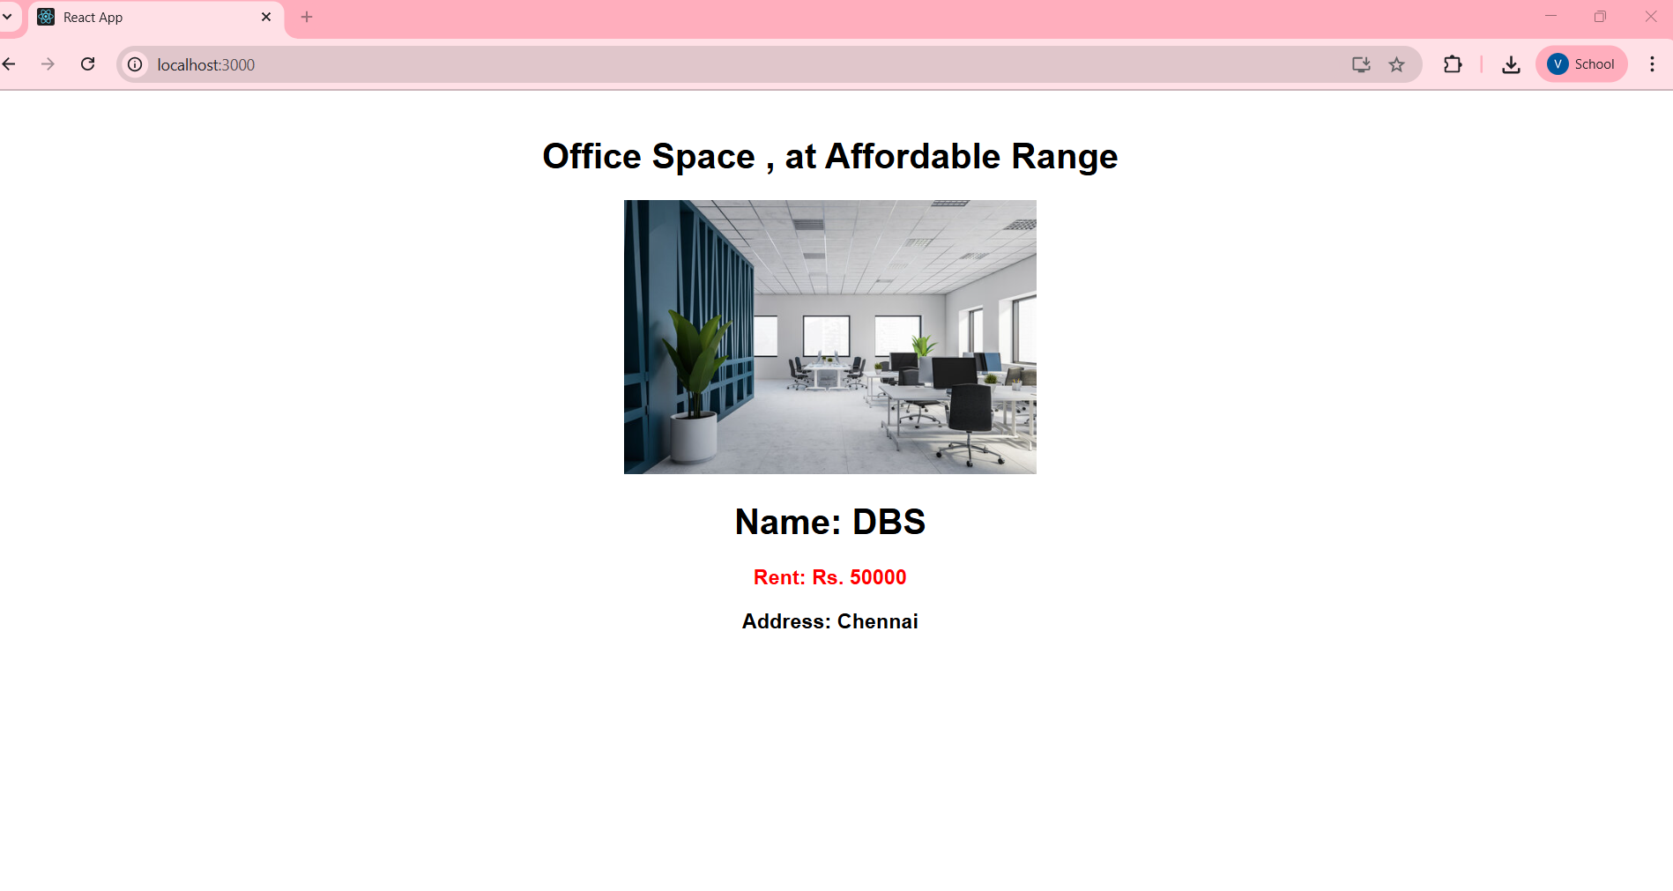

**HandsOn 3:**

**Code:**

**src/App.js -**

import React, { useState } from 'react';

import './App.css';

function CurrencyConvertor() {

  const [amount, setAmount] = useState('');

  const [currency, setCurrency] = useState('');

  const handleSubmit = (e) => {

  e.preventDefault();

  // Taking 1 Euro = ₹101

  const converted = (amount * 101);

  alert(`Converting to Euro Amount is ${converted}`);

};

  return (

    <div>

      <h2 className="greenText">Currency Convertor!!!</h2>

      <form onSubmit={handleSubmit}>

        <div>

          <label>Amount: </label>

          <input

            type="text"

            value={amount}

            onChange={(e) => setAmount(e.target.value)}

          />

        </div>

        <div>

          <label>Currency: </label>

          <input

            type="text"

            value={currency}

            onChange={(e) => setCurrency(e.target.value)}

          />

        </div>

        <button type="submit">Submit</button>

      </form>

    </div>

  );

}

function App() {

  const [count, setCount] = useState(5);

  const increment = () => {

    setCount(count + 1);

    sayHello(); // Additional method

  };

  const decrement = () => {

    setCount(count - 1);

  };

  const sayHello = () => {

    alert("Hello! Member1");

  };

  const sayWelcome = (message) => {

    alert(message);

  };

  const handleClick = () => {

    alert("I was clicked");

  };

  return (

    <div className="App">

      <h2>{count}</h2>

      <button onClick={increment}>Increment</button>

      <br />

      <button onClick={decrement}>Decrement</button>

      <br />

      <button onClick={() => sayWelcome("Welcome")}>Say welcome</button>

      <br />

      <button onClick={handleClick}>Click on me</button>

      <br /><br />

      <CurrencyConvertor />

    </div>

  );

}

export default App;

**src/App.css -**

.App {

  padding: 20px;

  font-family: Arial, sans-serif;

}

.greenText {

  color: green;

}

**Output:**

**After clicking on Increment -**

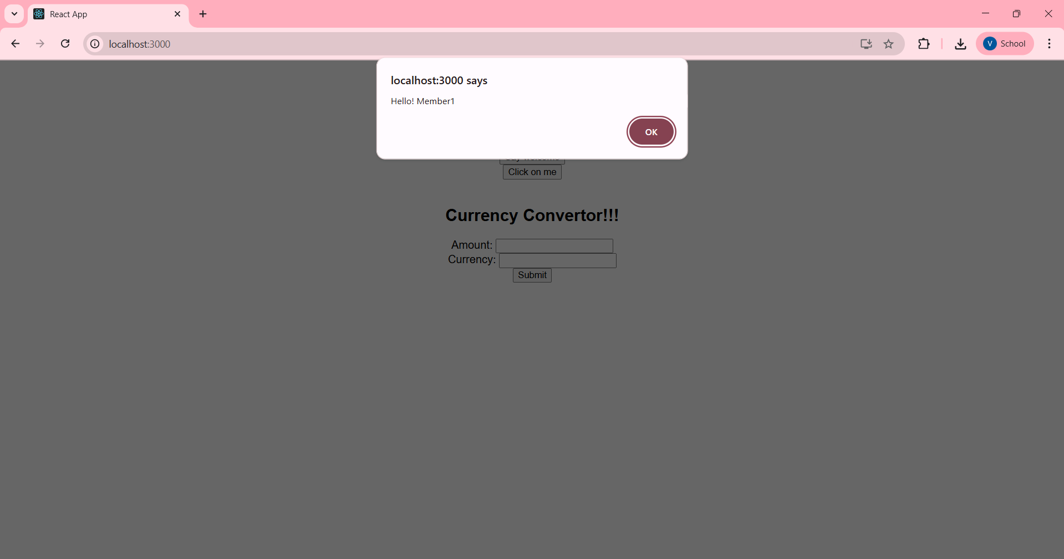

After clicking on ok 5 will get incremented to 6 and if we click on decrement 6 will get reduced to 5.

**After clicking on Say welcome -**

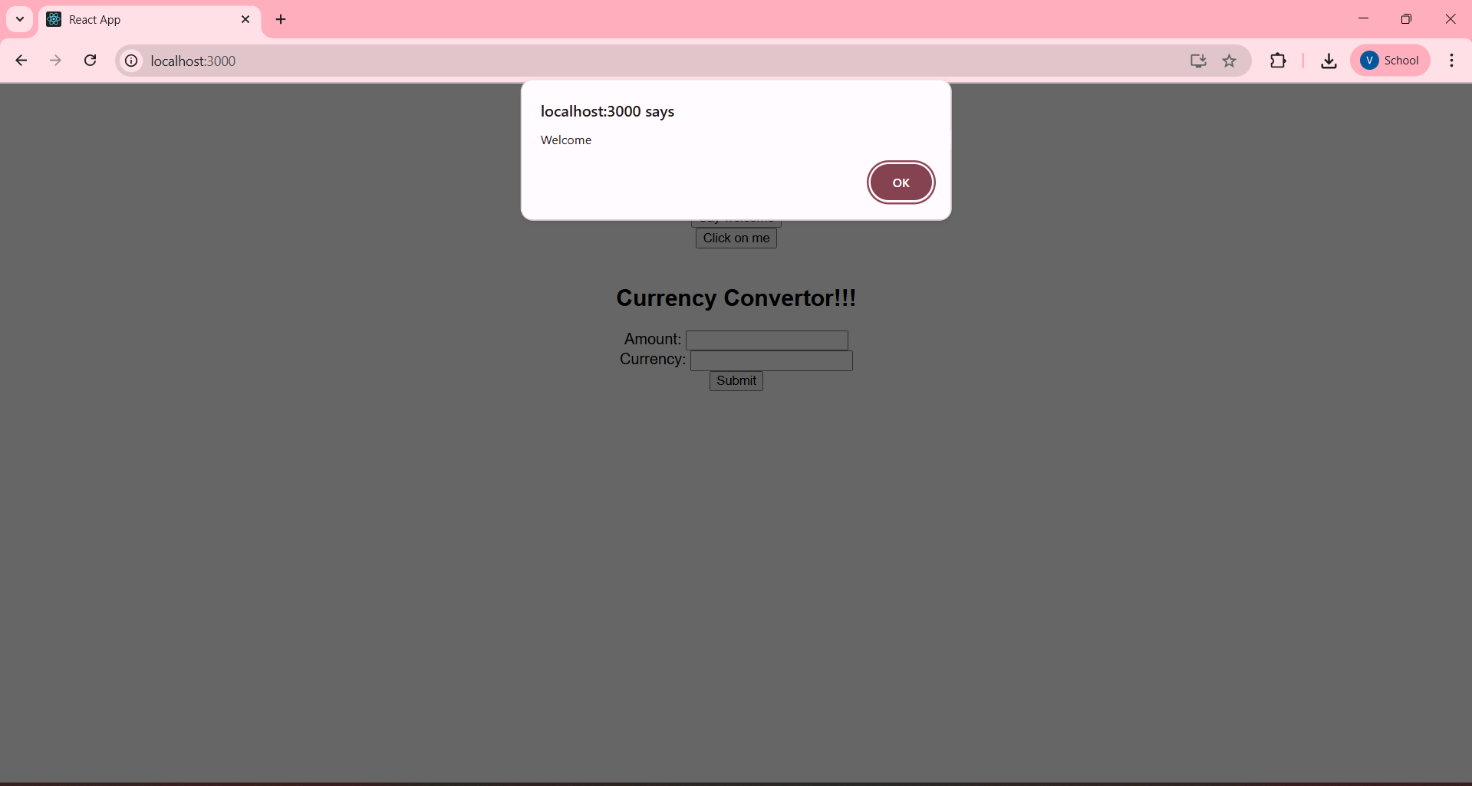

**After clicking on Click on me -**

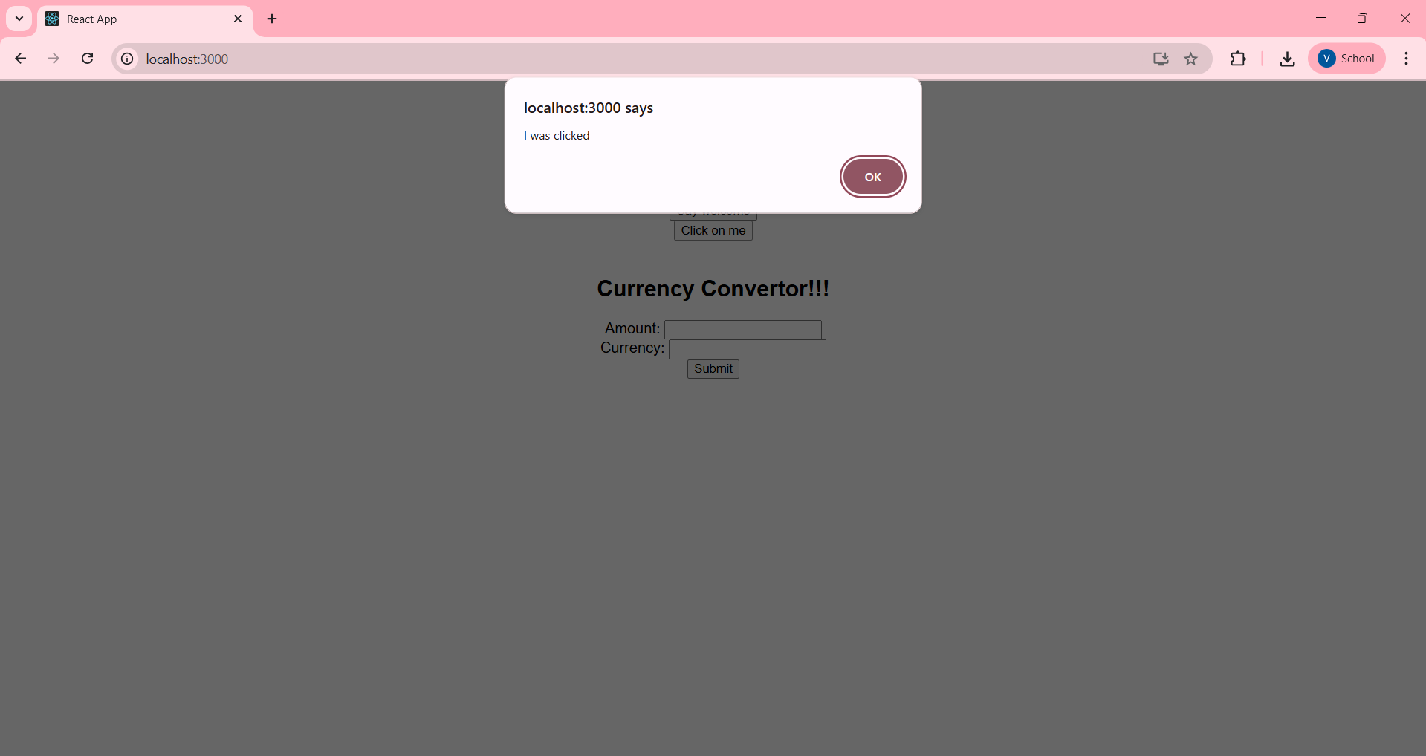

**After clicking on Submit for Currency Covertor -**

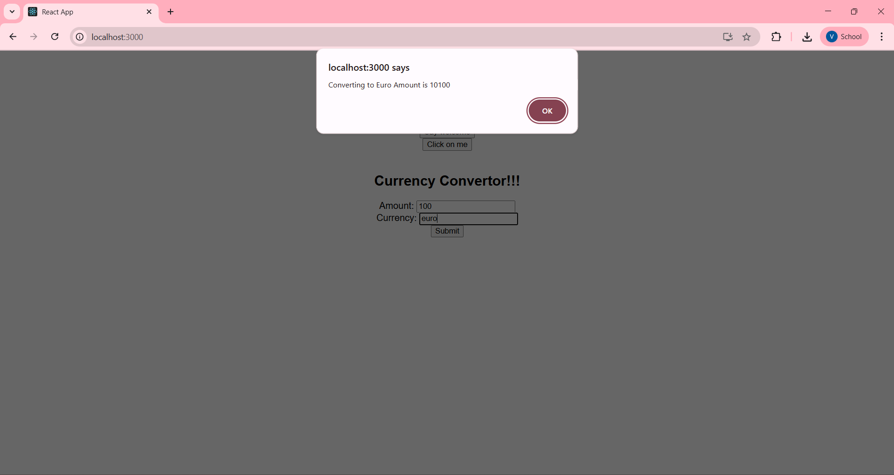

**HandsOn 4:**

**Code:**

**src/App.js -**

import React, { useState } from 'react';

import './App.css';

function GuestGreeting() {

  return <h1>Please sign up.</h1>;

}

function UserGreeting() {

  return <h1>Welcome back</h1>;

}

function Greeting(props) {

  const isLoggedIn = props.isLoggedIn;

  if (isLoggedIn) {

    return <UserGreeting />;

  }

  return <GuestGreeting />;

}

function LoginButton(props) {

  return (

    <button onClick={props.onClick}>

      Login

    </button>

  );}

function LogoutButton(props) {

  return (

    <button onClick={props.onClick}>

      Logout

    </button>

  );}

function App() {

  const [isLoggedIn, setIsLoggedIn] = useState(false);

  const handleLoginClick = () => {

    setIsLoggedIn(true);

  };

  const handleLogoutClick = () => {

    setIsLoggedIn(false);

  };

  let button;

  if (isLoggedIn) {

    button = <LogoutButton onClick={handleLogoutClick} />;

  } else {

    button = <LoginButton onClick={handleLoginClick} />;

  }

  return (

    <div className="App">

      <Greeting isLoggedIn={isLoggedIn} />

      {button}

    </div>

  );}

export default App;

**src/App.css -**

.App {

  padding: 40px;

  text-align: center;

}

**Output:**

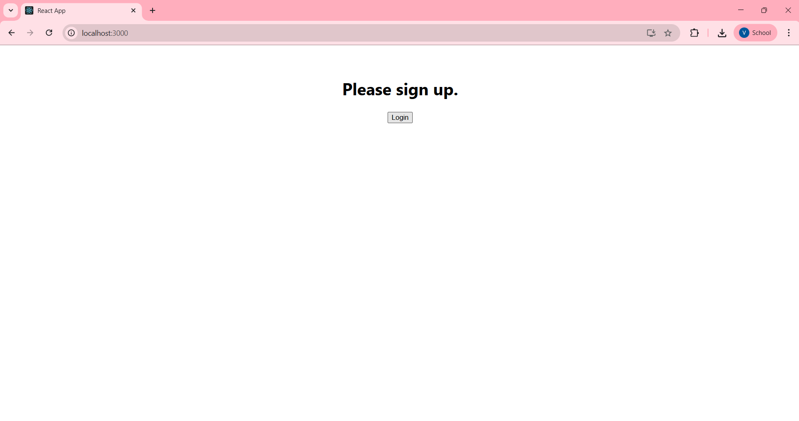

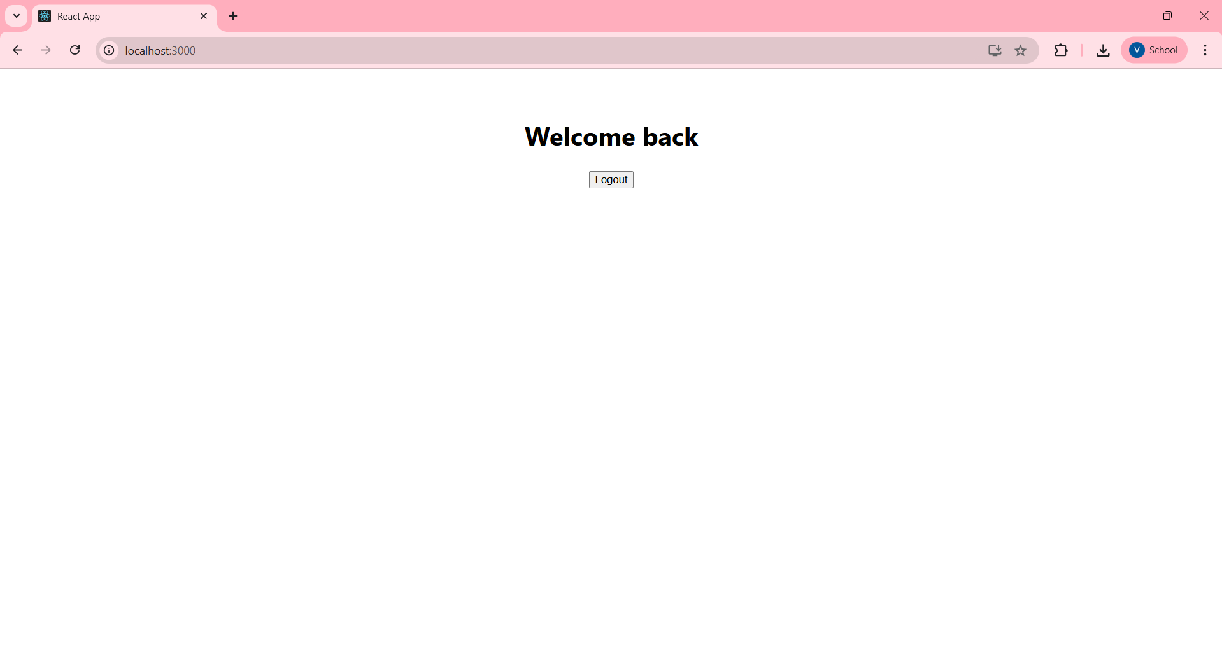

**HandsOn 5:**

**Code:**

**src/App.js -**

import React from 'react';

import './App.css';

const books = [

  { id: 101, bname: 'Master React', price: 670 },

  { id: 102, bname: 'Deep Dive into Angular 11 ', price: 800 },

  { id: 103, bname: 'Mongo Essentials', price: 450 },

];

const blogs = [

  {

    title: 'React Learning',

    author: 'Stephen Biz',

    content: 'Welcome to learning React!',

  },

  {

    title: 'Installation',

    author: 'Schwezdenier',

    content: 'You can install React from npm.',

  },

];

const courses = [

  { cname: 'Angular', date: '4/5/2021' },

  { cname: 'React', date: '6/3/2021' },

];

function BookDetails(props) {

  const bookdet = (

    <ul>

      {props.books.map((book) => (

        <div key={book.id}>

          <h3>{book.bname}</h3>

          <h4>{book.price}</h4>

        </div>

      ))}

    </ul>

  );

  return (

    <div className="st2">

      <h1>Book Details</h1>

      {bookdet}

    </div>

  );

}

function BlogDetails(props) {

  return (

    <div className="v1">

      <h1>Blog Details</h1>

      {props.blogs.length > 0 && (

        <ul>

          {props.blogs.map((blog, index) => (

            <div key={index}>

              <h2>{blog.title}</h2>

              <h4>{blog.author}</h4>

              <p>{blog.content}</p>

            </div>

          ))}

        </ul>

      )}

    </div>

  );

}

function CourseDetails(props) {

  const coursedet =

    props.courses.length > 0 ? (

      <ul>

        {props.courses.map((course, index) => (

          <div key={index}>

            <h2>{course.cname}</h2>

            <h4>{course.date}</h4>

          </div>

        ))}

      </ul>

    ) : (

      <p>No course data available</p>

    );

  return (

    <div className="mystyle1">

      <h1>Course Details</h1>

      {coursedet}

    </div>

  );

}

function App() {

  return (

    <div className="App">

      <div className="container">

        <CourseDetails courses={courses} />

        <BookDetails books={books} />

        <BlogDetails blogs={blogs} />

      </div>

    </div>

  );

}

export default App;

**src/App.css -**

.App {

  display: flex;

  justify-content: center;

  margin-top: 50px;

  font-family: Arial, sans-serif;

  text-align: left;

}

.container {

  display: flex;

  justify-content: center;

  gap: 50px;

  width: 70%;

}

 .mystyle1, .st2, .v1 {

  padding-left: 15px;

  width: 30%;

}

.st2, .v1 {

  border-left: 5px solid green;

}

**Output:**

