
CONVERSATION-STATE BASED APPROACH
Assignment on
A Assignment Report submitted in partial fulfilment of the requirements for the Course of

DSA0308 – Natural Language Processing
to the award of the degree of
BACHELOR OF Technology
IN
ARTIFICIAL INTELLIGENCE AND Machine Learning
Submitted by
Gurramkonda Harshitha-192324250
Under the Supervision of
Kumaragurubaran k

SIMATS ENGINEERING
Saveetha Institute of Medical and Technical Sciences
Chennai – 602105
SEPTEMBER 2026

CONVERSATION-STATE BASED APPROACH
1. Problem Statement and Problem Formulation
Problem Statement
An e-commerce chatbot may receive information about the same order over several conversational turns. A customer does not always repeat the complete information in every message. Instead, they may use expressions such as it, this order, that item, or there to refer to information already mentioned.
A chatbot that processes each message independently may lose this information and assign an incorrect intent. For example, in the given interaction, the customer first mentions a laptop order that has not arrived and later says:
“I don't want to cancel it. I just want to know when it will arrive.”
The meaning of “it” depends on the previous conversation. Similarly, the occurrence of cancel should not cause the chatbot to classify the message as Order Cancellation because the customer explicitly rejects cancellation.
The proposed solution therefore maintains a structured conversation state that is updated after every user message. This state stores entities, events, delivery status, temporal information, references, rejected actions and the current intent. The assignment requires conversational context and reference resolution to be handled explicitly.
Problem Formulation
Input:
Multiple customer messages belonging to one e-commerce conversation.
Internal Representation:
A continuously updated conversation state.
Output:
- Current intent
- Relevant entities
- Resolved references
- Conversation status
- Intent confidence
- Retrieved information
- Generated response
- Tamil translation
The possible intent classes are Order Tracking, Order Cancellation, Product Information, Return Request, Refund Request, Payment Problem, Delivery Information, Account Problem, Complaint and General Inquiry.

2. Objective and Expected Outcomes
Objectives
The main objective is to design a chatbot that understands the current user intention using both the current message and previously stored conversation information.
The specific objectives are:
- Process each conversational turn.
- Extract entities from every message.
- Maintain an evolving conversation state.
- Perform morphological processing.
- Generate n-gram representations.
- Perform POS tagging.
- Analyze sentence structure using CFG.
- Detect negated actions.
- Build semantic representations.
- Resolve references using previous turns.
- Maintain entity chains.
- Detect discourse relationships.
- Determine the current intent from the complete state.
- Retrieve information relevant to the intent.
- Generate an appropriate response.
- Translate the response into Tamil.
These objectives incorporate the course concepts specified in the assignment.
Expected Outcomes
For the given conversation, the state-based system should maintain:
Product = laptop
Order = existing customer order
Order Status = not received
Time = three days
Delivery Issue = delayed
Cancellation = rejected
Current Reference = existing order
Current Intent = order tracking
The final intent should therefore be:
Order Tracking / Delivery Information

3. Requirements, Constraints and Assumptions
Requirements
Functional Requirements
The chatbot must:
- accept multiple conversational turns;
- tokenize and normalize text;
- perform stemming;
- generate n-grams;
- perform POS tagging;
- construct syntactic representations;
- detect negation;
- perform semantic interpretation;
- identify entities;
- resolve references;
- maintain entity chains;
- analyze discourse;
- update the conversation state;
- determine the current intent;
- retrieve appropriate information;
- generate a response;
- translate the response.
The assignment specifically requires reference resolution for expressions such as it, this and that, along with conversational context maintenance.
State Requirements
The conversation state should be capable of storing:
ConversationState
├── customer
├── products
├── orders
├── order_status
├── delivery_status
├── temporal_information
├── references
├── negated_actions
├── discourse_relations
└── current_intent
Constraints
The system should not process every message as an isolated input.
It must:
- retain relevant previous information;
- resolve references from conversational context;
- explicitly identify negated actions;
- distinguish an entity from an intent;
- avoid replacing previously established facts without evidence;
- provide intermediate processing results;
- avoid generating responses inconsistent with the conversation.
These requirements are consistent with the technical constraints in the assignment.
Assumptions
- Conversation turns arrive sequentially.
- The system maintains state during a session.
- The most recent compatible entity is generally preferred for resolving simple references.
- Customer messages contain sufficient information for identifying the relevant intent.
- A predefined collection of e-commerce intents exists.
- The chatbot has access to a small information-retrieval store.
- Translation is performed after response generation.

4. Application of Relevant Course Knowledge / Concepts
Unit I – Morphological Analysis
Each message is tokenized and stemmed before higher-level processing.
For example:
Word | Stemmed Form
ordered | order
arrived | arriv
delivered | deliv
cancelling | cancel
tracking | track
This allows different word forms to be associated with similar concepts.
Regular expressions can also identify structured information such as order numbers and dates.

Unit II – N-Grams and POS
N-grams are used to preserve local word relationships.
For:
“I don't want to cancel it.”
Possible features include:
Unigrams
want
cancel
Bigrams
want cancel
cancel it
Trigrams
don't want cancel
want cancel it
The n-gram containing the negation context is more informative than the isolated word cancel.
POS tagging is used to distinguish actions, objects and other grammatical components.

Unit III – CFG and Negation
A simplified grammar can represent the structure of a customer statement:
S → NP VP
VP → Aux VP
VP → V NP
NP → Det N
The system separately detects negation.
For:
“I don't want to cancel it.”
the state records:
Action = cancellation
Negated = TRUE
This prevents the cancellation action from becoming the current customer goal.

Unit IV – Semantic Analysis and WSD
The semantic representation describes events and relationships.
For example:
Customer ordered Laptop
Order has not arrived
Customer requests arrival information
Customer rejects cancellation
A simplified FOPC representation is:
Ordered(Customer, Laptop)
NotArrived(Order)
Wants(Customer, ArrivalInformation)
NotWants(Customer, Cancellation)
WSD helps interpret terms according to the e-commerce context.
For example, order is interpreted as a purchase transaction rather than another possible meaning.

Unit V – Discourse, Reference and Context
This is the central component of Version 3.
The system creates an entity chain:
laptop → order → it → existing order
The word “it” is therefore not interpreted independently.
Similarly:
- but → introduces contrast;
- still → indicates an unresolved condition;
- just → restricts the customer's requirement.
The assignment explicitly identifies reference resolution, entity chains, discourse relations and coherence as Unit V concepts.

5. Design / Proposed Solution / Methodology
The proposed architecture is organized around a Conversation State Manager.
Customer Turn
↓
Preprocessing
↓
Morphological Analysis
↓
N-Gram + POS Analysis
↓
CFG + Negation
↓
Semantic Analysis
↓
Entity Extraction
↓
Reference Resolution
↓
Discourse Analysis
↓
UPDATE CONVERSATION STATE
↓
Current Intent Identification
↓
Information Retrieval
↓
Response Generation
↓
Tamil Translation
↓
Next Conversation Turn
The state is updated after every user message.
Conversation State Example
After the first message:
“I ordered a laptop three days ago, but it still hasn't arrived.”
the state becomes:
ConversationState
├── product = laptop
├── order_exists = TRUE
├── order_age = three days
├── arrival_status = not_arrived
├── delivery_problem = TRUE
└── probable_intent = order_tracking
After the second message:
“I don't want to cancel it. I just want to know when it will arrive.”
the state is updated:
ConversationState
├── product = laptop
├── order_exists = TRUE
├── order_age = three days
├── arrival_status = not_arrived
├── cancellation = REJECTED
├── current_reference = order
├── requested_information = arrival_time
└── current_intent = order_tracking
This state representation is the major distinction of this solution.

6. Algorithm / Pseudocode

BEGIN

Initialize ConversationState

FOR each user_message:

normalized_text ← preprocess(user_message)

tokens ← tokenize(normalized_text)

stems ← perform_stemming(tokens)

ngrams ← generate_ngrams(tokens, 1, 3)

pos_tags ← POS_tag(tokens)

parse_tree ← CFG_parse(user_message)

negation_info ← detect_negation(user_message)

semantic_info ← semantic_analysis(user_message)

entities ← extract_entities(user_message)

references ← find_references(user_message)

FOR each reference:

candidate_entities ← obtain_entities_from_state()

resolved_entity ← select_best_contextual_match(
reference,
candidate_entities)

END FOR

discourse_info ← analyze_discourse(user_message)

update ConversationState with:

entities
resolved references
temporal information
order information
delivery status
negated actions
discourse relations

candidate_intents ← generate_possible_intents(
current_message,
ConversationState)

FOR each candidate intent:

calculate linguistic evidence
calculate state/context evidence

IF intent is explicitly negated:
reduce intent score

IF intent agrees with stored state:
increase intent score

END FOR

current_intent ← highest_valid_score

retrieved_data ← retrieve_information(
current_intent,
ConversationState)

response ← generate_response(
current_intent,
retrieved_data)

translated_response ← translate_to_tamil(response)

display state
display resolved references
display intent
display response

END FOR

END
The algorithm contains the functions, data structure, loops, conditions and scoring required by the assignment's algorithm-design expectations.

7. Implementation / Source Code and Environment / Tools Used
Environment
Component | Tool
Programming Language | Python
NLP Library | NLTK
Regex Processing | Python re
Tokenization | NLTK
Stemming | PorterStemmer
POS Tagging | NLTK
CFG Parsing | NLTK
State Management | Python dictionaries/classes
Intent Processing | Python
Information Retrieval | Dictionary-based knowledge base
Translation | Suitable translation library/API

Conversation State Implementation
A Python class can represent the state:
class ConversationState:

def __init__(self):
self.product = None
self.order = None
self.order_status = None
self.delivery_status = None
self.time = None
self.references = {}
self.negated_actions = []
self.discourse = []
self.intent = None
After every message, the state is updated rather than recreated.
For example:
state.product = "laptop"
state.order_status = "existing"
state.delivery_status = "not_received"
state.time = "three days"
state.negated_actions.append("cancel")
state.intent = "order_tracking"
The important feature is that the second message can access the information extracted from the first message.

8. Test Cases and Expected / Actual Results
Test Case | Conversation | Expected Intent
TC1 | “Where is my order?” | Order Tracking
TC2 | “Cancel my order.” | Order Cancellation
TC3 | “My package hasn't arrived.” | Order Tracking
TC4 | “Can I return this item?” | Return Request
TC5 | “I paid but the payment failed.” | Payment Problem
TC6 | “I don't want to cancel it. When will it arrive?” after discussing an order | Order Tracking
TC7 | “What is its delivery status?” after mentioning an order | Order Tracking

Multi-Turn Test
Turn 1
“I ordered a laptop three days ago.”
State:
product = laptop
order = existing
time = three days
Turn 2
“It hasn't arrived yet.”
State becomes:
product = laptop
order = existing
delivery_status = not_received
reference("it") = order
Turn 3
“I don't want to cancel it.”
State becomes:
reference("it") = order
cancellation = rejected
Turn 4
“I just want to know when it will arrive.”
Final state:
requested_information = arrival_time
intent = order_tracking
Thus, the system uses all four turns rather than interpreting the final message independently.

9. Execution Screenshots / Outputs
The actual implementation should capture screenshots for the following.
Screenshot 1 – Preprocessing/tokenization output.
User:
I ordered a laptop three days ago,
but it still hasn't arrived.
Screenshot 2 – N-gram and POS-tagging output screenshot.

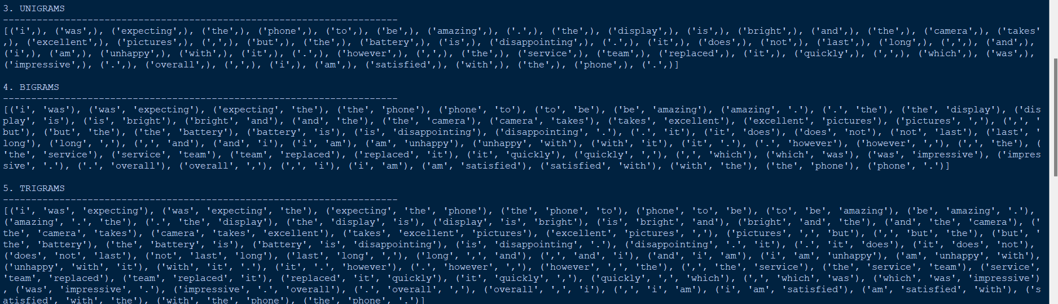
Screenshot 3 – Reference Resolution
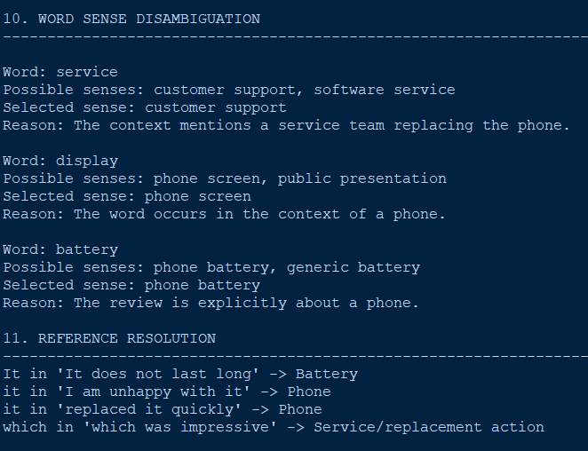
Reference:
"it"

Resolved To:
Existing Order
Screenshot 4 – Negation Analysis
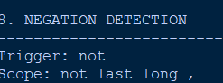
Detected Action:
Cancellation
Negation:
TRUE
Interpretation:
Customer rejects cancellation
Screenshot 5 – Final State
Conversation State
Product : Laptop
Order Status : Existing
Delivery Status : Not Received
Cancellation : Rejected
Current Reference : Order
Requested Information: Arrival Time
Current Intent : Order Tracking
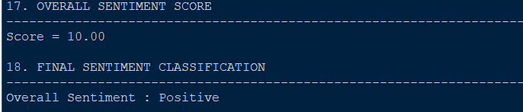
Screenshot 6 – Response
Final Intent:
Order Tracking
Response:
Please provide your order number so I can check
the current delivery status of your laptop.
Tamil Response:
The assignment requires evidence of intermediate NLP representations, final classification and generated chatbot output.

10. Results and Validation
Morphological Analysis
Word | Processed Form
ordered | order
arrived | arriv
cancelling | cancel
delivery | deliver
tracking | track
Conversation-State Validation
State Component | Value | Source
Product | Laptop | First turn
Order | Existing | First turn
Time | Three days | First turn
Delivery Status | Not received | First/second turn
Reference | “it” → order | Previous context
Cancellation | Rejected | Third turn
Requested Information | Arrival time | Final turn
Intent | Order Tracking | Complete conversation

Intent Validation
The critical distinction is:
cancel
↓
Potential cancellation signal

don't want to cancel
↓
Cancellation rejected

want to know when it will arrive
↓
Delivery/Tracking requirement
Therefore:
Final Intent: Order Tracking / Delivery Information
The assignment specifically requires the analysis to explain why “I don't want to cancel it” must not lead to Order Cancellation.
Validation Cases
Linguistic Feature | System Behaviour
Morphological variation | Normalizes related forms
N-gram dependency | Considers surrounding words
POS information | Provides grammatical evidence
Negation | Rejects negated intent
Reference | Resolves “it” from state
Ambiguity | Uses conversational context
Discourse | Interprets “but”, “still”, “just”
Multi-turn context | Retains previous information
Intent | Selects current user goal
Response | Generated according to state
These correspond to the validation areas required in the assignment.

11. Analysis, Comparison, Trade-offs and Justification
The major advantage of this approach is that it does not treat every message as an independent classification problem.
Consider:
“I ordered a laptop three days ago.”
At this point:
Intent = possibly Order Tracking
Then:
“It hasn't arrived.”
The reference “it” becomes meaningful because the state already contains the order.
Finally:
“I don't want to cancel it.”
The system already knows what it represents.
Importance of Reference Resolution
Without state:
"it" → unknown
With state:
"it" → existing order
This makes the chatbot much more capable of handling natural conversational behaviour.
Why “cancel” Does Not Become the Intent
The system stores:
negated_actions = ["cancel"]
Therefore:
cancel ≠ requested_intent
Instead:
requested_information = arrival time
and consequently:
intent = order tracking
Comparison
Approach | Main Advantage | Main Limitation
Keyword-based | Simple implementation | Cannot preserve context
Rule-based scoring | Explainable | Requires many manually designed rules
TF-IDF classifier | Learns statistical patterns | Limited conversation memory
Conversation-state model | Strong multi-turn understanding | State management is more complex
Proposed state-based approach | Context + linguistic processing | Requires careful state updates

Trade-off
The main trade-off is complexity versus conversational reliability.
Maintaining state requires additional memory and processing, but it substantially improves the system's ability to understand references and previous information.
This is particularly valuable in e-commerce because customers often refer back to an order without repeating its complete details.

12. Broader Considerations / SDG Relevance
The assignment maps the application to SDG 9 – Industry, Innovation and Infrastructure, with automated customer-service systems identified as an industry-relevant application.
Privacy
Conversation state may contain customer information such as products, order details and delivery information. The state should be protected and deleted appropriately after the session.
Bias
Reference resolution may perform differently depending on sentence construction and language style. Testing should include varied conversational expressions.
Incorrect State Updates
A major risk of this approach is storing an incorrect entity or reference. Once incorrect information enters the state, later responses may also become incorrect.
Accessibility
Tamil translation allows the system to provide customer support in a regional language.
Responsible AI
The chatbot should not perform irreversible actions merely because an intent was inferred. Actions such as cancellation should require explicit confirmation.

13. Conclusion, Limitations and Possible Improvements
Conclusion
A conversation-state-based e-commerce chatbot was designed to address the limitations of independent message classification. The system maintains information from previous turns and uses this information to interpret references, negation, entities and discourse.
The conversation state stores details such as the product, order status, delivery condition, temporal information, references and rejected actions.
For the given example, “it” is resolved to the customer's existing order, while the cancellation request is identified as negated. The customer's actual requirement is to determine when the order will arrive. Therefore, the final intent is Order Tracking / Delivery Information.
This demonstrates that maintaining conversational state can significantly improve the interpretation of multi-turn e-commerce interactions.
Limitations
- Incorrect entity extraction can affect later turns.
- Very long conversations can produce large states.
- Ambiguous references may have multiple possible antecedents.
- State management requires additional implementation effort.
- Complex discourse relations may require more advanced NLP models.
- The approach may struggle when customers suddenly change topics.
Possible Improvements
Future development could include:
- Transformer-based dialogue-state tracking.
- Advanced coreference resolution.
- Long-context conversational models.
- Automatic state-confidence estimation.
- Multilingual conversation-state tracking.
- Integration with real-time order-management systems.
- Human-agent escalation for uncertain states.

14. Individual Contribution of Group Members
The following is an example structure and should be modified according to the actual contributions.
Member | Contribution
Member 1 | Conversation-state architecture and problem formulation
Member 2 | Preprocessing, stemming and POS processing
Member 3 | Entity extraction and reference resolution
Member 4 | Negation, discourse analysis and intent determination
Member 5 | Response generation, Tamil translation, testing and documentation

15. References
The final report should cite the resources actually used during development. The assignment requires appropriate references for textbooks, research papers, NLP libraries, datasets, software/tools, websites and AI-assisted tools where applicable.
Suggested categories include:
- NLP course textbook.
- NLTK documentation.
- Python documentation.
- Research literature on dialogue-state tracking and conversational NLP.
- Documentation for the selected translation library/API.
- Dataset documentation, if a dataset is used.
- Software and development tools used during implementation.
- AI-assisted tools, if actually used.

16. One-Page Individual Reflection
Individual Reflection
Through this assignment, I gained a deeper understanding of sentiment analysis and realized that it involves much more than simply identifying positive and negative words. Initially, I believed that a sentiment analysis system mainly required a sentiment dictionary and a scoring mechanism. However, this assignment changed my perspective by showing me how strongly the meaning of an expression depends on its surrounding context. The phrase “does not last long” was an important example. Although the word “long” may appear neutral or positive when considered independently, the presence of negation changes the meaning of the complete expression. This helped me understand why analyzing sentiment at only the individual word level is not always reliable.
I also learned how different NLP techniques can be integrated to build a single application. Morphological analysis helped me understand the importance of word normalization, while N-gram analysis demonstrated how neighboring words contribute to meaning. POS tagging and CFG parsing helped me identify relationships between opinion words and the aspects they describe. Semantic representation allowed me to represent information such as the battery not lasting long, while Word Sense Disambiguation (WSD) showed me that the meaning of a word can vary depending on its context. Reference resolution was another important concept because pronouns such as “it” cannot always be associated with the same noun throughout a document. These techniques made me realize that an effective NLP system needs to make context-based decisions rather than depend only on fixed rules.
The discourse markers “but,” “However,” and “Overall” had a significant impact on my final analysis. They demonstrated that a review can contain both positive and negative opinions while still expressing one overall conclusion. In this example, the battery issue is clearly identified as a negative aspect, but the final statement indicates that the customer is satisfied with the phone. From this, I learned the importance of distinguishing between aspect-level sentiment and overall document-level sentiment instead of considering them to be the same.

