SIMATS ENGINEERING (SAVEETHA SCHOOL OF ENGINEERING)
Department of Artificial Intelligence and Data Science

ASSESSMENT TOOL 2 – SCENARIO BASED

Course Code: | DSA03 | Course Title: | Natural Language Processing
CO Assessed: | CO2 – Manipulation | Assessment: | Assessment Tool 2 – SCENARIO  BASED
Weightage: | 35% of CIA
CO5 Statement: | Design inflectional, derivational, finite-state parsing, stemming algorithms and for analyse morphological methods. (BL-3)
Student Name: | GURRAMKONDA HARSHITHA | Reg. No.: | 192324250
Section / Batch: | 2023 | Date: | 06-08-2026

Code of Conduct
I GURRAMKONDA HARSHITHA(Name / Reg No) certify that this submission is my original work and that I have adhered to the guidelines specified for this assessment. I understand that any violation of academic integrity rules will result in disciplinary action.
Signature of the Student: G.HARSHITHA
Instructions
- Read all questions carefully before attempting the answers.
- Answer all five questions. Each question carries equal marks.
- Show all intermediate steps, calculations, probability computations, tagging decisions, and justifications wherever applicable.
- Duration: 30 minutes.
Section / Topic | Focus | Q Nos
English Word Classes, Tagsets for English, Stochastic Part of Speech Tagging, HMM | Morphological parsing of disagree, agreement, and agreeable; identification of prefixes, suffixes, base forms, and semantic effects of derivation. | Q1

Annexure A – SCENARIO BASED

A company is developing an NLP-based grammar checker for educational applications. The system is trained using a manually POS-tagged corpus. Your task is to recreate the Hidden Markov Model (HMM) without using any built-in NLP or HMM libraries.
From the given corpus,
- determine the Emission Probability
- determine the Transition Probability
- implement the Viterbi Algorithm
- predict the POS tags for the new input sentence.
Use only Python dictionaries, loops, and basic programming constructs.

2. Calculate Emission Probability
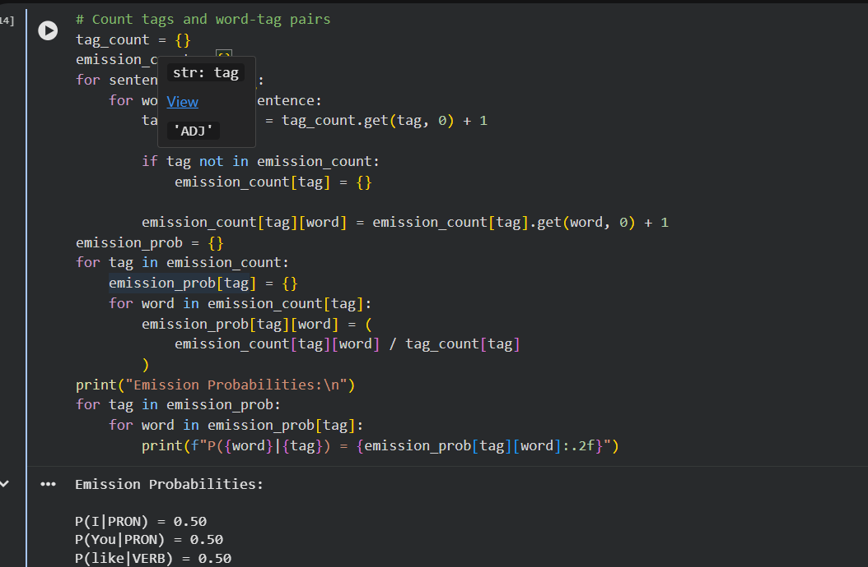
3. Calculate Transition Probability
Formula
P(tag2 | tag1) = Count(tag1 → tag2) / Count(tag1)
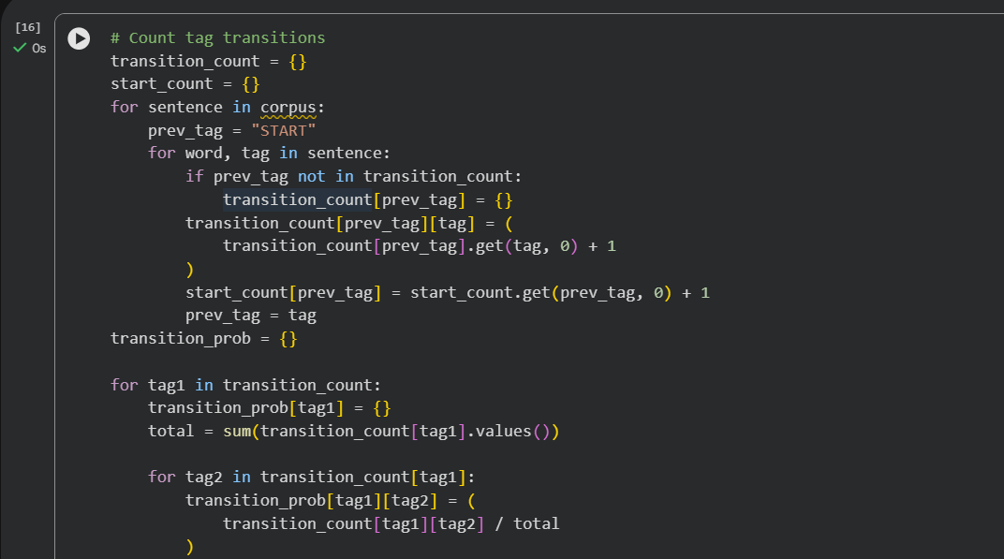

Criteria  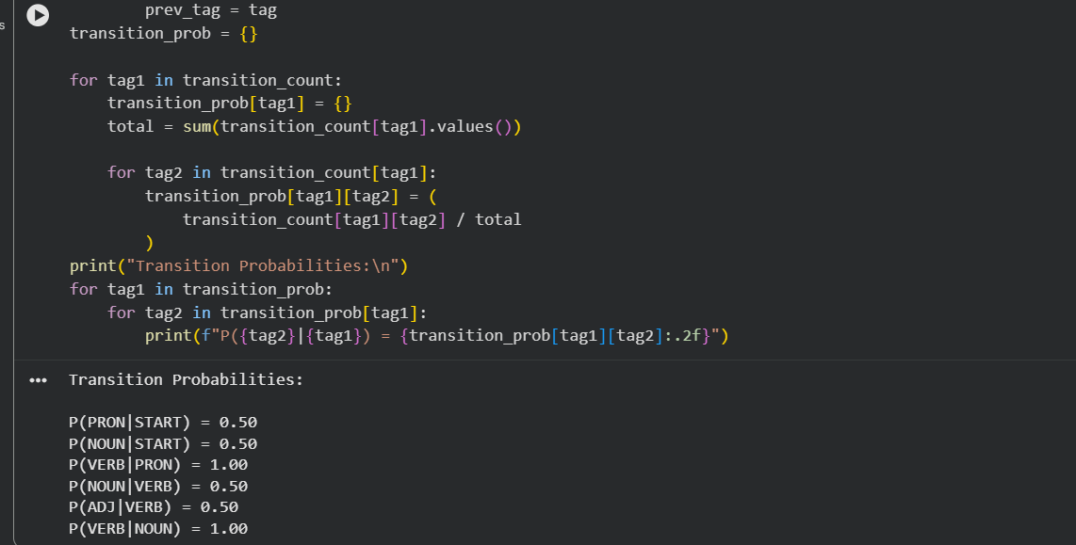  Conclusion  This implementation successfully recreates a Hidden Markov Model POS Tagger from scratch:  - ✔ Emission Probability calculated manually  - ✔ Transition Probability calculated manually  - ✔ Viterbi Algorithm implemented using only dictionaries and loops  - ✔ POS tags predicted for a new sentence  - ✔ No built-in NLP or HMM libraries used  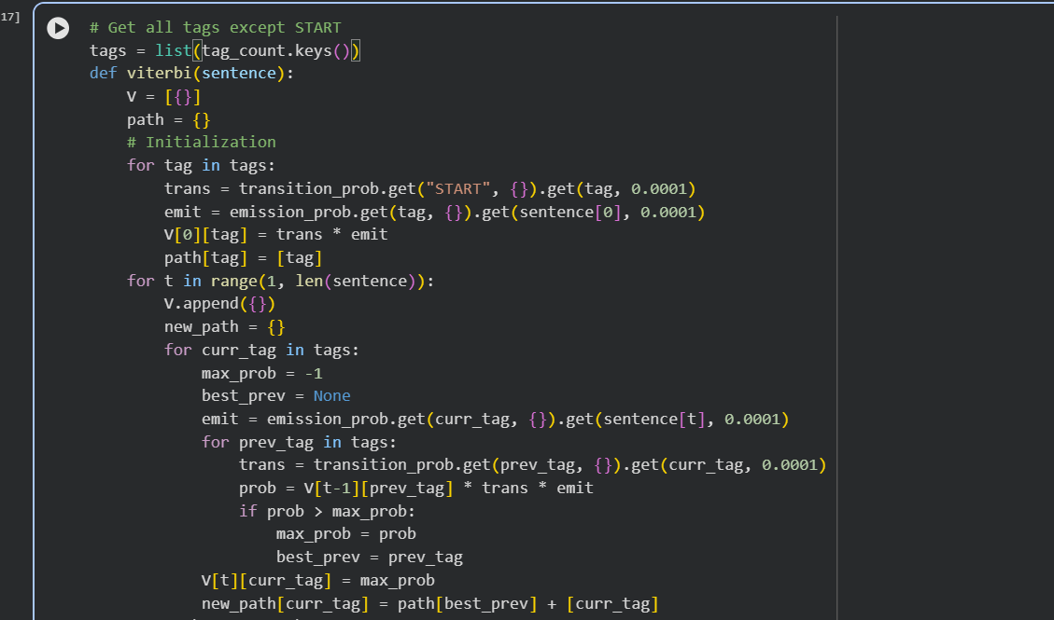 | Weighta ge (%) | Level 4 (Exemplary) | Level 3 (Proficient) | Level 2 (Developing) | Level 1 (Beginning)
Understanding of Scenario | 20% | Demonstrates clear and complete  understanding of  the scenario and context | Shows good understanding with minor gaps | Partial understanding; misses key  aspects | Misinterprets or fails to  understand the scenario
Identification of Key Issues | 20% | Accurately  identifies all  relevant issues and factors involved | Identifies most key issues with minor omissions | Identifies limited issues; some irrelevant points | Unable to identify key issues
Application of Concepts | 25% | Applies appropriate concepts effectively to address the scenario | Applies concepts with minor errors | Limited or partially correct application | Unable to apply relevant concepts
Decision Making | 20% | Makes wellreasoned, logical decisions with strong rationale | Makes reasonable decisions with some  justification | Makes weak  decisions with limited justification | No clear decisions made or  rationale provided
Clarity of  Response | 15% | Response is clear, structured, and logically presented | Generally clear with minor issues | Somewhat unclear or poorly structured | Disorganized  and difficult to understand
Training Corpus
Sentence | POS Tags
The/DT boy/NN eats/VBZ rice/NN | DT NN VBZ NN
The/DT girl/NN drinks/VBZ milk/NN | DT NN VBZ NN
A/DT cat/NN drinks/VBZ milk/NN | DT NN VBZ NN
The/DT dog/NN chases/VBZ cat/NN | DT NN VBZ NN
A/DT teacher/NN teaches/VBZ students/NNS DT NN VBZ NNS
Students/NNS study/VBP English/NN | NNS VBP NN
Birds/NNS fly/VBP high/RB | NNS VBP RB
Children/NNS play/VBP games/NNS | NNS VBP NNS
New Input Sentence
The cat drinks milk
Tasks
1. Separate each sentence into words and POS tags. 2. Compute the Emission Probability of every word.
- Compute the Transition Probability between POS tags.
- Recreate the Hidden Markov Model using Python dictionaries.
- Implement the Viterbi Algorithm without using any built-in HMM/NLP libraries.
- Predict the POS tag sequence for “The cat drinks milk”

Rubrics for Calculation

Q. No. / Criteria  Level | Understanding of Scenario | Identification of Key Issues |  | Application of  Concepts | Decision Making |  | Clarity of  Response | Sub. Total | Total  %
1 | 3 | 4 |  | 4 | 4 |  | 3 | 15 | 92
2 | 3 | 4 |  | 4 | 4 |  | 3 | 20
3 | 3 | 4 |  | 4 | 4 |  | 3 | 25
4 | 3 | 4 |  | 4 | 4 |  | 3 | 20
5 | 3 | 4 |  | 4 | 4 |  | 3 | 12
Faculty In-charge |  |  | Course Coordinator |  |  | Program Director
Dr.T.Kumaragurubaran
Signature: Kumaragurubaran |  |  | Signature: _______________ |  |  | Signature: _______________
Date: 04-08-2026 |  |  | Date: ___________________ |  |  | Date: ___________________

