**1.Write a c program to evaluate the binary heap**

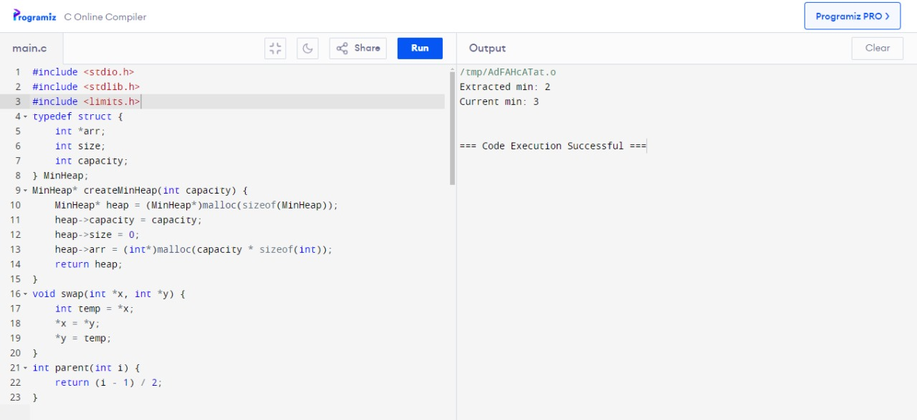

**2.Write a c program to evaluate the sort in ascending order**

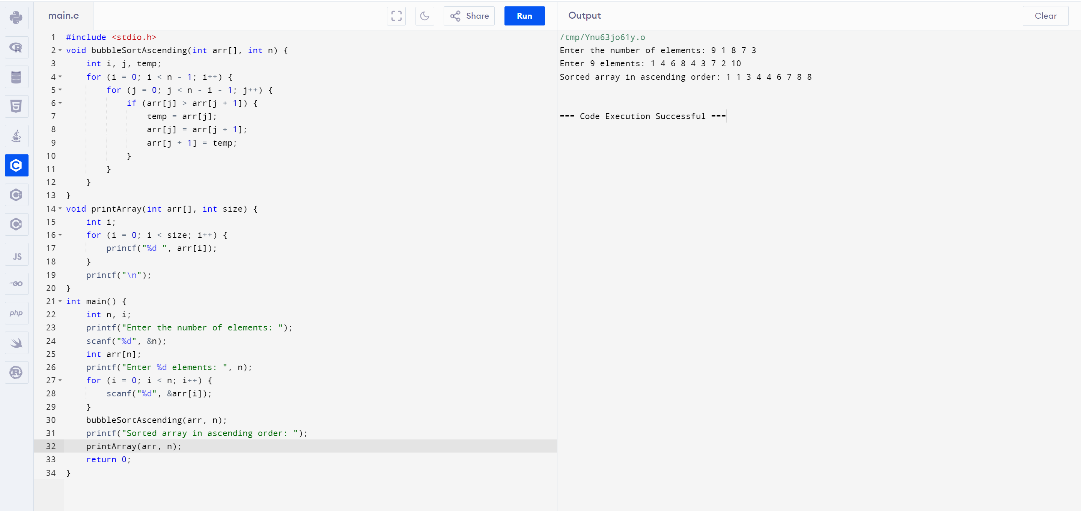

**3.Write a c program evaluating the sort in descending order**

