**1.Write a c program to evaluate the insertion sorting**

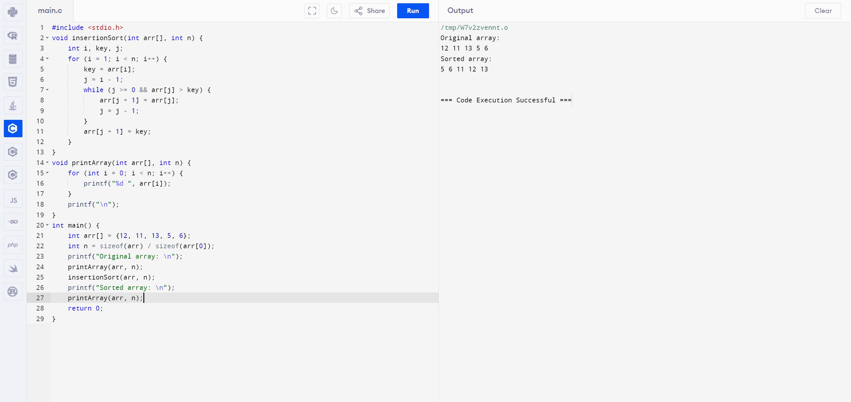

**2.Write a c program to evaluate the merge sorting**

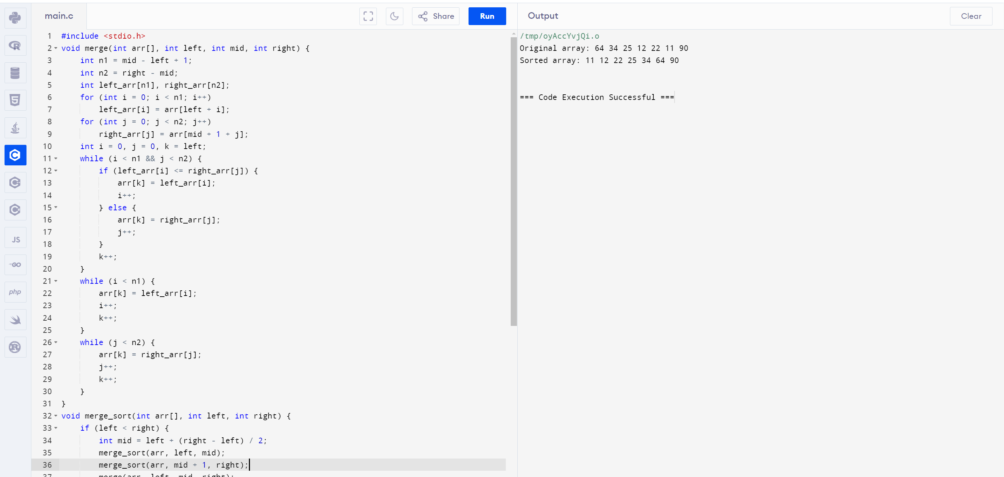

**3.Write a c program to evaluate the radix sorting**

