S. NO. | Title | Pg. No.
1. | Acknowledgement | 2
2. | Abstract | 4
3. | Introduction | 5
4. | History | 6
5. | About Electromagnetic Braking System | 8
6. | Types of Braking System | 10
7. | General Principles | 11
8. | Devices Used | 13
9. | Applications | 17
10. | Advantages | 18
11. | Limitations | 19
12. | Future Aspects | 21
13. | Conclusions | 22
14. | References | 24

INDEX
acknowledgement

I wish to express my deep gratitude and sincere thanks to the school for the encouragement and provided facilities for this school project. I sincerely appreciate his generosity by taking me into his fold for which I shall remain indebted to him. I extent my appreciation to Ms. Devesh Bhatt sir, our physics teacher who guided me to the successful competition of this project. I take this opportunity to express my deep sense of gratitude to her invaluable guidance, ongoing encouragement, enormous motivation, which has sustained my efforts at all the stages of project development.

I also would like to express my special thanks of gratitude to my teacher (Devesh Bhatt) who gave me the golden opportunity to do this wonderful project on the topic (Based on Induction), which also helped me in doing a lot of Research and I came to know about so many new things I am really thankful to them.
Secondly, I would also like to thank my parents and friends who helped me a lot in finalizing this project within the limited time frame.

I can’t forget to offer me since thanks to our lab assistant, Ms. Johansson and classmates who helped me to carry out this project successfully and for their valuable advice and support which I have received all the time.

Abstract

This project aims to create an electromagnetic braking system model capable of applying brakes without any friction loss and without losing the energy supplied. It uses two electromagnets which runs by the supply of power from the circuit. Also, there is a wheel which is attached to the motor so when the power the supplied, by the help of motor the wheel rotates. Then a fan is attached near electromagnets to cool the electromagnets from excessive heating. A metal bar is in the vicinity of the electromagnets and wheel so when the electromagnets produce eddy currents which stops the rotating wheel or rotor. This model helps in a way to be a used a retardation equipment in vehicles.
A non-contact method, using magnetic drag force principle, was proposed to design the braking systems to improve the shortcomings of the conventional braking systems. The extensive literature detailing all aspects of the magnetic braking is briefly reviewed, however little of this refers specifically to upright magnetic braking system, which is useful for industries. One of the major issues to design upright magnetic system is to find out the magnetic flux. The changing magnetic flux induces eddy currents in the conductor. These currents dissipate energy in the conductor and generate drag force to slow down the motion. Therefore, a finite element model is developed to analyse the phenomena of magnetic flux density when air gap and materials of track are varied. The verification shows the predicted magnetic flux is within acceptable range with the measured value. The results will facilitate the design of magnetic braking systems

Introduction

In this project I am trying to make a braking system. Which can be applicable in two-wheeler at high speed and low maintenance cost. Here we are using an electromagnetic coil and a plunger. There is an electromagnetic effect which moves the plunger in the braking direction.
When electricity is applied to the field, it creates an internal magnetic flux. That flux is then transferred into a hysteresis disk passing through the field. The hysteresis disk is attached to the brake shaft. A magnetic drag on the hysteresis disk allows for a constant drag, or eventual stoppage of the output shaft.
- This project intends to the design and implementation of new system of retardation (Braking) for automobiles.
- The design of the new brakes is based upon the phenomenon of electromagnetic induction and eddy currents.
- The design basically consists of very strong magnet and rotating metallic wheel.
- The wheel develops eddy currents development obeys Maxwell’s law of electromagnetic induction and Lenz’s law of direction of induction currents.
- The current in turn dissipates the rotational energy of the wheel as heat bringing the wheel to a stop.

History

It is found that electromagnetic brakes can develop a negative power which represents nearly twice the maximum power output of a typical engine, and at least three times the braking power of an exhaust brake. (Reverdin, 1994). These performances of electromagnetic brakes make them much more competitive candidate for alternative retardation equipment compared with other retarders. By using by using the electromagnetic brakes are supplementary retardation equipment, the friction brakes can be used less frequently, and therefore practically never reach high temperatures. The brake linings would last considerably longer before requiring maintenance and the potentially “brake fade” problem could be avoided. In research conducted by a truck manufacturer, it was proved that the electromagnetic brake assumed 80% of the duty which would otherwise have been demanded of the regular service brake (Reverdin, 1974). Furthermore, the electromagnetic brakes prevent the danger that can arise from the prolonged use of brake beyond their capability to dissipate heat. This is most likely to occur while a vehicle descending a long gradient at high speed. Ina study with a vehicle with 5 axles and weighting 40 tones powered by a powered by an engine of 310 b.h.p travelling down a gradient of 6% at a steady speed between 35 and 40 m.h.p, it can be calculated that the braking power necessary to maintain this speed of the order of 450 hp. The brakes, therefore, would have to absorb 300 hp, meaning that each brake in the 5 axels must absorb 30 hp, that a friction brake can normally absorb with self-destruction. The magnetic brake is well suited to such conditions since it will 9 independently absorb more than 300 hp (Reverdin, 1974). It therefore can exceed the requirements of continuous uninterrupted braking, leaving the friction brakes cool and ready for emergency braking in total safety. The installation of an electromagnetic brake is not very difficult if there is enough space between the gearbox and the rear axle. If did not need a subsidiary cooling system. It relays on the efficiency of engine components for its use, so do exhaust and hydrokinetic brakes. The exhaust brake is an on/off device and hydrokinetic brakes have very complex control system. The electromagnetic brake control system is an electric switching system which gives it superior controllability.
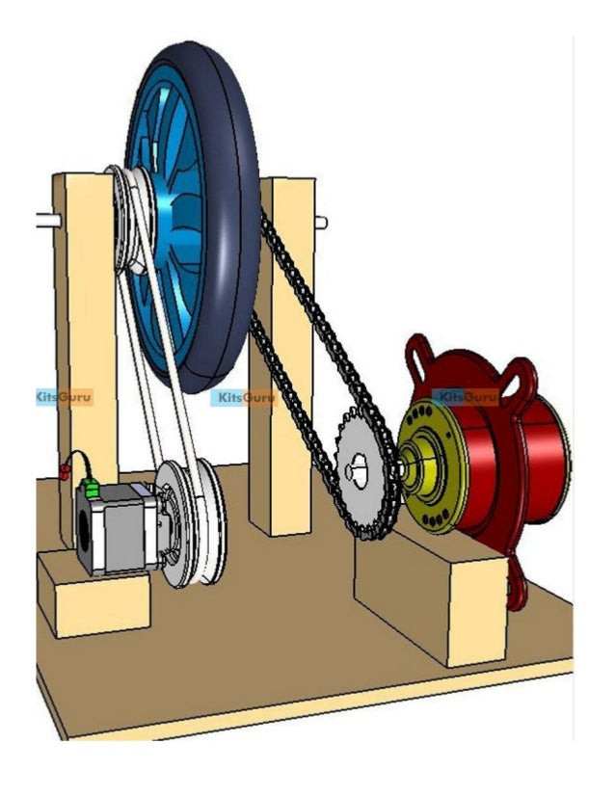
About Electromagnetic Braking System

Electromagnetic brakes (also called electro-mechanical brakes or EM brakes) slow or stop motion using electromagnetic force to apply mechanical resistance (friction). The original name was "electro-mechanical brakes" but over the years the name changed to "electromagnetic brakes", referring to their actuation method. Since becoming popular in the mid-20th century especially in trains and trams, the variety of applications and brake designs has increased dramatically, but the basic operation remains the same. Electromagnetic brakes are the brakes working on the electric power & magnetic power. They work on the principle of electromagnetism. These brakes are an excellent replacement on the convectional brakes due to their many advantages. The reason for implementing this brake in automobiles is to reduce wear in brakes as it frictionless. Electromagnetic brakes are of today’s automobiles. The working principle of this system is that when the magnetic flux passes through and perpendicular to the rotating wheel the eddy current flows opposite to the rotating wheel/rotor direction. This eddy current trying to stop the rotating wheel or rotor. This results in the rotating wheel or rotor comes to rest/ neutral.
Electromagnetic braking means applying brakes using electronic and magnetic power. Here we use the principle of electromagnetism to achieve friction less braking. This tends to increase the life span and reliability of brakes since no friction leads to less wearing out of brakes. Also, it requires less maintenance and oiling. This is an upcoming technological replacement for traditional braking systems. The main purpose behind the proposed use of these brakes in vehicles is that it is frictionless. This leads to a sizably less maintenance cost due to no friction and no oiling. Also, traditional braking systems are prone to slipping while this one is guaranteed to apply brakes to the vehicle. So, without friction or need of lubrication this technology is a preferred replacement for traditional braking. Also, it is quite smaller in size compared to the traditional braking systems.
To make electromagnetic brakes work, a magnetic flux when passed in a direction perpendicular to the rotating direction of the wheel, we see eddy current flowing in a direction opposite to the rotation of the wheel. This creates an opposing force to the wheel rotation and in turn slows down the wheel. Thus, we achieve electromagnetic braking as a better braking system for future automobiles.
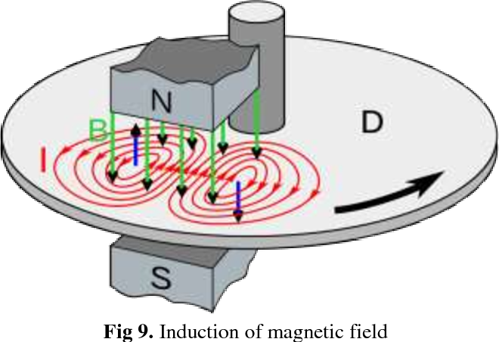

Types of Braking System
- Electromagnetic Braking System
A rising style of brake system, electromagnetic brakes use an electric motor that is included in the automobile which help the vehicle come to a stop. These types of brakes are in most hybrid vehicles and use an electric motor to charge the batteries and regenerative brakes. On occasion, some buses will use it as a secondary retarder brake.

- Frictional Brake System
A frictional brake system is found in many automobiles. They are service brakes, and typically found in two forms; pads and shoes. As the name implies, these brakes use friction to stop the automobile from moving. They typically include a rotating device with a stationary pad and a rotating weather surface. On most band brakes the shoe will constrict and rub against the outside of the rotating drum, alternatively on a drum brake, a rotating drum with shoes will expand and rub against the inside of the drum.

- Hydraulic Brake System
A hydraulic brake system is composed of a master cylinder that is fed by a reservoir of hydraulic braking fluid. This is connected by an assortment of metal pipes and rubber fittings which are attached to the cylinders of the wheels. The wheels contain two opposite pistons which are located on the band or drum brakes which pressure to push the pistons apart forcing the brake pads into the cylinders, thus causing the wheel to stop moving
General Principles
- INSTALLATION LOCATION: -
Electromagnetic brakes work in a relatively cool condition and satisfy all the energy requirements of the braking at high speeds, completely without the use of friction. Due to its specific installation location (transmission line rigid vehicles).

There are in existence several types of electromagnetic retarders of the Focal type. An electromagnetic retarder of the axial type is designed to be placed on a transmission shaft is in two parts, for mounting between those of the retarder. An electromagnetic retarder of the focal type is designed to be placed on a transmission shaft on the output side of the gearbox or on the axle of the vehicle. The axle of the vehicle drives at least one road wheel, which road wheel drives at least one wheel of the same vehicles. 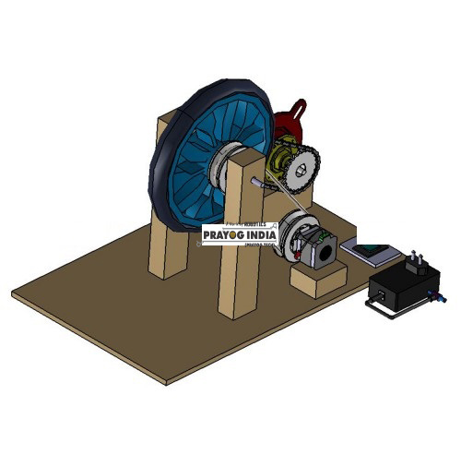

- WORKING: -

The working principle of the electric retarder is based on the creation of Eddy currents within a metal disc rotating between two electromagnets, which sets up a force opposing the rotation of the disc. If the electromagnet is not energized, the rotation of the disc is free and accelerates uniformly under the action of the weight to which its shaft is connected. When the electromagnet is energized, the rotation of the disc is retarded and the energy absorbed appears as heating of the disc.
In this type of electromagnetic braking system, electromagnet is fixed in the back plate in this way the unequal braking effect at one shoe are balanced, even if the lining on one shoe is worn more than other the plunger will move to one side so that shoe still share equal acting force.
In this braking system, any one shoe out of two will remove &instead of it we will use the electromagnetic coil. As the current passes through this electromagnetic coil, it will produce the magnetic flux, this flux will attract the shoe with much force, and brake will apply.
A typical retarder consists of stator and rotor. The stator holds 16 Induction coils, energized separately in group of four. The coils are made up of varnished aluminium wire mounded in epoxy resin. The stator assembly is supported resiliently through anti-vibration mounting on the chassis frame of the vehicle. The rotor is made up of two discs, which provide the braking force when subject to the electromagnetic influence when the coils are excited. Careful design of the fins, which are integral to the disc, permit independent cooling of the arrangement.

DEVICES USED

- DC Motor
A DC motor is any of a class of rotary electrical motors that converts direct current (DC) electrical energy into mechanical energy. The most common types rely on the forces produced by magnetic fields. Nearly all types of DC motors have some internal mechanism, either electromechanical or electronic, to periodically change the direction of current in part of the motor.
DC motors were the first form of motor widely used, as they could be powered from existing direct-current lighting power distribution systems. A DC motor's speed can be controlled over a wide range, using either a variable supply voltage or by changing the strength of current in its field windings. Small DC motors are used in tools, toys, and appliances. The universal motor can operate on direct current but is a lightweight brushed motor used for portable power tools and appliances. Larger DC motors are currently used in propulsion of electric vehicles, elevator and hoists, and in drives for steel rolling mills. The advent of power electronics has made replacement of DC motors with AC motors possible in many applications.
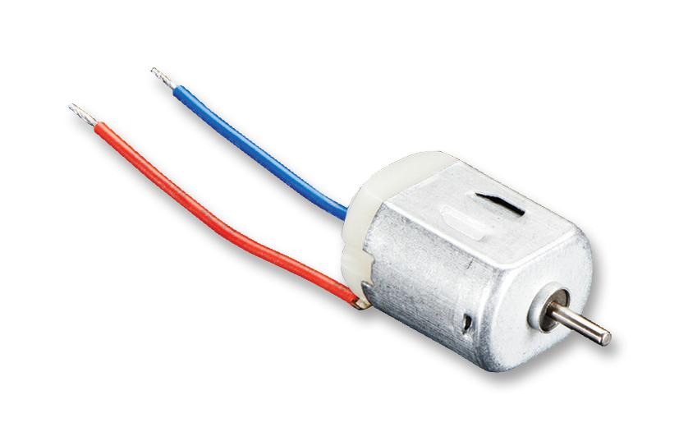

- Battery
An electric battery is a source of electric power consisting of one or more electrochemical cells with external connections for powering electrical devices.
When a battery is supplying power, its positive terminal is the cathode and its negative terminal is the anode. The terminal marked negative is the source of electrons that will flow through an external electric circuit to the positive terminal. When a battery is connected to an external electric load, a redox reaction converts high-energy reactants to lower-energy products, and the free-energy difference is delivered to the external circuit as electrical energy. Historically the term "battery" specifically referred to a device composed of multiple cells; however, the usage has evolved to include devices composed of a single cell.
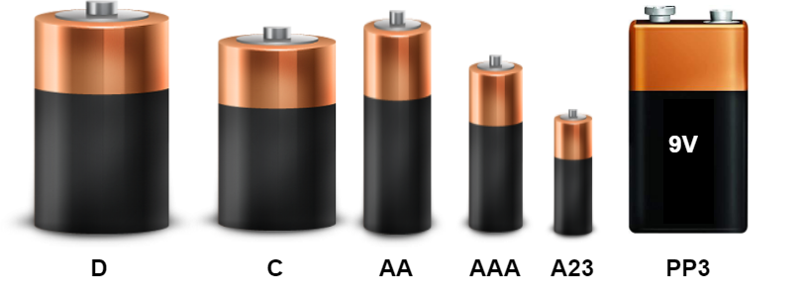
Primary (single-use or "disposable") batteries are used once and discarded, as the electrode materials are irreversibly changed during discharge; a common example is the alkaline battery used for flashlights and a multitude of portable electronic devices. Secondary (rechargeable) batteries can be discharged and recharged multiple times using an applied electric current; the original composition of the electrodes can be restored by reverse current. Examples include the lead-acid batteries used in vehicles and lithium-ion batteries used for portable electronics such as laptops and mobile phones.

- Ferromagnetism
Ferromagnetism is the basic mechanism by which certain materials (such as iron) form permanent magnets, or are attracted to magnets. In physics, several different types of magnetism are distinguished. Ferromagnetism (along with the similar effect ferrimagnetism) is the strongest type and is responsible for the common phenomenon of magnetism in magnets encountered in everyday life. Substances respond weakly to magnetic fields with three other types of magnetism—paramagnetism, diamagnetism, and antiferromagnetism but the forces are usually so weak that they can be detected only by sensitive instruments in a laboratory. An everyday example of ferromagnetism is a refrigerator magnet used to hold notes on a refrigerator door. The attraction between a magnet and ferromagnetic material is "the quality of magnetism first apparent to the ancient world, and to us today".
Permanent magnets (materials that can be magnetized by an external magnetic field and remain magnetized after the external field is removed) are either ferromagnetic or ferrimagnetic, as are the materials that are noticeably attracted to them. Only a few substances are ferromagnetic. The common ones are iron, cobalt, nickel and most of their alloys, and some compounds of rare-earth metals. Ferromagnetism is very important in industry and modern technology and is the basis for many electrical and electromechanical devices such as electromagnets, electric motors, generators, transformers, and magnetic storage such as tape recorders, and hard disks, and non-destructive testing of ferrous materials.
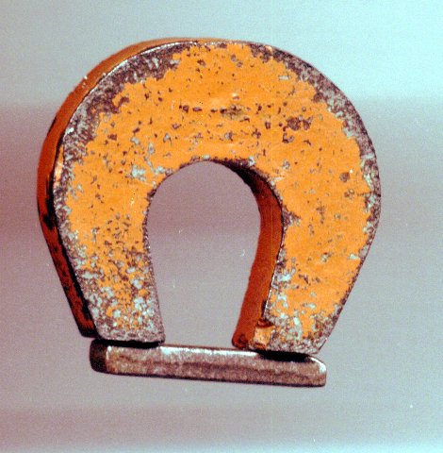
Ferromagnetic materials can be divided into magnetically "soft" materials like annealed iron, which can be magnetized but do not tend to stay magnetized, and magnetically "hard" materials, which do. Permanent magnets are made from "hard" ferromagnetic materials such as alnico and ferrimagnetic materials such as ferrite that are subjected to special processing in a strong magnetic field during manufacture to align their internal microcrystalline structure, making them very hard to demagnetize. To demagnetize a saturated magnet, a certain magnetic field must be applied, and this threshold depends on coercivity of the respective material. "Hard" materials have high coercivity, whereas "soft" materials have low coercivity. The overall strength of a magnet is measured by its magnetic moment or, alternatively, the total magnetic flux it produces. The local strength of magnetism in a material is measured by its magnetization.
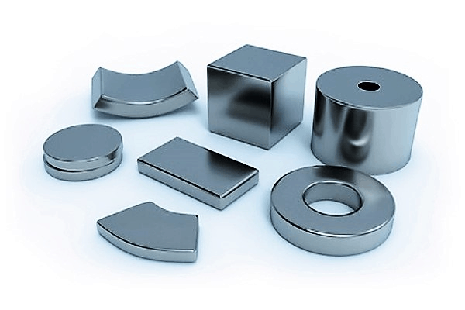

APPLICATIONS

- Already is used under some railway system.

- Can be used for any road vehicles.

- Equally applicable to heavy and light vehicles.

- Can be used as application retarder for aircrafts.

- May also find application in virtually any rotating system which have metallic parts.

- This brake system can be used in two-wheeler vehicles.

- Electromagnetic braking system will be used in all types of light motor vehicles like car and heavy motor vehicles.

LIMITATIONS

- Failure to act as a holding device.
- Usage of electric power for braking.
- Less effective under very low velocities.
- The installation of an electromagnetic brake is very difficult if there is not enough space between the gearbox and the real axle.
- Need a separate compressor.
- Maintenance of the equipment components such as hoses, valves have to done periodically.
- It cannot use grease or oil.
- Dependence on battery power to energize the brake system drains down the battery much faster.
- Due to residual magnetism present in electromagnetic brake shoe takes time to come back to its original position.

Advantages

- Problems of drum distortion at widely varying temperatures which is common for friction-brakes drums to exceed 500ºC surface temperatures when subject to heavy braking demands, and at temperatures of this order, a reduction in the coefficient of friction (“brake fade”) suddenly occurs.
- This is reduced significantly in electromagnetic dis brake systems.
- Potential hazard of tire deterioration and bursts due to friction is eliminated.
- There is no need to change brake oils regularly.
- There is no oil leakage.
- The practical location of the retarder within the vehicle prevents the direct impingement of air on the retarder caused by the motion of the vehicle.
- The retarders help to extend the life span of the regular brakes and keep the regular brakes cool for emergency situation.
- The electromagnetic brakes have excellent heat dissipation efficiency owing to the high temperature of the surface of the disc which is being cooled.
- Due to its special mounting location and heat dissipation mechanism, electromagnetic brakes have better thermal dynamic performance than regular friction brakes.
- Burnishing is the wearing or mating of opposing surfaces. This is reduced significantly here.
- In the future, there may be storage of crude oil; hence by-product such as brake oils will be in much demand. EMBs will overcome this problem.
- Electromagnetic braking system will reduce maintenance cost.
- The problem of brake fluid vaporization and freezing is eliminated.
- Electric actuation, no fluid.
- Easier integration with anti-lock, traction, and dynamic stability controls.
- Easy individual wheel braking control.
- During acceleration, the motor/generator unit acts as electric motor drawing electrical energy from batteries to provide extra driving force to move the vehicle.
- During braking electric supply from the battery is cut off by the electronic system.

FUTURE ASPECTS

- The proposed winding model should be verified and its validity with respect to frequency and model parameter settings investigated.
- In the core model the static hysteresis model should be improved, especially regarding the modelling of minor loops. E.g.-the distribution function of the pseudo particles and the relation between reversible and irreversible processes should be studied more in detail.
- In the dynamic magnetization model the optimization of the cauer circuit sections and the frequency and amplitude dependency of the parameter V_{o} could be studied. If it is possible to find that dependency for a class of material, this would make this model a very useful tool. Then the only necessary adapting step would be to fit the static curve to the measured static curve.
- The composite transformer model should also be validation in other operation models like transient overvoltage.
- A more detailed reluctance network model of the transformer including three-dimensional flux paths on the tank and construction details should be developed and verified.
- A static magnetization model that takes B as input and returns H should be developed.

CONCLUSION

Electromagnetic brakes have numerous preferences over frictional slowing mechanism. The blend of swirl present and attractive powers makes this brake more successful. This brake is often utilized as assistant stopping mechanism in vehicle. The use of abs is often dismissed by utilizing a smaller scale controlled electromagnetic framework. It is often utilized as a neighbourhood of rail mentors to decelerate the prepare occupation fast. Mixture of these brakes expands the brake life and act like completely stacked brakes. These brakes are often utilized as a part of wet condition, so there's no utilization of against slipping instrument .it is completely electrically controlled which brings about fewer mishaps. The braking power delivered during this brake isn't the maximum amount because the plate brakes. Subsequently, it is often utilized as an auxiliary or crisis slowing mechanism within the autos.
The Electromagnetic braking system is found to be more reliable as compared to other braking systems. In addition, it is found that electromagnetic brakes make up approximately 80% of all of the power applied brake applications. Electromagnetic brakes have been used as supplementary retardation equipment in addition to the regular friction of the brakes. This enhanced braking system not only helps in effective braking but also helps in avoiding the accidents and reducing the frequency of accidents to a minimum. Furthermore, the electromagnetic brakes prevent the danger that can arise from the prolonged use of brake beyond their capability to dissipate heat. ABS usage can be neglected by simply using a micro controlled electromagnetic disk brake system. For the brake distribution of the electromagnetic braking system, the abrasion, noise, harmful friction dust, and the risk of thermal failure in braking system were reduced obviously. These electromagnetic brakes can be used in wet conditions which eliminate the anti-skidding equipment, and cost of these brake are cheaper than the other types. The concept designed by us is just a prototype and needs to be developed more. It can not only be used in the field of automotives but also in the field of aeronautics. Hence the electromagnetic braking system can be a better technological revolution in the future application.

REFERENCES

- Book: S.L. Arora Class 12
- Book: H.C. Verma Class 11& 12
- Book: NCERT book class 12
- Websites: https://en.wikipedia.org/
- Websites: https://www.quora.com/
- Websites: https://nevonprojects.com/electromagnetic-braking-system/
- Websites: https://mechcontent.com/electromagnetic-braking-system/

