STATIC CODE ANALYSIS USING SONARQUBE
Java Duplicate Code and Maintainability Analysis

Name: R HARSHIT
Roll no: 2420030271
Section - 1

1. Objective
To perform static code analysis of a Java program using SonarQube, identify duplicate code and maintainability issues, and verify the analysis results before and after improving the code.

2. Software and Requirements
- Windows operating system
- Java JDK installed
- SonarQube Server installed locally
- SonarScanner CLI installed
- A Java source file containing duplicate statements
- Web browser

3. Project Folder Structure
Create the following project structure:
C:\Users\DELL\sonar-java-demo\src\main\java\DuplicateCode.java
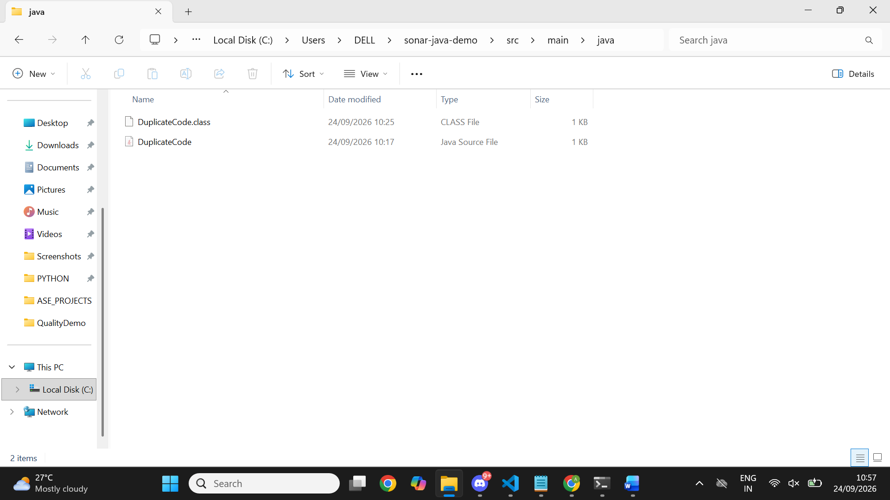

4. Create the Initial Java Program
Create a file named DuplicateCode.java and add the following code:
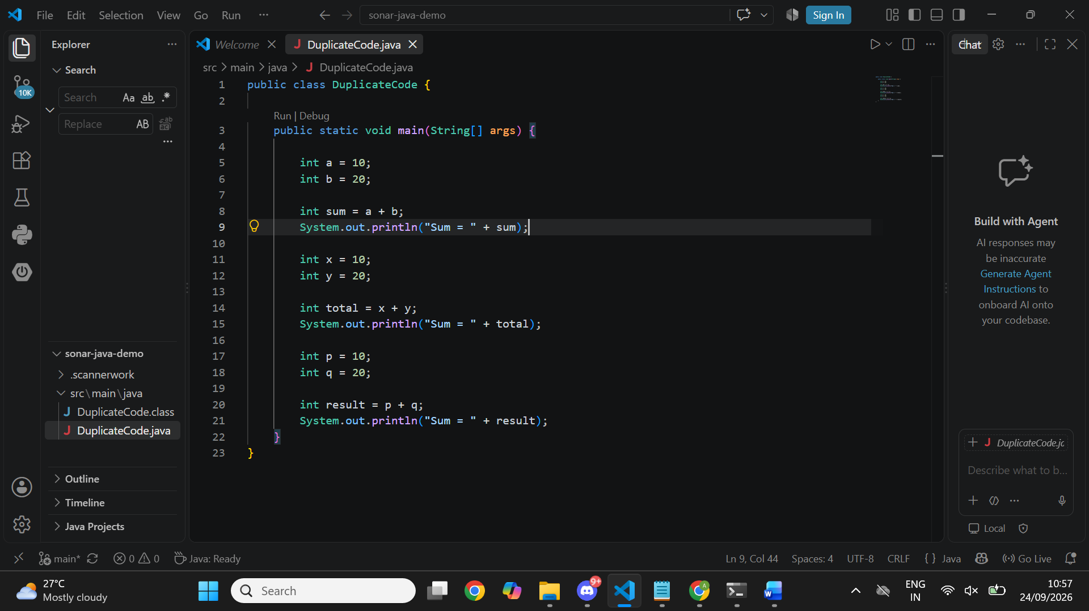

and Run the Java Program
Open Command Prompt and execute:
cd /d C:\Users\DELL\sonar-java-demo
javac src\main\java\DuplicateCode.java
java -cp src\main\java DuplicateCode
Expected output:
Sum = 30
Sum = 30
Sum = 30
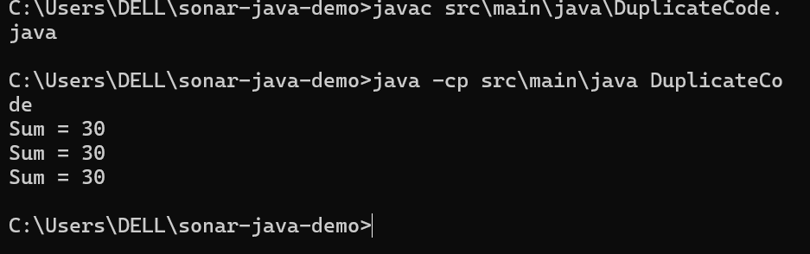

6. Start SonarQube Server
Open Command Prompt and run:
cd /d C:\Users\DELL\sonarqube-26.9.0.129388\bin\windows-x86-64
StartSonar.bat
After the server starts, open http://localhost:9000 in a browser and log in to SonarQube.
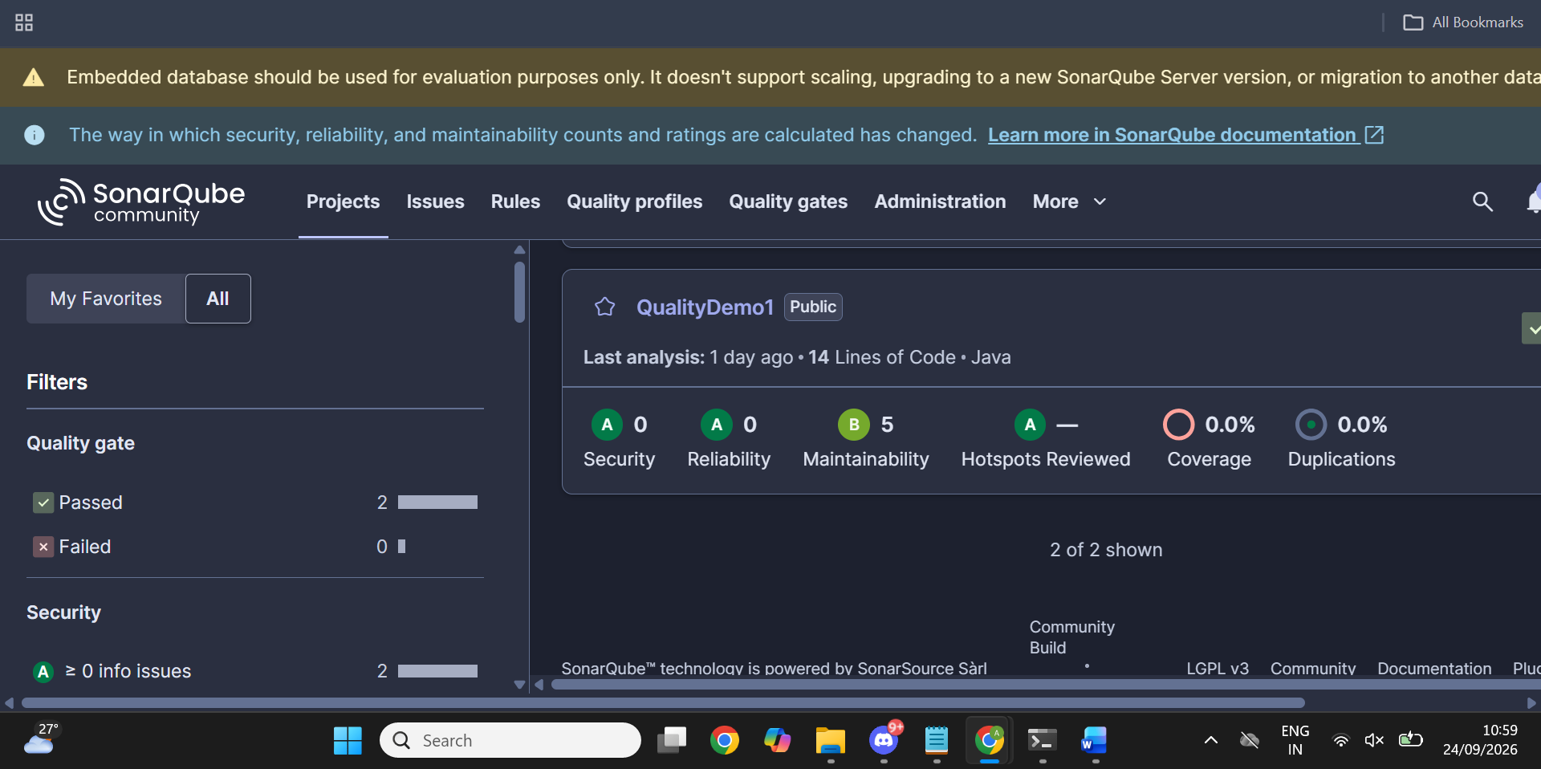

7. Create the SonarQube Project
Create a local project in SonarQube. Use the project name:
Java Duplicate Code Analysis
The project key used for the successful analysis is:
Java-Duplicate-Code-Analysis
For the new-code definition, the instance default (Previous version) can be retained.

8. Generate a SonarQube Analysis Token
Generate an analysis token in SonarQube and keep it private. Do not include the token in screenshots or in this report.

9. Verify SonarScanner Installation
Run:
sonar-scanner -v
The command should display the installed SonarScanner CLI version and the operating system information.

10. Run the First SonarQube Analysis
Open Command Prompt and run the following from the project directory:
cd /d C:\Users\DELL\sonar-java-demo
sonar-scanner -Dsonar.projectKey=Java-Duplicate-Code-Analysis -Dsonar.sources=src/main/java -Dsonar.host.url=http://localhost:9000 -Dsonar.token=YOUR_NEW_TOKEN
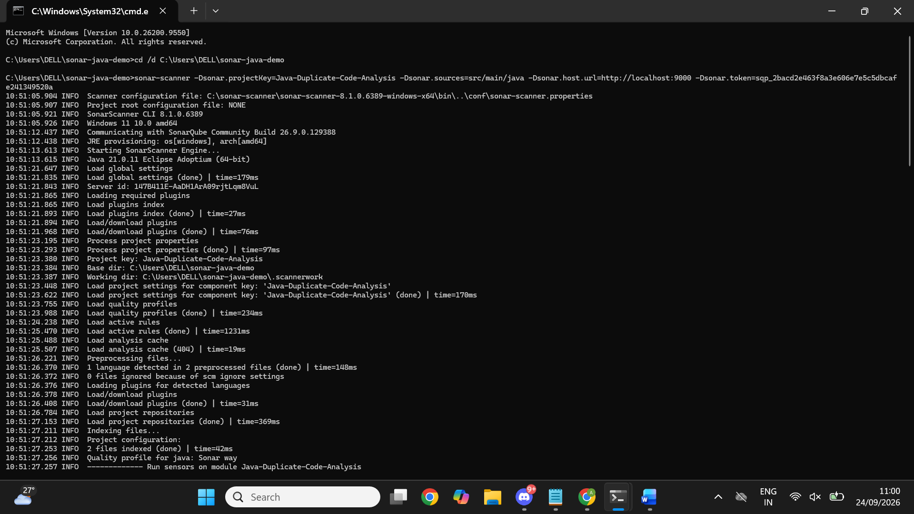

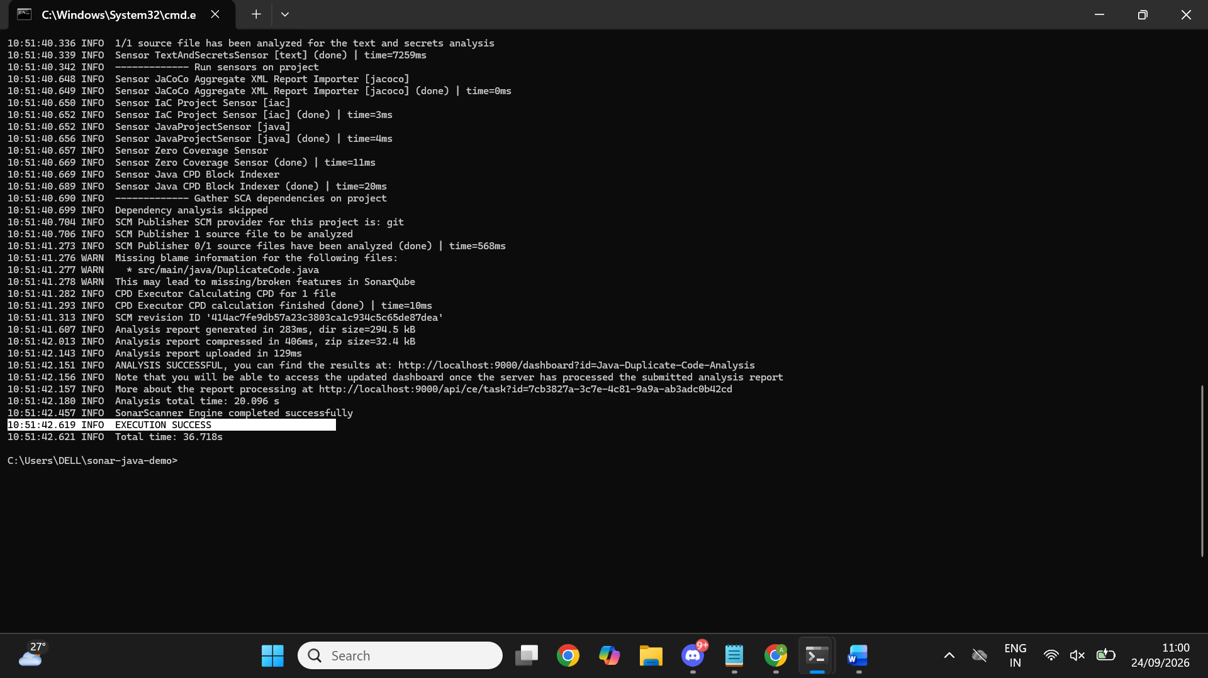

11. Open the SonarQube Dashboard
Open the project dashboard in SonarQube. The project URL used in this project is:
http://localhost:9000/project/dashboards/built-in/project-health?id=Java-Duplicate-Code-Analysis
The initial analysis showed 16 lines of code, Security A with 0 issues, Reliability A with 0 issues, Maintainability B with 5 issues, 0.0% coverage, and 0.0% duplications.
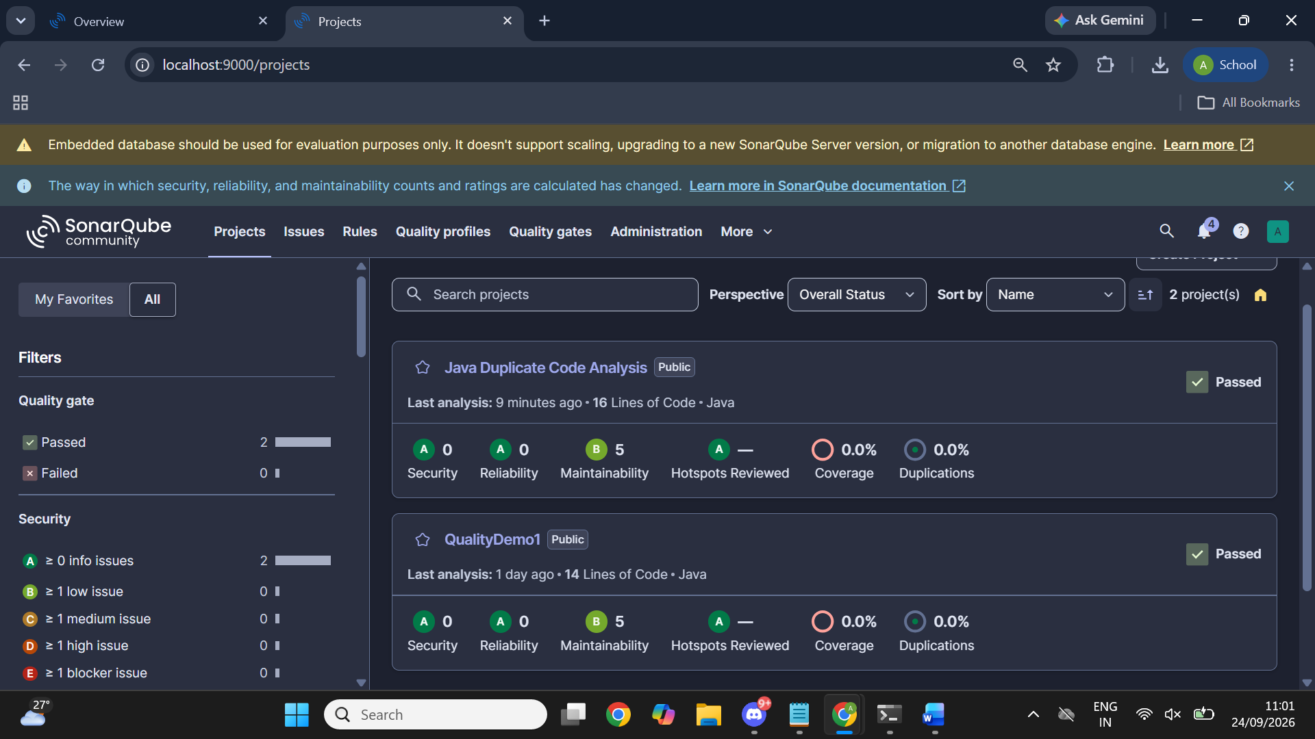

12. Conclusion
SonarQube can be used for static code analysis of Java applications to identify code-quality problems such as maintainability issues and code duplication. The project demonstrated the complete process of creating a Java program, running SonarQube analysis, reviewing the dashboard, identifying repeated code, and refactoring the program to improve maintainability.
