

|  |  |
| --- | --- |
| **Program Name** | ZGR_INDAS_CFS_RS_CRS_FINAL |
| **Created by** | Harshit Dixit |
| **Change Number** | 2025007382 |
| **Ticket Number** |  |

|  |  |
| --- | --- |
| **Date** | 07.07.2025 |
| **Job Log Number** | 2025007376 |
| **Prepared by (Functional person)** | Harshit Dixit |
| **Prepared by (Technical person)** | Harshit Dixit |

|  |  |
| --- | --- |
| **Technical Name** | ZGR_INDAS_CFS_RS_CRS_FINAL |
| **Description** | ZGR_INDAS_CONSOLIDATED_FINANCIALS |

|  |  |  |
| --- | --- | --- |
| **Revision History** | | |
| **SLR. No.** | **Date of Revision** | **Revision** |
| NA | NA |  |

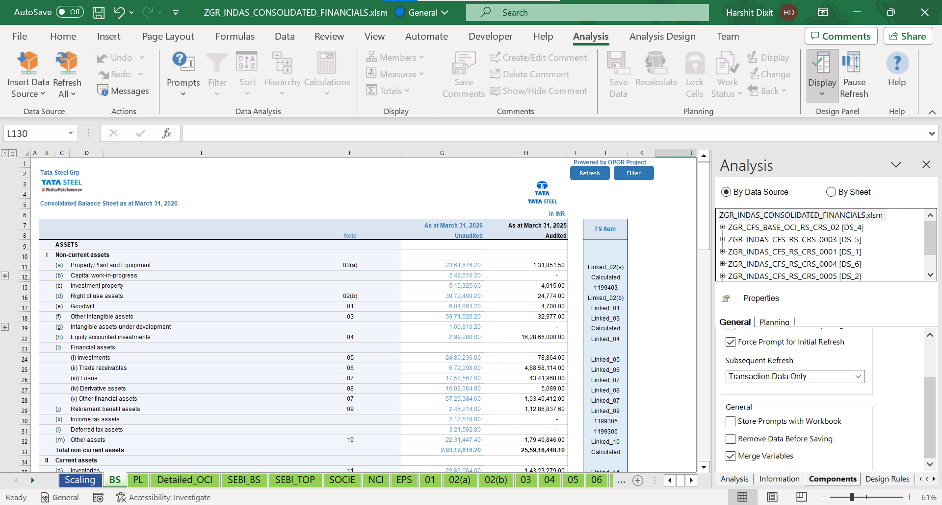

Output:

**Queries used:**

* **Customer Requirement**

New report according to user specification

**Technology Used:**

SAP HANA Studio, AFO

* **Interface with Other Systems, modules, or program:**

No interface with other systems.

* **No. of Users who will use this program:**

As per TSL authorization.

* **Security Privileges of the program :**

Only authorized person can access the program.

* **Files:**

Test Plan attached on ChaRM