1. information IDF FORM-A

(i) | Full Name | Vidushi Negi
 | VIT Register Number / Employee ID | 24BCE0786
 | Gender | FEMALE
 | Nationality | INDIAN
 | Position | STUDENT
 | Department | CSE CORE
 | School/Center | SCOPE
 | E-Mail (Office) | vidushi.negi2024@vitstudent.ac.in
 | E-Mail (Personal) | negividushi05@gmail.com
 | Mobile Number-1 | 6398310851
 | Mobile Number-2 | 7906666563
 | Phone | 7906944468
 | Complete Address (Office) | LH-D block, VIT VELLORE, KATPADI ROAD, VELLORE, TAMIL NADU, 632014
 | Complete Address (Personal / Home) | SHANTI VIHAR, AJABPUR, DEHRADUN, UTTARAKHAND, 248121
 | Signature | 
 | Photo | 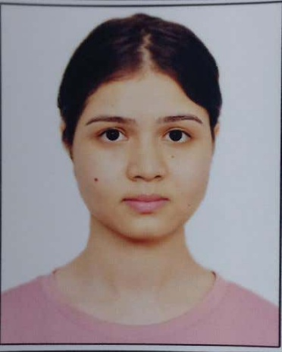
(ii) | Full Name | HARSHIT SINGH
 | VIT Register Number / Employee ID | 24BCI0100
 | Gender | MALE
 | Nationality | INDIAN
 | Position | STUDENT
 | Department | CSE spec. INFORMATION SECURITY
 | School/Center | SCOPE
 | E-Mail (Office) | harshit.singh2024@vitstudent.ac.in
 | E-Mail (Personal) | harsgit.hub@gmail.com
 | Mobile Number-1 | 6395401102
 | Mobile Number-2 | 9634709694
 | Phone | 9719760247
 | Complete Address (Office) | MH-L block, VIT VELLORE, KATPADI ROAD, VELLORE, TAMIL NADU, 632014
 | Complete Address (Personal / Home) | TURNER ROAD, CLEMENT TOWN, DEHRADUN, UTTARAKHAND, 248002
 | Signature | 
 | Photo | 

NOTE: In case of co-inventors from external organization (Academic institution/ Industry / R&D lab/Funding agency with specific IP sharing agreement) contact 9994886632.

Declaration: I declare that the information provided in this document is complete and true to the best of my knowledge and based on records.

Date: 31 March, 2026

Send Signature:
A clear image/scan of the fully signed IDF A document from your VIT Student / VIT Alumni Email for the official record.

Ensure each signature (signature image) has a clean, plain background to avoid any objection from the Patent Office.
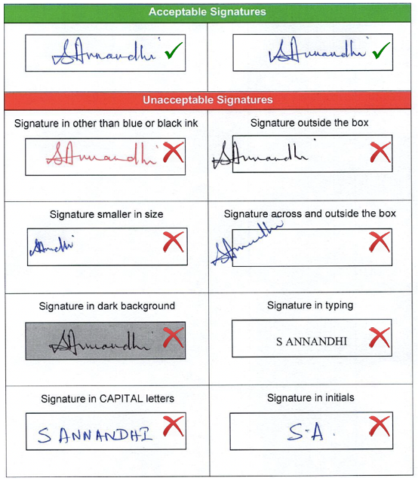
Inventor Name: Harshit Singh

Signature: 

Inventor Name: Vidushi Negi

Signature: 

Sustainability Development Goal (SDG) of your Invention: SDG 9 – Industry, Innovation and Infrastructure (Efficient AI computation for scalable intelligent systems)

(Choose any one from the given options which is most suitable with your patent Form-B title)

Type Here: Industry, Innovation and Infrastructure

Dispatch IDF A & B:
Immediately fill and send the IDF A & B (Invention Disclosure Form A & B) document to sivakumar.v@vit.ac.in from your VIT Student / VIT Alumni Email with your formal inventor signature.
Student Acknowledgement:

kindly mention the below statement in the return email stated as
Please reply to this email (sivakumar.v@vit.ac.in) with the following clear statement of consent:

"I, HARSHIT SINGH (24BCI0100), hereby grant my formal and irrevocable consent for the University to submit the technical disclosure for the project "Selective Feature Reprocessing Architecture using Uncertainty-Guided Adaptive Inference" as a patent application. I affirm my status as an inventor and acknowledge the terms regarding inventor remuneration and the VIT's IPR&TT policy."

Inventor Name-1: HARSHIT SINGH

Signature: 

"I, VIDUSHI NEGI (24BCE0786), hereby grant my formal and irrevocable consent for the University to submit the technical disclosure for the project " Selective Feature Reprocessing Architecture using Uncertainty-Guided Adaptive Inference " as a patent application. I affirm my status as an inventor and acknowledge the terms regarding inventor remuneration and the VIT's IPR&TT policy."

Inventor Name-2: VIDUSHI NEGI

Signature: 

---------------------END OF THE DOCUMENT-----------------------------

