 Invention Disclosure Format (IDF)-B | Document No.
 | Issue No/Date
 | Amd. No/Date

- Title of the invention:
Selective Feature Reprocessing Architecture using Uncertainty-Guided Adaptive Inference
- Field /Area of invention:
Artificial Intelligence
Machine Learning Systems
Neural Network Optimization
Efficient Inference Architectures
Adaptive Computation
Edge AI Systems
- Prior Patents and Publications from literature (provide a table summarizing the prior art)

# | Title | Type | Authors / Inventors Name | Journal link / Patent number | Year | Key Features | Limitations / Gaps | Differentiating Methodology
1. | Conditional Computation in Neural Networks for Faster Models | Publication | Emmanuel Bengio, Pierre-Luc Bacon, Joelle Pineau, Doina Precup | https://arxiv.org/abs/1511.06297 | 2016 | Introduces conditional activation of neural network units to reduce unnecessary computation. Uses reinforcement learning to learn activation policies dynamically. | Operates at neuron or layer level rather than semantic token level. Does not provide interpretable uncertainty signal for reasoning escalation. | Proposed invention identifies semantically unstable tokens via representation perturbation and selectively escalates reasoning complexity, enabling token-level adaptive computation rather than neuron-level gating.
2. | Adaptive Computation Time for Recurrent Neural Networks | Publication | Alex Graves | https://arxiv.org/abs/1511.06297 | 2017 | Enables neural networks to dynamically determine number of computational steps required for each input using a halting probability mechanism. Improves efficiency by allocating more computation to difficult inputs. | Adapts computation depth uniformly across entire input sequence, not individual semantic components. Does not localize uncertainty sources within representation space. | Present invention selectively increases reasoning depth only for semantically uncertain tokens, reducing unnecessary computation while preserving reasoning quality at fine granularity.
3. | Dynamic Deep Neural Networks: Optimizing Accuracy-Efficiency Trade-Offs by Selective Execution | Publication | Lanlan Liu, Jia Deng | https://ojs.aaai.org/index.php/AAAI/article/view/11630 | 2018 | Introduces controller modules that dynamically decide which network components execute for a given input, optimizing accuracy vs efficiency tradeoff. | Requires architectural modifications to network topology. Does not provide token-level interpretability or semantic instability measurement. | Proposed system determines reasoning escalation using instability in embedding space derived from leave-one-token-out perturbations, enabling architecture-agnostic adaptive reasoning.
4. | Spatially Adaptive Feature Refinement for Efficient Inference | Publication | Yizeng Han, Gao Huang, Shiji Song, Le Yang, Yitian Zhang, Haojun Jiang | https://drive.google.com/file/d/1ssb-FfphaJ69q0qp2wGUC_QP0bal3_0D/view | 2020 | Reduces computation by selectively refining only informative spatial regions of feature maps in CNNs. Uses dynamic spatial masks for efficient inference. | Limited to spatial feature redundancy in vision models. Not applicable to semantic reasoning or language representations. | Present invention identifies uncertainty in linguistic representations rather than spatial pixels, enabling selective reasoning escalation in transformer-based architectures.

*A preliminary patent search was conducted using Google Patents with keywords such as "adaptive neural inference", "dynamic neural routing", and "conditional computation neural network". No directly identical patent describing token-level uncertainty-guided selective reasoning was identified.

- Summary and background of the invention (Address the gap / Novelty)

Novelty of the Invention:
The invention proposes a selective feature-level reprocessing architecture for neural network inference systems, where intermediate feature representations are analyzed to detect uncertainty or instability during initial inference stages. Instead of reprocessing the entire input using deeper computational layers, only uncertain representation components are selectively forwarded for additional processing while stable representations are reused without re-computation.

The invention introduces a structured pipeline combining feature-level uncertainty estimation, selective reprocessing of unstable components, reuse of stable latent representations, and fusion of selectively refined features to produce final predictions.
This approach reduces redundant computation while maintaining predictive accuracy and improves computational efficiency in neural network inference systems.

Background of the Invention:
Most existing machine learning and deep learning inference systems process input data using fixed-depth architectures regardless of the complexity of individual input components. Even when certain portions of input data are easily predictable, the entire input is still processed through all computational layers.

Existing adaptive inference techniques typically rely on confidence-based early exit mechanisms or multi-stage cascaded architectures. However, such systems usually reprocess the complete input when confidence is low, resulting in redundant computation and increased processing time.

In many real-world applications such as computer vision, natural language processing, speech recognition, and edge AI deployment, only a subset of features contribute to uncertainty in predictions. Processing all features equally leads to inefficient use of computational resources.

Gap Covered:
Existing approaches generally apply deeper computation uniformly to entire inputs when uncertainty is detected, resulting in unnecessary re-computation of stable feature representations. There is limited focus on identifying instability at feature granularity and selectively refining only the uncertain components.

The proposed invention introduces a feature-level adaptive inference mechanism that:
• identifies unstable feature elements during intermediate inference stages
• selectively applies deeper computation only to uncertain feature components
• reuses stable feature representations without re-computation
• dynamically allocates computational resources based on representation instability

This enables fine-grained adaptive reasoning and improves computational efficiency while maintaining prediction performance.

- Objective(s) of Invention
The main objectives of the invention are:
- To develop an adaptive inference system that selectively allocates computational resources based on feature-level uncertainty.
- To reduce redundant computation in neural network inference systems by avoiding full reprocessing of stable input components.
- To improve inference efficiency in terms of processing time, floating point operations, and energy consumption.
- To design a feature-level uncertainty estimation mechanism capable of identifying unstable intermediate representations.
- To enable selective partial reprocessing of uncertain representation components using deeper computational layers.
- To enable reuse of stable intermediate representations to avoid unnecessary re-computation.
- To improve feasibility of deploying deep learning systems in resource-constrained environments such as edge devices.

- Working principle of the invention (in brief)
The invention operates using a multi-stage inference process.
In the first stage, a lightweight neural network processes the input data and generates intermediate feature representations.
An uncertainty estimation module analyses intermediate representations and computes instability scores indicating the confidence of prediction associated with different feature components.
Feature components with instability values above a defined threshold are marked as uncertain.
Only the uncertain feature components are selectively forwarded to deeper computational layers for additional processing.
Stable feature components are reused directly from the initial inference stage without re-computation.
A fusion module combines selectively refined uncertain features with reused stable features to produce the final output.
This process reduces redundant computation while maintaining prediction accuracy.
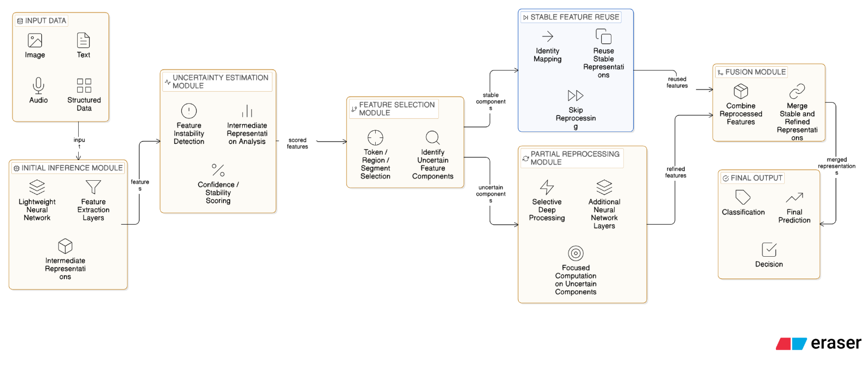

- Description of the invention in detail (Include drawing and or photograph as needed)
The invention describes an adaptive neural network inference architecture that optimizes computational efficiency by selectively applying deeper computation only to uncertain feature components identified during intermediate inference stages.

The system consists of the following modules:

Initial Inference Module
Processes input data using a lightweight neural network and produces intermediate feature representations across multiple layers.

Uncertainty Estimation Module
Computes instability or uncertainty scores for feature elements using inter-layer representation differences, entropy measures, or probabilistic divergence.

Feature Selection Module
Identifies representation components such as tokens, spatial regions, signal segments, or feature dimensions that exhibit high instability.

Partial Reprocessing Module
Applies deeper neural network layers selectively to uncertain components while bypassing stable components.

Representation Reuse Module
Preserves stable intermediate representations in a compatible latent feature space to ensure dimensional consistency between inference stages.

Fusion Module
Combines selectively reprocessed features with reused stable features to generate final predictions.
In one embodiment, feature instability is computed using representation change caused by perturbation of individual feature components:
Uᵢ = || f(x) − f(x\{i}) ||
where f(x) represents the intermediate feature representation of the input and f(x\{i}) represents the representation after removing or masking feature component i. Higher instability values indicate higher uncertainty associated with that component.

The deeper inference stage operates on a sparse subset of representation components, thereby reducing total computational operations.
The architecture can be implemented across various neural network types including convolutional neural networks, transformer networks, recurrent neural networks, and hybrid architectures.

- Experimental validation results:

A proof-of-concept implementation of the proposed selective feature reprocessing architecture was developed to evaluate whether feature-level instability can guide adaptive allocation of computational resources during neural network inference.

The prototype system processes textual input using an initial lightweight model to generate intermediate feature representations. An uncertainty estimation module computes instability scores for individual tokens by measuring changes in representation when tokens are perturbed. Tokens with higher instability values are selectively routed to a deeper processing stage, while stable tokens reuse previously computed representations without reprocessing.

Experimental evaluation was performed using a controlled dataset containing multiple sentence structures with varying semantic complexity. The system dynamically determines whether deeper processing is required for each input based on token-level instability scores.

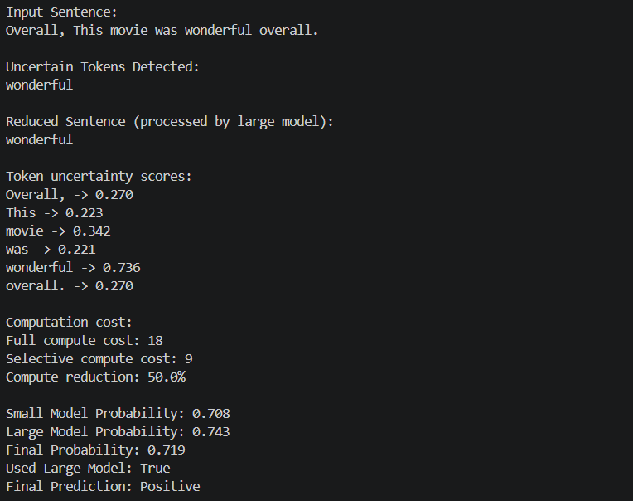
Figure 1: Token-level instability detection and selective routing behavior
It illustrates how the system identifies unstable tokens and selectively forwards only those components for deeper processing. In the example, the token “wonderful” exhibits higher instability compared to other tokens, resulting in selective routing while stable tokens reuse previously computed representations.

Observed results demonstrate:
• selective routing behaviour depending on input complexity
• identification of unstable tokens contributing to prediction uncertainty
• reuse of stable intermediate representations without recomputation
• reduction in estimated computational cost compared to uniform deep processing

Typical experimental observations include:
• unstable tokens per input typically ranged between 0–2 tokens
• selective deeper processing was triggered only when instability exceeded defined threshold
• estimated computational reduction observed in multiple cases due to reuse of stable representations
• system maintained consistent prediction output while reducing redundant computation steps

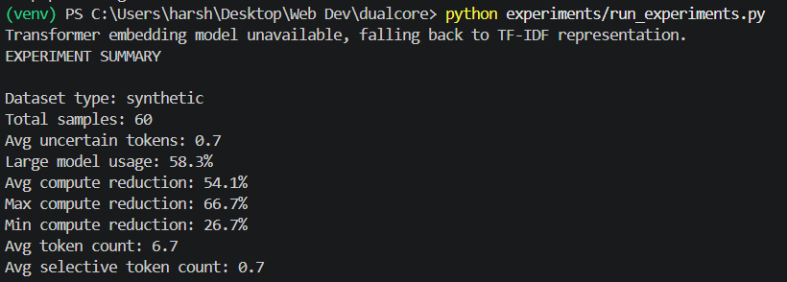
Figure 2: Aggregate experimental evaluation summary
It shows aggregate statistics obtained from experimental evaluation. Results demonstrate that deeper computation is triggered selectively rather than uniformly, achieving measurable reduction in estimated computational cost while maintaining prediction consistency.

To ensure reproducibility and structured evaluation, experimental outputs were also recorded in tabular form including token count, uncertain token count, routing decision, probability scores, and computation reduction metrics.

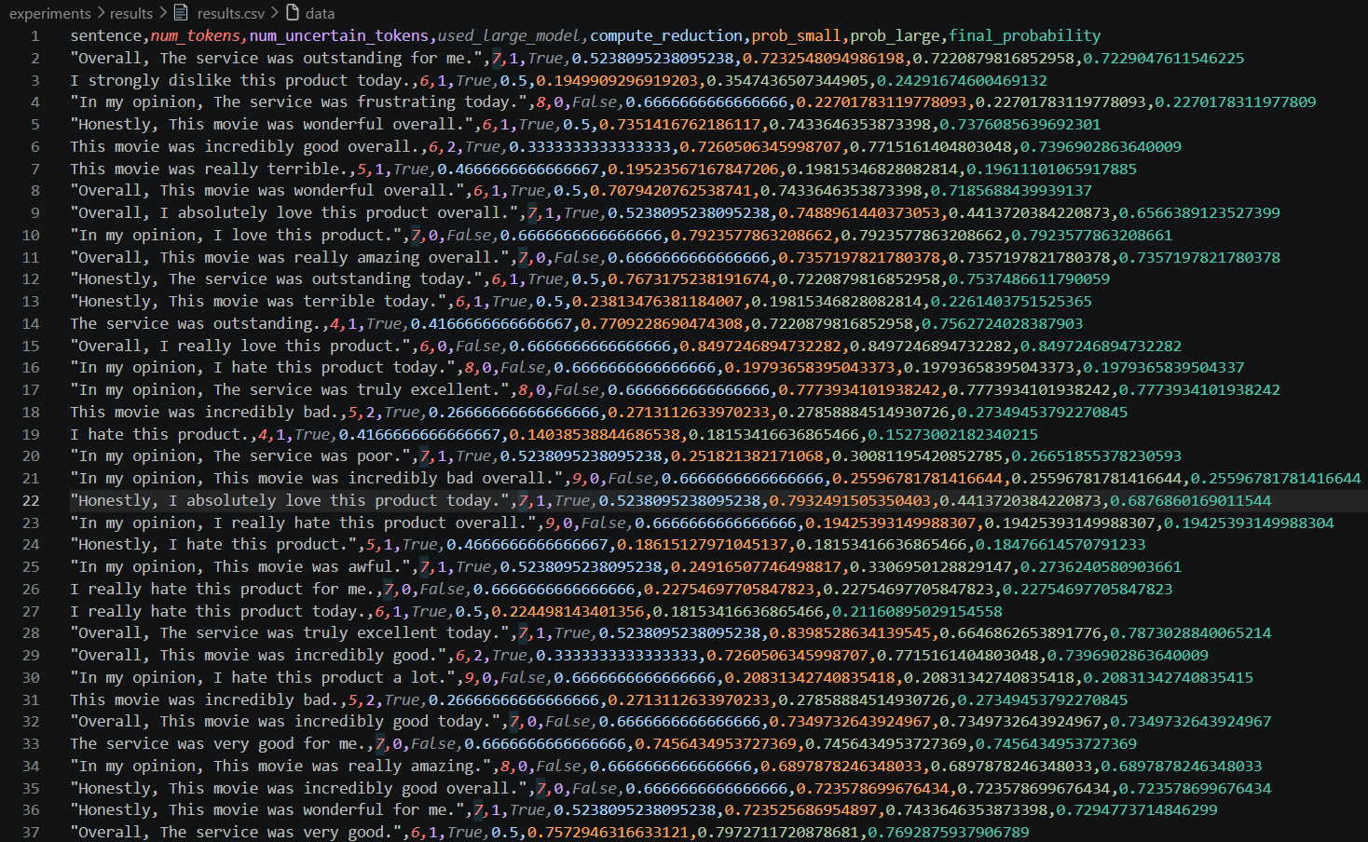
Figure 3: Structured experimental output recorded for reproducibility
It shows structured experimental results stored in tabular format. The recorded outputs demonstrate consistent adaptive routing decisions and computation reduction across multiple inputs.

The experimental results confirm that uncertainty can be localized at feature level and used to selectively allocate deeper reasoning resources only where required. This demonstrates feasibility of the proposed architecture for improving computational efficiency of neural network inference systems.

- What aspect(s) of the invention need(s) protection?
The following aspects require protection:
- Feature-level uncertainty estimation mechanism used to identify unstable intermediate representations.
- Selective partial reprocessing of uncertain representation components using deeper neural network layers.
- Reuse of stable intermediate representations without full re-computation.
- Adaptive allocation of computational resources based on representation instability.
- Sparse computational pathway enabling deeper processing only for selected feature components.
- Fusion mechanism combining selectively reprocessed uncertain features with reused stable representations.
- Overall architecture integrating uncertainty estimation, selective reprocessing, representation reuse, and fusion modules.

 Invention Disclosure Format (IDF)-B | Document No.
 | Issue No/Date
 | Amd. No/Date

- What is Technology readiness level of your invention? (Tick the appropriate TRL)

Research |  |  | Development |  |  | Deployment
TRL 1 | TRL 2 | TRL 3 | TRL 4 | TRL 5 | TRL 6 | TRL 7 | TRL 8 | TRL 9
Basic | Technology | Experimental | Technology | Technology | Technology | System | System | Actual system
Principles | concept | proof of | validated in | validated in a | demonstrated | prototype | complete | proven in an
observed | formulated | concept | a lab | relevant | in a relevant | demonstration | and | operational
 |  |  |  | environment | environment | in an | qualified | environment
 |  |  |  | (industrially | (industrially | operational |  | (competitive
 |  |  |  | relevant in | relevant in | environment |  | manufacturing
 |  |  |  | case of key | case of key |  |  | in case of key
 |  |  |  | enabling | enabling |  |  | enabling
 |  |  |  | technologies) | technologies) |  |  | technologies,
 |  |  |  |  |  |  |  | or in space )
 |  | ✅

----------------------- END OF THE DOCUMENT-----------------------------

