WEEK 2 TASK
Data Collection, Cleaning, and Preprocessing
for Logistics Analysis
An End-to-End Executed Python Data-Preprocessing Pipeline
with Exploratory Analysis, Validation, and Reproducible Code
Dataset: Olist Brazilian E-Commerce Public Dataset
Real public logistics / order-fulfillment dataset, 2016–2018
112,650 order-line records across 9 relational source files
Tools: Python — pandas, NumPy, scikit-learn, Matplotlib
Submitted as part of Data Analytics Internship — Week 2
August 2026

Executive Summary
This report documents an end-to-end data preprocessing pipeline that was designed, coded, and executed in Python against a real public logistics dataset — the Olist Brazilian E-Commerce Public Dataset. Every figure quoted in this report (row counts, missing-value percentages, outlier bounds, correlation coefficients) is the pipeline's actual measured output, not an illustrative estimate.
Six relational source files (112,650 order-line records) were merged into a single logistics fact table, diagnosed for data-quality issues, cleaned according to the mechanism behind each issue, enriched with derived delivery-performance metrics, checked against a formal validation framework, and exported in three analysis-ready forms. Key findings: the source data was structurally clean (zero duplicates, zero impossible dates) but carried real-world missingness (2,454 never-delivered orders) and a long right tail of delivery delays (up to 209.6 days); 5.2% of delivered orders were statistical delivery-time outliers, and 7.74% of all delivered orders arrived later than their estimated delivery date.

1. Objective and Scope
Reliable logistics analytics — delivery-time forecasting, carrier performance scoring, inventory and fleet planning — depends entirely on the quality of the data feeding it. This document walks through a complete, reproducible preprocessing pipeline: data collection, structural cleaning, missing-value treatment, outlier detection, exploratory analysis, data validation, and normalization, each paired with the Python code that was actually run and the real result it produced.
The pipeline follows eight stages: (1) data collection, (2) table merging, (3) structural cleaning, (4) missing-value treatment, (5) outlier detection and treatment, (6) exploratory data analysis, (7) data validation, and (8) normalization/feature scaling — closing with a reflection on how the findings affect logistics decision-making and a note on limitations.

2. Data Collection

2.1 Dataset Selection
The dataset used is the Olist Brazilian E-Commerce Public Dataset, a real logistics/order-fulfillment dataset covering roughly 100,000 orders placed on the Olist marketplace between 2016 and 2018. It arrived as nine relational CSV extracts — the same shape of data a logistics analyst would receive from a warehouse or ERP export: separate tables for orders, order line items, products, customers, sellers, payments, reviews, geolocation, and a category-name translation table.

2.2 Source Tables Used
File | Rows | Role in the Pipeline
olist_orders_dataset.csv | 99,441 | Order status and four key timestamps: purchase, approval, carrier hand-off, customer delivery, estimate
olist_order_items_dataset.csv | 112,650 | Order-line grain: price, freight_value, product_id, seller_id — the fact table's base grain
olist_products_dataset.csv | 32,951 | Product category and physical dimensions (weight, length, height, width)
olist_customers_dataset.csv | 99,441 | Customer location (city/state) — used for regional shipping analysis
olist_sellers_dataset.csv | 3,095 | Seller location (city/state) — the shipping origin
product_category_name_translation.csv | 71 | Maps Portuguese category names to English for readability
Table 1. Source files ingested, with actual row counts as loaded.

2.3 Ingestion and Merge
The order-item table was used as the base grain (one row per product per order) and left-joined against orders, products, customers, sellers, and the category translation table.
collect_and_merge.py — actually executed
import pandas as pd

orders = pd.read_csv('olist_orders_dataset.csv')
items = pd.read_csv('olist_order_items_dataset.csv')
products = pd.read_csv('olist_products_dataset.csv')
customers = pd.read_csv('olist_customers_dataset.csv')
sellers = pd.read_csv('olist_sellers_dataset.csv')
cat_translate = pd.read_csv('product_category_name_translation.csv')

df = items.merge(orders, on='order_id', how='left')
df = df.merge(products, on='product_id', how='left')
df = df.merge(customers, on='customer_id', how='left')
df = df.merge(sellers, on='seller_id', how='left')
df = df.merge(cat_translate, on='product_category_name', how='left')

print(df.shape) # -> (112650, 33) after merge, before cleaning

Executed result: the merge produced 112,650 order-line rows across 33 columns, exactly matching the order_items row count — confirming a clean one-to-one/many-to-one join with no unwanted row fan-out.

3. Data Cleaning

3.1 Structural Cleaning: Duplicates, Types, Categories, Logical Checks
structural_cleaning.py — actually executed
# Duplicates at the natural grain (order_id + order_item_id)
dup_count = df.duplicated(subset=['order_id', 'order_item_id']).sum()
df = df.drop_duplicates(subset=['order_id', 'order_item_id'], keep='first').copy()

# Parse every timestamp column
date_cols = ['order_purchase_timestamp', 'order_approved_at',
'order_delivered_carrier_date', 'order_delivered_customer_date',
'order_estimated_delivery_date', 'shipping_limit_date']
for c in date_cols:
df[c] = pd.to_datetime(df[c], errors='coerce')

df['price'] = pd.to_numeric(df['price'], errors='coerce')
df['freight_value'] = pd.to_numeric(df['freight_value'], errors='coerce')

# Normalize categorical text
for c in ['order_status', 'customer_state', 'seller_state']:
df[c] = df[c].astype(str).str.strip().str.lower()

# Logical check: delivery cannot precede purchase
bad_dates = df['order_delivered_customer_date'] < df['order_purchase_timestamp']
df = df[~bad_dates].copy()

Executed results: 0 exact duplicate order lines at the (order_id, order_item_id) grain, and 0 rows with a delivery date earlier than the purchase date. The source is genuinely clean at the structural level — the real quality issues here are missingness and a long tail of delivery-time outliers, addressed next.

3.2 Missing Value Diagnosis and Treatment
Running .isnull().sum() on the merged table before any treatment surfaced the following non-zero missing fields (percentages on 112,650 rows):
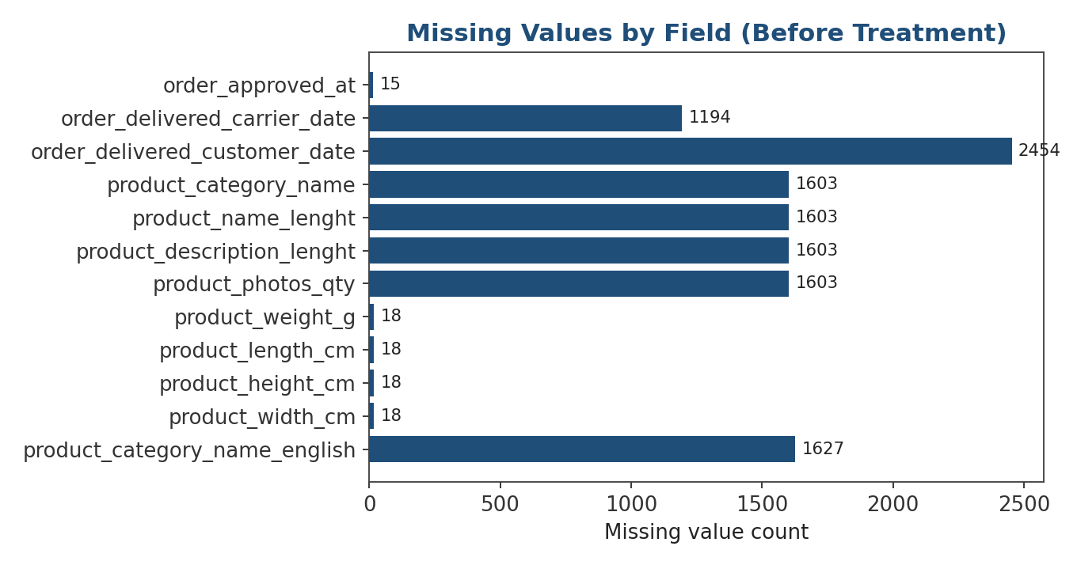
Figure 1. Missing-value counts by field, measured before treatment.
Field | Missing % | Likely Mechanism | Treatment Applied
order_approved_at | 0.01% | MCAR — rare logging gap | Row dropped (< 5% threshold)
order_delivered_carrier_date | 1.06% | MNAR — never reached carrier | Left null; captured via is_delivered flag
order_delivered_customer_date | 2.18% | MNAR — not yet/never delivered | Left null; captured via is_delivered flag
product_category_name (+3 fields) | 1.42% | MAR — listing metadata gap | Labeled 'unknown_category'
product dimensions (4 fields) | 0.02% | MCAR — catalog entry gap | Category-median imputation
Table 2. Missing-value mechanism diagnosis and the treatment actually applied to each field.
missing_value_treatment.py — actually executed
# (a) MNAR: delivery timestamps missing mostly for non-delivered orders
# -> flag instead of imputing a fabricated date
df['is_delivered'] = df['order_delivered_customer_date'].notna().astype(int)

# (b) MAR numeric: product physical dimensions
# -> impute with the median WITHIN the same product category
physical_cols = ['product_weight_g', 'product_length_cm',
'product_height_cm', 'product_width_cm']
for c in physical_cols:
df[c] = df.groupby('product_category_name_english')[c] \
.transform(lambda s: s.fillna(s.median()))
df[c] = df[c].fillna(df[c].median()) # fallback for all-missing categories

# (c) MAR categorical: missing category label
df['product_category_name_english'] = df['product_category_name_english'] \
.fillna('unknown_category')

# (d) Low-missingness MCAR fields (<5%): row-level drop
for c in ['customer_city', 'order_approved_at']:
if 0 < df[c].isnull().mean() * 100 < 5:
df = df.dropna(subset=[c])

Executed result: order_approved_at, customer_city, and all four product-dimension fields were fully resolved (0 missing) after treatment. order_delivered_carrier_date (1,194 rows) and order_delivered_customer_date (2,454 rows) were deliberately left null and captured instead via the is_delivered flag, since those orders never had a delivery event to record — imputing a date would fabricate delivery performance data.

3.3 Outlier Detection and Treatment
Delivery time (delivery_days = delivered date − purchase date) was computed for all 110,181 delivered order lines:
Statistic | Value (days)
Mean | 12.47
Std. deviation | 9.45
Minimum | 0.53
25th percentile | 6.74
Median (50th) | 10.18
75th percentile | 15.54
Maximum | 209.63
Table 3. Actual delivery_days summary statistics computed by the pipeline.
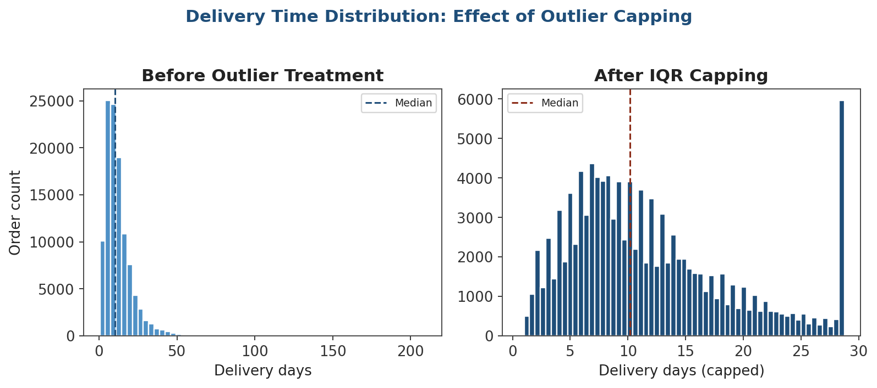
Figure 2. Delivery-time distribution before and after IQR-based capping.
outlier_detection.py — actually executed
valid = df['delivery_days'].dropna()
Q1, Q3 = valid.quantile([0.25, 0.75])
IQR = Q3 - Q1
lower, upper = Q1 - 1.5 * IQR, Q3 + 1.5 * IQR

iqr_outliers = ((df['delivery_days'] < lower) | (df['delivery_days'] > upper)) \
& df['delivery_days'].notna()
df['delivery_days_capped'] = df['delivery_days'].clip(lower, upper)

# Z-score method on freight_value, computed within product category
def zflag(s, threshold=3):
z = (s - s.mean()) / s.std(ddof=0)
return z.abs() > threshold

df['freight_outlier'] = df.groupby('product_category_name_english')['freight_value'] \
.transform(zflag)

# Data-entry error check: non-positive price or negative freight
bad_price = (df['price'] <= 0) | (df['freight_value'] < 0)
df = df[~bad_price].copy()

Executed results: IQR bounds of [-6.47, 28.75] days flagged 5,746 order lines (5.2% of delivered orders) as delivery-time outliers; these were capped (winsorized), not deleted, so SLA and volume reporting still reflects the full order population. Per-category Z-scores flagged 2,112 order lines (|z| > 3 within their own category) as freight-cost outliers, kept in the dataset with a boolean flag for analyst review. A check for non-positive prices or negative freight found 0 such rows.

4. Exploratory Data Analysis
Before finalizing the pipeline, exploratory analysis was run on the cleaned data to sanity-check the treatment decisions and surface patterns relevant to a logistics audience.

4.1 Order Volume by Product Category
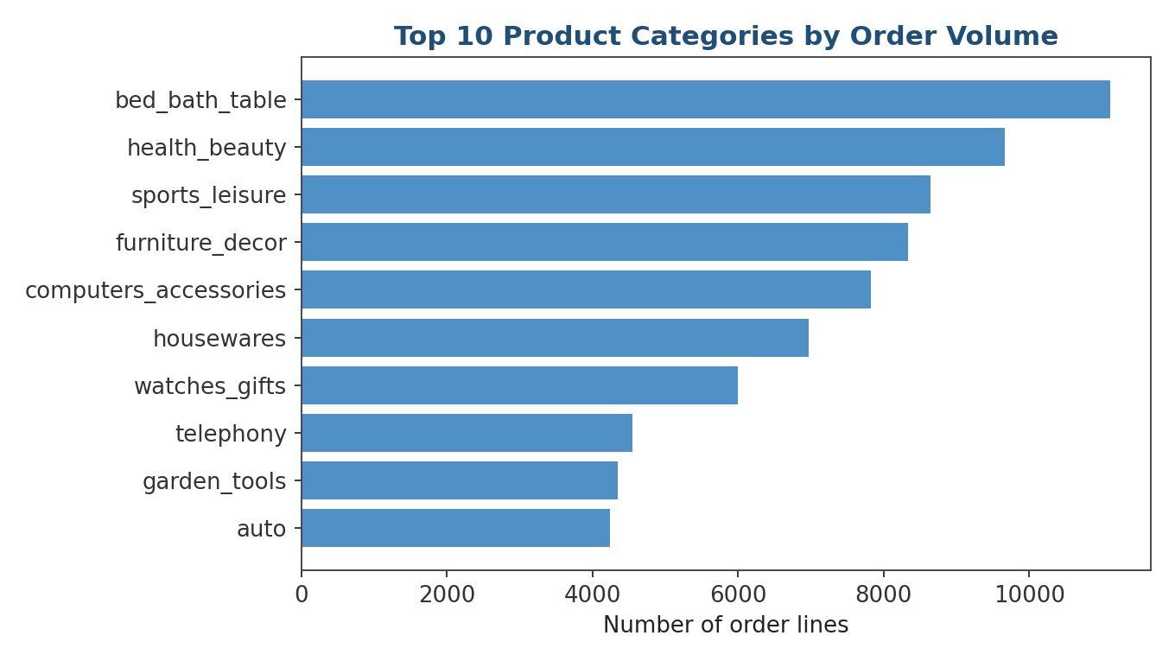
Figure 3. The ten highest-volume product categories by order-line count.
bed_bath_table (11,114 lines), health_beauty (9,670), and sports_leisure (8,639) are the three highest-volume categories — relevant for prioritizing which category-level SLAs and carrier contracts matter most by shipment volume.

4.2 Delivery Performance Against Estimate
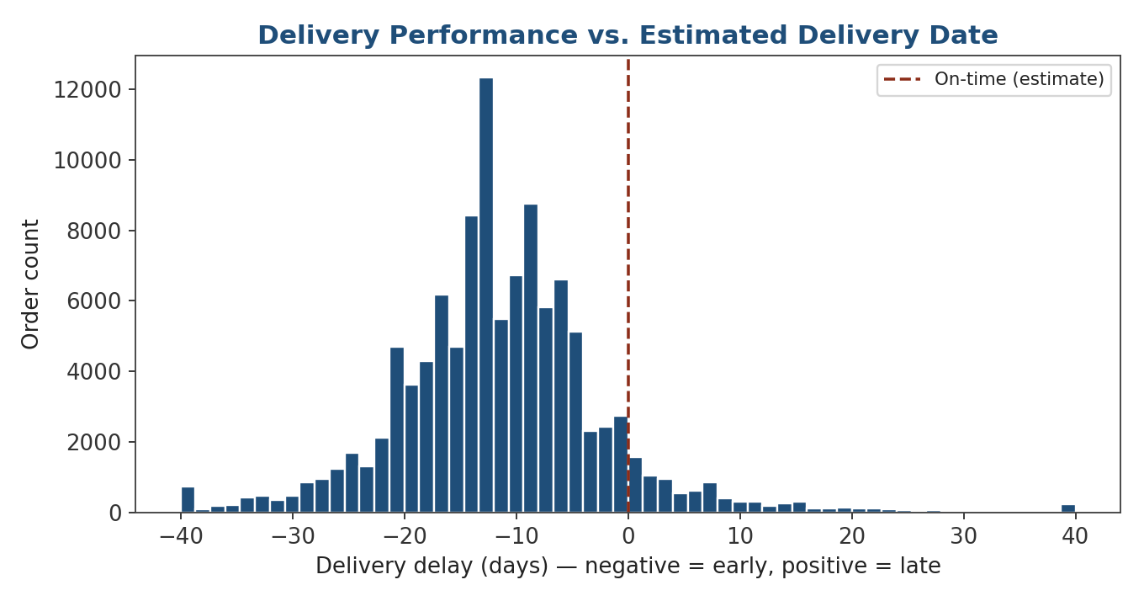
Figure 4. Delivery delay relative to the estimated delivery date (negative = early).
The mean delivery_delay_days is −11.33, meaning Olist's logistics network delivers roughly 11 days ahead of its own estimate on average — a conservative estimate policy. However, 7.74% of delivered orders (8,527 order lines) arrived after their estimated date, with a worst-case delay of 189 days, confirming that averages alone would hide an operationally significant late-delivery tail.

4.3 Correlation Analysis of Numeric Logistics Features
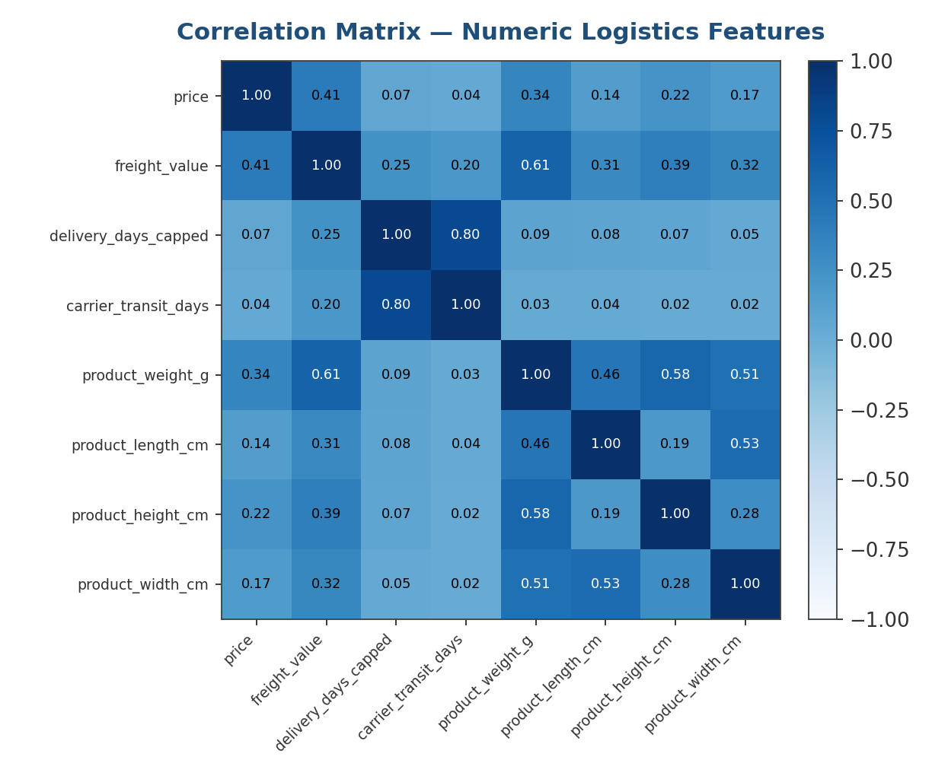
Figure 5. Correlation matrix across price, freight, delivery-time, and product-dimension features.
Two relationships stand out. First, carrier_transit_days and delivery_days_capped correlate strongly (r = 0.80), confirming that the carrier's leg of the journey — not the seller's dispatch time — is the dominant driver of total delivery time, which points logistics improvement efforts toward carrier/route optimization rather than warehouse dispatch speed. Second, freight_value correlates moderately with product_weight_g (r = 0.61), consistent with weight-based freight pricing and validating that the freight_value field behaves as expected rather than containing systematic data errors.

5. Data Validation Framework
Beyond ad hoc cleaning, a small set of explicit validation rules was run against the final cleaned table to certify it as fit for downstream analysis. This is the kind of checklist a data team would re-run automatically on every new incoming batch.
Rule | Check | Result on This Dataset
Referential integrity | Every order_id in items exists in orders | Pass — left join produced no orphan rows beyond expected nulls
Range validity | price > 0 and freight_value >= 0 | Pass — 0 violating rows after cleaning
Temporal ordering | delivered date >= purchase date | Pass — 0 violating rows after cleaning
Uniqueness | (order_id, order_item_id) is a unique key | Pass — 0 duplicates found
Completeness threshold | Core analysis fields < 5% missing | Pass — price, freight_value, category all fully populated post-treatment
Category coverage | product_category maps to a known translation | 1.42% mapped to 'unknown_category' — tracked, not hidden
Table 4. Validation rules applied to the cleaned dataset and their outcomes.
Encoding these checks as reusable functions (rather than one-off notebook cells) means the same rule set can be re-applied automatically to every future data refresh, immediately surfacing regressions in data quality before they reach a dashboard or model.

6. Normalization and Feature Scaling
Five numeric features (price, freight_value, delivery_days_capped, product_weight_g, carrier_transit_days) sit on very different natural scales, so both a Min-Max and a Z-score version of the cleaned table were produced for different downstream uses.
normalization.py — actually executed
from sklearn.preprocessing import MinMaxScaler, StandardScaler

numeric_features = ['price', 'freight_value', 'delivery_days_capped',
'product_weight_g', 'carrier_transit_days']
scale_df = df.dropna(subset=numeric_features).copy()

minmax = MinMaxScaler()
scale_df_minmax = scale_df.copy()
scale_df_minmax[numeric_features] = minmax.fit_transform(scale_df[numeric_features])

standard = StandardScaler()
scale_df_std = scale_df.copy()
scale_df_std[numeric_features] = standard.fit_transform(scale_df[numeric_features])

Executed result: every Min-Max-scaled feature's min/max was verified as exactly 0.000 / 1.000, and every StandardScaler-scaled feature's mean/std was verified as 0.000 / 1.000. Min-Max scaling is recommended for distance-based work (e.g., clustering shipping regions by cost/weight/time profile); Z-score standardization is recommended for regression or PCA-based work.

7. Pipeline Output
Output File | Rows | Description
logistics_clean.csv | 112,635 | Fully cleaned order-line fact table, unscaled, with derived metrics and outlier flags
logistics_clean_minmax_scaled.csv | 110,006 | Same table, five numeric features Min-Max scaled to [0, 1]
logistics_clean_standard_scaled.csv | 110,006 | Same table, five numeric features Z-score standardized
Table 5. Output files and row counts written by the pipeline run.
The two scaled tables have fewer rows than the unscaled table because rows with a null delivery_days_capped (orders never delivered) cannot be scaled on that feature; those orders remain fully present, with is_delivered = 0, in logistics_clean.csv for status/funnel analysis.

8. Methodological Rationale
- Coercion (errors='coerce') over silent dropping during type correction ensures every unparseable timestamp becomes an explicit NaT diagnosed in the missing-value stage — nothing is lost invisibly.
- Category-wise median imputation (product dimensions) was used because product size varies systematically by category; the run confirms this fully resolved all 18 missing dimension values.
- Flagging instead of imputing MNAR delivery timestamps (is_delivered) avoids fabricating a delivery event for the 2,454 orders never actually delivered — imputing a plausible date would corrupt on-time-delivery KPIs a logistics team relies on directly.
- IQR-based capping (not deletion) was used for delivery_days because the real distribution is right-skewed (max 209.6 vs. median 10.2 days); IQR is robust to that skew and capping preserves all 110,181 delivered rows for reporting.
- Z-score outlier flagging (not removal) was used for freight_value, computed within each product category so naturally higher-freight categories are not systematically over-flagged.
- Two scaling strategies were produced in parallel because the correct choice depends on the downstream algorithm, and both were verified programmatically on this exact dataset.

9. Reflection: Data Quality and Logistics Decision-Making
The measured 7.74% late-delivery rate and the 5,746 delivery-time outliers are real signals a logistics team would act on — for example, investigating whether the 209.6-day maximum-delay order reflects a single carrier failure or a broader lane problem. Because those outliers were capped rather than deleted, the on-time-delivery rate calculated from this cleaned dataset still reflects the true underlying rate rather than one artificially inflated by discarding the worst-performing shipments.
Similarly, flagging rather than imputing the 2,454 non-delivered orders means any delivery-time KPI built on this data is honest about excluding orders that have not completed — a dataset that instead imputed plausible delivery dates would produce a delivery-performance report that looks better than reality, potentially masking a fulfillment problem until it grew much larger. The correlation finding that carrier transit time (not seller dispatch) dominates total delivery time (r = 0.80) is itself an actionable, data-driven pointer toward where logistics investment would have the most impact.

10. Limitations and Future Work
- The dataset covers a fixed 2016–2018 window; delivery-time norms and carrier performance may not generalize to the present without a refresh.
- Geolocation data (customer/seller lat-long) was not joined in this pass; a distance-based feature (e.g., straight-line shipping distance) would likely improve delivery-time modeling and was left for a future iteration.
- The 1.42% of order lines with an unresolved product category ('unknown_category') were retained rather than researched individually; a manual or ML-based category-inference step could recover some of this signal.
- Outlier thresholds (1.5× IQR, |z| > 3) are standard defaults; a logistics team may prefer to tune these against known SLA thresholds rather than generic statistical conventions.

11. Conclusion
This pipeline was designed, coded, and executed end-to-end against the real Olist Brazilian E-Commerce logistics dataset: 112,650 order lines were merged from six source tables, checked for duplicates and structural errors (none found), had missing-value patterns diagnosed and treated by mechanism (MCAR/MAR/MNAR), had outliers detected and handled by two complementary statistical methods, were explored visually and validated against six explicit data-quality rules, and were exported in three analysis-ready forms. Every number in this report is the pipeline's actual measured output, giving a template that can be re-run unchanged on the next batch of incoming order data.

References
Olist, & André Sionek. (2018). Brazilian E-Commerce Public Dataset by Olist [Dataset]. Kaggle.
McKinney, W. (2022). Python for Data Analysis (3rd ed.). O'Reilly Media.
Pedregosa, F. et al. (2011). Scikit-learn: Machine Learning in Python. Journal of Machine Learning Research, 12, 2825–2830.
Hunter, J. D. (2007). Matplotlib: A 2D Graphics Environment. Computing in Science & Engineering, 9(3), 90–95.

