**GROUP MEMBERS:**

* Harshit Singhania(55)
* Aakash Singh(54)
* Parth Kitawat(22)

**CLASS DIAGRAM:**

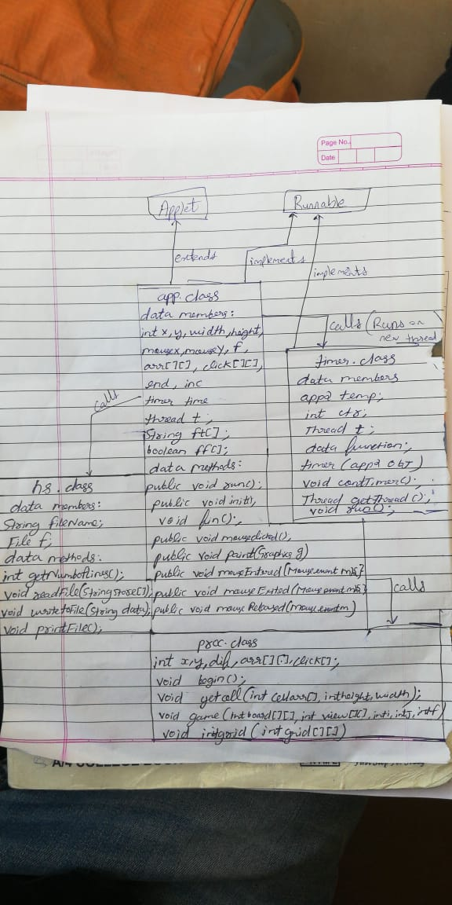

***PROCEDURE:***

* The grid is initialized in the begin method of proc class
* The begin method calls initgrid() to randomly place mines and initialize the grid
* This grid is displayed by repaint()
* A timer begins now
* Then on mouseClick the game progresses by calling getCell() and game()
* At the end by readFile and writeToFile methods the previous scores are dsplayed, these are in hs classs
* The file io methods are wrapped in an accessController methods because applets by default don’t have the permissions to write to the file system, in addition to this the following command must be run to run the applet $*appletviewer -J-Djava.security.policy=mypol apphtml.html*
* mypol is a policy file to allow write permissions to the applet

**SCREENSHOTS:**

