CoreInventory
Inventory Management System
Product Requirements Document (PRD)

Field | Value | Field | Value
Version | 1.0 | Status | Draft
Date | 2025 | Owner | Product Team
Document | PRD | Product | CoreInventory IMS

1. Product Overview
CoreInventory is a modular, cloud-ready Inventory Management System (IMS) that digitizes and centralizes all stock-related operations. It replaces manual registers, spreadsheets, and fragmented tracking methods with a single real-time, role-based platform supporting receipts, deliveries, internal transfers, and stock adjustments across multiple warehouses.

The system is intended for two primary user roles:
- Inventory Manager — oversees stock operations, approves documents, manages catalog and warehouse settings.
- Warehouse Staff — executes day-to-day operations: picking, packing, shelving, counting, and transfer execution.

2. UI Mockup Reference
The following wireframe (exported from Excalidraw) illustrates the full screen layout and navigation flow of CoreInventory as designed in the discovery phase.

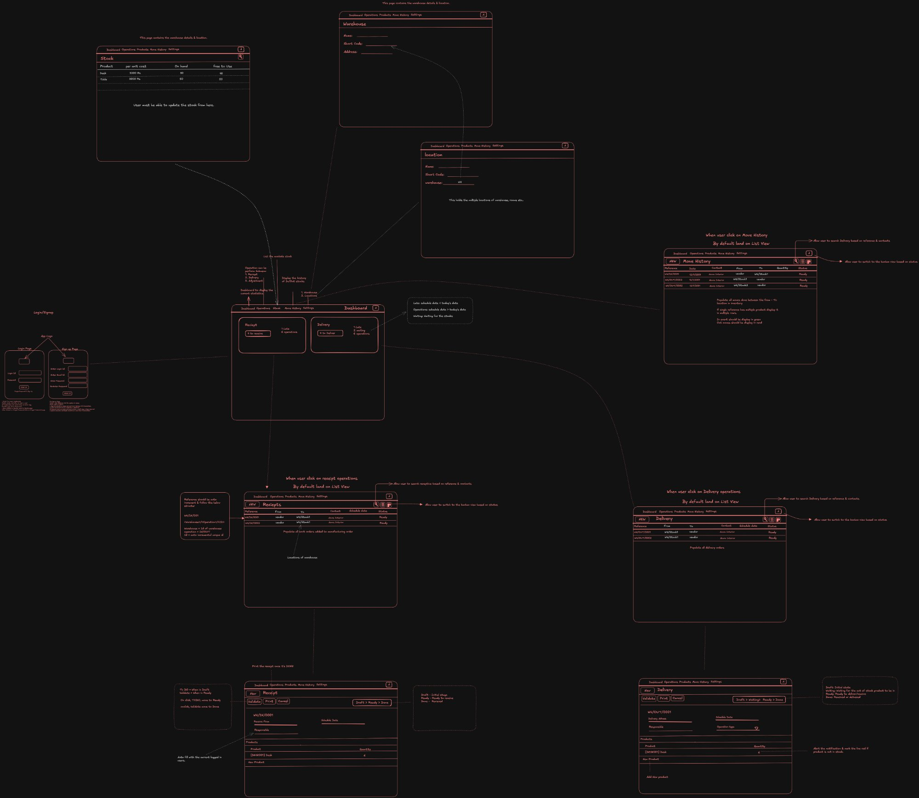
Figure 1 — CoreInventory Full Wireframe (Excalidraw)

3. Business Goals & Success Metrics

3.1 Business Goals
- Eliminate manual stock tracking errors and data silos.
- Provide real-time visibility into stock levels across all warehouse locations.
- Accelerate goods receipt and dispatch workflows.
- Enable proactive low-stock management through automated alerts.
- Maintain a comprehensive, tamper-evident audit trail for all inventory movements.

3.2 Success Metrics
Metric | Target
Stock discrepancy rate | < 1% after 3 months go-live
Receipt processing time | Reduced by ≥ 60%
Low-stock alert response | < 24 hours
User adoption (warehouse staff) | > 90% within 1 month
System uptime | 99.5% SLA

4. Target Users & Personas

4.1 Inventory Manager
Goal: Full operational control. Needs high-level KPI dashboards, document approval flows, reorder rule configuration, and multi-warehouse reporting. Typically office-based; uses desktop browser.

4.2 Warehouse Staff
Goal: Execute day-to-day tasks efficiently. Needs fast access to receipts, deliveries, and transfers; must be able to validate operations and adjust stock. Often tablet- or mobile-based on the warehouse floor.

5. Feature Requirements

5.1 Authentication
- Email/password sign-up and login.
- OTP-based password reset via registered email or phone.
- Role-based access control: Inventory Manager vs. Warehouse Staff.
- Secure JWT session management; auto-logout after inactivity.

5.2 Inventory Dashboard
The primary landing page after login. Displays a real-time operational snapshot with KPI cards and a filterable operations list.

KPI Cards
- Total Products in Stock
- Low Stock / Out-of-Stock Items (with configurable threshold per product)
- Pending Receipts — count of receipts in Draft or Waiting state
- Pending Delivery Orders
- Internal Transfers Scheduled

Filters on Operations List
- By document type: Receipts, Delivery Orders, Internal Transfers, Adjustments
- By status: Draft → Waiting → Ready → Done → Canceled
- By warehouse or location
- By product category

5.3 Product Management
- Create, view, edit, and soft-delete products.
- Product fields: Name, SKU/Code, Category, Unit of Measure, Initial Stock (optional).
- Stock availability view per warehouse location.
- Product category management — create, rename, delete.
- Reordering rules: minimum threshold quantity and preferred reorder quantity per product.

5.4 Receipts — Incoming Stock
Records goods arriving from external vendors. Stock increases automatically on validation.

Step | Action | System Behavior
1 | Create new receipt | Draft generated with auto-incremented receipt number
2 | Add supplier & products | Supplier lookup; SKU/name product search
3 | Input received quantities | Editable quantity field per line item
4 | Validate | Stock increases automatically; ledger entry created; status → Done

5.5 Delivery Orders — Outgoing Stock
Manages stock leaving the warehouse for customer shipments. Stock decreases automatically on validation.

- Pick items from assigned source location.
- Pack items — system generates packing reference.
- Validate delivery — stock decreases; ledger updated; status → Done.
- Status lifecycle: Draft → Waiting → Ready → Done / Canceled.

5.6 Internal Transfers
- Move stock between any two configured internal locations.
- Total stock quantity unchanged; per-location balances updated in real time.
- Supports: Main Warehouse → Production Floor, Rack A → Rack B, Warehouse 1 → Warehouse 2.
- Every movement logged in the Stock Ledger with source, destination, quantity, and operator.

5.7 Stock Adjustments
- Select product and location.
- Enter physically counted quantity.
- System calculates and applies the delta (positive increase or negative decrease).
- Adjustment reason is mandatory: Damage, Loss, Counting Error, Found Goods, Other.
- Auto-updates stock and appends a ledger entry.

5.8 Move History (Stock Ledger)
- Chronological log of all movements: receipts, deliveries, transfers, adjustments.
- Filterable by product, location, date range, document type, and operator.
- Default view loads today's data; Operations tab shows today's data.
- Export to CSV or PDF for external reporting.

5.9 Warehouse & Location Settings
- Create and configure multiple warehouses (Name, Short Code, Address).
- Define sub-locations within each warehouse (Racks, Floors, Shelves).
- Assign default receiving and shipping locations per warehouse.

5.10 Alerts & Notifications
- In-app alerts triggered when stock falls below configured threshold.
- Notification badge on the dashboard and nav menu.
- Configurable per-product or per-category thresholds.

6. Application Navigation Structure
Based on the wireframe, the navigation is structured as follows:

Nav Item | Sub-items | Access Role
Dashboard | KPIs, Receipts, Deliveries, Transfers summary | Both
Operations | Receipts, Delivery Orders, Internal Transfers, Adjustments | Both
Products | Product list, Categories, Reorder Rules | Manager
Move History | Stock ledger, Filters | Both
Settings | Warehouse, Location | Manager
Profile Menu | My Profile, Logout | Both

7. Non-Functional Requirements
Category | Requirement
Performance | Dashboard loads < 2 s; list views < 3 s on standard broadband.
Scalability | Support up to 10,000 SKUs and 50 warehouse locations per tenant.
Security | HTTPS everywhere; bcrypt passwords; JWT sessions; RBAC enforced server-side.
Usability | Mobile-responsive UI; WCAG 2.1 AA compliant; tablet-optimized for warehouse use.
Reliability | 99.5% uptime SLA; daily automated backups; rollback capability.
Auditability | All mutations logged with user ID, timestamp, before/after values.
Localization | Support for multiple units of measure and date formats.

8. Out of Scope — v1.0
- ERP or e-commerce platform integration (planned v2.0).
- Barcode / QR scanner hardware integration.
- Automated purchase order generation.
- Financial accounting, costing, or invoicing.
- Supplier or customer portal access.

9. Assumptions & Constraints
- Single tenant per deployment in v1.0.
- Internet connectivity required; no offline mode in v1.0.
- Users have basic digital literacy; no special training required beyond onboarding.
- Product data (name, SKU, category) is provided by the client during onboarding.

10. Risks & Mitigations
Risk | Likelihood | Impact | Mitigation
Resistance to adoption by warehouse staff | Medium | High | Simple UI; training sessions; champion users
Data migration from Excel sheets | Medium | Medium | Provide CSV import template; guided migration
Multi-warehouse sync conflicts | Low | High | Optimistic locking; server-side conflict resolution
Low-stock threshold misconfiguration | Medium | Medium | Default thresholds + alert test feature

