CoreInventory
Inventory Management System
Technical Requirements Document (TRD)

Field | Value | Field | Value
Version | 1.0 | Status | Draft
Audience | Engineering Team | Date | 2025
Product | CoreInventory IMS | Stack | React · Node.js · PostgreSQL

1. Technical Overview
CoreInventory is a web-based SaaS application built on a RESTful API backend and a React single-page application (SPA) frontend. It adopts a layered MVC architecture on the server, with PostgreSQL as the primary relational data store. All inventory operations are transactional to ensure data consistency across concurrent users.

2. Screen & Wireframe Reference
The wireframe below (from Excalidraw) is the authoritative UI reference for all frontend implementation work. Each labeled frame maps to a route and component described in Section 6.

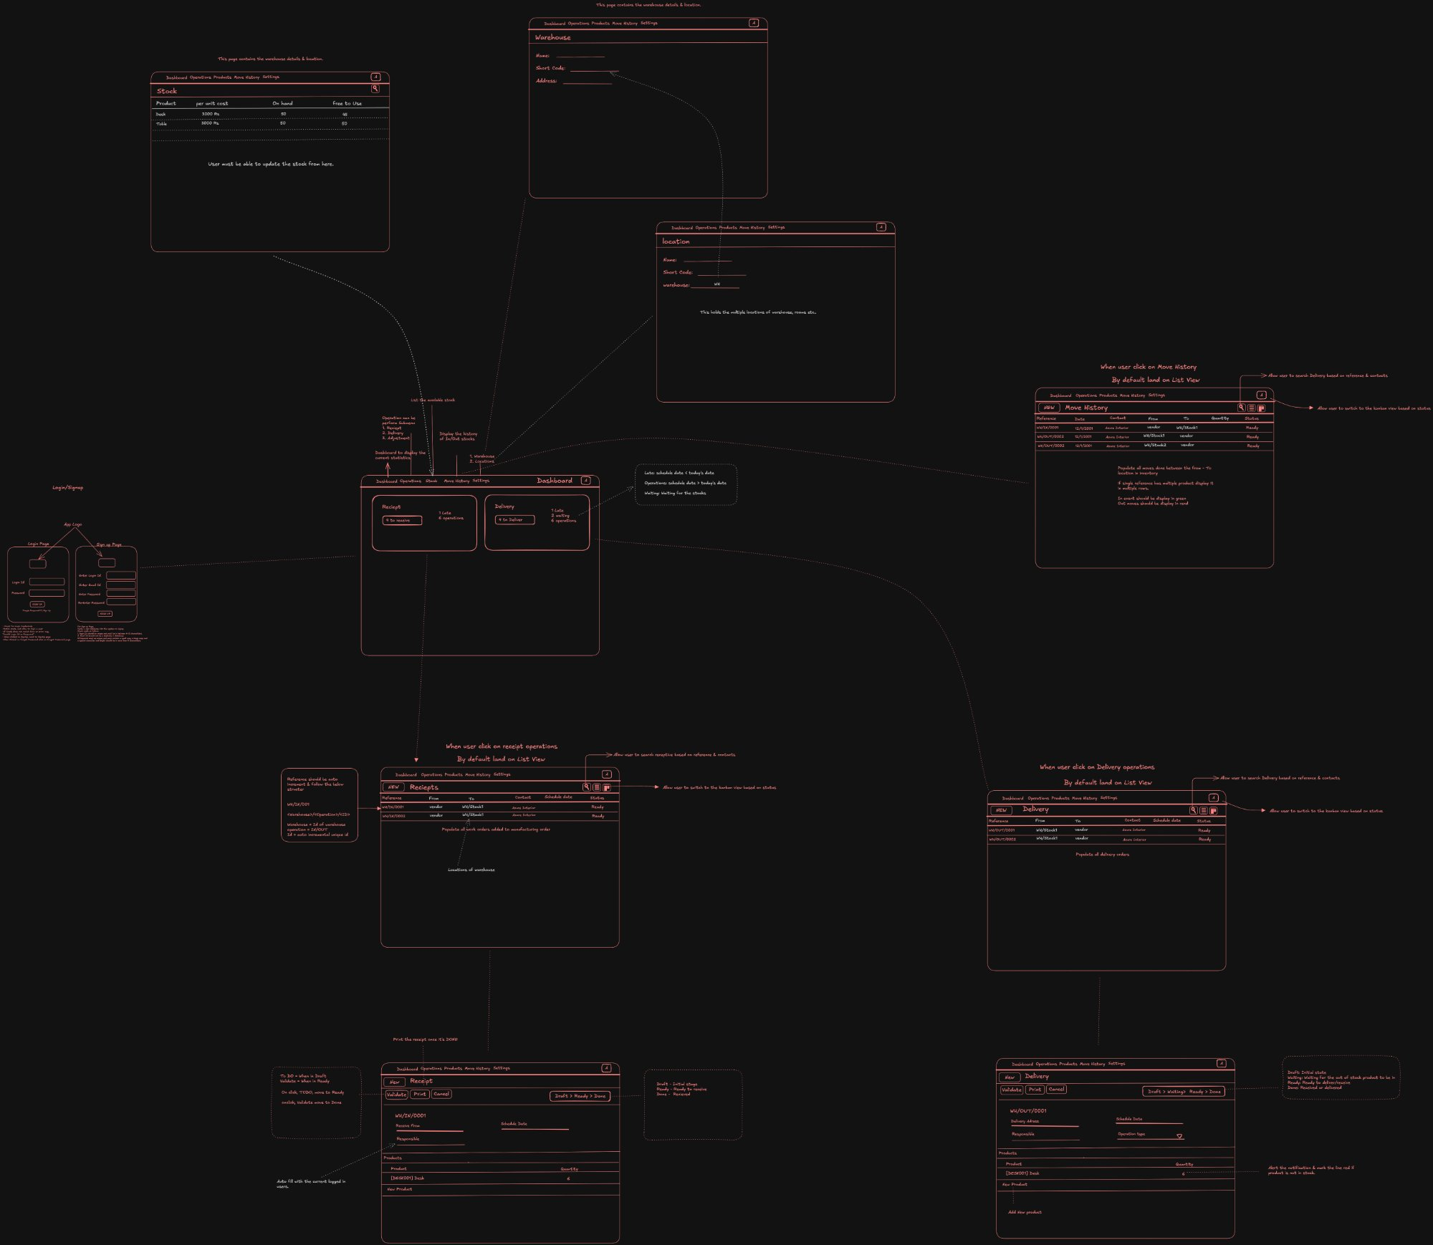
Figure 1 — CoreInventory Wireframe (Excalidraw export)

3. Technology Stack
Layer | Technology | Rationale
Frontend | React 18 + TypeScript | Component reusability; type safety; large ecosystem
UI Library | Tailwind CSS + shadcn/ui | Rapid styling; accessible headless components
State Management | Zustand / React Query | Server-state caching; optimistic updates
Backend | Node.js + Express.js | Non-blocking I/O; JSON-native; easy REST API
ORM | Prisma | Type-safe DB queries; auto-migration support
Database | PostgreSQL 15 | ACID transactions; relational integrity; JSON columns
Auth | JWT + bcrypt | Stateless auth; secure password hashing
File Export | PDFKit + csv-writer | Server-side PDF/CSV generation for ledger exports
Hosting | Docker containers on cloud (AWS/GCP) | Portable; horizontally scalable
CI/CD | GitHub Actions | Automated test + deploy pipeline

4. Database Schema
All tables use UUID primary keys. Soft deletes (deleted_at timestamp) are used for products, warehouses, and locations. All monetary/quantity fields use NUMERIC(12,4) for precision.

4.1 Core Tables
Table | Key Columns | Notes
users | id, email, password_hash, role, created_at | Roles: manager | staff
warehouses | id, name, short_code, address, deleted_at | Multi-warehouse support
locations | id, warehouse_id, name, short_code, warehouse_id (FK) | Sub-location within a warehouse
products | id, name, sku, category_id, uom, reorder_min, reorder_qty, deleted_at | Soft-deletable
categories | id, name, deleted_at | Product categories
stock_levels | id, product_id, location_id, quantity | Current stock per product-location
receipts | id, reference, supplier, status, created_by, validated_at | Status enum: draft|waiting|ready|done|canceled
receipt_lines | id, receipt_id, product_id, expected_qty, received_qty | Line items per receipt
deliveries | id, reference, customer, status, created_by, validated_at | Same status enum
delivery_lines | id, delivery_id, product_id, qty | Line items per delivery
transfers | id, reference, from_location_id, to_location_id, status, created_by | Internal transfer header
transfer_lines | id, transfer_id, product_id, qty | Line items per transfer
adjustments | id, reference, product_id, location_id, counted_qty, delta, reason, created_by | Stock adjustment record
stock_ledger | id, product_id, location_id, document_type, document_id, delta, balance_after, created_by, created_at | Immutable audit log

4.2 Ledger Design
The stock_ledger table is append-only (no updates or deletes). Every stock mutation — receipt validation, delivery validation, transfer completion, adjustment — writes one or more ledger rows. balance_after is the running stock total for that product-location at the time of the event.

5. API Design
All endpoints are prefixed with /api/v1. Authentication uses Bearer JWT tokens in the Authorization header. Responses follow the JSON:API envelope: { data, meta, errors }.

5.1 Authentication Endpoints
Method | Endpoint | Description | Auth
POST | /auth/register | Create new user account | None
POST | /auth/login | Authenticate; returns JWT | None
POST | /auth/request-otp | Send OTP for password reset | None
POST | /auth/reset-password | Validate OTP and set new password | None
POST | /auth/logout | Invalidate refresh token | Bearer

5.2 Product Endpoints
Method | Endpoint | Description
GET | /products | List all products (paginated, filterable)
POST | /products | Create product
GET | /products/:id | Get product detail + stock by location
PUT | /products/:id | Update product
DELETE | /products/:id | Soft-delete product
GET | /products/:id/stock | Stock availability per location
GET | /categories | List product categories
POST | /categories | Create category

5.3 Operations Endpoints
Method | Endpoint | Description
GET | /receipts | List receipts (filter by status, date, supplier)
POST | /receipts | Create receipt (Draft)
GET | /receipts/:id | Get receipt detail with lines
PUT | /receipts/:id | Update receipt (Draft/Waiting only)
POST | /receipts/:id/validate | Validate receipt → stock increases
GET | /deliveries | List delivery orders
POST | /deliveries | Create delivery order
POST | /deliveries/:id/validate | Validate delivery → stock decreases
GET | /transfers | List internal transfers
POST | /transfers | Create internal transfer
POST | /transfers/:id/validate | Complete transfer → update locations
GET | /adjustments | List stock adjustments
POST | /adjustments | Create and apply adjustment

5.4 Reporting & Ledger Endpoints
Method | Endpoint | Description
GET | /ledger | Full stock ledger (filterable by product, location, date, type)
GET | /ledger/export | Export ledger as CSV or PDF
GET | /dashboard/kpis | Dashboard KPI aggregates
GET | /warehouses | List warehouses
POST | /warehouses | Create warehouse
GET | /warehouses/:id/locations | Locations for a warehouse
POST | /locations | Create location

6. Frontend Architecture

6.1 Route Map
Route | Component | Description | Wireframe Frame
/login | LoginPage | Login form | Login/Signup (left)
/signup | SignupPage | Registration form | Login/Signup (left)
/dashboard | Dashboard | KPI cards + operations list | Dashboard center frame
/receipts | ReceiptList | Paginated receipt list | Receipts list view
/receipts/:id | ReceiptDetail | Receipt form; Validate/Print/Cancel | Single Receipt form (bottom-left)
/deliveries | DeliveryList | Paginated delivery order list | Delivery list view
/deliveries/:id | DeliveryDetail | Delivery form; Validate | Single Delivery form (bottom-right)
/transfers | TransferList | Internal transfer list | —
/adjustments | AdjustmentForm | Stock adjustment form | —
/move-history | MoveHistory | Stock ledger with filters | Move History list view
/products | ProductList | Product catalog | —
/settings/warehouses | WarehouseSettings | Warehouse CRUD | Warehouse settings frame
/settings/locations | LocationSettings | Location CRUD | Location settings frame
/profile | UserProfile | Profile and password change | —

6.2 State Architecture
- React Query handles all server state (fetch, cache, invalidate on mutation).
- Zustand store manages UI state: sidebar open/close, active filters, modal state.
- Auth state (user, token) persisted in memory + httpOnly cookie for refresh token.
- Optimistic updates applied for status transitions to improve perceived performance.

6.3 Key UI Components
Component | Reuse | Description
<KPICard /> | Dashboard | Displays label, count, trend icon; clickable to filtered list
<OperationsTable /> | Dashboard, Lists | Sortable, filterable data table with status badges
<StatusBadge /> | All lists | Color-coded pill: Draft(gray) Waiting(yellow) Ready(blue) Done(green) Canceled(red)
<DocumentForm /> | Receipt/Delivery/Transfer | Generic form wrapper: header fields + line items table + action bar
<LineItemRow /> | DocumentForm | Editable row: product search, quantity input, delete
<StockLedgerTable /> | Move History | Virtualized table for large ledger datasets
<AlertBanner /> | Nav/Dashboard | Low-stock alert notification strip
<FilterBar /> | All list views | Multi-select filters: type, status, location, category, date range

7. Core Business Logic

7.1 Stock Mutation Flow
Every stock change (receipt, delivery, transfer, adjustment) follows this transactional sequence:
- Begin database transaction.
- Validate document status (must be in correct state for the action).
- For each line item: UPDATE stock_levels SET quantity = quantity + delta WHERE product_id AND location_id.
- INSERT one row into stock_ledger per line item.
- UPDATE document status to Done (or appropriate terminal state).
- Commit transaction. On any error: rollback entire transaction.

7.2 Stock Level Constraints
- Delivery and transfer source stock cannot go below 0 — server returns 422 if insufficient stock.
- Adjustments can produce a 0 balance (full write-off) but cannot result in negative stock.
- Low-stock alert fires when stock_levels.quantity <= products.reorder_min after any mutation.

7.3 Document Status Machine
Document Type | Valid Transitions
Receipt | Draft → Waiting → Ready → Done | Draft/Waiting/Ready → Canceled
Delivery Order | Draft → Waiting → Ready → Done | Draft/Waiting/Ready → Canceled
Internal Transfer | Draft → Ready → Done | Draft/Ready → Canceled
Adjustment | Single step: Created → Applied (no intermediate states)

8. Security Requirements
- All API routes (except /auth/*) require a valid JWT in the Authorization: Bearer header.
- Role enforcement middleware checks user.role against route permission map server-side.
- Passwords hashed with bcrypt, cost factor 12.
- OTP codes expire after 10 minutes and are single-use.
- All inputs sanitized and validated via Zod schemas before processing.
- HTTP security headers set via Helmet.js (CSP, HSTS, X-Frame-Options).
- SQL injection prevented by parameterized queries via Prisma ORM.

9. Performance & Scalability
- Database indexes on: stock_ledger(product_id, location_id, created_at), receipts/deliveries(status, created_at), products(sku).
- Pagination required on all list endpoints: default page size 50; max 200.
- Dashboard KPI endpoint uses pre-aggregated DB views refreshed every 60 seconds.
- Move History table virtualizes rows (react-virtual) to handle 10,000+ ledger entries smoothly.
- File exports (CSV/PDF) generated asynchronously; user polls for download-ready status.

10. Error Handling & Validation
HTTP Code | Scenario | Response body
400 | Invalid request body (Zod validation failure) | { errors: [{field, message}] }
401 | Missing or expired JWT | { error: 'Unauthorized' }
403 | Insufficient role for route | { error: 'Forbidden' }
404 | Resource not found | { error: 'Not found' }
409 | Duplicate SKU on product create | { error: 'SKU already exists' }
422 | Insufficient stock for delivery/transfer | { error: 'Insufficient stock', details: {...} }
500 | Unhandled server error | { error: 'Internal server error' } + logged to monitoring

11. Testing Strategy
Test Type | Tooling | Coverage Target
Unit Tests | Jest | Business logic, status machine, stock calculations — 80%+
Integration Tests | Supertest + test DB | All API endpoints, auth flows, mutations — 70%+
E2E Tests | Playwright | Critical flows: login, receipt validation, delivery, adjustment
Load Testing | k6 | Dashboard + ledger endpoints at 100 concurrent users

12. Deployment Architecture
- Frontend: Static build served from CDN (CloudFront / Vercel).
- Backend: Docker container deployed on managed container service (ECS / Cloud Run).
- Database: Managed PostgreSQL with automated daily snapshots and point-in-time recovery.
- Environment configs: dev, staging, production — all managed via environment variables.
- CI/CD: GitHub Actions runs lint → test → build → deploy on merge to main.

