CoreInventory
Inventory Management System
User Flow Document

Field | Value | Field | Value
Version | 1.0 | Status | Draft
Audience | Product, UX, Engineering | Date | 2025

1. Document Purpose
This document maps every user interaction within CoreInventory to the corresponding screens, actions, and system responses. Each flow below is derived from the wireframe produced in Excalidraw and the feature specifications in the PRD. Flows are written from the perspective of the two primary roles: Inventory Manager and Warehouse Staff.

2. Wireframe Overview
The wireframe below is the canonical reference for all flows in this document. Labels in flow tables reference the screen names visible in the wireframe.

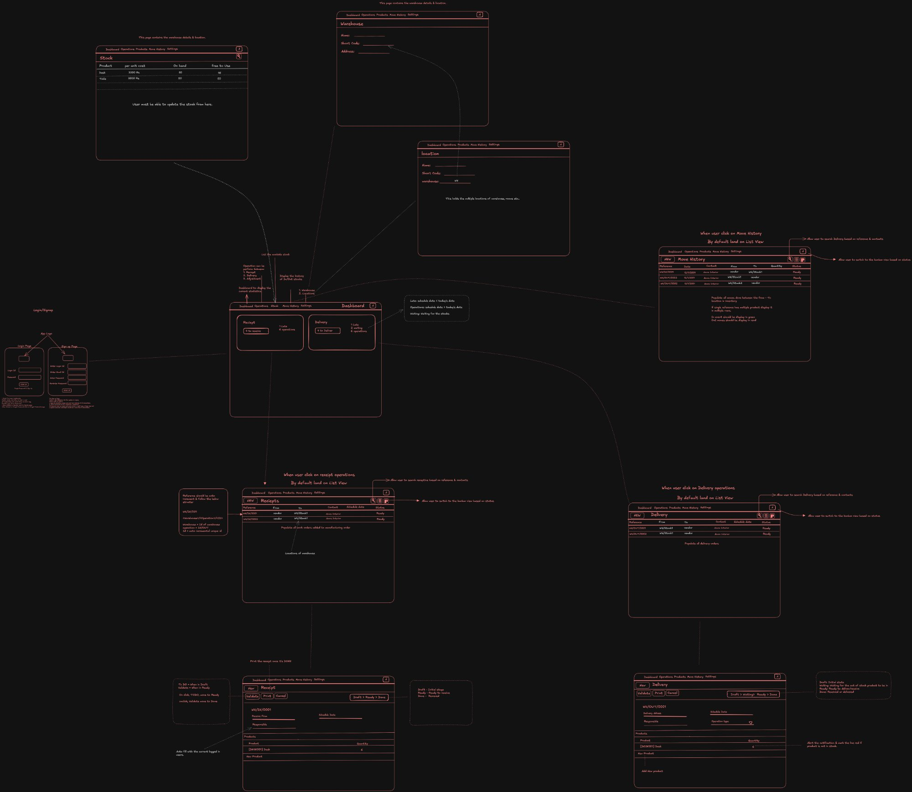
Figure 1 — CoreInventory Full Wireframe (Excalidraw export)

3. Screen Inventory
All screens identified in the wireframe, grouped by navigation section:

Screen Name | Route | Role Access | Wireframe Location
Login / Signup | /login, /signup | All users | Left side of wireframe
Dashboard | /dashboard | Both roles | Center frame
Receipts List | /receipts | Both | Bottom-left cluster
Receipt Detail | /receipts/:id | Both | Bottom-left single form
Deliveries List | /deliveries | Both | Bottom-right cluster
Delivery Detail | /deliveries/:id | Both | Bottom-right single form
Move History | /move-history | Both | Right cluster
Warehouse Settings | /settings/warehouses | Manager only | Top-center frame
Location Settings | /settings/locations | Manager only | Top-right frame
Stock View | /products/:id/stock | Both | Top-left frame
Profile / Logout | Profile menu | Both | Left sidebar

4. Flow 1 — Authentication

4.1 Sign Up
# | Actor | Screen | User Action | System Response / Outcome
1 | New User | Login / Signup | Opens app; clicks 'Sign Up' tab | Signup form is displayed
2 | New User | Signup form | Enters name, email, password, role selection | Client-side validation runs
3 | New User | Signup form | Clicks 'Create Account' | POST /auth/register called
4 | System | — | Server creates user record (hashed password) | Success → auto-login; redirect to Dashboard
5 | System | Dashboard | JWT token stored; user session starts | KPI Dashboard loads with empty/initial state

4.1 Alternate / Error Paths
Step | Error / Alt Condition | System Behavior
3 | Email already registered | Show inline error: 'An account with this email already exists'
3 | Password too weak (< 8 chars) | Show inline validation: 'Password must be at least 8 characters'

4.2 Login
# | Actor | Screen | User Action | System Response / Outcome
1 | Existing User | Login form | Enters email and password | —
2 | Existing User | Login form | Clicks 'Login' | POST /auth/login called
3 | System | — | JWT issued; user role verified | Redirect to /dashboard
4 | System | Dashboard | Dashboard loads last 24 hrs data by default | KPI cards and operations list render

4.2 Alternate / Error Paths
Step | Error / Alt Condition | System Behavior
2 | Wrong credentials | Show error: 'Invalid email or password'
2 | Account not found | Same generic error (no enumeration)
3 | Session expires | Redirect to /login with 'Session expired' toast

4.3 Password Reset via OTP
# | Actor | Screen | User Action | System Response / Outcome
1 | User | Login form | Clicks 'Forgot Password?' | OTP request form shown
2 | User | OTP form | Enters registered email; clicks 'Send OTP' | POST /auth/request-otp; OTP sent to email
3 | User | OTP form | Receives 6-digit OTP; enters it | OTP validated server-side
4 | User | Reset form | Enters new password + confirm | POST /auth/reset-password
5 | System | Login form | Password updated; OTP invalidated | Redirect to login with success toast

5. Flow 2 — Dashboard & Navigation
# | Actor | Screen | User Action | System Response / Outcome
1 | User | Dashboard | Lands on dashboard after login | KPI cards load: Total Stock, Low Stock, Pending Receipts, Pending Deliveries, Transfers
2 | User | Dashboard | Views 'Receipts' card (e.g. '4 to process') | Card shows count by status
3 | User | Dashboard | Clicks 'Receipts' card | Navigates to /receipts filtered by pending status
4 | User | Dashboard | Clicks 'Delivery' card | Navigates to /deliveries filtered by pending status
5 | User | Dashboard | Applies filter: by Document Type, Status, Warehouse, Category | Operations list below KPIs updates in real time
6 | Manager | Dashboard | Sees low-stock alert banner | Alert lists products below threshold; links to product detail
7 | User | Left Sidebar | Clicks any nav item: Operations, Products, Move History, Settings | Routes to respective screen

6. Flow 3 — Receipts (Incoming Stock)

6.1 View & Search Receipts
# | Actor | Screen | User Action | System Response / Outcome
1 | Staff / Manager | Receipts List | Navigates to Operations > Receipts | List loads; default sort: newest first
2 | User | Receipts List | Types in search bar (reference or supplier) | GET /receipts?search=... results filter live
3 | User | Receipts List | Applies status filter (Draft / Waiting / Ready / Done) | List re-renders with matching receipts
4 | User | Receipts List | Clicks a receipt row | Navigates to /receipts/:id (detail view)

6.2 Create & Validate a Receipt
# | Actor | Screen | User Action | System Response / Outcome
1 | Staff | Receipts List | Clicks '+ New Receipt' | Blank receipt form opens in Draft status
2 | Staff | Receipt Detail | Selects/types supplier name | Supplier field populated
3 | Staff | Receipt Detail | Clicks 'Add Product'; searches by name or SKU | Product search dropdown appears
4 | Staff | Receipt Detail | Selects product; enters received quantity | Line item row added to Products table
5 | Staff | Receipt Detail | Repeats step 3–4 for all products | All line items listed
6 | Staff | Receipt Detail | Clicks 'Validate' | POST /receipts/:id/validate called
7 | System | Receipt Detail | DB transaction: stock_levels +qty for each line item; ledger entries written | Status changes to Done; toast: 'Receipt validated'
8 | Staff | Receipt Detail | Sees updated status badge: Done | Stock counts updated across all views

6.2 Alternate / Error Paths
Step | Error / Alt Condition | System Behavior
6 | No products added | Validation blocked; error: 'Add at least one product line'
6 | Quantity is 0 or blank | Inline error on the row: 'Quantity must be > 0'
7 | DB error / server timeout | Transaction rolled back; error toast shown; status remains unchanged

7. Flow 4 — Delivery Orders (Outgoing Stock)

7.1 Create & Validate a Delivery
# | Actor | Screen | User Action | System Response / Outcome
1 | Staff | Deliveries List | Clicks '+ New Delivery' | Blank delivery form opens; status: Draft
2 | Staff | Delivery Detail | Enters customer / order reference | Header fields populated
3 | Staff | Delivery Detail | Adds products; enters quantities to ship | Line items added; system shows current stock level per product
4 | Staff | Delivery Detail | Reviews items; clicks 'Validate' | POST /deliveries/:id/validate called
5 | System | Delivery Detail | Stock check: confirms sufficient quantity per line item | If OK: stock_levels -qty; ledger written; status → Done
6 | Staff | Delivery Detail | Sees Done status badge | Stock counts reduced in real time

7.1 Alternate / Error Paths
Step | Error / Alt Condition | System Behavior
5 | Insufficient stock for one or more products | 422 returned; error message lists affected products with shortfall quantities; status unchanged
4 | Delivery already in Done/Canceled state | Edit action disabled; 422 if attempted via API

8. Flow 5 — Internal Transfers
# | Actor | Screen | User Action | System Response / Outcome
1 | Staff / Manager | Operations Menu | Navigates to Operations > Internal Transfers | Transfer list loads
2 | Staff | Transfer List | Clicks '+ New Transfer' | Blank transfer form opens; status: Draft
3 | Staff | Transfer Detail | Selects Source Location from dropdown (e.g. Main Warehouse) | Location list loads from /warehouses/:id/locations
4 | Staff | Transfer Detail | Selects Destination Location (e.g. Production Floor) | Cannot be same as source (client + server validation)
5 | Staff | Transfer Detail | Adds products and quantities | System shows available stock at source location
6 | Staff | Transfer Detail | Clicks 'Validate' | POST /transfers/:id/validate
7 | System | Transfer Detail | DB transaction: stock_levels -qty at source, +qty at destination; ledger entries for both locations | Status → Done; total stock unchanged

Alternate / Error Paths
Step | Error / Alt Condition | System Behavior
4 | Source = Destination | Client blocks selection; 'Source and destination cannot be the same'
7 | Insufficient stock at source | 422: lists products with shortfall; no stock change applied

9. Flow 6 — Stock Adjustments
# | Actor | Screen | User Action | System Response / Outcome
1 | Manager | Operations Menu | Navigates to Operations > Adjustments | Adjustment form loads
2 | Manager | Adjustment Form | Selects product (name or SKU search) | Current recorded stock level shown
3 | Manager | Adjustment Form | Selects location | Per-location stock level displayed
4 | Manager | Adjustment Form | Enters physically counted quantity | System calculates delta: counted - recorded
5 | Manager | Adjustment Form | Selects reason from dropdown (Damage / Loss / Found / Counting Error / Other) | Reason required to proceed
6 | Manager | Adjustment Form | Clicks 'Apply Adjustment' | POST /adjustments; DB transaction applies delta; ledger entry created
7 | System | Adjustment Form | Stock level updated; success toast | Adjustment logged with operator, timestamp, before/after values

10. Flow 7 — Move History (Stock Ledger)
# | Actor | Screen | User Action | System Response / Outcome
1 | User | Move History | Navigates to Move History from nav | Ledger loads; default: today's movements, sorted newest first
2 | User | Move History | User clicks on Receipts or Delivery from the list view | Navigates to the relevant document detail
3 | User | Move History | Applies filters: Product, Location, Date Range, Type | Table updates; URL params updated for shareability
4 | User | Move History | Clicks a row | Shows detail: document reference, before/after stock, operator
5 | Manager | Move History | Clicks 'Export' | Modal: choose CSV or PDF; POST /ledger/export; download triggered

11. Flow 8 — Warehouse & Location Settings

11.1 Create Warehouse
# | Actor | Screen | User Action | System Response / Outcome
1 | Manager | Settings > Warehouses | Clicks '+ New Warehouse' | Warehouse form opens (Name, Short Code, Address)
2 | Manager | Warehouse Form | Fills details; clicks 'Save' | POST /warehouses; warehouse created
3 | System | Warehouse List | New warehouse appears in list | Available as location source/destination across all operations

11.2 Create Location
# | Actor | Screen | User Action | System Response / Outcome
1 | Manager | Settings > Locations | Selects parent warehouse; clicks '+ New Location' | Location form: Name, Short Code, warehouse_id pre-filled
2 | Manager | Location Form | Fills details; clicks 'Save' | POST /locations; location created and linked to warehouse
3 | System | Location List | New location available in all transfer/receipt source/destination dropdowns | Stock page also reflects the new location

12. Flow Summary Table
Flow # | Flow Name | Primary Actor | Entry Point | Exit / End State
1a | Sign Up | New User | App open | Logged in → Dashboard
1b | Login | Existing User | Login page | Logged in → Dashboard
1c | Password Reset | Any User | 'Forgot Password' link | Password updated → Login
2 | Dashboard & Navigation | Both | Post-login | Navigated to target section
3 | Receipt (Incoming Stock) | Warehouse Staff | Receipts List | Receipt validated → stock increased
4 | Delivery (Outgoing Stock) | Warehouse Staff | Deliveries List | Delivery validated → stock decreased
5 | Internal Transfer | Both | Transfers List | Transfer validated → location balances updated
6 | Stock Adjustment | Inventory Manager | Adjustments | Adjustment applied → stock corrected + ledger entry
7 | Move History | Both | Move History nav | Ledger viewed / exported
8a | Warehouse Settings | Manager | Settings | New warehouse created
8b | Location Settings | Manager | Settings | New location created

