
CONTINENTAL INSTITUTE OF ENGINEERING AND TECHNOLOGY
Training : 6 Weeks

Project Report
On
Banking Management System

Submitted in the partial fulfillment of the requirement for the award of degree of

Bachelors of Technology
In

COMPUTER SCIENCE ENGG


Under the Guidance of  Name of the Training Guide: Harsh Kapila | Submitted by  Name of the Student: Nishan Singh  University Roll Number: 90200303578

Submitted to Er. Gursimran Singh- Training Incharge

Certificate

Certified that Nishan Singh (90200303578), student of Computer Science Engineering Department, CONTINENTAL INSTITUTE OF ENGINEERING AND TECHNOLOGY has completed the Training at this company entitled “HK Computers” for the partial fulfillment of the requirement for the award of Bachelors of Technology (Computer Science Engineering) Degree of PTU, Jalandhar,
This is a record of student’s own study carried under my supervision & guidance.

This report has been submitted for the award of B-Tech degree.

Name of Project Guide:Harsh Kapila  Designation : Trainer | Signatures:  Stamp:

CONTENTS

- TASK 3……………………………..…………

  - Analysis………………………………………

  - Design…………………………………………

  - Implementation…………………………..

  - Testing………………………………………..

- Review…………………………………………

Photocopy of the Certificate from Company

Acknowledgement
At the very outset, I am highly indebted to HK Computer for giving me an opportunity to carry out my project on “Banking” at their esteemed organization. I would specially thank Harsh Kapila, Project Guide, and HK Computers Patiala for giving time and guidance throughout my training without whom it would have been impossible to attain success.

My heartiest thanks to Trainees and employees at HK Computers Patiala for helping me throughout the project tenure.

I own my regards to the entire faculty of the department of computer science and information technology at “Continental Group Of Collages “ from where I have learnt the basics of Computer Science and whose informal discussions and able guidance was a become light for me in the entire duration of this work.

I would also like to thank my team members who worked with me and our combined efforts lead to the completion of the project.

Nishan Singh

INTRODUCTION &
OVERVIEW OF PROJECT
INTRODUCTION
The project is based on “Banking Mamagement System”. This project is carried out at HK Computers Patiala. This software firm deals in developing software for its clients. This is a Collage Data Management software at college level, using Swings and Microsoft Access Database. First of all database and tables etc created in MS Office Access.
In modern civilization has become so complicated and sophisticated that to survive one has to be competitive. This compiles the people to be acquainted with all type of happening in the society; mankind is surrounded with a vast amount of data available. Modern business management system has also rendered in a fashion so that it can be utilized with minimum possible time. Paper files require a high amount of storage space and storage creates several other problems like fire risk, spoilage and deterioration by way of aging humidity etc. Computerization of documents and the files has solved this problem to create extent. Not only this, but it has to be high amount of relaxation to human mind, as everything can be automated. Now the documents can in a number of ways, styles and number of documents can be created as and when required without making any mistakes.

The suitable of computerization for an application may be determined as follows:
- Volume of storage and calculation: Computerization is best suited to handle large volume of data. The sufficient, economic and reliable storage characteristic of computer media must be exploited properly.

- Quality of Output: Quality of output in terms of accuracy, elegance of output, aesthetics in formality through use of word processing and powerful editing could justify use of a computer.

- Computerized solutions should be cost justifiable: Money, time saving and efficiency justify the cost of preparing writing and executing a program, Now-computer devices such as calculator can perform money tasks more economically.

PROBLEM DEFINITION

The institute currently operates under a manual system of conducting exams of students. The primary function of the staff is to file and retrieve the information regarding the students, tests and tests type, performance reports of every student in different subjects, and to maintain batch records.
There are the five major areas in which the manual system affects costs:
- Slow retrieval time results
- The system is labor and space intensive
- The manual system produces a risk of missing files
- There is a lack of confidently.
- No back up exists to support disaster recover.
The volume of paper is one of the things that stand in the way of increasing productivity in institute.

Value of missing information
Combined with the typical lost document static’s reviewed above, one could estimate the industry average cost of not having the document’s information when needed. But to obtain first hand actual data for as software organization. This company decided to measure that actual dollar value of lost information. Over a two week period, the file staff filled out a form for each request to retrieve a document from the storage rooms. The data collected documented the total number of filed requested and the results of each request.

Maintaining Registers is Costly
Traditionally, documents have been stored in batches and then filed in the cabinets and boxes. A numerical system is then assigned. Specially a batch number assigned to organize the files. Operative notes are classified alphabetically.
Listed below are the cost elements in our paper based filling system:
- Labor: Creating new files, labeling, applying batch header sheets to file into the system, collating and entering information into a batch log book.
- Supplies: File folders, dividers, folder labels, batch header sheets, requisitions slips, file logs and filling boxes.
- Equipment: File cabinets and shelving units

Drawbacks of the Existing System
Due to large of data a lot of complexities are involved in maintaining, updating and retrieving selected information, since old system is totally maintained manually, some of the complexities involved in existing system is as follows:
- Redundancy of data: In the existing system, all data is maintained in different files and registers. This often leads to considerable duplication of data and redundancy.

- Difficulty in Updating the Data: Problem of updating data in the existing systems since everything is stored in registered and files. It is very difficult and time consuming to update data

- Delay in retrieving information: Retrieving information is quite time consuming process because of large volume of data. If it is required to locate a particular record, a large number of registers have to be scanned.

- Problem or keeping the data: As the data is voluminous, more space is required to store it. Also, everything is stored on papers, so this type of storage is more prone to damage with time and due to other accidental factors.

- No Integration of Relation between data: Present system does not support any type of data integrity.

- Not Informative: It is very difficult to get up to date information in the existing system. If any information is required for any specific purpose. All the sorting to be done manually and the needs to be reentered at some other place

Introduction

The very first step of developing any system is to study the whole existing system this is called the initial study, analysis and feasibility of the project is being done. Analysis is the detailed study of the various operations performed by the system and their relationship within and outside the system. In context to this project although the records are not maintained on the daily basis but the same procedure is repeated each day and everyday. Hence the need for the computerization is necessary to make the work easier and more comfortable.

The feasibility study is carried out to select the best process that meets the performance requirements. This entails identification, description and evaluation of the candidate process and the selection of the best candidate process for the job. Now according to this project the analysis is to have the complete knowledge about how the software that is going to develop is going to function. From where is the input going to come and what will be the output vs. what is the required output. Once analysis is done or completed the analyst has the firm knowledge of what is to be done. The next step is to decide how the problem might be solved. Thus, in systems design, we move from the logical to the physical aspects of the life cycle.

So the conclusion of the initial study is that the computerized version of the existing system of the institute will be able to serve its teachers and students in more efficient manner as this type of system will save their lot of tremendous time, energy, tiring, and repetitive paperwork

Existing System

As stated earlier in the introduction to the project, Hospital system at the present time is totally manual. The various information related to the patients is entered in the registers. Calculations of bills of the different category products and preparing results of the each and every visitor to the store are very tedious work for the administrator. The Administrator Office of the hospital is unable to keep with the pace of the increasing demands of its rapid growth. The office currently operates under a manual system of filing and retrieving documentation. These documents prepared manually like performance reports of every patient, final bill report
In the manual system, searching for some specific information is the time consuming exercise. A number of registers are being maintained. Proper upkeep of the register is very difficult, as only the concerned person know where the desired information is available. The system is highly resource intensive as well as prone to errors. Piles of registers are there as new additions to these existing piles are occurring as time passes.

There are five major areas in which the manual system affects costs:

- Slow retrieval time results in delayed or lost income.
- The system is labor and space intensive.
- The manual system produces a risk of missing files which causes lost income.
- There is a lack of confidentiality.
- No back up to support disaster recovery.

Salient Features in Project:

- User friendly.
- Providing protection to data, through password.
- Efficient retrieval of information.
- Ensure accuracy of data, with in-built validations and checks.
- Efficient linkage of information.
- Informative reports.
- Elimination of paper works to a great extent.

Proposed Strategy:

The software is made using Java,Swing and Awt as Front End and MS Access as back end. This gives us the knack to develop application software, which ensures that software can be accessed on any Microsoft platform that supports Common Language Runtime. Microsoft SQL gives the ability to handle the large database. So software can be used for the small as well as the large shopping stores. SQL has the advantage of importing and exporting the database easily.

Objectives of Project

After thoroughly analyzing the existing system the following objectives have been set:
- Providing user friendly interface
- Keeping exams online
- Easy access of data
- Maintaining data consistency
- Providing better performance
- Facility to update the data time to time
- Adequate security of the database
- Efficient retrieval of information.

- Providing protection to data, through password.

- Elimination of paper works to a great extent.

SYSTEM REQUIREMENT ANALYSIS
Prior to the software development efforts in any type of system it is very essential to understand the requirements of the systems and users. A complete specification of the software is the 1st step is the analysis of system. Requirements analysis provides the designer with the representation of functions and procedures that can be translated into data, architecture and procedural design.
The goal of requirement analysis is to find out how the current system is working and if there are any areas where improvement is necessary and possible. This may result in using alternative ways to data capturing and processing.

INTERFACE REQUIREMENT

- User Interface
The package must be user friendly and robust. It must prompt the user with proper message boxes to help them perform various actions and how to precede further the system must respond normally under any in out conditions and display proper message instead of turning up faults and errors.

- Hardware Specification
HARDWARE | SPECIFICATION
CPU | Intel Pentium IV
SPEED | 1.5GHz
RAM | 256 MB
HARD DISK | 40GB
KEYBOARD | 105 Keys

Software Specifications

Software is a set of program, documents, and procedure, routines associated with computer system. Software is an essential complement to hardware. It is the computer programs which when “Student Management System” has been developed using the following tools:
- Java Swing, Awt
- MS Access

System Development Life Cycle Model (SDLC Model)
This is also known as Classic Life Cycle Model (or) Linear Sequential Model (or) Waterfall Method. This has the following activities.
1. System/Information Engineering and Modeling

2. Software Requirements Analysis

3. Systems Analysis and Design

4. Code Generation

5. Testing

6. Maintenance

System/Information Engineering and Modeling
As software is always of a large system (or business), work begins by establishing requirements for all system elements and then allocating some subset of these requirements to software. This system view is essential when software must interface with other elements such as hardware, people and other resources. System is the basic and very critical requirement for the existence of software in any entity. So if the system is not in place, the system should be engineered and put in place. In some cases, to extract the maximum output, the system should be re-engineered and spruced up. Once the ideal system is engineered or tuned, the development team studies the software requirement for the system.

Software Requirement Analysis
This is also known as feasibility study. In this phase, the development team visits the customer and studies their system. They investigate the need for possible software automation in the given system. By the end of the feasibility study, the team furnishes a document that holds the different specific recommendations for the candidate system. It also includes the personnel assignments, costs, project schedule, and target dates. The requirements gathering process is intensified and focused specially on software. To understand the nature of the program(s) to be built, the system engineer ("analyst") must understand the information domain for the software, as well as required function, behavior, performance and interfacing. The essential purpose of this phase is to find the need and to define the problem that needs to be solved.

System Analysis and Design
In this phase, the software development process, the software's overall structure and its nuances are defined. In terms of the client/server technology, the number of tiers needed for the package architecture, the database design, the data structure design etc are all defined in this phase. A software development model is created. Analysis and Design are very crucial in the whole development cycle. Any glitch in the design phase could be very expensive to solve in the later stage of the software development. Much care is taken during this phase. The logical system of the product is developed in this phase.

Code generation
The design must be translated into a machine-readable form. The code generation step performs this task. If the design is performed in a detailed manner, code generation can be accomplished without much complication. Programming tools like Compilers, Interpreters, and Debuggers are used to generate the code. Different high level programming languages like C, C++, Pascal, and Java are used for coding. With respect to the type of application, the right programming language is chosen.

Testing
Once the code is generated, the software program testing begins. Different testing methodologies are available to unravel the bugs that were committed during the previous phases. Different testing tools and methodologies are already available. Some companies build their own testing tools that are tailor made for their own development operations.

Task 3

Analysis

A) Implementation of a banking system that has the following details for a current account customer:
- Account Name
- Account Number
- Sort Code

The system should also be able to provide the following services to a customer:
- Opening an account
- Depositing money in an account
- Withdraw money from an account with the condition that the customer cannot withdraw more money than the amount that is present in the account
- Ask for a balance of the account
- Provide a mini statement showing a maximum of the last 10 transactions
- Close an account

B) Extend the program so that two additional services are provided by the system for long standing customers.
- The customer can open a joint account that can be shared by 3 people
- The customer can have an overdraft of $5000

Assumptions
The task does not require the data of a customer to be saved permanently. Thus all data related to a particular session is deleted once the application ends.

The task does not require the application to be a multi user application thus the application is started by opening an account and ended by closing that particular account.

Design

The design of the application is shown in terms of class diagrams, flow charts and pseudo code.
Class Diagram

The class diagram shows classes that make up the application in terms of the relevant methods that those classes expose and the variables that point to data.

A)
Banks

Account current
float amount
String strAmount
String strTemp

Banks()
setVariables()
addActionListenerAllBtns()
setAllBtnsEnabled(boolean bool)
actionPerformed(ActionEvent e)
Main(String[] args)

JFrame

Transaction

float amountDeposited
float amountWithDrawn
float currentBalance
float float[] transactionAmount
float int[] transactionNumber
String[] transactionType

depositInToAccount(float amountDeposited, int transactionNumber)
withDrawFromAnAccount(float amountWithDrawn,int transactionNumber)
showMiniStatement()

Account

String accountName
String accountNumber
String sortCode
Transaction trans
float amountDeposited
float amountWithDrawn
float currentBalance

getAccountName()
getAccountNumber()
getSortCode()
setAccountName(String accountName)
setAccountNumber(String accountNumber)
setSortCode(String sortCode)
openAnAccount(String accountName, String accountNumber, String sortCode)
deposit(float amountDeposited)
withDraw(float amountWithDrawn)
withDraw(float amountWithDrawn, float overDrawnAmount)
askBalance()
askMiniStatement()
closeAnAccount()
getX()

B)
JAccount

String accountName2
String accountName3

getAccountName2()
getAccountName3()
setAccountName2(String accountName2)
setAccountName3(String accountName2)
openAnAccount(String accountName,String accountName2,String accountName3, String accountNumber, String sortCode)
openAnAccount(String accountName,String accountName2, String accountNumber, String sortCode)
withDraw(float amountWithDrawn)
closeAnAccount()
Account

Flow Chart

The flow chart shows the flow & logic of the program.

A & B)
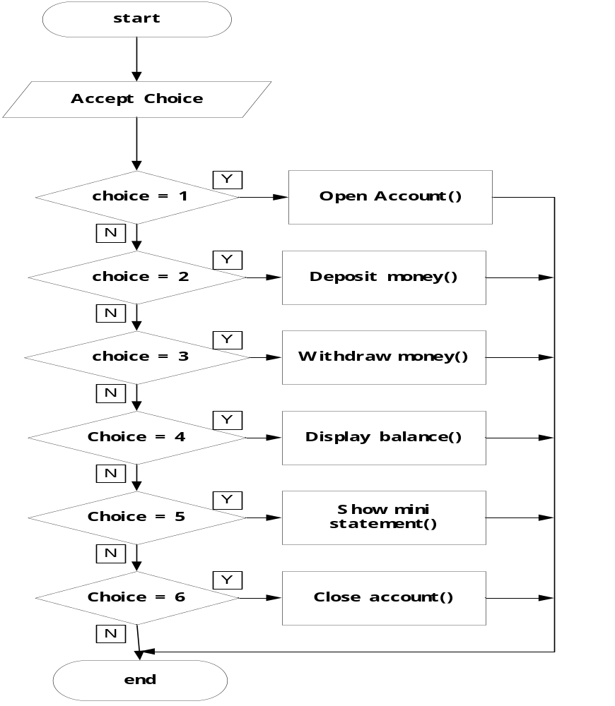KEY
Y=YES, N=NO
Pseudo Code

The pseudo code shows the program in terms of steps, from one step to another without any syntax.

A & B)

Procedure Open Account ( )
Accept Account Name, Account Number, Sort Code
name:= Account
accNum:= Account Number
sortcode:= Sort Code
END Procedure

Procedure Deposit money ( )
Accept Amount
balance:= balance + amount
END Procedure

Procedure withdraw money ( )
Accept amountToWithDraw
IF (balance < amountToWithDraw)
THEN Print “Balance is less than amount”
ELSE
balance := balance – AmountToWithDraw
END IF
END PROCEDURE

Procedure Display Balance ( )
Print balance
END Procedure

Procedure showMiniStatement ( )
Use variable: i Of TYPE INTEGER
i:= 1
FOR (i=1; i<= 10; ++i)
PRINT “Transaction” + Transaction [ i]
End FOR
END PROCEDURE

Procedure close Account ( )
Use variables: i OF TYPE INTEGER
name := “ “
accNum := “ “
sortCode :=” “
Balance :=0
Amount :=0
AmountToWithDraw :=0

i:= 1
FOR (i:=1; i<=10; ++i)
Transaction [ i] = Null
END FOR
END Procedure

Procedure withdraw money ( )
Use variable: test Of TYPE REAL
Accept amountToWithDraw
Test := balance - amountToWithDraw
IF (test>=-5000)
THEN balance := balance – AmountToWithDraw
ELSE
THEN PRINT “NOT ENOUGH FUNDS”
END IF
END Procedure

Implementation
A & B)

/* NAME:::::DIP K. KOTAK::::::
::::JAVA ASSIGNMENT::::::::
:::::::TASK 3::::::::::::::
:::::::::BANKS:::::::::::::
::::::BY GENIUSDIP:::::::::
:::::::::::::::::::::::::::
:::::::::::::::::::::::::::
*/

//IMPORTING THE NECESSARY PACKAGES
import javax.swing.*;
import java.awt.*;
import java.awt.event.*;

//BANKS CLASS INHERITS FROM THE JFRAME CLASS AND IMPLEMENTS ACTIONLISTENERS INTERFACE
public class Banks extends JFrame implements ActionListener
{

//DECLARATION SECTION

//DECLARING IMAGEICONS FOR THE BUTTONS
private ImageIcon image1;
private ImageIcon image2;

private ImageIcon image3;
private ImageIcon image4;

private ImageIcon image5;
private ImageIcon image6;

//DECLARING COMPONENTS
private JButton openButton, depositButton, withDrawButton, balanceButton, miniStaButton, closeButton;
private JToolBar bar;
private JTextArea txtTextArea;
private JScrollPane scrBarForTextArea;

//DECLARING THE DIMENSIONS FOR THE BUTTONS
private Dimension buttonSize = new Dimension(200,50);

//DECLARING COLOR THAT ARE TO BE USED
private Color blue = new Color(10,110,255);
private Color white = new Color(255,255,255);

//DECLARING THE FONTS
private Font head = new Font("Castellar",Font.ITALIC,17);

//DECLARING VARIABLES
private String strTemp=null;
private String strAmount = "";
private float amount = 0;

//CREATING OBJECTS OF OTHER CLASSES
private Account current = new Account();
private JAccount joint = new JAccount();

//CONSTRUCTOR FOR THE BANKS CLASS
public Banks()
{
super("GENIUSDIP'S BANKS");
setDefaultCloseOperation(JFrame.EXIT_ON_CLOSE);
Container con = getContentPane();
con.setLayout(new BorderLayout());
con.add(getScrBarForTextArea(),BorderLayout.CENTER);

JToolBar bar = new JToolBar(SwingConstants.VERTICAL);

//ADDING BUTTONS TO THE TOOL BAR
bar.add(getOpenButton());
bar.add(getDepositButton());
bar.add(getWithDrawButton());
bar.add(getBalanceButton());
bar.add(getMinaStaButton());
bar.add(getCloseButton());

//DISABLING SOME BUTTONS
setAllBtnsEnabled(false);

//ADDING ACTION LISTENERS TO ALL THE BUTTONS
addActionListenerAllBtns();

//ADDING THE BAR TO THE CONTENT PANE
con.add(bar,BorderLayout.WEST);
}

//FUNCTION THAT RETURNS A TEXTAREA WITH SOME PROPERTIES SET
private JTextArea getTxtTextArea()
{
if(txtTextArea==null)
{
txtTextArea=new JTextArea(10,10);
txtTextArea.setBackground(white);
txtTextArea.setForeground(blue);
txtTextArea.setEditable(false);
txtTextArea.setFont(head);
txtTextArea.setText("\t Geniusdip's Banks \n\n");
}
return txtTextArea;
}

//FUNCTION THAT RETURNS A SCROLLPANE WITH SOME PROPERTIES SET
private JScrollPane getScrBarForTextArea()
{
if(scrBarForTextArea==null)
{
//VIEWING THE TEXTAREA FROM THE SCROLLPANE
scrBarForTextArea=new JScrollPane(getTxtTextArea());
}
return scrBarForTextArea;
}

//FUNCTION THAT RETURNS A BUTTON WITH SOME PROPERTIES SET
private JButton getOpenButton()
{
if(openButton==null)
{
ImageIcon image1 = new ImageIcon("OPENANACCOUNTANI.gif");
openButton=new JButton("",image1);
openButton.setPreferredSize(buttonSize);
}
return openButton;
}

//FUNCTION THAT RETURNS A BUTTON WITH SOME PROPERTIES SET
private JButton getDepositButton()
{
if(depositButton==null)
{
ImageIcon image2 = new ImageIcon("DEPOSIT.gif");
depositButton=new JButton("",image2);
depositButton.setPreferredSize(buttonSize);
}
return depositButton;
}

//FUNCTION THAT RETURNS A BUTTON WITH SOME PROPERTIES SET
private JButton getWithDrawButton()
{
if(withDrawButton==null)
{
ImageIcon image3 = new ImageIcon("WITHDRAW.gif");
withDrawButton=new JButton("",image3);
withDrawButton.setPreferredSize(buttonSize);
}
return withDrawButton;
}

//FUNCTION THAT RETURNS A BUTTON WITH SOME PROPERTIES SET
private JButton getBalanceButton()
{
if(balanceButton==null)
{
ImageIcon image4 = new ImageIcon("BALANCE.gif");
balanceButton=new JButton("",image4);
balanceButton.setPreferredSize(buttonSize);
}
return balanceButton;
}

//FUNCTION THAT RETURNS A BUTTON WITH SOME PROPERTIES SET
private JButton getMinaStaButton()
{
if(miniStaButton==null)
{
ImageIcon image5 = new ImageIcon("MINI.gif");
miniStaButton=new JButton("",image5);
miniStaButton.setPreferredSize(buttonSize);
}
return miniStaButton;
}

//FUNCTION THAT RETURNS A BUTTON WITH SOME PROPERTIES SET
private JButton getCloseButton()
{
if(closeButton==null)
{
ImageIcon image6 = new ImageIcon("CLOSE.gif");
closeButton=new JButton("",image6);
closeButton.setPreferredSize(buttonSize);
}
return closeButton;
}

//FUNCTION TO ENABLE OR DISABLE BUTTONS
private void setAllBtnsEnabled(boolean bool)
{
getDepositButton().setEnabled(bool);
getWithDrawButton().setEnabled(bool);
getBalanceButton().setEnabled(bool);
getMinaStaButton().setEnabled(bool);
getCloseButton().setEnabled(bool);
}

//FUNCTION TO ADD ACTIONLISTENERS TO BUTTONS
private void addActionListenerAllBtns()
{
getOpenButton().addActionListener(this);
getDepositButton().addActionListener(this);
getWithDrawButton().addActionListener(this);
getBalanceButton().addActionListener(this);
getMinaStaButton().addActionListener(this);
getCloseButton().addActionListener(this);
}

//FUNCTION TO SET VARIABLES TO POINT TO NOTHING
private void setVariables()
{
strTemp=null;
strAmount = "";
amount = 0;
current = null;
joint = null;
}

//THE ACTION PERFORMED METHOD
//EXECUTES WHEN THE CLICK EVENT IS FIRED
public void actionPerformed(ActionEvent e)
{

Object source = e.getSource();

//OPEN BUTTON CLICKED
if(source==openButton)
{
String Name = "";
String ANumber = "";
String Name2 = "";
String Name3= "";

//QUERY THE USER FOR THE NEEDED INFORMATION
do
{
strTemp = JOptionPane.showInputDialog(null,"Please Enter C To Open A Current Account \n Or J To Open A Joint Account");
}while(strTemp==null || strTemp.length()==0);
switch(strTemp.charAt(0))
{
case 'c':
case 'C':
//ENABLE ALL OTHER BUTTON EXCEPT THE OPEN BUTTON
setAllBtnsEnabled(true);
openButton.setEnabled(false);
do
{
Name = JOptionPane.showInputDialog(null,"Please Enter The Account Holder's Name");
}while(Name==null || Name.length()==0);
do
{
ANumber = JOptionPane.showInputDialog(null,"Please Enter The Account Number");
}while(ANumber==null || ANumber.length()==0);
current.openAnAccount(Name,ANumber,"Current Account");
txtTextArea.append("Current Account Created With The Following Details \n");
txtTextArea.append("Account Holder's Name:::" + current.getAccountName() + "\n");
txtTextArea.append("Account Number::::::::::" + current.getAccountNumber()+ "\n");
txtTextArea.append("Account Sort Code:::::::" + current.getSortCode()+ "\n");
break;
case 'j':
case 'J':
setAllBtnsEnabled(true);
openButton.setEnabled(false);
String choice = null;
do
{
choice = JOptionPane.showInputDialog(null,"Please Enter 2 If They Are 2 Account Holders For The Joint Account \n Or 3 If They Are 3 Account Holders For The Joint Account");
}while(choice==null || choice.length()==0);
switch(choice.charAt(0))
{
case '2':
do
{
Name = JOptionPane.showInputDialog(null,"Please Enter The First Account Holder's Name");
}while(Name==null || Name.length()==0);
do
{
Name2 = JOptionPane.showInputDialog(null,"Please Enter The Second Account Holder's Name");
}while(Name2==null || Name2.length()==0);
do
{
ANumber = JOptionPane.showInputDialog(null,"Please Enter The Account Number");
}while(ANumber==null || ANumber.length()==0);
joint.openAnAccount(Name,Name2,ANumber,"Joint Account");
txtTextArea.append("Joint Account Created With The Following Details \n");
txtTextArea.append("First Account Holder's Name:::" + joint.getAccountName() + "\n");
txtTextArea.append("Second Account Holder's Name:::" + joint.getAccountName2() + "\n");
txtTextArea.append("Account Number::::::::::" + joint.getAccountNumber()+ "\n");
txtTextArea.append("Account Sort Code:::::::" + joint.getSortCode()+ "\n");
break;
case '3':
do
{
Name = JOptionPane.showInputDialog(null,"Please Enter The First Account Holder's Name");
}while(Name==null || Name.length()==0);

do
{
Name2 = JOptionPane.showInputDialog(null,"Please Enter The Second Account Holder's Name");
}while(Name2==null || Name2.length()==0);

do
{
Name3 = JOptionPane.showInputDialog(null,"Please Enter The Third Account Holder's Name");
}while(Name3==null || Name3.length()==0);

do
{
ANumber = JOptionPane.showInputDialog(null,"Please Enter The Account Number");
}while(ANumber==null || ANumber.length()==0);

joint.openAnAccount(Name,Name2,Name3,ANumber,"Joint Account");
txtTextArea.append("Joint Account Created With The Following Details \n");
txtTextArea.append("First Account Holder's Name:::" + joint.getAccountName() + "\n");
txtTextArea.append("Second Account Holder's Name:::" + joint.getAccountName2() + "\n");
txtTextArea.append("Third Account Holder's Name:::" + joint.getAccountName3() + "\n");
txtTextArea.append("Account Number::::::::::" + joint.getAccountNumber()+ "\n");
txtTextArea.append("Account Sort Code:::::::" + joint.getSortCode()+ "\n");
break;
default:
do
{
Name = JOptionPane.showInputDialog(null,"Please Enter The First Account Holder's Name");
}while(Name==null || Name.length()==0);

do
{
Name2 = JOptionPane.showInputDialog(null,"Please Enter The Second Account Holder's Name");
}while(Name2==null || Name2.length()==0);

do
{
Name3 = JOptionPane.showInputDialog(null,"Please Enter The Third Account Holder's Name");
}while(Name3==null || Name3.length()==0);

do
{
ANumber = JOptionPane.showInputDialog(null,"Please Enter The Account Number");
}while(ANumber==null || ANumber.length()==0); joint.openAnAccount(Name,Name2,Name3,ANumber,"Joint Account");
txtTextArea.append("Joint Account Created With The Following Details \n");
txtTextArea.append("First Account Holder's Name:::" + joint.getAccountName() + "\n");
txtTextArea.append("Second Account Holder's Name:::" + joint.getAccountName2() + "\n");
txtTextArea.append("Third Account Holder's Name:::" + joint.getAccountName3() + "\n");
txtTextArea.append("Account Number::::::::::" + joint.getAccountNumber()+ "\n");
txtTextArea.append("Account Sort Code:::::::" + joint.getSortCode()+ "\n");
}
break;
default:
setAllBtnsEnabled(true);
current = new Account();
do
{
Name = JOptionPane.showInputDialog(null,"Please Enter The Account Holder's Name");
}while(Name==null || Name.length()==0);
do
{
ANumber = JOptionPane.showInputDialog(null,"Please Enter The Account Number");
}while(ANumber==null || ANumber.length()==0);
current.openAnAccount(Name,ANumber,"Current Account");
txtTextArea.append("Current Account Created With The Following Details \n");
txtTextArea.append("Account Holder's Name:::" + current.getAccountName() + "\n");
txtTextArea.append("Account Number::::::::::" + current.getAccountNumber()+ "\n");
txtTextArea.append("Account Sort Code:::::::" + current.getSortCode()+ "\n");
}
//DEPOSIT BUTTON CLICKED
}
else if(source==depositButton)
{
boolean success = false;
while(success == false)
{
try
{
strAmount = JOptionPane.showInputDialog(null,"Please Enter The Amount To Deposit");
amount = Float.parseFloat(strAmount);
success = true;
}
catch(Exception am)
{
JOptionPane.showMessageDialog(null,"Invalid Numerals Added");
}
}
switch(strTemp.charAt(0))
{
case 'c':
case 'C':
current.deposit(amount);
txtTextArea.append(Float.toString(amount) + " Deposited Into Current Account \n");
break;
case 'j':
case 'J':
joint.deposit(amount);
txtTextArea.append(Float.toString(amount) + " Deposited Into Joint Account \n");
break;
}
//WITHDRAW BUTTON CLICKED
}
else if(source==withDrawButton)
{
boolean success = false;
while(success == false)
{
try
{
strAmount = JOptionPane.showInputDialog(null,"Please Enter The Amount To WithDraw");
amount = Float.parseFloat(strAmount);
success = true;
}
catch(Exception amo)
{
JOptionPane.showMessageDialog(null,"Invalid Numerals Added");
}
}
switch(strTemp.charAt(0))
{
case 'c':
case 'C':
String strTemp2 = current.withDraw(amount);
txtTextArea.append(strTemp2 + "\n");
break;
case 'j':
case 'J':
String strTemp3 = joint.withDraw(amount);
txtTextArea.append(strTemp3 + "\n");
break;
}
//BALANCE BUTTON CLICKED
}
else if(source==balanceButton)
{
switch(strTemp.charAt(0))
{
case 'c':
case 'C':
txtTextArea.append(Float.toString(current.askBalance()) + "\n");
break;
case 'j':
case 'J':
txtTextArea.append(Float.toString(joint.askBalance()) + "\n");
break;
}
//MINI STATEMENT BUTTON CLICKED
}
else if(source==miniStaButton)
{
switch(strTemp.charAt(0))
{
case 'c':
case 'C':
txtTextArea.append(current.askMiniStatement() + "\n");
break;
case 'j':
case 'J':
txtTextArea.append(joint.askMiniStatement() + "\n");
break;
}
//CLOSE BUTTON CLICKED
}
else if(source==closeButton)
{
openButton.setEnabled(true);
switch(strTemp.charAt(0))
{
case 'c':
case 'C':
current.closeAnAccount();
setVariables();
System.exit(0);
break;
case 'j':
case 'J':
//SET ALL VARIABLES TO POINT AT NOTHING
joint.closeAnAccount();
setVariables();
//EXIT THE SYSTEM
System.exit(0);
break;
}
txtTextArea.setText("\t Geniusdip's Banks \n\n");
}

}

//MAIN METHOD
public static void main(String[] args)
{
Banks fram=new Banks();
fram.setBounds(0,0,900,500);
fram.show();
}

}

//CLASS ACCOUNT TO HANDLE CURRENT ACCOUNT
class Account
{
private String accountName="", accountNumber="", sortCode="";
private Transaction trans = new Transaction();
private float amountDeposited=0, amountWithDrawn=0, currentBalance=0;
private int x=0;

//PUBLIC PROPERTY TO GET ACCOUNT NAME
public String getAccountName()
{
return accountName;
}

//PUBLIC PROPERTY TO GET ACCOUNT NUMBER
public String getAccountNumber()
{
return accountNumber;
}

//PUBLIC PROPERTY TO GET SORT CODE
public String getSortCode()
{
return sortCode;
}

//PUBLIC PROPERTY TO SET ACCOUNT NAME
public void setAccountName(String accountName)
{
this.accountName = accountName;
}

//PUBLIC PROPERTY TO SET ACCOUNT NUMBER
public void setAccountNumber(String accountNumber)
{
this.accountNumber = accountNumber;
}

//PUBLIC PROPERTY TO SET SORTCODE
public void setSortCode(String sortCode)
{
this.sortCode = sortCode;
}

//FUNCTION TO OPEN AN ACCOUNT
public void openAnAccount(String accountName, String accountNumber, String sortCode)
{
this.setAccountName(accountName);
this.setAccountNumber(accountNumber);
this.setSortCode(sortCode);
}

//FUNCTION TO DEPOSIT
public void deposit(float amountDeposited)
{
trans.depositInToAccount(amountDeposited,x);
x++;
}

//OVERLOADED FUNCTION TO WITHDRAW WITH ONE ARGUMENT
public String withDraw(float amountWithDrawn)
{
String strWD="";
if(trans.queryCurrentBalance()>=amountWithDrawn)
{
trans.withDrawFromAnAccount(amountWithDrawn,x);
x++;
strWD=Float.toString(amountWithDrawn) + " Amount Withdrawn";
}
else
{
strWD="Insufficient Funds In Account";
}
return strWD;
}

//OVERLOADED FUNCTION TO WITHDRAW WITH 2 ARGUMENTS
public String withDraw(float amountWithDrawn, float overDrawnAmount)
{
trans.withDrawFromAnAccount(amountWithDrawn,x);
x++;
return Float.toString(overDrawnAmount);
}

//FUNCTION TO RETURN CURRENT BALANCE
public float askBalance()
{
float balance = trans.queryCurrentBalance();
return balance;
}

//FUNCTION TO RETURN MINI STATEMENT
public String askMiniStatement()
{
String strStatement = trans.showMiniStatement();
return strStatement;
}

//FUNCTION TO CLOSE AN ACCOUNT
public void closeAnAccount()
{
setAccountName(null);
setAccountNumber(null);
setSortCode(null);
trans = null;
}

//FUNCTION THAT RETURNS THE NEXT TRANSACTION NUMBER
public int getX()
{
x++;
return x;
}
}

//CLASS TRANSACTIONS FOR ALL THE BANKING TRANSACTIONS
//INCLUDING ASK BALANCE, DEPOSIT, WITHDRAW & MINI STATEMENT
class Transaction
{

private float amountDeposited=0, amountWithDrawn=0, currentBalance=0;
private float[] transactionAmount = new float[10];
private int[] transactionNumber = new int[10];
private String[] transactionType = new String[10];

public void depositInToAccount(float amountDeposited, int transactionNumber) throws IndexOutOfBoundsException
{
try
{
if(amountDeposited>0)
{
this.amountDeposited = amountDeposited;
this.currentBalance = this.currentBalance + amountDeposited;
if(transactionNumber > 9)
{
for(int i=0;i<9;++i)
{
//REINITIALIZE THE ARRAY IF THE TRANSACTION NUMBER IS > 9
//ALL THE ELEMENTS SHOULD GO ONE STEP BACK WARDS
//THE FIRST ELEMENT IS DELETED
this.transactionNumber[i] = this.transactionNumber[i+1];
this.transactionType[i] = this.transactionType[i+1];
this.transactionAmount[i] = this.transactionAmount[i+1];
}
//THE NEW ELEMENT IS ADDED AT THE END
this.transactionNumber[9] = transactionNumber;
this.transactionType[9] = "Deposited";
this.transactionAmount[9] = amountDeposited;
}
else
{
//ELSE JUST ADD IT AT THE INDEX SPECIFIED
this.transactionNumber[transactionNumber] = transactionNumber;
this.transactionType[transactionNumber] = "Deposited";
this.transactionAmount[transactionNumber] = amountDeposited;
}
}
}
catch(IndexOutOfBoundsException a)
{

}
}

//WITHDRAW FROM ACCOUNT FUNCTION
public String withDrawFromAnAccount(float amountWithDrawn,int transactionNumber)
{
String strWithDraw="";
currentBalance = currentBalance - amountWithDrawn;
if(transactionNumber > 9)
{
//REINITIALIZE THE ARRAY IF THE TRANSACTION NUMBER IS > 9
//ALL THE ELEMENTS SHOULD GO ONE STEP BACK WARDS
//THE FIRST ELEMENT IS DELETED
for(int i=0;i<9;i++)
{
this.transactionNumber[i] = this.transactionNumber[i+1];
this.transactionType[i] = this.transactionType[i+1];
this.transactionAmount[i] = this.transactionAmount[i+1];
}
//THE NEW ELEMENT IS ADDED AT THE END
this.transactionNumber[9] = transactionNumber;
this.transactionType[9] = "Withdrawn";
this.transactionAmount[9] = amountWithDrawn;
}
else
{
//ELSE JUST ADD IT AT THE INDEX SPECIFIED
this.transactionNumber[transactionNumber] = transactionNumber;
this.transactionType[transactionNumber] = "Withdrawn";
this.transactionAmount[transactionNumber] = amountWithDrawn;
}
return strWithDraw;
}

//ASK FOR BALANCE FUNCTION
public float queryCurrentBalance()
{
return currentBalance;
}

//SHOW MINI STATEMENT FUNCTION RETURN A STRING WITH THE
//LAST 10 TRANSACTIONS
public String showMiniStatement() throws IndexOutOfBoundsException
{
String str="Transaction Number \t Transaction Type \t Transaction Amount \n";
try
{
for(int i = 0;i<=9;++i)
{
str = str + Integer.toString(this.transactionNumber[i]) +"\t\t"+ this.transactionType[i] +"\t\t"+ Float.toString(this.transactionAmount[i])+"\n";
}
}
finally
{
return str;
}
}

}

//THE JACCOUNT CLASS INHERITS FROM THE ACCOUNT CLASS
//TO HANDLE JOINT ACCOUNT
class JAccount extends Account
{

private String accountName2="";
private String accountName3="";

//PUBLIC SET ACCOUNT NAME 2 PROPERTY
public String getAccountName2()
{
return accountName2;
}

//PUBLIC GET ACCOUNT NAME 3 PROPERTY
public String getAccountName3()
{
return accountName3;
}

//PUBLIC SET ACCOUNT NAME 2 PROPERTY
public void setAccountName2(String accountName2)
{
this.accountName2 = accountName2;
}

//PUBLIC SET ACCOUNT NAME 3 PROPERTY
public void setAccountName3(String accountName2)
{
this.accountName3 = accountName2;
}

//OVERRIDING & OVERLOADING THE OPENANACOUNT FUNCTION
public void openAnAccount(String accountName,String accountName2,String accountName3, String accountNumber, String sortCode)
{
this.setAccountName2(accountName2);
this.setAccountName3(accountName3);
super.openAnAccount(accountName,accountNumber,sortCode);
}

//OVERRIDING & OVERLOADING THE OPENANACOUNT FUNCTION
public void openAnAccount(String accountName,String accountName2, String accountNumber, String sortCode)
{
this.setAccountName2(accountName2);
super.openAnAccount(accountName,accountNumber,sortCode);
}

//OVERRIDING THE WITHDRAW FUNCTION
public String withDraw(float amountWithDrawn)
{
String strWD="";
float test = askBalance()-amountWithDrawn;
if(test>=0)
{
strWD=super.withDraw(amountWithDrawn);
}
else if(test>=-5000 & test<0)
{
super.withDraw(amountWithDrawn,test);
strWD="Amount Withdrawn Utilized Over Draft Facility";
}
else
{
strWD="Insufficient Funds In Account Even With Over Draft Facility";
}
return strWD;
}

//FUNCTION TO CLOSE THE ACCOUNT
public void closeAnAccount()
{
setAccountName2("");
setAccountName3("");
super.closeAnAccount();
}
}

Testing

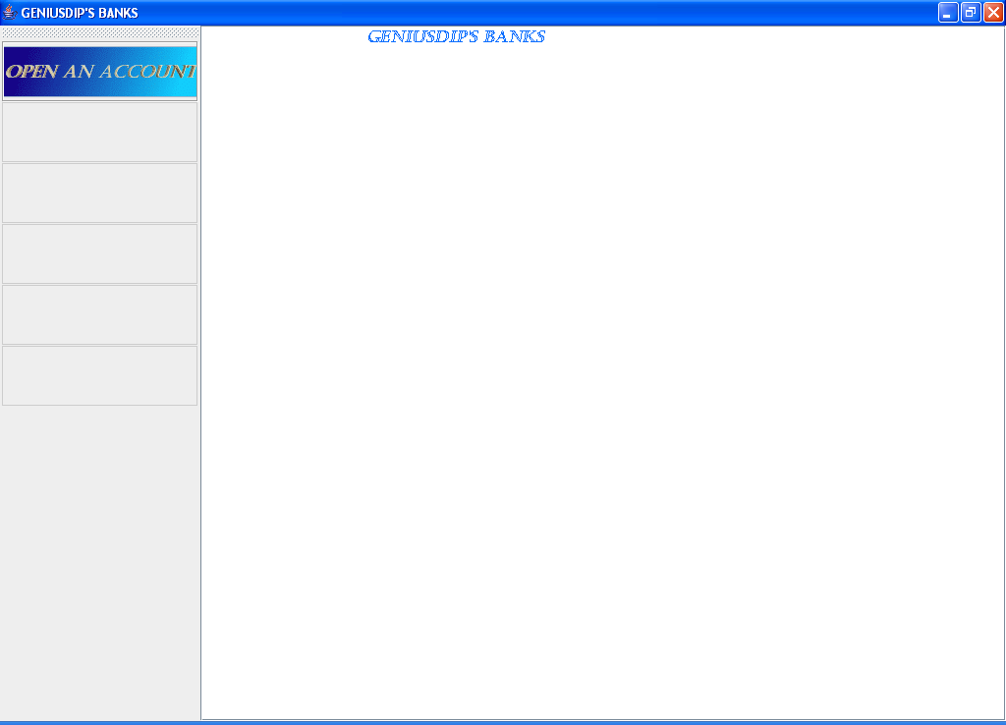

Above is the screen shot of the program at run time. The user has to press the open account button to open an account.

The following screen shows the inputbox that appears when the open button is clicked.

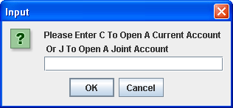

The user has to key in either C to open a current account or J to open a joint account.

The following screen appears when the user clicks the ok button of the above screen with:

Option C:

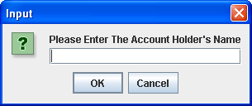
The user has to enter the Account Holders Name, the test data that was used was the name Dip

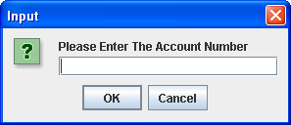

The user has to enter the Account Number, the test data that was used was 00599963.
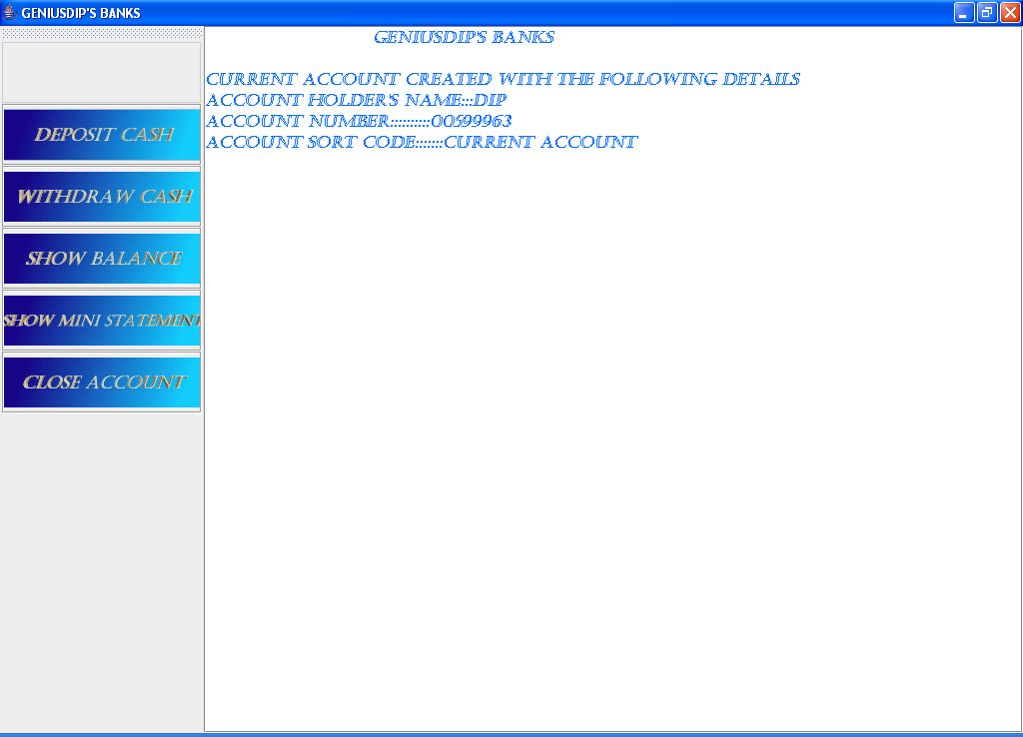

The above screen shows the result of pressing the ok button of the previous input box. All the data that was entered is displayed in the text area. All the other buttons are enabled except the open an account button.

With Option J:

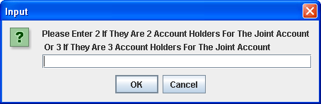

The user has to chose if the joint account will have 2 or 3 account holders. The test data that was used was 3.

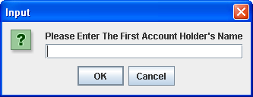

The user has to enter the first account holder’s name. The test data that was user was Dip.

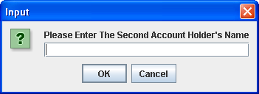

The user has to enter the second account holder’s name. The test data that was used was Shivam.

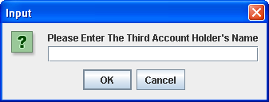

The user has to enter the third account holder’s name. The test data that was user was Dev.

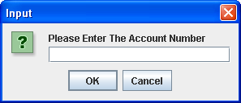

The user has to enter the account number, the test data that was used was 0006369.
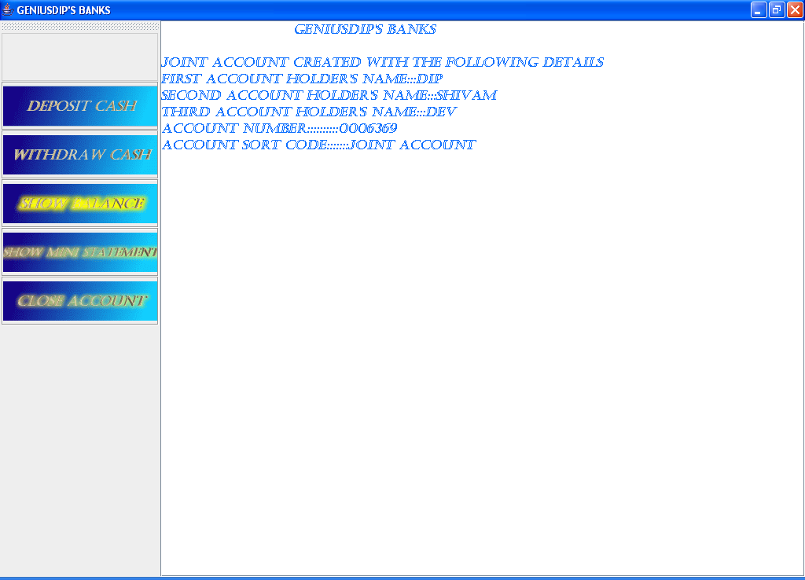

The above screen shows the results of pressing the ok button of the previous input box.

For Both Cases The Following is applicable:

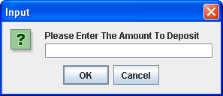

When the user presses the deposit cash button, the above input box appears. The user has to enter the amount of cash to deposit.

When the user presses the withdraw cash button the following input box appears

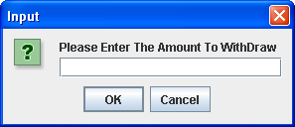

The user has to enter the amount of cash to withdraw. If there is an error in withdrawing like funds not enough, the error will be displayed on the text area.

When the user presses the show balance button, the current balance is displayed on the screen.

When the user presses the show mini statement button, the last 10 transactions are displayed in the text area. The following screen shows an example of what is displayed.

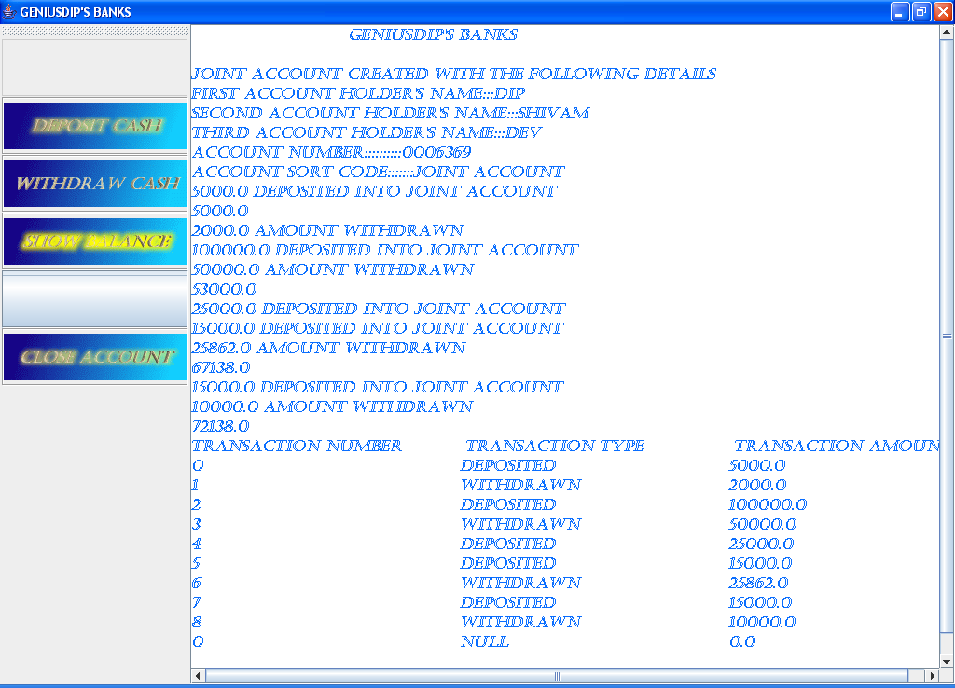

When the user presses the close button the application ends.
Review

Strength
- The application has a very attractive user interface.

Weakness
- The application does not save an user information

Conclusion

These tasks have taught me a lot about the importance of proper documentation and use of good software engineering principles. Java as a programming language is one of the best languages that I have learnt until now.

