### EXIT THE PLUGIN

### A MINI PROJECT REPORT

#### Submitted by

#### Group/Team No: G7/T12

**Harshit Rana (2210991639)**

**Harshit Sharma (2210991640)**

**Harshit Sharma (2210991641)**

**Harshita (2210991642)**

#### in partial fulfillment for the award of the degree of

## BACHELEOR OF ENGINEERING

***in***

COMPUTER SCIENCE & ENGINEERING



**CHITKARA UNIVERSITY**

**CHANDIGARH-PATIALA NATIONAL HIGHWAY**

**RAJPURA (PATIALA) PUNJAB-140401 (INDIA)**

##### 02/05/2023

###### TABLE OF CONTENTS

|  |  |  |
| --- | --- | --- |
| **Sr.no** | **Section** | **Page no** |
| 1. | Introduction | 1 |
| 2. | Problem Statement | 1 |
| 3. | Technical Details | 2 |
| 4. | Key Features | 3 |
| 5. | Project Highlights | 4-5 |
| 6. | Conclusion | 6 |
| 7. | References/Links used | 6 |
|  |  |  |

**Introduction**

* **Exit plugin is an essential tool for website owners who want to improve their website’s usability and provide users with a positive and hassle-free experience.**
* **With its customizable design and tracking options, the plugin is a valuable addition to any website looking to enhance its user experience.**
* **As websites become increasingly complex and interactive, it's more important than ever to ensure that users can easily navigate and interact with your website. One common frustration that users face is difficulty in exiting a webpage.**
* **Exit widgets are used to capture the attention of website visitors who are about to leave a website or close a tab. These widgets provide a last-ditch effort to retain the visitor's attention and prevent them from leaving the website. This project helped us to make an exit widget and a pop-up ad on our website.**

**Problem Statement**

**One common problem user faces is difficulty in exiting a webpage. While most websites include a back button or a navigation menu,these options can be hard to locate to users who are not familiar with website’s layout.**

* **To address this challenge, we propose the development of "Exit Plugin," a customizable exit button plugin that can be easily added to webpages. By providing users with a clear and easy way to exit the page, the Exit Plugin can improve website usability and user experience, ultimately benefiting website owners.**

**Technical Details**

Here are some technical details that you can consider for a project on social share buttons using HTML and CSS:

**HTML and CSS Frameworks**: We have used HTML and CSS frameworks to make the development process easier and more efficient.

**Icon Fonts**: We have used Google icon fonts to display more amazing icons and buttons. This will help to keep the file size small and make the icons look sharp on any screen resolution.

**CSS Flexbox**: We have used CSS flexbox to create a responsive layout for the social share buttons. This will allow the buttons to adjust to different screen sizes and device orientations.

**Add Interactivity**: HTML and CSS alone won’t make your webpage interactive. You’ll need to use JavaScript to add interactivity, such as showing and hiding fields based on user input or validating input fields to ensure they are filled out correctly.

**Key Features**

1. Customizable exit

2. No need to install heavy code editors

3. Cross-browser compatibility

4. Tracking options

5. Responsive design

6. Accessibility options

* Overall, the key features are designed to make exiting webpages easy, convenient and hassle-free with customizable design, tracking options and many more features.
* The exit popup should be triggered by a specific event, such as when the user moves their mouse towards the top of the browser window or attempts to close the browser tab.
* The exit popup should be timed appropriately to avoid being too intrusive or annoying to the user.

The exit popup should include a clear way for the user to dismiss it or opt-out if they are not interested in engaging with it.

**Project Highlights**

Our project is online code editor. Basically, our vision is to resolve the problem of setting up an environment of programming languages on systems for developers. Many people use online code editors on a daily basis when they don’t have the resources to install the compilers on their personal computers, so this is a very helpful website in daily use. As the owner of the website, our job is to keep the user on the website as long as possible, so we use the idea of exit-intent-plugin.

It is basically a popup that appears on the webpage whenever the user tries to leave the website and the popup tries to keep them on the webpage longer through motivational language and other exciting challenges.

Here are some screenshots of the webpage while working:

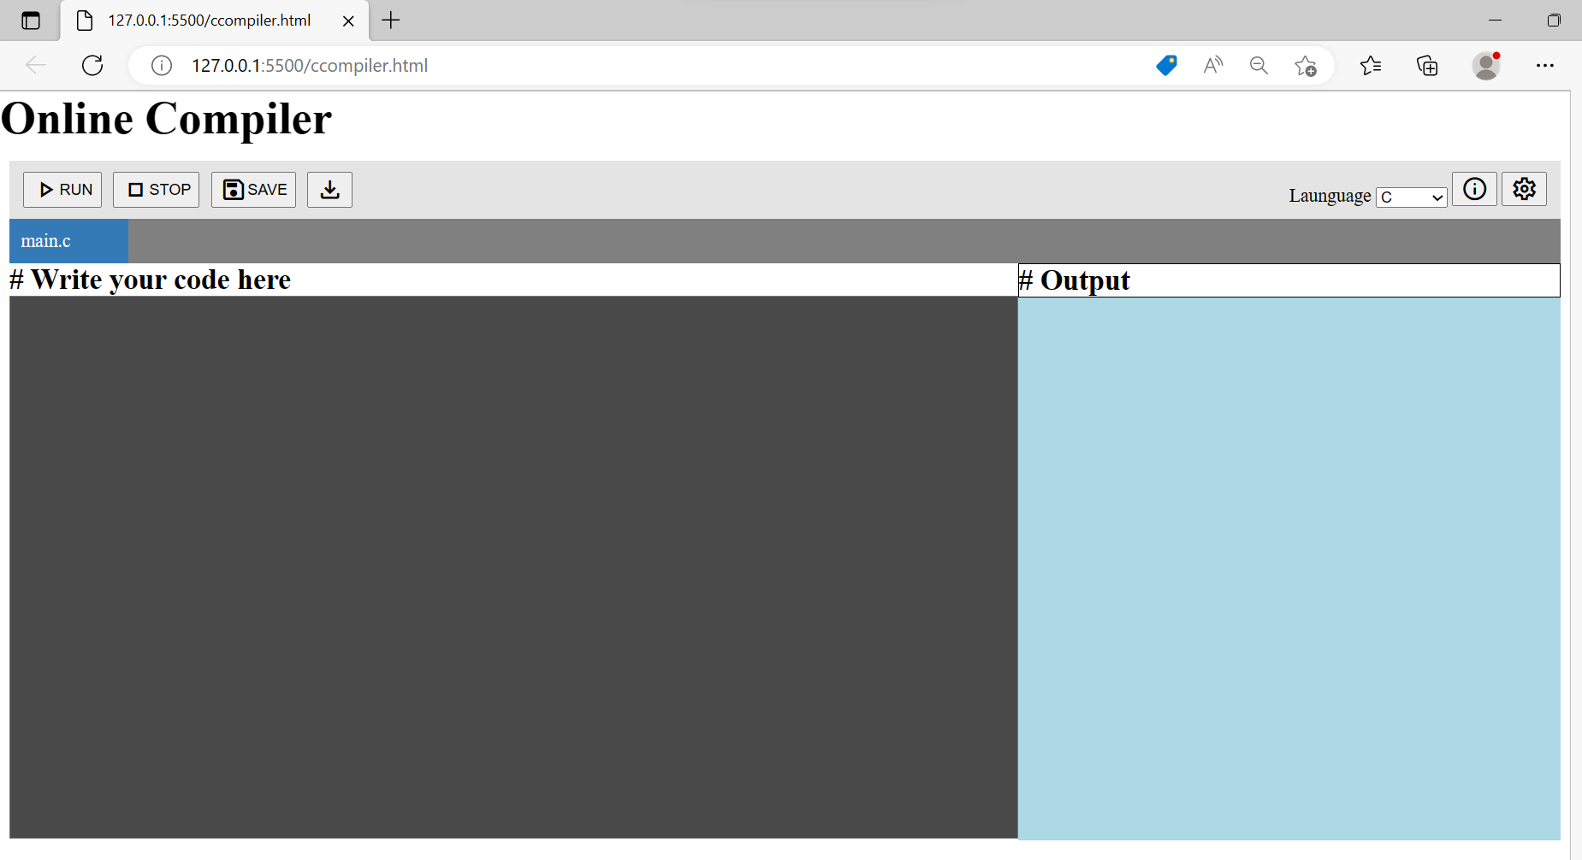

**Exit-Intent-Popup**:

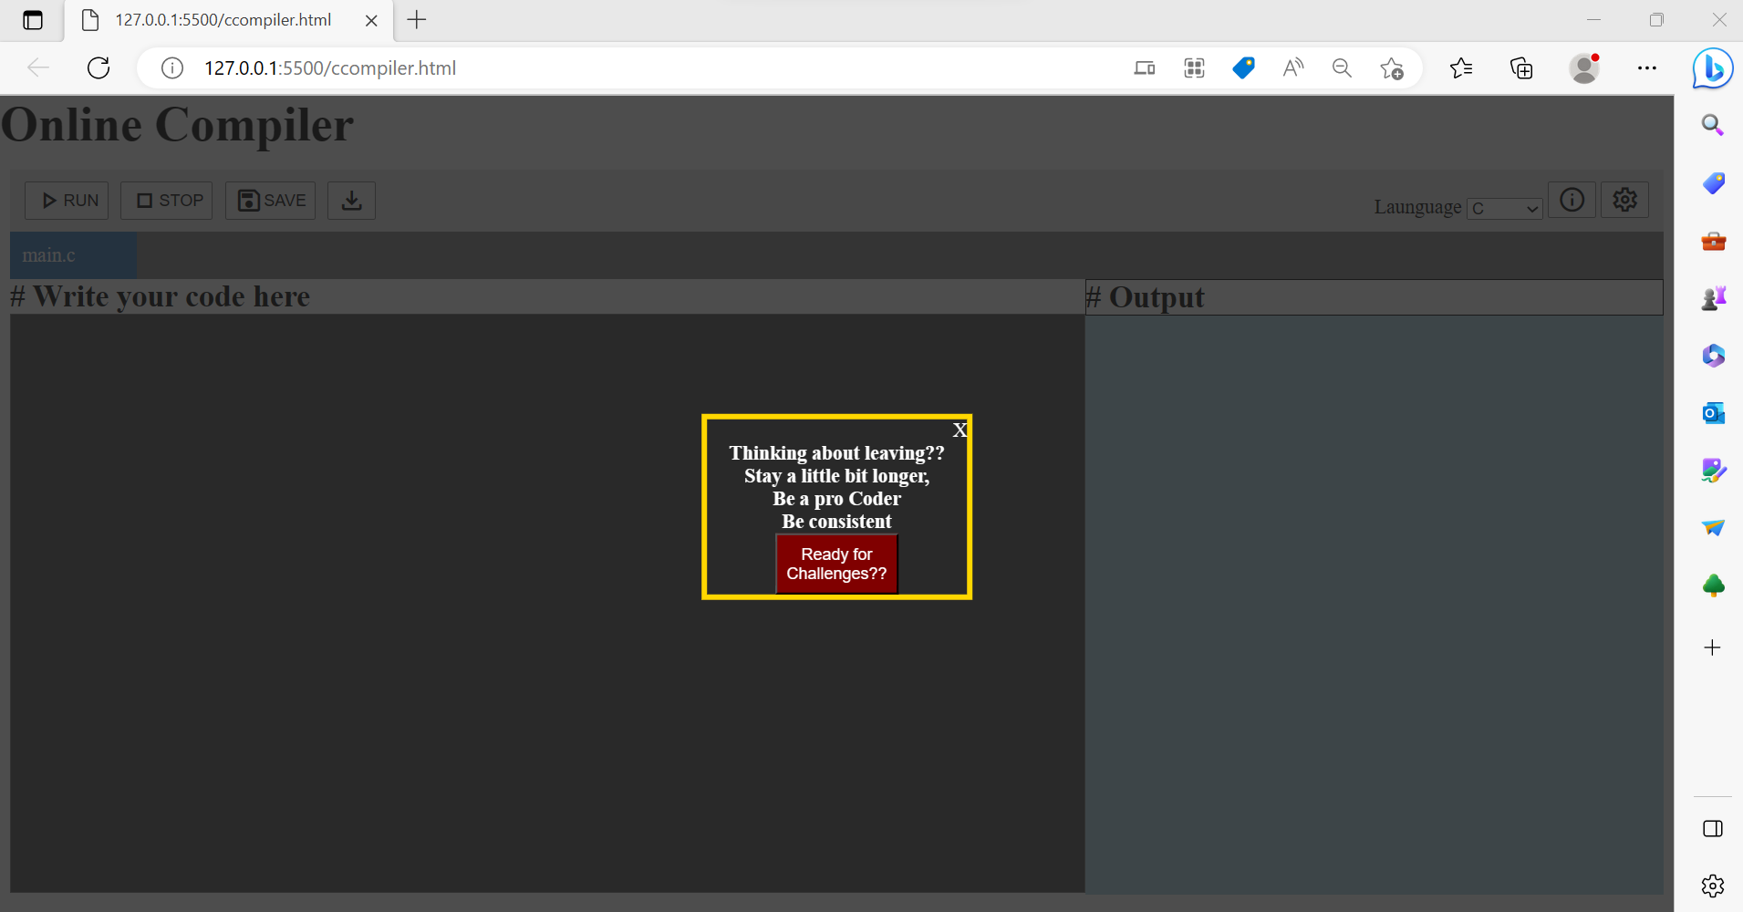

**Conclusion**

* In conclusion, the Exit the Plugin is an effective tool for improving website usability and user experience. Its core features, such as a customizable exit button and accessibility options, provide users with a simple and convenient way to exit webpages.
* While also improving accessibility for users with accessibility needs. Its bonus feature of social media integration further enhances its value, providing website owners with a comprehensive tool for improving website engagement and social media reach.

**Refrences/Links Used**

1. <https://www.w3schools.com/>
2. <https://stackoverflow.com/>
3. https://www.geeksforgeeks.org/
4. HTML and CSS: Design and Build Websites
5. Learning Web Design: A Beginner's Guide to HTML, CSS, JavaScript, and Web Graphics