Gait Detection For Human Posture Analysis

Dr.S Sivakumar Associate Professor Senior School of Electronics Engineering VIT, Chennai Chennai, India
Akul Nagashayana
School of Electronics Engineering
VIT, Chennai
Chennai, India akul.nagashayana2021@vitstudent.ac.in
Harshit Prem Kareer
School of Electronics Engineering
VIT, Chennai
Chennai, India
harshitprem.kaereer2021@vitstudent.ac.in

Abstract— Posture degradation is significant health concern, often leading to chronic conditions like spine and joint pain. Gait analysis is widely used in clinical practice to help in understanding the gait abnormalities and its association with a certain underlying medical condition for better diagnosis. Our aim is to present an efficient approach using OpenCV and Mediapipe for real time posture and gait classification. OpenCV is open-source library that helps in image and video processing, while Mediapipe enables key point detect body joints and find spatial relationships for posture analysis. Through key point detection and feature extraction, OpenCV integrated with MediaPipe facilitates the extraction of 2D body landmarks to detect posture. We have also integrated an IoT based system using esp and a vibrating motor that acts as a notifier when the posture is in bad state. 1-D CNN model classifies human postures and gait patterns. Results demonstrate a real time posture analysis model with a notifier using pre-defined classes.
Keywords—Gait detection, posture classification, CNN, key-point extraction.

Posture-related health issues are increasingly common, with sedentary lifestyles and prolonged screen time contributing to musculoskeletal problems, including chronic back pain, joint issues, and neck strain. Posture degradation, if unaddressed, can lead to long-term health complications and reduced quality of life.

Introduction.
Conventional methods of Posture correction focus mostly on the physical assessment carried out by the healthcare expert without the advantage of constant monitoring. Manual observation and video analysis are often relied on by healthcare professionals to objectively evaluate posture and gait; however, these approaches tend to be problematic as the absence of real time monitoring basing on the assessments is imprecise. Motion capture systems comprise of cameras and body markers that are placed on salient joints of the body such that they provide stereoscopic 3D data regarding body movement with precision. Nevertheless, they are expensive and require a specialized setup which makes them undesirable for prolonged or real-time use.
The proposed model in this study is a real time model-based image recognition system that utilizes OpenCV to acquire images, which are then processed using media pipelining key point extraction. This data is then processed using Convolutional Neural Networks (CNNs) and predicted into four classes; those being good sitting, bad sitting, good standing, bad standing, using a pre-trained dataset, after which real-time analysis of the depicted classes takes place.
Convolutional Neural Networks (CNNs) enhance the system's ability to differentiate subtle differences in posture. Through pre-trained models, the system can accurately classify images into the four categories—good sitting, bad sitting, good standing, and bad standing—ensuring that the feedback is both specific and actionable.
We have created an IoT based solution which is inclusive of the Esp-32 based model in which when a person is having a bad posture then the model sends a signal to the vibrating motor integrated with Esp-32 in order to curb bad postures.
The use of an ESP-32 microcontroller allows real-time communication between the model and a physical response mechanism, in this case, a vibrating motor. This integration means that as soon as bad posture is detected, a signal is sent to the motor, providing immediate haptic feedback that prompts the user to adjust their posture. The model seeks to solve and address the challenges caused by posture concentration on the sections mostly affected by a range of sedentary lifestyle and hard work. The targeted population in this case constitutes of men aged between 20 and 60 years and young boys, who are the most afflicted with pain and other health challenges brought about by poor postures.

Proposed methodology

Data collection and Keypoint Extraction
We have created a custom data set that included images of 30 for every class in four different posture classes: Good Sitting, Bad Sitting, Good Standing, Bad Standing. Each image came loaded with landmarks that give spatial information necessary for body posture recognition. The annotations were generated through mp_pose(). It is a framework that enables detection and tracking of body joints in real time with the aid of machine learning models. It is usually used for the purpose of implementing pose detection and landmark based extraction functionalities in MediaPipe. It allows the use of Pose solution in Media Pipe that is capable of locating and extracting 33 significance markers on the human frame. This includes the points over major joints and the sections of the physical form such as the shoulder, elbow, hip, knee and ankle, making the generation of body posture accurate. The landmarks that were extracted were later placed in a CSV for storage reasons making it easy to retrieve them when training and testing.
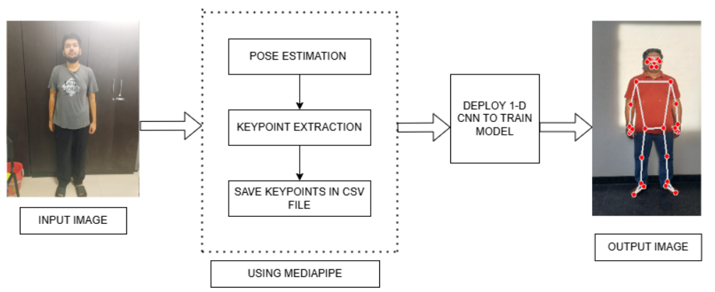

Model Architecture

In our research work, we have employed a 1-D CNN architecture that is well fitted for the task as it is capable of local dependencies amongst the adjacent joints. When applied over the coordinates in a 1D array, the network can distinguish patterns that show whether certain body parts for example the head and shoulders or the spine, are in proper alignment. This specific arrangement of the joints is also very important for determining bad posture, as such postures are characterized by deviations from the proper alignment of such joints. The organization of the classification of the posture can be described in the following way.:
- The model's input shape is (33, 3), corresponding to 33 body landmarks, each represented by three coordinates (x, y, z). This configuration preserves spatial relationships between neighboring joints, enabling the model to capture postural patterns effectively.
- The main component of a 1D CNN is the convolutional layer, which applies a filter (or kernel) across this input sequence. For each position iii, the convolution operation is given by:

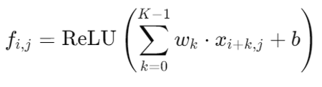
The layer had 64 filters with a kernel size of 3, meaning each filter scanned three adjacent joints at a time.
This layer performs convolution operations by sliding the kernel across the input sequence to capture local dependencies, which helps the model detect misalignments in posture, such as a slumped spine or uneven shoulders.
- After convolution, an activation function i.e ReLU (Rectified Linear Unit) is applied element-wise to introduce non-linearity, allowing the network to learn complex relationships

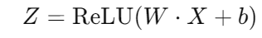
This function sets negative values to zero, which helps to avoid vanishing gradients and adds computational efficiency.
This layer outputs a tensor of shape (31, 64), where:
31 = 33 (input length) - 3 (kernel size) + 1 (standard “valid” padding).
64 = Number of filters
- Following convolution, max pooling layers were applied. Max pooling layers reduce the dimensionality of the data, retaining only the most significant features. The pooling operation resulted in a down with a shape of (15, 64), where 15 represents the reduced spatial dimension and 64 represents the number of filters.

- The output layer provided the classification result as a probability distribution over the four classes (good sitting, bad sitting, good standing, bad standing). The class with the highest probability was chosen as the model’s prediction.
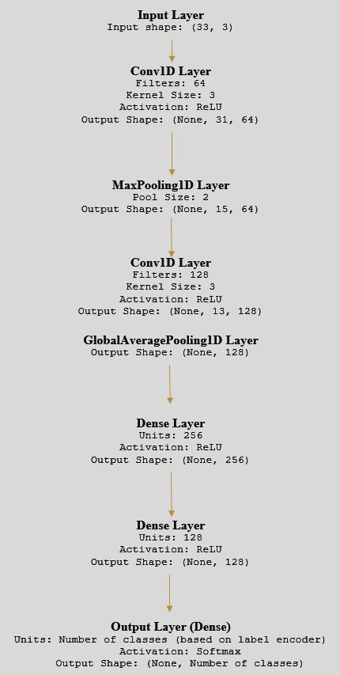

Model Implementation

Model Testing and Evaluation

The model was tested on an expanded dataset of 47 images to validate its classification accuracy and robustness. Testing involved assessing the model’s ability to accurately detect instances of bad posture across various samples.
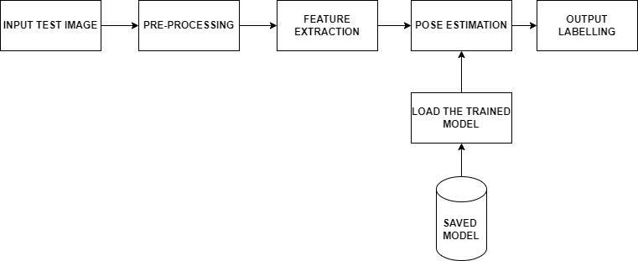

Reatime Implementation
Real-time implementation was carried out by making use of a laptop camera incorporating the OpenCV library. The exaggerated model input was the live camera feed, where the system was able to continually check the user’s posture. In addition, the system also comprised an ESP32 microcontroller. This was done in a situation where the model identified the user as slouching, causing the ESP32 to trigger a loop in which the user would be prompted to adjust their posture to avoid enduring effects of prolonged bad posture.
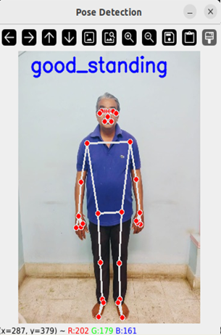

Discussion
The model suggested exhibits considerable promise for real-time posture categorization in a variety of settings. In contrast to conventional methods, this image-based approach is convenient and non-intrusive as it does not entail the use of any wearable sensors. The system could be of particular relevance in situations where individuals are sedentary for long periods of time, like in offices or home work desk providing real-time corrective feedback on pruning their postures.

Limitations

It should be pointed out, however, that the model does have its own drawbacks. To begin with, it needs to operate under specific and constant illumination for accurate extraction of the key points. Performance may dip in low light and if certain body parts are hidden. It is also worth noting the model is susceptible to changes in body type, which may hinder its application to a wider user base.

Potential Applications
This gait detection system has several potential applications:

- Health and Ergonomics: Used in offices and workplaces, the model could provide alerts when poor posture is detected, helping users make real-time adjustments.
- Rehabilitation and Therapy: For individuals recovering from injuries, the model can track adherence to recommended posture or gait patterns.
- Fitness and Personal Training: Integrated with fitness apps, the model could guide users on correct form and posture, reducing injury risks during workouts.

Conclusion
This study proposed a real-time gait classification model based on 1D-CNN architecture. Through efficient key-point extraction and classification using CNN, model was able to classify four different postures. Results indicate the model's precision and its usefulness for postural correction and control in real time. The approach proposed, although useful, has room for improvement on the existing method. In the future researches, aiming to minimize the computational cost, enhance the resilience against light conditions, and look into extending to bigger sizes data sets In addition to this, it will be more interesting to see how this model will play out when fused with a wearable or mobile application for better usability. This multimodal approach would allow for a more nuanced understanding of body mechanics, capturing subtle movements that might be missed through visual data alone. The model’s ability to monitor and correct posture in real time could have profound implications for workplace health, especially in environments where employees are sedentary for long periods

Future work

In the upcoming work, we will focus on the improvement of the dataset in terms of quality and quantity by capturing images in more diverse conditions and involving different types of bodies. Furthermore, the use of transfer learning through the application of previously trained models is expected to enhance the quality of generalization. In addition, looking into the methods of 3D pose estimation would help tackle the problem of occlusion and improve the correctness of the posture classification even further. We also working on creating web based platform for bad posture recognition mainly focusing for corporates.
While the model currently performs well with the dataset used, expanding to larger datasets will improve its generalizability and ability to handle diverse postures. Future research could involve gathering extensive and varied datasets from different age groups, body types, and activity levels, enhancing the model’s versatility and resilience.

References

- ALI ROHAN ,(Associate Member, IEEE), MOHAMMED RABAH2, TAREK HOSNY, AND SUNG-HO KIM , “Human Pose Estimation-Based Real-Time Gait Analysis Using Convolutional Neural Network”,DOI https://doi.org/10.1109/ACCESS.2020.3030086
- Hao Ma, Student Member, IEEE, and Wei-Hsin Liao, Senior Member, IEEE, “Human Gait Modeling and Analysis Using a Semi-Markov Process with Ground Reaction Forces”, DOI https://doi.org/10.1109/TNSRE.2016.2584923
- I Aditya Viswakumar , Venkateswaran Rajagopalan , Tathagata Ray, Chandu Parimi,” Human Gait Analysis Using OpenPose”, DOI http://www.jneuroengrehab.com/content/11/1/131
- HAN SU, FENG-GANG HUANG, “HUMAN GAIT RECOGNITION BASED ON MOTION ANALYSIS”, DOI https://ieeexplore.ieee.org/document/1527725 .
- Ryo Takedaa, Shigeru Tadanoa, , Masahiro Todoha, Manabu Morikawaa,1, Minoru Nakayasua,2, Satoshi Yoshinarib, “Gait analysis using gravitational acceleration measured by wearable sensors, DOI https://doi.org/10.1016/j.jbiomech.2008.10.027
- Kanae Nishizaki, Tatsuki Izumiura, Hiromitsu Nishizaki, Shin-ichi Izumi, Hitoshi Ikegami, “Evaluation of a Gait Analysis Tool Using Posture Estimation Technology in Clinical Rehabilitation,”, DOI https://doi.org/10.1109/LifeTech52111.2021.9391832
- Rijun Liao , Shiqi Yu b , Weizhi An , Yongzhen Huang , “A model-based gait recognition method with body pose and human prior knowledge” DOI https://doi.org/10.1016/j.patcog.2019.107069

