Project Learn

Overview

Welcome to Project Learn
Welcome to Project Learn! You will help us develop high-quality Kaggle-style prediction tasks on real datasets, plus scoring scripts that objectively measure whether a solution is correct, utilizing machine learning and data science skills.

Right now, we are focused on the Kaggle task layer, creating complex prediction challenges that current LLMs are not able to solve, with clear objectives, rich datasets, and non-trivial predictions.

The deadline to create kaggle style tasks is Monday, March 2, but the sooner the better! There will be the reviewing process that follows and will end on Tuesday, March 3.

Compensation:
$75 per approved and completed task
$15 per critique completed

Note: The reviewing of the corresponding pipeline must be done for a task to be considered “complete”.

Please upload all of the files to the AfterQuery Experts Project Carrot platform! Access the platform here

Each task should have the following files:
- train.csv
- test.csv
- solution.csv (typically, test.csv with the labels)
- sample_submission.csv
- perfect_submission.csv
- score_submission.py
- instruction.md
- golden_workflow.md
- dataset_card.md

Onboarding
To be fully onboarded, 1. signed your contracts here, and 2. Read this whole instruction document before getting started

Goal
Your goal is to create tasks that follow our task requirements, utilizing data analysis and science skills to create high-quality prediction tasks.

How to Submit
Please read the full instructions in the next few pages. This guide explains what to include in your task, how to format it, and how to upload it correctly. Please read it carefully and thoroughly

Questions?
If you have any questions, message me (@Jean Lin) on Slack. We’re here to help. We look forward to seeing your submissions!

General Practices
- Tasks need to be sufficiently complex so that current LLMs are not able to solve them.
- You must own the content of your projects. You agree that you have full ownership rights over all code submitted and that all submitted code has been written only by you.
- Each project should follow the required project structure. See the project structure below.
- Ensure the project has all required files: the core program files, configuration documents, and any dependency management specifications, such as requirements.txt
- Projects with greater complexity or cover niche topics have a higher chance of being approved

Workflow Process Summary

A task is a single, self-contained prediction challenge built on top of a dataset you know well.

For every task:
- The agent will be asked to train a model / pipeline / etc on train.csv
- The agent uses the model to predict test.csv
- The agent generates the predictions as submission.csv
- We run score_submission.py to validate and score the submission deterministically against solution.csv
  - We will run `python3 score_submission.py --submission-path submission.csv --solution-path solution.csv`
  - We expect this command to output a single float that represents the score
- Reviewers check the task is correct + realistic + scorable

Reference Example: Before creating your tasks, review these Kaggle competitions to understand what well-structured prediction challenges look like: link here

Why this is a good example:
- Clear objective: “Predict the final sale price of homes”
- Rich dataset: 79 features describing house attributes
- Non-trivial prediction: Price depends on complex feature interactions
- Clear metric: RMSE on log-transformed prices
- Well-defined submission format: Id, SalePrice

Additionally, here are:
- Acceptable task buckets
- Task difficulty guidelines

1. Submit Competition

- Go to the Afterquery Experts site, go to “Carrot” and make sure on the top right you are in the “Curator” view. Then click on the “Go” button in the Submit Competition area
- Give your competition a deterministic name in the “Competition Name” area

2. Upload Dataset Files

- Required Files:
  - train.csv - must include: id column, feature columns, and target label column
  - test.csv - must include: id column and feature columns only (no target)
  - sample_submission.csv - must include the exact required columns for submission.csv

3. Write the Dataset Card

- Naming: dataset_card.md
- This should be written in the following format:

- ## Overview - What this dataset is, how it was collected/generated, and the domain it comes from
- ## Source - Where this data originated. If public, include the link to the original dataset
- ## License
  - One of: CC0-1.0, CC-BY-4.0, ODC-PDDL-1.0, ODC-By-1.0, CDLA-Permissive-2.0, OGL-UK-3.0, Public-Domain-US-Gov, MIT, AQ Internal
  - NOT allowed: CC BY-NC, CC BY-ND, or any license with NC or ND terms
  - NOT allowed without written approval: share alike / reciprocal licenses, including CC-BY-SA-4.0, ODbL-1.0, CDLA-Sharing-1.0
  - Kaggle rule: If you found the dataset on Kaggle, you may use it only as a discovery link. You must link to the original upstream source with an allowed license and download the files from the upstream source, not from Kaggle
  - Any dataset uploaded without a license will become AQ IP. If it does have a license, please provide the public link as well so we can verify the source
- ## Features - Brief description of columns/fields — what they represent, how they were measured.
  - Doesn't need to be exhaustive; focus on provenance and meaning
- ## Splitting & Leakage - How train/test was split (time, group, random) and any known leakage risks to watch for.
  - Write "Random split, no known leakage risks" if nothing special

4. Scoring

- Required file: score_submission.py
- This file must:
  - Read submission.csv
  - Validate submission format:
    - file exists
    - required columns exist (must match sample_submission.csv)
    - row count equals test.csv row count
    - ids match test.csv ids (same set; ideally same order or sortable)
  - Compute the metric deterministically
  - Print a single numeric score
- When we run score_submission.py, it should take two arguments:

score_submission.py --submission-path /path/to/submission.csv --solution-path /path/to/solution.csv

- score_submission.py should print a single numeric score for the submission using whatever metric
  - sample_submission.csv should get a valid score
  - perfect_submission.csv should get close to the best score possible (e.g. min loss, max accuracy)
- Determinism requirement: same submission → same score every time.

5. Write instruction.md
- Include instruction.md in this order:
  - Objective (what to predict)
  - Inputs (train.csv, test.csv)
  - Output (submission.csv)
  - Submission format (columns + meaning)
  - Metric + any constraint (time/group split, forbidden columns)

6. Write golden_workflow.md

- golden_workflow.md describes the best workflow you would personally follow to solve your own task. It must be dataset-specific and sufficiently detailed. Use the following headings where applicable: Data sanity checks, Validation strategy, Preprocessing plan, Baseline model, Iteration plan, Error analysis, Leaderboard safety, and Submission checks.
- golden_workflow must not be a generic checklist. Under each heading, you must explain the following for the steps you recommend:
  - Rationale: Why you are doing this step, and what decision it informs.
  - Dataset and objective nuances: What is specific about this dataset or target that makes this step necessary. Examples include target skew, time dependence, grouped observations, label noise, class imbalance, heavy-tailed errors, leakage-prone fields, or metric sensitivity.

7. Write perfect_submission.csv

8. Run Quality Checks

- Click through each of the quality checks and ensure all pass!

9. Submit

Review Process
Your project and tasks will be reviewed against the following criteria:
- Dataset is sufficiently complex
- Task Description is sufficiently detailed
- Tasks are sufficiently complex
- High code quality across tasks

CRITIQUE PHASE

Now that your task has been approved, you can move on to the critique phase! We have generated multiple broken AI implementations of your task. These broken attempts are packaged into a Task and assigned back to you to critique. Your critiques are used to generate rubrics and improve the evaluation loop, so they must be specific and evidence-based.

1. Go to Critique Pipelines

- Look at the tasks that have been approved, and click into a task

2. Review each task

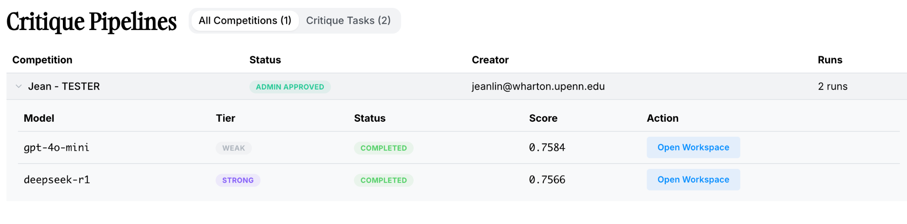

- Click on each competition to see all of the critiques that need to be completed
- Click on the blue “Open Workspace” button on the right side for each of the agents. These are faulty implementations of the task you have created.
- Critique ALL of the files that the agent created (has an “agent” label next to it)
  - Highlight the lines of code you want to critique
  - Add an annotation
  - 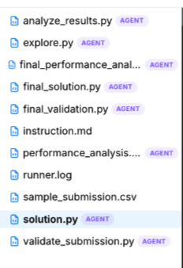
- After you have made some annotations, a “suggest critiques” feature will appear. Your role is to review these generated annotations to ensure they are valid. You can choose to accept, edit, or reject one of the suggested critiques
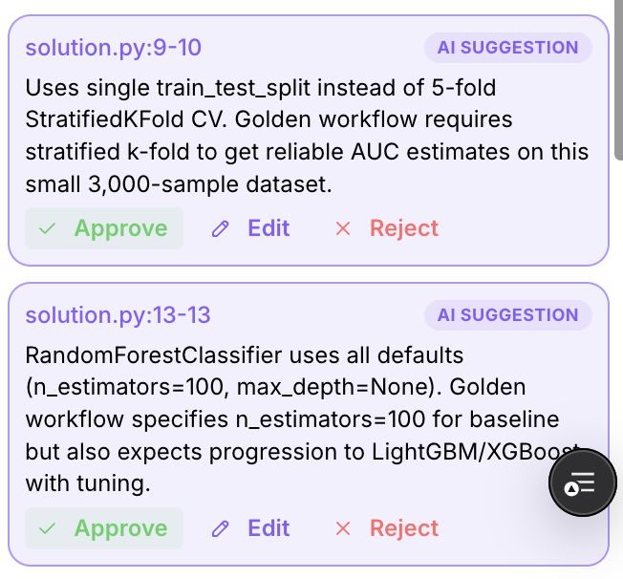
- Once you are done annotating the code, summarize the logical flaws you found in “Overall Notes”

Hit the “Save” button

3. “Generate Rubric” (COMING SOON)

- Run the Generate Rubric button on the bottom right corner. This will automatically generate a set of rubrics using your annotations

4. Click “Audit” and make any necessary changes (COMING SOON)

5. Click “Submit” and repeat for all tasks! (COMING SOON)

REMINDER: All critiques must be complete for a task to count as completed

FAQ

Do I need a new dataset for every task?
For now, you can make 1-6 tasks per dataset.

