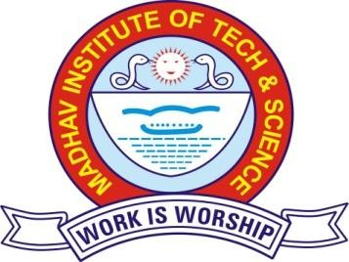Himanshu Sahu

B.Tech.. - Chemical DOB: 03/06/2000

S/o: Jagram Sahu Add: Hanuman Ganj

Danda Dabra, Dist. Gwalior

Email Id: [601himanshusahu@gmail.com](mailto:601himanshusahu@gmail.com) Mob: +91- 8871482503

**Career Objectives** Looking for an organization which will help me to explore my talent, hone my skills and utilize them in the best possible way for the attainment of their goals.

# Academic Credentials:

|  |  |  |  |  |
| --- | --- | --- | --- | --- |
| **Examination** | **Year** | **Percentage** | **Institution** | **Board/University** |
| B.Tech.  (Chemical) | 2022 | 67.7  (Upto 6th Sem) | Madhav Institute Of Technology &  Science,Gwalior, M.P. | RGPV University  Bhopal |
| Class XII | 2017 | 70.2 | Maa Peetambra Higher Secondary  School, Dabra Dist. Gwalior, M.P. | MP BOARD |
| Class X | 2015 | 52.83 | Maa Peetambra Higher Secondary School, Dabra Dist. Gwalior, M.P. | MP BOARD |

**Projects & Trainings:**

* Minor Project - **“Multifeed Distillery Plant Based On Rice/Grains as Raw material”** at Gwalior Distilleries Pvt. Ltd, Bhind (May ’02 - June ’06)
* Internship - **“Process Integragtion & Automation in Chemical Industries“** Under The Finishing School Programme (May ’14 – May’30)
* Summer Internship – Chemical Reaction Engineering , Mass Transfer.

# Skills:

* MS Office, Basics in Java , Oops

# Rewards & Recognitions:

* Participated in the **8th Vigyan Manthan Yatra 2014-15** As Excellent Student Of Krishna Group In The Interactive Visit to Scientific And Research Institution Of Hyderabad Under **Madhya Pradesh Excellence Programme**, Organized During 7 - 16 November 2014 By **M.P Council Of Science & Technology , Bhopal**
* Received **NPTEL Courses Certificates** - Nano Technology , Enviromental Quality & Monitoring Analysis.
* Won 1st Prize in ‘Group Dance’ in Classs 8th , 1st prize in ‘Kho kho’ In Class 8th , 1st prize in ‘Cricket’ in class 9th.
* Received appreciation certificate from Red Cross Socierty (2019).

# Co-Curricular:

* Currently working as an Coordinator Of TEC (Techinal Exhibition Club).
* Organised various Events Under TEC.

# Interests & Hobbies:

* Outdoor Games, Social work.