# VISVESVARAYA TECHNOLOGICAL UNIVERSITY

# JNANA SANGAMA, BELGAUM – 590018



**MINI-PROJECT REPORT**

**ON**

# “Baby Monitoring System”

**Submitted in partial fulfillment of the requirements for the award of the degree**

**BACHELOR OF ENGINEERING**

**IN**

**ELECTRONICS AND COMMUNICATION**

**Submitted by**

**Ankit Kumar (1MV20EC016)**

**Arman Aryan (1MV20EC024)**

**Harshit (1MV20EC053)**

**Himanshu Sekhar Das (1MV20EC055)**

**Under the guidance of**

**Dr. Sasmita Mohapatra**

**Professor, Department of ECE**



**SIR M. VISVESVARAYA INSTITUTE OF TECHNOLOGY**

**DEPARTMENT OF ELECTRONICS AND COMMUNICATION ENGINEERING**

**Bengaluru-562157**

**2022-23**

**SIR M. VISVESVARAYA INSTITUTE OF TECHNOLOGY**

**BENGALURU-562157**

**Department of Electronics and Communication Engineering**



**CERTIFICATE**

This is to certify that the project entitled **“BABY MONITORING SYSTEM”** is a bonafide work carried out by **ANKIT KUMAR (1MV20EC016), ARMAN ARYAN (1MV20EC024),HARSHIT (1MV20EC053), HIMANSHU SEKHAR DAS (1MV20EC055)** of **Sir M. Visvesvaraya Institute of Technology,** Bangalore, in partial fulfillment for the award of degree of Bachelor of Engineering in **Electronics and Communication** of the **Visvesvaraya Technological University,** Belagavi during the academic year 2022-2023. It is certified that all corrections/suggestions indicated for Internal Assessment have been incorporated in the report. The project report has been approved as it satisfies the academic requirements in respect of Mini-project (18ECMP68) prescribed for Bachelor of Engineering degree.

|  |  |  |
| --- | --- | --- |
| **Dr. SASMITA MOHAPATRA** | **Dr. SUPRIYA V. G.** | **Prof. RAKESH S. G.** |
| Professor | Professor & Head | Principal |
| Department of ECE | Department of ECE | Sir MVIT, Bengaluru |

**External Examination**

**Name of Examiners: Signature with Date**

1. ………………………………… …………………………..
2. ………………………………… …………………………..

# ACKNOWLEDGEMENT

It gives us immense pleasure to express our sincere gratitude to the management of **Sir M. Visvesvaraya Institute of Technology**, Bengaluru for providing the opportunity and the resources to accomplish our project work in their premises.

We would like to convey our regards and sincere thanks to **Prof. Rakesh S.G., Principal, Sir MVIT** for providing us with the infrastructure and facilities needed to develop our project.

We are also grateful to **Dr. Supriya V.G.,** Professor & Head, **Dept. of ECE** for her suggestions, constant support and encouragement.

On the path of learning, the presence of an experienced guide is indispensable and we would like to thank our guide **Dr. Sasmita Mohapatra, Professor, Dept. of ECE**, for her invaluable help and guidance.

We would also like to thank the staff of the Department of Electronics and Communication Engineering and lab-in-charges for their co-operation and suggestions.

Finally, we would like to thank all our friends for their help and suggestions without which completing this project would not have been possible.

**Ankit Kumar (1MV20EC016)**

**Arman Aryan (1MV20EC024)**

**Harshit (1MV20EC053)**

**Himanshu Sekhar Das (1MV20EC055)**

# ABSTRACT

The baby monitoring system using ESP32, incorporating sound and temperature sensors, is a comprehensive project aimed at ensuring the safety and comfort of infants. The ESP32 microcontroller, along with the sound and temperature sensors, collects vital data to monitor the baby's environment accurately. The sound sensor detects audio cues, while the temperature sensor provides real-time temperature readings. The system offers a reliable solution for parents and caregivers to monitor their baby's well-being and promptly address any discomfort. With the integration of ESP32 and the sensors, the project enables efficient monitoring and ensures a safe environment for the baby. This baby monitoring system serves as an essential tool for enhancing parental peace of mind and ensuring optimal care for infants.

# TABLE OF CONTENTS

**Page no.**

CHAPTER 1: INTRODUCTION 1

CHAPTER 2: PROBLEM STATEMENT 2

CHAPTER 3: LITERATURE SURVEY 3

CHAPTER 4: OBJECTIVES 5

CHAPTER 5: METHODOLOGY 6

CHAPTER 6: HARDWARE DETAILS 8

**CHAPTER 7: SOFTWARE DETAILS 13**

**CHAPTER 8: RESULTS AND OUTCOMES 17**

**CHAPTER 9: MERITS AND DEMERITS 18**

**CHAPTER 10: CONCLUSION AND FUTURE SCOPE 19**

**REFERENCES 20**

**CHAPTER 1**

**INTRODUCTION**

The People these days not seem to be always in urge with their work and they may not be able to monitor the child all the time. In order to come over this difficulty, the baby monitoring system is developed that works on the principle of IoT. The baby monitoring system is a kind of alarm system which can detect baby movements and activities and can convey the message about the condition of babies to the concerned authority via mobile and laptop into any place. In proposed system baby monitoring has been designed and developed using ESP 32 as control unit. The different sensors like temperature sensor, sound sensor are used to assist baby monitoring and are interfaced with the ESP 32. The baby sound like crying is detected by sound sensor and then motor start swing the cradle. The baby’s temperature is monitored by the temperature sensor. The result obtained from the designed work shows the easier and convenient way of baby monitoring for busy parents. The proposed system provides an easier and convenient way for busy parents in taking care of their babies. In the Smart Baby Monitoring System one of the important goals is to provide basic attention to the baby in absence of the parent for some time. In these current pandemic times, Work from Home facility has been enabled to the employees, while working in different room/space it will be convenient for parents to sooth the babies through our design. Instead of keeping the child in a Day-care, or hiring some nurse to attend the baby, working parents can manage to take care of their baby with the help of the smart cradle.

**CHAPTER 2**

**PROBLEM STATEMENT**

Current baby monitoring systems have limitations that hinder their effectiveness in ensuring the safety and well-being of infants. Traditional audio-only monitors provide limited information, leaving parents uncertain about their baby's specific needs or activities. Video-based systems may lack essential features like two-way communication or real-time alerts for motion or sound. Furthermore, existing systems may have connectivity issues, range limitations, or complex setups that make them inconvenient for parents to use. As a result, there is a need for an advanced and comprehensive baby monitoring system that incorporates features such as audio and video monitoring, two-way communication, motion and sound sensors, temperature monitoring, mobile app integration, and reliable connectivity. This system should be user-friendly, provide accurate and timely information, and ensure parents can easily and confidently monitor their baby's safety and well-being. Parents and caregivers often face challenges when it comes to keeping a close watch on their infants or young children, particularly when they are in a different room or away from home. While traditional audio-only baby monitors can provide some level of reassurance, they may not provide enough information or functionality to ensure the baby's safety and well-being. Furthermore, some baby monitoring systems may suffer from connectivity issues, low battery life, or poor audio and video quality, which can lead to unreliable monitoring and false alarms. Therefore, there is a need for a modern and reliable baby monitoring system that incorporates advanced features such as video monitoring, two-way communication, motion and sound sensors, temperature and humidity monitoring, mobile app integration, and a user-friendly interface. Such a system would provide parents with the peace of mind they need to attend to their baby's needs and ensure their safety, no matter where they are.

**CHAPTER 3**

**LITERATURE SURVEY**

**[1] IoT- BBMS :Internet of things-based baby monitoring system for smart cradle ,Waheb a jabbar and Saidatul n.i.s hamid,IEEE,2021**

**Overview of the paper:**

IoT-based Baby Monitoring System using sensors to track ambient temperature, moisture, and crying is proposed to monitor babies in real-time. The system consists of a baby cradle with a swinging motor, an external web camera for remote monitoring, and an MQTT server to control the lullaby toy. The prototype was designed using Nx Siemens software, tested, and proven effective.

**[2] IOT Based Baby Monitoring System Smart Cradle ,Senoj Joseph and Ajay Gautham.J,IEEE,2022**

**Overview of the paper:**

The project is centered around a plan to develop a IO T based Smart baby cradle that would assist the Parents with monitoring and keeping an eye on their infants regardless of whether they are at home or at work and can identify each activity of the infants from any inaccessible corner of the world. It is a brilliant, imaginative and defensive Cradle System to support a newborn child in a productive manner. This framework considers all the moment subtleties that are needed for the consideration and insurance of the Baby in the support. The plan of keenness and development accompanies the utilization of advancements which incorporate Internet of Things (IOT), Modules like Raspberry Pi, Gas sensor, sound sensor and Temperature sensor, Cry Detecting Mechanism, camera surveillance, and much more. To recognize each and every movement of Baby, various Sensors are connected to the Cradle: Gas & Temperature Sensing Module for discovery of wetness of the cradle.

**[3] IoT based Smart Cradle for Baby Monitoring System, N Lakshman Pratap and Sunanda Nalajala,IEEE,2021**

**Overview of the paper:**

A smart cradle with an automated baby monitoring system was developed to assist working mothers in monitoring their babies' health parameters in real-time. The system uses sensors to capture the baby's motion and position and displays the readings in a mobile application. Abnormal readings trigger alerts to the caretaker and parents. The system is proven to be accurate and safe and helps in time management for parents and caretakers.

**[4] . Design and Development of a Smart Baby Monitoring System based on Raspberry Pi and Pi Camera, Aslam Forhad Symon and Nazia Hassan,IEEE,2022**

**Overview of the paper:**

This project presents a baby monitoring system for busy parents so that they can ensure the proper care and safety of their babies. This system can detect the baby’s motion and sound; especially crying and video output of baby’s present position can be displayed on a display monitor so that the mother or another responsible person can watch the baby while away from him or her. This baby monitoring system is capable of detecting motion and crying condition of the baby automatically. The Raspberry Pi B+ module is used to make the total control system of the hardware, condenser MIC is used to detect baby’s crying, PIR motion sensor is incorporated to detect baby’s movement and Pi camera is used to capture the baby’s motion. A display is used to have video output of sleeping baby.

**CHAPTER 4**

**OBJECTIVES**

* Develop a baby monitoring system that utilizes temperature, humidity and sound sensors to provide real-time monitoring of a baby's environment.
* Ensure accurate and reliable measurement of temperature fluctuations in the baby's surroundings, allowing parents or caregivers to respond promptly to any changes that may affect the baby's comfort or well-being.
* Implement a robust sound sensing capability to detect and analyze various audio cues, such as crying, laughter, or irregular noises, enabling caregivers to monitor the baby's activities and intervene when necessary

**CHAPTER 5**

**METHODOLOGY**

The temperature sensor continuously measures the temperature and humidity fluctuation in the baby's room. It provides temperature readings in real-time. As soon as the temperature rises above 31 degree celsius the dc fan which is connected to one channel relay is switched on. The sound sensor detects the sound levels in the room, capturing any noise or disturbances that occur. As soon as the sound is detected the cradle starts to swing using the servo motor.

**5.1 BLOCK DIAGRAM**

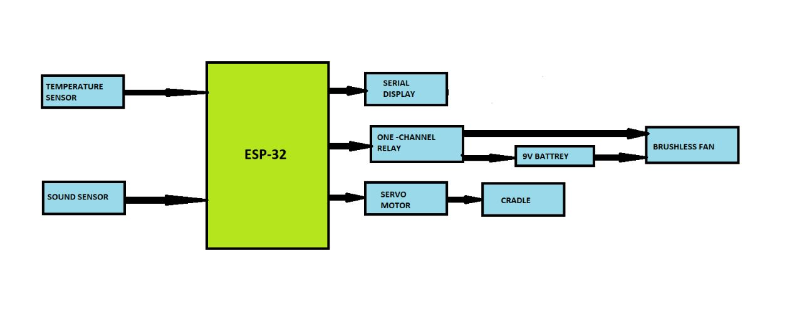

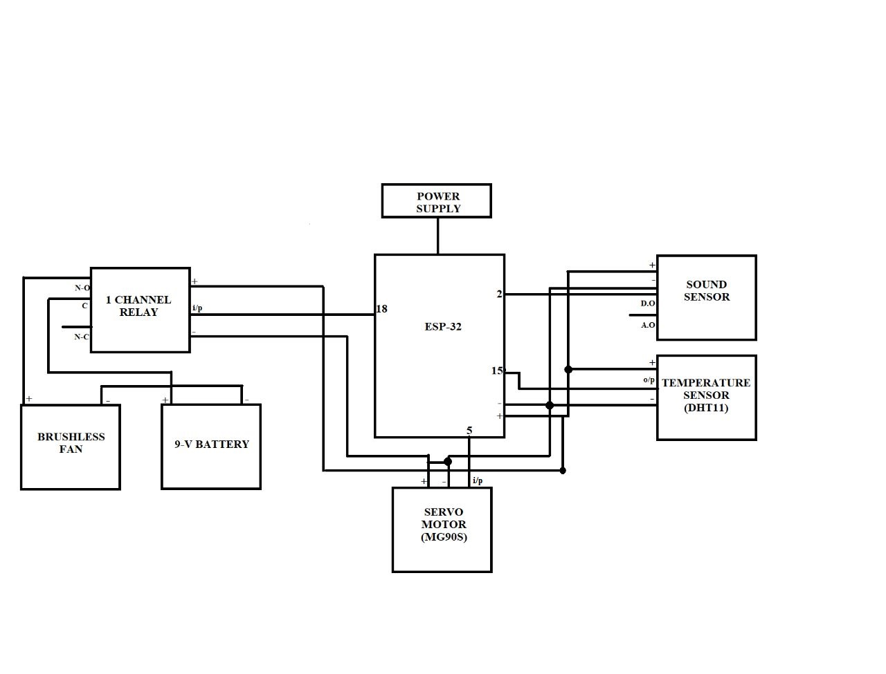**5.2 CIRCUIT DIAGRAM**

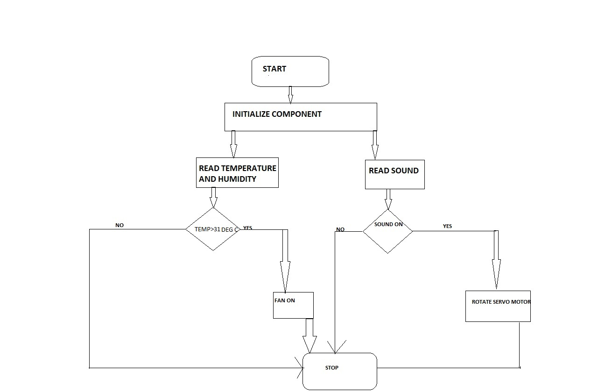**5.3 FLOW CHART**

**CHAPTER 6**

**HARDWARE DETAILS**

## Hardware Requirements: -

## ESP-32

## ONE CHANNEL RELAY

## SERVO MOTOR

* SOUND SENSOR
* TEMPERATURE SENSOR
* DC FAN
* 9V BATTERY

**6.1 ESP-32 Microcontroller**

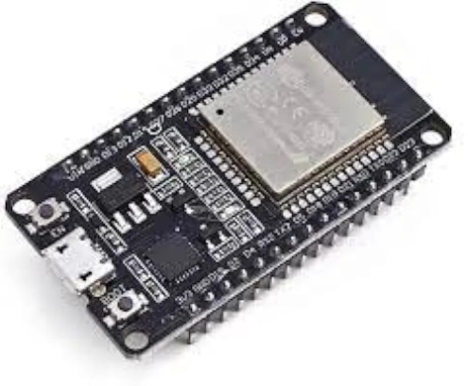

Fig 6.1 ESP-32 Microcontroller

The ESP32 is a popular microcontroller module that combines Wi-Fi and Bluetooth connectivity with a powerful dual-core processor, making it a versatile platform for a wide range of applications

**6.2 ONE CHANNEL RELAY**

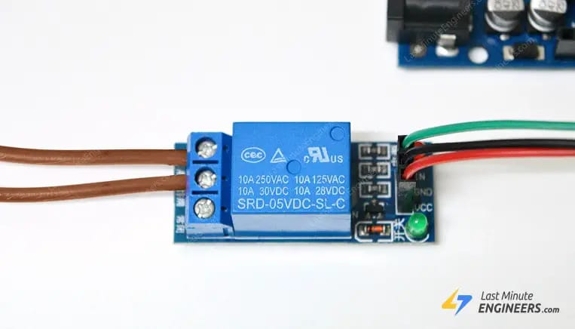

Fig. 6.2 one channel relay

A one-channel relay, also known as a single-channel relay, is an electrical switching device that allows the control of a single circuit or load using an input signal.

It is commonly used in various applications to automate or control the operation of devices or systems.

**6.3 SERVO MOTOR**

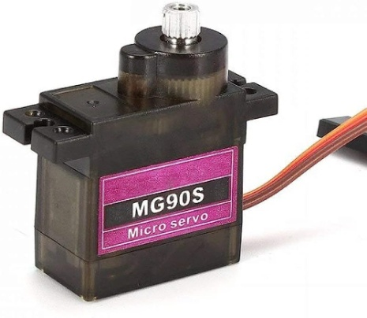

Fig 6.3 Servo motor

The MG90S servo motor typically comprises a DC motor, a set of gears, a control circuit, and a feedback mechanism

**6.4 SOUND SENSOR**

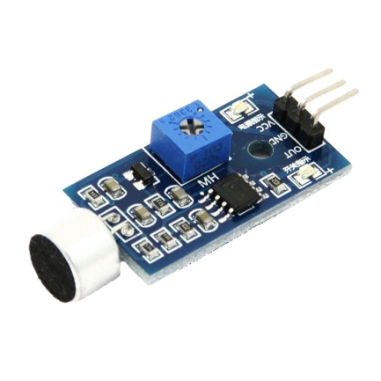

Fig 6.4 Sound Sensor

A sound sensor, also known as a sound detector or microphone sensor, is an electronic device that detects sound waves in the surrounding environment and converts them into electrical signals.

**6.5 TEMPERATURE SENSOR**

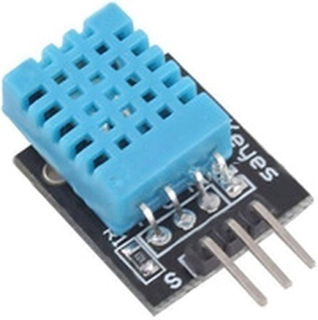

Fig 6.5 Temperature sensor

The DHT11 sensor is a widely used digital temperature and humidity sensor.

**6.6 DC FAN**

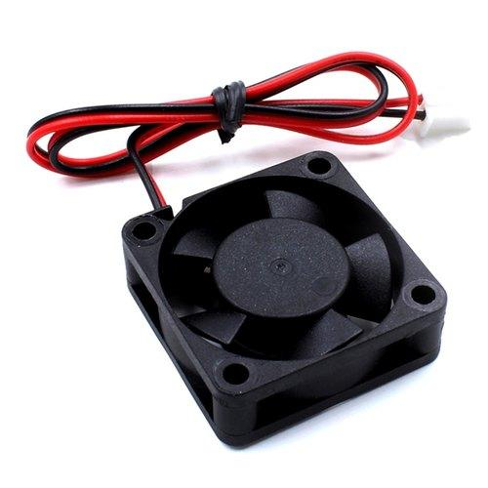

Fig 6.6 DC Fan

A 5V brushless DC (BLDC) fan is a type of fan that operates on a 5-volt power supply and utilizes brushless DC motor technology.

**6.7 9V BATTERY**



Fig 6.7 9V Battery

A 9V DC battery is a type of portable power source that provides a direct current (DC) voltage of approximately 9 volts.

**CHAPTER 7**

**SOFTWARE DETAILS**

**7.1 Arduino IDE**

Arduino IDE (Integrated Development Environment) is a powerful software platform designed specifically for programming and developing projects using Arduino boards. It offers a user-friendly interface and a simplified programming language based on C/C++, making it accessible to both beginners and experienced users. With its built-in code editor, compiler, and uploader, users can write, compile, and upload their code directly to Arduino boards, simplifying the development process. Arduino IDE supports a wide range of Arduino boards and shields, providing flexibility for various hardware projects and applications.

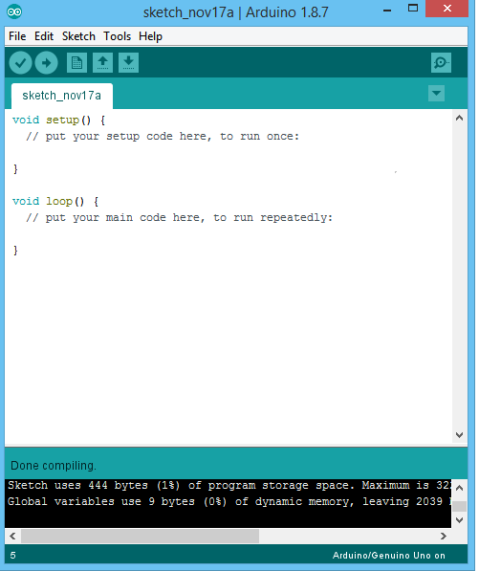

**7.2 SOURCE CODE**

#include <Wire.h>

#include <ESP32Servo.h>

#include <DHT.h>

#define DHTPIN 15//Sensor Pin

#define DHTTYPE DHT11

DHT dht(DHTPIN, DHTTYPE);

int sound = 2;

int fan = 18;

int val;

Servo myservo;

void setup()

{

Serial.begin(9600); // initialize serial communication at 115200 bits per second:

dht.begin();

pinMode(sound,INPUT);

pinMode(fan,OUTPUT);

myservo.attach(5);

}

void loop()

{

float h = dht.readHumidity();

float f = dht.readTemperature();

String state = String((float)f)+" C"+"|"+String((float)h)+" %";

Serial.println(state);

if(f>34)

{

digitalWrite(fan,HIGH);

}

else

{

digitalWrite(fan,LOW);

}

val=digitalRead(sound);

if(val==0)

{

myservo.write(140);

delay(600);

myservo.write(160);

delay(600);

}

else

{

myservo.write(160);

}

}

#include <Wire.h>

#include <ESP32Servo.h>

#include <DHT.h>

#define DHTPIN 15//Sensor Pin

#define DHTTYPE DHT11

DHT dht(DHTPIN, DHTTYPE)

int sound = 2;

int fan = 18;

int val

Servo myservo;

void setup()

{

Serial.begin(9600); // initialize serial communication at 115200 bits per second:

dht.begin();

pinMode(sound,INPUT);

pinMode(fan,OUTPUT);

myservo.attach(5);

}

void loop()

{

float h = dht.readHumidity();

float f = dht.readTemperature();

String state = String((float)f)+" C"+"|"+String((float)h)+" %";

Serial.println(state);

if(f>31)

{

digitalWrite(fan,HIGH);

}

else

{

digitalWrite(fan,LOW);

}

val=digitalRead(sound);

if(val==0)

{

myservo.write(140);

delay(600);

myservo.write(160);

delay(600);

}

else

{

myservo.write(160);

}

}

**CHAPTER 8**

**RESULT AND OUTCOMES**

Results and outcomes: A baby monitoring system equipped with a temperature sensor, sound sensor, and servo motor can offer a range of results and outcomes to enhance the safety and care of the baby. Here are some potential results you may expect from such a system.

Temperature Monitoring: The temperature sensor continuously measures the ambient temperature in the baby's room.

Sound Detection: The sound sensor detects sounds within the baby's environment. When the system detects specific sounds, such as crying, loud noises, or unusual sounds, it can send alerts to parents' or caregivers' devices.

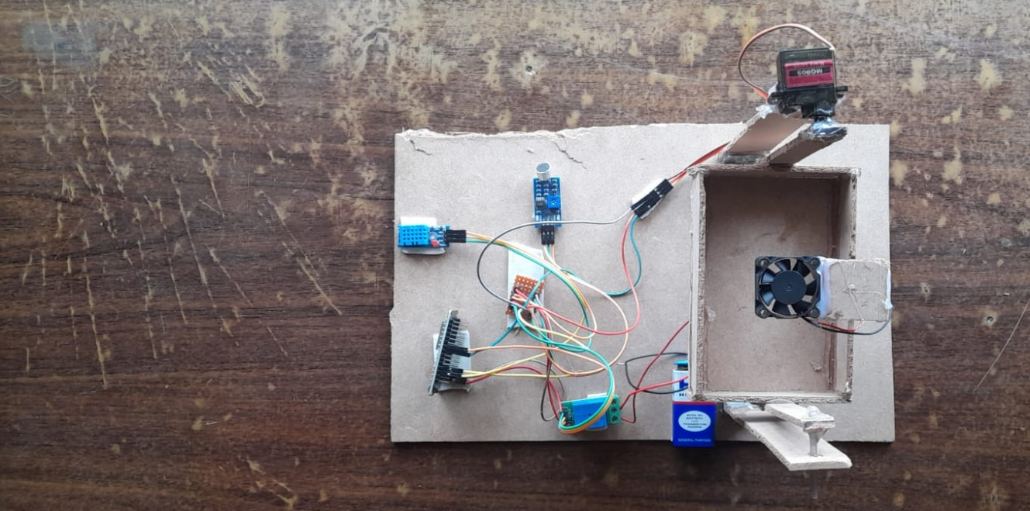

Fig. 8.1 Final project

**CHAPTER 9**

**MERITS AND DEMERITS**

**9.1 Merits :**

* **Enhanced Safety:** A baby monitoring system allows parents to keep a close eye on their baby, ensuring their safety and well-being.
* **Convenience:** Baby monitoring systems provide convenience by allowing parents to monitor their baby remotely through audio or video feeds.
* **Connectivity and Mobile Apps:** Many modern baby monitoring systems offer connectivity features and mobile apps, allowing parents to monitor their baby's activities using smartphones or tablets.

**9.2 Demerits:**

* **False Alarms:** Baby monitoring systems may sometimes generate false alarms, such as motion detection triggered by unrelated movements or sound detection misinterpreting ambient noise.
* **Over-Reliance and Stress:** In some cases, parents may become overly reliant on the baby monitoring system, constantly monitoring the baby's activities.
* **Cost:** Baby monitoring systems can vary in cost, and more advanced systems with additional features may come with a higher price tag.

**CHAPTER 10**

**CONCLUSION AND FUTURE SCOPE**

**10.1 CONCLUSION:**

In conclusion, the baby monitoring system using ESP32 offers a range of benefits for parents and caregivers in ensuring the safety and well-being of their infants. The project has a promising future scope with several potential enhancements and advancements.

By expanding the sensor capabilities, including parameters like temperature, humidity, air quality, and motion detection, the system can provide a comprehensive monitoring solution. Integrating a camera module enables real-time video streaming, allowing parents to visually check on their baby remotely.

**10.2 FUTURE SCOPE:**

Mobile Application: Develop a dedicated mobile application that can connect to the ESP32-based baby monitoring system.

Wearable Devices: Explore the possibility of developing wearable devices, such as smart clothing or wristbands, for the baby.

Cloud Connectivity: Enable cloud connectivity to store and analyze the collected data.

Video Monitoring: Integrate a camera module with the ESP32 to enable real-time video streaming and monitoring of the baby.

**REFERENCES**

1. N. L. Pratap, K. Anuroop, P. N. Devi, A. Sandeep and S. Nalajala, "IoT based Smart Cradle for Baby Monitoring System," 2021 6th International Conference on Inventive Computation Technologies (ICICT), Coimbatore, India, 2021, pp. 1298-1303, doi: 10.1109/ICICT50816.2021.9358684.

2. W. A. Jabbar, H. K. Shang, S. N. I. S. Hamid, A. A. Almohammedi, R. M. Ramli and M. A. H. Ali, "IoT-BBMS: Internet of Things-Based Baby Monitoring System for Smart Cradle," in IEEE Access, vol. 7, pp. 93791-93805, 2019, doi: 10.1109/ACCESS.2019.2928481.

3. A. F. Symon, N. Hassan, H. Rashid, I. U. Ahmed and S. M. Taslim Reza, "Design and development of a smart baby monitoring system based on Raspberry Pi and Pi camera," 2017 4th International Conference on Advances in Electrical Engineering (ICAEE), Dhaka, Bangladesh, 2017, pp. 117-122, doi: 10.1109/ICAEE.2017.8255338.

4. Ü. Duman and E. Aydin, "IOT Based Baby Cradle System with Real Time Data Tracking," 2020 5th International Conference on Computer Science and Engineering (UBMK), Diyarbakir, Turkey, 2020, pp. 274-279, doi: 10.1109/UBMK50275.2020.9219506.