Flexible and stretchable redistribution layer with embedded chips for human-machine interface

Martin Schubert1,4,*, Laura Wambera1,4, Olha Mudrievska1, Krzysztof Nieweglowski1,4, Jens Wagner2,4, Johannes Partzsch3,4, Christian Mayr3,4, Frank Ellinger2,4, Karlheinz Bock1,4

*1 Institute of Electronic Packaging Technology, Department of Electrical and Computer Engineering*

*2 Chair of Circuit Design and Network Theory*, *Institute of Principles of Electrical and Electronic Engineering*

*3 Chair of Highly-Parallel VLSI Systems and Neuromorphic Circuits, Institute of Principles of Electrical and Electronic Engineering*

*4 Centre for Tactile Internet with Human-in-the-Loop (CeTI) Technische Universität Dresden, Germany*

*corresponding author e-mail: [martin_schubert@tu-dresden.de](mailto:martin_schubert@tu-dresden.de)

***Abstract*—Suitable stretchable electronics is the key to promote future human-machine collaboration to facilitate processes in daily life. Sensors and actuators on humans will enable a close and yet unhesitating interaction with robots by translating data between biological and technical systems. This paper describes our first approach for chip integration and stretchable interconnect manufacturing in order to achieve reliable stretchable interconnects. Therefore inkjet printed silver horseshoe-interconnects with a radius of 500µm on spin coated polyurethane substrate are tested on a self-developed stretch test setup. More than 400 stretch and release cycles on 10% and 20% stretching were achieved. Furthermore, a polymer chip-embedding process by polymer casting is shown to apply fan-out redistribution layer directly on thin chip carrier. Those carriers can be integrated in stretchable foils in order to achieve miniaturized and low-profile assemblies for human-machine interfaces.**

***Keywords— flexible, stretchable, interconnect, chip embedding***

1. INTRODUCTION

The success of digitalization continues resolutely, while devices and processes become more interconnected. In future, robots will be a significant part of our daily life. Therefore, the development of suitable human-machine interfaces (HMI) is crucial. Those interfaces, such as smart skin, smart glove or smart body suits, need perfectly integrated sensor-networks for their flawless and non-interfering application on the user. They require to be small, fast and reliable in order to allow a natural collaboration and interaction between human and machine. To achieve a holistic digital representation of the user, a large number of sensors and actuators on the body is necessary building a so-called body area network. In order to reduce the system size, ultra-compact fully integrated wireless transceivers at high frequencies have to be developed. Although wireless communication between sensors and computing chips at present promise the best performance. However, a power supply partially needs to be wired. Therefore, it is crucial to achieve low resistance, stretchable and reliable interconnects. Today, achieving reliable interconnects between rigid and stretchable materials is still challenging [1]. For manufacturing of stretchable conductors various new material systems such as intrinsically conductive polymers, pastes or inks have been developed.[2,3,4]. Often, conductive particles such as metal nanowires, carbon particles or nanotubes are mixed into an extensible polymer matrix (e.g. PDMS) and processed by screen printing or dispensing [5,6]. In this way, large elongations of several hundred percent’s can

Funded by the German Research Foundation (DFG, Deutsche Forschungs- gemeinschaft) as part of Germany’s Excellence Strategy – EXC 2050/1 – Project ID 390696704 – Cluster of Excellence “Centre for Tactile Internet with Human-in-the-Loop” (CeTI) of Technische Universität Dresden.

978-1-7281-6293-5/20/$31.00 ©2020 IEEE

be achieved. Due to the increasing distance of the particles from each other, the electrical resistance also increases with stain. This characteristic is nevertheless well suited for capacitive applications [7]. Another approach to achieve high strains (> 100 %) is using ionic pastes or liquids (e.g. hydrogels) or liquid metals (e.g. EGaIn, an eutectic alloy of gallium, indium and tin) [1, 8, 9]. These materials are used in combination with microchannels in elastomers to create electrical conductors. Rigid materials such as metals can also be used for stretchable applications considering geometric arrangements. It has been known for several decades that ductile metals, such as Au, Ag, Cu, Pt, are flexible in a sufficiently thin layer thickness and are slightly (approx. 1 %) stretchable [4]. By choosing suitable trace geometries (e.g. wave form, horseshoe, kirigami) it is attempted to convert the performed strains into bends of the trace elements [10,11]. For this purpose, metals are often deposited physically from the vapour phase or electrochemically on an extensible substrate [12, 11]. Another method is to pre-stretch the substrates before deposition of the material and subsequent relaxation [13, 14]. This method aims at introducing a vertical waveform into the structure for enhanced stretchability. In literature presented so far, a distinction can be made between the tests to determine the maximum possible elongation and the cyclical stretch- release tests at lower elongation. Structures which enable a large strain are suited for various strain sensors such as motion, temperature and pressure sensors [15, 16]. For example, Kim et al. showed systems as smart skin for recording electromyogram (EMG) signals made of gold, PDMS and polyester, which are stretchable up to 30 % [17]. Sun et al. demonstrated silver filled polymers (PDMS, TPU) with an elongation of up to 200 % [6]. At 25% elongation, the resistance increases by approx. 500 % (PDMS) or approx. 170% (TPU). Also inkjet printing of horseshoe structures with silver ink on PDMS (27 % pre-stretch) have been demonstrated [18]. Cyclic stretching by (10-15) % for 500 repetitions caused a resistance increase of three to six times and for 1000 repetitions up to seven times of the initial resistance. Those resistance changes are not suitable for power supply of low energy IC’s such as transceivers or computing units.

This paper describes the approach for flexible and stretchable interconnects for demonstration of contacting of sensor network with wearable computing (body computing hub (BCH) and transceiver modules. The BCH is the central computing unit for all generated sensor data, transmitted by transceivers. In order to achieve miniaturized and low-profile assemblies, chip-carriers with in polymer embedded chips are developed

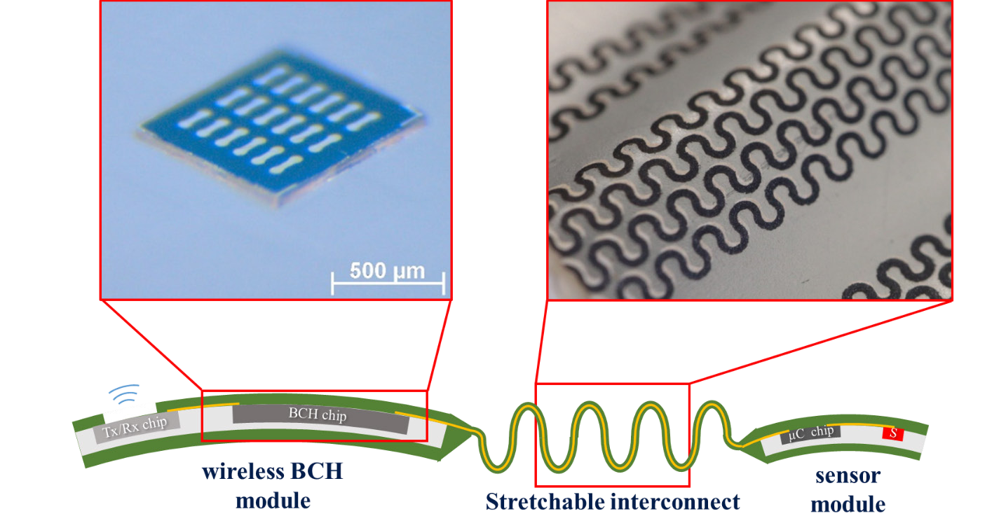

Fig. 1. Flexible wireless module for the future body computing hub (BHC)

These chip-packages can be contacted via stretchable, inkjet printed, conductive lines. This leads to the scenario as shown in Fig. 1, where sensor and transceiver unit on e.g. a glove are connected via stretchable tracks for energy supply and sensor data communication respectively. The following chapters show single steps on a way to achieve an all comprising system. The following papers will demonstrate further merging and integration of the herein described steps.

1. STRETCHABLE INTERCONNECTS
2. *Materials and methods*

For stretchable interconnect manufacturing, inkjet and screen printing has been chosen. Literature described horseshoe-structures as most suited design for stretchable electronics [12]. For this reason, horseshoe-structures were inkjet printed with silver nanoparticle ink (Ag-LT-20, Fraunhofer-Institut für Keramische Technologien und Systeme) on polyurethane substrates (Chronoflex Ar, AdvanSource Biomaterials). Furthermore, horseshoe- structures were screen printed with silver paste (PE876, DuPont de Nemours) and covered with carbon paste (PE671, DuPont de Nemours) on Intexar TE-11C film. The line width is about 200 µm and the horseshoe radius between 200 µm and 500 µm. For performing the stretch-test the test bench shown in Fig. 2 was developed. It consists of a linear drive for testing and a portable unit to clamp polymer foils. For resistance monitoring during the test a self-designed and manufactured current source circuit and a DAQ board was used. The structures were contacted with silver adhesive (H20E, Epoxy Technology, Inc.) and copper wires. The stretch test was performed with 10 % and subsequent 20 % stretching. The 10 % stretch-test was stopped after about 400 stretch cycles.

1. *Results*

The screen printing structures have been used in order to take advantage of good resistance values of about 30 Ω-40 Ω on 15 mm length, due to the structure height of about 11 µm. In

comparison, the inkjet printed structures show values about 108 Ω, at a thickness of about 1 µm. However, the screen printing structures demonstrate a very fast increase of resistance were damaged at maximum of 41 cycles. This is the reason why this paper focuses on the results on inkjet printed structures. Fig. 3 and Fig. 4 show exemplarily the monitored resistance of the inkjet printed structures during 10 % and 20 % stretch test. The strain-dependent resistance alternates between a maximum and a minimum value. From those, an average resistance value Raver, is interpolated. The average resistance increases over the course of the test depending on the structure. Here, it increases about 116 % after 450 cycles. Fig. 5 shows positive and negative deviations R/Raver of interpolated maxima and minima to the average value. This variance is displayed at the time of the beginning and the end of the test. The large variation between the individual structures can be observed. The total variance, i.e. the sum from positive round negative deviation, varies between approx. 5 % and approx. 40 % of the average value. All structures show an increase in the total deviation between start and end of the test. This indicates an irreversible aging of the samples even at relatively low strain of 10 %.

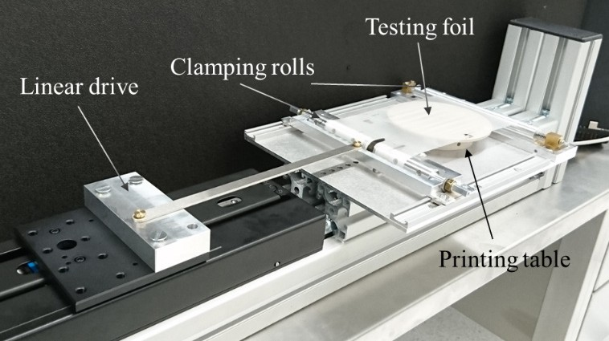

Fig. 2. Test setup for stretchable substrates

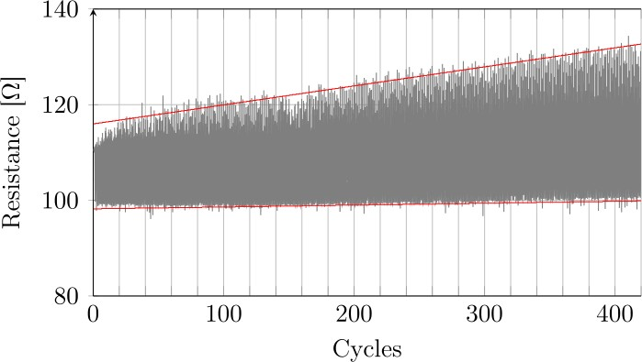

Fig. 3. Resistance monitored during stretch cycling test at 10 %

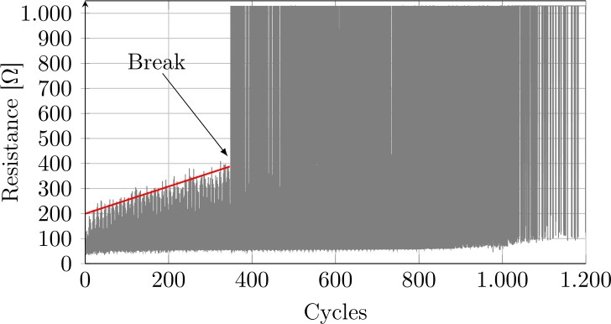

Fig. 4. Resistance monitored during stretch cycling test at 20 %

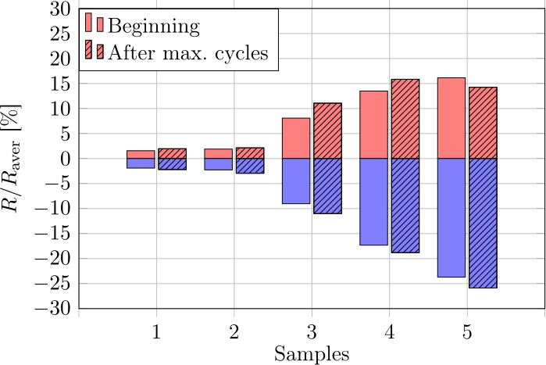

Fig. 5. Positive and negative deviations R/Raver before and after the stretch cycling test with 10 % strain

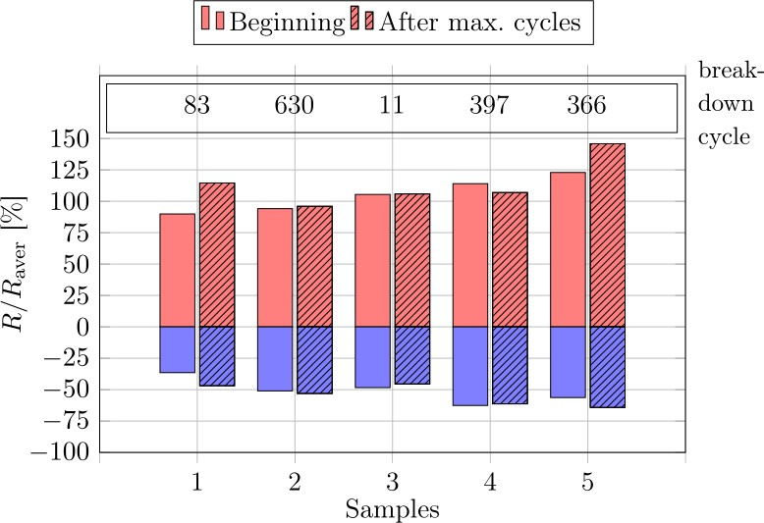

Fig. 6. Positive and negative deviations R/Raver before and after the stretch cycling test with 20 % strain and the number of the breakdown cycle of each sample

During the stretch test with 20 % strain, all samples break. The resistance value after break of about 1 kΩ is the limit of the measurement range. This measurement shows also higher increase of resistance and the results show a larger deviation between the samples.

1. CHIP EMBEDDING AND CONTACTING
2. *Chip embedding*

The chip embedding into polymer aims at generating certain gradient between the rigid silicon and the stretchable polymer. Recently the 3D-printing process for embedding of additive IC-devices was demonstrated [19]. In this paper we used an even easier way for chip embedding: polymer casting process. The advantage against 3D printing is not as size limited and even roll-to-roll process enabling. Fig. 7 shows the casting process, which will be described in detail as follows.

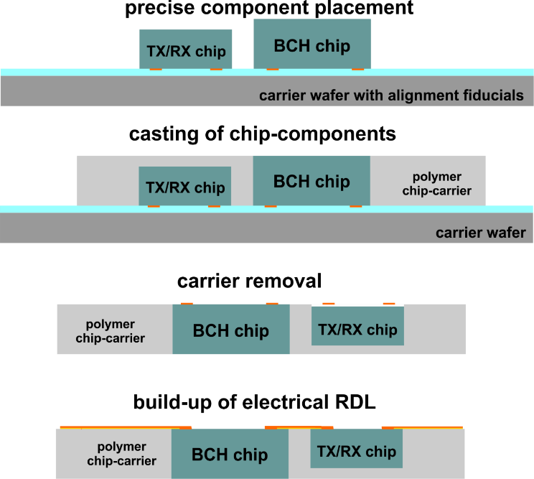

Fig. 7. Embedding process for fabrication of polymeric chip-carrier

The fabrication process starts with exact placement of chip-components on the temporary wafer carrier. For this a glass-mask with alignment fiducials was used. With this method the relative alignment between the mask and the chips on temporary carrier is maintained. After this step, UV- definable polymer with high thermal stability and low viscosity is used for chip embedding. After the material deposition, the carrier wafer including the chips is pressed with defined force parallel against a flat substrate with release film. The setup is exposed with UV-light. The thickness of the polymer chip-carrier is defined by the thickest chip component placed on the carrier wafer. After UV-curing, the temporary carrier is removed. As a result, a polymeric chip- carrier with exposed electrical contact pads results. By subsequent build-up of metal multilayer stack an electrical redistribution network for routing electrical signals can be realized. In order to contact the electrical pads of embedded chips and also realize interconnects between chips and provide the connection to stretchable interconnects, the build-up of metallic redistribution directly on the chip-carrier need to be carried out. Therefore, a PVD deposition of WTi as an adhesion and diffusion barrier and Cu as seed layer are necessary. Following the negative dry-film photoresist DuPontTM MX5015 is laminated, which is stable in contact with chemicals used in the subsequent chemical and electroplating steps. The next steps of mask-based UV

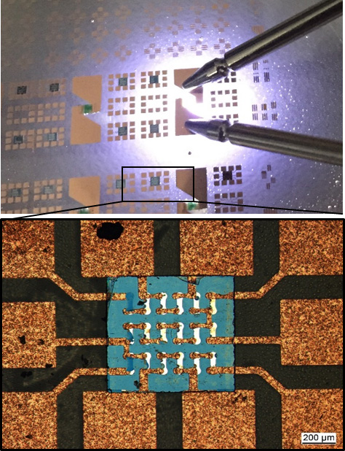

Fig. 8. Embedded chips and LED’s in polymer with fan-out redistribution layer. The shining LED demonstrates electrical contact.

exposure, PEB and development structure the resist. Subsequently DC electroplating using a deposition of thick Cu-metallization acid copper plating formulation (NB Semiplate Cu 100) is used in order to raise the Cu thickness to 2 µm -°3 µm. After resist stripping the wet differential etching of Cu-seed and WTi-layer follows. Fig. 8 shows an exemplary result of structuring of Cu-contacts on the top of embedded chip-carrier.

1. *Chip-carrier contacting*

The contacting of embedded chips in polymeric chip- carriers is performed with printing technologies. Inkjet printing as well as well as screen printing is possible. First, the stretchable Intexar from DuPont was laser cut for cavities. Following the dummy chip modules placed within the cavity as close as possible to the edge near the pads to be contacted to. In future, processes, cavity and chip-module sizes need to be aligned accordingly, to minimize this gap. For chip placement a Fineplacer from Finetech GmbH & Co. KG was used. A polymer was dispensed on the gap to form a polymer bridge between chip-module and stretchable substrate. This enables the printing of silver paste onto the pads, which was screen printed with EKRA X3 from Asys Automatisierungssysteme GmbH and cured at 130 °C for 20 min. Fig. 9 shows the screen printed horseshoe lines contacting a dummy chip-module with fan-out redistribution layer.

1. SUMMARY

This paper presented the first approach for manufacturing of flexible and stretchable interconnects for contacting a wearable sensor and computing network. Essential parts of this development are chip embedding and redistribution layer manufacturing as well as fabrication of the stretchable interconnects. The presented parts will be further improved by

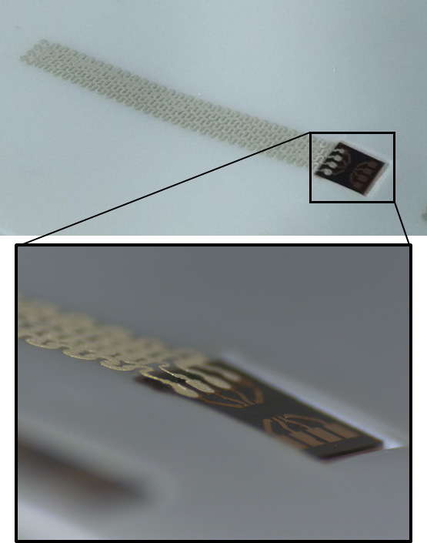Fig. 9. Direct contacting of fan-out pads (dummy) by printing

materials and processing and merged in future work in order to achieve a functional human-machine interface system. The highest reliable stretching percentage of the interconnects will be the design factor for the complete system. The system will be tested on stretchable and electrical properties and on performance using functional transceiver chips.

ACKNOWLEDGMENT

Funded by the German Research Foundation (DFG, Deutsche Forschungs-gemeinschaft) as part of Germany’s Excellence Strategy – EXC 2050/1 – Project ID 390696704 – Cluster of Excellence “Centre for Tactile Internet with Human-in-the-Loop” (CeTI) of Technische Universität Dresden. The authors thank M. Luniak and I. Sotiriou for supporting the lab work.

REFERENCES

1. N. Naserifar, P. R. LeDuc and G. K. Fedder, “Drop casting of stiffness gradients for chip integration into stretchable substrates”, Journal of Micromechanics and Microengineering, vol. 27, 4, 2017
2. A. J. Bandodkar, R. Nuñez-Flores, W. Jia und J. Wang, “All-Printed Stretchable Electrochemical Devices“, Advanced Materials, vol. 27, 19, pp. 3060–3065, 2015
3. J. A. Rogers, T. Someya und Y. Huang., “Materials and Mechanics for Stretchable Electronics“, Science, vol. 327, 5973, pp. 1603–1607, 2010
4. A. Shankar, E. Salcedo, A. Berndt, D. Choi und J. E. Ryu, “Pulsed light sintering of silver nanoparticles for large deformation of printed stretchable electronics“, Advanced Composites and Hybrid Materials, vol 1, 1, pp. 193–198, 2017
5. M. Park, J. Park und U. Jeong, “Design of conductive composite elastomers for stretchable electronics“, Nano Today. vol. 9, 2, pp. 244– 260, 2014
6. Hongye Sun, Zongyou Han und Norbert Willenbacher., “Ultrastretchable Conductive Elastomers with a Low Percolation Threshold for Printed Soft Electronics“, ACS Applied Materials & Interfaces, vol. 11, 41, pp. 38092–38102, 2019
7. B. O'Brien, T. Gisby und I. A. Anderson, “Stretch sensors for human body motion“, Electroactive Polymer Actuators and Devices (EAPAD), SPIE, 2014.
8. P. Salvo, R. Raedt, E. Carrette, D. Schaubroeck, J. Vanfleteren und L. Cardon, “A 3D printed dry electrode for ECG/EEG recording“, Sensors and Actuators A: Physical 174, pp. 96–102, 2012
9. R. D. Ponce Wong, J. D. Posner und V. J. Santos, “Flexible microfluidic normal force sensor skin for tactile feedback“, Sensors and Actuators A: Physical 179, pp. 62–69, 2012
10. Y. Morikawa, S. Ayub, O. Paul, T. Kawano and P. Ruther, "Highly Stretchable Kirigami Structure with Integrated Led Chips and Electrodes for Optogenetic Experiments on Perfused Hearts," 20th International Conference on Solid-State Sensors, Actuators and Microsystems & Eurosensors XXXIII (TRANSDUCERS & EUROSENSORS XXXIII), Berlin, Germany, pp. 2484-2487, 2019
11. D. S. Gray, J. Tien und C. S. Chen, “High-Conductivity Elastomeric Electronics“, Advanced Materials, vol. 16, 5, pp. 393–397, 2004
12. D. Brosteaux, Fabrice Axisa, M. Gonzalez und J. Vanfleteren, “Design and Fabrication of Elastic Interconnections for Stretchable Electronic Circuits“, IEEE Electron Device Letters, vol. 28, 7, pp. 552–554,2007
13. N. Bowden, S.t Brittain, A. G. Evans, J. W. Hutchinson und G. M. Whitesides, “Spontaneous formation of ordered structures in thin films of metals supported on an elastomeric polymer“, Nature, vol. 393, 6681, pp. 146–149, 1998
14. T. Cheng, Y. Zhang, W.-Y. Lai und W. Huang, “Stretchable Thin-Film Electrodes for Flexible Electronics with High Deformability and Stretchability“. In: Advanced Materials, vol. 27, 22, pp. 3349–3376, 2015
15. J. Kim et al., “Stretchable silicon nanoribbon electronics for skin prosthesis“, Nature Communications, vol 5, 1, 2014
16. J. Zhang, Y. Song, H. Chen, X. Cheng, X. Chen, B. Meng, Q. Yuan und H. Zhang, “Stretchable, transparent and wearable sensor for multifunctional smart skins“, 30th International Conference on Micro Electro Mechanical Systems (MEMS), IEEE, 2017
17. D.-H. Kim et al., “Epidermal Electronics“, Science, vol. 333, 6044, pp. 838–843, 2011
18. J. Abu-Khalaf, L. Al-Ghussain und A. Al-Halhouli, “Fabrication of Stretchable Circuits on Polydimethylsiloxane (PDMS) Pre-Stretched Substrates by Inkjet Printing Silver Nanoparticles“, Materials, vol. 11, 12, p. 2377, 2018
19. T. Tiedje, S. Lüngen, K. Nieweglowski, and K. Bock, “Will 3d- semiadditive packaging with high conductive redistribution layer and process temperatures below 100°C enable new electronic applications?” in *Proc. of 7th Electronic System-Integration Technology Conference (ESTC)*, pp. 1–5,2018