SOFTWARE-TASK-1
SUBTASK-1, APPLICATION OF LK ON A PORTION OF VIDEO
(HARSHIT RANA, 25CS10016)
BRIEF THEORY:
I applied Lucas Kanade with pyramids on a portion of a video to track features, I also added some new function and transformation for removing noise and smoother tracking.

Lucas Kanade/Pyramids:
Lucas Kanade is an optical flow algorithm which uses a differential method for detecting the motion of objects in consecutive images.
Key assumptions of lucas kanade is:
- The core assumption of the lucas kanade algorithm is that the intensity of a feature/object does not significantly change between two consecutive frames.
- Another assumption of lucas kanade is that the objects that have been traced are not moving at high speed. Or we can say that lucas kanade best works on slow moving objects.
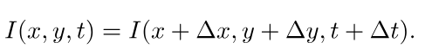
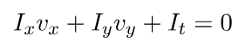

These two equations fundamentally drive the algorithms.
Since for a given pixel we have two unknown (Vx and Vy) and only one variable, we bring another assumption.

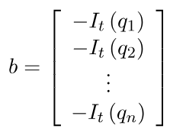
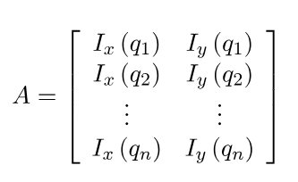
We assume that optical flow(Vx and Vy vectors) are the same for a patch of points. This provides us with the given linear equations.
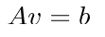

From here we get the closed form solution,
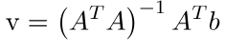
ABOUT THE CODE:
- I firstly selected the frames on which I have applied the algorithm, the function “frame_generator” does this work. The starting frame is frame 900 and ending frame is 1500.
- In each frame, I applied gaussian transformation to smoothen the pixel intensity distribution and reduce noise. The function “gaussian_weights” does this.
- The algorithm uses Pyramids to tackle fast moving objects, since lucas kanade alone can not effectively track fast moving objects. By progressively downsampling the image (build_pyramid function), large pixel jumps in the original video become tiny, mathematically manageable shifts at the lowest resolution. The Pyramid depth is 3.
- Finally the “lk_single_level” function calculates the gradient for each frame by vectorisation.
- To focus exclusively on moving subjects, the pipeline uses a MOG2 background subtractor to generate a foreground mask, which is refined by morphological operations. Feature detection is restricted to this active mask, completely ignoring static backgrounds. To replace lost or drifting points, new features are dynamically added every three frames up to a set memory limit.
- For detecting the feature the algorithm used the Shi-Tomasi method, which distinguishes features on the basis of intensity gradient. There was a maximum limit to the number of features that are to be tracked, it was set to 200 features.
CHALLENGES FACED AND SOLUTIONS:
- I applied parameter tuning on certain variables such, Quality level(Shi-Tomasi function), Maximum features, NUM_LEVELS(Pyramid depth). These were the crucial parameters that were to be tuned.
- In the start of the video initially the Shi-Tomasi was detecting various points on the wall(as the background had various intensity gradients). I used the MOG2 function to ignore the static background wall.

SUBTASK-2
BRIEFING:
I have implemented the Artificial potential field concept to navigate through an obstacle environment, the target created attractive vectors while the road boundaries and obstacles created repulsive vectors.

BRIEF THEORY:

