
Payload system for crack detection using thermal imaging
Team Members:- Supervisor:-
Sujal Sanjay Patil (23031060,CSE) Mr. Sabarishwaran.R Harshit Pinaki Mishra(23101066,IOT)
Atharv Manohar Shitape(23011103,MECH) Shreyas Sujit Awati(1024012109,MECH) Amit Rajendra Shinde(23011058,MECH)

- Area of work /Introduction:-
Crack detection is essential for maintaining safety in structures like buildings, bridges, and aircraft. Using a UAV with a thermal imaging payload, cracks can be detected quickly and accurately by observing temperature differences on the surface. This method is fast, non- contact, and effective for inspecting large or hard-to-reach areas.
  - Payload Design – Selection of suitable thermal camera, sensors, and gimbal.
  - UAV Integration – Mounting and balancing the payload on a drone platform.
  - Image Acquisition – Capturing thermal data during UAV flight missions.
  - Image Processing – Using software or algorithms to detect and highlight cracks.
  - Result Analysis – Identifying damaged areas and mapping their locations.

    - Literature Review:-

Sr.  No. | Name of Article | Author | Year and country | Key Details | Remarks
1. | Thermographic  Laplacian pyramidfiltering for delamination detection in concrete | Chongsheng Cheng Rina Zhigang Shen | 2019 ,China | Uses single thermal images of concrete decks and applies  Laplacian of Gaussian filters in a multi-scale Laplacian-pyramid framework to detect abnormal thermal patterns caused by delaminations (internal crack-related defects) | Effective for multi-size delamination detection and robust to uneven temperature, but limited by single- image sensitivity and not UAV-specific.

Sr.  No. | Name of Article | Author | Year and  country | Key Details | Remarks
2. | SS-GAN (Semantic Segmentation Generative Adversarial Network) based road surface crack region segmentation: a semi- supervised approach | A. Sekar, S. Dutta, R. S. Rao | 2024,  India | Proposes semi- supervised GAN approach for road crack segmentation using limited labeled images.  Focus on Indian road pavements. | Effective for low- labeled datasets, good for rural scenarios.
3. | Terrestrial LiDAR-derived 3D point cloud model, digital terrain model and pavement distress analysis | Terrestrial LiDAR-derived 3D point cloud model, digital terrain model and pavement distress analysis | 2024,  India | Uses LiDAR for pavement surface models and distress evaluation. Applied to Indian highways. | Expensive equipment but accurate in rural areas.

Sr.  No. | Name of Article | Author | Year and country | Key Details | Remarks
4. | Detecting Concrete Abnormality Using Time-series Thermal Imaging and Supervised Learning | Cheng,  Shen | 2018, – | Combines time-series thermal imaging with supervised learning. Uses features like PCA to classify regions as defective or not. | Robust due to ML integration, but limited to lab/controlled conditions; may not scale well to UAV or field settings.
5. | Deep learning–based autonomous concrete crack evaluation through hybrid image scanning | Keunyoung Jang, Namgyu Kim, Yun- Kyu An | 2019, – | Uses hybrid imaging (visible camera + infrared thermography + line laser) and GoogLeNet deep learning to detect macro- and micro- cracks in concrete. | High crack detection accuracy via sensor fusion and deep learning; limited by lab scale, sensor complexity, and UAV deployment challenges.
6. | Concrete Subsurface Crack Detection Using Thermal Imaging | Mabrouka Abuhmida et al. | – | Uses thermal imaging to detect subsurface cracks. Applies U-Net for segmentation on thermally stimulated data; classifies cracked vs non-cracked. | High subsurface detection accuracy; limited by lab- scale heating and environmental constraints for real-world UAV applications.

Sr.  No. | Name of Article | Author | Year and  Country | Key Details | Remarks
7. | Deep-Learning- and UAV-Based Structural Crack Detection in Concrete | Tao Jin et al. | 2023 | Trains DNNs (U-Net, DeepLab, TransUNet) on existing crack datasets, tests on UAV images for semantic segmentation of concrete cracks. | Demonstrates generalization from handheld to UAV images; field validation; dataset size limited; mostly visible spectrum imaging.
8. | Crack detection and quantification for concrete structures using UAV and transformer (IBR- Former) | J. Shu et al. | 2023, – | UAV-based visible imaging with transformer model (IBR-Former) for segmentation and crack width quantification with gimbal calibration. | Accurate width quantification without markers; practical field experiments; dependent on high-res imaging and stable UAV; visible imaging only.
9. | Bridge Girder Crack Assessment Using Faster R-CNN Inception V2 and Infrared Thermography | Unknown  (SCI-RP  study) | – | UAV-based infrared thermography with Faster R-CNN Inception V2 for crack detection on bridge girders; 3D drone mapping and photogrammetry for crack localization and measurement. | Combines IR and photogrammetry for length and area measurement; good for large structures; limited by thermal contrast, edge resolution, and environmental noise.

Sr.  No. | Name of Article | Author | Year and  Country | Key Details | Remarks
10. | SS-GAN (Semantic Segmentation Generative Adversarial Network) based road surface crack region segmentation: a semi- supervised approach | A. Sekar, S. Dutta, R. S. Rao | 2024, India | Proposes semi-supervised GAN approach for road crack segmentation using limited labeled images. Focus on Indian road pavements. | Effective for low- labeled datasets, good for rural scenarios.
11. | Terrestrial LiDAR-derived 3D point cloud model, digital terrain model and pavement distress analysis | N. H. R. Khan,  P. S. Reddy, K. Venkatesh | 2024, India | Uses LiDAR for pavement surface models and distress evaluation. Applied to Indian highways. | Expensive equipment but accurate in rural areas.
12. | Detecting Concrete Abnormality Using Time- series Thermal Imaging and Supervised Learning | Cheng, Shen | 2018,  China | Combines time-series thermal imaging with supervised learning. Uses features like PCA to classify regions as defective or not. | Robust due to ML integration, but limited to lab/controlled conditions; may not scale well to UAV or field settings.

Sr.  No. | Name of Article | Author | Year and Country | Key Details | Remarks
13. | Automatic detection of building surface cracks using UAV and deep learning-combined approach | Jiehui Wang, Pujin Wang, Lei Qu, et al. | 2024, China | UAV-based visible imaging with CNN/object detection models (ResNet50, YOLOv8)  for crack classification and detection on building surfaces. | High classification accuracy; extensive model comparison; limited by visible imaging constraints such as lighting and small crack depth detection.
14. | Deep learning–based autonomous concrete crack evaluation through hybrid image scanning | Keunyoung Jang, Namgyu Kim, Yun-Kyu An | 2019, South Korea | Uses hybrid imaging (visible camera + infrared thermography + line laser) and GoogLeNet deep learning to detect macro- and micro- cracks in concrete. | High crack detection accuracy via sensor fusion and deep learning; limited by lab scale, sensor complexity, and UAV deployment challenges.

Sr.  No. | Name of Article | Author | Year and Country | Key Details | Remarks
15. | Hybrid Vision + Thermal Imaging for Crack Detection | Various (cf. Jang et al., 2019) | – | Combines infrared thermography and visible imaging to improve crack detection robustness under challenging conditions (lighting, contamination, dust, rust). | Fusion improves detection accuracy and reliability; complexity and UAV deployment remain challenges.
16. | Terrestrial LiDAR- derived 3D point cloud model, digital terrain model and pavement distress analysis | N. H. R. Khan,  P. S. Reddy, K.  Venkatesh | 2024, India | Uses LiDAR for pavement surface modeling and distress evaluation. Applied to Indian highways. | Expensive equipment but accurate in rural areas.
17. | SS-GAN (Semantic Segmentation Generative Adversarial Network) based road surface crack region | A. Sekar, S. Dutta, R. S. Rao | 2024, India | Proposes semi-supervised GAN approach for road crack segmentation using limited labeled images. Focus on Indian road pavements. | Effective for low-labeled datasets; good for rural scenarios.

Literature gaps :
- Limited accuracy in complex materials – Thermal imaging often struggles with heterogeneous or layered materials.

- Insufficient real-time processing – Many systems lack fast, onboard data analysis for immediate crack detection.

- Environmental interference – Effects of ambient temperature, sunlight, and weather conditions on thermal readings
are under-addressed.

- Depth detection limitations – Difficulty in detecting subsurface cracks or differentiating crack depths.

- Integration with other sensors – Few studies explore combining thermal imaging with other NDT (Non-Destructive
Testing) techniques for improved reliability.

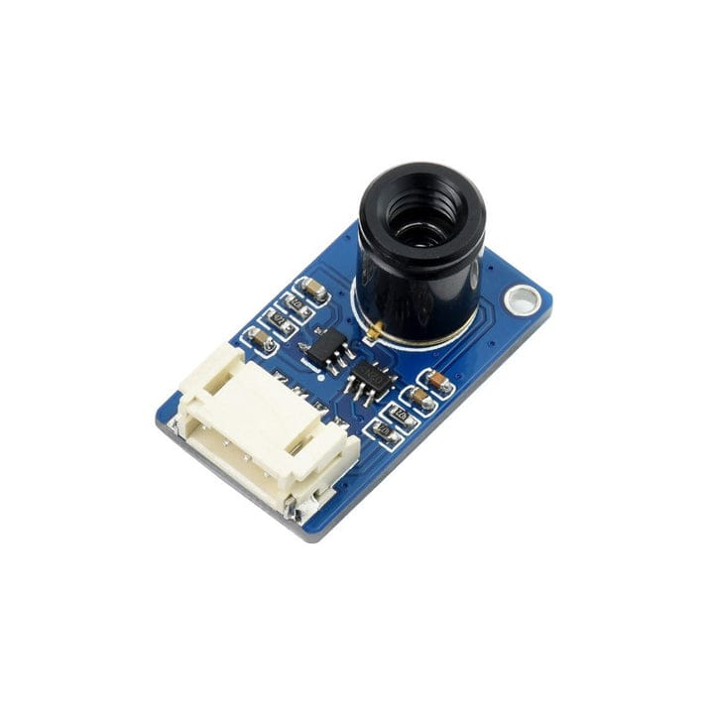
Objectives:
- Build lightweight thermal imaging payload.

- Improve crack detection accuracy with AI.

- Enable real-time processing.

- Reduce environmental impact on data.

- Detect surface and subsurface cracks.

- Combine thermal imaging with other sensors.

- Create annotated thermal image datasets.

- Develop easy-to-use analysis software.

- Optimize for low power use.

- Validate system in real conditions.

- Resources Required :
- Thermal camera (e.g., FLIR, Seek Thermal) with high resolution and sensitivity

- UAV or robotic platform to carry the payload (drones, ground robots)

- Embedded processing unit (e.g., NVIDIA Jetson, Raspberry Pi with GPU) for real-time analysis

- Power supply (lightweight batteries with sufficient capacity)

- Stabilization/gimbal system for steady thermal imaging

- Data storage device (SSD or SD card) for image/video recording

- Communication module (Wi-Fi, LTE, or RF) for data transmission

- Thermal Excitation Source (for Active Thermography):Lightweight heating element (e.g., high-power LED array, flash lamp, or a low-power resistor/induction coil) to induce a controlled thermal gradient in the material under inspection
- Cooling system (if required) to maintain hardware performance

- Visible Light (RGB) Camera: Used in parallel to provide visual context for the thermal data

Software:-

1)Camera Manufacturer's App/Software: Most commercial thermal cameras (e.g., FLIR, HIKMICRO) come with basic software or mobile apps (like the FLIR ONE mobile app) that are used as viewfinders, for real-time data streaming, initial image capture, and managing camera settings like emissivity and temperature range.
2)Drone Flight/Navigation Software: For drone-based inspections, specialized software.
3) DJI Thermal SDK (for DJI drones: to extract full radiometric data and GPS information.
4) MATLAB: Provides a flexible environment for algorithm exploration, multi-sensor fusion, and segmenting/analyzing thermal images.
5)Python: With libraries like OpenCV and TensorFlow/PyTorch, Python is a popular choice for custom solutions, especially for integrating machine learning.
6)Machine Learning/Deep Learning Frameworks: These are critical for automated crack detection.
7)Reporting Tools: Integrated features within commercial software like FLIR Thermal Studio Pro and Testo IR Soft allow users to quickly generate professional, customizable reports in formats like PDF or Word, documenting findings for stakeholders.
8) Data Management Systems: Software or cloud platforms for managing thousands of thermal images and associated data, often integrating with maintenance management systems for long-term condition monitoring.
- Thermal Camera: Detects temperature variations to identify cracks.

- Thermal Excitation Source (Optional-If natural heat gradient is not present):Lightweight heating element (e.g., high-power LED array, flash lamp, or a low-power resistor/induction coil) to induce a controlled thermal gradient in the material under inspection

- Gimbal: Stabilizes camera during flight.

- Data Link: Sends thermal images to ground station.

- Processor (optional): Analyzes images for cracks using AI.

- Advantage: Detects hidden cracks quickly, works in all light conditions.

- Budget:

Sr. no. | Component | Cost
1. | Drone | We arrange
2. | Thermal camera | 4500
Total |  | 4500

Reference:
- Thermographic Laplacian pyramid filtering for delamination detection in concrete.
- SS-GAN (Semantic Segmentation Generative Adversarial Network) based road surface crack region segmentation: a semi-supervised approach.
- Terrestrial LiDAR-derived 3D point cloud model, digital terrain model and pavement distress analysis.
- Detecting Concrete Abnormality Using Time-series Thermal Imaging and Supervised Learning.
- Deep learning–based autonomous concrete crack evaluation through hybrid image scanning.
- Concrete Subsurface Crack Detection Using Thermal Imaging.
- Deep-Learning- and UAV-Based Structural Crack Detection in Concrete.
- Crack detection and quantification for concrete structures using UAV and transformer (IBR-Former).
- Bridge Girder Crack Assessment Using Faster R-CNN Inception V2 and Infrared Thermography.
- SS-GAN (Semantic Segmentation Generative Adversarial Network) based road surface crack region segmentation: a semi-supervised approach.
- Terrestrial LiDAR-derived 3D point cloud model, digital terrain model and pavement distress analysis. 12.Detecting Concrete Abnormality Using Time-series Thermal Imaging and Supervised Learning.

Thank you

