
MINOR PROJECT - I
LAB PRACTICAL

Submitted in Partial Fulfillment of the Requirements for the Award of the Degree of BACHELOR OF TECHNOLOGY IN COMPUTER SCIENCE & ENGINEERING SUBMITTED TO


Rajiv Gandhi Proudyogiki Vishwavidyalaya, Bhopal (M.P.)

SUBMITTED BY

HARSHIT VERMA
CSE 5th Sem, Section – B , Roll no. :- 89

0176CS241094
UNDER THE SUPERVISION OF
DR. DEEPAK SONI


Department of Computer Science & Engineering
Lakshmi Narain College of Technology Excellence, Bhopal (M.P.)

ABSTRACT

LNCTShares is a peer-to-peer ride-sharing platform developed to address transportation challenges faced by students of LNCT Bhopal. The limited availability of college bus services at fixed timings creates difficulties for students travelling outside the scheduled hours, often forcing them to depend on costly cabs, auto-rickshaws, or personal vehicles.

The proposed system provides a student-focused platform that connects users travelling on similar routes, allowing them to share available vehicle seats and reduce travel expenses and unnecessary vehicle usage. The backend is developed using Java and Spring Boot 3.2.5, with JWT-based authentication, PostgreSQL database, and WebSocket communication, while the frontend is developed using React 18 and Tailwind CSS.

The system provides features such as student registration and email verification, ride posting, ride searching, vehicle management, booking, real-time notifications, profile management, ratings, and safety preferences. Leaflet and OSRM are integrated to provide interactive map visualization and real-road route information for locations across Bhopal.

The system was tested using 6 registered users and 5 posted rides to verify its core functionality, including authentication, ride management, and booking operations. The developed platform demonstrates the feasibility of a community-oriented ride-sharing solution for improving transportation convenience and reducing unnecessary travel costs and vehicle usage among college students.

LIVE URL FOR THE APPLICATION : https://lnctshares.vercel.app

INTRODUCTION
1.1 OVERVIEW
- Transportation is an important part of student life, particularly for students who travel daily between their homes and college.

- At LNCT Bhopal, college bus services operate at limited fixed timings, creating difficulties for students who need transportation outside these hours.

- Students may have to depend on cabs, rickshaws, or personal vehicles, which can increase travel expenses and fuel consumption.

- These challenges create a need for a community-based transportation solution within the college environment.

- LNCTShares is proposed as a platform that enables students traveling toward similar destinations to connect and share rides.

- The concept promotes cost sharing, better utilization of available vehicle seats, and reduced dependence on individual transportation.

- As the platform is intended for the LNCT student community, it provides a more relevant transportation environment than general-purpose ride-sharing services.

- The project aims to provide a convenient, economical, and community-oriented transportation option for students.

1.2 PROBLEM STATEMENT
- Limited college bus availability outside the scheduled timings.
- High cost of alternative transportation such as cabs and auto-rickshaws.
- Safety concerns associated with travelling alone, particularly for female students.
- Available vehicle seats often remain unused.
- Individual rides increase fuel consumption, traffic, and environmental impact.
- Lack of a dedicated platform for connecting LNCT students travelling on similar routes.

1.3 MOTIVATION
- Address a practical transportation problem faced by college students.
- Provide a cost-effective alternative to individual cab or auto travel.
- Improve the utilization of empty seats in students' vehicles.
- Provide a more organized alternative to informal WhatsApp groups.
- Create a verified student-oriented environment for ride sharing.
- Encourage shared transportation and reduce unnecessary individual vehicle usage.

1.4 OBJECTIVES
- Develop a web-based ride-sharing platform for LNCT students.
- Allow students to post, search, and book rides.
- Implement secure authentication and email verification.
- Provide real-time notifications for ride-related activities.
- Integrate route visualization using real road maps.
- Provide safety-oriented features such as gender preferences and ratings.

1.5 SCOPE
1.5.1 In Scope
- Web-based ride-sharing platform for LNCT students.
- Ride posting, searching, and booking.
- Vehicle and route information.
- Bhopal-based pickup and destination locations.
- User verification, ratings, and safety preferences.
- Route visualization and real-time notifications.
1.5.2 Out of Scope
- Native Android or iOS mobile application.
- Online payment integration.
- Continuous live GPS tracking.
- Integration with external cab services such as Uber or Ola.
- Automatic vehicle navigation or driver tracking

LITERATURE SURVEY
2.1 Existing Solutions
Several ride-sharing and communication platforms are currently available for transportation. However, most of them are designed for general users, long-distance travel, or informal communication rather than the specific requirements of college students.

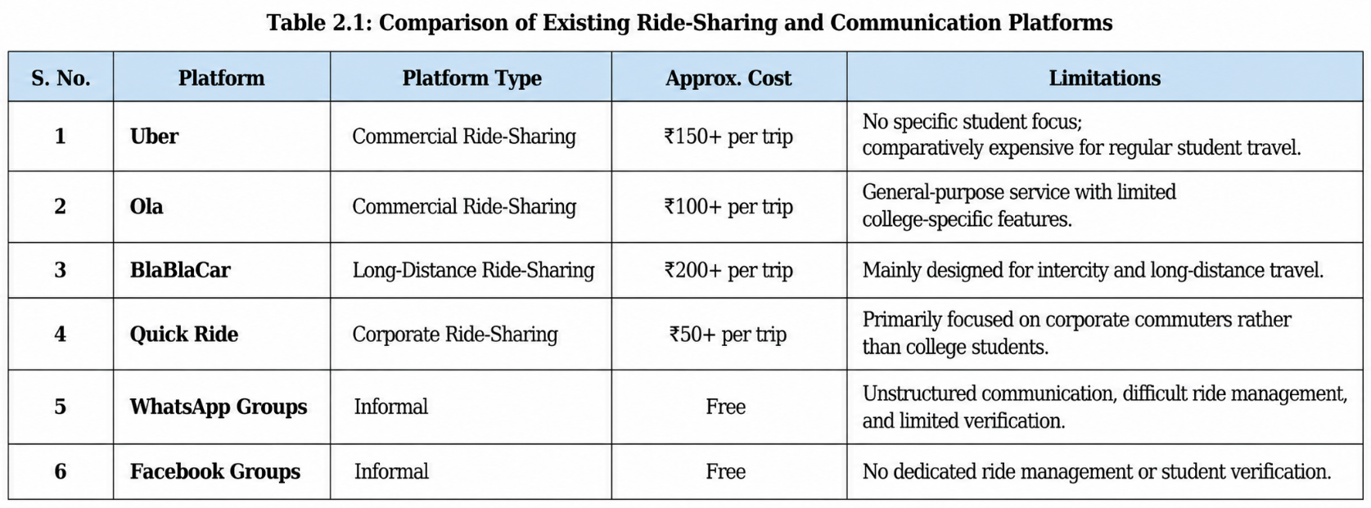

2.2 Gaps Identified

The study of existing transportation and ride-sharing solutions highlights the following gaps:
- Lack of a college-specific ride-sharing platform designed around student requirements.
- Absence of verified student accounts through institutional email verification.
- Limited support for short-distance route matching within a city.
- Lack of interactive route visualization for student rides.
- Limited availability of gender-based safety preferences.
- Informal platforms such as WhatsApp and Facebook do not provide structured ride posting, searching, and booking.
.
SYSTEM ANALYSIS

3.1 Existing System
The existing transportation coordination among students is mostly informal and lacks a dedicated system.
- Ride coordination is mainly performed through WhatsApp groups.
- There is no structured database for managing rides and users.
- Limited mechanisms are available for user verification and trust.
- No proper accountability or ride-booking management is available.
- Finding suitable rides can be difficult due to unorganized communication.

3.2 Proposed System
LNCTShares provides a structured web-based solution for student ride sharing.
- Web-based platform accessible through a modern browser.
- Structured ride posting and searching.
- Secure JWT-based authentication.
- Email verification for student accounts.
- Vehicle and route information management.
- Booking management for passengers and drivers.
- Real-time notifications for important ride-related activities.
- Interactive route visualization using digital maps.

3.3 COMPLETE TECHNOLOGY STACK
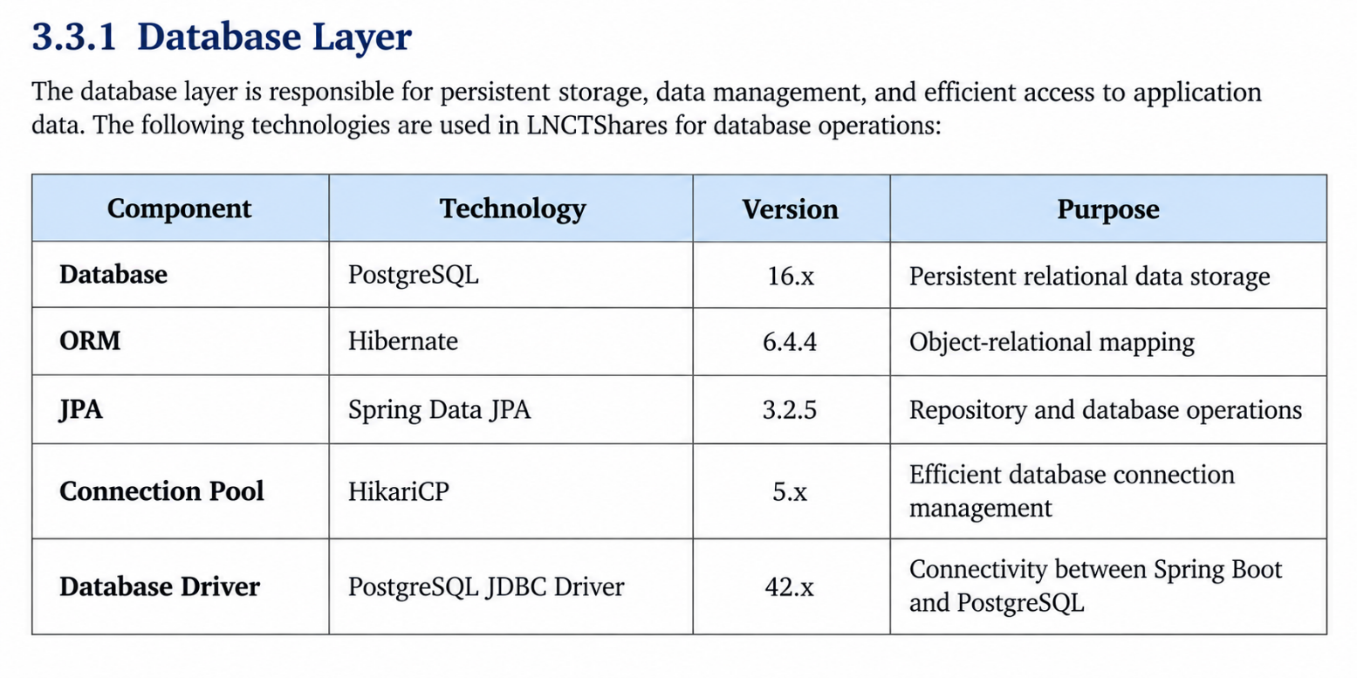
Why PostgreSQL?
- Provides reliable and persistent relational data storage.
- Supports concurrent users and multiple database connections.
- Provides strong SQL support and transaction management.
- Suitable for production deployment and cloud hosting.
- Can handle larger datasets and future system expansion
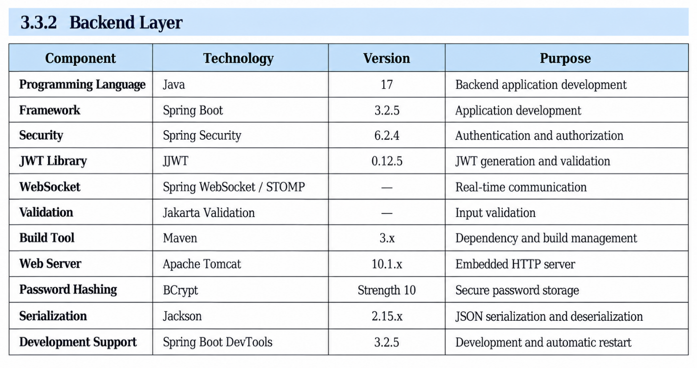
Why Spring Boot?
- Provides a well-established framework for Java-based web applications.
- Provides integrated support for REST APIs, security, JPA, and WebSocket communication.
- Reduces development time through auto-configuration.
- Supports modular and maintainable application development.
- Has extensive documentation and community support.

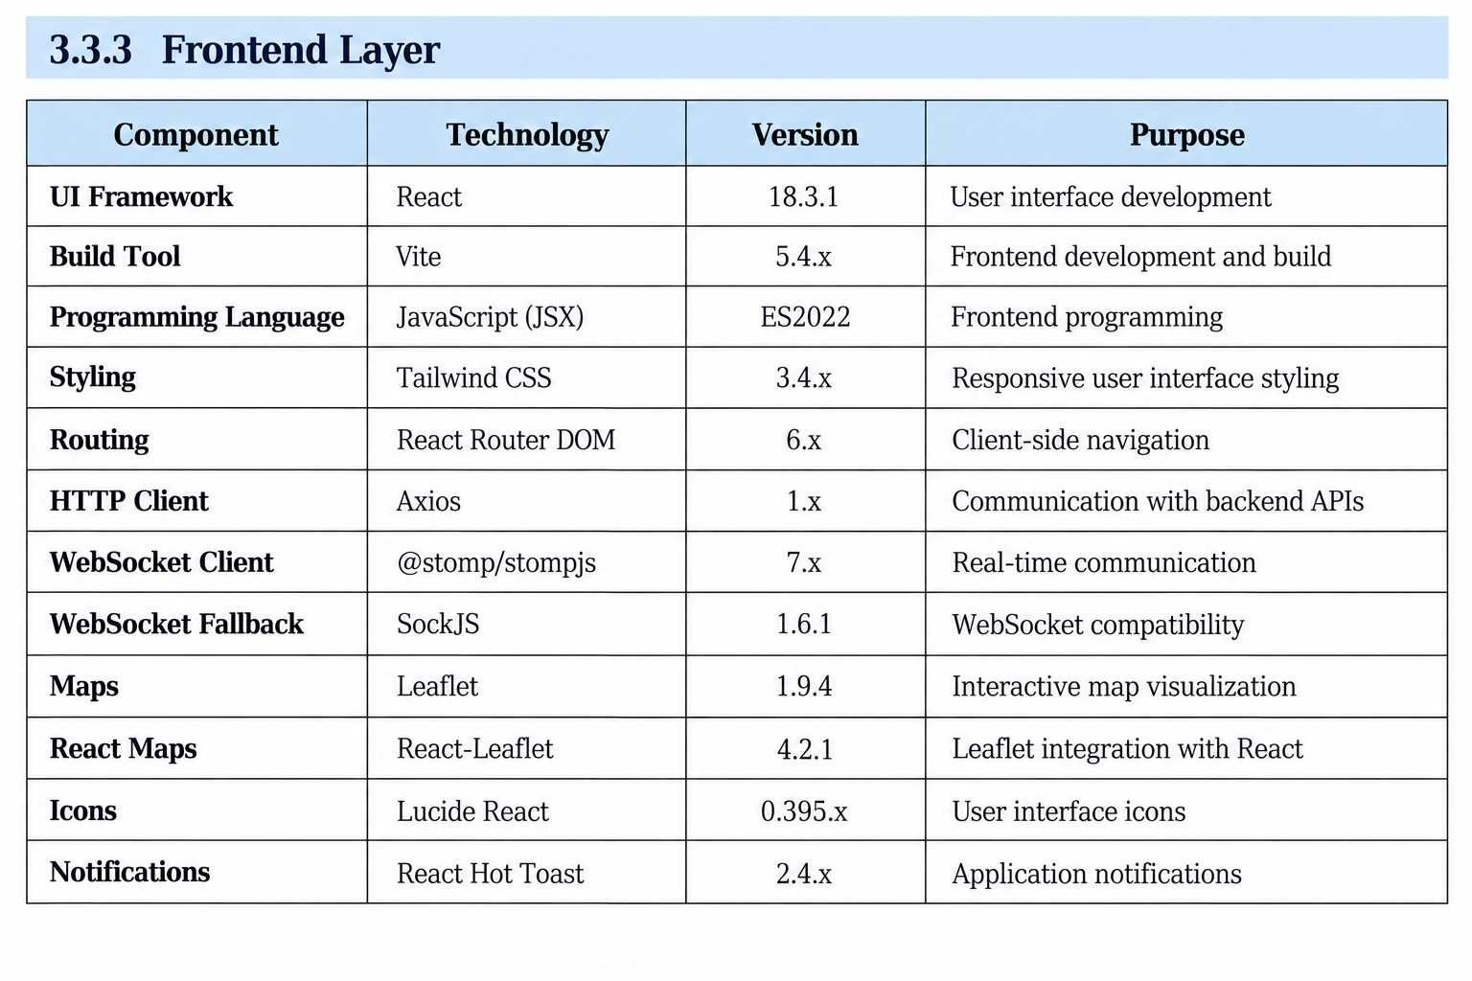
- React provides reusable components and efficient UI development.
- Vite provides fast development builds and Hot Module Replacement.
- Tailwind CSS enables consistent and responsive interface design.
- The combination provides a modern, modular, and maintainable frontend architecture.
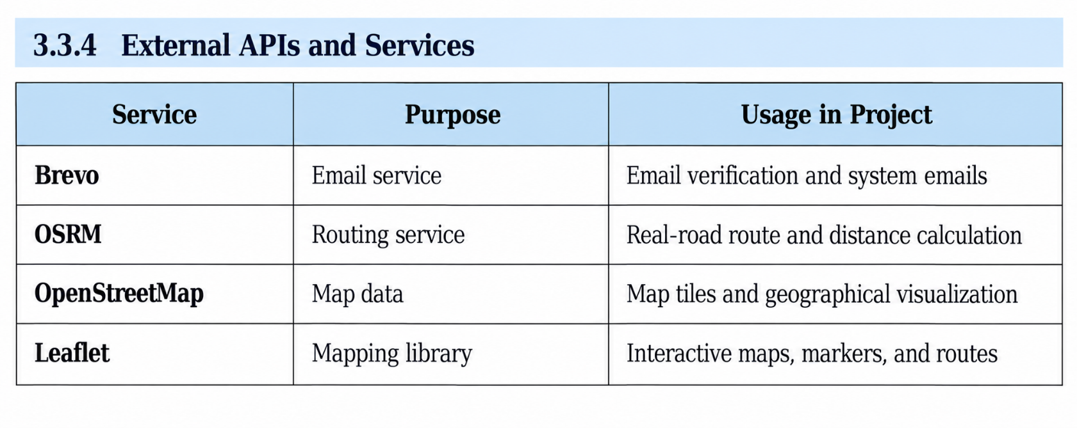 Purpose of External Services
- Brevo: Used for sending account verification and related emails.
- OSRM: Used to calculate routes based on actual road networks.
- OpenStreetMap: Provides geographical map data for the application.
- Leaflet: Provides interactive map functionality on the frontend.

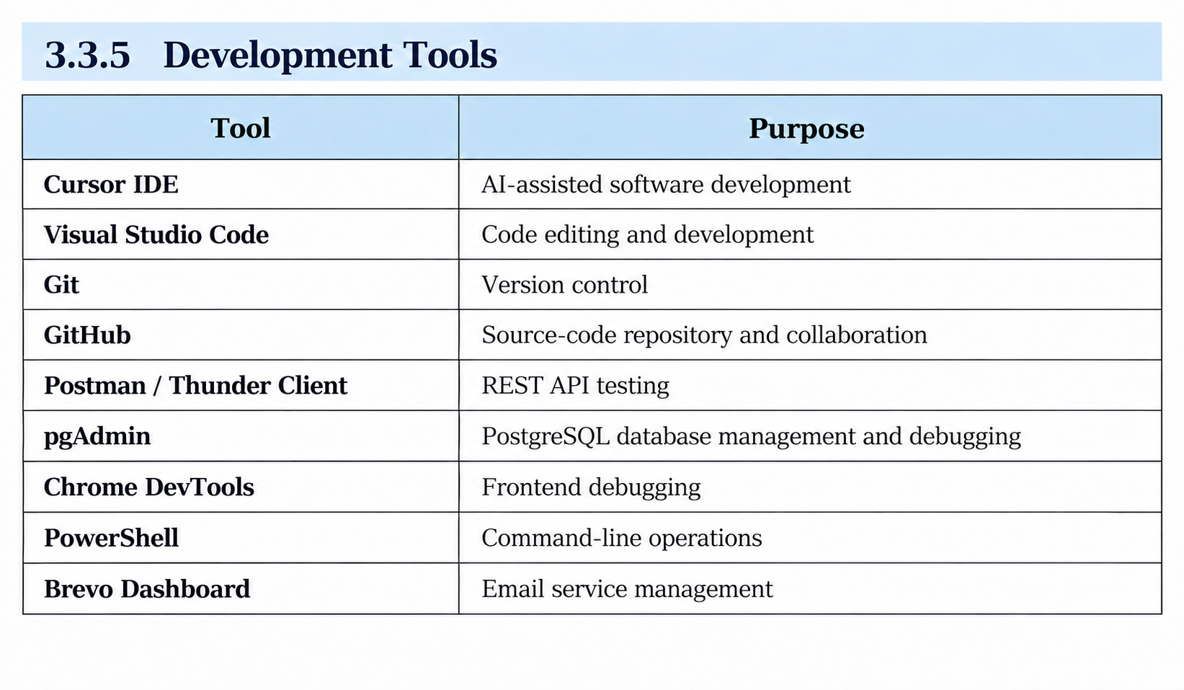
3.4 FEASIBILITY STUDY

The feasibility study evaluates whether the proposed LNCTShares system can be successfully developed and implemented from technical, economic, operational perspectives.

3.4.1 Technical Feasibility
Aspect | Assessment
Technology | Java 17, Spring Boot, React, PostgreSQL, and related technologies are suitable for the proposed system.
Development Resources | Required software tools, frameworks, and documentation are readily available.
Hardware | The system can be developed using a standard computer with at least 8 GB RAM.
Security | JWT authentication, BCrypt password hashing, and email verification provide basic security mechanisms.
Scalability | The system architecture can be extended with more powerful hosting and database infrastructure when required.

3.4.2 Economic Feasibility
The project primarily uses free and open-source development tools and services, making the development cost minimal.
3.4.3 Operational Feasibility
The system is designed for students and uses a web-based interface similar to commonly used online platforms, making it easy to operate.

3.5 SOFTWARE REQUIREMENTS SPECIFICATION (SRS)

3.5.1 Functional Requirements

FR-1: The system shall allow users to register using a valid college email address.

FR-2: The system shall provide email verification through Brevo

FR-3: The system shall provide secure login using JWT-based authentication.

FR-4: The system shall allow users to add, edit, and delete vehicle details.

FR-5: The system shall allow users to post rides with route, date, time, and vehicle
information.

FR-6: The system shall allow users to search for rides based on source, destination,
and date.
FR-7: The system shall allow passengers to book available seats on posted rides.

FR-8: The system shall allow drivers to accept or reject booking requests
FR-9: The system shall provide real-time notifications for ride-related activities.
FR-10: The system shall provide interactive maps and route visualization.

FR-11: The system shall allow users to manage their profile information.

FR-12: The system shall allow users to view their ride history.

FR-13: The system shall allow users to delete their own posted ride

3.5.2 Non-Functional Requirements

NFR-1: The system should provide API responses within 200 ms under
normal operating conditions.
NFR-2: The application should load pages within 2 seconds under normal
network conditions.
NFR-3: The system should support at least 100 concurrent users as a
target.
NFR-4: The system should maintain an availability of approximately 95%
or higher.
NFR-5: User data and communication should be protected using HTTPS
and JWT-based authentication.
NFR-6: The application should provide a responsive interface for screen
widths ranging from 375 px to 1440 px.
NFR-7: The application should support modern browsers including
Chrome, Firefox, Safari, and Edge.
NFR-8: The interface should follow applicable WCAG 2.1 AA accessibility
guidelines.

3.5.3 Hardware Requirements

Development System

- Processor: Intel Core i3 or equivalent and above
- RAM: 4 GB minimum, 8 GB recommended
- Storage: At least 10 GB of free storage
- Operating System: Windows, macOS, or Linux

Production Server
- The application can be deployed on a cloud hosting platform such as Render.
- Server resources depend on the selected hosting plan.

Client System
- Any desktop, laptop, tablet, or smartphone with a modern web browser.
- Stable internet connection is required.
- No additional software installation is required because LNCTShares is a web-based application.

FEATURE DESCRIPTION
System Architecture Diagram
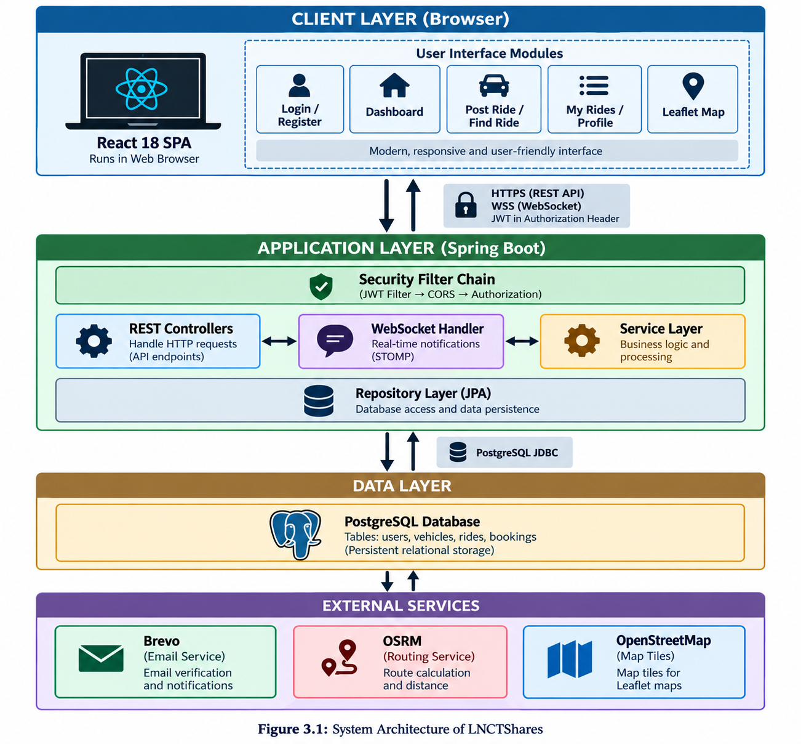
DATA FLOW DIAGRAM OF LNCTSHARES 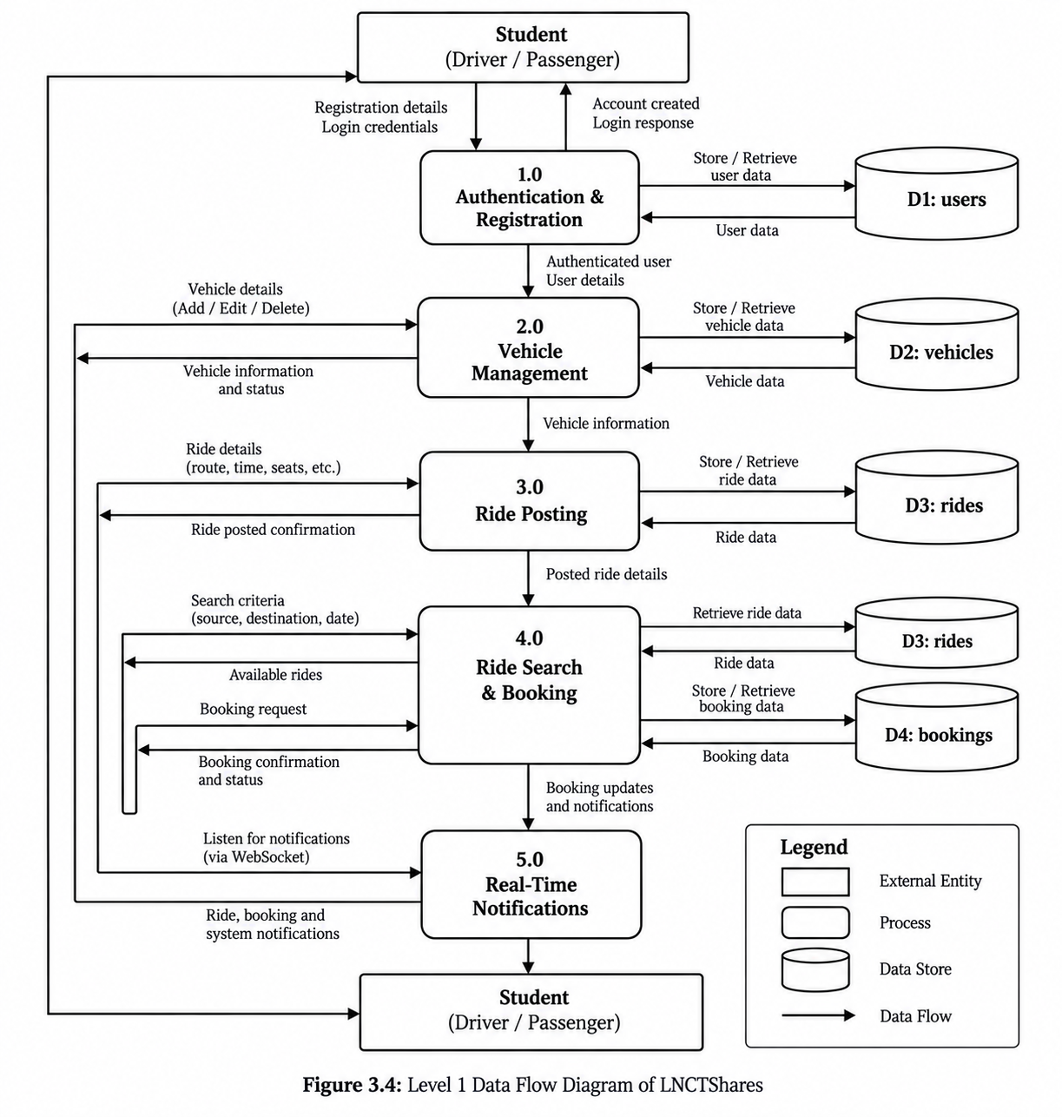

FEATURE DESCRIPTION
Authentication: Provides secure registration, email verification, JWT-based login, and automatic logout when the authentication token expires.
Ride Management: Allows students to post rides with vehicle and route information, search for available rides, view routes on an interactive map, and manage their own posted rides.
Booking Management: Enables passengers to request available rides while allowing drivers to accept or reject requests. Users can also cancel their bookings.
Vehicle Management: Allows users to add, update, and remove their vehicle information and associate a vehicle with a posted ride.
Real-Time Notifications: Uses WebSocket communication to provide notifications for events such as new rides and booking activities.
User Experience: Provides responsive design, gender preferences, loading states, empty states, and toast notifications for improved usability.
Statistics: Displays relevant public statistics related to users and rides on the platform.

SCREENSHOTS OF THE WEBSITE
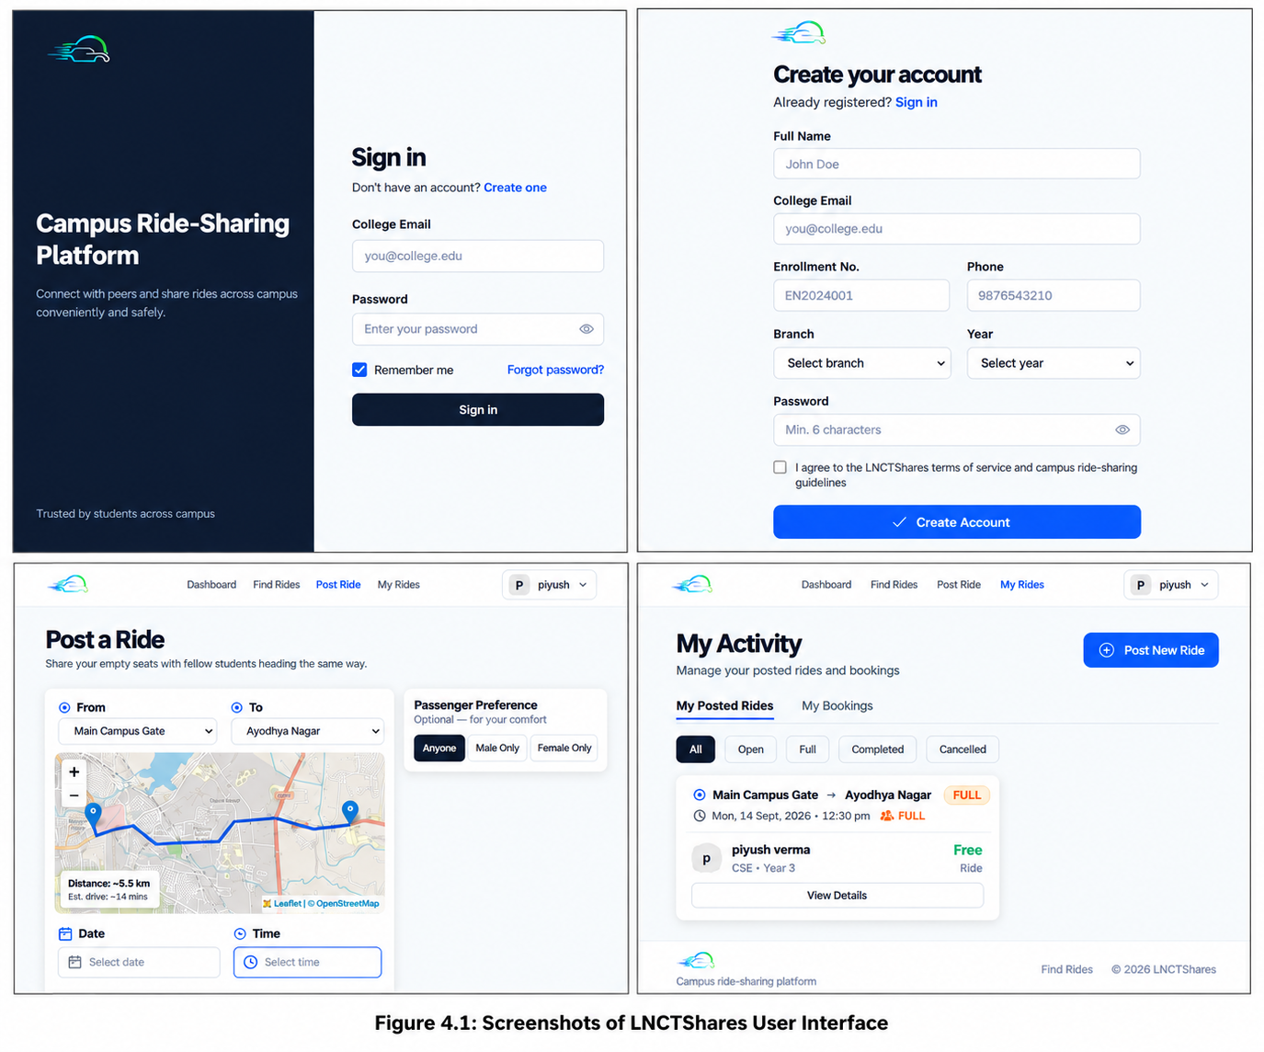

TESTING
TEST CASES 8.1
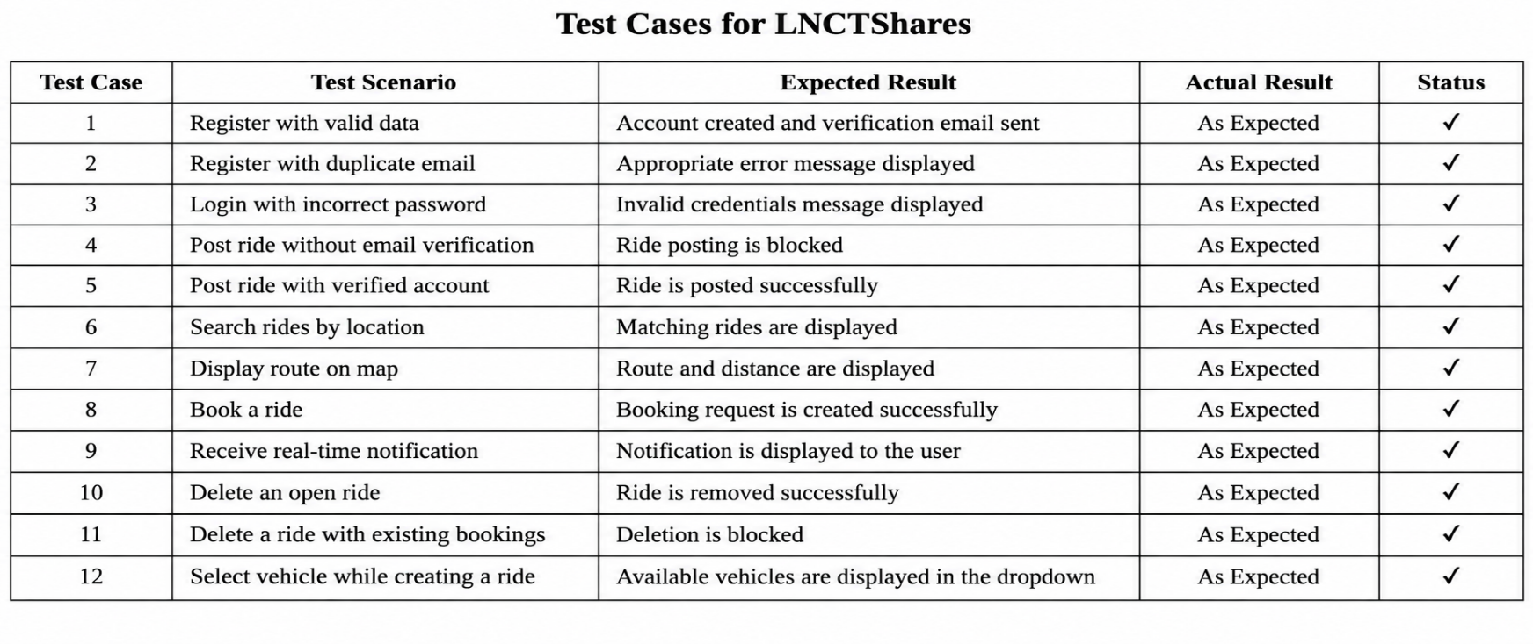
8.2 Performance Results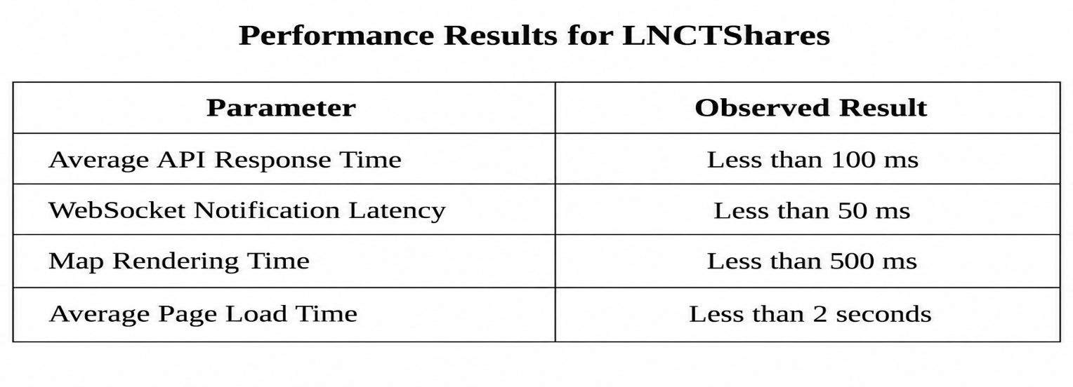
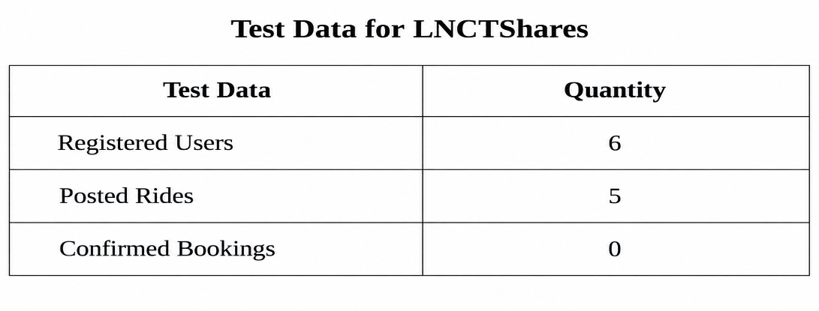
9.1 FUTURE SCOPE

The future scope of LNCTShares includes:
- Development of a mobile application using React Native.
- Integration of online payment facilities.
- Implementation of live GPS tracking.
- Addition of ratings and reviews.
- Introduction of in-app chat between users.
- Development of an administrator panel.
- Support for multiple colleges.
- Implementation of AI-based ride matching.
- Automated ride reminders and notifications.
- Improved production deployment with a verified domain and email system.

9.2 CONCLUSION
LNCTShares successfully addresses the transportation challenges faced by students by providing a dedicated platform for peer-to-peer ride sharing. The system connects students travelling on similar routes and provides features for ride posting, ride searching, booking, vehicle management, route visualization, and real-time notifications.
The project demonstrates a complete full-stack implementation using Spring Boot, React, PostgreSQL, WebSocket, Leaflet, and OSRM. Functional testing was performed using 6 registered users and 5 posted rides, covering major system operations.

