INSTRUCTIONS

1. GOTO: files/input.xlxs
2. 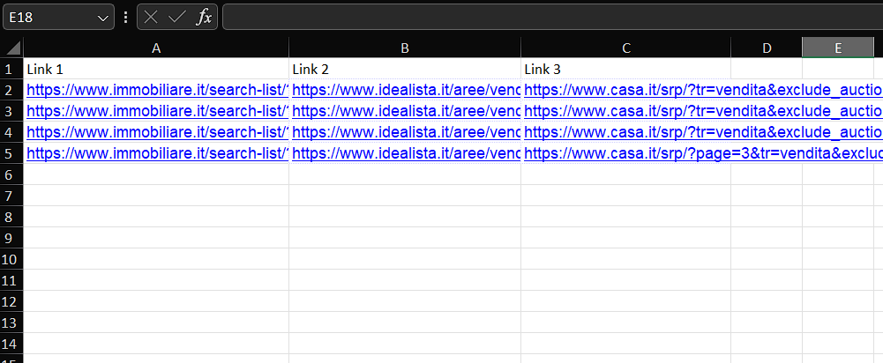

Input Link 1, Link 2, Link 3 from imobiliare, idealista, casa respectively. Input should be done in proper order.

1. Column will contains Links to be scraped.
2. Make sure, python is installed in the system.
3. Then open terminal in that folder.
4. 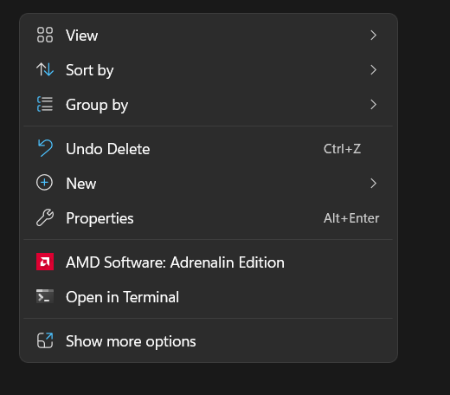
5. **pip install -r requirements.txt**
6. **py main.py**
7. When scraping is finished, “file.xlxs” will be generated.