Diagrams Of Sell-Support

# Results:

**UML diagrams:**

1. 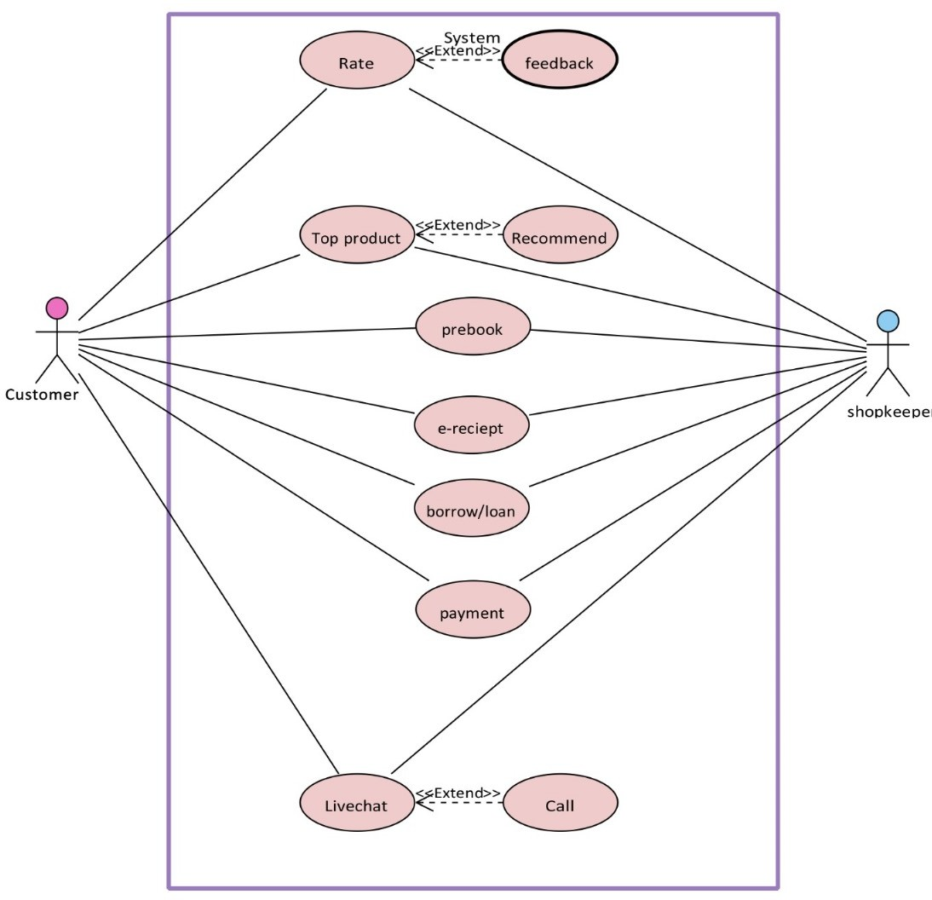**Use-case Diagram**
2. 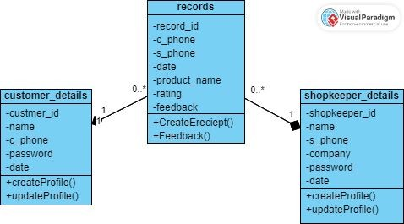**Class Diagram**
3. 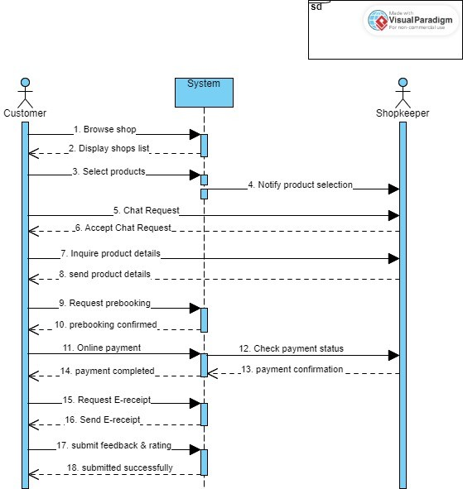**Sequence Diagram**
4. **Data Flow Diagram**

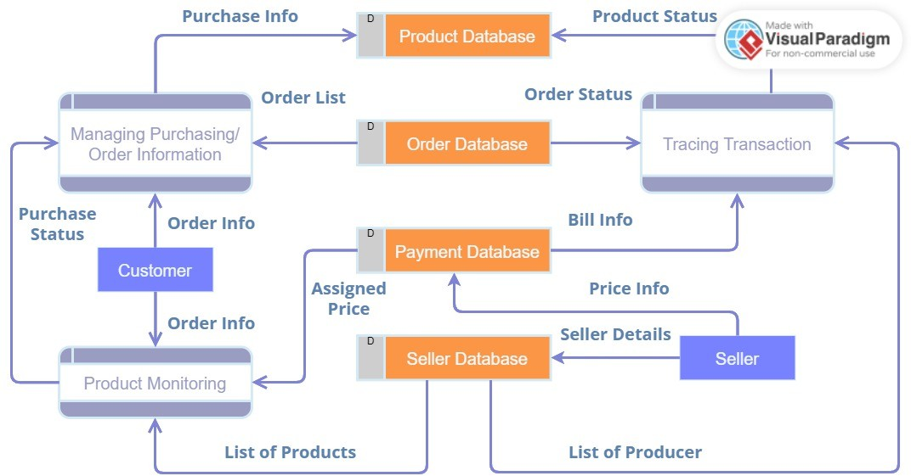

1. 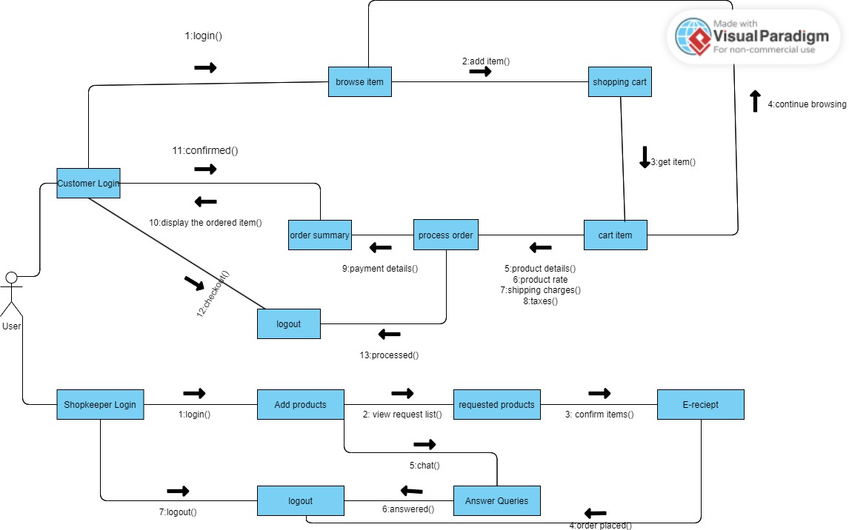**Collaboration Diagram**

# Charts:

1. **PERT Chart**

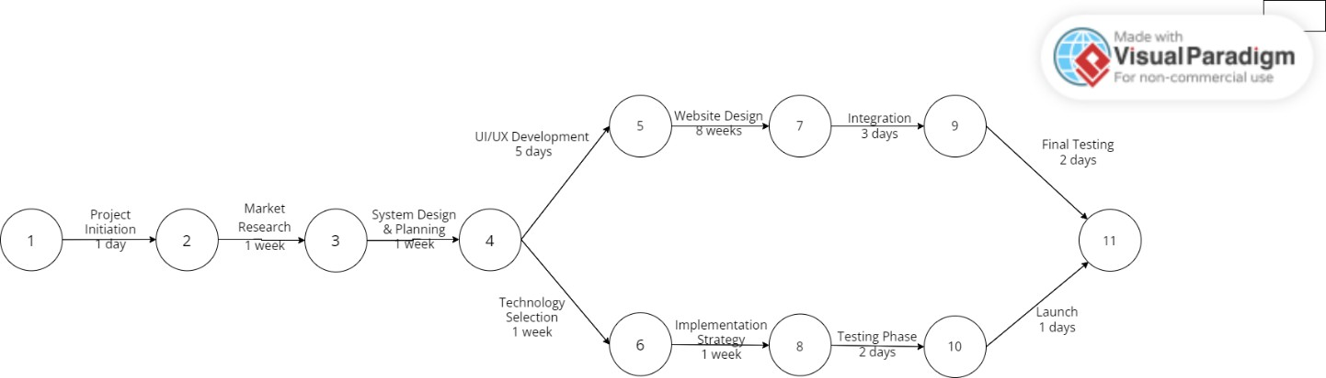

1. **Gantt Chart**

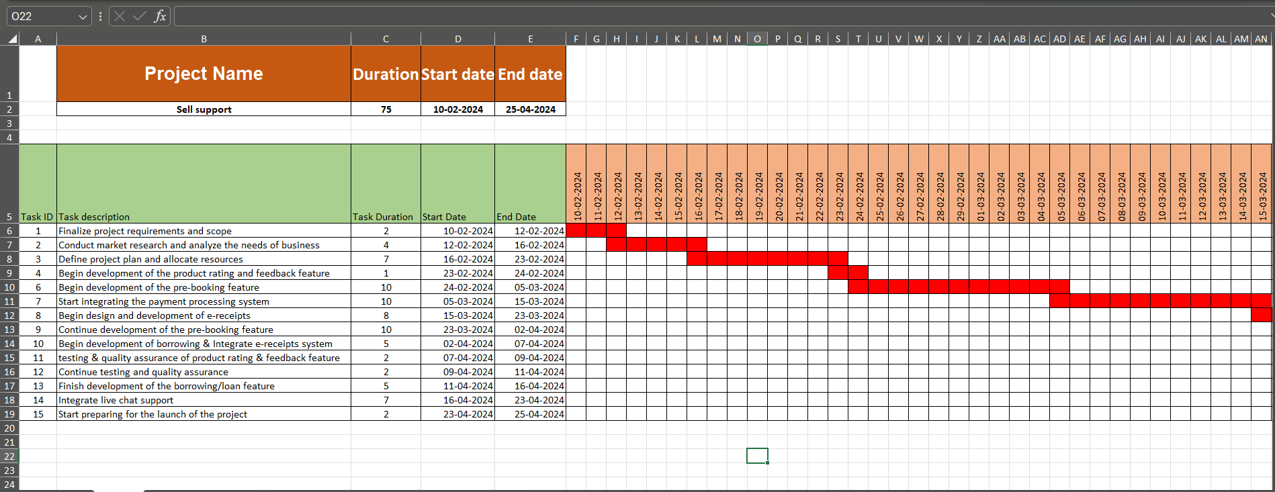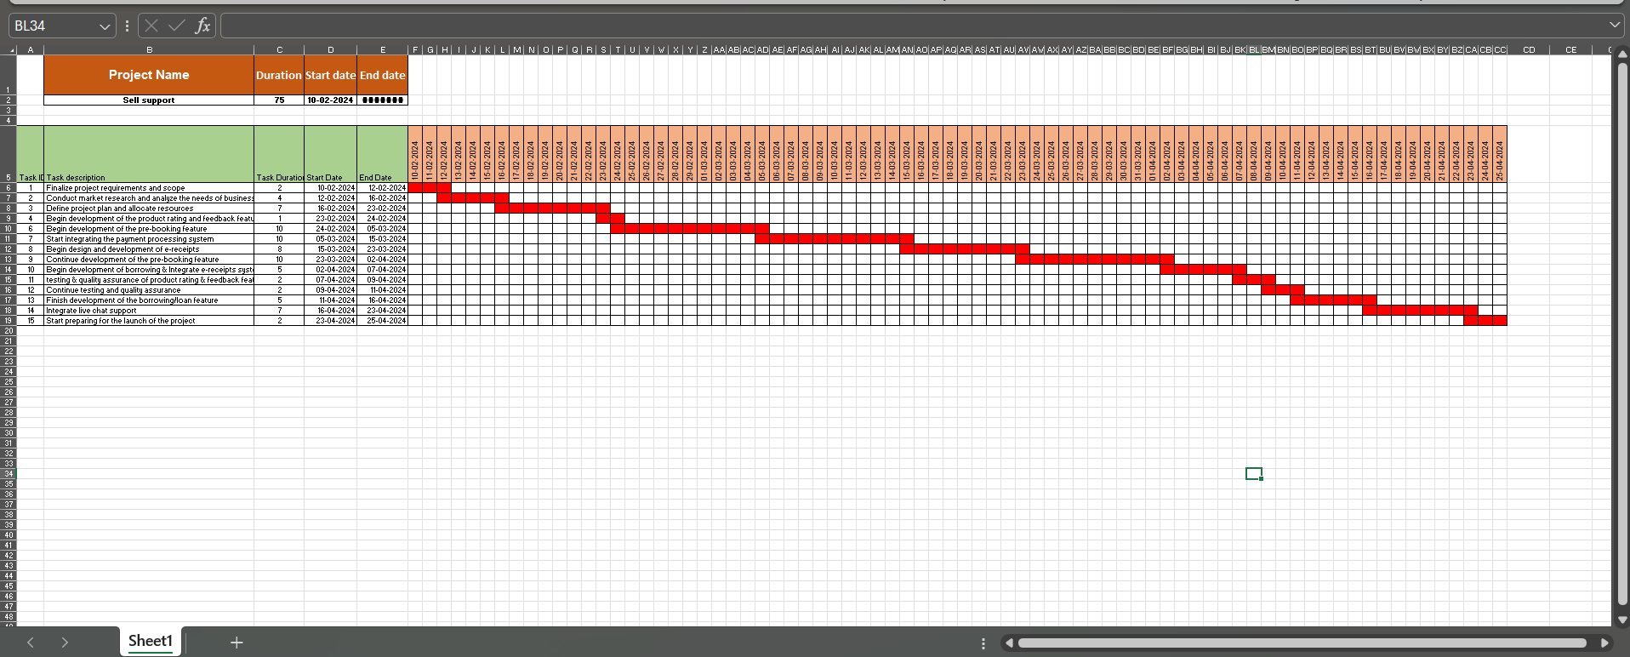

* 1. **Work Breakdown Structure-1**

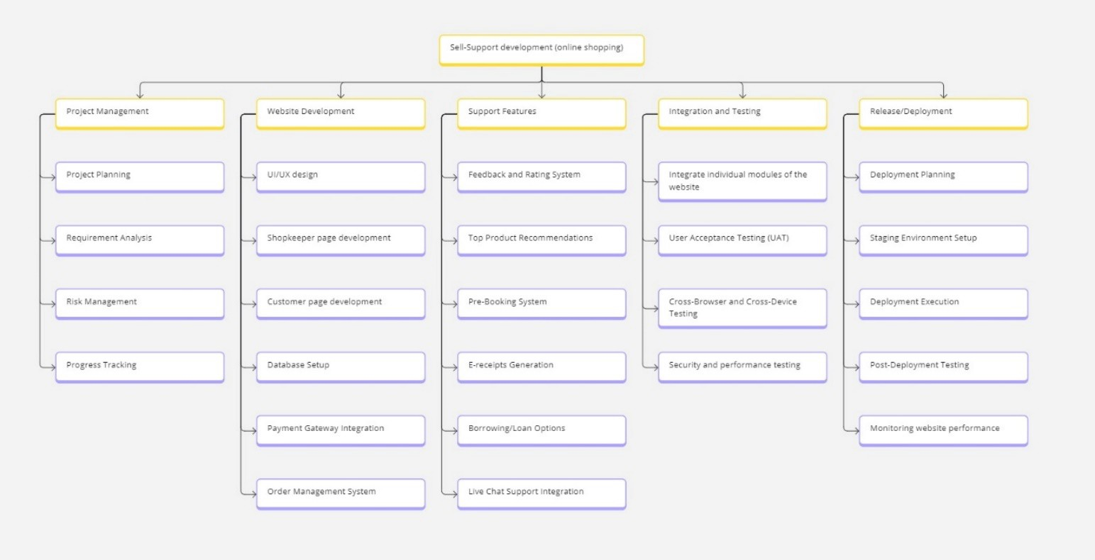

* 1. **Work Breakdown Structure-2**

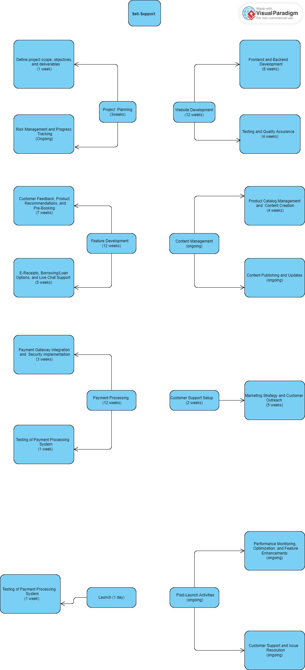

1. 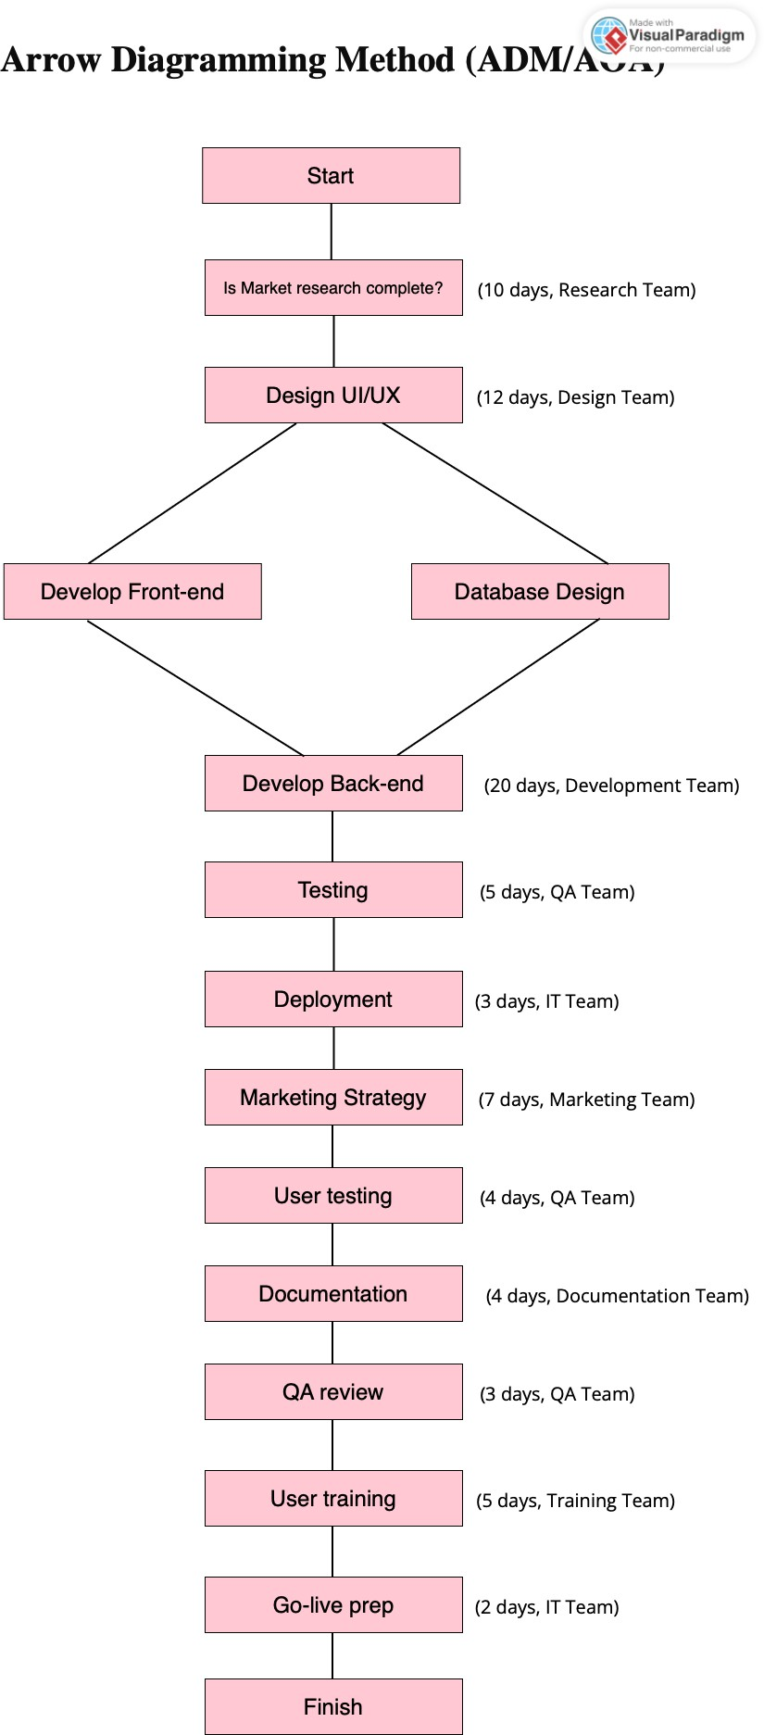**Project Network Diagram**
2. 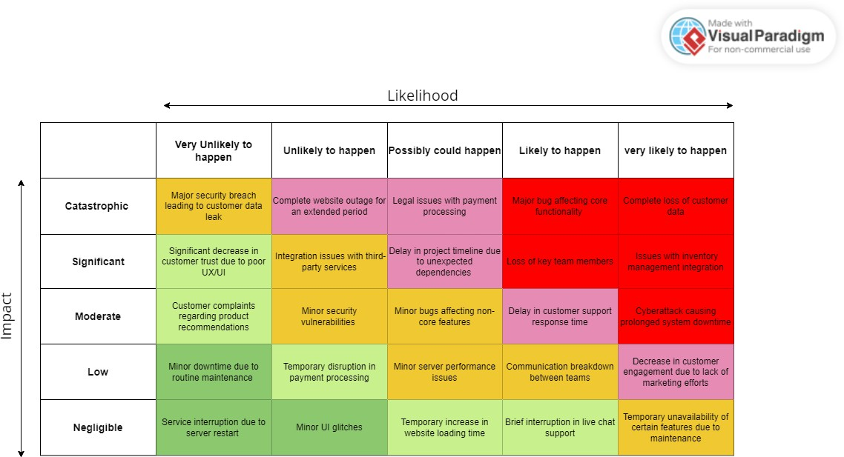**Risk Matrix Assessment**
3. 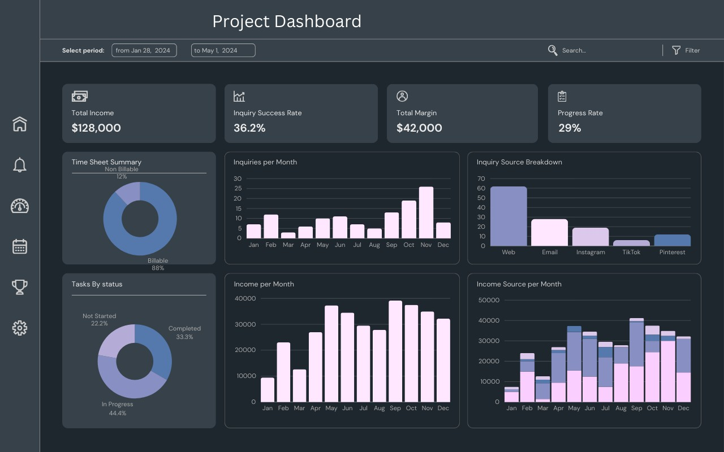**Project Dashboard**
4. **Project Report**

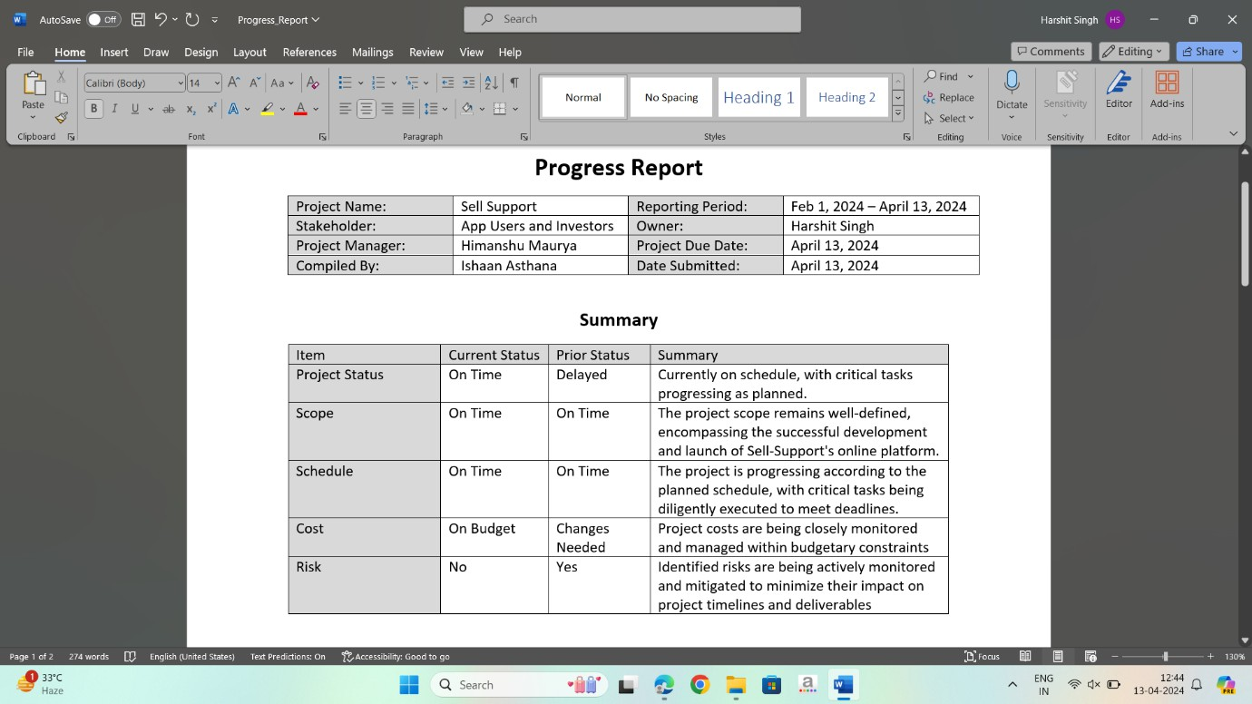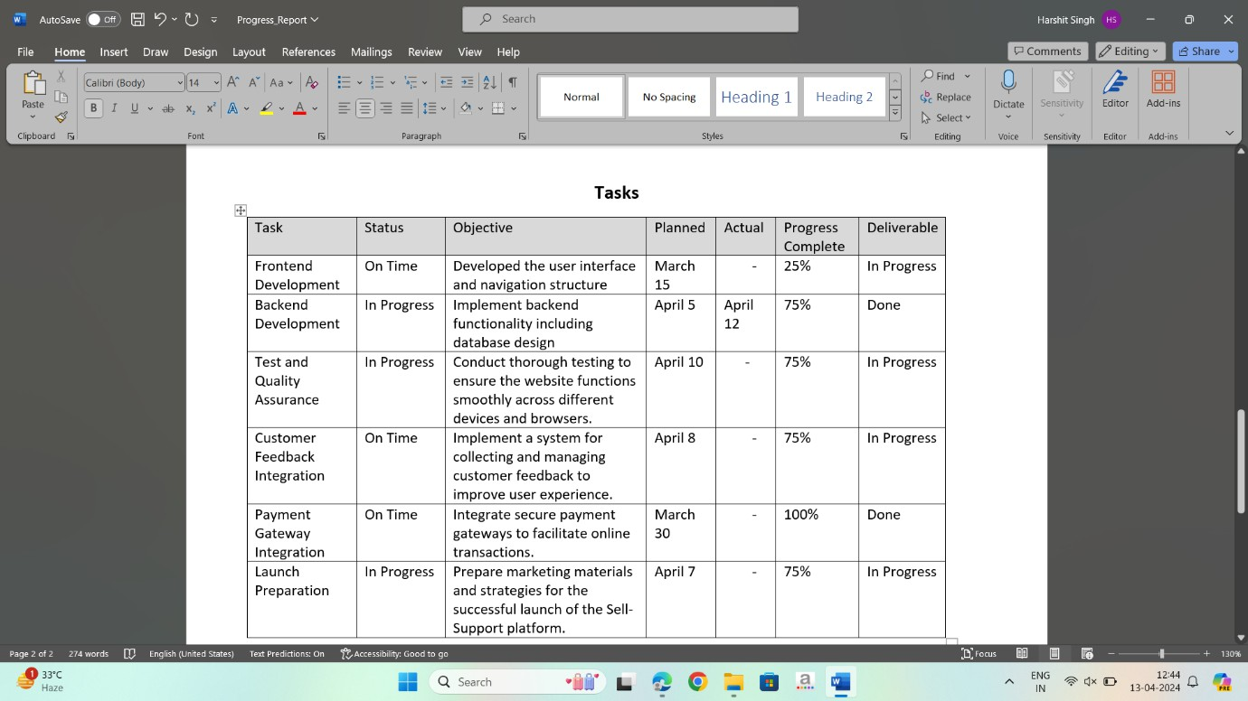

1. **Agile Project Development**

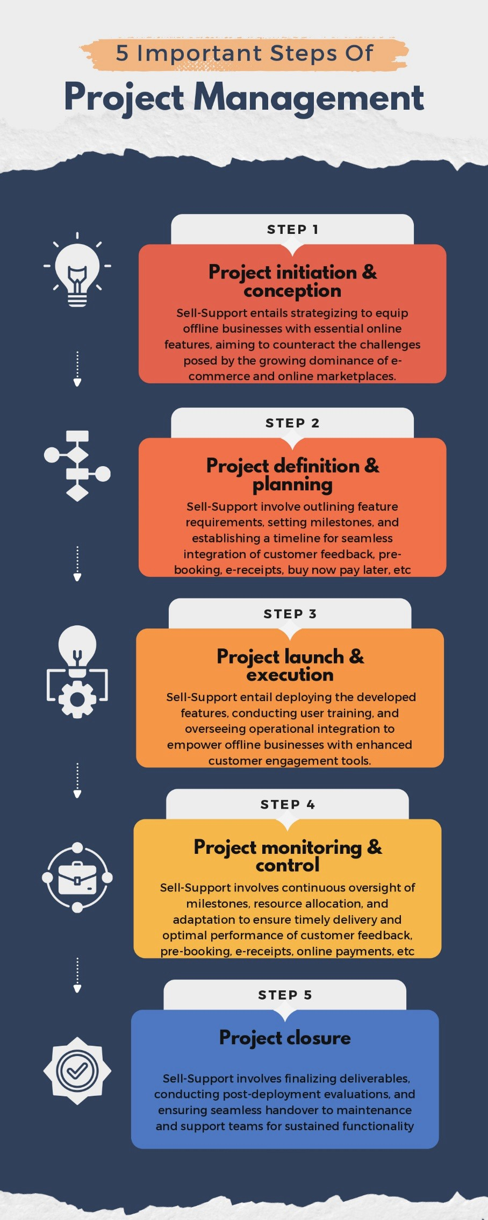

**G. Critical Path method**

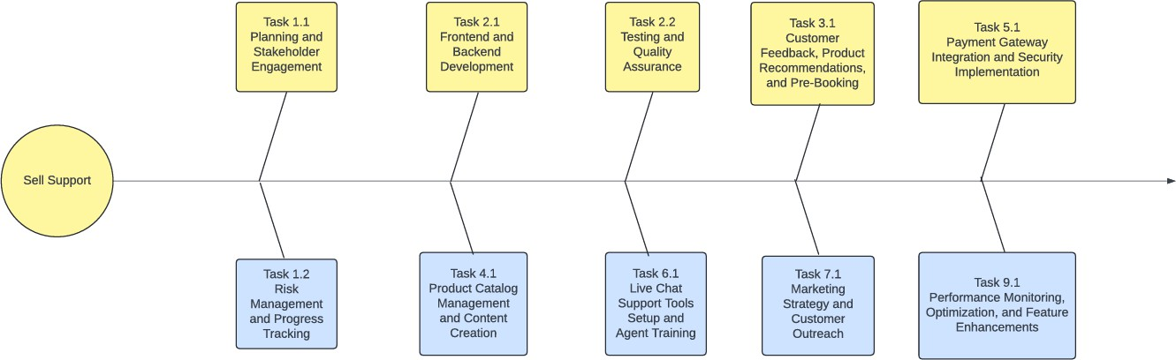

1. 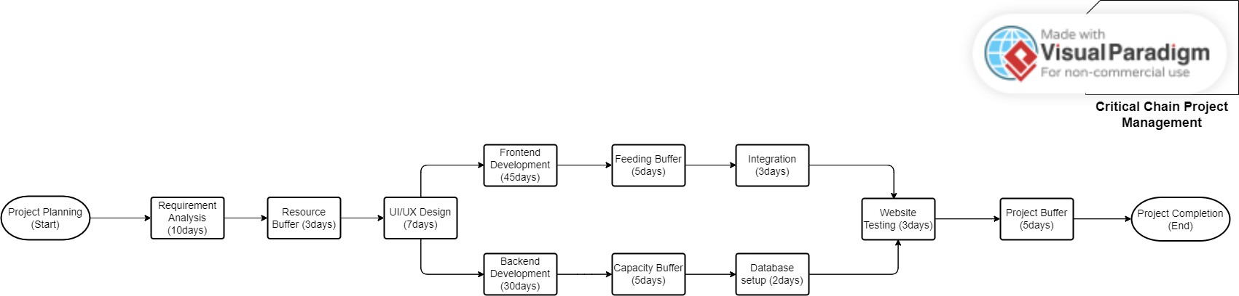**Critical Chain Project Management**
2. 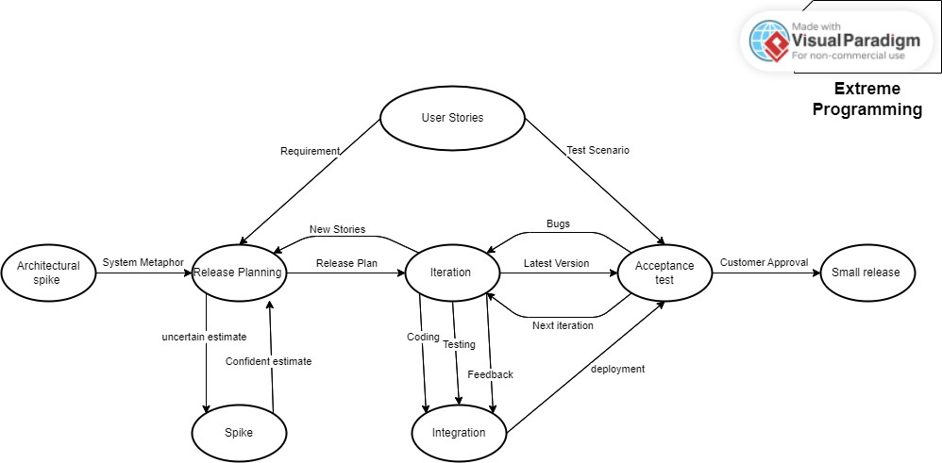**Extreme Programming**
3. **Prince2**

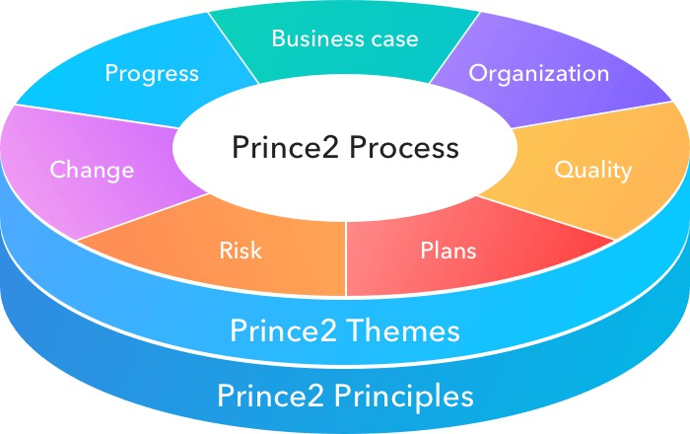

1. **Rational Unified Process**

1. 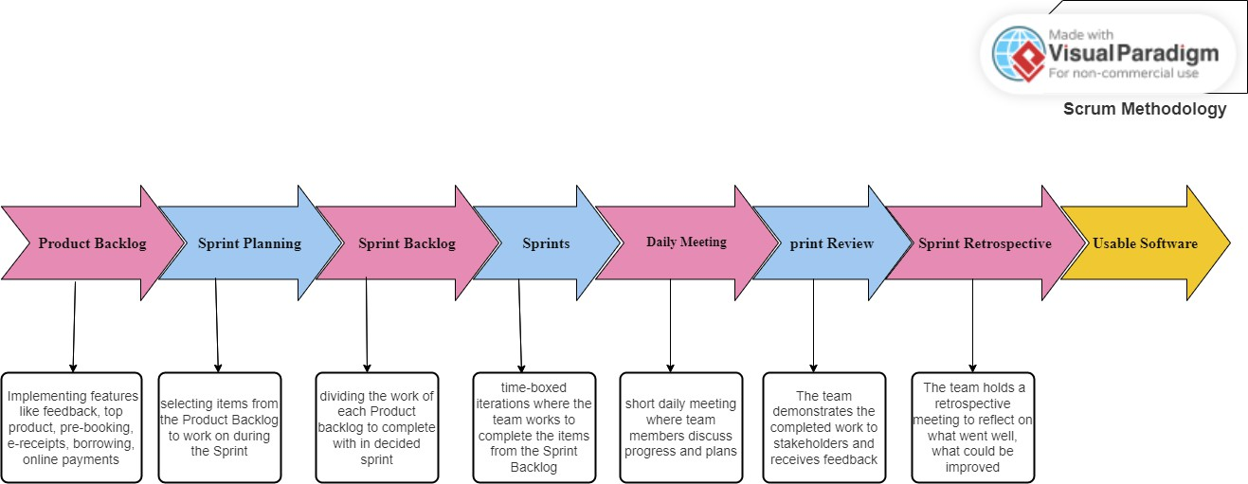**Scrum Methodology**
2. **Architecture Diagram:**

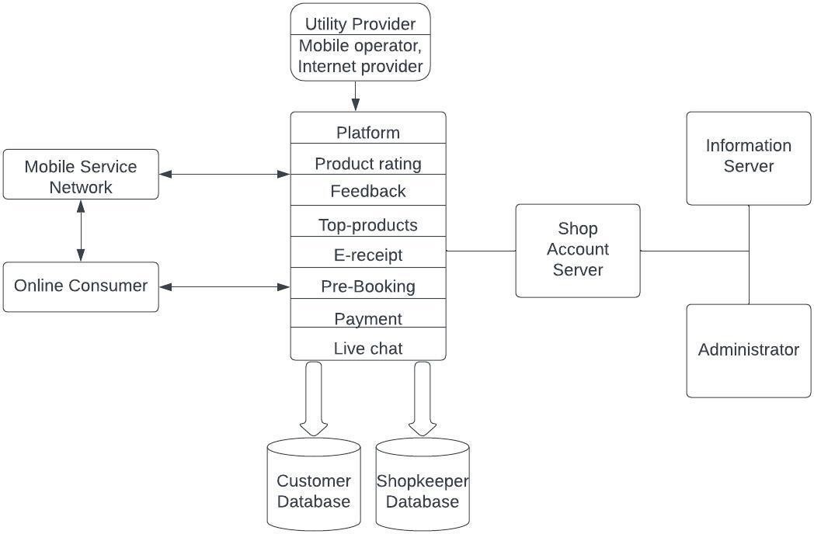

**Activity Diagram:**

**-*Complete App***

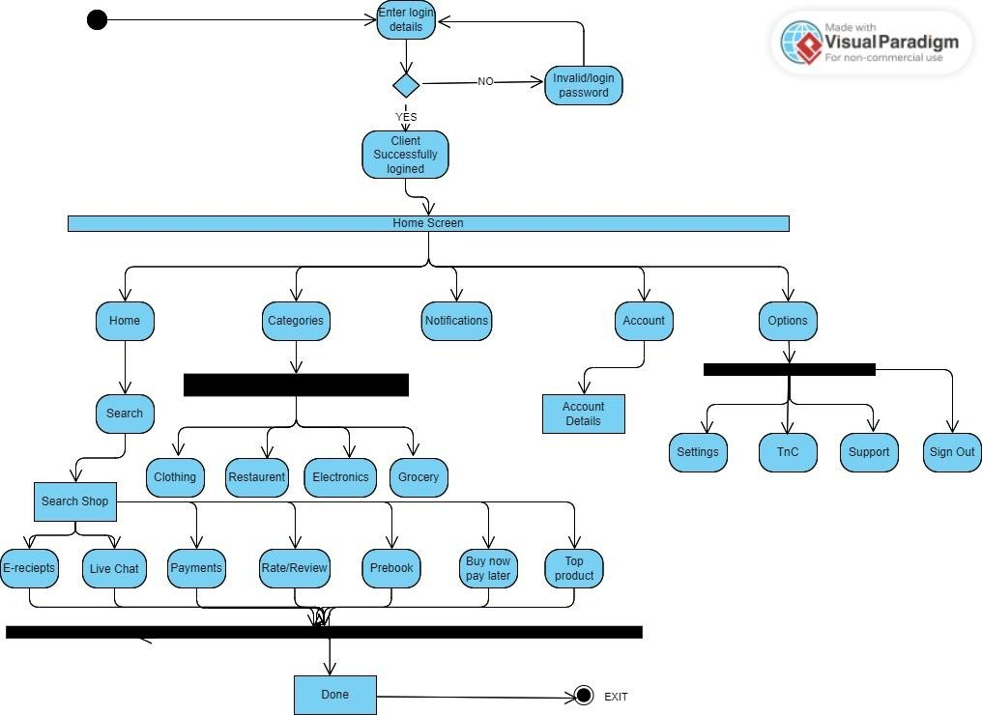

-*Activity Diagram for “Search” function*

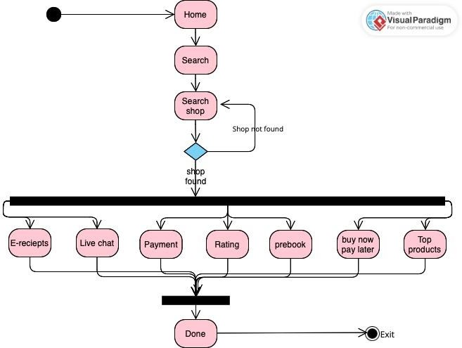

-*Activity Diagram for “Categories” function*

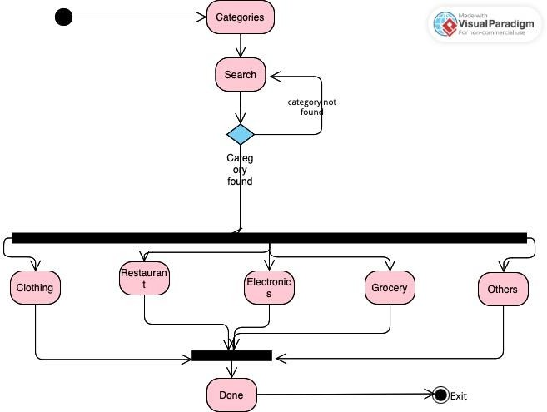

-*Activity Diagram for “Options” function*

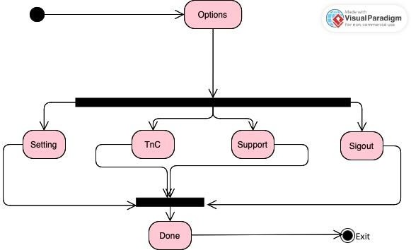

-*Activity Diagram for “Account” function*

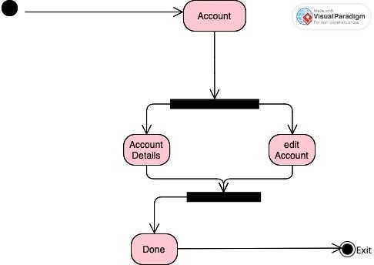

-*Activity Diagram for “Notifications” function*