**OSOC Induction Task**

1. Command for searching pattern line by line in any document with an example.

The grep command searches a file for a particular pattern of characters, and displays all lines that contain that pattern.

grep stands for globally search for regular expression and print out.

Syntax:

grep [options] pattern [files]

**Example:-**

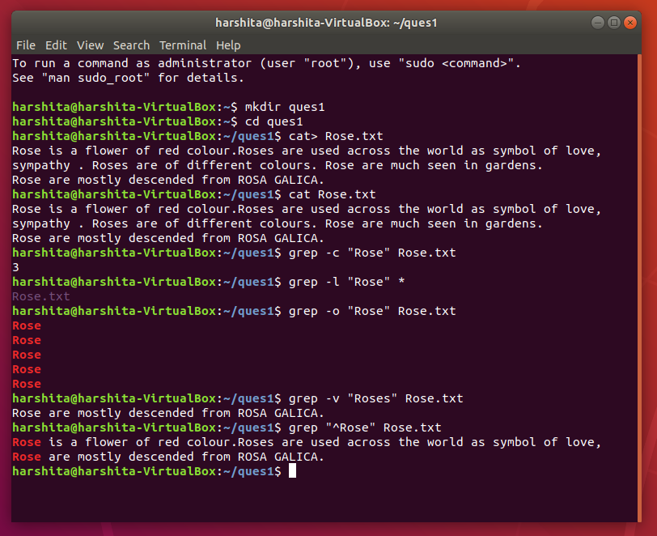

2. What all permissions are there in Linux? State all permissions and different way of changing permissions with example.

Every file and directory in your UNIX/Linux system has following 3 permissions defined for all three owners.

1. **Read:** This permission give you the authority to open and read a file. Read permission on a directory gives you the ability to lists its content.

**2.** **Write:**The write permission gives you the authority to modify the contents of a file. The write permission on a directory gives you the authority to add, remove and rename files stored in the directory.

3. **Execute:** In Unix/Linux, you cannot run a program unless the execute permission is set. If the execute permission is not set, you might still be able to see/modify the program code(provided read & write permissions are set), but not run it.

**Example:-**

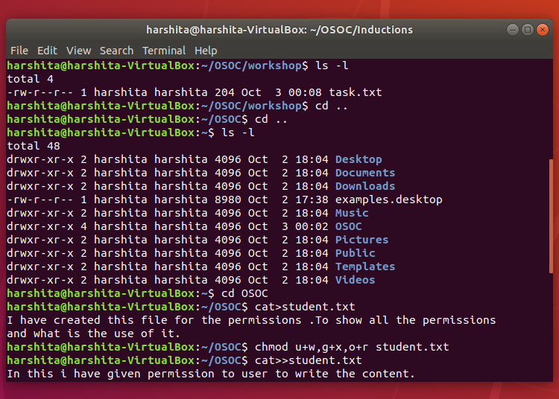

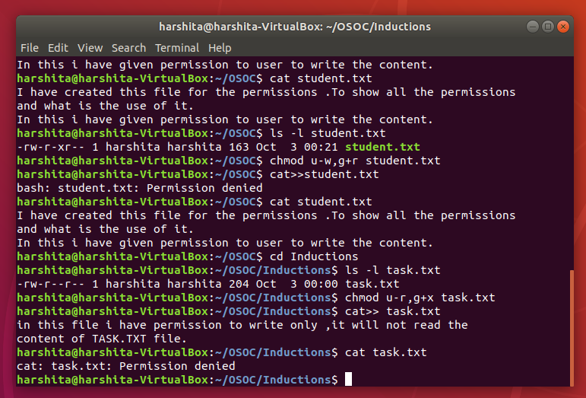

3. Create a folder OSOC and inside that another folder Inductions and now create a file task.txt inside Inductions with some content now copy this file into another folder Workshop in OSOC.

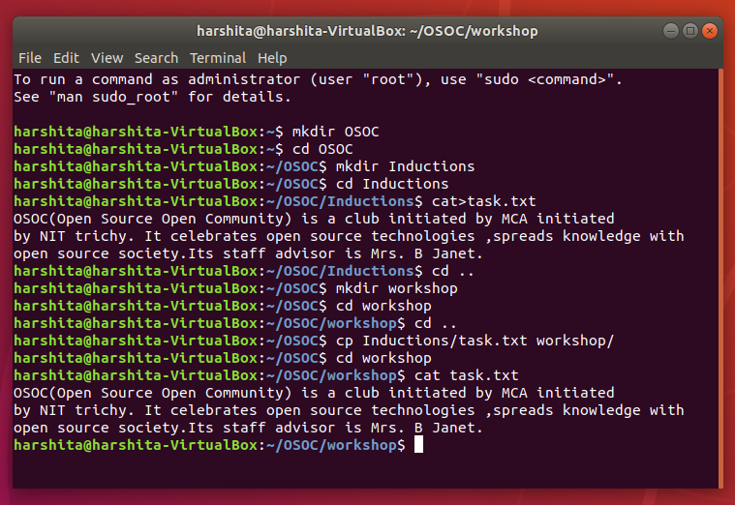

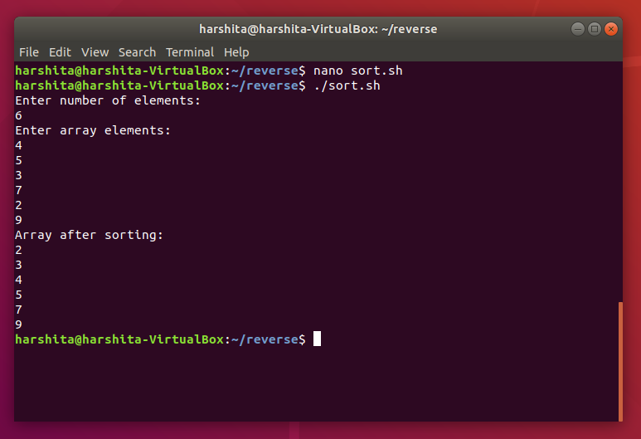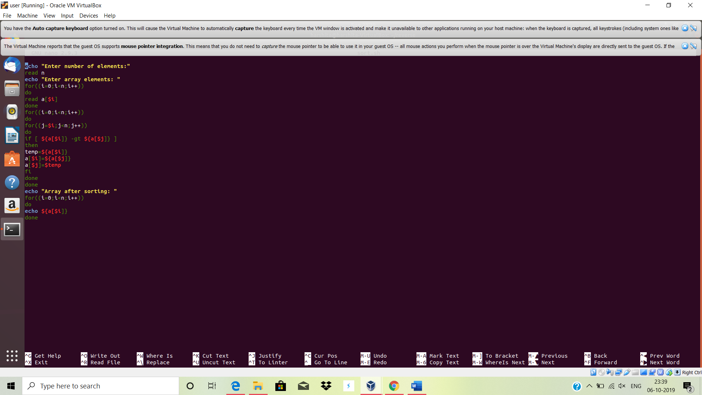6. Using shell scripting write program for sort an Array. Input should be taken from user.

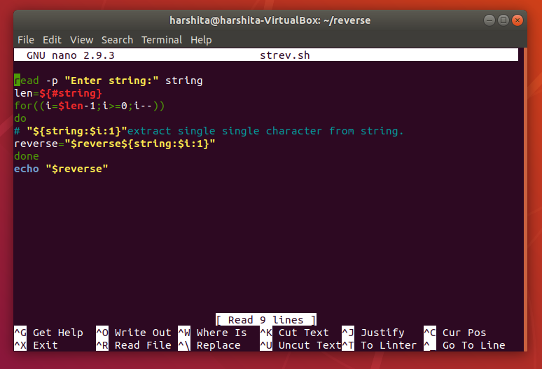7. Using Shell scripting write a program to reverse a string. Input should be taken from user.

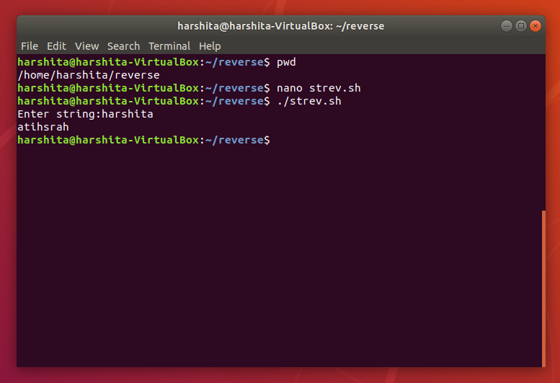

8. What is the concept of Branching? How it is useful? Explain with working example.

A branch in git is simply a lightweight movable pointer to one of these commits. The default branch name in Git is master. As you initially make commits, you’re given a master branch that points to the last commit you made. Every time you commit, it moves forward automatically.

Advantages:-

1. You work on features independently, and so they never affect anyone else's work until it comes time to merge.

2. You can do code reviews and targeted testing on the feature branch without holding anyone else up if there's a problem.

Example:-

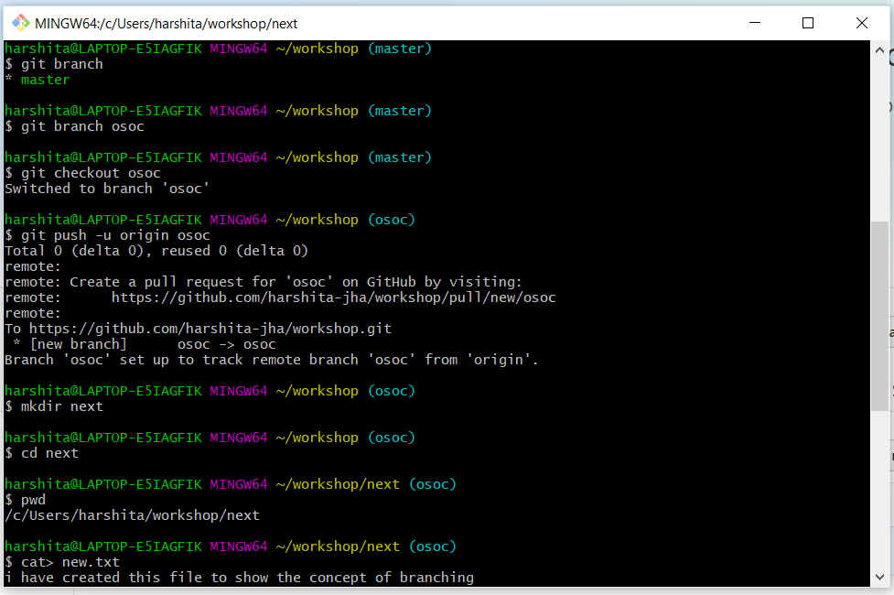

9. What is Push, Pull and Commit? Explain with example.

The git push command allows you to send (or *push*) the commits from your local branch in your local Git repository to the remote repository.

Syntax :

git push <repo name> <branch name>

The Git Pull command used to update the local version of a repository from remote. It does two things:-

1. update the current local working branch

2. update the remote tracking branchesfor all others branches.

**The commit command is used to save your changes to the local repository.**

**Syntax:**

git commit [options] “message”

