Customer Segmentation Using K-Means Clustering

Introduction
Customer segmentation is the process of dividing customers into different groups based on their characteristics and behavior. Businesses use customer segmentation to understand customer preferences, improve marketing strategies, and provide personalized services. In this project, K-Means Clustering was used to group customers based on their Annual Income and Spending Score.

Objective
The main objective of this project is to identify distinct customer groups using the K-Means Clustering algorithm and analyze customer spending behavior.

Dataset Description
The dataset used in this project is the Mall Customers Dataset. It contains information about customers visiting a shopping mall.

Features in the Dataset
- CustomerID: Unique identifier for each customer
- Gender: Gender of the customer
- Age: Age of the customer
- Annual Income (k$): Annual income of the customer in thousand dollars
- Spending Score (1-100): Score assigned by the mall based on customer spending behavior
The dataset contains 200 customer records.

Tools and Libraries Used
- Python
- Pandas
- NumPy
- Matplotlib
- Scikit-learn

Data Preprocessing
The dataset was loaded using the Pandas library. The following preprocessing steps were performed:
- Loaded the dataset into a DataFrame.
- Checked dataset information using the info() function.
- Generated statistical summaries using the describe() function.
- Checked for missing values using isnull().sum().

Missing Values Analysis
No missing values were found in the dataset. Therefore, no additional data cleaning was required.

Methodology

Feature Selection
For customer segmentation, the following two features were selected:
- Annual Income (k$)
- Spending Score (1-100)
These features help identify customer purchasing patterns.

Elbow Method
The Elbow Method was used to determine the optimal number of clusters. The Within-Cluster Sum of Squares (WCSS) was calculated for cluster values ranging from 1 to 10.
The graph showed a noticeable bend at K = 5, indicating that five clusters would provide a good balance between accuracy and simplicity.
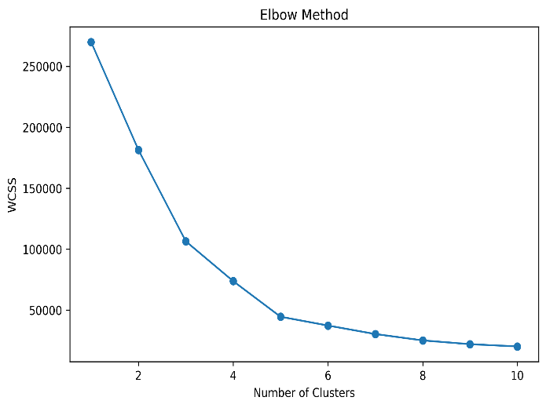

K-Means Clustering
After determining the optimal number of clusters, the K-Means algorithm was applied with K = 5. The algorithm grouped customers into five distinct clusters based on their annual income and spending score.
Results and Visualization
The customer segmentation graph displays five different customer groups along with their cluster centroids.
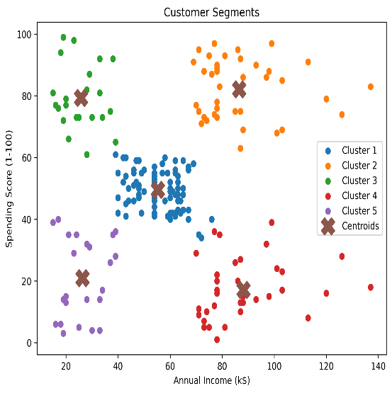
Detailed Observations

Cluster 1 (Blue) – Average Income, Average Spending
- Annual Income approximately 40–70 k$.
- Spending Score approximately 40–60.
- Represents regular customers with balanced spending habits.
- This is the largest customer segment in the dataset.

Cluster 2 (Orange) – High Income, High Spending
- Annual Income approximately 70–140 k$.
- Spending Score approximately 65–100.
- These customers spend heavily and contribute significantly to revenue.
- They are the most valuable customers and should be targeted through loyalty programs and premium services.

Cluster 3 (Green) – Low Income, High Spending
- Annual Income approximately 15–40 k$.
- Spending Score approximately 60–100.
- Despite having lower income levels, these customers spend frequently.
- Promotional offers and reward programs can help retain this segment.

Cluster 4 (Red) – High Income, Low Spending
- Annual Income approximately 70–140 k$.
- Spending Score approximately 1–40.
- These customers have strong purchasing power but currently spend less.
- Personalized marketing campaigns may encourage higher spending.

Cluster 5 (Purple) – Low Income, Low Spending
- Annual Income approximately 15–40 k$.
- Spending Score approximately 1–40.
- This segment represents low-value customers with limited spending activity.
- Basic marketing strategies are sufficient for this group.

Advantages of Customer Segmentation
- Helps businesses understand customer behavior.
- Improves targeted marketing campaigns.
- Increases customer satisfaction.
- Supports better business decision-making.
- Enhances customer retention strategies.

Conclusion
This project successfully implemented K-Means Clustering for customer segmentation. Using Annual Income and Spending Score, customers were divided into five meaningful groups. The results demonstrate how machine learning techniques can help businesses identify customer patterns and improve marketing strategies. Customer segmentation is an effective tool for data-driven decision-making and business growth.

Future Scope
- Include additional customer features such as age and gender.
- Apply advanced clustering algorithms for comparison.
- Develop interactive dashboards for business analysis.
- Use larger real-world datasets for deeper insights.

