iMovies
Online Movie Ticket Booking System

1. Introduction

Project Title
iMovies: Online Movie Ticket Booking System
Name | Role | Responsibilities
Harshita Singh | Full-stack developer (individual project) | Requirements, system design, React frontend, Node/Express backend, MongoDB database design, authentication, payment and seat-booking logic, testing, documentation

2. Project Overview

Purpose
iMovies lets people discover movies, choose a show, pick their own seats and pay for tickets online, without queuing at the theater. It also gives theater administrators one place to manage movies, theaters, show schedules and bookings.
Goals:
- Make browsing movies and booking tickets quick and simple on any device.
- Prevent double-booking by holding seats for a short time while a user pays.
- Show seat availability to all viewers in real time.
- Process payments securely and keep a record of every transaction.
- Give administrators full control over content, schedules and reports.

Features
Feature | Description
User registration and authentication | Create an account, log in securely and access booking services with a token-based session.
Movie listings | Title, genre, language, duration, ratings, cast and release date, with search and genre/language filters.
Theater and show management | Administrators manage theaters, screens and show schedules with pricing.
Seat selection and availability | Visual seat map with live availability. Selected seats are held for a limited time.
Ticket booking management | Confirm bookings, view booking history and cancel upcoming bookings.
Secure payment integration | Payment order and verification flow, with a mock mode for development and a Razorpay-ready mode.
Watchlist and favorites | Save movies to a personal watchlist.
Reviews and ratings | Users rate movies from 1 to 5 and write reviews. The movie average updates automatically.
Admin dashboard | Statistics, forms to add movies, theaters and shows, and a list of recent bookings.
Notifications | Booking confirmation email with ticket details (SMTP). If SMTP is not set up, the email is printed in the server log.

3. Architecture
iMovies uses a client–server architecture. The React single-page application talks to a REST API built with Node.js and Express. The API stores data in MongoDB through Mongoose and pushes live seat changes to browsers through Socket.io.
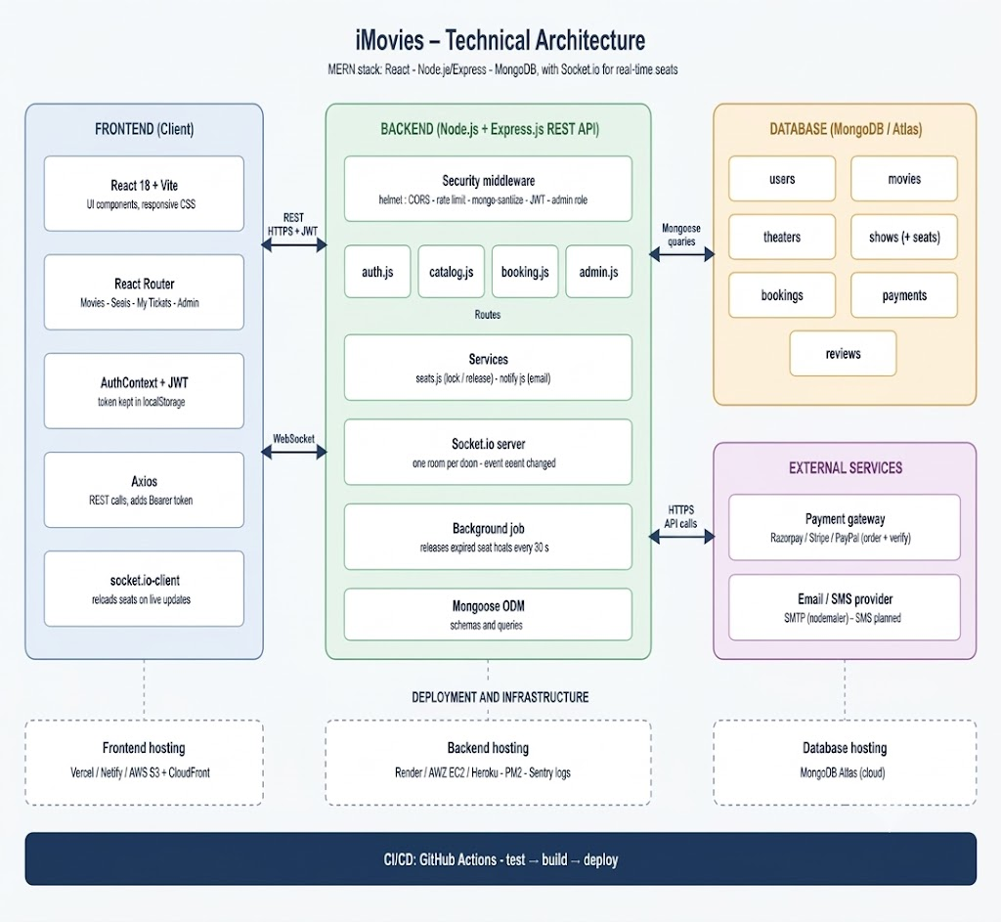
Figure 1: System architecture diagram

Frontend (React)
- Framework: React 18 with Vite for fast development and building.
- Routing: React Router v6 handles pages: Movies, Movie details, Seat selection, My tickets, Login, Admin.
- API calls: Axios with a shared instance. An interceptor adds the JWT to every request.
- State: A React Context (AuthProvider) keeps the logged-in user and token. Page-level state uses React hooks.
- Real time: socket.io-client joins a room for the open show and reloads seats when the server announces a change.
- Styling: Plain CSS with variables, responsive down to mobile, visible keyboard focus and reduced-motion support.
Page | Route | Purpose
Movies | / | Browse and filter movies
MovieDetail | /movies/:id | Details, showtimes, reviews, watchlist
Seats | /shows/:id/seats | Seat map, hold, pay
Profile | /profile | Booking history, cancellation, watchlist
Login | /login | Log in and register
Admin | /admin | Dashboard and management forms (admin only)

Backend (Node.js and Express.js)
- Framework: Express 4 REST API, organized into route files, middleware and services.
- Middleware: JWT authentication, role check for admin routes, error-handling wrapper for async routes.
- Security: helmet (secure headers), CORS limited to the client origin, express-rate-limit, express-mongo-sanitize, request size limit.
- Real time: Socket.io server with one room per show. Events: join, leave, seats:changed.
- Background job: A timer runs every 30 seconds and releases seat holds that have expired.
Service file | Responsibility
routes/auth.js | Register, login, current user
routes/catalog.js | Movies, reviews, favorites, theaters, shows
routes/booking.js | Seat locking, bookings, payments
routes/admin.js | Statistics, all bookings, users
services/seats.js | Seat release, expiry sweep, seat layout generator
services/notify.js | Email notifications

Database (MongoDB)
MongoDB stores all data. Mongoose defines the schemas below. Seats are stored inside each Show document so a single atomic update can claim a seat.
Collection | Main fields | Notes
users | name, email (unique), password (hash), role, favorites[] | role is user or admin
movies | title, genre[], language, duration, cast[], releaseDate, poster, description, rating, ratingCount | rating is the review average
theaters | name, city, screens
shows | movie, theater, screen, startTime, price, seats[{seatNo, status, lockedBy, lockExpiry}] | status: available, locked, booked
bookings | user, show, seats[], amount, status, payment | status: pending, confirmed, cancelled
payments | booking, user, amount, orderId, paymentId, status | status: paid, refund-due
reviews | user, movie, rating (1-5), comment | one review per user per movie

How seat booking works
- The user selects seats. The server claims each seat with one atomic database update, so two users cannot hold the same seat.
- The held seats are locked for 8 minutes (configurable). Other users see them as held.
- A pending booking is created with the total amount.
- On successful payment verification, the seats become booked and the booking becomes confirmed.
- If the hold expires, payment fails or the user releases the seats, they become available again.
- Every change is broadcast with Socket.io so other open seat maps refresh instantly.
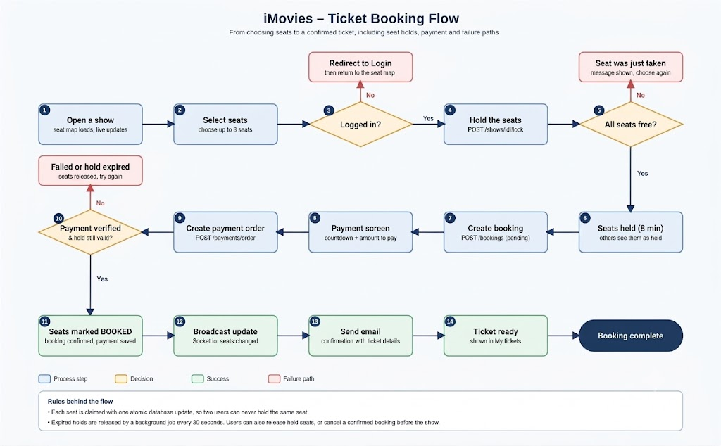
Figure 2: Booking flow diagram

4. Setup Instructions

Prerequisites
Software | Version | Purpose
Node.js | 18 or newer | Runs the backend and builds the frontend
npm | 9 or newer | Installs dependencies
MongoDB | 6 or newer (local) or a free MongoDB Atlas cluster | Database
Git | Any recent version | Clone the repository
Browser | Chrome, Edge or Firefox | Use the app

Installation
1. Clone the repository
git clone <https://github.com/harshita-singh1600/imovies-movie-booking>
cd imovies

2. Install and configure the server
cd server
npm install
cp .env.example .env # on Windows: copy .env.example .env

3. Edit server/.env
Variable | Example | Meaning
PORT | 5000 | API port
MONGO_URI | mongodb://127.0.0.1:27017/imovies | MongoDB connection string
JWT_SECRET | a long random string | Secret used to sign tokens
CLIENT_URL | http://localhost:5173 | Allowed browser origin (CORS)
SEAT_HOLD_MINUTES | 8 | How long selected seats are held
PAYMENT_MODE | mock or razorpay | Payment behavior
RAZORPAY_KEY_ID / RAZORPAY_KEY_SECRET | (from Razorpay dashboard) | Only for razorpay mode
SMTP_HOST, SMTP_PORT, SMTP_USER, SMTP_PASS, MAIL_FROM | (your mail provider) | Optional. Without SMTP, emails are printed in the console

4. Load demo data (optional but recommended)
npm run seed

This creates two users (admin@imovies.com / admin123 and user@imovies.com / user123), four movies, one theater and 36 shows. Change these passwords before any real deployment.
5. Install the client
cd ../client
npm install

The client proxies /api and /socket.io to http://localhost:5000 (see client/vite.config.js), so it needs no environment file in development.

5. Folder Structure

Client
client/
├── index.html
├── package.json
├── vite.config.js # dev server and API proxy
└── src/
├── main.jsx # app entry, router, auth provider
├── App.jsx # navigation and routes
├── api.js # Axios instance and helpers
├── auth.jsx # AuthContext (user, login, logout)
├── styles.css # all styling
└── pages/
├── Movies.jsx
├── MovieDetail.jsx
├── Seats.jsx
├── Profile.jsx
├── Login.jsx
└── Admin.jsx

Server
server/
├── server.js # app setup, security, Socket.io, DB connection
├── seed.js # demo data
├── .env.example
├── models/index.js # Mongoose schemas
├── middleware/index.js # auth, optAuth, admin, async wrapper
├── routes/
│ ├── auth.js
│ ├── catalog.js
│ ├── booking.js
│ └── admin.js
└── services/
├── seats.js
└── notify.js

6. Running the Application
Open two terminals. Start MongoDB first if you use a local database.
Part | Directory | Command | URL
Backend | server | npm start (or npm run dev for auto-restart) | http://localhost:5000
Frontend | client | npm run dev | http://localhost:5173

Note: the client uses Vite, so its start command is npm run dev. If your submission format requires npm start, add "start": "vite" to the scripts section of client/package.json and it will work the same way.
Production build of the client: run npm run build in the client directory. The output is created in client/dist.

7. API Documentation
Base URL: http://localhost:5000/api. All request and response bodies are JSON. Protected endpoints need the header Authorization: Bearer <token>. Errors return a JSON body such as {"message": "Email or password is incorrect."} with an HTTP status of 400, 401, 403, 404, 409 or 410.

7.1 Authentication
Method | Endpoint | Access | Request | Example response
POST | /auth/register | Public | Body: name, email, password (min 6) | 201 {"token":"<jwt>","user":{"id":"..","name":"Asha","email":"asha@mail.com","role":"user"}}
POST | /auth/login | Public | Body: email, password | 200 {"token":"<jwt>","user":{...}}
GET | /auth/me | Token | - | 200 {"id":"..","name":"Asha","email":"..","role":"user"}

7.2 Movies, reviews and favorites
Method | Endpoint | Access | Request | Example response
GET | /movies | Public | Query (optional): q, genre, language | 200 [{"_id":"..","title":"Orbit Kitchen","genre":["Comedy"],"language":"English","duration":102,"rating":4.5,"ratingCount":2}]
GET | /movies/:id | Public | Path: id | 200 {movie object} 404 {"message":"Movie not found."}
POST | /movies | Admin | Body: title, genre, language, duration, cast, releaseDate, description, poster | 201 {created movie}
DELETE | /movies/:id | Admin | Path: id | 200 {"ok":true}
GET | /movies/:id/reviews | Public | Path: id | 200 [{"rating":5,"comment":"Loved it","user":{"name":"Asha"}}]
POST | /movies/:id/reviews | Token | Body: rating (1-5), comment | 201 {"ok":true}
GET | /favorites | Token | - | 200 [{movie objects}]
POST | /favorites/:movieId | Token | Path: movieId (toggles) | 200 {"favorite":true}

7.3 Theaters and shows
Method | Endpoint | Access | Request | Example response
GET | /theaters | Public | - | 200 [{"_id":"..","name":"Galaxy Cinemas","city":"Raipur","screens":3}]
POST | /theaters | Admin | Body: name, city, screens | 201 {created theater}
GET | /shows | Public | Query: movie (optional). Returns upcoming shows only | 200 [{"_id":"..","startTime":"2026-10-27T13:00:00Z","price":220,"screen":2,"theater":{..},"movie":{"title":".."}}]
GET | /shows/:id | Public (token optional) | Path: id | 200 {"_id":"..","price":220,"seats":[{"seatNo":"A1","status":"available"},{"seatNo":"A2","status":"mine"},{"seatNo":"A3","status":"booked"}]}
POST | /shows | Admin | Body: movie, theater, screen, startTime, price, rows, cols | 201 {created show with generated seats}
DELETE | /shows/:id | Admin | Path: id | 200 {"ok":true}
Seat status values returned to the client: available, locked (held by someone else), mine (held by you), booked.

7.4 Seat holds, bookings and payments
Method | Endpoint | Access | Request | Example response
POST | /shows/:id/lock | Token | Body: seats ["A1","A2"] (1 to 8) | 200 {"seats":["A1","A2"],"expiresAt":"2026-10-26T10:08:00Z"} 409 {"message":"Seat A2 was just taken. Please choose another."}
POST | /shows/:id/unlock | Token | Body: seats | 200 {"ok":true}
POST | /bookings | Token | Body: showId, seats (must be held by you) | 201 {"_id":"..","status":"pending","seats":["A1","A2"],"amount":440}
GET | /bookings/me | Token | - | 200 [{"_id":"..","status":"confirmed","seats":[..],"amount":440,"show":{"startTime":"..","movie":{"title":".."},"theater":{..}}}]
DELETE | /bookings/:id | Token | Path: id (confirmed, show not started) | 200 {"ok":true}
POST | /payments/order | Token | Body: bookingId | 200 {"orderId":"mock_order_..","amount":440,"mode":"mock"}
POST | /payments/verify | Token | Body: bookingId, orderId, paymentId, signature (razorpay mode) | 200 {booking with status "confirmed"} 410 {"message":"Your seat hold expired before payment completed. Please book again."}

7.5 Admin
Method | Endpoint | Access | Request | Example response
GET | /admin/stats | Admin | - | 200 {"users":2,"movies":4,"theaters":1,"shows":36,"bookings":3,"revenue":1100}
GET | /admin/bookings | Admin | - | 200 [latest 50 bookings with user and movie]
GET | /admin/users | Admin | - | 200 [users without passwords]

7.6 Real-time events (Socket.io)
Event | Direction | Meaning
join (showId) | Client to server | Subscribe to seat changes for a show
leave (showId) | Client to server | Unsubscribe
seats:changed | Server to client | Seats were held, booked or released. The client reloads the seat map

8. Authentication and Authorization

Authentication
- Passwords are hashed with bcrypt (10 salt rounds) before they are stored. Plain passwords are never saved or returned.
- After login or registration the server signs a JSON Web Token (JWT) with JWT_SECRET. The token contains the user id and role and expires in 7 days.
- The client stores the token in localStorage and sends it in the Authorization: Bearer header on every request through an Axios interceptor.
- The server verifies the token in the auth middleware. Invalid or missing tokens receive 401 and the client shows the login page.
- On page refresh, the client calls GET /auth/me to restore the session. The API is stateless, so no server-side sessions are used.

Authorization
Role | Can do
Visitor | Browse movies, showtimes, seat availability and reviews
User | Everything a visitor can, plus hold seats, book, pay, cancel own bookings, write reviews, manage own watchlist
Admin | Everything a user can, plus manage movies, theaters and shows, and view statistics, all bookings and users (admin middleware returns 403 otherwise)

Other protections
- HTTPS should be enabled in production.
- Rate limiting: 600 requests per 15 minutes per IP on the API and 40 on login/register.
- Input checks and Mongo sanitization against NoSQL injection. Regex input from search is escaped.
- CORS restricted to CLIENT_URL; helmet adds secure HTTP headers.
- Payment signatures are verified on the server in Razorpay mode.
- Users can only read or change their own bookings.

9. User Interface
Add a screenshot for each screen below. Use a browser window of about 1280 px width, and one mobile-size capture if you can. In Word, click inside a box, delete the placeholder text and use Insert > Pictures.
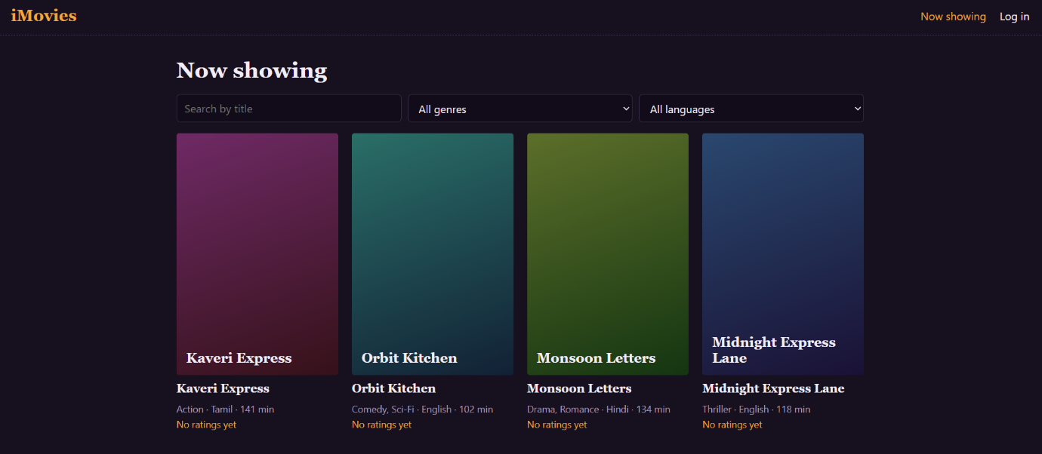
Figure 3: Home: movie list with search and filters
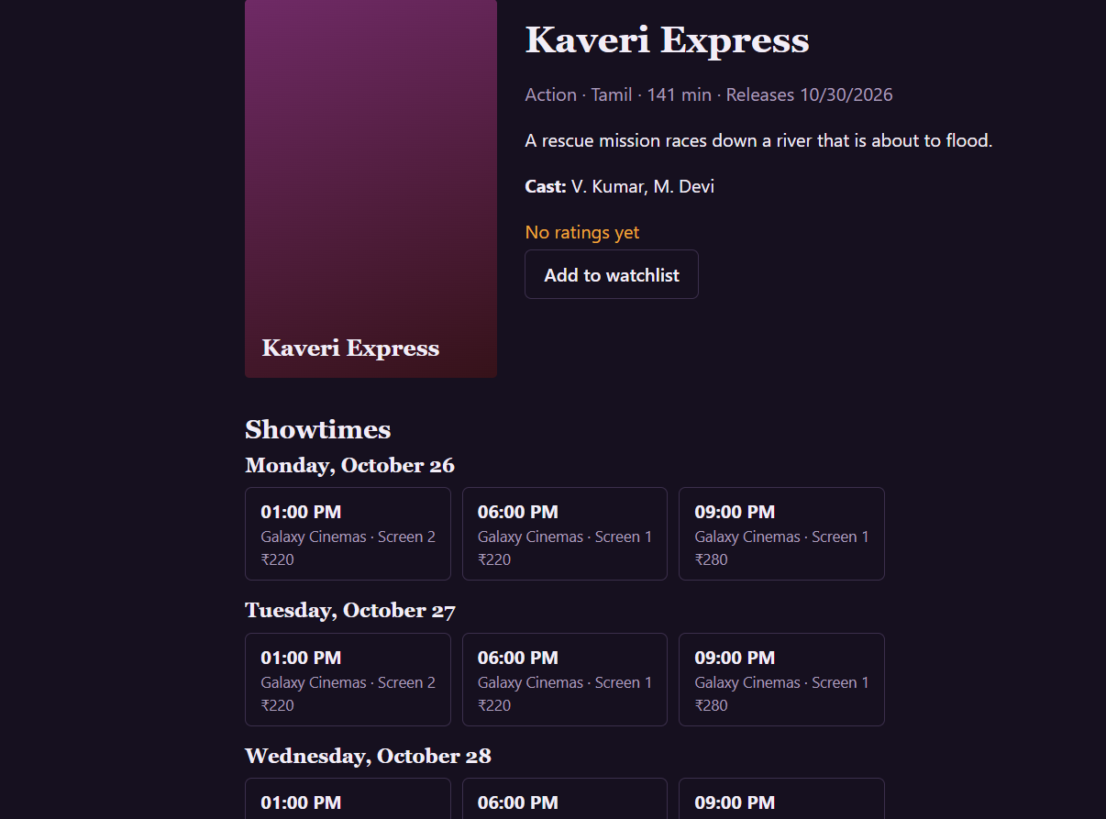
Figure 4: Movie details with showtimes and reviews
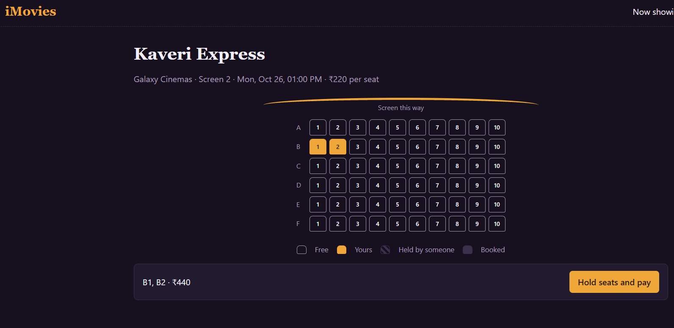
Figure 5: Seat selection showing free, held, selected and booked seats
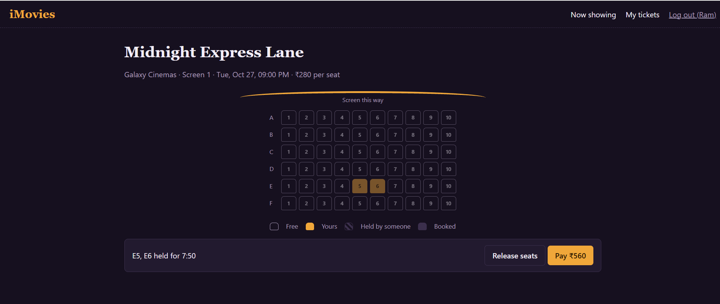
Figure 6: Payment step with the hold countdown
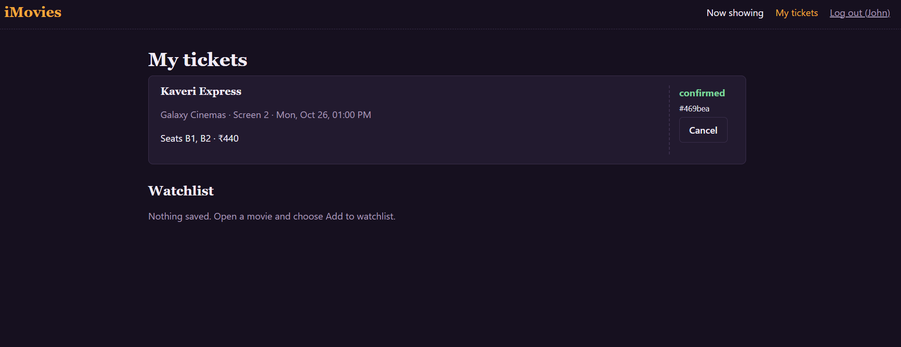
Figure 7: My tickets: booking history and watchlist
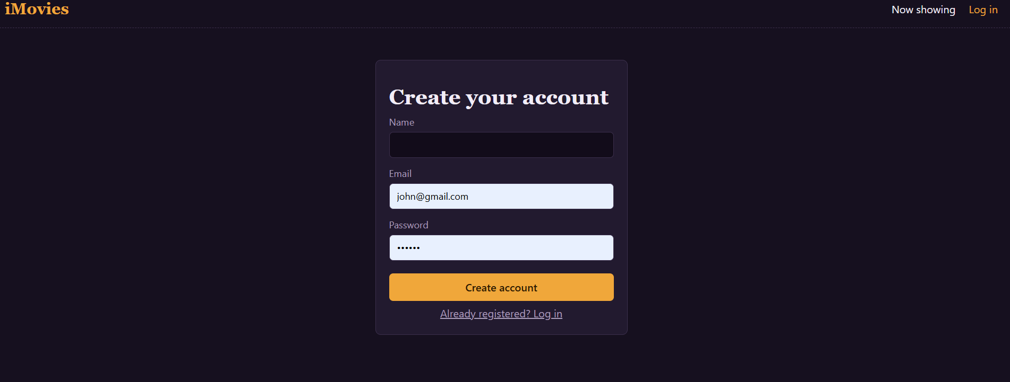
Figure 8: Login and registration
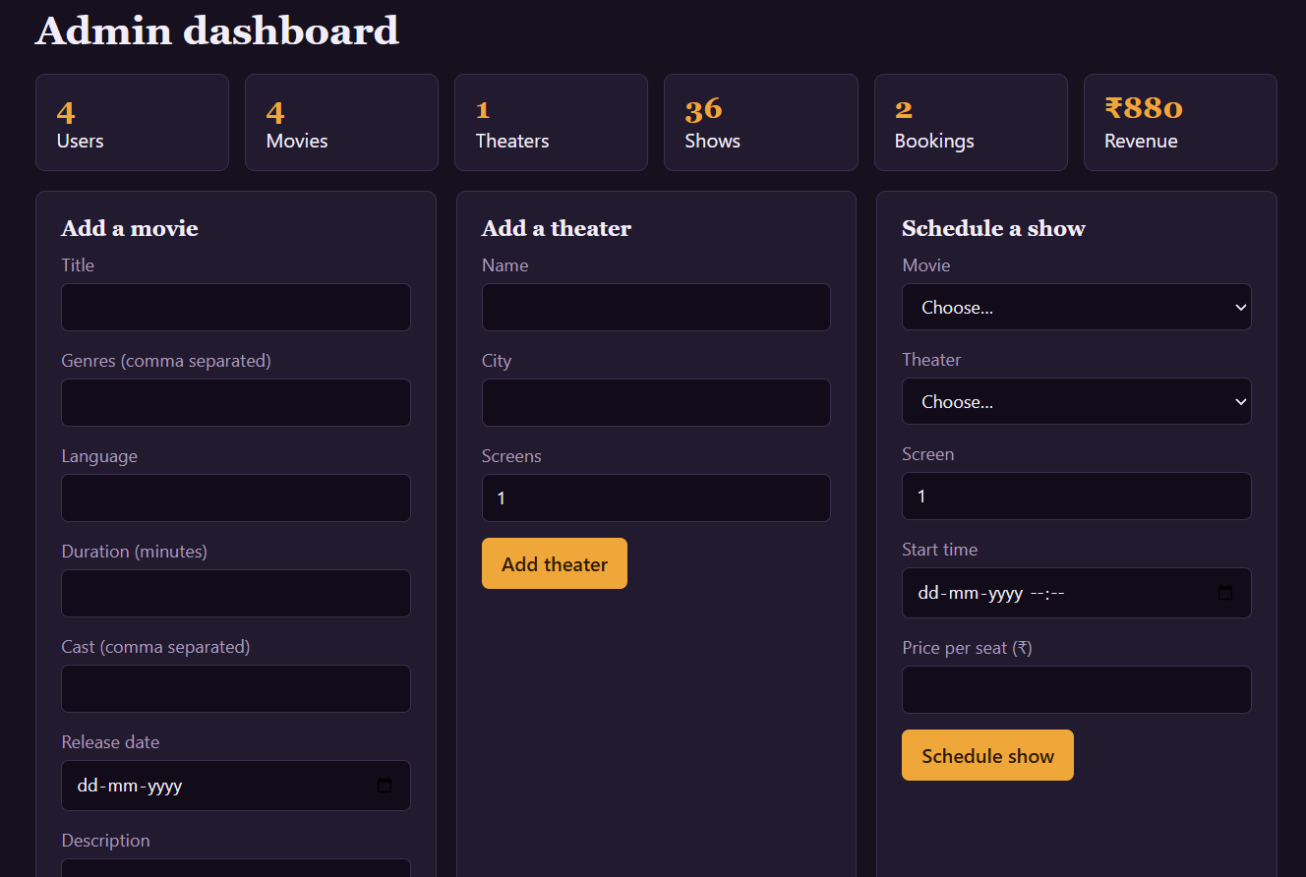
Figure 9: Admin dashboard
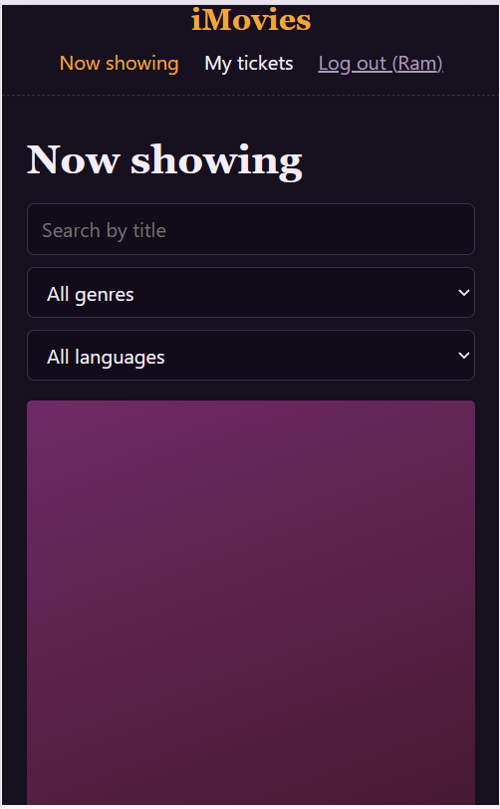
Figure 10: Mobile view

10. Testing

Strategy
The project currently includes manual functional testing. Automated tests are not included yet. The recommended strategy for further work:
Level | Tool | What to test
API / integration | Jest + Supertest + mongodb-memory-server | Auth, seat locking race conditions, booking and payment verification, admin access
Frontend components | Vitest + React Testing Library | Seat map selection, forms, route guards
Manual API checks | Postman or Thunder Client | Every endpoint in Section 7
End-to-end | Playwright or Cypress | Register, choose seats, pay, see ticket

Manual test cases
Fill the Result column after running each case.
ID | Test case | Expected result | Result
T1 | Register with a new email | Account created, user logged in
T2 | Register with an existing email | 409 message: email already registered
T3 | Log in with a wrong password | 401 message shown, no token stored
T4 | Search and filter movies | List updates to matching movies
T5 | Select seats and continue as a visitor | Redirected to login
T6 | Hold seats, then open the same show in a second browser | Seats appear as held, not selectable
T7 | Two users hold the same seat at the same time | Only one succeeds, the other gets 409
T8 | Wait for the hold to expire | Seats become available again, countdown ends with a message
T9 | Pay for held seats | Booking confirmed, seats booked, email logged
T10 | Cancel a confirmed booking | Seats become available, status cancelled
T11 | Open /admin as a normal user | Redirected to home; API returns 403
T12 | Admin adds a movie, theater and show | They appear on the site, seats generated
T13 | Post a review | Review listed, movie average updated
T14 | Add and remove a watchlist item | Watchlist updates on My tickets page

11. Demo

Item | Link
Demo video | https://drive.google.com/drive/folders/1gskg_JlwGnd2ZKt3qDrE9Y_mKk3f_1en?usp=sharing
GitHub repository | https://github.com/harshita-singh1600/imovies-movie-booking

12. Known Issues
Issue | Impact | Planned fix
Payment mode "mock" confirms without charging. In razorpay mode the order and signature check are implemented on the server, but the Razorpay Checkout window is not added to the client. | No real payments yet | Add Checkout script and webhook
SMS notifications are not implemented. Email works only when SMTP is configured. | Email only | Add an SMS provider such as Twilio
Refunds are not processed. Cancelling marks the payment as refund-due. | Manual refund needed | Call the gateway refund API
Rescheduling a booking is not implemented (cancel and rebook instead). | Extra steps for users | Add reschedule endpoint
The JWT is stored in localStorage, which is exposed if the site has an XSS flaw. | Security trade-off | Move to httpOnly cookies
No password reset, email verification or account lockout. | Account recovery missing | Add reset flow
No automated tests yet. The code was syntax-checked but needs a full manual test run. | Bugs may remain | Add tests listed in Section 10
Multi-seat holds are claimed one seat at a time (rolled back on failure), not in a database transaction. | Very rare partial states under heavy load | Use a transaction on a replica set
Movie posters are shown from a URL or a generated placeholder. Image upload is not supported. | Limited visuals | Add upload to cloud storage
Lists (movies, bookings) are not paginated. Seat layout defaults to 6 rows by 10 seats. | Slower with large data | Add pagination and layout editor

13. Future Enhancements
- Real payments: Razorpay Checkout, webhooks, automatic refunds and invoices (PDF).
- QR-code tickets: Generate a QR code per booking and a scanner page for theater staff.
- Recommendations: Suggest movies from watchlist, genres and past bookings.
- Food and beverage pre-order: Add snacks to a booking.
- Offers: Coupons, wallet and loyalty points.
- Theater owner role: Separate dashboards for each theater, with revenue reports and charts.
- Seat map editor: Custom layouts, premium and recliner categories with different prices.
- Notifications: SMS and push reminders before the show and alerts for upcoming releases.
- Mobile app: React Native app sharing the same API.
- Performance and reliability: Redis for seat holds, pagination, caching, Docker setup and CI/CD with GitHub Actions.
- Accessibility and languages: Screen-reader seat labels, multi-language interface.
- Testing: Full automated unit, API and end-to-end test coverage.

