GUI-Booking.com

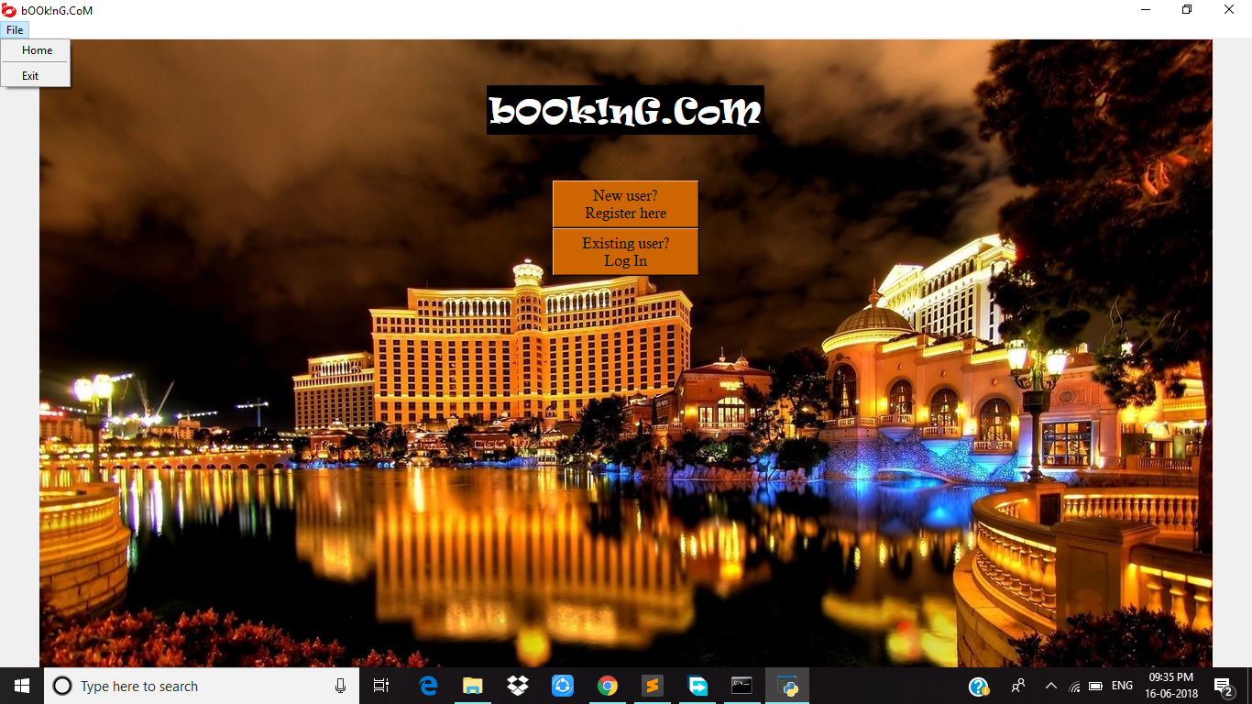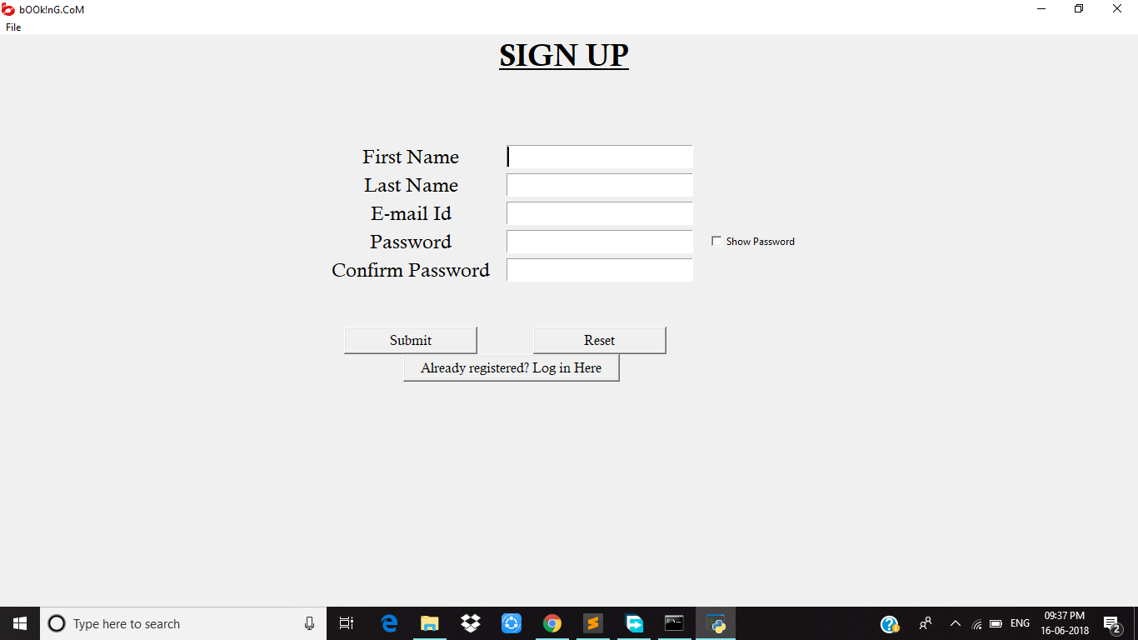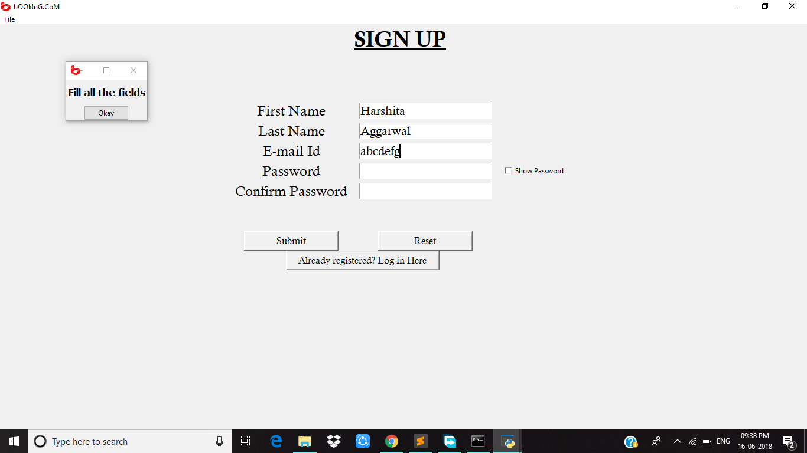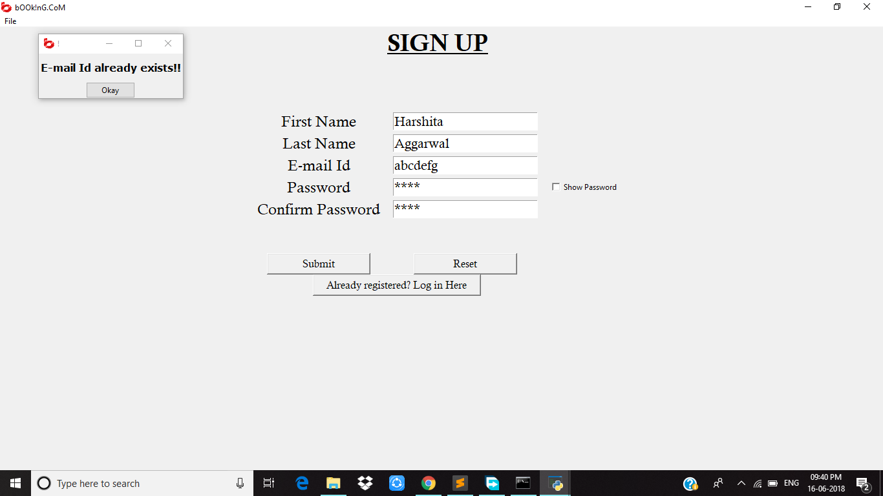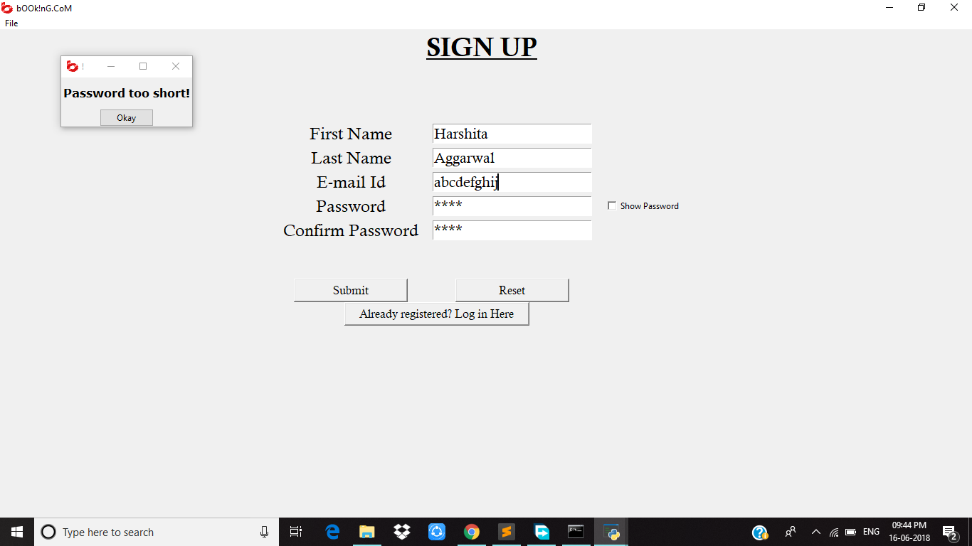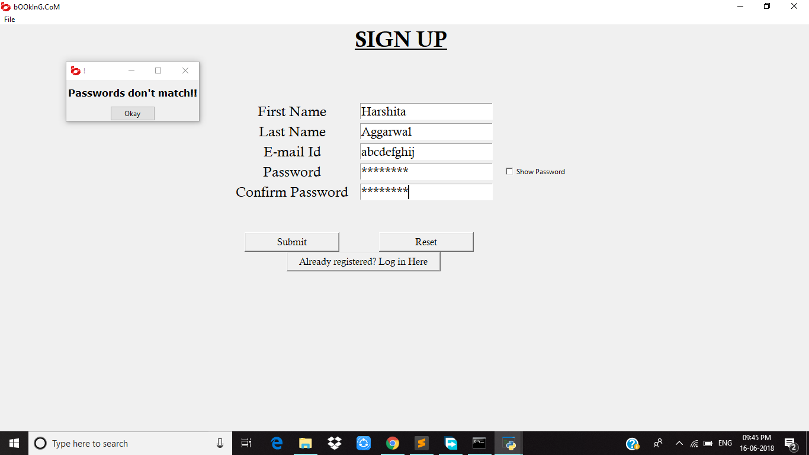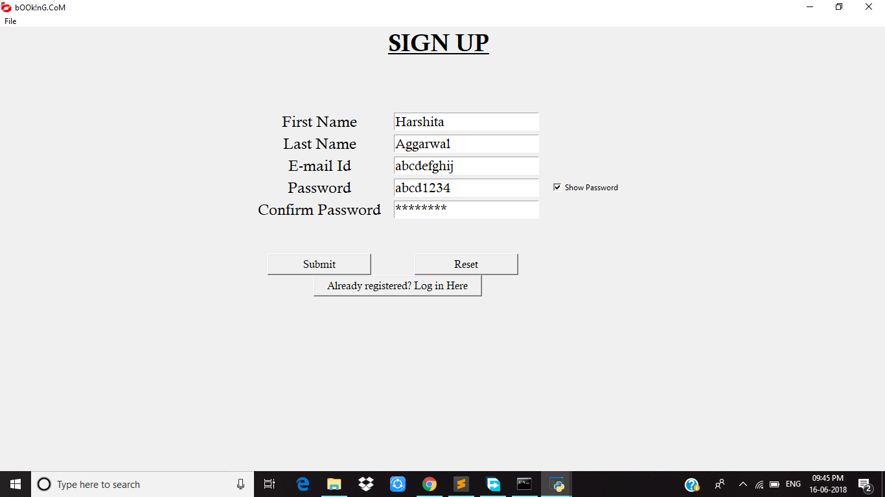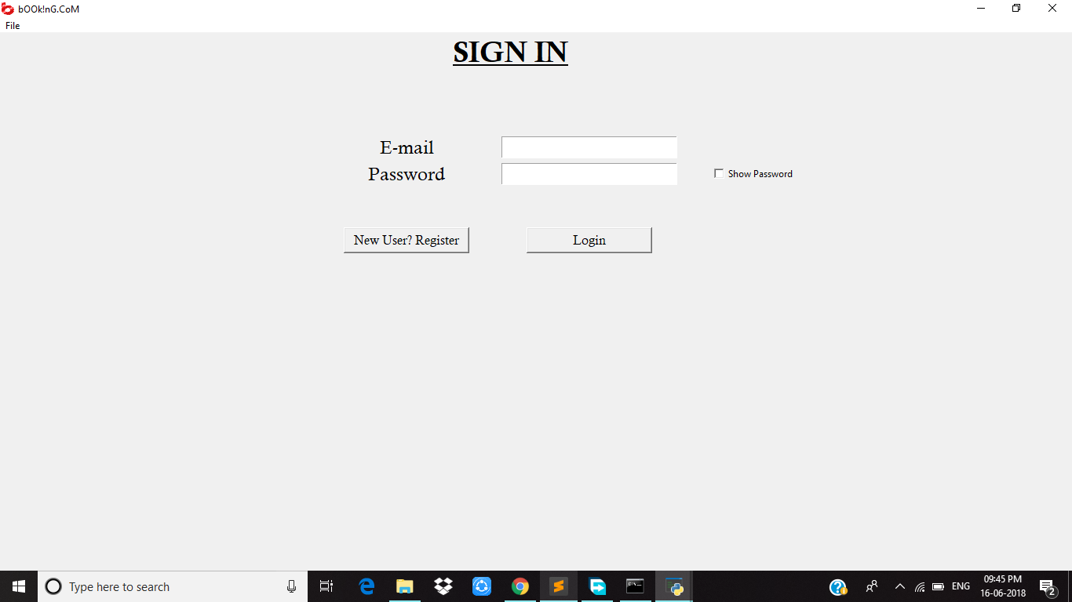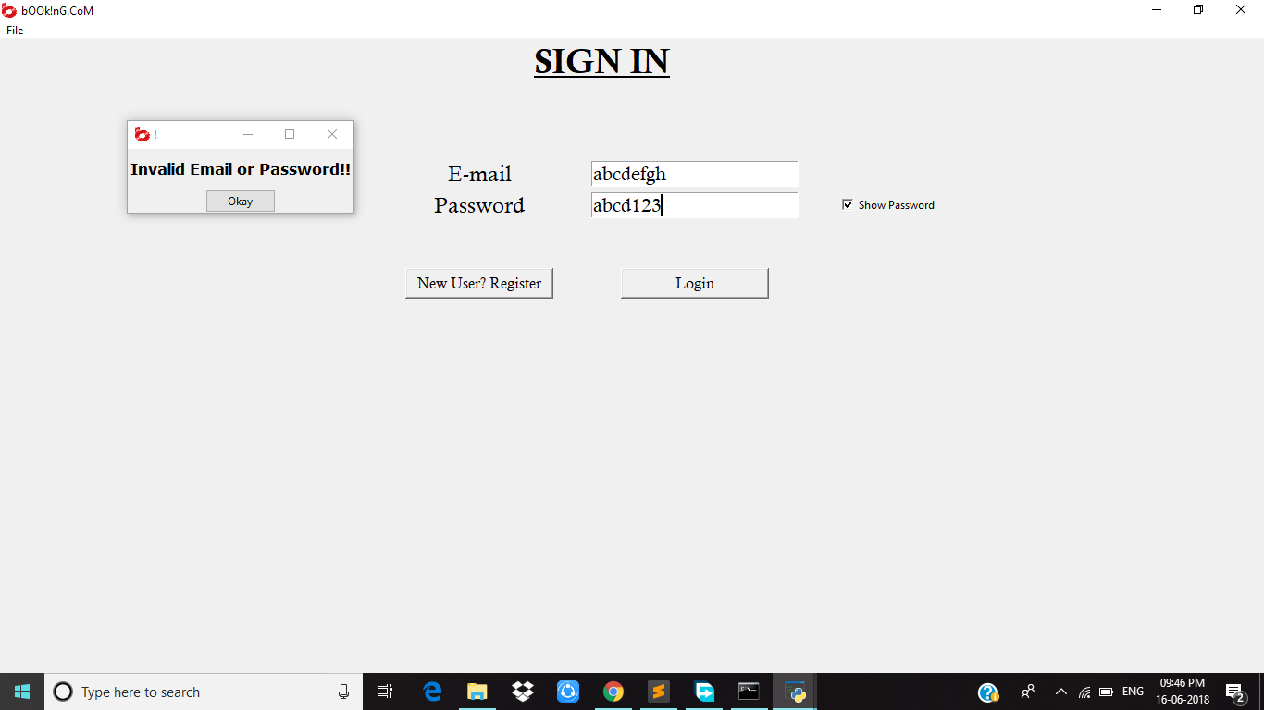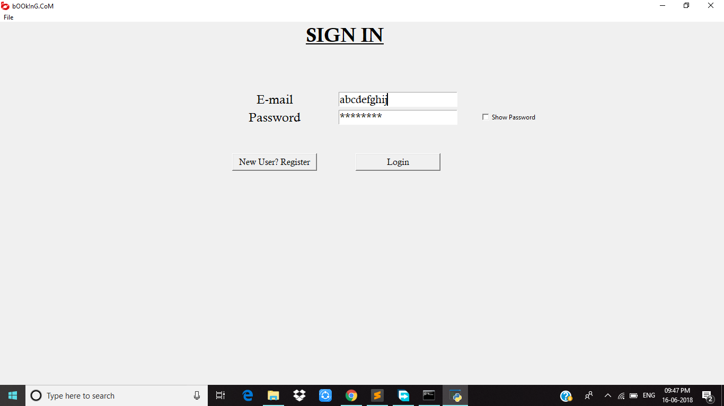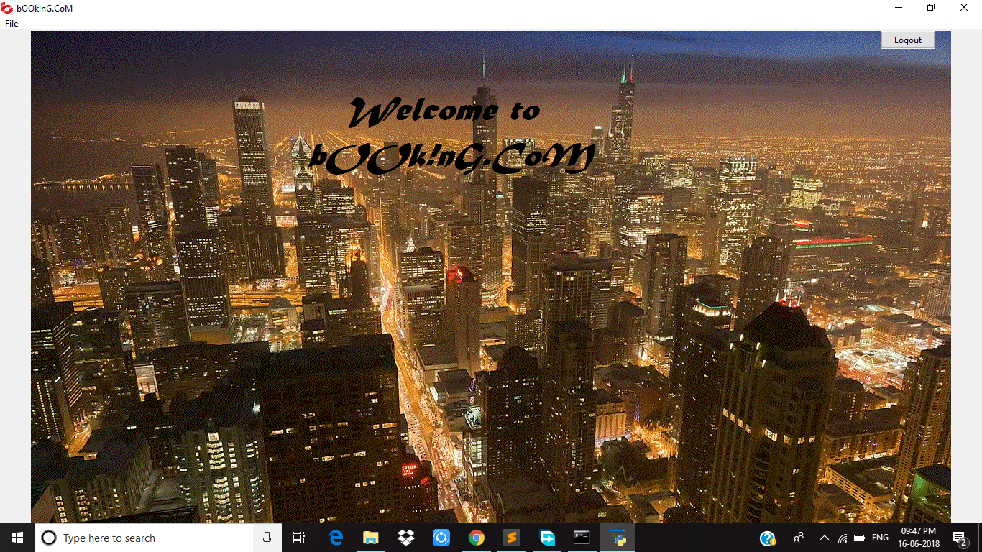

**CODE:**

import tkinter as tk

from tkinter import ttk

from tkinter import Entry, Toplevel, Canvas

from tkinter import Frame, Entry, Radiobutton, Checkbutton, Text, Listbox, Tk, Label, StringVar,Menu,IntVar

# import tkMessageBox as messagebox

from PIL import Image, ImageDraw, ImageTk, ImageFont

import json

import pickle

class bookingApp(Tk):

def __init__(self,*args,**kwargs):

Tk.__init__(self,*args,**kwargs)

Tk.wm_title(self,"bOOk!nG.CoM")

Tk.iconbitmap(self,"logo.ico")

container = Frame(self)

container.pack(side="top",fill="both",expand = True)

container.grid_rowconfigure(0,weight=1)

container.grid_columnconfigure(0,weight=1)

menubar = Menu(container)

filemenu = Menu(menubar,tearoff=0)

filemenu.add_command(label="Home", command = lambda: self.show_frame(StartPage))

filemenu.add_separator()

filemenu.add_command(label="Exit", command=quit)

menubar.add_cascade(label="File", menu=filemenu)

Tk.config(self, menu=menubar)

self.frames={}

for F in (StartPage,RegisterPage,LoginPage,WelcomePage):

frame = F(container,self)

self.frames[F] = frame

frame.grid(row=0, column=0, sticky="nsew")

self.show_frame(StartPage)

def show_frame(self,cont):

frame = self.frames[cont]

frame.tkraise()

class StartPage(tk.Frame):

def __init__(self,parent,controller):

tk.Frame.__init__(self,parent)

image = Image.open("bg2.jpg")

background_image=ImageTk.PhotoImage(image)

background_label = Label(self, image=background_image)

background_label.place(x=0, y=0, relwidth=1, relheight=1)

background_label.image = background_image

label1 = Label(self,text="bOOk!nG.CoM",font=("Ravie",26),bg="black",fg="white")

label1.pack(padx=10,pady=50)

text1 = "New user?\nRegister here"

button1 = tk.Button(self, text=text1,font=("Calisto MT",12),command = lambda: controller.show_frame(RegisterPage),activebackground="white",

relief=tk.RAISED,width = 15,bg="darkorange3")

button1.pack()

text2 = "Existing user?\nLog In"

button2 = tk.Button(self, text=text2,font=("Calisto MT",12), command=lambda: controller.show_frame(LoginPage), activebackground="white",

relief=tk.RAISED,width = 15,bg="darkorange3")

button2.pack()

class RegisterPage(tk.Frame):

def __init__(self,parent,controller):

Frame.__init__(self,parent)

rows=0

while rows<50:

# self.grid_rowconfigure(rows,weight=6)

self.grid_columnconfigure(rows,weight=1)

rows+=1

label = Label(self,text="SIGN UP",font=("Calisto MT",28,"bold","underline"),bg="gray94",fg="black")

label.grid(row=0,column=23,columnspan=3,rowspan=3)

Label(self,text="\n\n\n\n").grid(row=3)

label1 = Label(self, text="First Name",font=("Calisto MT",18))

label1.grid(row=6,column=23)

label2 = Label(self, text="Last Name",font=("Calisto MT",18))

label2.grid(row=7,column=23)

Label(self, text="E-mail Id",font=("Calisto MT",18)).grid(row=8,column=23)

Label(self, text="Password",font=("Calisto MT",18)).grid(row=9,column=23)

Label(self, text="Confirm Password",font=("Calisto MT",18)).grid(row=10,column=23)

e1 = Entry(self,font=("Calisto MT",16))

e2 = Entry(self,font=("Calisto MT",16))

e1.grid(row=6, column=24)

e2.grid(row=7, column=24)

e3 = Entry(self,font=("Calisto MT",16))

e3.grid(row=8, column=24)

ep1= Entry(self,font=("Calisto MT",16),show="*")

ep1.grid(row=9, column=24)

ep2=Entry(self,font=("Calisto MT",16),show="*")

ep2.grid(row=10, column=24)

dict_ent = {"FirstName":e1,"LastName":e2,"E-mail":e3,"Password":ep1,"ConfPassword":ep2}

var1 = IntVar()

cb1 = Checkbutton(self, text="Show Password",variable=var1,command=lambda:cb_change(var1,ep1))

cb1.grid(row=9, column=25)

Label(self,text="\n\n").grid(row=11)

button1 = tk.Button(self, text="Submit",font=("Calisto MT",12),command = lambda: self.reg_status(controller,dict_ent),

activebackground="light cyan",relief=tk.RAISED,width = 15)

button1.grid(row=13,column=23)

button2 = tk.Button(self, text="Reset",font=("Calisto MT",12),command = lambda: reset_field([e1,e2,e3,ep1,ep2]),activebackground="light cyan",

relief=tk.RAISED,width = 15)

button2.grid(row=13,column=24)

button2 = tk.Button(self, text="Already registered? Log in Here",font=("Calisto MT",12),command = lambda: [controller.show_frame(LoginPage),reset_field([e1,e2,e3,ep1,ep2])],activebackground="light cyan",

relief=tk.RAISED,width = 25)

button2.grid(row=14,column=23,columnspan=2)

def reg_status(self,controller,dict_ent):

dict_out = {}

jsonObj = []

dict_out = collect_ent(dict_ent)

for key in dict_out:

if dict_out[key] =="":

popupmsg("Fill all the fields")

return

varE = self.exist_email(dict_out)

if(varE==1):

popupmsg("E-mail Id already exists!!")

return

if(len(dict_out["Password"])<8):

popupmsg("Password too short!")

return

if(dict_out["Password"]!=dict_out["ConfPassword"]):

popupmsg("Passwords don't match!!")

return

else:

jsonObj.append(dict_out)

fw = open("database.txt","a")

fw.write(json.dumps(jsonObj))

fw.write("\n")

fw.close()

controller.show_frame(LoginPage)

ent_lst=[]

for key in dict_ent:

ent_lst.append(dict_ent[key])

reset_field(ent_lst)

# fr.close()

def exist_email(self,dict_):

lst = read_filejson()

for dict1 in lst:

if dict1['E-mail']==dict_['E-mail']:

return 1

return 0

class LoginPage(tk.Frame):

def __init__(self,parent,controller):

Frame.__init__(self,parent)

rows=0

while rows<21:

# self.grid_rowconfigure(rows,weight=6)

self.grid_columnconfigure(rows,weight=1)

rows+=1

label = Label(self,text="SIGN IN",font=("Calisto MT",28,"bold","underline"),bg="gray94",fg="black")

label.grid(row=0,column=10,columnspan=2,rowspan=3)

Label(self,text="\n\n\n\n").grid(row=3)

label1 = Label(self, text="E-mail",font=("Calisto MT",18))

label1.grid(row=6,column=10)

label2 = Label(self, text="Password",font=("Calisto MT",18))

label2.grid(row=7,column=10)

e1 = Entry(self,font=("Calisto MT",16))

e2 = Entry(self,font=("Calisto MT",16),show="*")

e1.grid(row=6, column=11)

e2.grid(row=7, column=11)

ldict_ent = {"E-mail":e1,"Password":e2}

var1 = IntVar()

cb1 = Checkbutton(self, text="Show Password",variable=var1,command=lambda:cb_change(var1,e2))

cb1.grid(row=7, column=12)

Label(self,text="\n\n").grid(row=8)

button1 = tk.Button(self, text="Login",font=("Calisto MT",12),command =lambda: self.log_status(controller,ldict_ent),activebackground="light cyan",

relief=tk.RAISED,width = 15)

button1.grid(row=10,column=11)

button2 = tk.Button(self, text="New User? Register",font=("Calisto MT",12),command = lambda: controller.show_frame(RegisterPage),activebackground="light cyan",

relief=tk.RAISED,width = 15)

button2.grid(row=10,column=10)

def log_status(self,controller,ent):

dict_out = {}

dict_out = collect_ent(ent)

# print(dict_out)

for key in dict_out:

if dict_out[key] =="":

popupmsg("Incomplete Fields!!")

return

varE = self.match_det(dict_out)

if(varE==0):

popupmsg("Invalid Email or Password!!")

return

else:

controller.show_frame(WelcomePage)

ent_lst=[]

for key in ent:

ent_lst.append(ent[key])

reset_field(ent_lst)

def match_det(self,dict_):

lst = read_filejson()

# print(dict_)

for dict1 in lst:

# print(dict1)

if dict1['E-mail']==dict_['E-mail']:

if dict1['Password']==dict_['Password']:

return 1

return 0

class WelcomePage(tk.Frame):

def __init__(self,parent,controller):

Frame.__init__(self,parent)

rows=0

image = Image.open("bg3.gif")

background_image=ImageTk.PhotoImage(image)

background_label = Label(self, image=background_image)

background_label.place(x=0, y=0, relwidth=1, relheight=1)

background_label.image = background_image

rows=0

while rows<10:

# self.grid_rowconfigure(rows,weight=6)

self.grid_columnconfigure(rows,weight=1)

rows+=1

button1 = ttk.Button(self, text="Logout",command = lambda: controller.show_frame(StartPage))

button1.grid(row=0,column=9)

def quit():

app.destroy()

def reset_field(lst):

for ent in lst:

ent.delete(0,tk.END)

def popupmsg(msg):

popup = Tk()

def leavemini():

popup.destroy()

popup.wm_title("!")

popup.iconbitmap("logo.ico")

label = Label(popup,text=msg,font=("Verdana",12,"bold"))

label.pack(side="top",fill="x",pady=10)

button1 = ttk.Button(popup,text="Okay",command=leavemini)

button1.pack()

popup.mainloop()

def cb_change(var1,ep1):

if(var1.get()):

ep1.config(show="")

else:

ep1.config(show="*")

def collect_ent(dict):

dict_temp = {}

for key in dict:

dict_temp[key] = dict[key].get()

return dict_temp

def read_filejson():

lst = []

fr = open("database.txt","r")

for line in fr:

data = json.loads(line)

# dict1 = data[0]

# print(data[0])

lst.append(data[0])

fr.close()

return lst

app=bookingApp()

app.geometry("1280x720")

app.mainloop()