**Department of Electronics & Communication**

**Engineering**

Bharati Vidyapeeth

(Deemed to be University)

College of Engineering,

Pune – 411043

**Academic Year: 2022-23**

**Project Based Learning Report**

on

**Implement of OSPF Routing Protocol usnig Cisco Packet Tracer**

Submitted in the partial fulfillment of the requirements

For the Project based learning in (**Computer Communication Network**)

in

Electronics & Communication Engineering

By

**2014111074 Harshita kumari**

**2014111070 Rahul Kumar**

**2014111037 Prakriti Deep**

Under the guidance of Course In-charge

Prof. Dr. Tanuja Dhope

Department of Electronics & Communication Engineering

Bharati Vidyapeeth

(Deemed to be University)

College of Engineering,

Pune – 4110043

**Academic Year: 2022-23**

**Bharati Vidyapeeth**

**(Deemed to be University)**

**College of Engineering,**

**Pune – 411043**

**DEPARTMENT OF ELECTRONICS & COMMUNICATION ENGINEERING**

**CERTIFICATE**

Certified that the Project Based Learning report entitled, “**Implement of OSPF Routing Protocol usnig Cisco Packet Tracer”** is work by

**2014111074 Harshita kumari**

**2014111070 Rahul Kumar**

**2014111037 Prakriti Deep**

in partial fulfillment of the requirements for the award of credits for Project Based Learning (PBL) in **Computer Communication Network** of Bachelor of Technology Semester VI, in Electronics and communication engineering.

**Date:**

**Dr. Tanuja Dhope Dr. Arundhati A. Shinde**

**Course In-charge Professor & Head**

|  |  |  |
| --- | --- | --- |
| Sr no | Topics | Page number |
| 1. | Description/Problem Statement of the project Based Learning: | 5 to 6 |
| 3. | Configure in Cisco Packet Tracer | 9 to 8 |
| 4. | Results and Analysis with photograph | 8 to 9 |
| 5. | Conclusion & Outcome | 9 |

**Chapter 1**

**Description of the project Based Learning:**

OSPF Protocol

The OSPF stands for **Open Shortest Path First**. It is a widely used and supported routing protocol. It is an intradomain protocol, which means that it is used within an area or a network. It is an interior gateway protocol that has been designed within a single autonomous system. It is based on a link-state routing algorithm in which each router contains the information of every domain, and based on this information, it determines the shortest path. The goal of routing is to learn routes. The OSPF achieves by learning about every router and subnet within the entire network. Every router contains the same information about the network. The way the router learns this information by sending LSA (Link State Advertisements). These LSAs contain information about every router, subnet, and other networking information. Once the LSAs have been flooded, the OSPF stores the information in a link-state database known as LSDB. The main goal is to have the same information about every router in an LSDBs.

OSPF Areas

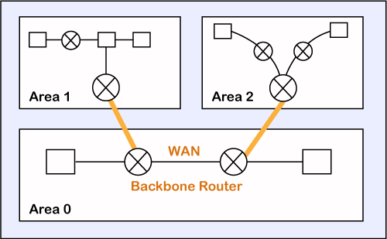

OSPF divides the autonomous systems into areas where the area is a collection of networks, hosts, and routers. Like internet service providers divide the internet into a different autonomous system for easy management and OSPF further divides the autonomous systems into Areas.

Routers that exist inside the area flood the area with routing information

In Area, the special router also exists. The special routers are those that are present at the border of an area, and these special routers are known as Area Border Routers. This router summarizes the information about an area and shares the information with other areas.

All the areas inside an autonomous system are connected to the backbone routers, and these backbone routers are part of a primary area. The role of a primary area is to provide communication between different areas.

### Types of links in OSPF

A link is basically a connection, so the connection between two routers is known as a link.

**There are four types of links in OSPF:**

1. **Point-to-point link:** The point-to-point link directly connects the two routers without any host or router in between.
2. **Transient link:** When several routers are attached in a network, they are known as a transient link.  
   The transient link has two different implementations:  
   Unrealistic topology: When all the routers are connected to each other, it is known as an unrealistic topology.  
   Realistic topology: When some designated router exists in a network then it is known as a realistic topology. Here designated router is a router to which all the routers are connected. All the packets sent by the routers will be passed through the designated router.
3. **Stub link:** It is a network that is connected to the single router. Data enters to the network through the single router and leaves the network through the same router.
4. **Virtual link:** If the link between the two routers is broken, the administration creates the virtual path between the routers, and that path could be a long one also.

### OSPF States

**The device running the OSPF protocol undergoes the following states:**

* **Down:** If the device is in a down state, it has not received the HELLO packet. Here, down does not mean that the device is physically down; it means that the OSPF process has not been started yet.
* **Init:** If the device comes in an init state, it means that the device has received the HELLO packet from the other router.
* **2WAY:** If the device is in a 2WAY state, which means that both the routers have received the HELLO packet from the other router, and the connection gets established between the routers.
* **Exstart:** Once the exchange between the routers get started, both the routers move to the Exstart state. In this state, master and slave are selected based on the router's id. The master controls the sequence of numbers, and starts the exchange process.
* **Exchange:** In the exchange state, both the routers send a list of LSAs to each other that contain a database description.
* **Loading:** On the loading state, the LSR, LSU, and LSA are exchanged.
* **Full:** Once the exchange of the LSAs is completed, the routers move to the full state.

Why we use ospf:

[Open shortest path first](https://commonerrors.blogspot.com/2012/07/ospf-design-guide-open-shortest-path.html) is design for replacement of RIP and support large and most complex networks. The most recent version of OSPF is version 3 that is defined is RFC 2740, which also have the IPv6 support. OSPF is open standard protocol, you can run OSPF among any vender.

OSPF has the following key advantages:

* Compared with distance-vector routing protocols such as the Routing Information Protocol (RIP), OSPF is more suitable for serving large, heterogeneous internetworks. OSPF can recalculate the routes in a short amount of time when the network topology changes.
* With OSPF, you can divide an Autonomous System (AS) into areas and keep area topologies separate to decrease the OSPF routing traffic and the size of the link-state database of each area.
* OSPF provides equal-cost multipath routing. You can add duplicate routes to the TCP stack using different next hops.

**Chapter 2**

**Configure in Cisco Packet Tracer**

To configure an open shortest path first protocols in Cisco Packet Tracer, you can follow the steps below:

1. Open Cisco Packet Tracer and create a new network topology.
2. Next, add two PCs to the topology by selecting "End Devices" and then "PC." Place the PCs on the topology.
3. Next we connect switch to the pc and then connect three router to the switch .
4. After the connection we change the ip address default gateway address of pc1 and pc2, then we change the ip configuration of router 0 and router 2 and then we go to the cli command and apply ospf command

Step 1: show the network

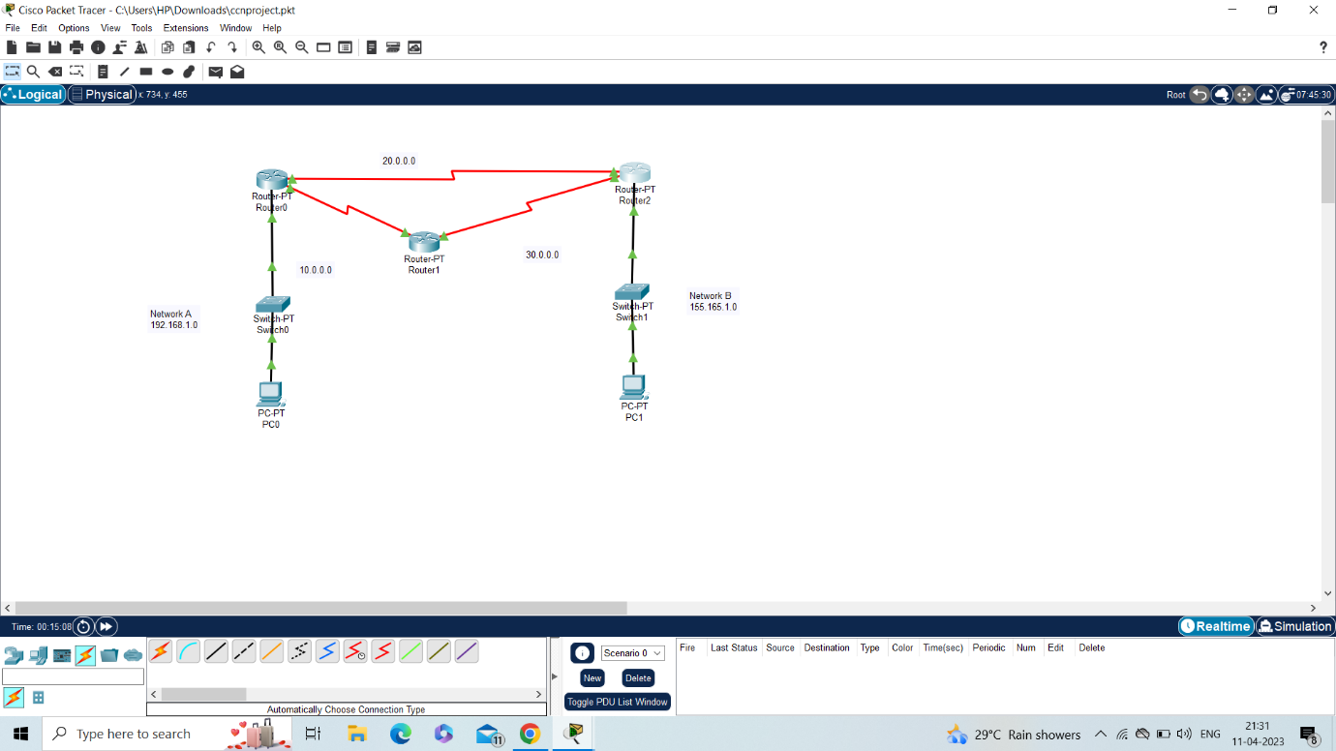

Step 2:show the change of ip address and default gateway address of PC0 and PC1

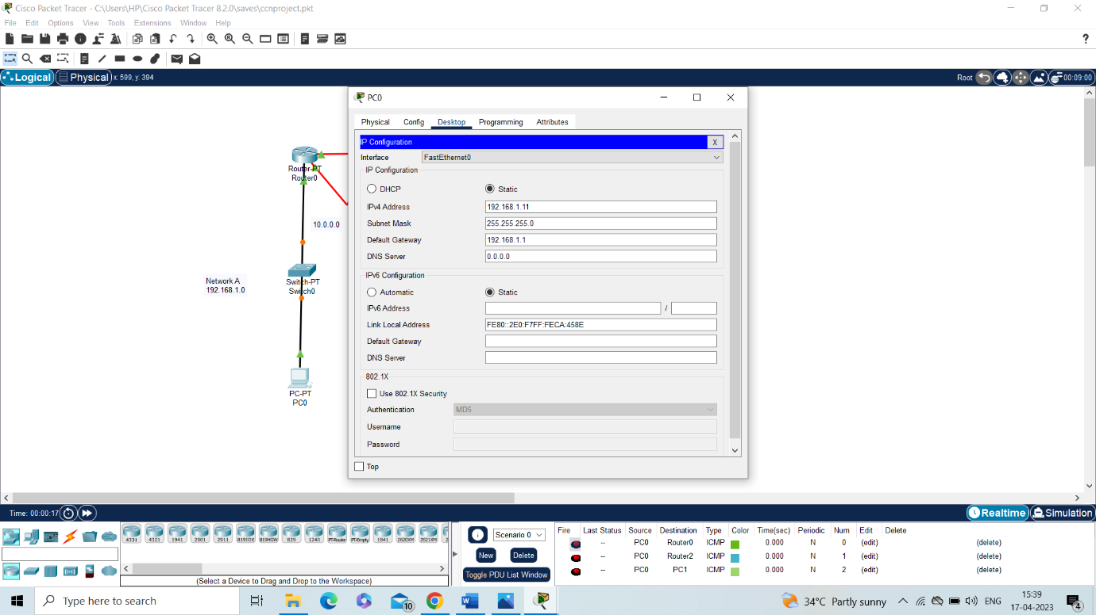

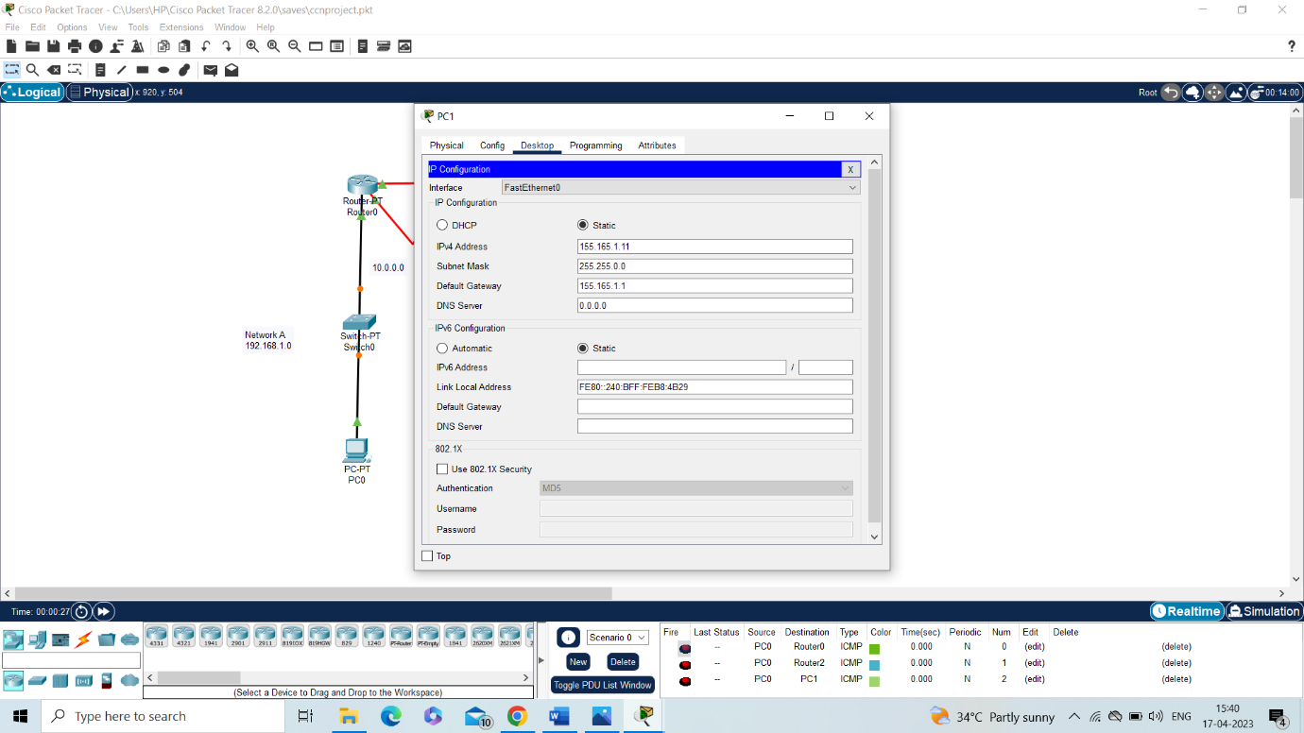

Step 3: shown change of ip configuration of router0, router1, router2 of fast ethernet and serial connection

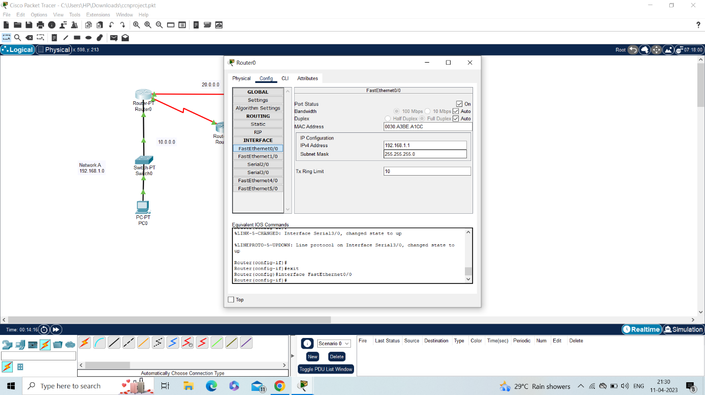

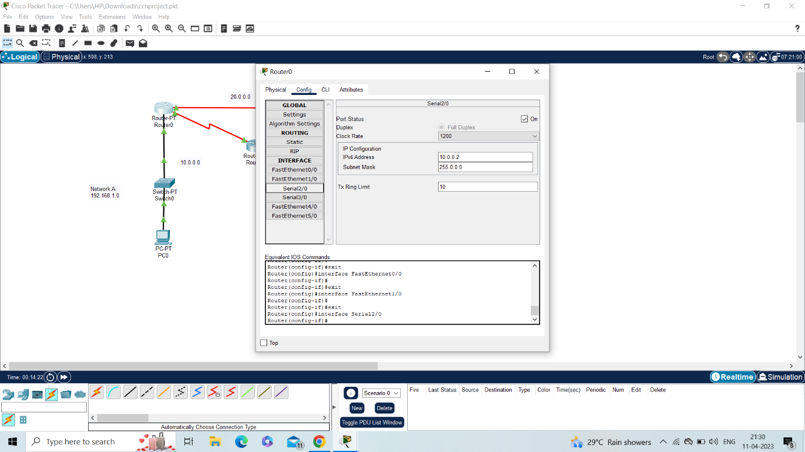

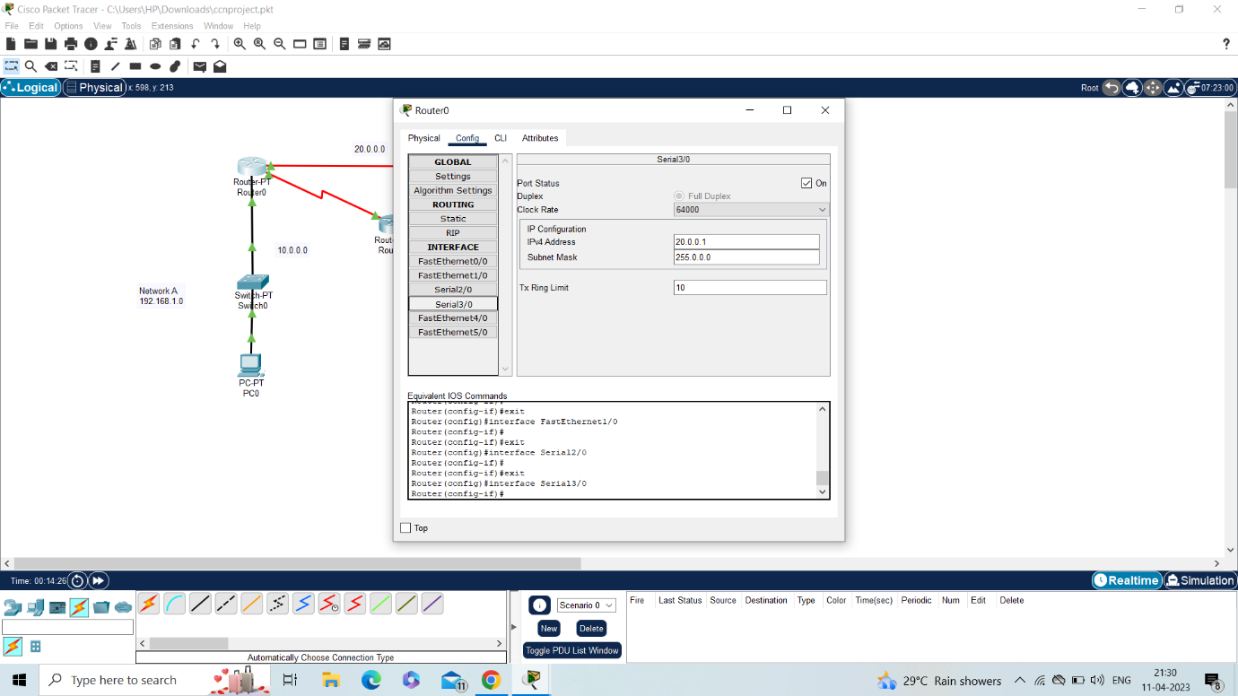

Router1:

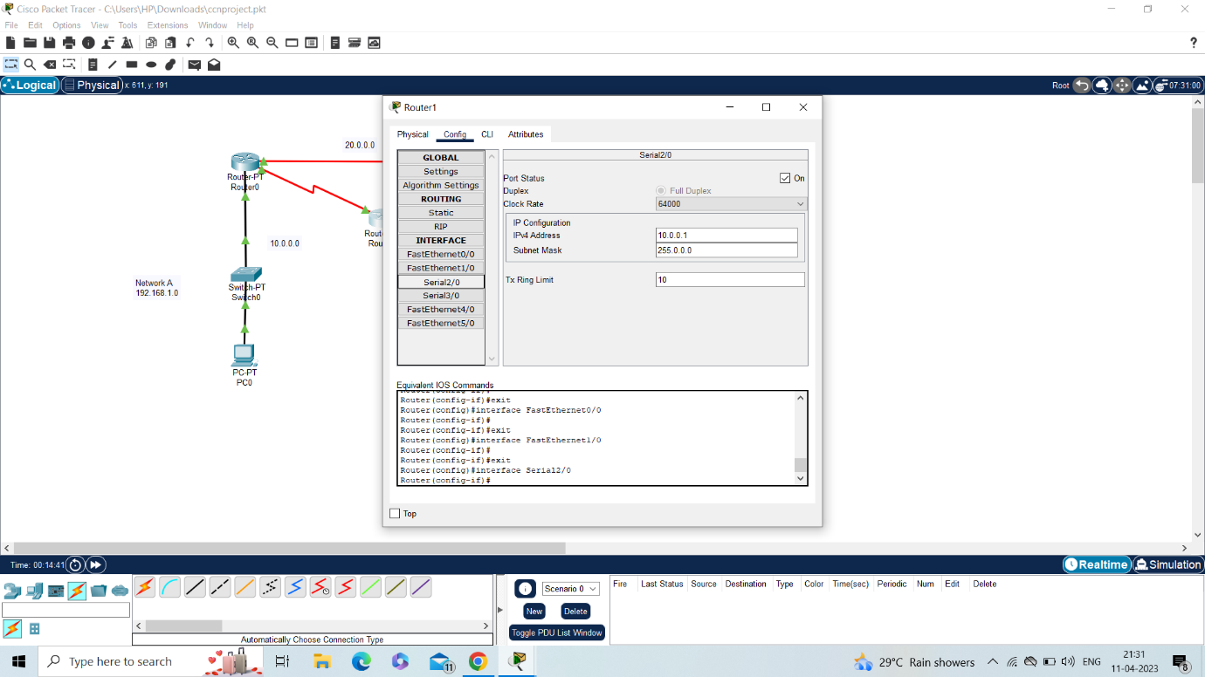

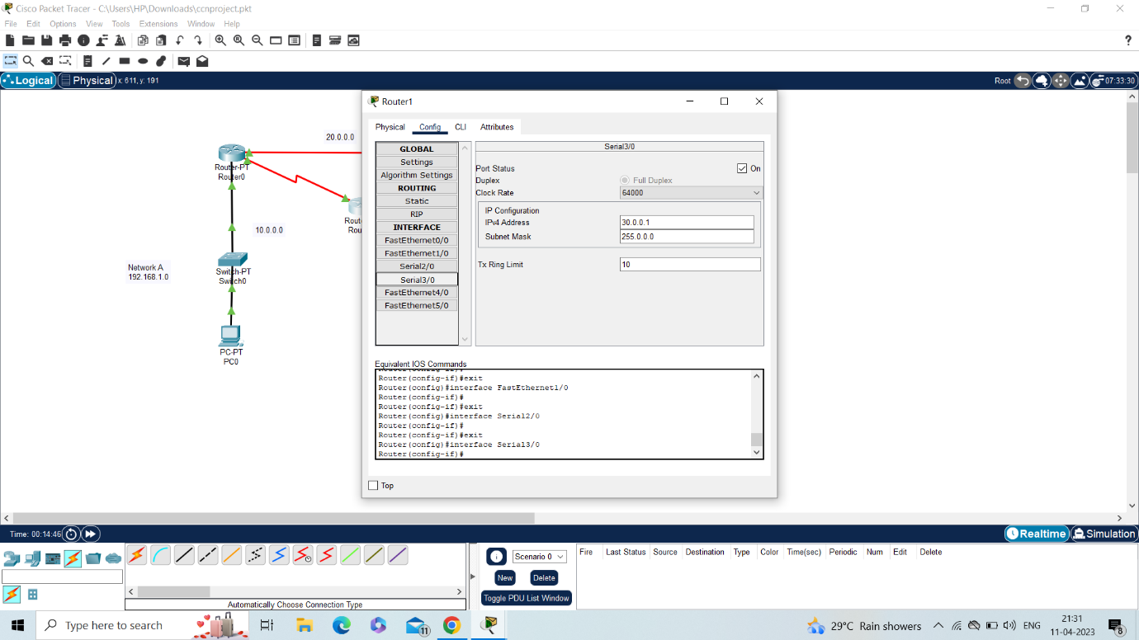

Router2:

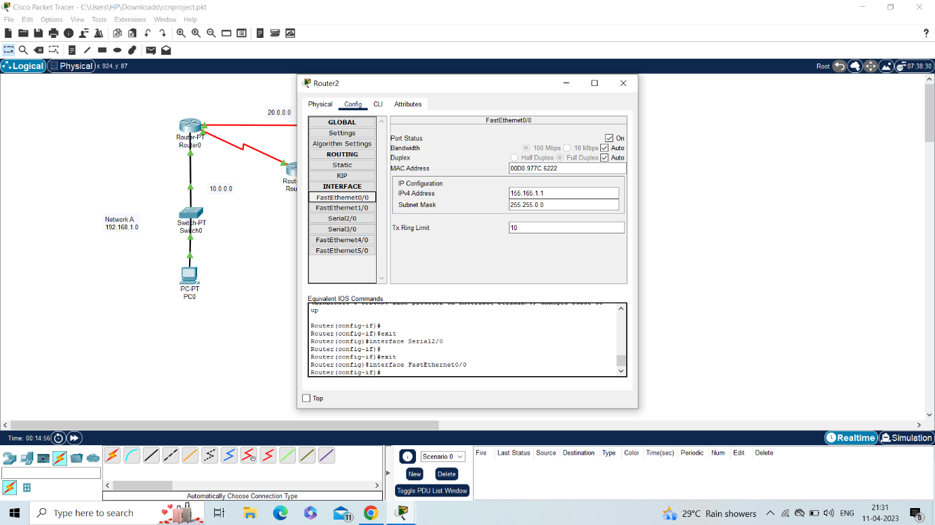

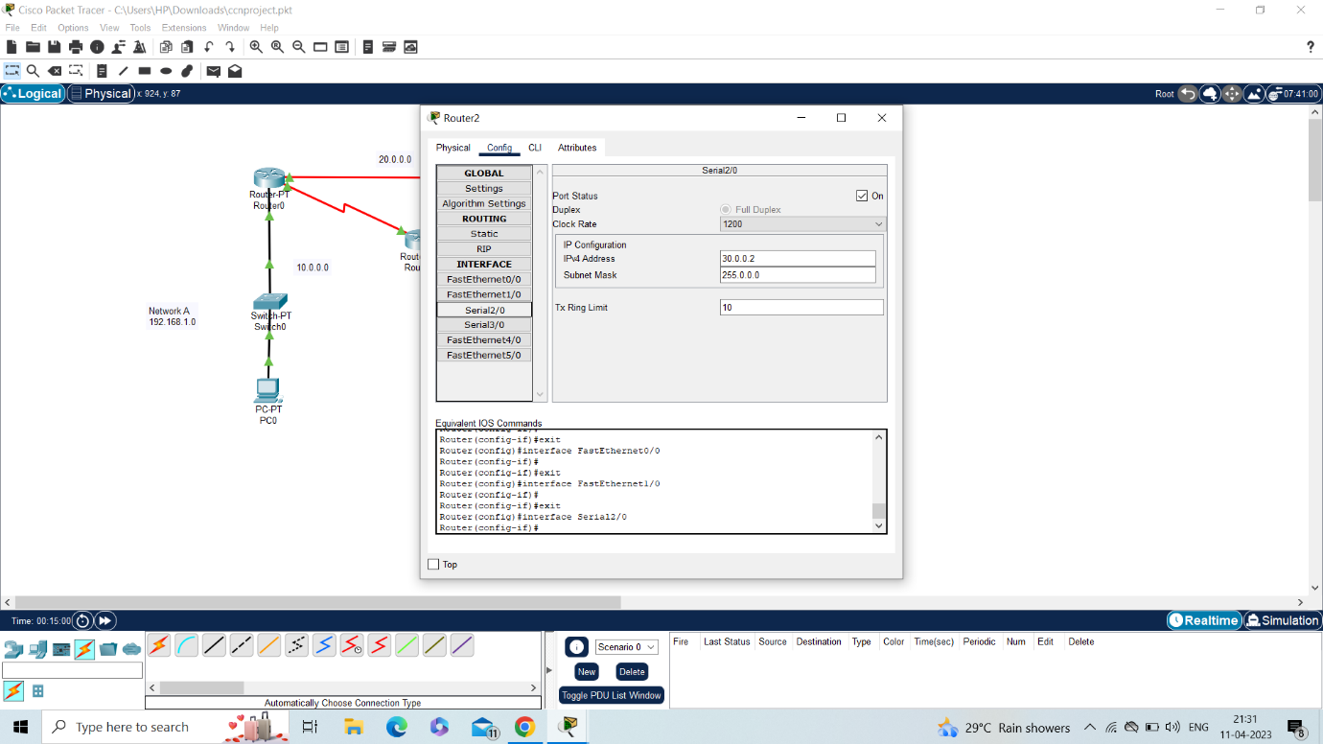

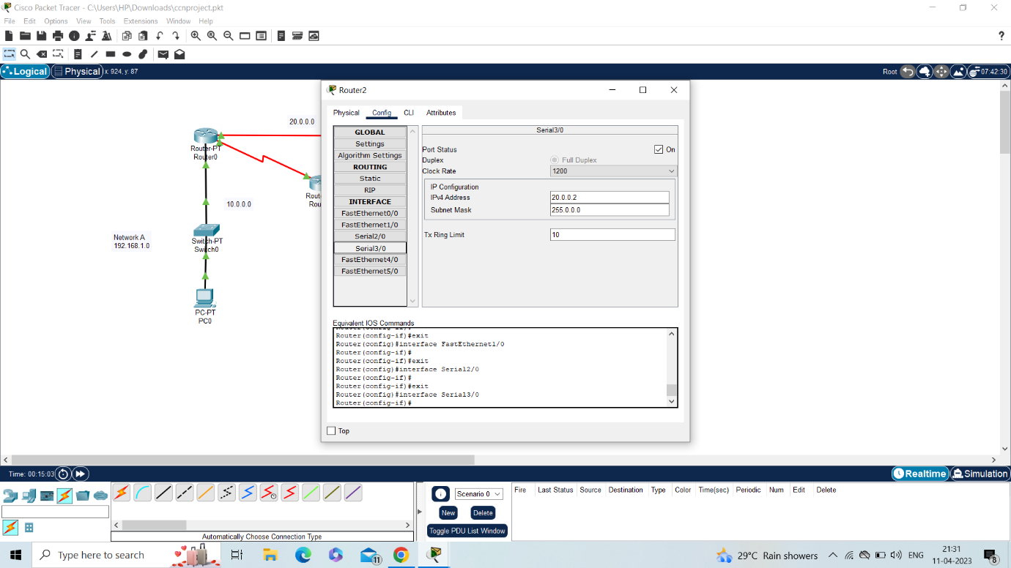

Step 4:show the configuration of cli command of router0 router1 router2

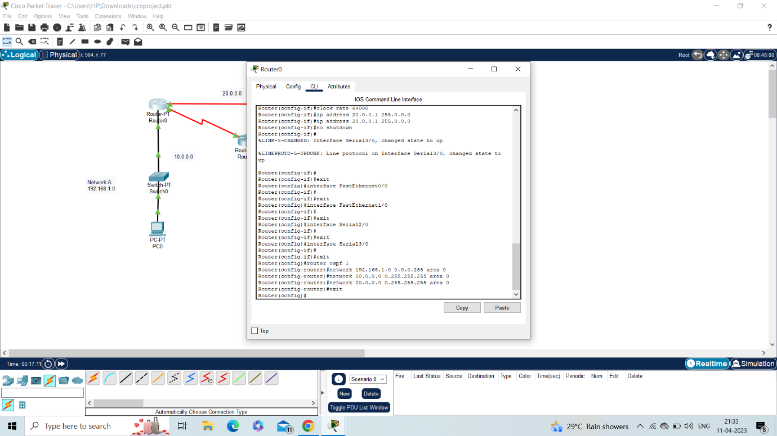

Router1:

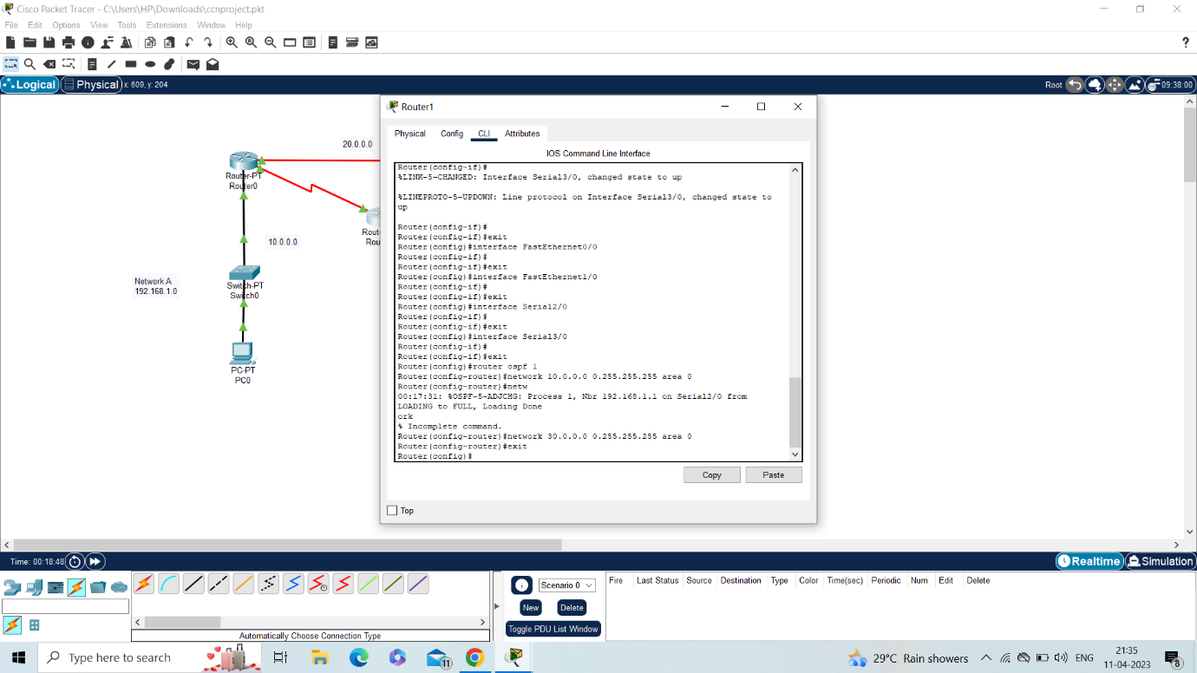

Router2:

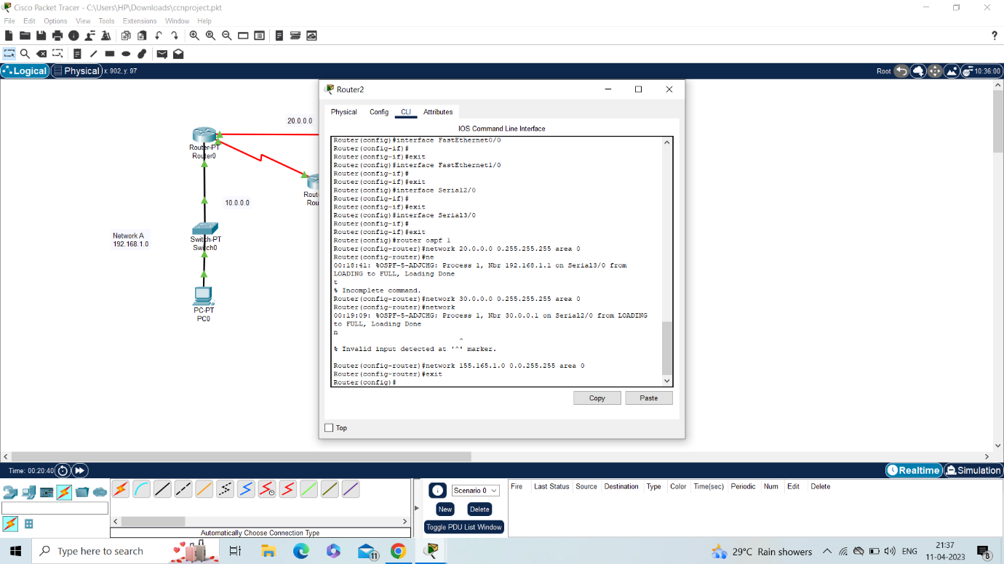

**Chapter 3**

**Results and Analysis with photograph:**

**Realtime simulation:**

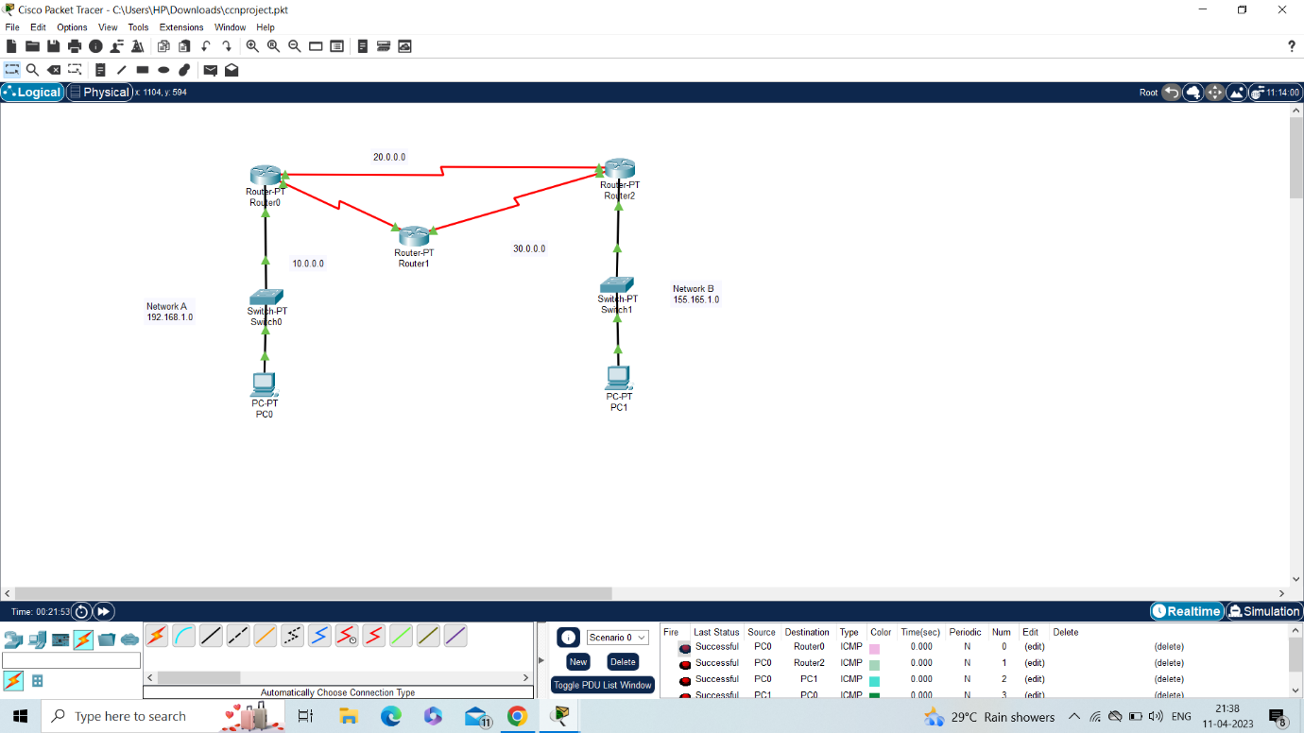

**Simulation:**

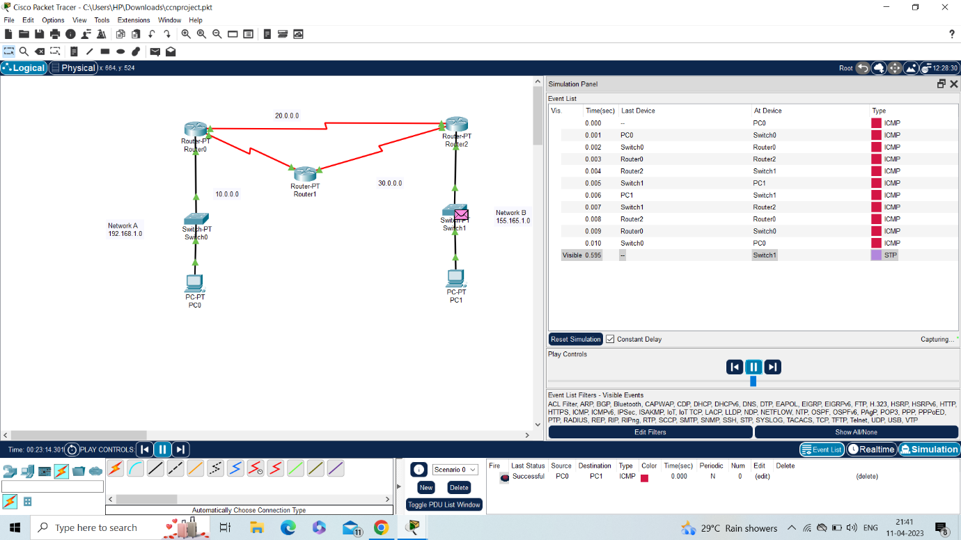

**Ping command simulation:**

Pc0:

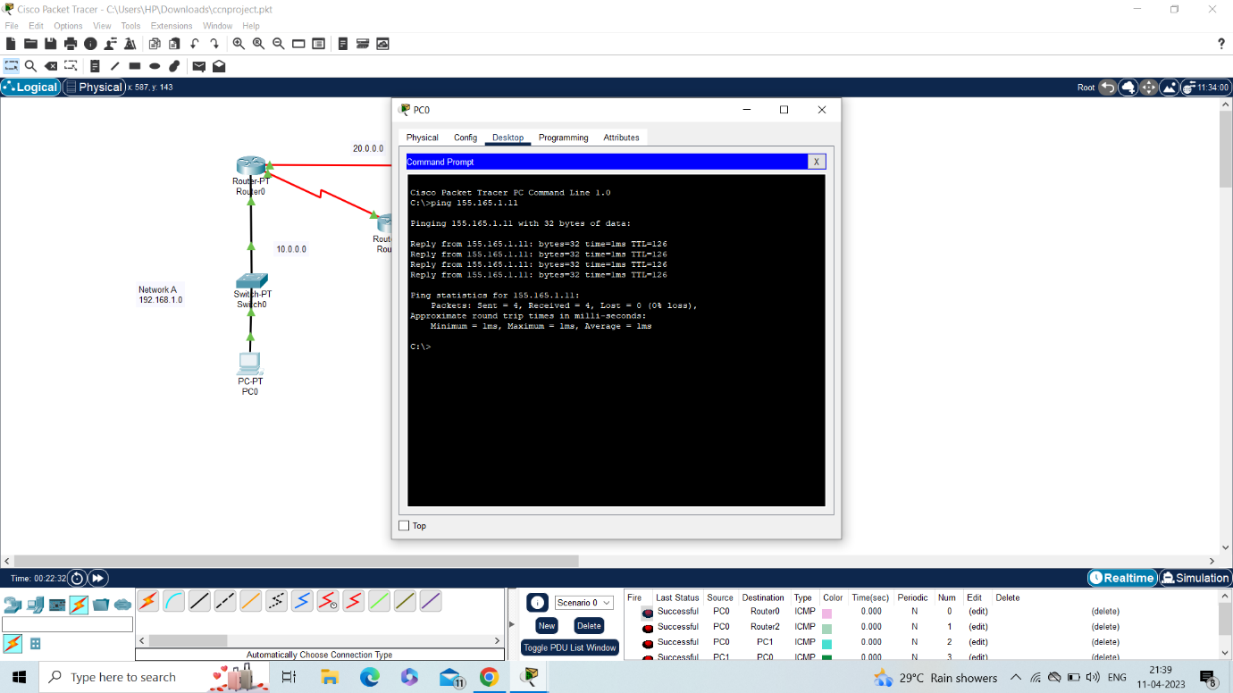

Pc1:

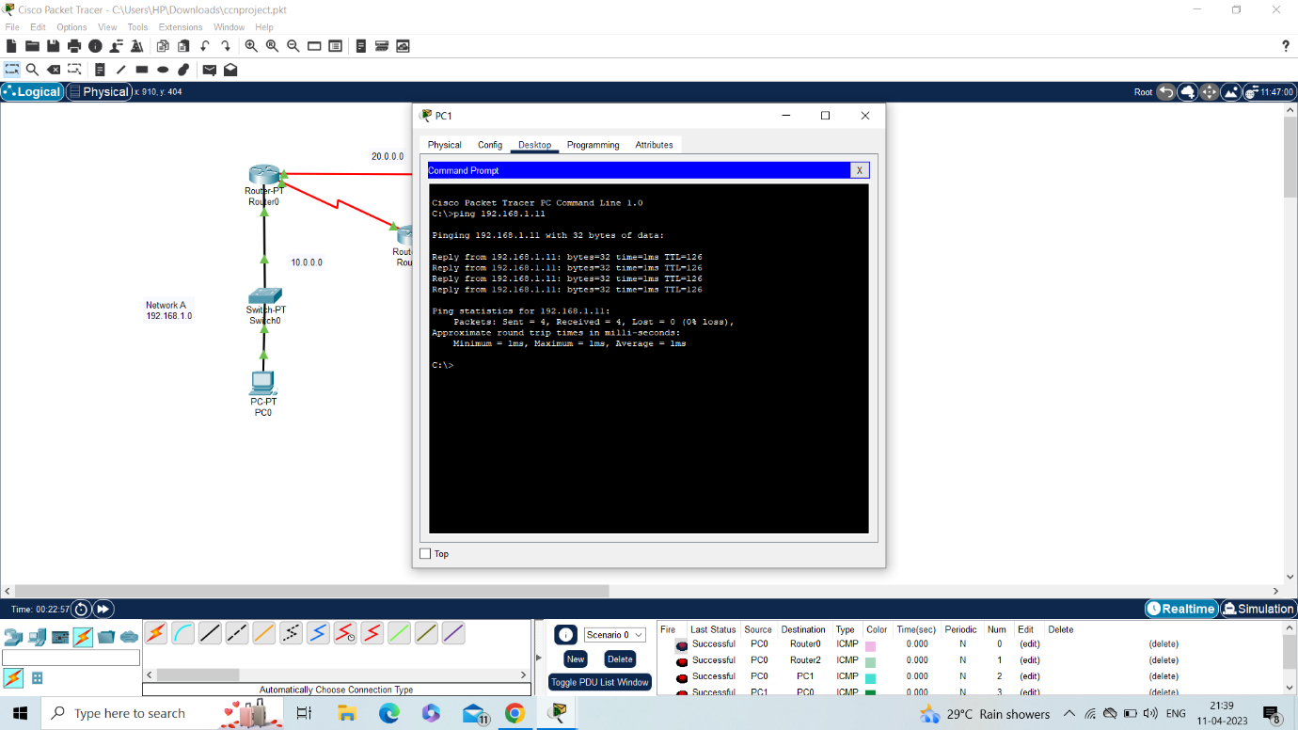

**Chapter 4**

**Outcome:**

This project satisfy the CO3 outcome.in this we have to design a network model and determine the routing of packets using different algorithm.

**Conclusion:**

This topic collection describes i5/OS support for OSPF configuration, authentication methods, point-to-point links, packet types and splitting an OSPF autonomous system (AS) into areas. It also includes three scenarios, one that demonstrates OSPF routes on a TCP/IP stack, one that demonstrates multipath routes, and another that demonstrates an i5/OS API.