**GCP PROJECT**

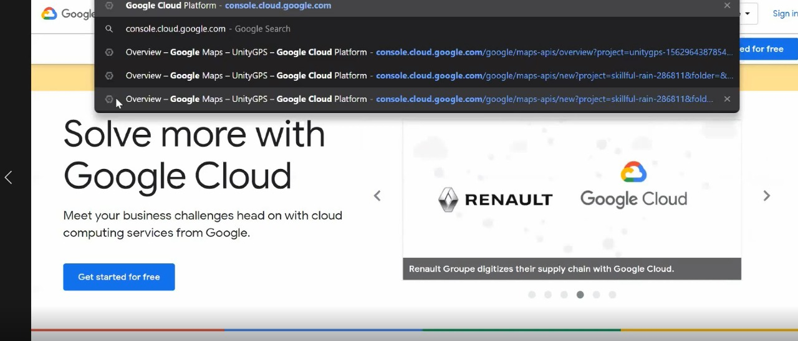

Firstly make account in google cloud platform and so we will go to console.cloud.google.com

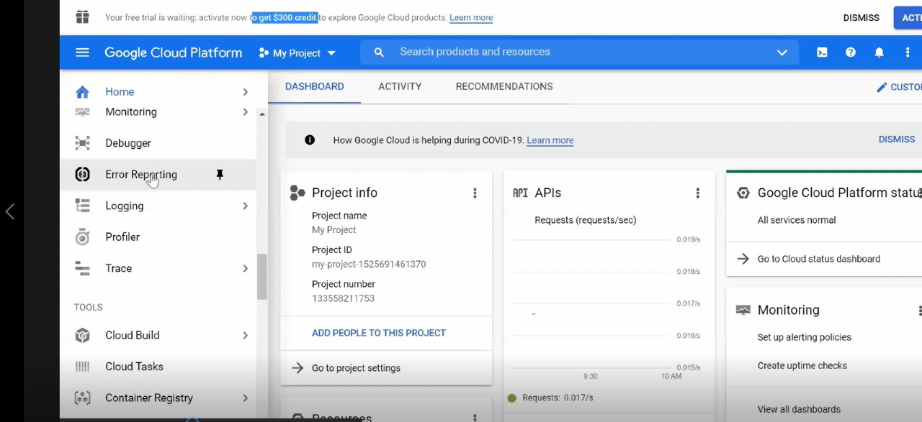

Then we need to purchase free credits for billing account by using credit card or debit card

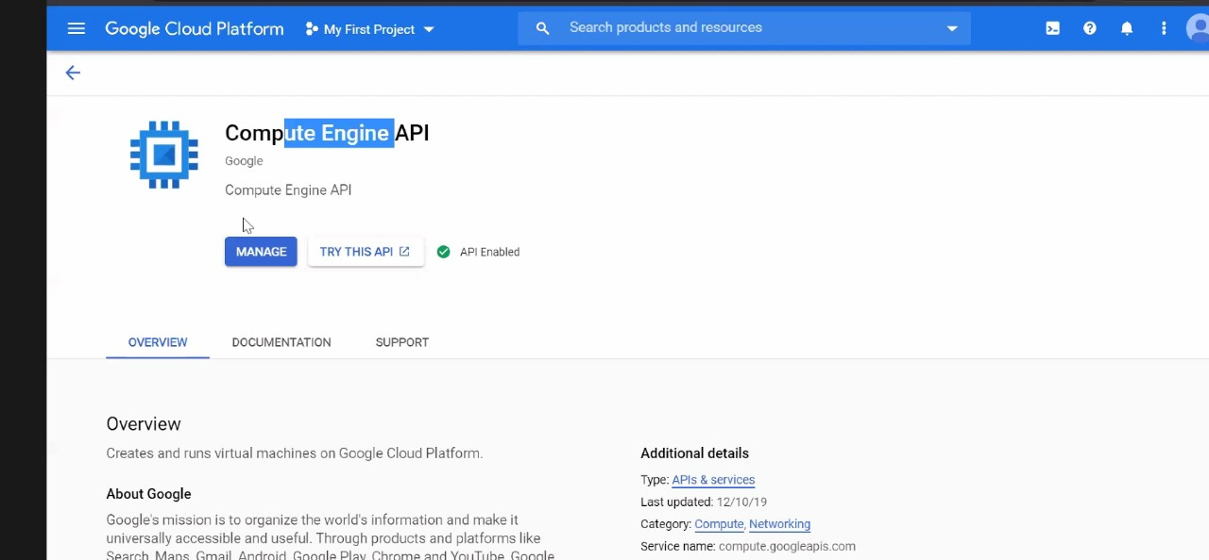

Then we will enable compute engine API for using its features.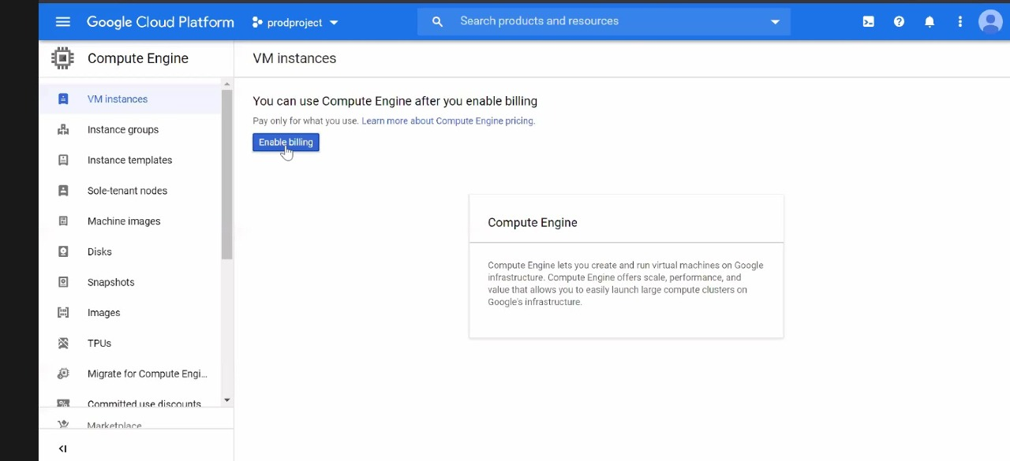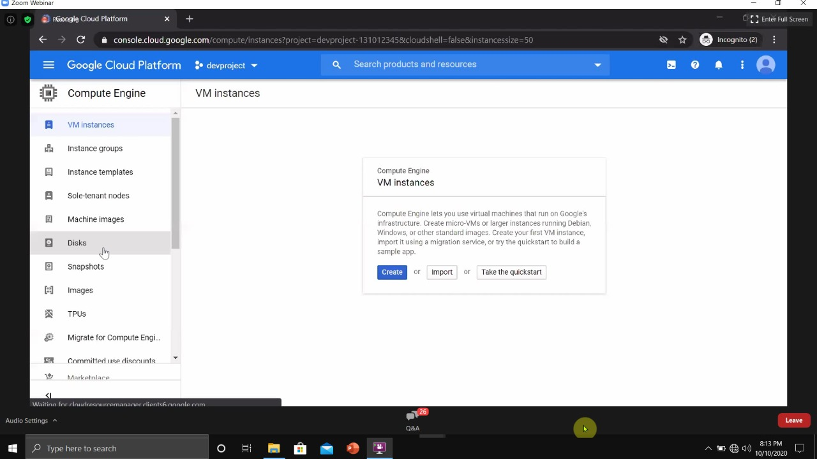

Then enable billing to use compute engine and we will then create VM instances that is inside compute engine.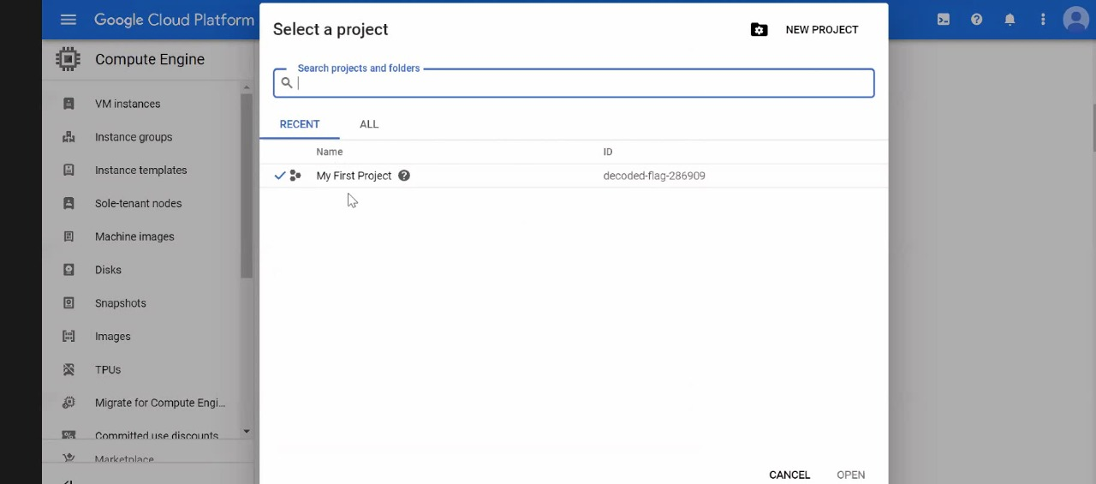

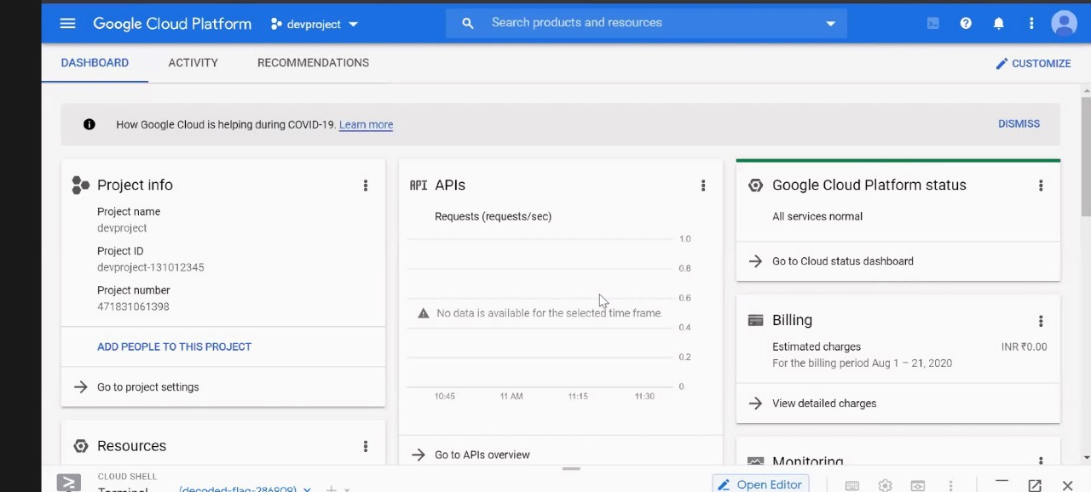

Then we have to make two projects that is devproject and prodproject.

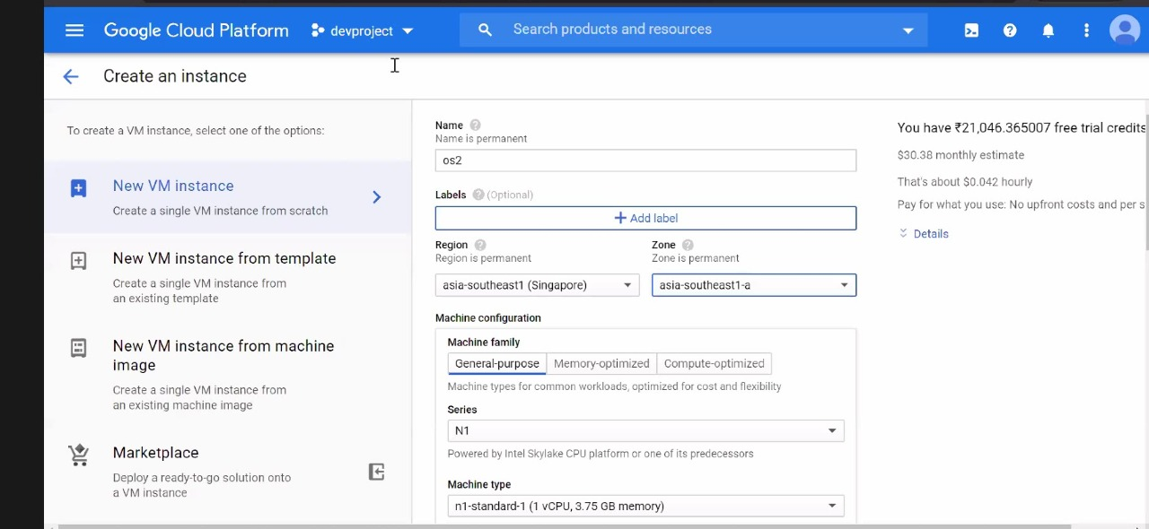

So will create a new VM instance and for we will fill required details such as name we want to give it. Then the region we want it in, the zone. The machine type in which we want our O.S.

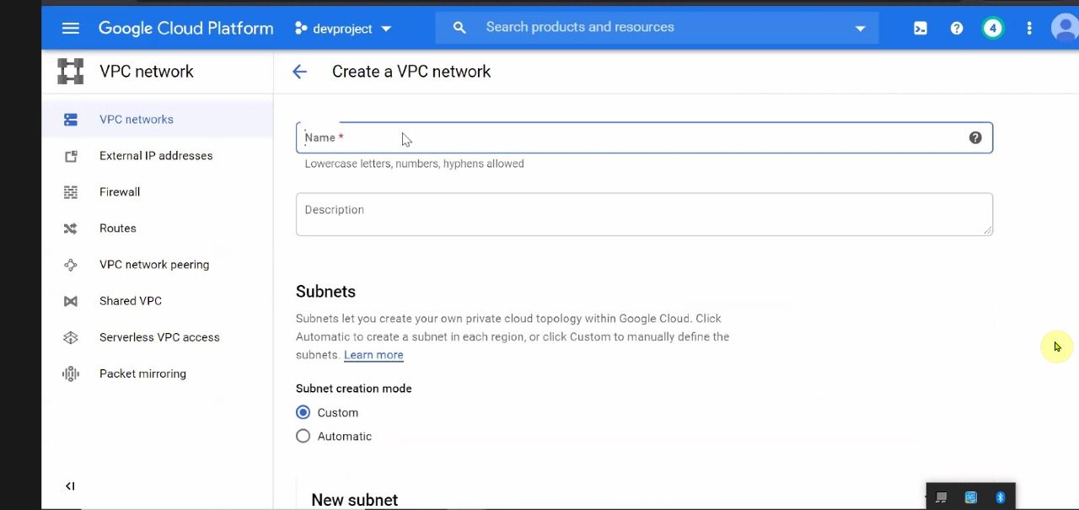

Then create VPC network in which we will have our subnets. So will give some name to our VPC network select subnet creation mode as custom.

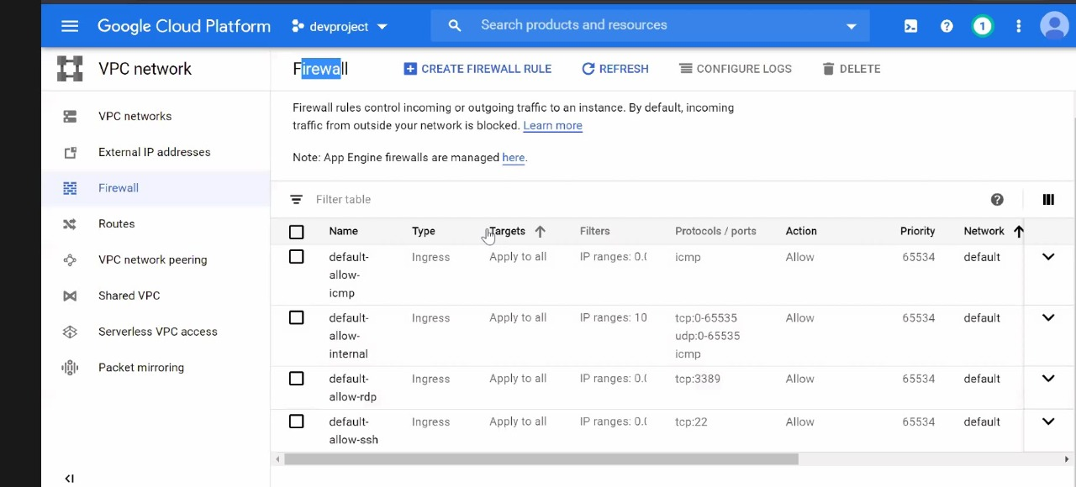

Then we will create a firewall rule inside VPC Network. Firewall rule control incoming or outgoing traffic to an instance. By default, incoming traffic from outside your network is blocked.

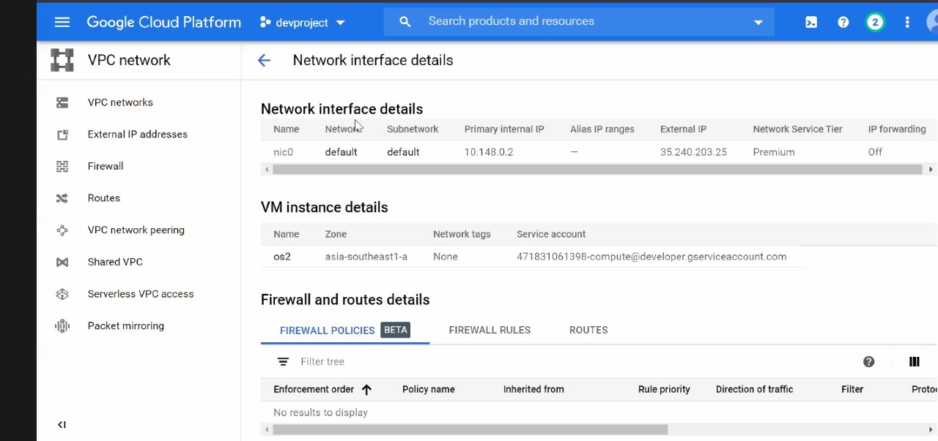

After creating firewall rule, we will look through Network interface details,VM instance details,Firewall and routes details. This will give as external and internal IP.

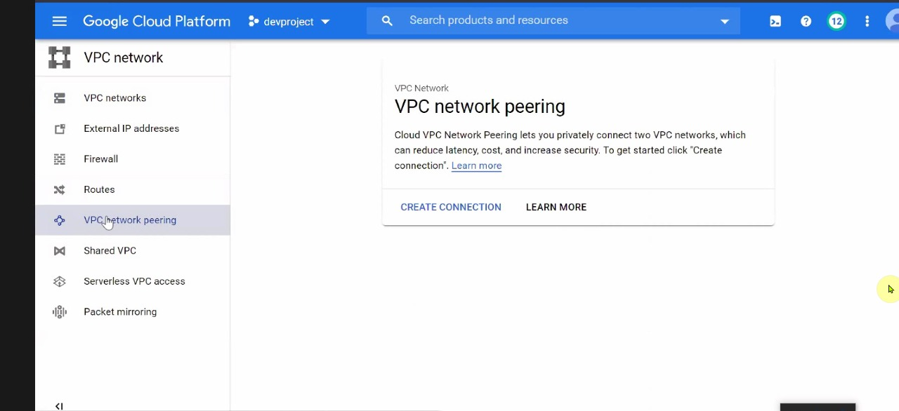

Then for VPC network peering , we will go to VPC network peering inside VPC network. VPC network peering lets us privately connect two VPC networks, which can reduce latency and increase security. So we will start creating connection.

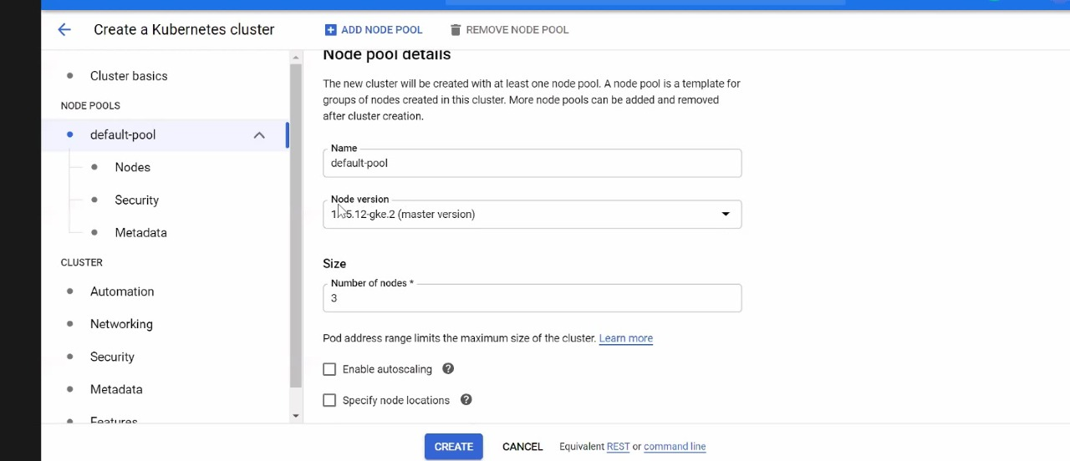

Then we will create Kubernetes cluster for having nodes inside it for development project that is devproject. So we will enter name we want for it and number of nodes we want in it.

We can also add docker in this project.

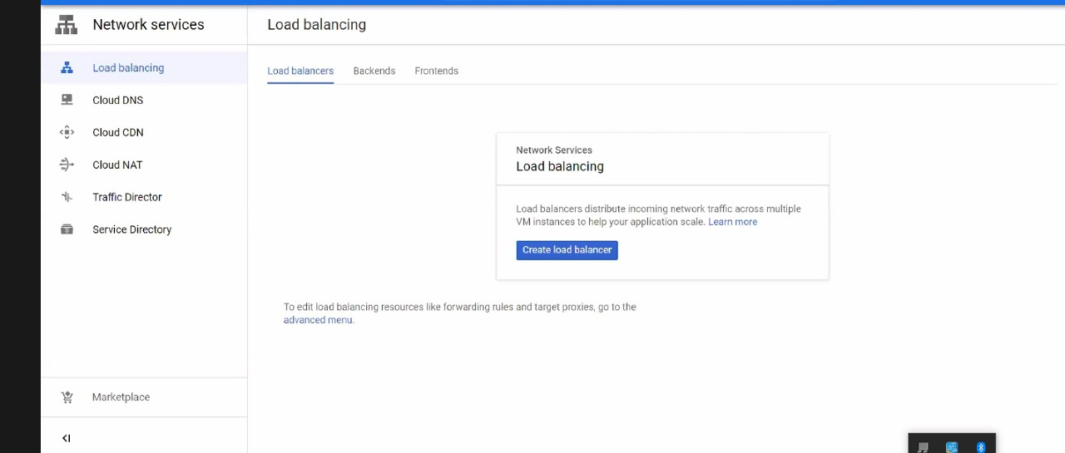

Then we will add load balancer as load balancing distribute incoming network traffic across multiple VM instances to help in application scaling.

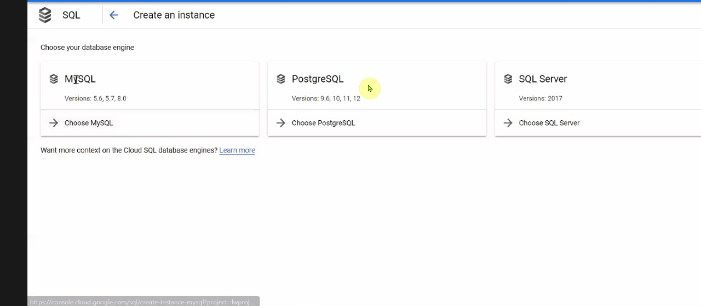

Then we will create an instance inside SQL for database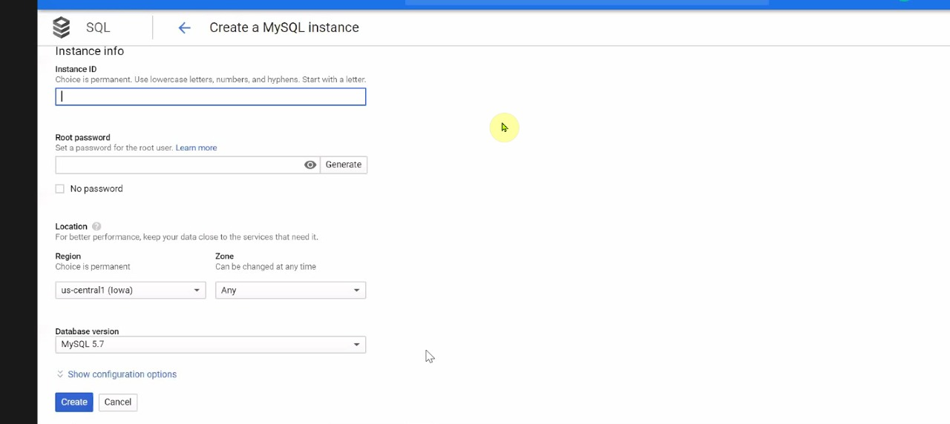

So we will create an MYSQL instance by providing instance ID,root password,region and database version.

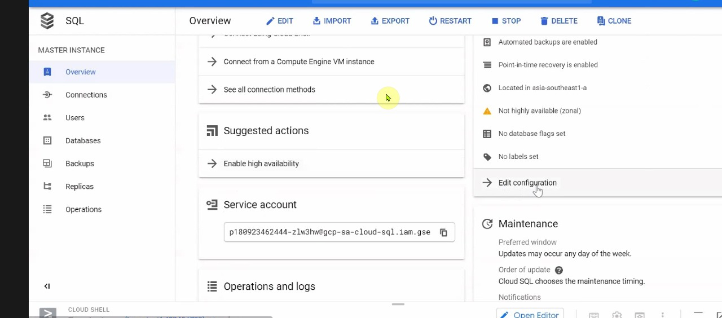

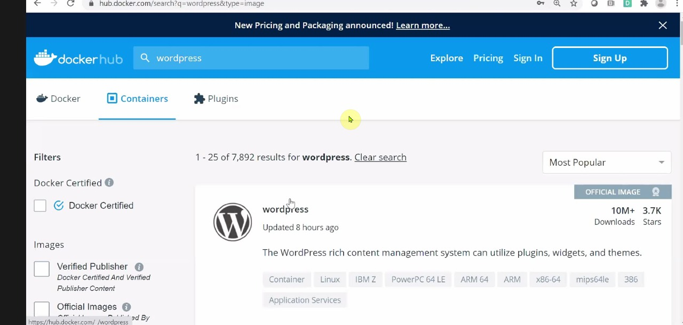

Then we will connect to wordpress to host our development site.