1. **Git Configuration**

**Step 1:** Setup your machine with Git Configuration

To create a new repository, sign up with **GitLab/GitHub** and register your credentials.  
Login to GitLab and create a project named **"GitDemo"**.

**1. Check if Git client is installed properly**  
Open Git Bash and run:

|  |
| --- |
| git –version |

If the output shows Git version information, it means Git is installed correctly.

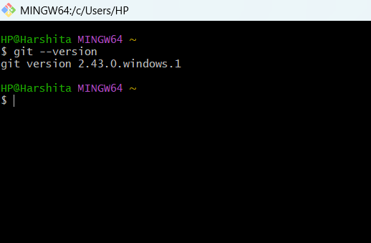

**2. Configure user information (user ID and email ID)**

**3. Verify the configuration**

|  |
| --- |
| git config --global user.name "Your Name"  git config --global user.email "your.email@example.com” |

|  |
| --- |
| git config --list |

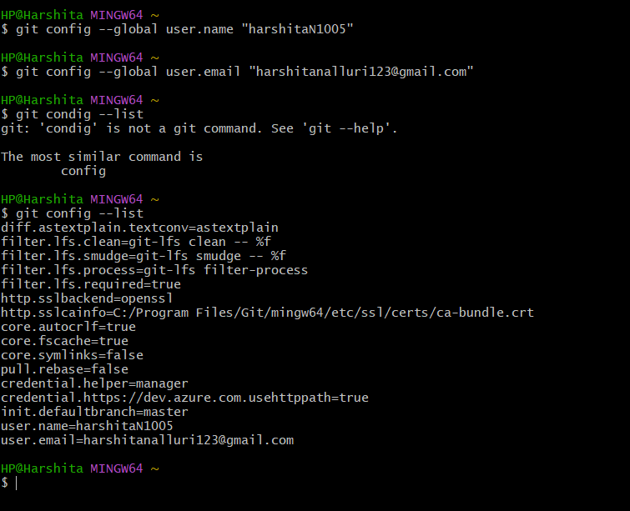

**Step 2:** Integrate Notepad++ as Default Git Editor

**1. Test if Notepad++ runs from Git Bash**

|  |
| --- |
| notepad++ |

If the command is not recognized, add Notepad++ path to the **Environment Variables**:  
Control Panel → System → Advanced System Settings → Environment Variables → Edit **PATH** and add:

C:\Program Files\Notepad++\

**2. Restart Git Bash** and check:

notepad++

**3. Create an alias for Notepad++**

alias np='"/c/Program Files/Notepad++/notepad++.exe"'

**4. Set Notepad++ as the default Git editor**

|  |
| --- |
| git config --global core.editor "notepad++" |

**5. Verify**

|  |
| --- |
| git config --global -e |

**Step 3:** Add a File to Source Code Repository

**1. Create a project folder and move into it**

|  |
| --- |
| mkdir GitDemo  cd GitDemo |

**2. Initialize Git repository**

|  |
| --- |
| git init |

**3. Create a file and add content**

|  |
| --- |
| echo "Welcome to Git" > welcome.txt |

**4. Verify file creation**

|  |
| --- |
| ls |

**5. View file content**

|  |
| --- |
| cat welcome.txt |

**6. Check repository status**

|  |
| --- |
| git status |

**7. Stage the file**

|  |
| --- |
| git add welcome.txt |

**8. Commit with multi-line message using default editor**

|  |
| --- |
| git commit |

**9. Check status again**

|  |
| --- |
| git status |

**10. Create a remote repository on GitLab named "GitDemo"**

**11. Pull remote repository**

|  |
| --- |
| git pull origin master |

**12. Push local repository to remote**

|  |
| --- |
| git push origin master |