**11. React Application – eventexamplesapp**

**Objective:**

To build a React application named eventexamplesapp to demonstrate handling of different events in React using form elements and buttons. In this CurrencyConvertor component also included that converts Indian Rupees to Euro.

**Software Requirements:**

* Node.js and npm
* Visual Studio Code
* Web browser

Steps for creating the React Application:

**Step1**: Create a react app:

Open the command prompt and execute the below command to create a new React application,

|  |
| --- |
| npx create-react-app eventexamplesapp  cd eventexamplesapp |

After creating the event examples react app open the project folder in vscode  
i.e.,

|  |
| --- |
| code . |

**Step2**: Modify the App.js to meet the requirements.

i.e.,

Part A: Increment and Decrement buttons with event handling.

1. Add state and counter.

i.e.,

|  |
| --- |
| const [count, setCount] = useState(0); |

This initializes a state variable count.

1. Add functions for Increment and Decrement to pop a message.

i.e.,

|  |
| --- |
| const handleIncrement = () => {      const cnt = count + 1;      setCount(cnt);      alert (`Hello!! Member ${cnt}`);    }    const handleDecrement = () => {      setCount(count - 1);    } |

1. Add Increment and Decrement buttons in JSX.

In App.js place the below code inside the return() block.

|  |
| --- |
| <p>Count: {count}</p>        <button onClick={handleIncrement}> increment </button>        <br/>        <br/>  <button onClick={handleDecrement}> decrement </button> |

Part B: Say Welcome Button.

1. Add a Function with Argument inside the button in JSX.

i.e.,

|  |
| --- |
| const sayWelcome = (message) => {      alert(`You clicked: ${message}`);    };  <button onClick={() =>  sayWelcome("Welcome")}>  Say Welcome  </button> |

This button passes “**Welcome**” as an argument to the function.

Part C: Synthetic event example.

1. Create a synthetic event handler and add a button to trigger synthetic event.

i.e.,

|  |
| --- |
| <button onClick={(e) =>  alert ('I was clicked')}>  click on me  </button> |

Part D: Create a component i.e., CurrencyConvertor.

i.e., create a new .js file with name currencyConvertor.

|  |
| --- |
| import React, { useState } from "react";  import "./App.css";  function CurrencyConvertor () {    const [amount, setAmount] = useState(0);    const [currency, setCurrency] = useState("");    const handleConvert = () => {      const conversionRate = 101.01;      const euros = (amount / conversionRate).toFixed(2);      alert(`Converting to Euro amount is ${euros}`);    };    return (      <div className="App">        <h3>Currency Converter</h3>        <label>          Amount:          <input            type="number"            placeholder="Amount in Rupees"            value={amount}            onChange={(e) => setAmount(e.target.value)}          />        </label>        <br />        <br />        <label>          Currency:          <input            type="text"            placeholder="Currency in Euros"            value={currency}            onChange={(e) => setCurrency(e.target.value)}          />        </label>        <br />        <br />        <button onClick={handleConvert}>submit</button>      </div>    );  }  export default CurrencyConvertor; |

**Step 3**: Now update the App.js by adding the CurrencyConvertor component to the App.js

i.e.,

App.js

|  |
| --- |
| import React, {useState} from 'react';  import CurrencyConvertor from './currencyConvertor';  import './App.css';  function App() {    const [count, setCount] = useState(0);    const handleIncrement = () => {      const cnt = count + 1;      setCount(cnt);      alert(`Hello!! Member ${cnt}`);    }    const handleDecrement = () => {      setCount(count - 1);    }    const sayWelcome = (message) => {      alert(`You clicked: ${message}`);    };    return (      <>      <div className = "App">        <p>Count: {count}</p>        <button onClick={handleIncrement}> increment </button>        <br/>        <br/>        <button onClick={() => sayWelcome("Welcome")}>Say Welcome</button>        <br/>        <br/>        <button onClick={handleDecrement}> decrement </button>        <br/>        <br/>        <button onClick={(e) => alert('I was clicked')}>click on me</button>        <CurrencyConvertor/>      </div>      </>    )  }  export default App; |

**Step4**: Run the Application.

Now open the terminal in the vscode and execute the below command then the development server starts automatically.

i.e.,

|  |
| --- |
| npm start |

Expected outcome is as follows:

Initially it looks like;

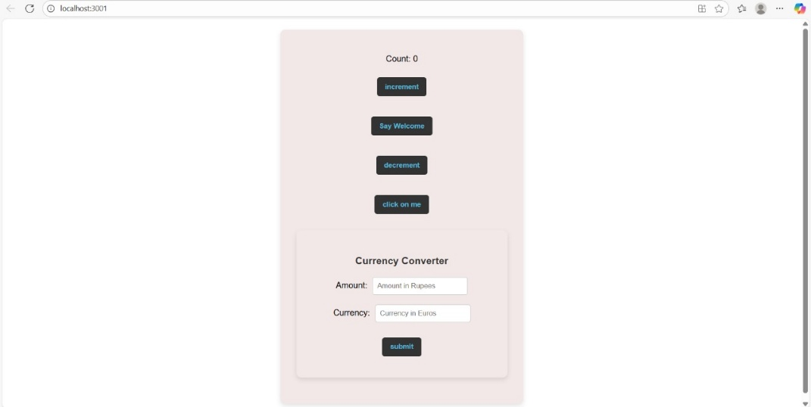

After the **Increment button** is clicked the outcome is,

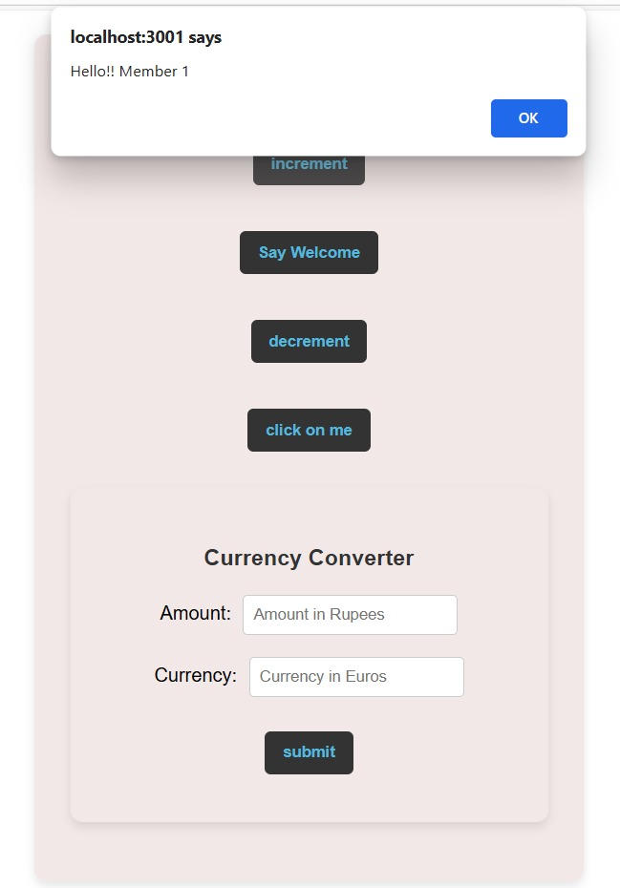

When we click the **Say Welcome button** then expected output is,

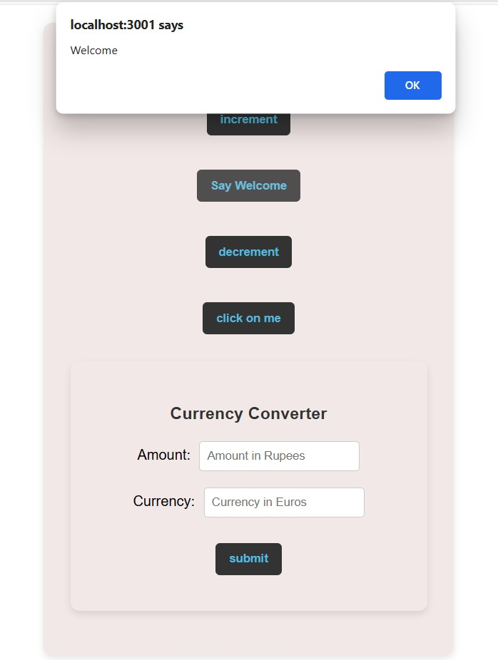

The variation in count when **Decrement button** is clicked.

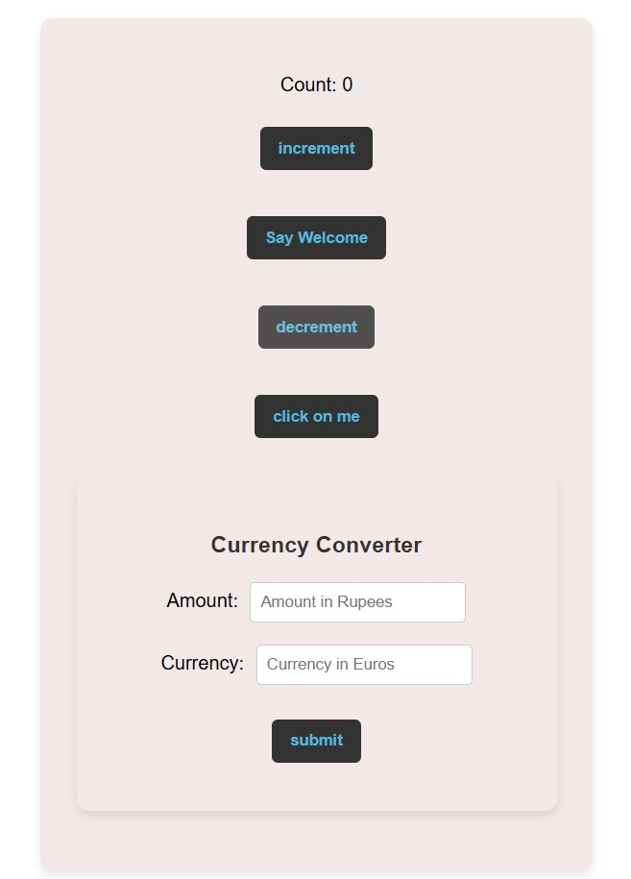

The outcome when the **click me button** is clicked,

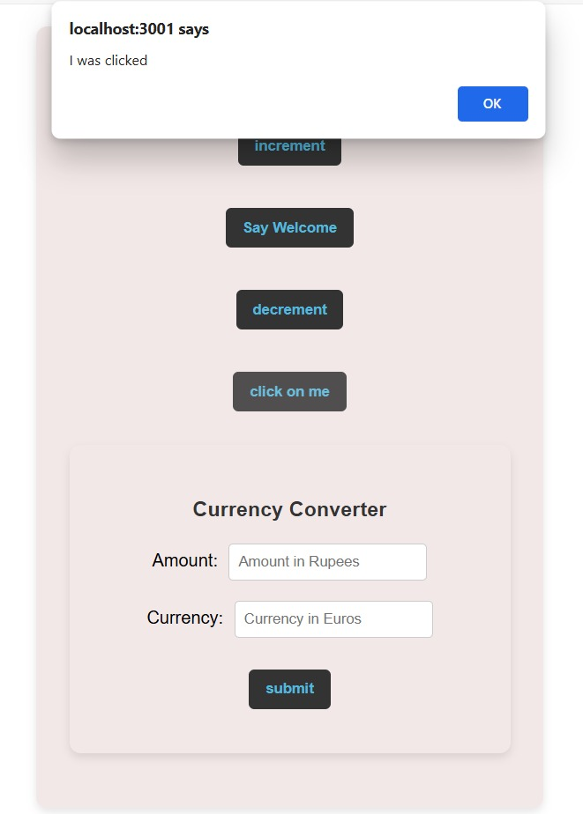

Finally, when the details of amount are entered and when we press **submit button** the alert message is,

