**12. React Application – ticketbookingapp**

**Objective:**

To develop a React application named ticketbookingapp with below functionalities:

* Guest users: Browse flight details.
* Logged-in users: Book tickets.

**Software Requirements:**

* Node.js and npm
* Visual Studio Code
* Web browser

Steps for creating React Application:

**Step 1**: Create React Application.

Open the command prompt and execute the below command to create new react application.

i.e.,

|  |
| --- |
| npm create-react-app ticketbookingapp  cd ticketbookingapp |

Also open the project directory in the vscode ide i.e.,

|  |
| --- |
| code . |

**Step 2:** Modify App.js

We need to modify the App.js by updating with the two components i.e.,

1. **UserGreeting.js**
2. **GuestGreeting.js**

Firstly the UserGreeting.js shows the details after the user login to the web page where the book now option is available.

i.e.,

|  |
| --- |
| import React from "react";  function UserGreeting({ flights, onLogout }) {    return (      <div>        <h1>User Dashboard</h1>        <button onClick={onLogout}>Logout</button>        <h2>Book Your Tickets</h2>        <ul>          {flights.map((flight) => (            <li key={flight.id}>              {flight.name} | {flight.route} | {flight.price}              <button style={{ marginLeft: "10px" }}>Book Now</button>            </li>          ))}        </ul>      </div>    );  }  export default UserGreeting; |

Also, the GuestGreeting shows just about the flight details as the user stays logout.

i.e.,

|  |
| --- |
| import React from "react";  function GuestGreeting ({ flights, onLogin }) {    return (      <div>        <h1>Welcome Guest</h1>        <button onClick={onLogin}>Login</button>        <h2>Available Flights</h2>        <ul>          {flights.map((flight) => (            <li key={flight.id}>              {flight.name} | {flight.route}            </li>          ))}        </ul>      </div>    );  }  export default GuestGreeting; |

Now the Modified App.js is:

|  |
| --- |
| import React, { useState } from "react";  import "./App.css";  import GuestGreeting from "./GuestGreeting";  import UserGreeting from "./UserGreeting";  function App () {    const [isLoggedIn, setIsLoggedIn] = useState(false);    const flights = [      {id: 1, name: "Indigo 6E-123", route: "Delhi → Mumbai", price: "₹4500"},      {id: 2, name: "Air India AI-456", route: "Chennai → Hyderabad", price: "₹5000"},      {id: 3, name: "SpiceJet SJ-789", route: "Bangalore → Goa", price: "₹3500"}    ];    const handleLogin = () => {      setIsLoggedIn(true);    };    const handleLogout = () => {      setIsLoggedIn(false);    };    return (      <div className="App">        {isLoggedIn? (          <UserGreeting flights={flights} onLogout={handleLogout} />        ) : (          <GuestGreeting flights={flights} onLogin={handleLogin} />        )}      </div>    );  }  export default App; |

Step3: Update the App.css

As we updated the App.js we also need to update App.css as below.

i.e.,

|  |
| --- |
| . App {    font-family: Arial, sans-serif;    text-align: center;    padding: 20px;    background-color: #f9f9f9;    min-height: 100vh;  }  button {    background-color: #007bff;    color: white;    border: none;    padding: 10px 18px;    margin: 10px;    border-radius: 5px;    cursor: pointer;    font-size: 14px;  }  button : hover {    background-color: #0056b3;  }  ul {    list-style: none;    padding: 0;    max-width: 500px;    margin: 20px auto;    text-align: center;  }  li {    background-color: white;    margin: 10px 0;    padding: 15px;    border-radius: 8px;    box-shadow: 0px 2px 5px rgba (0, 0, 0, 0.1);    display: flex;    justify-content: space-between;    align-items: center;  }  li button {    background-color: #28a745;    padding: 8px 12px;    font-size: 12px;  }  li button: hover {    background-color: #1f7a33;  } |

**Step 4:** Run the Application.

Now, open the terminal in vscode and run the below command to start the development server.

|  |
| --- |
| npm start |

**Expected outcome** is;

Initially when the user is not logged in, he is in GuestMode i.e.,

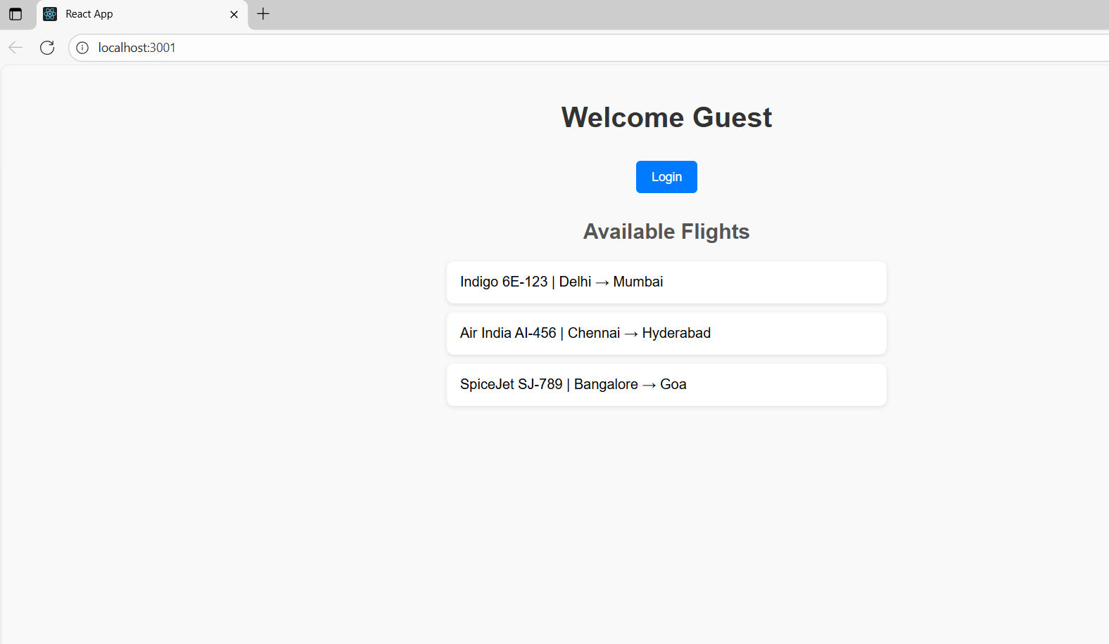

When the user logins to the ticketbookingapp then he will be able to see all the specifications;

