**13. React Application – bloggerapp**

**Objective:**

To create a react application named bloggerapp that displays three sections:

1. Course Details
2. Book Details
3. Blog Details

**Software Requirements:**

* Node.js and npm
* Visual Studio code
* Web browser

Steps for creating React Application:

**Step1**: Create a React App

Open the command prompt and execute the below command.

i.e.,

|  |
| --- |
| npx create-react-app bloggerapp  cd bloggerapp |

Also open the project directory in the VSCode ide.

**Step2:** Create the component CourseDetails

i.e.,

CourseDetails.js

|  |
| --- |
| import React from "react";  function CourseDetails () {  const courses = [  {name: "Angular", date: "4/5/2021"},  {name: "React", date: "6/3/2021"}  ];  return (  <div>  <h2>Course Details</h2>  {courses.map((c, index) => (  <div key={index}>  <h3>{c.name} </h3>  <p>{c.date}</p>  </div>  ))}  </div>  );  }  export default CourseDetails; |

**Step3**: Create the BookDetails component.

i.e.,

|  |
| --- |
| import React from "react";  function BookDetails () {  const books = [  {name: "Master React", price: 670},  {name: "Deep Dive into Angular 11", price: 800},  {name: "Mongo Essentials", price: 450}  ];  return (  <div>  <h2>Book Details</h2>  {books.map((b, index) => (  <div key={index}>  <h3>{b.name}</h3>  <p>{b.price}</p>  </div>  ))}  </div>  );  }  export default BookDetails; |

**Step4**: Create the component BlogDetails

i.e.,

|  |
| --- |
| import React from "react";  function BlogDetails () {  const blogs = [  { title: "React Learning", author: "Stephen Biz", content: "Welcome to learning React!" },  { title: "Installation", author: "Schwezdneir", content: "You can install React from npm." }  ];  return (  <div>  <h2>Blog Details</h2>  {blogs.map((blog, index) => (  <div key={index}>  <h3>{blog.title}</h3>  <b>{blog.author}</b>  <p>{blog.content}</p>  </div>  ))}  </div>  );  }  export default BlogDetails; |

**Step5**: Modify the App.js

Updated App.js is:

|  |
| --- |
| import React, {useState} from "react";  import "./App.css";  import CourseDetails from "./CourseDetails";  import BookDetails from "./BookDetails";  import BlogDetails from "./BlogDetails";  function App () {  const [view, setView] = useState("all");  let content;  if (view === "courses") {  content = <CourseDetails />;  } else if (view === "books") {  content = <BookDetails />;  } else if (view === "blogs") {  content = <BlogDetails />;  } else {  content = (  <div className="container">  <div className="box"><CourseDetails /></div>  <div className="box"><BookDetails /></div>  <div className="box"><BlogDetails /></div>  </div>  );  }  return (  <div className="App">  <h1>Blogger App</h1>  <div style={{ marginBottom: "20px" }}>  <button onClick={() => setView("all")}>Show All</button>  <button onClick={() => setView("courses")}>Show Courses</button>  <button onClick={() => setView("books")}>Show Books</button>  <button onClick={() => setView("blogs")}>Show Blogs</button>  </div>  {view === "all" ? (  <div>  {content}  </div>  ) : (  <div>  {content}  </div>  )}  {view === "all" && <p style={{ color: "green" }}>All sections displayed</p>}  </div>  );  }  export default App; |

**Step 6**: Run the App

Open the terminal in VSCode and execute the below command so the development server starts automatically.

|  |
| --- |
| npm start |

**Expected outcome:**

Initially the output is:

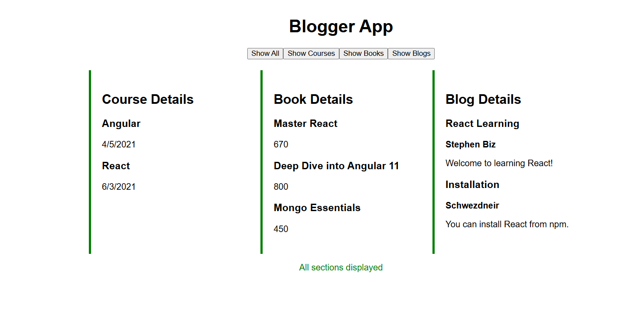

Later the Show courses display available courses:

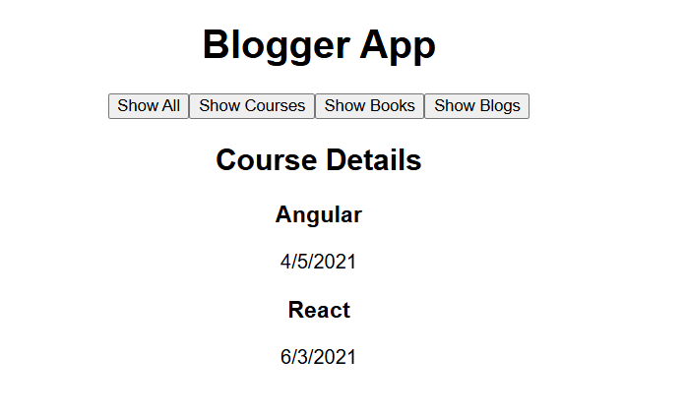

When the showBooks is clicked the outcome is:

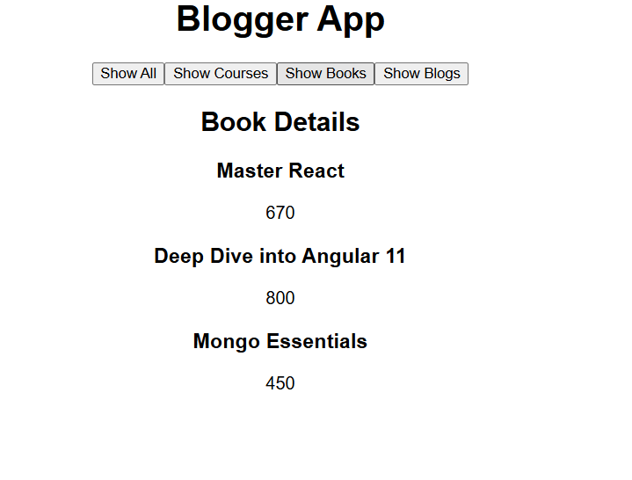

When the showBlogs is clicked then:

