Technology, Reporting and Crimes Against Women in India
Draft for supervisors · 19 October 2026

Introduction
India has added several hundred million internet users in a decade, and generative AI tools that can make fake sexual images became freely available from late 2022. Research in other countries links both changes to online abuse of women, such as stalking, blackmail and the sharing of intimate or fake images. For India, there is almost no quantitative evidence on whether these changes show up in the crimes that are reported.
This paper asks three questions using public data only. First, do States with more internet access record more cyber crime against women? Second, did recorded cyber crime against women rise more after 2022 in States that were better connected before generative AI spread? Third, how does police-recorded crime compare with the complaints women make directly to online platforms?
The paper treats India's crime data as part of the question, not only as a source. The National Crime Records Bureau (NCRB) has no category for AI-generated or deepfake abuse, files about three in four cyber crimes against women under "other", and changed its legal categories when the new criminal code took effect in July 2024. A finding of no link can therefore mean either that there is no link or that the records cannot see it, and the design is built to tell these apart where possible.

Literature review
Studies of internet access and sexual crime reach different answers in different places. In Norway, the rollout of broadband raised reported rape and other sex crimes (Bhuller, Havnes, Leuven and Mogstad, 2013), while in Germany broadband expansion went with fewer sex crimes, which the author reads as offenders substituting online material for offline offending (Diegmann, 2019). Research on mobile phones and partner violence finds that women who own a mobile phone face less violence from their partners (Pesando, 2022), but it measures offline violence only. On online abuse itself, the evidence is descriptive: a 2019 industry count found that 96% of deepfake videos online were non-consensual pornography, almost all of women (Deeptrace, 2019). We found no quantitative study linking internet access or AI image tools to recorded cyber crime against women in India.
A second literature shows that India's police records of crimes against women move with how easy it is to report. When seats in village councils were reserved for women, recorded crimes against women rose, mainly through more reporting rather than more crime (Iyer, Mani, Mishra and Topalova, 2012). Women-only police stations raised recorded crimes against women by 29%, again a reporting effect (Amaral, Bhalotra and Prakash, 2021). This is why our design separates abuse from reporting.
This review will be expanded in the next draft.

Methodology
The study has three parts, each answering one question with the data best suited to it. Parts 1 and 2 use police records for 35 States and Union Territories from 2017 to 2024. Part 3 compares those records with monthly complaints to online platforms from 2022 to 2024. All data are public. Every step is run in Python, and Parts 1 and 2 are also replicated in Stata.

Data and why each source was collected
Table A Data sources
Data | Years | Where it comes from | Why we use it
Cyber crimes against women, by State and type | 2017–2024 | NCRB, Crime in India, victim-based cyber crime tables | The main outcome: the only official count of these crimes by State
Five offline crimes against women | 2017–2024 | NCRB, Crime in India: cruelty by husband or relatives, dowry deaths, kidnapping of women, assault and insult to modesty | A comparison group: it moves with reporting and policing in the State, but not with internet use
Cyber fraud | 2017–2024 | NCRB | A placebo: an online crime not aimed at women
Internet access by State | 2017-18, 2019-21, 2022-23 | NSS 75th round (22 States), NFHS-5, CAMS 2022-23 (MoSPI survey reports) | Measures of how connected each State is, from three independent surveys
Internet connections per 100 people | 2022–2024 | TRAI quarterly reports (December of each year) | The only access measure that changes every year by State
Income per head | 2017-18 to 2022-23 | RBI, Handbook of Statistics on Indian States 2024-25 | A control: richer States may both connect more and record more crime
Urban share of the population | 2022-23 | Calculated from CAMS 2022-23 rural, urban and total internet-use rates | A control for urbanisation
Police strength, cyber police stations and cyber cells | 2020–2024 | BPR&D, Data on Police Organizations; India Justice Report data | Controls for police capacity, the main alternative explanation
Complaints to platforms by category, monthly | 2021–2026 | Monthly reports under India's IT Rules 2021: Facebook, Instagram, X, Google, Snapchat; ShareChat and Moj to Oct 2022 | The record of abuse reported online rather than to the police
Searches for AI image tools, by State | 2018–2024 | Google Trends and Google Ads keyword volumes | Alternative measures of exposure to AI image tools in Part 2

NCRB counts come from the tables in each year's report and match published national totals. Platform figures were read from each company's original monthly reports; the Meta reports were downloaded from its transparency centre and kept in the project files. BPR&D tables were read from the reports for 1 January 2020, 2021, 2022 and 2024, and their national totals match the published figures.

Building the panels
- One row per State and year, and per State, crime type and year. We use 35 units. Jammu and Kashmir is combined with Ladakh, and Dadra and Nagar Haveli with Daman and Diu, because these units split or merged during the period. Counts are added and rates recomputed.
- Cyber crimes against women are added into one total. States sort the same crime into different types, and about three in four cases are filed as "other". The total is robust to that sorting, so it is the main outcome; the separate types are used only as checks.
- Delhi and Haryana are combined for the TRAI measure only. TRAI's Delhi licence area also covers Gurgaon and Faridabad (Haryana) and Noida and Ghaziabad (Uttar Pradesh). Between 2023 and 2025, TRAI's count for Delhi State fell by 8 million while the Delhi licence area grew by 7 million and Haryana's count rose by 10 million. This is a shift between the two, so we combine them, following the practice of merging units into areas with stable boundaries (Kumar and Somanathan, 2009).
- Labelling breaks are flagged. A State-year has a break when the share of cyber cases filed under the IT Act, or the share of cyber crimes against women filed as "other", jumps by more than 30 percentage points (in years with at least 20 cases). 17 of 35 States have at least one break. These mark changes in how a State records cases, not in crime.
- Exposure is standardised. Each State-level measure is rescaled to mean 0 and standard deviation 1, so every estimate reads as the change for a State one standard deviation more exposed.

How every model is estimated
- Poisson regression on counts. Many State-years have small counts, including zeros. Poisson regression handles these directly, and each coefficient converts to a percentage change, reported as a rate ratio (1.10 = 10% higher).
- Fixed effects remove differences we do not want to compare: a State's usual level of each crime, anything that hits all crimes in a State in a year (a new police chief, a reporting drive), and anything that hits one crime type nationally in a year (a change in national law).
- Standard errors are clustered by State, because a State's records are related from year to year.
- Randomisation inference checks the main estimates: exposure is shuffled across States 300 times and the real estimate is compared with the shuffled ones. This does not depend on having many States.

Part 1: internet access and recorded cyber crime against women
Part 1 asks whether better-connected States record more cyber crime against women, in three steps.
- Across States. We compare the level of recorded cyber crime against women across States with different access (CAMS 2022-23), with year effects and population as the base. We then add income, urban share and police capacity, because better-connected States are also richer, more urban and better policed. The same model on offline crimes against women is the check: access should not predict them.
- Growth within States (Model 1). Each State's cyber crimes against women are compared with its own offline crimes, and we ask whether the gap grew faster in better-connected States:
cases_{sct} = exp( β · Cyber_{c} × Access_{s} × (t − 2017) + α_{sc} + γ_{st} + δ_{ct} ) (1)
Here s is the State, c the crime type and t the year. β is the extra yearly growth for a State one standard deviation more connected. Checks: each access survey in turn, each cyber crime type, cyber fraud in place of cyber crime against women, dropping 2020 (lockdown) or 2024 (new criminal code), and dropping Karnataka and Telangana, two States with unusually high cyber crime counts.
Step 3: changes in connections (TRAI, 2022–2024). We ask whether a State's recorded cyber crime against women rises in the years its internet connections rise, using State and year effects. Checks: offline crimes as a placebo, and a control for growth in all other cyber crime, which captures how much the State's police are recording cyber cases generally.
We also show the national trend from 2017 to 2024: internet users (World Bank) and recorded cyber crime against women. This is descriptive only, since any two rising series move together.

Part 2: the period after AI image tools spread (Model 2)
Part 2 compares recorded cyber crime against women before (2017–2022) and after (2023–2024), across States that were more or less connected before 2023:
cases_{sct} = exp( β · Cyber_{c} × Post_{t} × Exposure_{s} + α_{sc} + γ_{st} + δ_{ct} ) (2)
Post equals 1 in 2023 and 2024. The main exposure is internet access in NFHS-5 (2019-21), chosen because it was measured before the period, so it cannot be caused by it. Other exposures: CAMS access, searches for "nudify" tools relative to all AI-tool searches, and Google Trends interest in deepfakes and face swapping from 2018 to 2022.
Why the outcome is all cyber crimes against women, and why "other" matters. Cyber crime takes a growing share of all recorded crimes against women: 1.2% in 2017, 3.2% in 2022 and 4.4% in 2023 (NCRB, national totals). Almost all of the rise after 2022 sits in the "other" category, which names no offence. Comparing 2023–24 with 2021–22, "other" cases rose 68% while the five named types together rose 18%, and "other" grew from 65% of cyber crimes against women in 2021 to 75% in 2024. NCRB has no category for AI-made images, so new kinds of abuse such as fake sexual images have nowhere to be filed except "other". This fits, but cannot prove, AI-enabled abuse being recorded there. It is why the main outcome includes "other" rather than the named types alone, and we also run the model on "other" by itself as a check.
The design is valid only if more- and less-exposed States were on the same path before 2023. We test this in four ways:
- Event study: one estimate per year relative to 2022, with a joint test that the years before 2023 are zero.
- Fake start years: the same model with the "after" period starting in 2019, 2020 or 2021, using only 2017–2022. These should show nothing.
- Placebo: cyber fraud in place of cyber crime against women.
- Dropping years and States: as in Part 1.
Controlling for labelling. Because recording practice changes, we re-run the model (a) without the 17 States with breaks, (b) with a separate baseline for each State's recording period, (c) controlling for the "other" and IT Act shares, and (d) allowing the effect to differ between stable and unstable States. Controlling for capacity, we add income, urban share, civil police per lakh people (2020) and cyber police units, each interacted the same way as exposure.
Finally, using cyber police stations and cells for each year from 2020 to 2024, we test whether States that expand cyber policing record more cyber crime against women, with cyber fraud as the comparison.

Part 3: police records versus complaints to platforms
Part 3 compares how fast police-recorded cyber crime against women grew with how fast complaints about sexual content to platforms grew over 2022–2024. Platforms publish national figures only, so this part cannot compare States. The main comparison is share-adjusted: each source is measured against its own comparison group. This matters because complaints to Meta for every reason rose about seven-fold in 2023, when the amended IT Rules and the government's Grievance Appellate Committee came in. Raw counts would pick up that policy change instead of a change in reporting of gendered abuse.
- Platforms and categories. Each platform names its categories differently. We use the category closest to sexual abuse: on Facebook and Instagram, complaints about content showing the complainant nude or in a sexual act; on X, sensitive adult content and synthetic or manipulated media; on Google (including YouTube), graphic sexual content; on Snapchat, reports of sexual content. ShareChat and Moj stopped publishing in October 2022, so they serve only as a baseline.
- Police side. Using the State data, we estimate how much faster cyber crimes against women grew each year than the five offline crimes against women over 2022–2024, with fixed effects for State × crime type and State × year and standard errors clustered by State.
- Platform side. For each platform, we estimate how much faster its sexual-content complaints grew each year than all its other complaints, using monthly data from January 2022 to December 2024 with month effects. The month effects absorb anything that moves every complaint on that platform, including a policy change that sends more people to the complaint route.
- Comparison. For each platform we test whether its share-adjusted growth differs from the police side's:
z = (θ_{platform} − β_{NCRB}) / √( se_{θ}² + se_{β}² ) (3)
The two sources are independent, so their errors add.
Step 5: raw growth, as a secondary comparison. We also compare the growth of the raw counts: recorded cyber crimes against women against each platform's sexual-content complaints, without comparison groups. This shows the scale of reporting to platforms, but it mixes in growth of the complaint routes themselves, so it is reported second. Here we also pool the five platforms into one estimate, as a rough summary of the platform side against police growth.
The window is 2022–2024 because full-year platform data begins in 2022, NCRB data ends in 2024, and X changed its report format in March 2025.

Caveats built into the design
- Recorded crime is not crime. Every NCRB measure counts cases registered by police, so it reflects reporting and police practice as well as abuse. The offline comparison, the fixed effects and the labelling and capacity controls exist to separate these.
- Exposure is fixed per State. Most access measures come from one survey year. Only TRAI connections change each year, and they count connections, not people.
- The after period is short. Two years, 2023 and 2024, and 2024 is the year the new criminal code began.
- The urban share is calculated, not taken from the Census. The Census 2011 tables could not be downloaded; the calculated shares are close to Census figures for the States checked.
- Platform categories differ and change. Each platform is compared only with itself over time, and with police growth; we never claim one platform's growth differs from another's. The five-platform pooled estimate in Part 3 is a rough summary of the whole platform side against police growth, not a ranking or comparison between individual platforms.

Results
All estimates below are from the Stata runs (stata/part1.do, part2.do, part3.do) and match the Python runs. Tables show rate ratios with p-values in parentheses; 1.10 means 10% higher.

Part 1: internet access and recorded cyber crime against women
1. What we ran. Three tests and one descriptive trend. Step 1 compares the level of recorded cyber crime against women across States with different internet access (CAMS 2022-23), first alone and then with income, urban share and police capacity as controls; the same models on offline crimes against women are the check. Step 2 is Model 1: whether cyber crime against women grew faster than offline crimes in better-connected States, 2017–2024, for four access measures, each cyber crime type, a cyber fraud placebo and dropped years or States. Step 3 asks whether recorded cyber crime against women rises in the years a State's TRAI internet connections rise (2022–2024, Delhi and Haryana combined). Finally, India's internet users are set against recorded cyber crime against women by year.
2. Why. Step 1 shows whether connected States record more of this crime, and whether that survives the obvious explanations: richer, more urban, better-policed States. Step 2 tests whether access drives growth, which is closer to the question than levels. Step 3 uses the only access measure that changes every year within a State.
3. Results (Stata).
Table 1.1 Step 1: across States. Outcome: cyber crimes against women
Rate ratio per SD of each State variable; p-values in parentheses
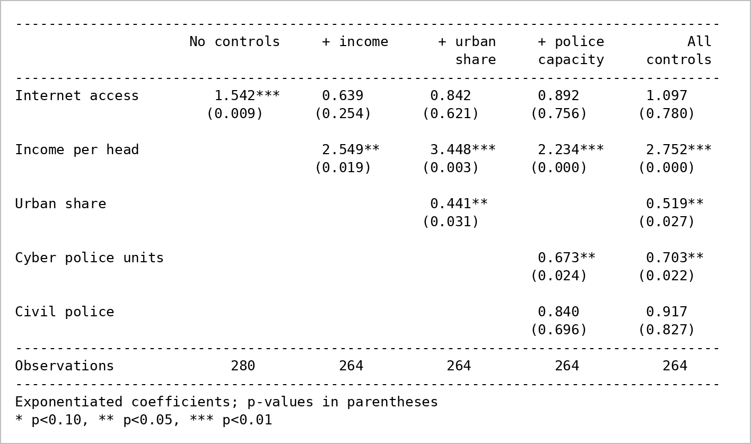
Note: Poisson regression with year fixed effects; female population as exposure; SE clustered by State. Columns 2 to 5: 33 States (RBI publishes no income for Lakshadweep or DNH-DD).
Table 1.2 Step 1: same models. Outcome: offline crimes against women
Rate ratio per SD; p-values in parentheses
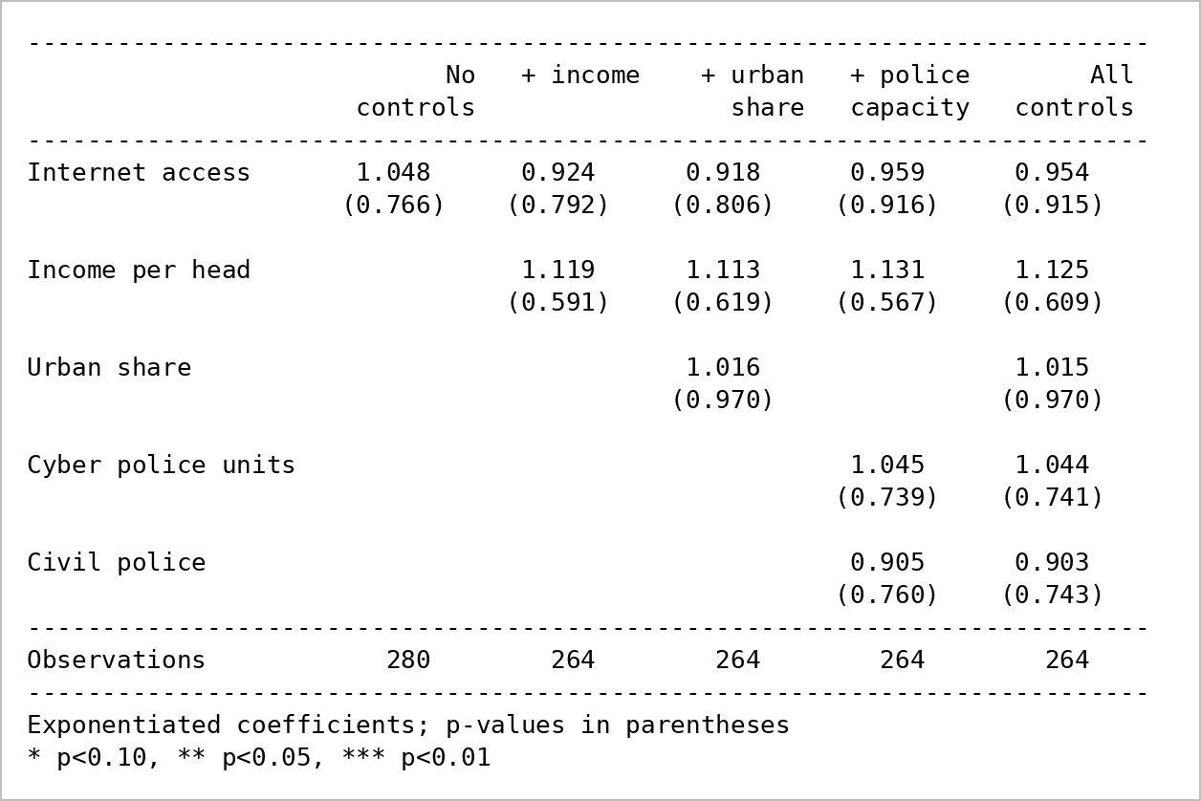
Note: As Table 1.1.
Table 1.3 Step 2: Model 1, extra yearly growth per SD of access, 2017–2024
Rate ratio; p-values in parentheses
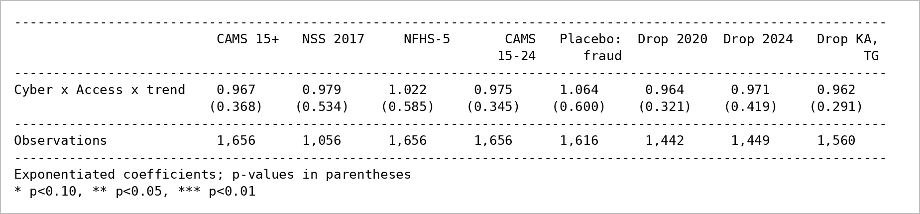
Note: Fixed effects: State × crime, State × year, crime × year; SE clustered by State. Columns 5 to 8 use CAMS 15+. By cyber crime type (CAMS 15+): blackmail 1.007 (0.926); morphing 0.886 (0.113); fake profile 0.914 (0.413); obscene material 1.009 (0.769); other 0.971 (0.542); stalking 0.930 (0.175).
Table 1.4 Step 3: TRAI connections, per 10 more connections per 100 people, 2022–2024
Rate ratio; p-values in parentheses
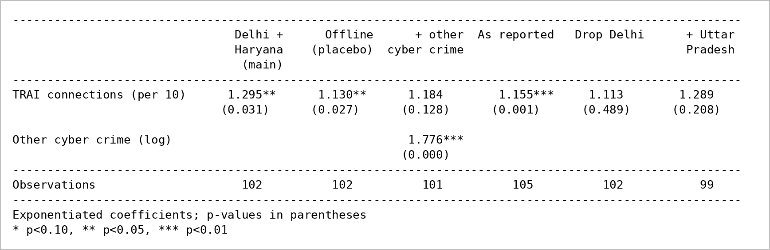
Note: State and year fixed effects; female population as exposure; SE clustered by State.
Table 1.5 India by year, 2017–2024
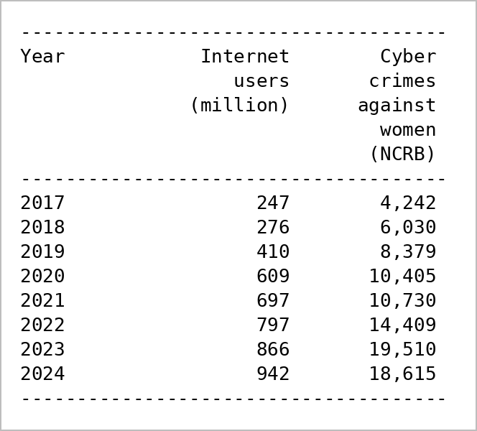
Note: Log of cyber crimes on log of internet users: elasticity 0.991 (p < 0.001), R² 0.94. Correlation of logs 0.969; correlation of yearly growth 0.278 (7 years). Sources: World Bank (internet users), NCRB.
4. What the results show. Better-connected States record more cyber crime against women (1.54 per SD, p = 0.009) and not more offline crime (1.05, p = 0.77). This link is explained by income: once income per head is held fixed, access no longer matters (0.64 to 1.10, all p > 0.25), while richer States record far more (2.23 to 3.45 per SD) and do not record more offline crime. States with more cyber police stations and cells per person record somewhat less (0.67), likely because small north-eastern States have many units for few people. Within States, access does not predict faster growth under any access measure (0.97 to 1.02, all p > 0.34), for any crime type, or after dropping years or States. TRAI connections move with recorded cyber crime against women (1.30, p = 0.031), but offline crimes move with them too (1.13, p = 0.027), and the link fades once growth in all other cyber crime is held fixed (1.18, p = 0.13), so it reflects broader growth in what police record. Nationally, internet users and recorded cyber crime against women rose together almost one-for-one (elasticity 0.99), but years of faster internet growth were not years of faster crime growth (correlation 0.28).
5. How this led to Part 2. Part 1 finds that recorded cyber crime against women follows income and police recording, not internet access as such. That raised two questions for Part 2: did a newer change, AI image tools after 2022, leave a mark that access did not, and how much of what we see is shaped by how States record and police these crimes? Part 2 therefore tests the post-2022 period and adds labelling and capacity controls directly.

Part 2: the period after AI image tools spread
1. What we ran. First, national totals showing how cyber crime and its "other" category grew within all crimes against women. Then Model 2: whether cyber crime against women rose more after 2022 than offline crimes in States that were more exposed before 2023, for six exposure measures. Validity checks: an event study with a joint pre-trend test, fake start years (2019, 2020, 2021), a cyber fraud placebo, and dropping 2020, 2024 or Karnataka and Telangana. The model was also run for each cyber crime type, under four labelling controls, with income, urban share, civil police and cyber police units as controls, and as a within-State test of expanding cyber policing (2020–2024).
2. Why. If AI image tools raised abuse that reaches the police, the rise should be larger where more people were online before the tools arrived. The validity checks test whether more- and less-exposed States were already on different paths. The labelling and capacity controls address the two reasons, found in Part 1, why the records might hide or fake an effect.
3. Results (Stata).
Table 2.1 Cyber crime and the "other" category, India
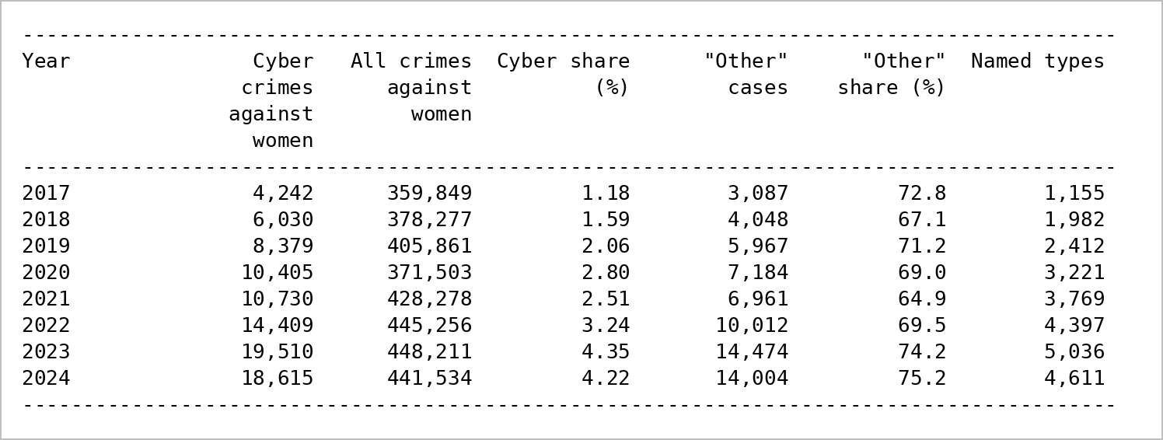
Note: NCRB national totals. 2023–24 against 2021–22: "other" × 1.68; the named types together × 1.18.
Table 2.2 Model 2: change after 2022 per SD of exposure
Rate ratio; p-values in parentheses
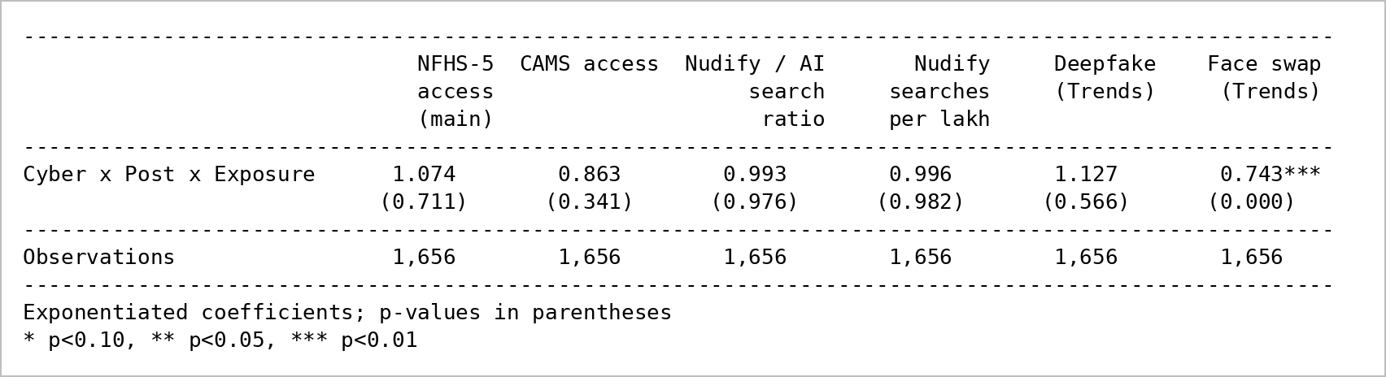
Note: Fixed effects: State × crime, State × year, crime × year; SE clustered by State. Randomisation inference for the main column: p = 0.58. The face-swap estimate has an implausibly small standard error for 35 States.
Table 2.3 Event study, base year 2022, NFHS-5 exposure
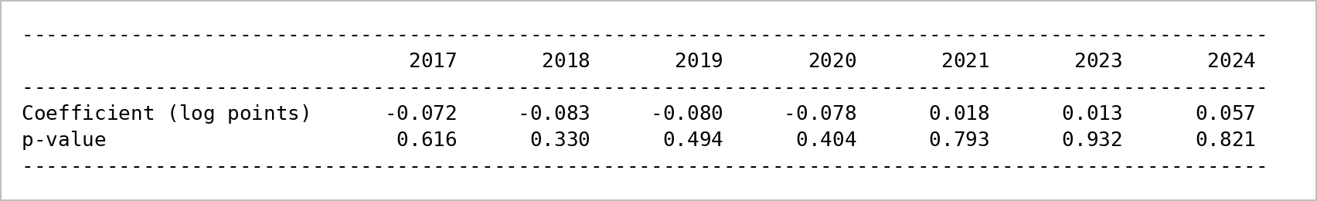
Note: Joint pre-trend test (2017–2021 = 0): χ²(5) = 2.80, p = 0.731. With the nudify / AI search ratio as exposure: χ²(5) = 39.19, p < 0.001 (fails).
Table 2.4 Validity checks, NFHS-5 exposure
Rate ratio; p-values in parentheses
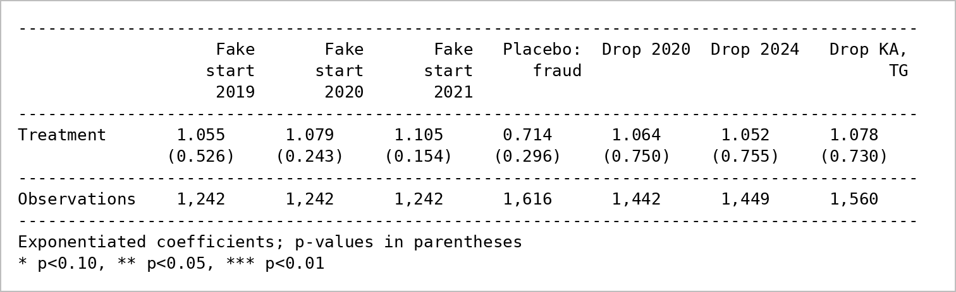
Note: By cyber crime type: blackmail 0.906 (0.757); morphing 0.183** (0.022); fake profile 0.494 (0.402); obscene material 1.015 (0.880); other 1.220 (0.455); stalking 0.706 (0.162).
Table 2.5a Labelling controls (NFHS-5 exposure unless named)
Rate ratio; p-values in parentheses
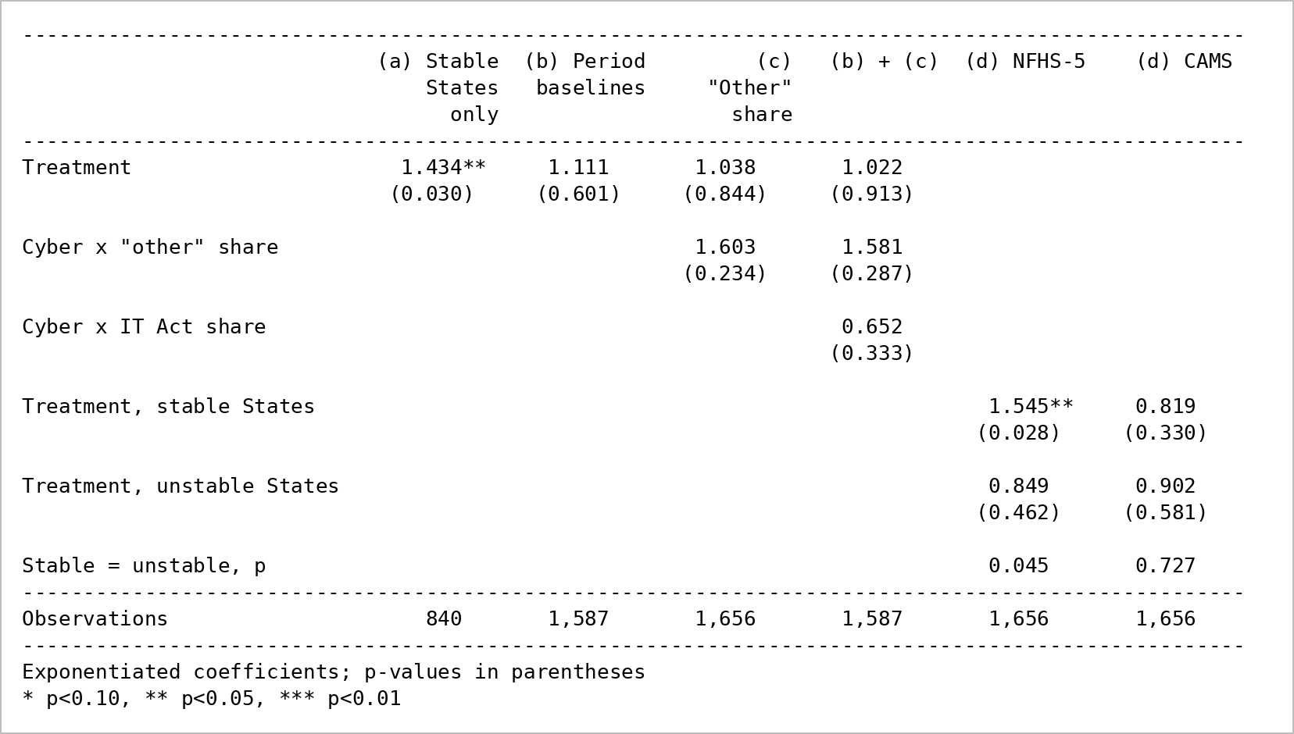
Note: (a) the 18 States without labelling breaks; (b) a separate baseline for each State's recording period; (c) controls for the "other" and IT Act shares; (d) effect allowed to differ between stable and unstable States.
Table 2.5b Capacity controls, 33 States
Rate ratio per SD after 2022; p-values in parentheses
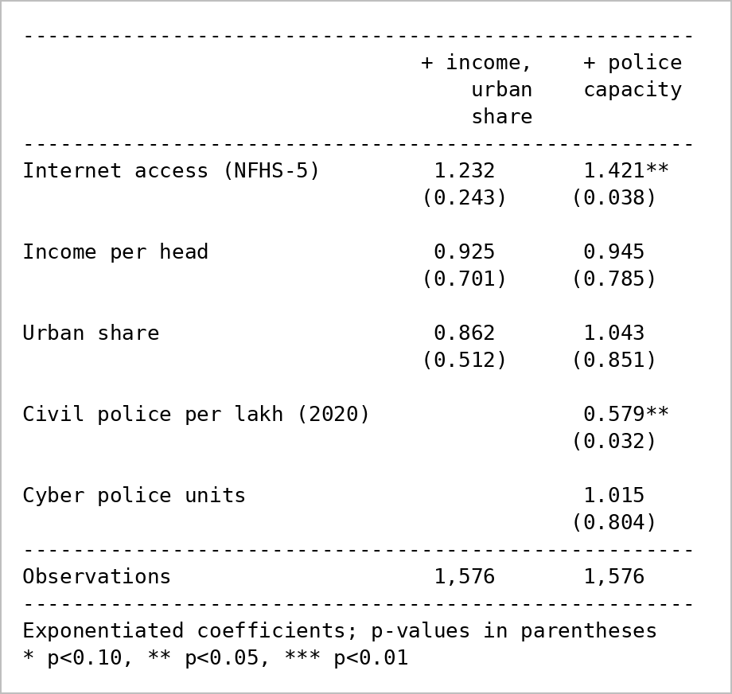
Note: Each control interacted the same way as exposure (Cyber × Post × Control).
Table 2.6 Expanding cyber policing within States, 2020–2024
Rate ratio per log unit of cyber police stations and cells per crore people; p-values in parentheses
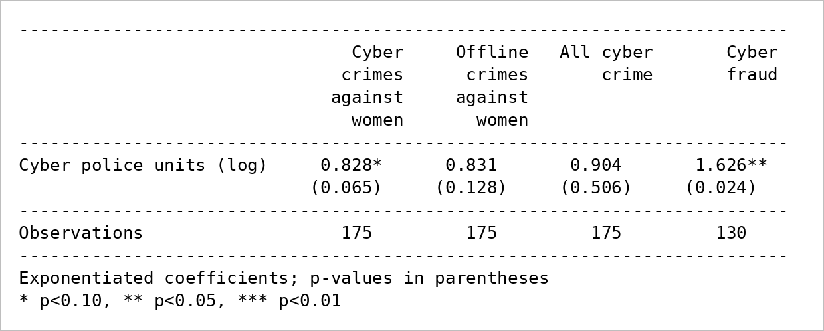
Note: State and year fixed effects; population as exposure; SE clustered by State. BPR&D reports for 1 January 2020, 2021, 2022, 2024; 2023 interpolated.
4. What the results show. Cyber crime grew from 1.2% to 4.4% of all recorded crimes against women between 2017 and 2023, and the growth after 2022 sits mostly in "other" (up 68%, against 18% for the named types). But Model 2 finds no larger rise after 2022 in better-connected States (1.07, p = 0.71). The design holds: the years before 2023 show no gap (pre-trend p = 0.73), fake start years show nothing, and the placebo and dropped-year results match. The search-based exposures are null too, and the face-swap estimate is not credible (its standard error is implausibly small for 35 States). There are two exploratory exceptions. In the 18 States with stable recording, the rise is larger in better-connected States (1.43, p = 0.030; the difference from unstable States has p = 0.045). With civil police strength held fixed, access shows a larger rise (1.42, p = 0.038) and better-policed States a smaller one (0.58), though neither shows alone and the CAMS measure does not repeat the stable-State result. Expanding cyber policing raised recorded cyber fraud (1.63, p = 0.024) but not cyber crime against women (0.83, p = 0.065).
5. How this led to Part 3. Police records give no robust sign of an AI-period effect, while hints appear only where recording is stable or policing is held fixed, and cyber policing has gone to fraud. This pointed away from the police records and toward the record of abuse reported online, which does not depend on police recording. Part 3 therefore compares police records with complaints made directly to platforms.

Part 3: police records versus complaints to platforms
1. What we ran. First, national counts by year of police-recorded cyber crime against women and of sexual-content complaints to platforms, and each platform's sexual-content complaints as a share of all its complaints. Then the main share-adjusted comparison for 2022–2024: the yearly growth of cyber crimes against women relative to offline crimes in police records, against the yearly growth of each platform's sexual-content complaints relative to its other complaints, with a test of whether each platform differs from the police side. Last, the secondary comparison of raw growth, and a pooled estimate across the five platforms.
2. Why. Parts 1 and 2 suggest the police records may not capture what is happening. Platform complaints are a separate record of abuse reported online. The share adjustment removes growth of the complaint routes themselves, such as the seven-fold rise in all complaints to Meta in 2023 after the IT Rules amendment and the Grievance Appellate Committee, so the comparison is about sexual-content complaints and not about more people using the routes.
3. Results (Stata).
Table 3.1 Police records and platform complaints by year, India
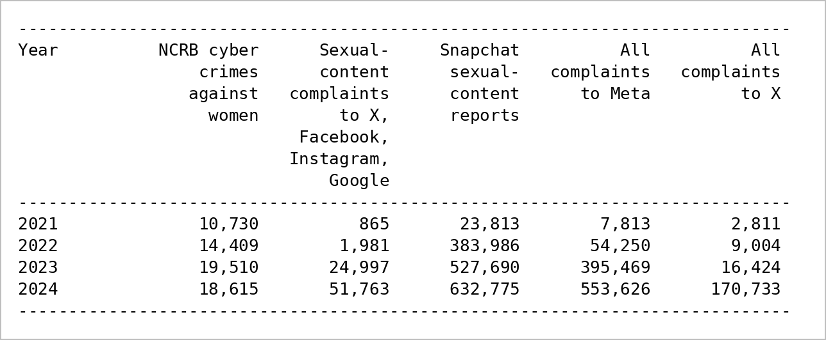
Note: 2021 covers June to December for most platforms; NCRB ends in 2024. Sources: NCRB; monthly reports under the IT Rules 2021.
Table 3.2 Sexual-content complaints as % of each platform's complaints
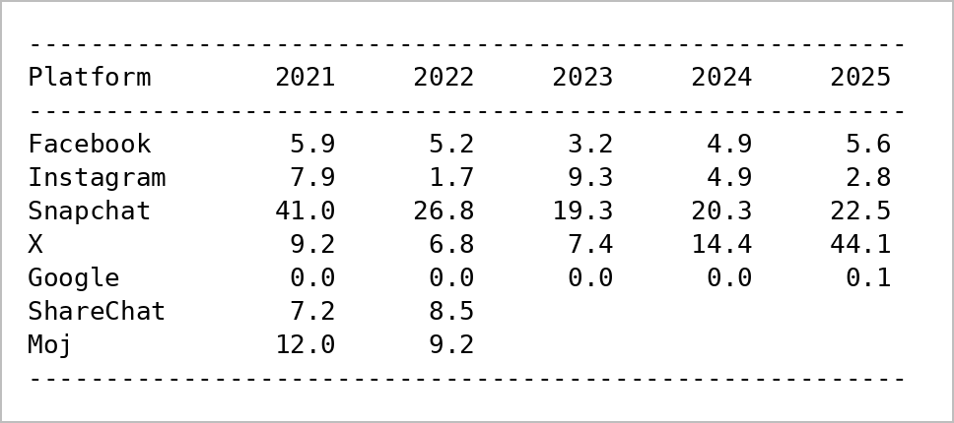
Note: X 2025 covers January and February only. ShareChat and Moj stopped publishing after October 2022. Compare each platform with itself over time only.
Table 3.3 Growth per year, 2022–2024: main (share-adjusted) and secondary (raw)
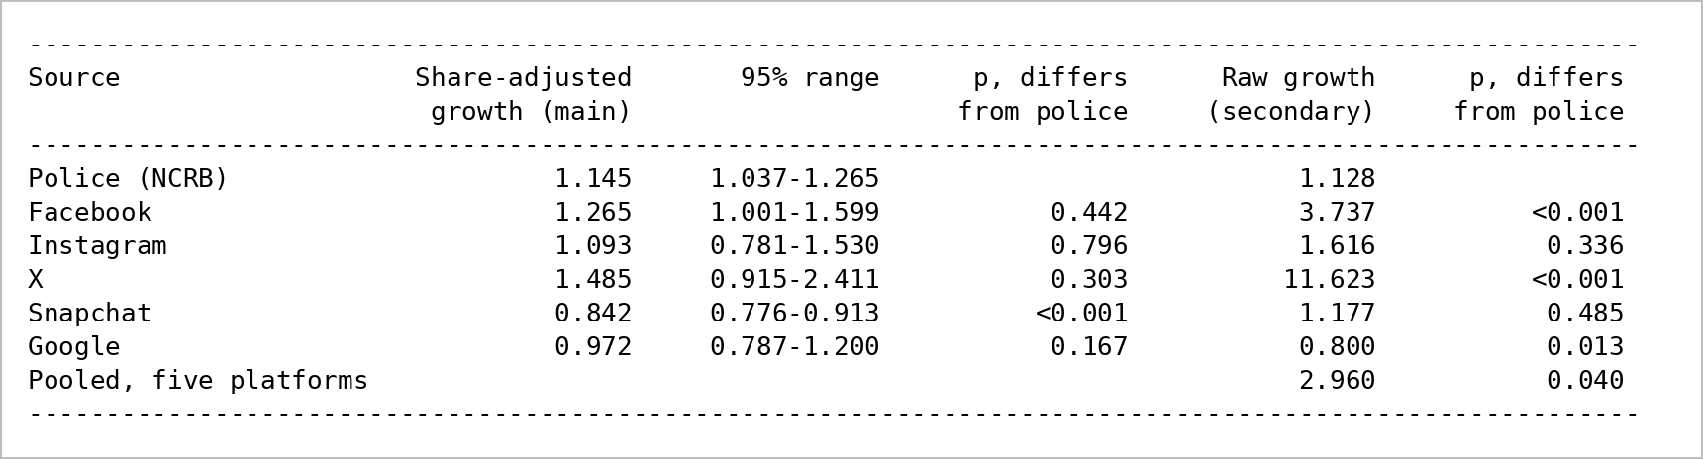
Note: Share-adjusted: relative to each source's own comparison group (police: offline crimes against women; platform: its other complaints). p tests whether the platform's growth equals police growth. The pooled estimate is a rough summary of the platform side, not a comparison between platforms.
4. What the results show. In raw numbers, complaints to platforms grew far faster than police records: sexual-content complaints to X, Facebook, Instagram and Google rose from 1,981 in 2022 to 51,763 in 2024, while recorded cyber crime against women rose from 14,409 to 18,615. Raw growth was 3.7 times a year for Facebook and 11.6 for X, against 1.13 for police records (both p < 0.001), and 2.96 for the five platforms pooled (p = 0.040). Much of this is growth of the complaint routes: all complaints to Meta rose from 54,250 in 2022 to 553,626 in 2024. In the main, share-adjusted comparison, police records show cyber crime against women growing 1.15 times a year faster than offline crime, and no platform's sexual-content complaints grew faster than that relative to its other complaints (Facebook 1.27, p = 0.44; X 1.49, p = 0.30; Instagram 1.09, p = 0.80; Google 0.97, p = 0.17). Snapchat's grew more slowly (0.84, p < 0.001). So the gap between online and police reporting is one of scale: far more is reported to platforms, and that volume grew much faster, but the share that concerns sexual content changed about as much as cyber crime did in police records.
5. Where this leads. Taken together, the three parts find that India's police records track income and recording capacity, show no robust sign of the AI period, and capture a small and steady slice of what is reported online. This supports measuring technology-facilitated abuse from sources outside police records; possible extensions are listed under Optional ways forward.

Limitations
The study measures associations, not causes. No source gives a change in internet access or AI tools that reaches some States and not others by chance, so every estimate can still reflect something that differs between States, such as income or policing, even after the controls.
- Police records miss most abuse, and new kinds have no category. Only cases that are reported and registered appear, the share reported is unknown and likely differs by State, and NCRB cannot separate abuse that uses AI-made images from other cyber crime against women.
- Few States and years. With 35 units, eight years and only two years after 2022, small effects cannot be detected.
- Recording changes over time. Half the States show sudden shifts in how they label cyber cases, and the new criminal code changed categories in July 2024. The labelling controls reduce this problem but cannot remove it.
- Some measures are coarse. Survey access comes from single years, TRAI counts connections rather than people, cyber police units are counted only from 2020 and may respond to the crimes as well as drive them, and there is no State-level measure of AI-tool use before 2023.
- Platform data are national and inconsistent. Platforms do not report by State, use different categories, change formats (X in March 2025) or stop reporting (ShareChat and Moj after October 2022), and the national cyber crime portal publishes no breakdown by category.

Optional ways forward (if needed)
These are possible extensions, not part of the current plan.
- A risk index for technology-facilitated abuse. Following the Geopolitical Risk index (Caldara and Iacoviello, 2022), which counts newspaper articles about adverse geopolitical events, build a monthly index from text such as news, platform reports and searches. It would measure the problem without depending on how police file a case.
- The market for AI abuse tools. Collect public posts from Telegram, Reddit, X and YouTube offering to generate sexual images of real people, recording how many such services appear over time, what they charge and how many users each channel has. This would measure the supply of these tools directly. It is left for later because collecting and cleaning the data, with ethical review, is a large task.

References
Amaral, S., Bhalotra, S. and Prakash, N. (2021). Gender, Crime and Punishment: Evidence from Women Police Stations in India. IZA Discussion Paper 14250.
Bhuller, M., Havnes, T., Leuven, E. and Mogstad, M. (2013). Broadband Internet: An Information Superhighway to Sex Crime? Review of Economic Studies, 80(4), 1237–1266.
Caldara, D. and Iacoviello, M. (2022). Measuring Geopolitical Risk. American Economic Review, 112(4), 1194–1225.
Deeptrace (2019). The State of Deepfakes: Landscape, Threats, and Impact. Amsterdam: Deeptrace.
Diegmann, A. (2019). The Internet Effects on Sex Crime Offenses: Evidence from the German Broadband Internet Expansion. Journal of Economic Behavior and Organization, 165, 82–99.
Iyer, L., Mani, A., Mishra, P. and Topalova, P. (2012). The Power of Political Voice: Women's Political Representation and Crime in India. American Economic Journal: Applied Economics, 4(4), 165–193.
Kumar, H. and Somanathan, R. (2009). Mapping Indian Districts Across Census Years, 1971–2001. CDE Working Paper 176, Delhi School of Economics.
Pesando, L. M. (2022). Safer If Connected? Mobile Technology and Intimate Partner Violence. Demography, 59(2), 653 onwards.

