**Business Requirement Document (BRD)**

E-Commerce Checkout Process Improvement

**Version: 1.0  
Author: Harshita Devangan  
Date: September 10, 2025**

# 1. Executive Summary

This project aims to improve the checkout process of an e-commerce platform to reduce cart abandonment and increase successful order completions. The initiative will simplify the process, introduce guest checkout, integrate multiple payment options, and improve overall user experience.

# 2. Business Objectives

* Reduce checkout abandonment by 20% in 6 months.
* Improve conversion rate of checkout page by 15%.
* Provide a seamless and faster checkout experience (3 steps maximum).
* Offer multiple secure payment options (UPI, Wallets, COD, Cards).
* Increase customer satisfaction and retention.

# 3. Current vs Proposed Process

Current Checkout Process:

1. Cart
2. Login/Sign-up
3. Address Page
4. Payment Page
5. Order Confirmation

Proposed Checkout Process:

1. Cart
2. Combined Checkout Page (Login/Guest, Address, Payment, Delivery Charges, Summary)
3. Order Confirmation

# 4. Scope

In Scope:

* Redesign of checkout workflow.
* Integration of multiple payment gateways.
* Implementation of guest checkout.
* Display of real-time delivery charges & estimated delivery date.
* Enhanced order summary page.

Out of Scope:

* Changes to product browsing/catalogue.
* Warehouse/logistics systems.
* Marketing campaigns.

# 5. Stakeholders

* Business Owner / CEO: Wants revenue growth.
* Product Manager: Owns checkout feature roadmap.
* Business Analyst: Gather requirements, document BRD, ensure alignment.
* UI/UX Team: Redesign checkout flow.
* Developers: Implement changes.
* QA/Testers: Validate new checkout process.
* Customers: End-users of the checkout process.

# 6. Requirements

Functional Requirements:

* System should allow guest checkout without mandatory login.
* User should be able to save multiple addresses.
* Payment options should include UPI, Cards, Wallets, Net Banking, COD.
* System should show real-time delivery charges & delivery date.
* Checkout should complete in 3 steps or less.
* Order summary should display total cost, delivery, and discounts clearly.

Non-Functional Requirements:

* Page load time should be < 3 seconds.
* Payment transactions should have 99.9% success rate.
* System should comply with PCI DSS (payment security standards).

# 7. Use Case Example

Use Case: Guest Checkout

* Actor: Customer
* Trigger: Customer clicks 'Proceed to Checkout' with items in cart.
* Steps:
* 1. Customer selects 'Guest Checkout'.
* 2. Enters delivery address & contact info.
* 3. Selects payment option.
* 4. Reviews order summary.
* 5. Confirms order.
* Outcome: Order placed successfully without login.

# 8. Key Performance Indicators (KPIs)

* Cart abandonment rate reduced by 20%.
* Conversion rate increased by 15%.
* Average checkout time reduced from 5 mins to < 2 mins.
* Customer satisfaction score improved from 70% to 85%.

# 9. Diagrams

Process Flow Diagram:

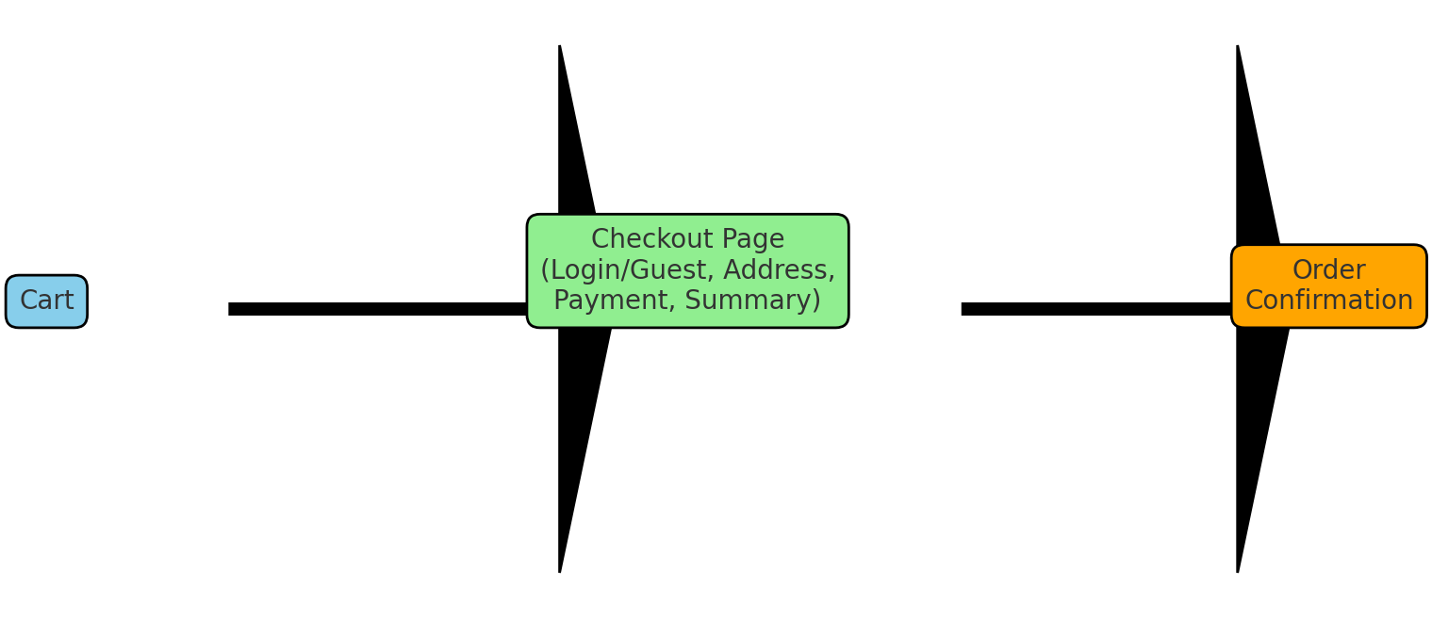

Use Case Diagram:

