Section-a

QUES 1: Create a program for fetch routine of the instruction cycle.

ANS:

Insert the instructions created for fetch rotine in “edit machine’s fetch sequence”.

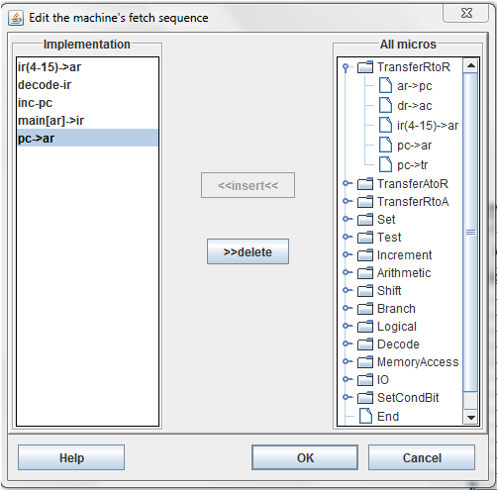

QUES 2:Simulate the machine to determine the contents of AC,E,PC,AR and IR registers in hexadecimal after the execution of each of following register reference instructions:

a.CLA e.CIR i.SNA

b.CLE f.CIL j.SZA

c.CMA g.INC k.SZE

d.CME h.SPA i.HLT

Initialize the contents of AC to A937,that of PC to hexadecimal 021 and the value of E to 1.

ANS:1.Go to create new machine and then modify and then to hardware modules. Create registers ac,ar,dr,e,ir and pc.

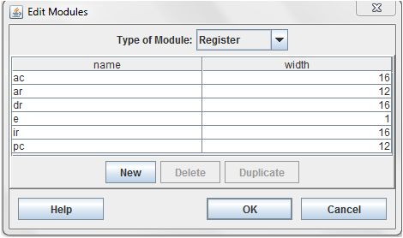

2.Go to type of module-condition bit.Create halt bit with following specification.

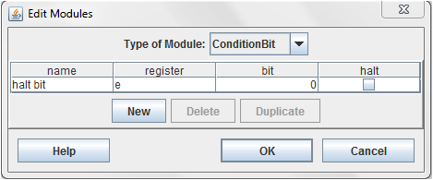

3.Create RAM of suitable size.

For example-4096 in this case of 4096\*16 memory.

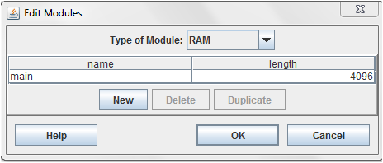

4.Now go to mico instructions and create the following instructions.

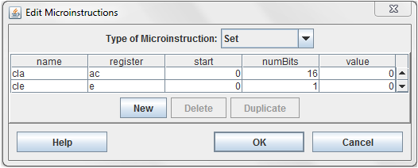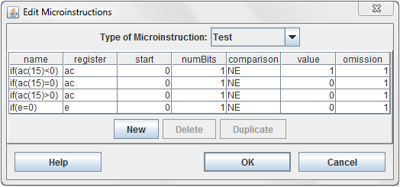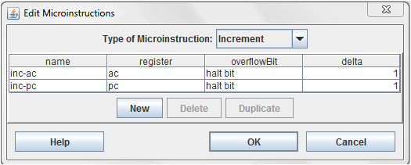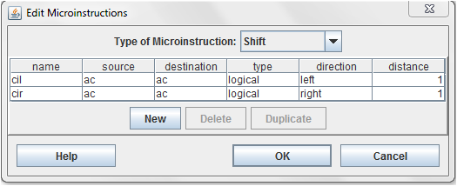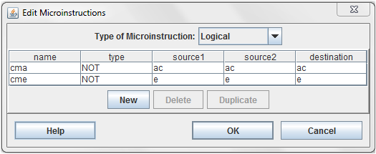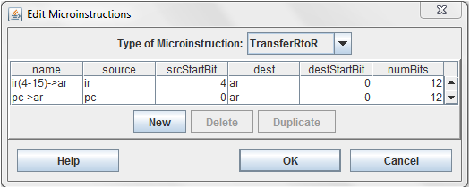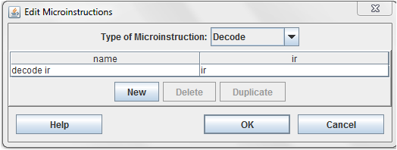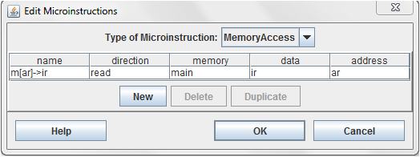

5.Go to edit field and create field for micro-instructions.

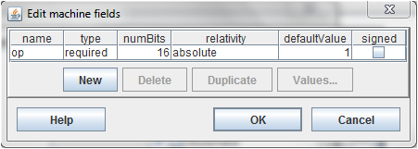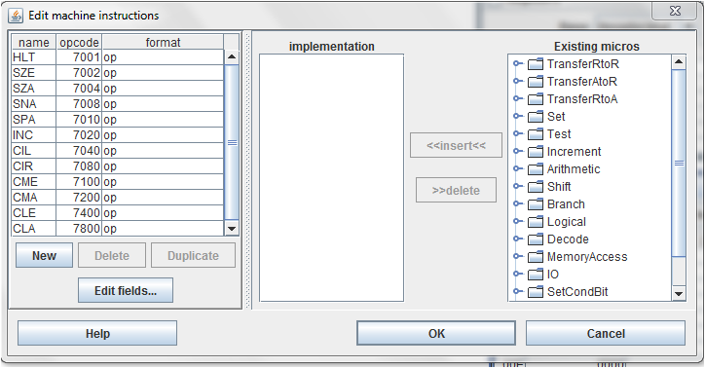

Implement each machine instruction with appropriate micro-instruction.

For ex:

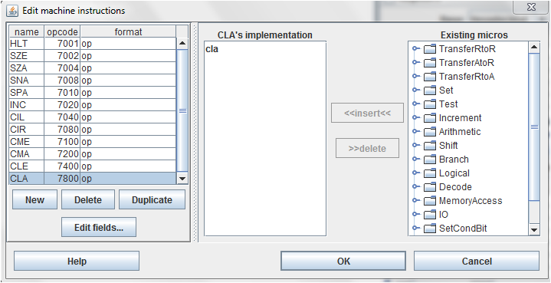

6.Create fetch sequence.

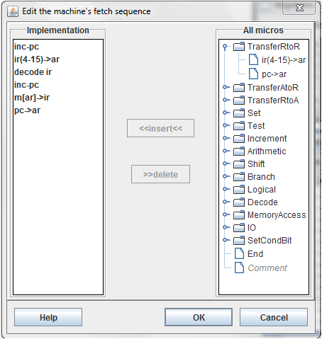

7.Go to execute and then to options and then to loading insert starting address in decimal.

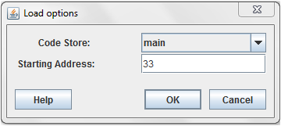

8.View RAM and REGISTERS.

9.After execution of micro instructions value in the registers will be as follow:

(a).CLA

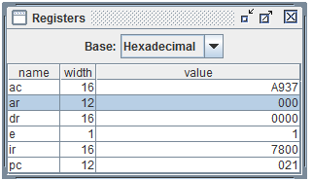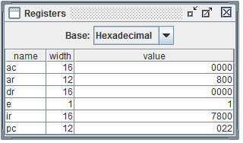

(b)CLE

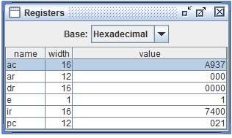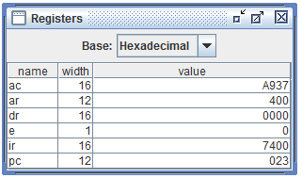

(c) CMA

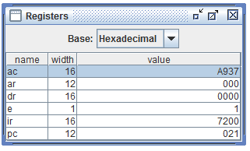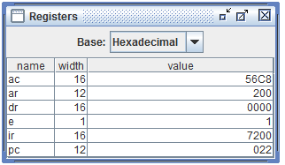

(d) CME

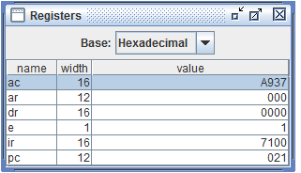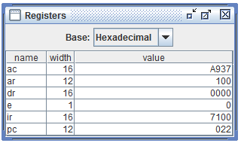

(e) CIR

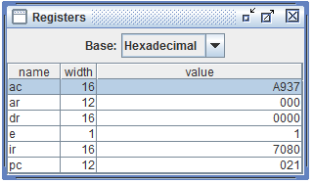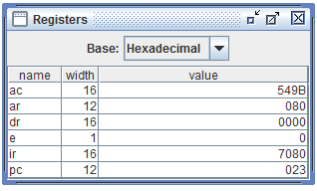

(f) CIL

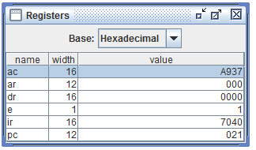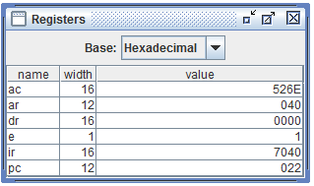

(g) INC

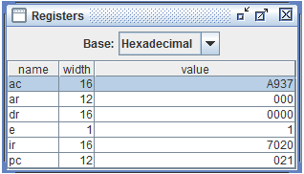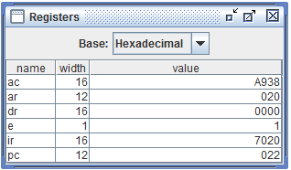

(h) SPA

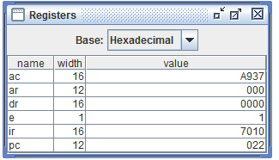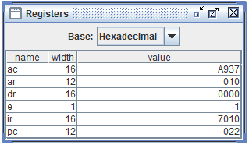

(i)SNA

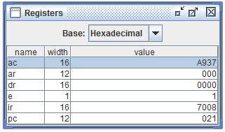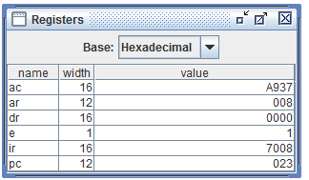

(j) SZA

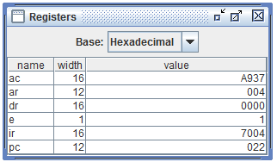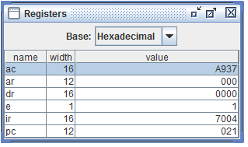

(k) SZE

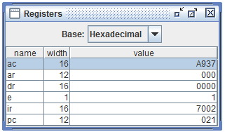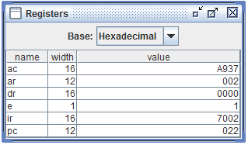

QUES 3-Simulate the machine for following memory-reference instructions with i=0 and address part=083. The instruction to be stored at address 021.Initialize the memory word at address 083 with the operand B8F2 and AC with A937.Determine the contents of AC,DR,PC,AR and IR in hexadecimal after the execution.

1.ADD 5.BUN

2.AND 6.BSA

3.LDA 7.ISZ

4.STA

ANS:1.Create registers in the hardware module.

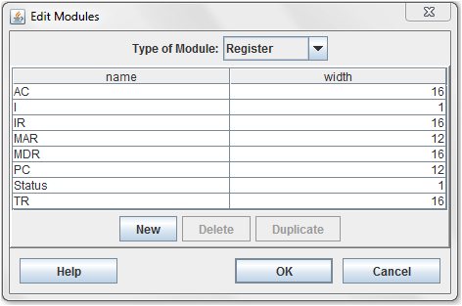

Create condition bit.

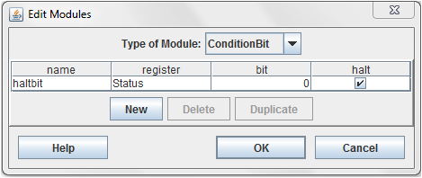

Create RAM

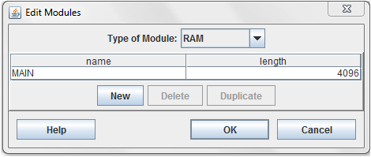

2.Create micro-instructions.

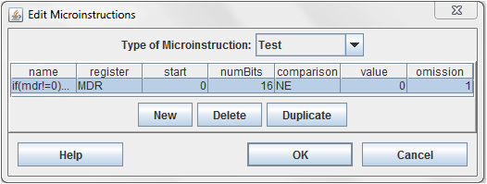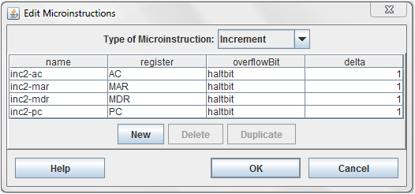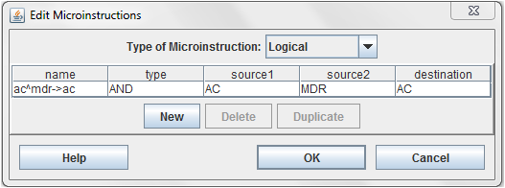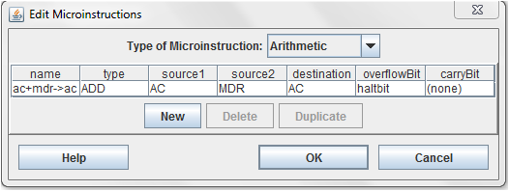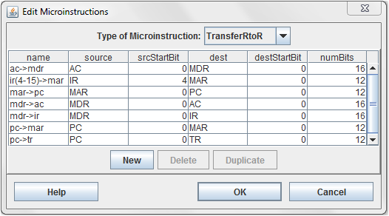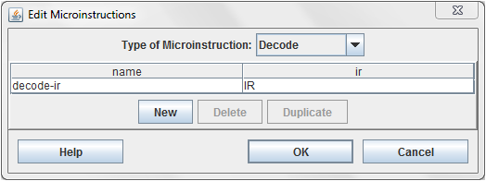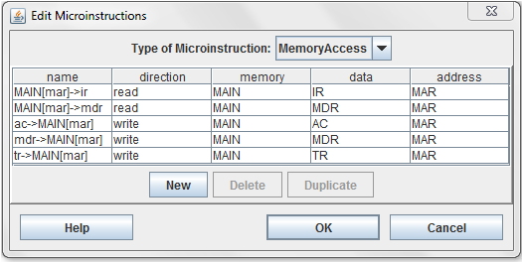

3.Create fields for machine instruction and then instructions with specific op code.

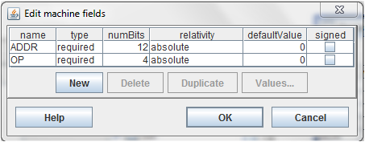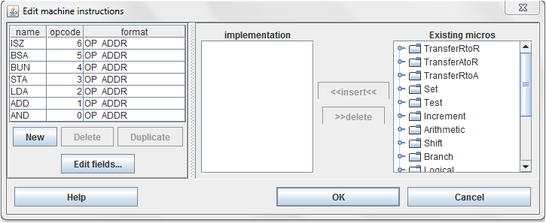

Implement each instruction with its micro-instruction.for ex:

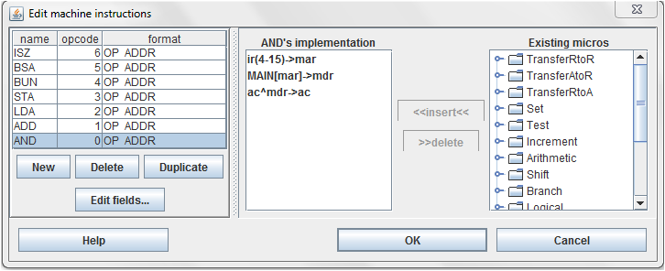

4.Create fetch sequence.

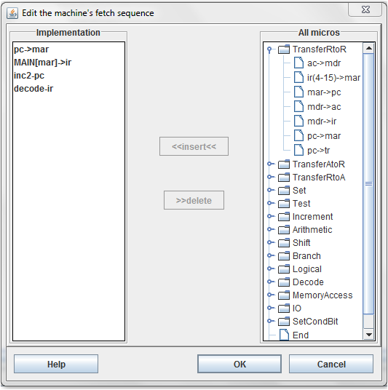

5.Go to execute ,option and then in loading and insert starting address.

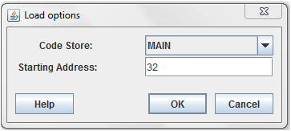

6.Go to view.and click on REGISTERS and RAM.

Write the given values of registers.

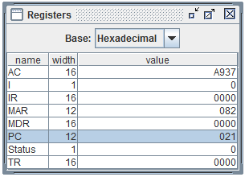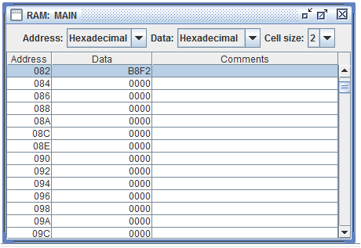

QUES 4:Repeat ques 3 with i=1.

ANS:1.Create registers in the hardware module.



Create condition bit.



Create RAM



2.Create micro-instructions.



3.Create fields for machine instruction and then instructions with specific op code.



Implement each instruction with its micro-instruction.for ex:



4.Create fetch sequence.



5.Go to execute ,option and then in loading and insert starting address.



6.Go to view.and click on REGISTERS and RAM.

Write the given values of registers.

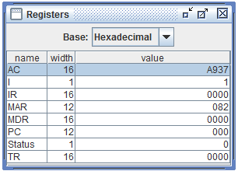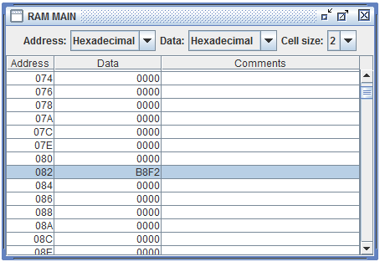

QUES 5:Modify the machine for basic computer as follows:

a.Add a register CTR(count register)

b.Add a new instruction LDC that loads a number into CTR

LDC Address CTR<-M[Adress]

c.Add a new instruction ICSZ(increment CTR and skip if zero)

ANS:

1.Modify hardware module.

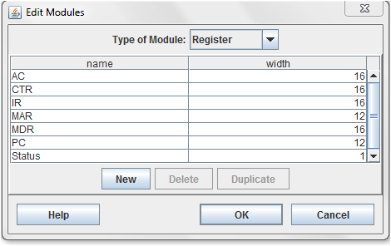

2.Then modify mcro-instructions.

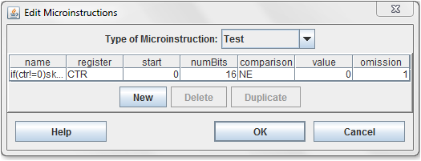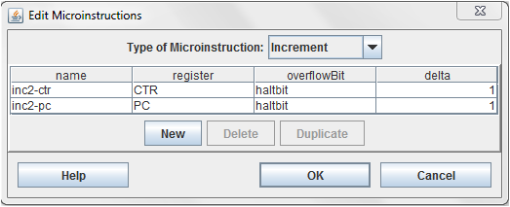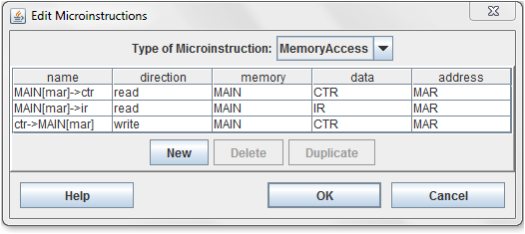

3.Edit machine instruction as follow:

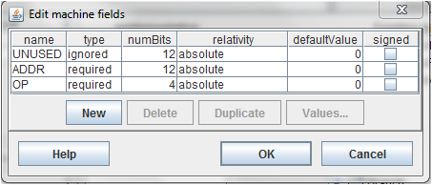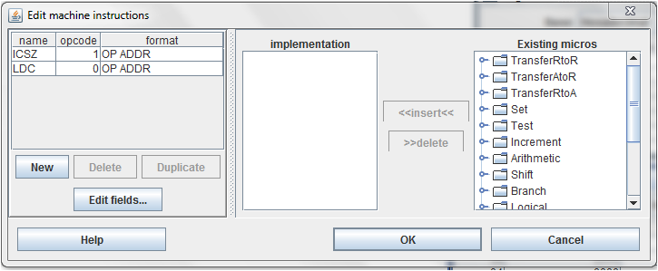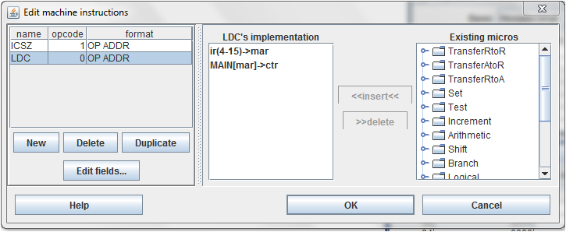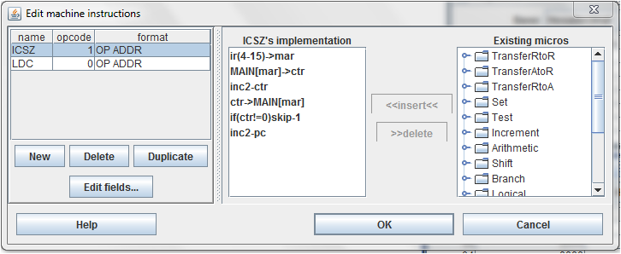

SECTION-B

QUES 1:Create a microprogram for hypothetical basic computer given in ch.-7 of Morris Mano. Repeat ques no. 2 of section A for this machine.

ANS: 1.Go to create new machine and then modify and then to hardware modules. Create registers ac,ar,dr,e,ir and pc.

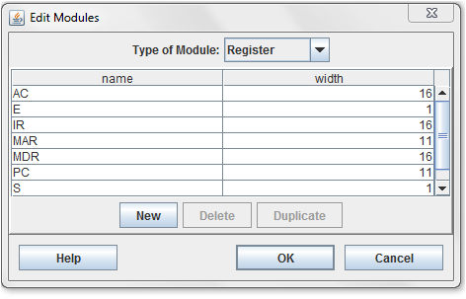

2.Go to type of module-condition bit.Create halt bit with following specification.

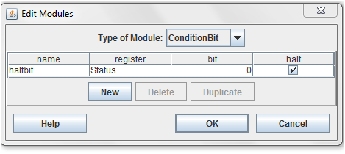

3.Create RAM of suitable size.

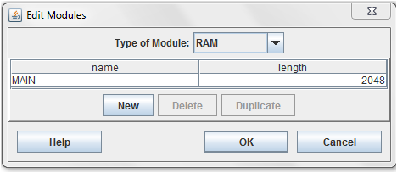

4.Now go to mico instructions and create the following instructions.

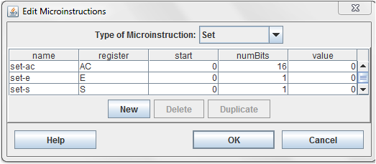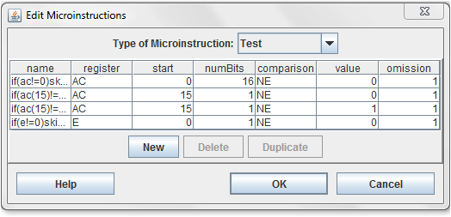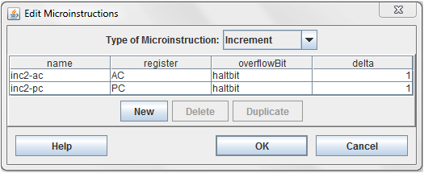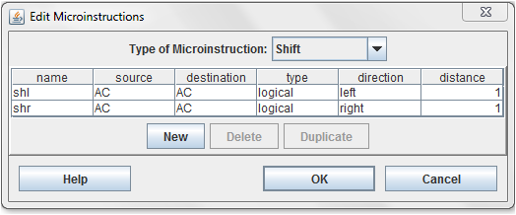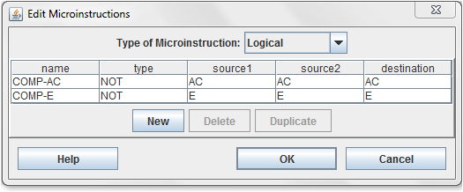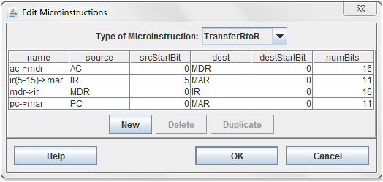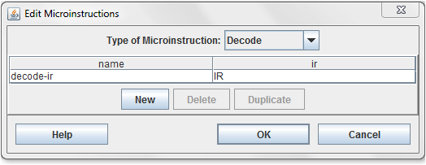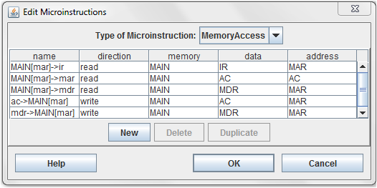

5.Go to edit field and create field for micro-instructions.

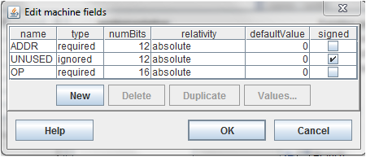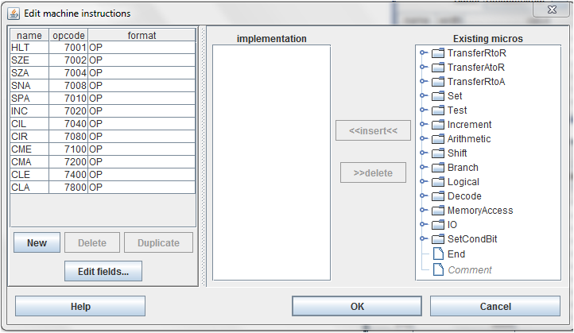

Implement each machine instruction with appropriate micro-instruction.

For ex:

6.Create fetch sequence

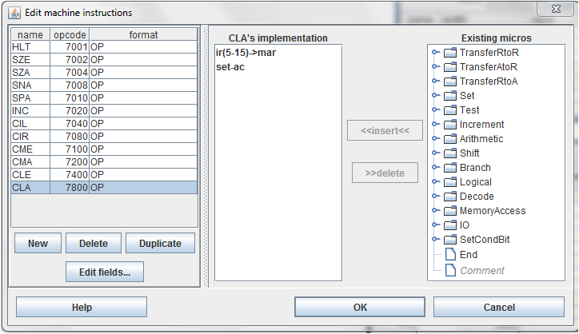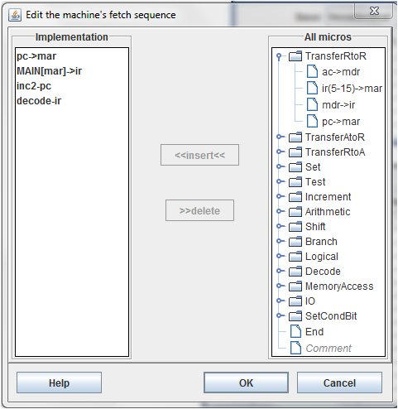

7.Go to execute and then to options and then to loading insert starting address in decimal

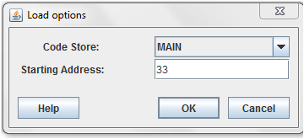

8.View RAM and REGISTERS.

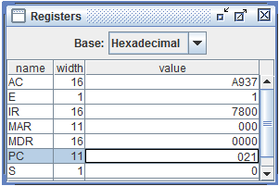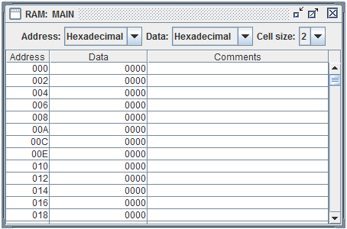

After execution of micro-instructions,registers value are as follow:

(a)CLA

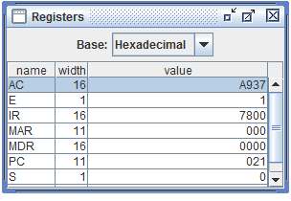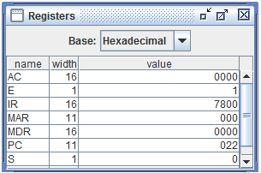

(b) CLE

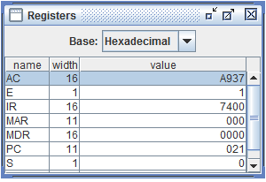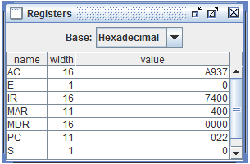

(c) CMA

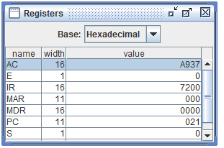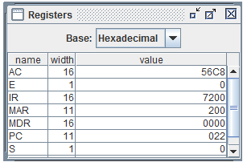

(d) CME

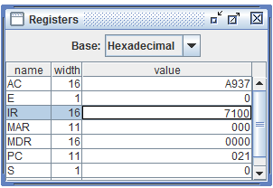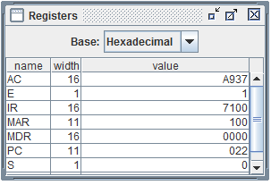

(e) CIR

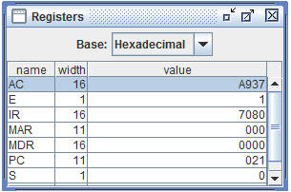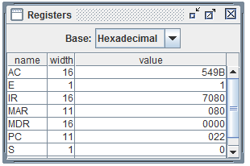

(f) CIL

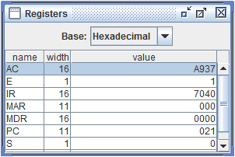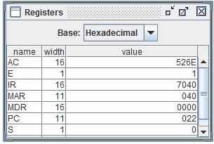

(g)INC

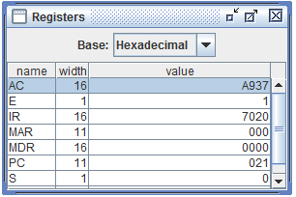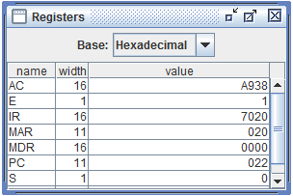

(h) SPA

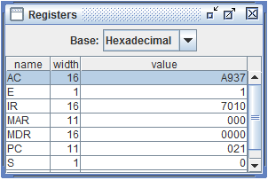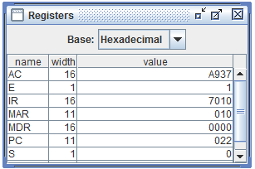

(i)SNA

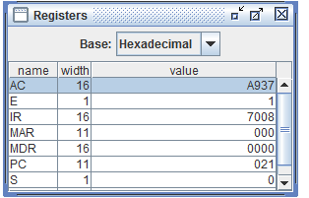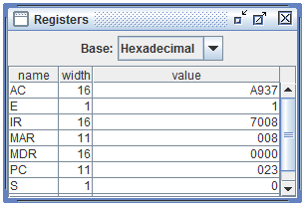

(j) SZA

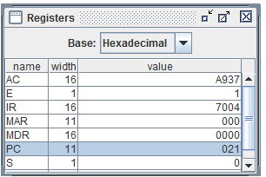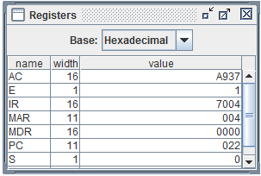

(k)SZE

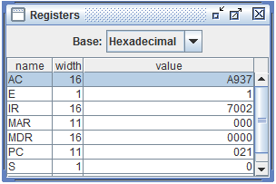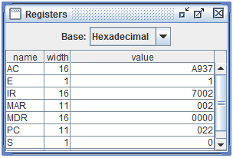

QUES 2: Create a microprogram for hypothetical basic computer given in ch.-7 of Morris Mano. Repeat ques no. 3 of section A for this machine.

ANS:1.Create registers in the hardware module.

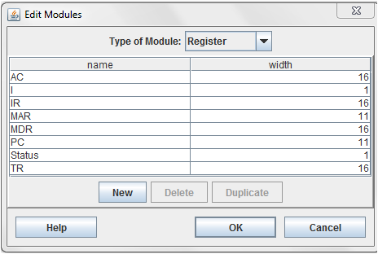

Create condition bit.

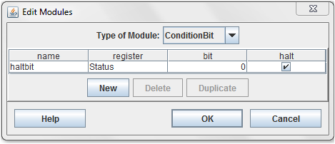

Create RAM

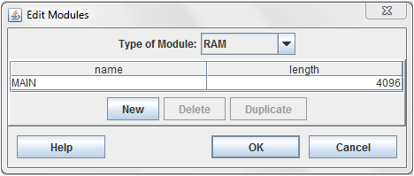

2.Create micro-instructions.

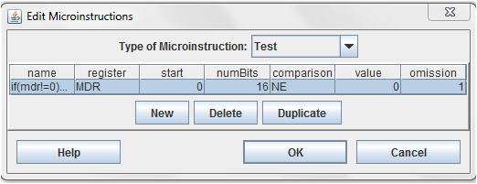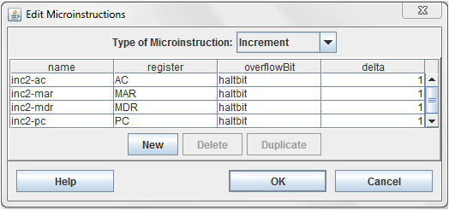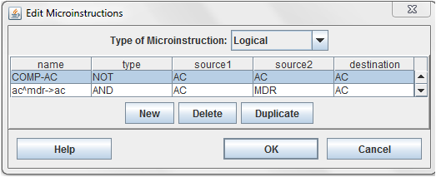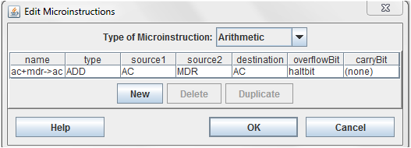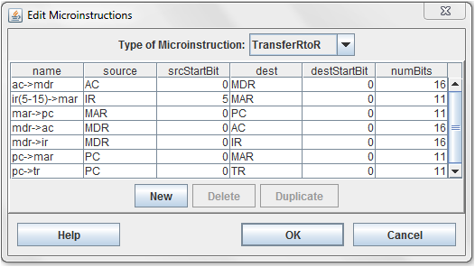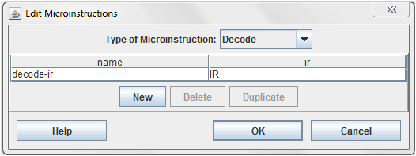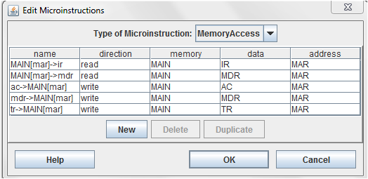

3..Create fields for machine instruction and then instructions with specific op code.

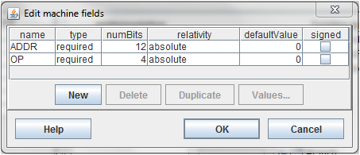

Implement each instruction with its micro-instruction.for ex:

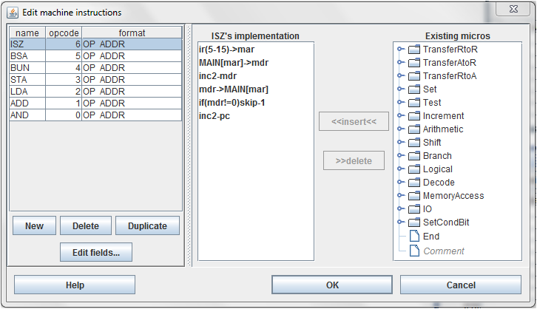

4.Create fetch sequence

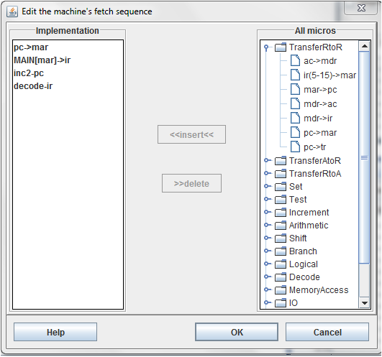

5.Go to execute ,option and then in loading and insert starting address.

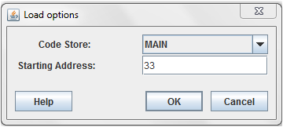

6.Go to view.and click on REGISTERS and RAM.

Write the given values of registers.

After execution of micro-instructions value of registers are:

(a)AND

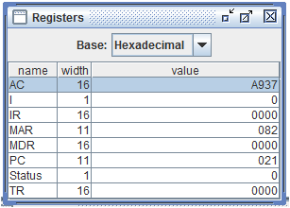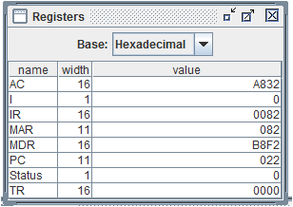

(b)ADD

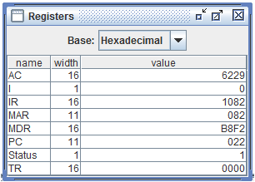

(c) LDA

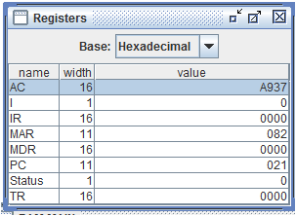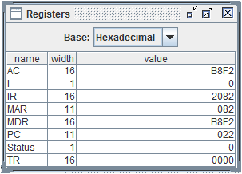

(d)STA

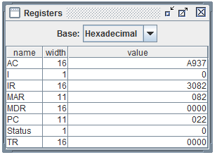

(e)BUN

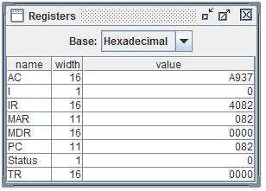

(f)BSA

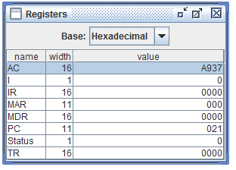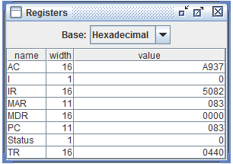

(g)ISZ

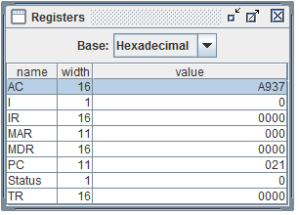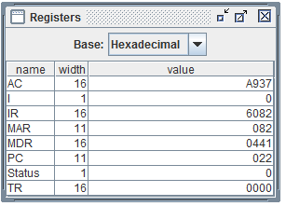

QUES 3: Create a microprogram for hypothetical basic computer given in ch.-7 of Morris Mano. Repeat ques no. 4 of section A for this machine.

ANS:1.Create registers in the hardware module.



Create condition bit.



Create RAM



2.Create micro-instructions.



3..Create fields for machine instruction and then instructions with specific op code.



Implement each instruction with its micro-instruction.for ex:



4.Create fetch sequence



5.Go to execute ,option and then in loading and insert starting address.



6.Go to view.and click on REGISTERS and RAM.

Write the given values of registers.

After execution of mocro-instructions, value of registers are:

(a)AND

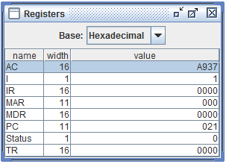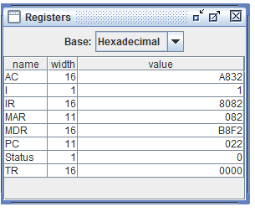

(b)ADD

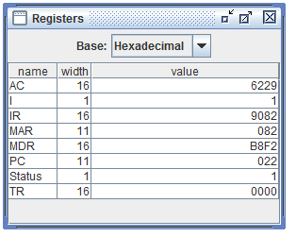

(c) LDA

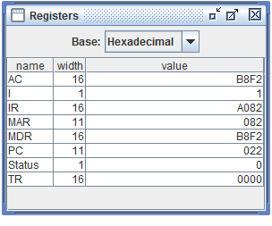

(d)STA

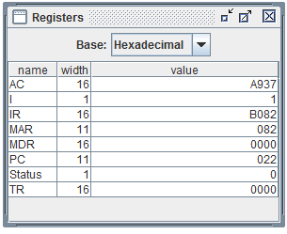

(e) BUN

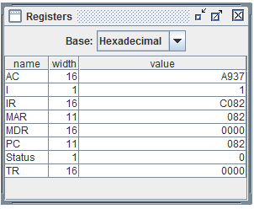

(f)BSA

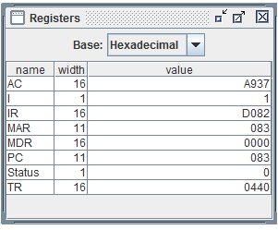

(g)ISZ



SECTION-C

QUES 1:Write a program to add two user-entered numbers.

ANS:

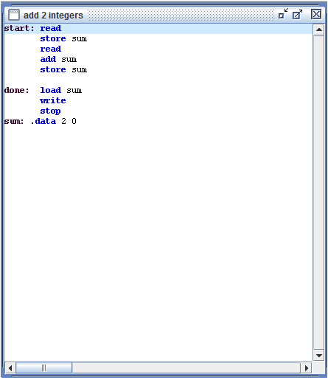

OUTPUT:

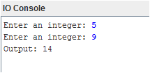

QUES 2:Write a program to subtract two user-entered numbers.

ANS:

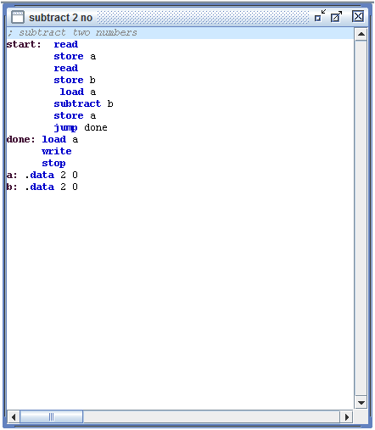

OUTPUT:

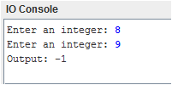

QUES 3: Write a program to add the numbers entered by user until a 0 is entered.

ANS:

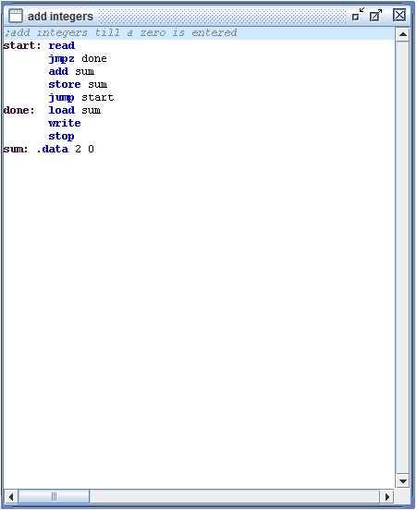

OUTPUT:

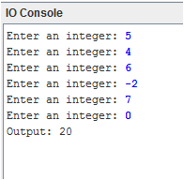

QUES 4:Write a program to multiply two numbers using successive addition.

ANS:

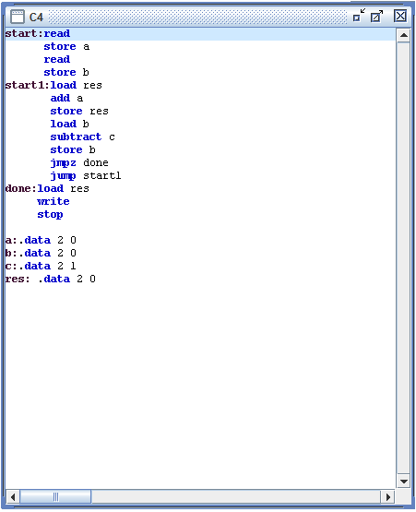

OUTPUT:

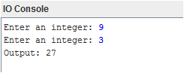

QUES 5: Write a program to multiply two numbers by shifting.

ANS:

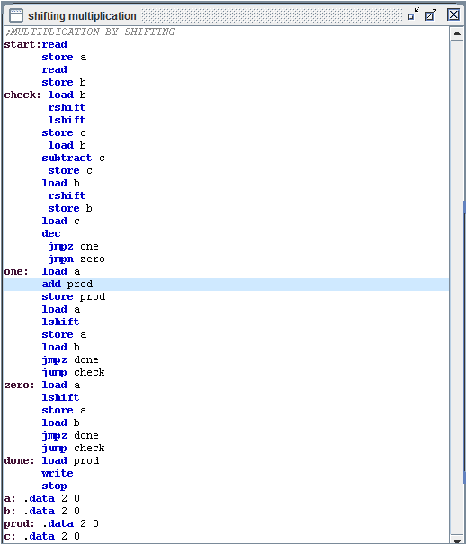

output

