Answer 1 -->An access token is an object that describes the security credentials of a process or thread.

The information in a token includes the identity of the user account associated with the process.

When a user logs on, the system verifies the user's password by comparing it with information stored in a security database.

If the password is authenticated, the system produces an access token.

Every process executed on behalf of this user has a copy of this access token.

Acces token --> https://github.com/settings/tokens/188731272

------------------------------------------------------------------------------------------------

Answer 2 --> In this answer im making the help of a tool named as mxtoolbox.com/DNSLookup

For Google

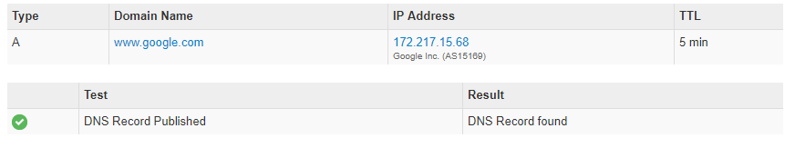

For Twitter

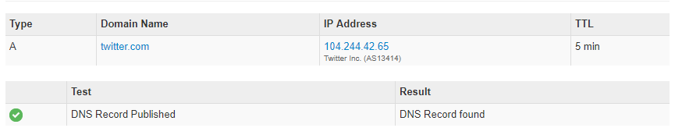

For Acadview

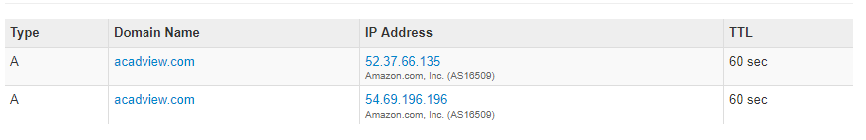

------------------------------------------------------------------------------------------------

Answer 3 --> API is a part of library which defines how an application communicates with external code .

API can be written in any language.

Library is written in same language which is a collection of all the functionalities required for the use case.

For example : Numpy is a library of Python, adding support for large, multi-dimensional arrays and matrices, along with a large collection of high-level mathematical functions to operate on these arrays.

------------------------------------------------------------------------------------------------