**1.What is SDLC**

**Ans :** SDLC stands for “Software Development life Cycle” model. It descibes the sequence of phases or steps to develop any software.

**2.Write SDLC phases with basic introduction**

**Ans**:

**Requirements Collection / Gathering** :- All the relevant information collected from the customer to develop a product per their expectation.

**Analysis Phases :-** in this phases the bussiness manager analysis each requirement to ensure the requirement can be included in the software without causing breaks or problems The deliverale result at the end of this phases is a requirement document.

**Design Phases :-**  Design Architecture Document.

Performance analysis.

Implementation plan.

With the help of requirement document designer design the software .

**Implementation Phases :-**  when the designing of software is complete then a group of developer start coding of design using programing language

in this phase with the help of the Architecture Document from the design phase and Requirement document from the analysis phase , the team should build exactly what has been requested, though there is still room for innovation and flexibility.

Its longest phase of SDLC.

**Testing phases :-** Once the software devlopment is completed then it is sent to the testers. The testing team start testing the functionality of the entier system.

In this phase the software is checked for bug or error. Whenever a bug is found then the software is resent to coders to fix it and then overall software is re-tested.

**Maintenance Phases :-** after overall testing of the software and checking that is bug free then the software and available for customer use. Even after the deployment any bug or error found then the maintance team re-evaluted software and re-deployment with new version.

**3. What is SRS**

**Ans** : SRS stands for “Software requirement specification ”document. Where all the software requirment are writen .

In SRS document describe the intended purpose requirement and nature of a sotware to be developes .it also includes the cost of software.

**4.Explain the phase of waterfall model.**

**Ans** :

* In this model each phase start only after the previous step has been completed.
* Requirement are very well documented clear and fixed.
* Technology is understood and its not dynamic.
* The projec is short.

WATERFALL MODEL PHASES :-

1.Requirement

2.Analysis

3.Design

4.Implementation

5.Testing

6.Maintenance.

# Pros :-

* Simple and easy to Understand and Use.
* Phases are processed nd completed ane at a time.
* Works well for smaller projects where requirement are very well understood.
* Easy to arrang task.

# Cons :-

* Not good model for complex and object-oriented project.
* Poor model for long and ongoing projects.
* Not suitable for the projects where requirements are at a moderate to high risk of changing.

**5.Write phases of spiral model.**

**Ans:-**

1. Planning
2. Risk Analysis
3. Engineering
4. Customer Evaluation

**6.What is agile methodology?**

**Ans:-** Agile SDLC model is a combination of iterative and incremental process models with focus on process model adaptability and customer satisfaction by rapid delivery of working software product.

Agile method break the product into small incremental builds.

These builds are provided in iteration.

**7.Explain working methodology of agile model and also write pros and cons?**

**Ans:-** In agile methodology large project divided into small iteration to deliver specific features for a release. The working software build is delivered after every iteration. Each build is incremental in terms of features the final build holds all the features required by Customer.

# Pros :-

* Is a very realistic approach to software development.
* Little or no planning required
* Easy to Manage
* Gives flexibility to developers

## Cons :-

* Not suitable for handling complex dependencies
* Depends heavily on customer interaction, so if customer is not clear, team can be driven in the wrong direction
* More risk of sustainability, maintainability and extensibility

**8.Write agile manifesto principals?**

**Ans** :-

1. Individuals and interactions
2. Working software
3. Customer collabration
4. Responding to change

**9.What is oops?**

**Ans**:- oop stands for “object oriented programing”

Identifying objects and assigning responsibilities to this objects. An object is like a black box.

**10.Write basic Concept of opps?**

**Ans**.

1. Object
2. Class
3. Encapsulation
4. Inheritance
5. Polymorphism
6. Abstraction

**11.What is object?**

**Ans**:- Object is instance of a class to access all the properties of an class except private.

**12.What is class?**

**Ans**:-class is an collection of data member,member function with its behavior.

**13.What is Encapsulation?**

**Ans**:- wrapping up of data into single unit i.e. private your data member or member function.

**14.What is inheritance?**

**Ans**:- Properties of parent class extends into child class.

**15.What is polymorphism?**

**Ans**:-polymorphism means one name many forms. One function behaves in different forms.

**16.What is RDBMS?**

**Ans**:-RDBMS stands for” Relational Database Management System”. A Relational database management system is a database management system that is based on the relational model.

**17.What is SQL?**

Ans:- SQL stands for ”Structure Query Language” is a domail specifis language used in programing data held in relation database management system.

**18.Write SQL commands?**

Ans:-

1. DDL(Data Defination Language)
2. DML(Data Manipulation Language)
3. DQL(Data Query Language)
4. DCL/TCL(Data/Transaction Control Language)

**19.Draw Usecase on online book shopping**

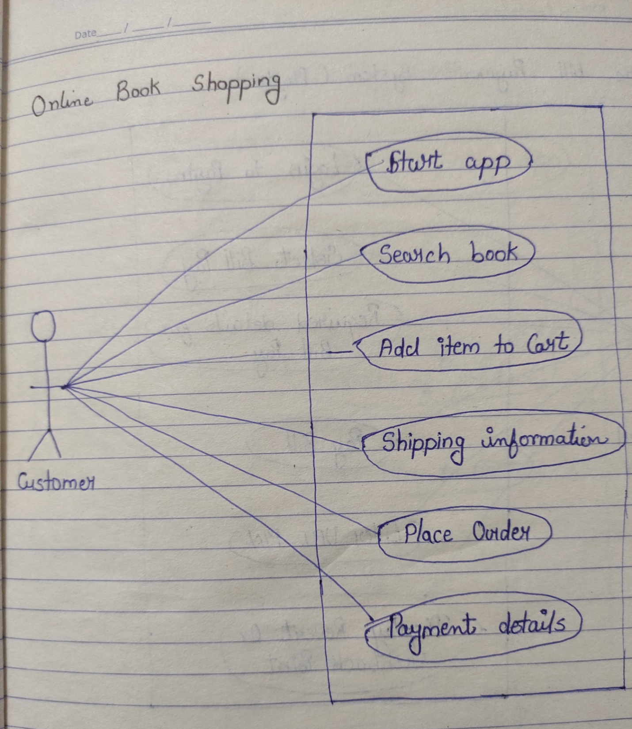

**20.Draw Usecase on online bill payment system(paytm)**

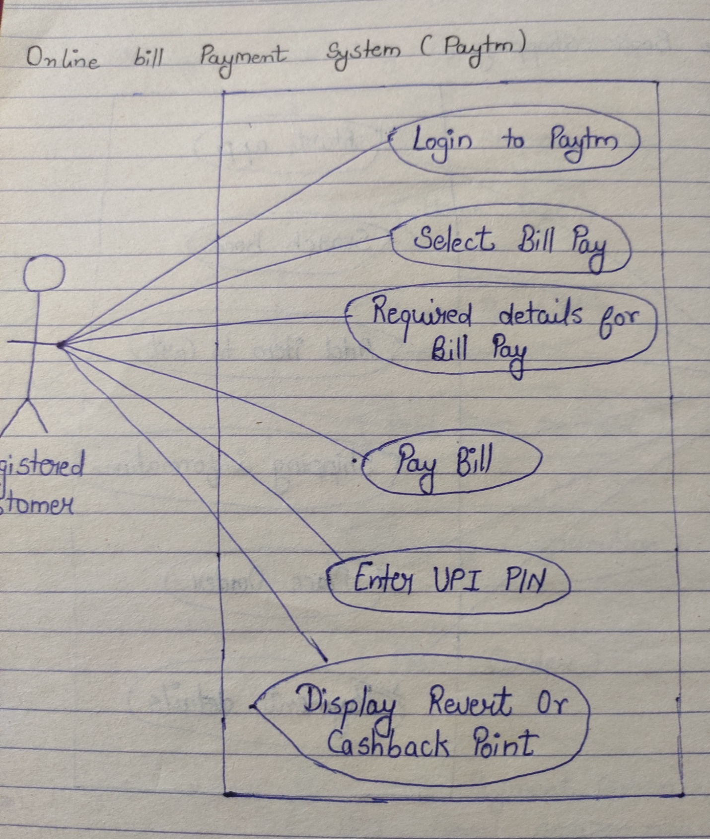

**21.Draw Usecase on online shopping product using COD.**

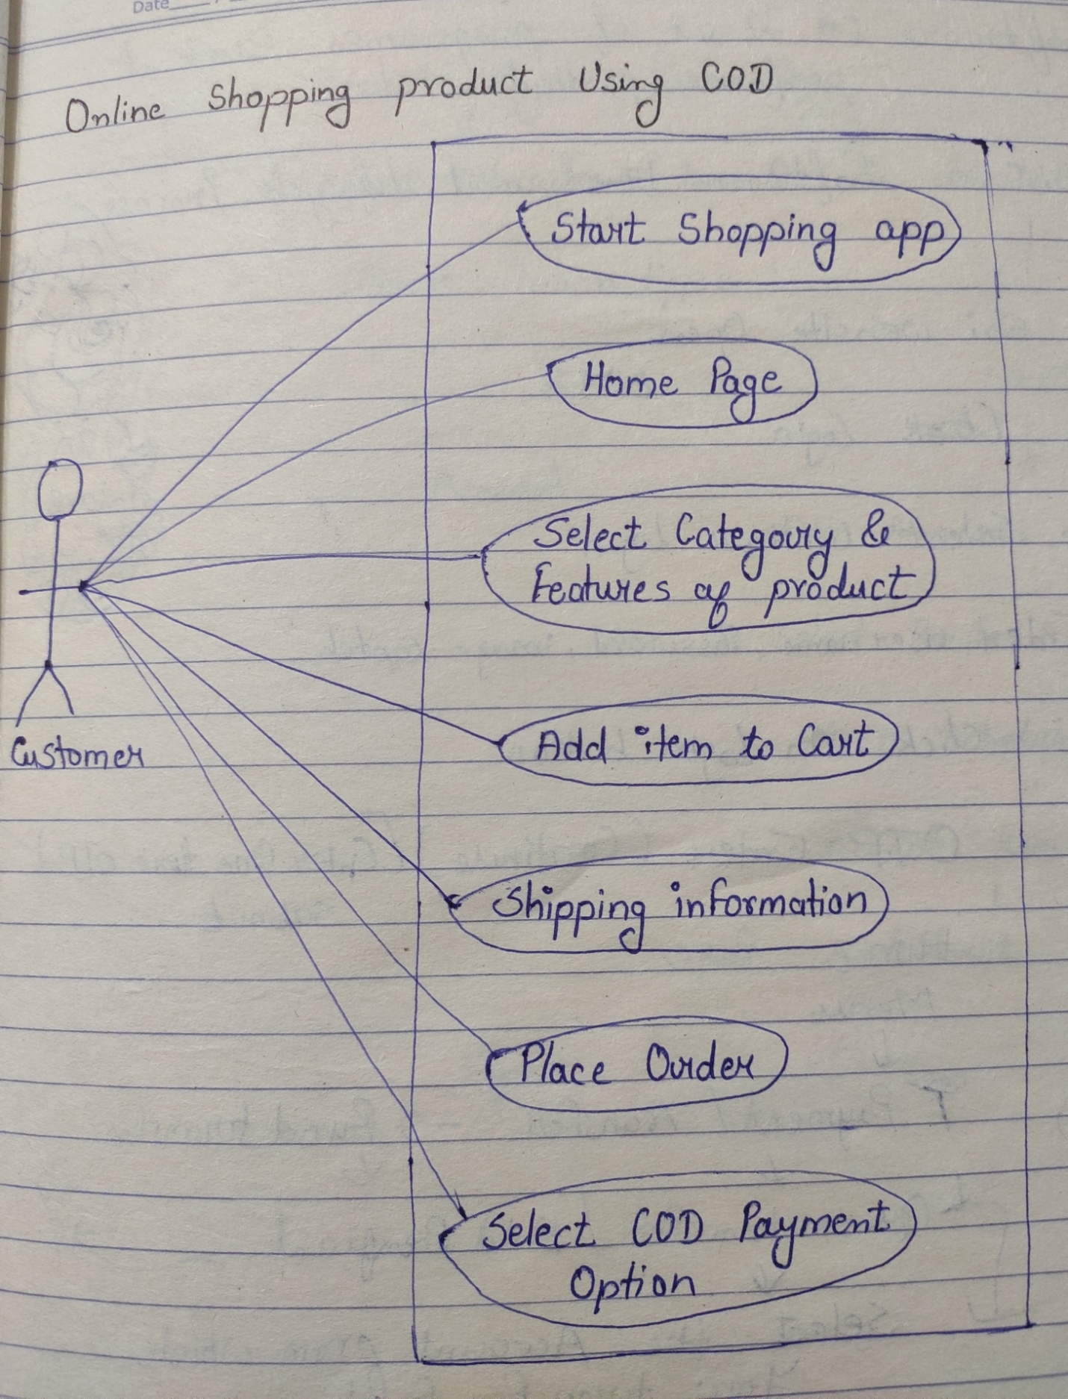**22.Draw Usecase on online shopping product using Payment Gateway**

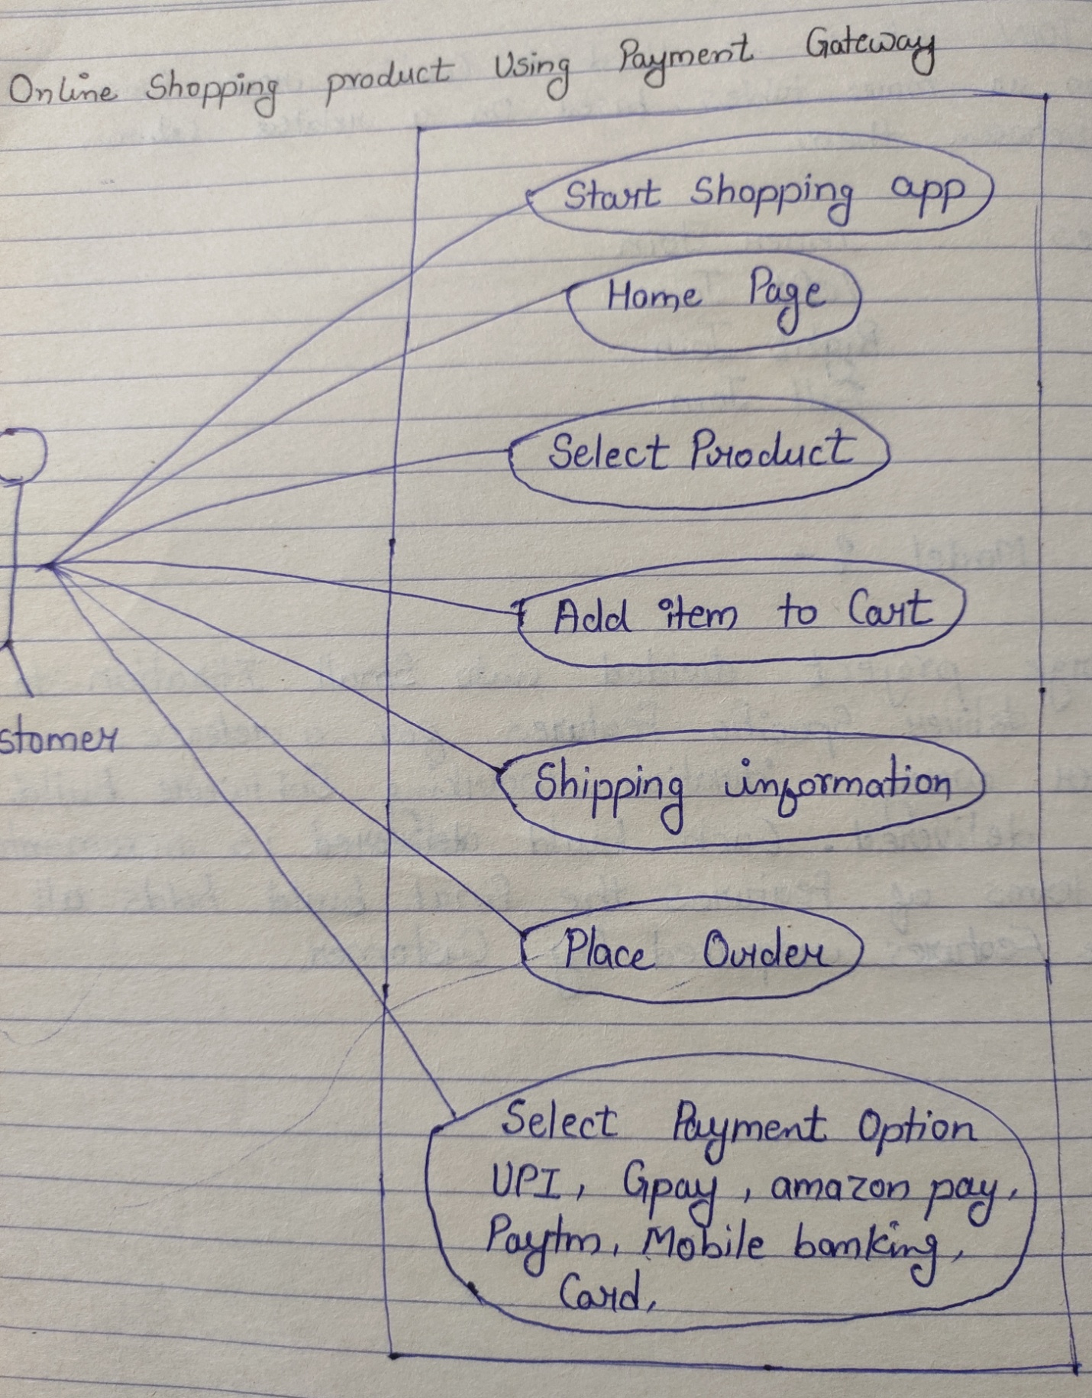

**23.What is JOIN**

**Ans**:- A join clause is used to combine rows from two or more tables based on a related column between them.

**24.Write types of JOIN**

**Ans**:-

1. Inner join
2. Left join
3. Right join
4. Full join