SOFTWARE TESTING REPORT
Amazon Website — Manual Functional Testing

Student Name | MS. HARSHITA MALVIYA
Student ID / Roll No. | 2504030100426
Application Under Test | Amazon website (amazon.com / amazon.in as shown in captures)
Testing Approach | Manual functional and user-interface testing
Environment | Desktop browser on macOS; browser shown in supplied screenshots
Evidence Date | 10 October 2026 (from screenshot filenames)

1. Objective
To perform and document manual testing of selected Amazon website workflows using the screenshots supplied. The report records visible page behavior, navigation, sign-in and verification interfaces, and product information display.

2. Scope of Testing
The practical covers homepage loading, opening the navigation drawer, displaying the sign-in page, reaching the OTP verification interface, observing the OTP-entry screen and passkey prompt, and viewing a product detail page. No purchase was made or verified.

3. Testing Method
Each supplied screenshot was reviewed as evidence. Expected results are written for the action shown, and actual results are limited to what is visibly supported by the screenshot. Authentication is not marked successful unless the evidence clearly confirms it.

4. Test Summary
Status | Count | Interpretation
Pass | 5 | The visible page or interface matched the expected display.
Blocked / Not Confirmed | 2 | The screenshots do not confirm successful OTP verification or completed sign-in.
Fail | 0 | No clear failure of a tested visible interface is established by the screenshots.
Note: These counts summarize the seven evidence-based test cases in this report; they do not imply that all Amazon functionality was tested.

5. Detailed Test Cases and Screenshot Evidence

TC-01 — Homepage
Testing Step | Open Amazon website
Expected Result | Amazon homepage and primary controls should load.
Actual Result | Homepage loaded with search bar, account area, cart, category navigation and shopping panels; delivery-region notice visible.
Status | Pass
Personal Comments & Suggestions | Homepage loaded. Consider dismissing the delivery notice or confirming the intended region before continuing.
Screenshot 1: Amazon Homepage
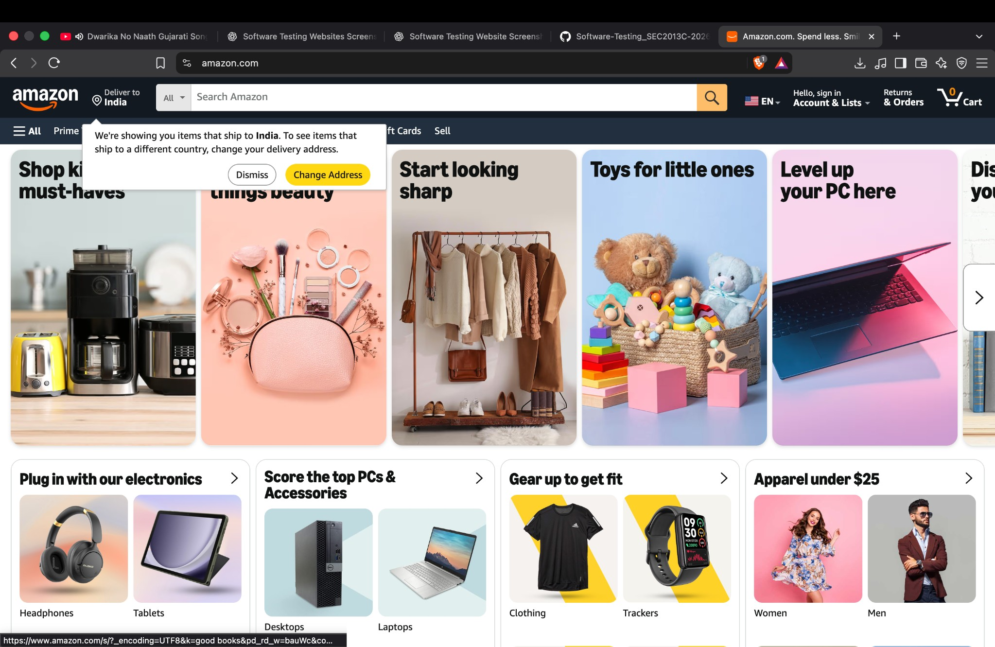
The Amazon homepage loaded and displayed the search bar, account links, cart, category navigation, and shopping panels. A delivery-region notice was visible.

TC-02 — Navigation
Testing Step | Select the All/navigation menu
Expected Result | Navigation drawer should open and display available sections.
Actual Result | Left-side navigation drawer displayed department, digital content, programs and help sections.
Status | Pass
Personal Comments & Suggestions | Menu opened as expected. A separate close-menu test can be added if required.
Screenshot 2: Navigation Menu
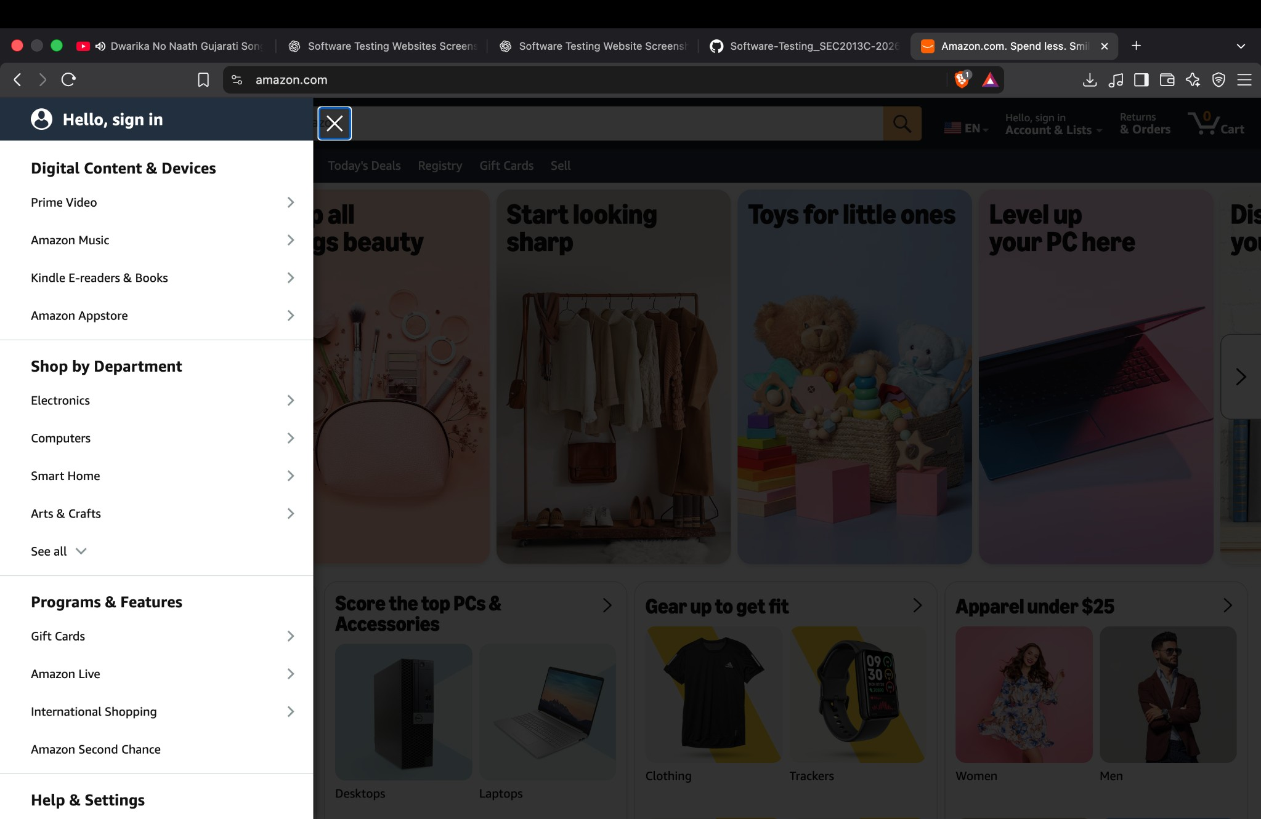
The navigation drawer opened over the homepage and displayed department links and program/help sections.

TC-03 — Sign-in UI
Testing Step | Open Account & Lists / sign-in
Expected Result | Sign-in page should show a mobile/email input and Continue action.
Actual Result | Sign-in interface displayed mobile number/email field, Continue button and policy links.
Status | Pass
Personal Comments & Suggestions | Only the interface is confirmed, not a successful login.
Screenshot 3: Sign-in Interface
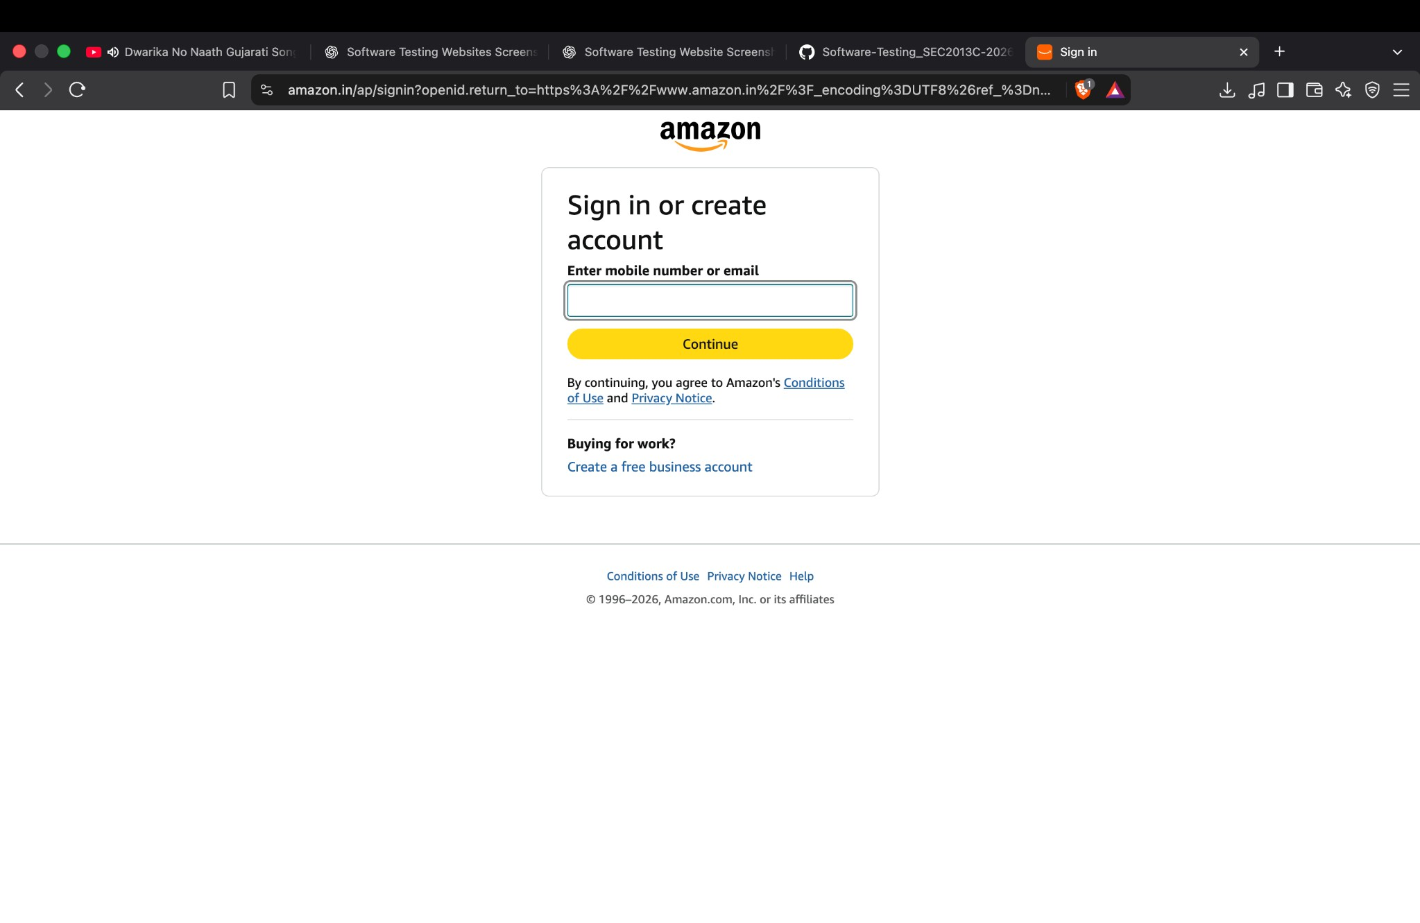
The sign-in page displayed a mobile number/email input and Continue button, along with policy links.

TC-04 — OTP UI
Testing Step | Continue through the account verification flow
Expected Result | OTP verification page should show an input and verification options when required.
Actual Result | WhatsApp OTP screen displayed an OTP field, Verify, resend and SMS options.
Status | Pass
Personal Comments & Suggestions | The screen is displayed, but successful verification is not proven.
Screenshot 4: OTP Verification Screen
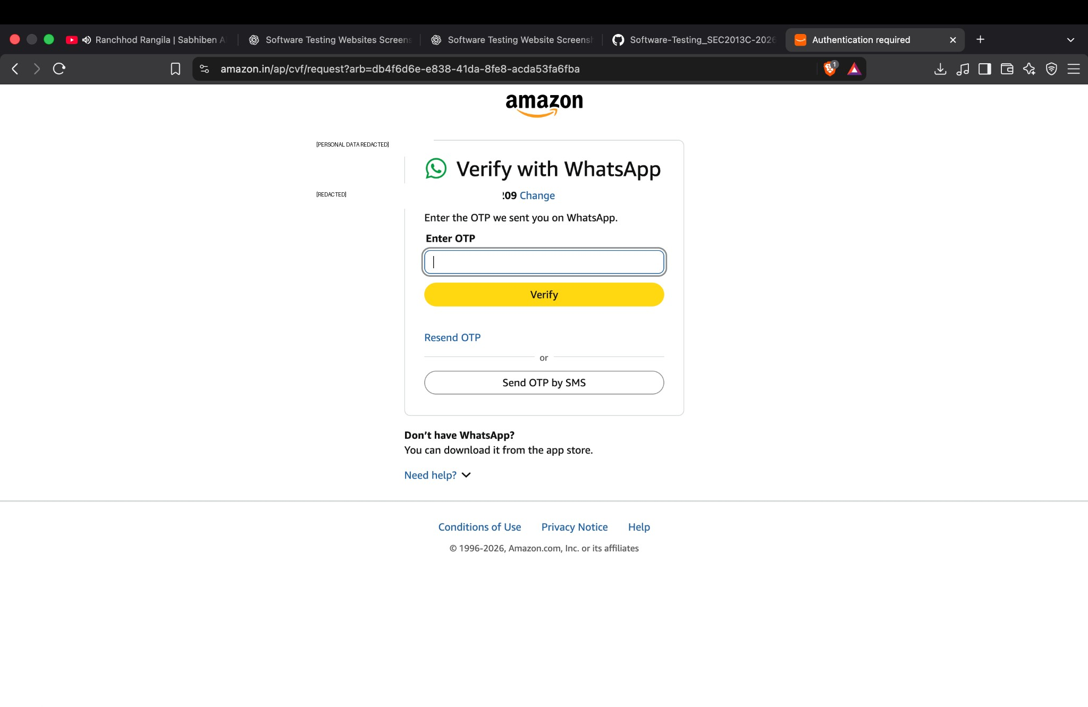
Amazon displayed a WhatsApp OTP verification screen with an OTP field, Verify button, resend option, and SMS alternative. The screenshot does not establish successful verification.

TC-05 — OTP verification
Testing Step | Enter the OTP received by the account holder
Expected Result | A valid OTP should be accepted and the flow should proceed.
Actual Result | OTP field contained an entry, but no success message or completed transition is visible.
Status | Blocked / Not Confirmed
Personal Comments & Suggestions | Do not claim Pass until a success state or next authenticated page is captured.
Screenshot 5: OTP Field Entered
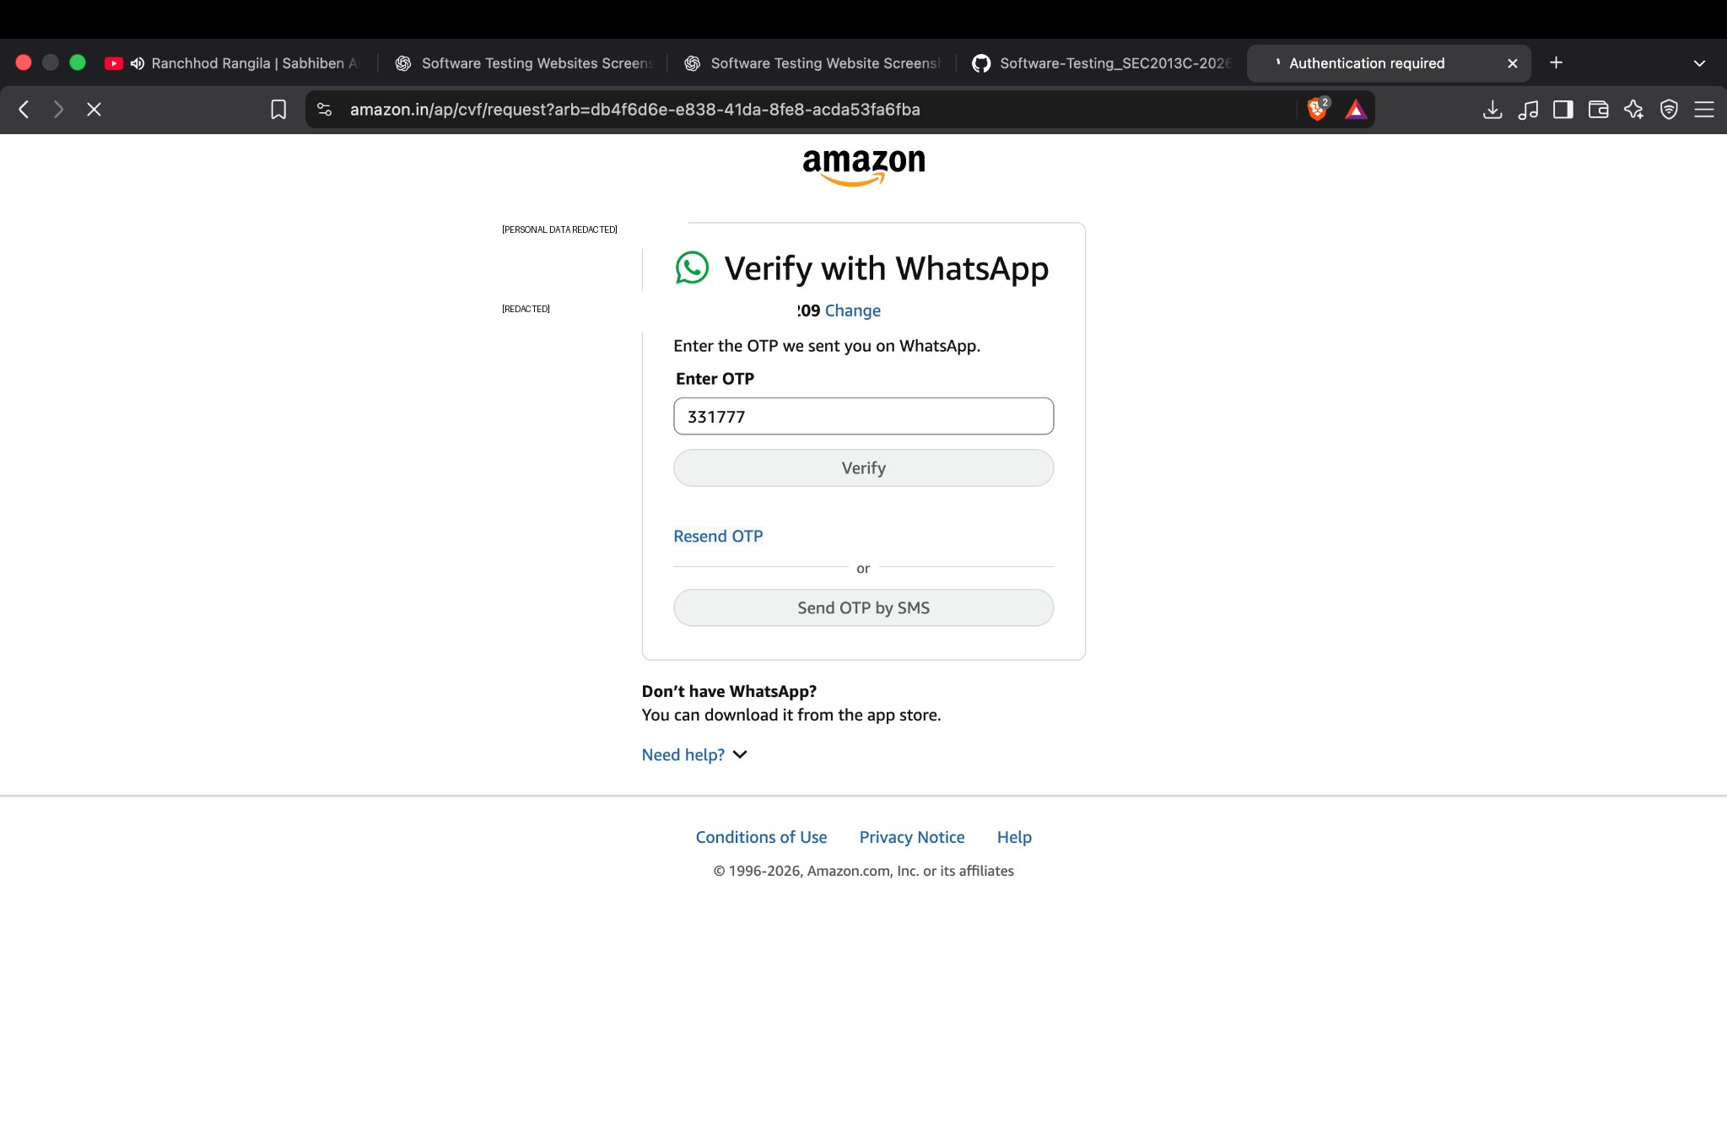
The OTP field was populated, but the screenshot does not show a confirmed successful verification result.

TC-06 — Passkey prompt
Testing Step | Observe the browser passkey prompt
Expected Result | Prompt should provide a choice to save or cancel the passkey.
Actual Result | A browser passkey-save prompt was displayed; no completed authenticated session is proven.
Status | Blocked / Not Confirmed
Personal Comments & Suggestions | Do not save a passkey on a shared device. This prompt alone is not login evidence.
Screenshot 6: Passkey Prompt
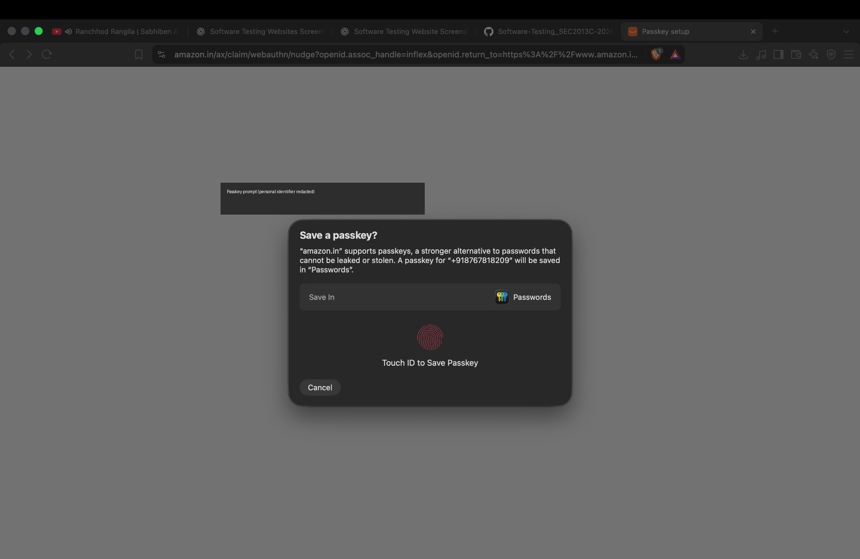
A browser prompt offered to save a passkey. This is not sufficient evidence that authentication was completed.

TC-07 — Product details
Testing Step | Open the displayed watch product page
Expected Result | Product title, price, availability and purchase controls should be visible.
Actual Result | Product page displayed product image/title, rating, price, stock status, quantity selector, Add to cart and Buy Now controls.
Status | Pass
Personal Comments & Suggestions | Product details displayed. Cart behavior was not verified, and no order should be placed for this practical.
Screenshot 7: Product Detail Page
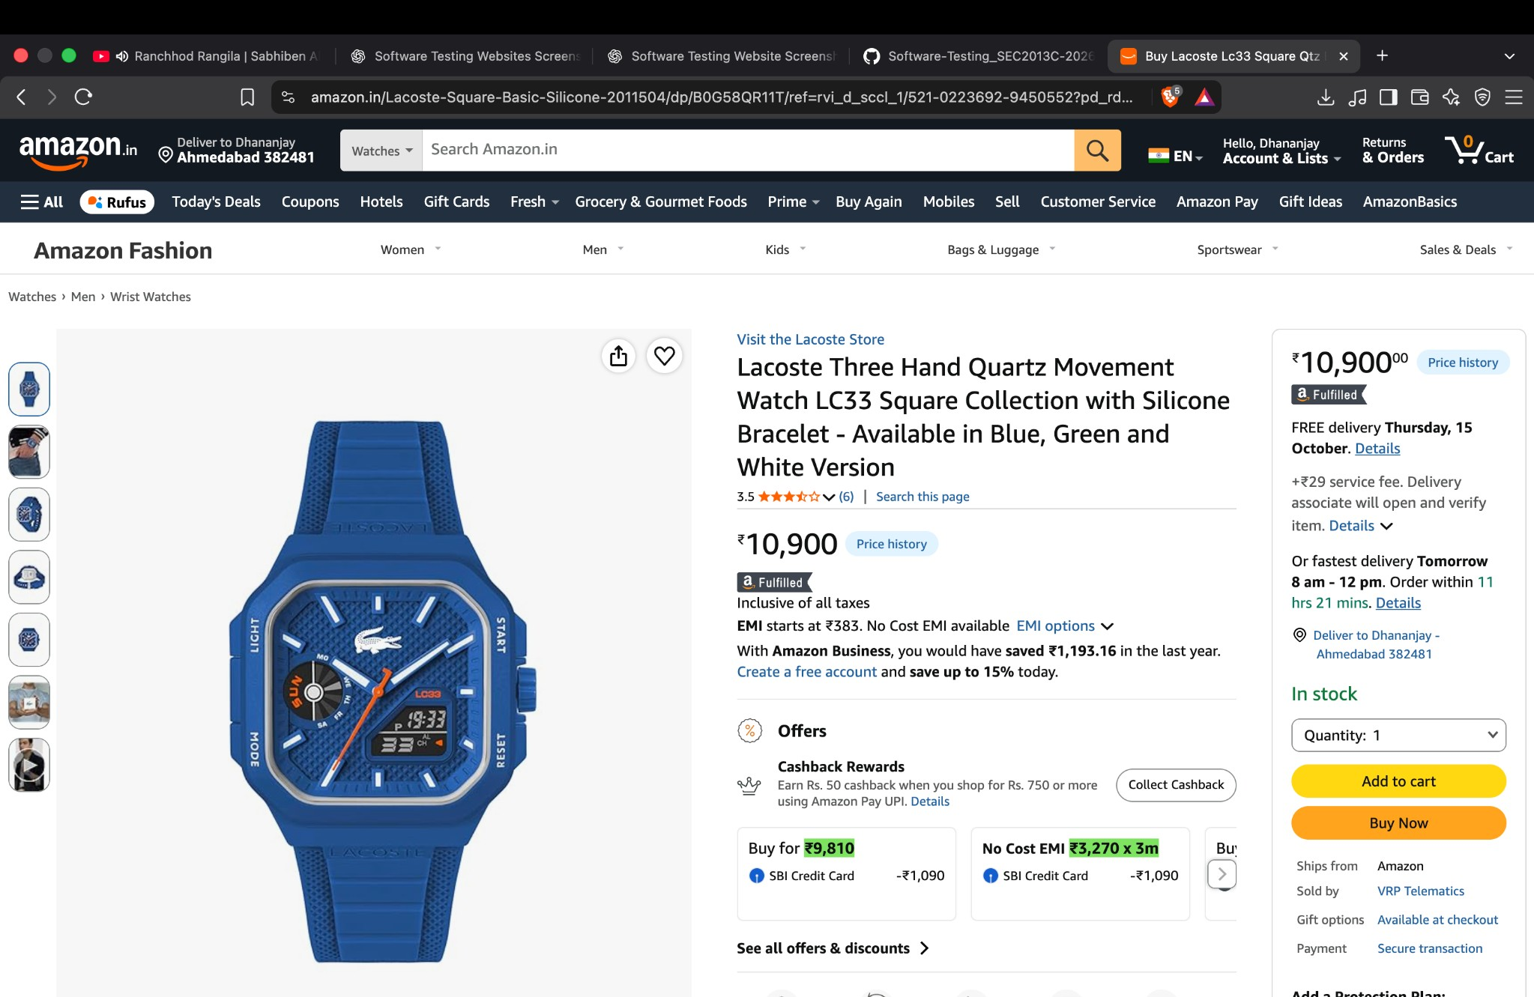
A product detail page displayed a watch image, title, rating, price, availability, quantity selector, Add to cart, and Buy Now controls.

6. Observations
- Amazon homepage and navigation controls were visible and responsive in the supplied captures.
- The sign-in flow reached an OTP verification interface.
- The supplied evidence does not prove successful OTP verification or completed sign-in; these items remain Blocked / Not Confirmed.
- The product detail page displayed core product information and purchase controls.
- Only the actions represented by the screenshots are documented; search results, cart update, checkout, payment, and order placement were not confirmed.

7. Conclusion
The practical documented selected Amazon website screens and workflows using manual, screenshot-based testing. The evidence supports successful display of the homepage, navigation menu, sign-in interface, OTP interface, passkey prompt, and product detail page. Authentication completion and cart/checkout functionality require additional evidence before they can be marked as passed.

8. Evidence and Privacy Note
Personal phone/OTP-related details have been redacted in the embedded copies of screenshots used in this report. Original screenshots should be handled privately. Test only with your own account and do not include passwords, OTPs, or other sensitive authentication data in a submitted report.

